INTERNATIONAL MARKETING

NAME: SHAHINA YUSUFBHAI PATEL
STUDENT NUMBER: 1710755
MODULE TITLE: SBMA7108 INTERNATIONAL MARKETING
ASSIGNMENT TITLE: INTERNATIONAL MARKETING ASSIGNMENT-1
LECTURER’S NAME: TUSHARA BALENDRAN

Table of Contents
Introduction 3
Company Overview 5
Audi 5
Pestle analysis of Audi Automobile Company in context of UK and Germany 6
Compare macro environmental factor of Audi in Germany and UK with Hofstede model 8
SWOT analysis 11
Porters Five Force Model 15
STP analysis of Audi in Germany and UK 19
Marketing Mix strategy 21
Directional development strategy 24
Recommendation 26
Conclusion 27
References 28
Appendix 31

Introduction
In the today’s business world, marketing the organization is not limited to the national borders only. In this, the global presence is the most significant factor for an organization as the international marketing will serve the further brand expansion and brand enhancement in the different nations. It not only serves the increasing growth prospects but also the marketing of the products and services in the new places. With this, the organization can attain the competitive advantages in the market along with the efficient brand recognization (Samaha, et. al., (2014). In order to compete in the global market, it is important to have the effective global strategies in the organization. In this context, the report highlights the importance of strategic analysis along with the international marketing in the automobile industry. The automobile industry has shown the major hike in the past few years as the global sales of car passengers has increased rapidly in the world. According to the statistical data, car passenger hit 78.6 million vehicles in 2017. Thus with this demand for the automotive companies has risen in the various markets. In this, the famous brands like Toyota, Volkswagen and many others are competing for the higher revenue sales (Aichner, 2014).
The demand of the automobiles has risen in different nation out of these Germany is the biggest sources for the automobile industry. In this, the ratio of the human forces is extremely high, as the country has 7, 47,000 employee working in the automobile industry. Germany is the nation which is majorly famous for new innovation as well as the excellence in the engineering. While considering the different cars from Asia to America, German cars embody highly cherished values of innovation, reliability, safety and design. The below chart showcase graph, which states that Germany has the highest production and the registration in the cars (Drauz, 2014). In this, the German market is considered as the Europe biggest market for the automotive sector, manufacturing leader, largest industry and the Research and development leader in the whole world.
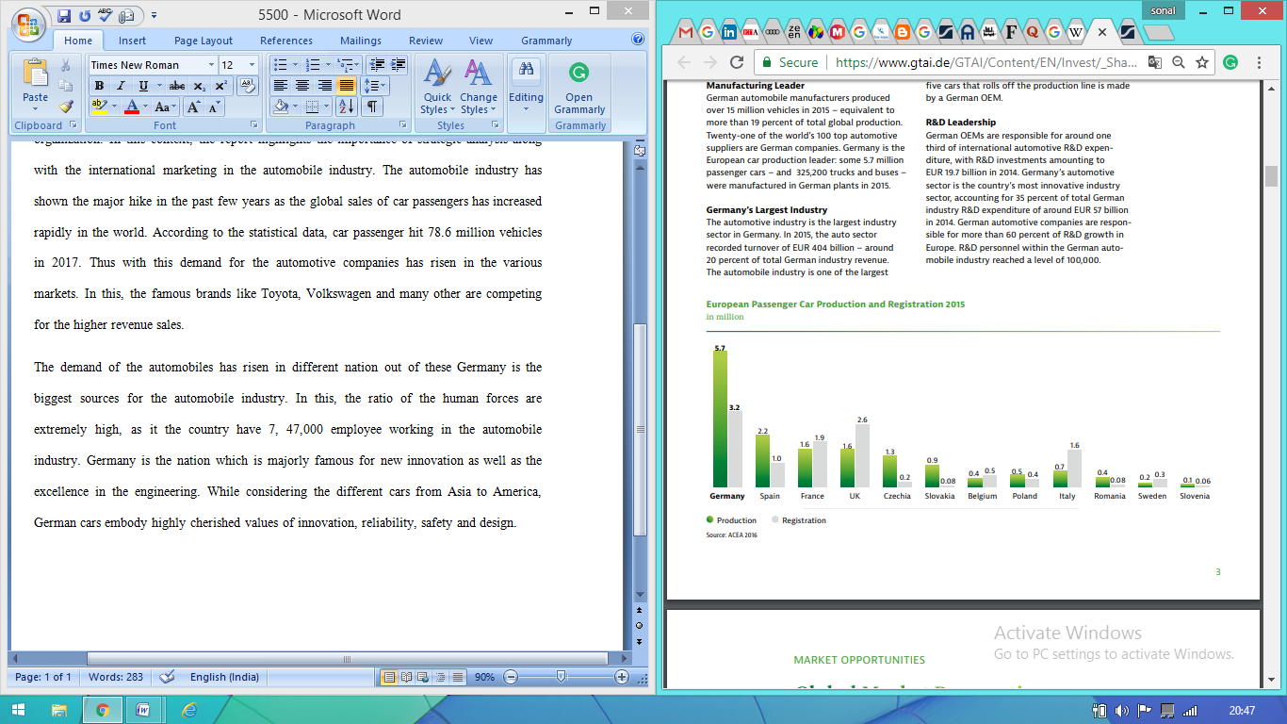
source: Hashmi and Biesebroeck, (2016)
On another side, the UK is also considered as the player in the automotive sector because the turnover estimated from the industry is the biggest sources through which value has been added to the nation. However, the ratio of the employers is lesser than Germany but the country is famous to serves the different ranges of cars. In the early 90’s UK was considered as the second largest car manufacturing firm present in the nation but in today’s world the different regions have made the innovation and started earning with them. Thus the lower growth has made that reduces their ratio and country with compare to other has the lesser scope in the automobile sector. It has been seen that the UK market is famous for the premium and sports cars that is mainly produced by Bentley, Caterham Cars, Daimler, Jaguar, Lagonda, Land Rover, Lister Cars, Lotus, McLaren, MG, Mini, Morgan and Rolls-Royce. Other than that the volume cars are produced by Volkswagen, Honda And others (Ngo, et. al., 2016).

Company Overview

Audi
Audi is a leading German automobile company that produces the designer’s cars for the customers. Its parent company is Volkswagen and the cars produce into the nine different production facility of the nation. The organization was founded in the year1949 after that Audi specifically began their journey in 1960 because the company has been acquired by Volkswagen. Audi has the high brand image in the different nation, as the Chinese and German citizens mainly prefer this brand. The logo of Audi showcases the unique story itself, in this four rings showcases the four different tyres of the company that has merged with the company. Audi, from the BMW and Mercedes-Benz, is among the best-selling luxury automobile brands in the world (Audi 2017). This multi-featured automobile company is founded by August Horch. The company has always believed in the effective marketing strategy of the company because the company is serving the high end product in the market. They have the slogan of “progress through technology” that means that the further innovation can lead to creating new creatures. While launching the Audi brand, F103 series has been launched in the market. After this launch, Audi has become the front-runner in car engineering and in the recent time it is a most famous car in the German and another market (Audi 2017).

Pestle analysis of Audi Automobile Company in context of UK and Germany
Pestle analysis is consider as a tool that has been used by the marketer to monitor and analysis the various macro environmental factors which make an impact within an organization. Pestle analysis is used by the organization to identify threats and weakness that has been used in the SWOT analysis. With the help of this tool, the organization will able to track environment and also planning to launch new product, service and new projects (Tan et al., 2010). Pestle analysis stands for Political, social, economic, legal, technological and environmental that is used for the strategic marketing planning, change within the organization, development of product and service in the particular country and so on. The pestle analysis of Audi in context of Germany and UK can be described as below-
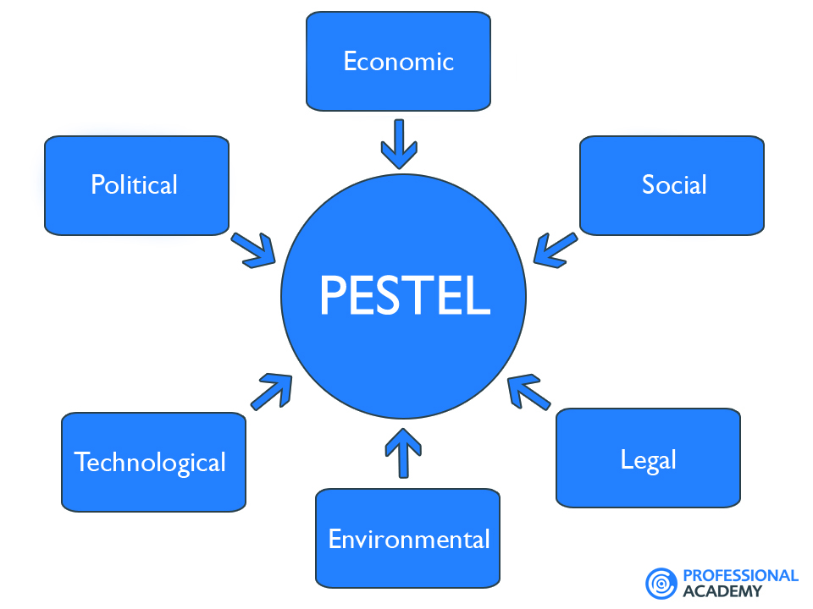
Political
From the last century, Germany is the country that has been famous for making cars like Audi, Mercedes, and BMW and so on. The government of Germany was also encouraged the procedure of motor to show the car which is made in German to the customers worldwide. The company set it’s headquarter in Ingolstadt and also having strong human resource with 60000 staff member within different nations. On the other hand, political factor also played an important role in UK and also have a direct impact on the profitability of UK (Zhao, 2010). The government of UK will always favour the vehicles related to low emission. The Audi market in UK also providesubsidy for the low emission vehicles and the environment friendly vehicles demand has been increased at global manner.
Economical
In 2008, there has been an economic recession all over the world. The economy at global level has been recovered at the end of 2009 but still there are some countries which faced issue related to credit crunch. The government of Germany has been spent billions of dollar to support and encourage the families to buy the car made in German. In UK, the government also gave some benefits when the people will exchange their new car in a dealer (Cox et al., 2014). As per the statistics of Audi, the new car sales has been increased from 2009 to 2010 in North American markets as well as European market. Along with this, the company has been delivered 108,000 cars to china within first three months as compare to total sell of Audi car at the same period.
Social
Audi has been known as the largest manufacture in the world and the impact at social level is inevitable. The company has provided support to more than 60000 families every year. In this way, the company has been improved its workshop condition for providing high level of satisfaction to employee. The company also offers success to the business for creating exceptional cars, when employee join the group member in Germany. The market of UK in context of Audi has been influenced at deep manner because of the socio culture forces (Zhao, 2010). Every next year, new model has been released to keep the preference of people in the mind. The company has been able to release the vehicles on the basis of preference of the customers within the target population in Germany.

Compare macro environmental factor of Audi in Germany and UK with Hofstede model
Hofstede model is known as the cultural dimension theory and a framework for the cross culture communication and developed by Geert Hofstede. The Hofstede model analysis the range of dimensions like power distance, individualism, masculinity and uncertain avoidance. It is a great example for analysing the cross cultural environment in context of two countries. Audi has been involved in the cultural aspect for more than 50 years (Cox et al., 2014). The dimension towards culture is main aspect for the business in terms of growth as well success of the company.
COUNTRY COMPARISON of Germany and UK in context of culture dimension for Audi
Germany
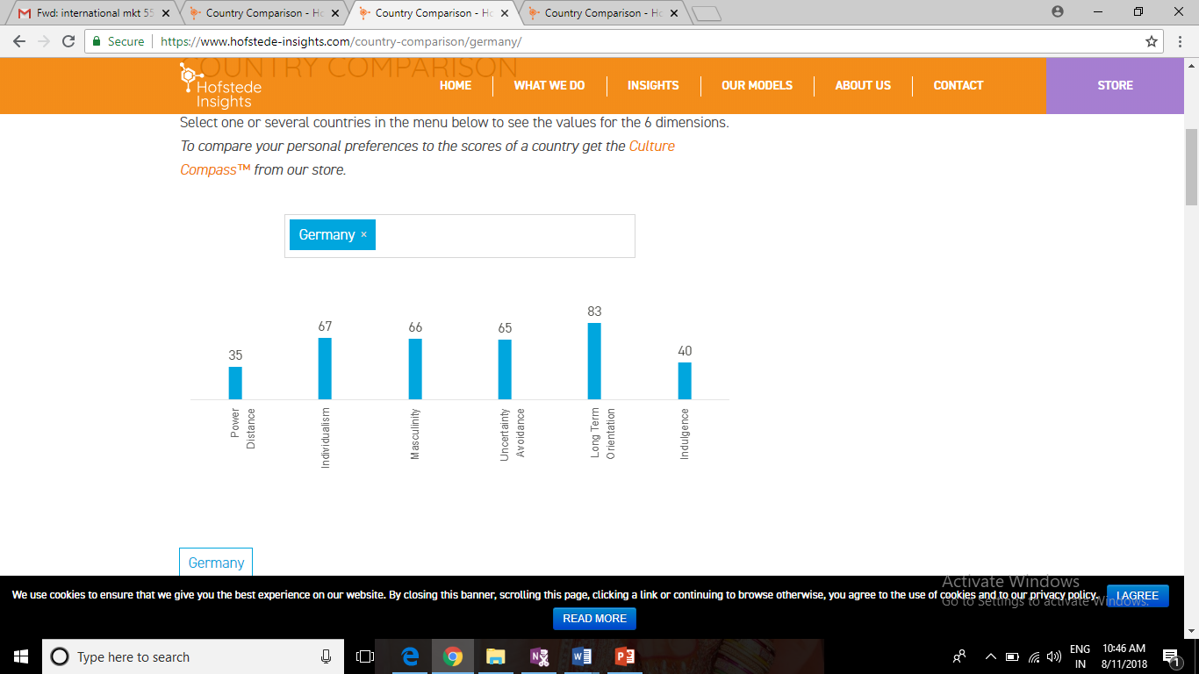
(Source: Hiftede, 2011)
UK
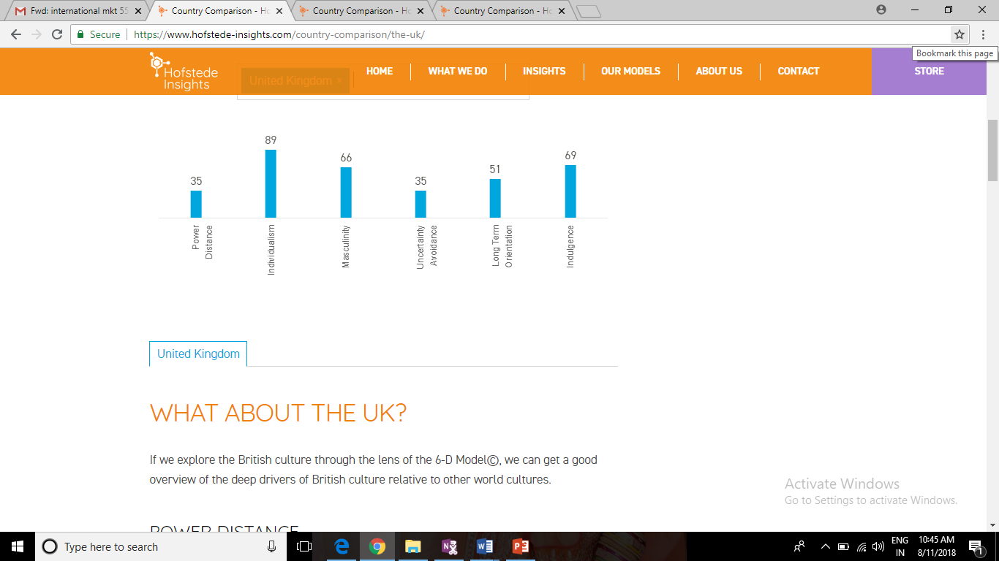
In Germany, the power distance dimension deal with the important fact that all the individual within societies are not compare equally. As it is helpful to express cultural trend and attitude along with these kind of inequalities. The country is highly decentralized and supported by strong middle class and the nation is not surprisingly among the power distance country. The society within Germany are truly individualist. Small families within the country will always make their focus on parent children relationship as compare to uncle and aunt’s relation are most common. The country is having strong believe towards the idea of self-actualization (Hiftede, 2011). UK is having highest individualist scores and it can be beaten by the common wealth countries like Australia and USA.
In addition to this, with the high score, Germany is the country that has been considered as a masculine society. Most of the people in the nation live in order to work and also draw self- esteem along with the allocated task at the various companies. On the other hand, UK is also considered as the highly success driven and oriented country. The people within UK live their life in order to work and also will able to achieve the clear performance ambition. Germany is known as the uncertainty avoidance country by which the people preference for uncertainty avoidance. The national always prefer to compensate their high uncertainty to make a strong relying towards expertise (De Mooij and Hofstede, 2010). UK is having low score of uncertainty avoidance and it is results not to make a detail oriented in context result in work terms.
Technological
The development within technology is the key feature of Audi and the company best known as permanent four wheel car system that is called QUATTRO. In the present context, Quattro is widely used as the famous Audi Model and also offer more safety to the drivers in different situations in Germany. As the comfort aspect, the company has been introduced air adapted suspension and this equipment will provide suspension to achieve high level of performance within the different condition of road (Borowski, 2010). In UK, the company will increase their focus on the eco-friendly vehicle which encourage the people for continuously making investment for research and development. The innovation and new level of technologies plays a vital role for maintaining the competitive level in Germany towards international competitiveness like an economic performer.
Legal
The company has been responsible to set the group of legislation in Germany in order to protect the road user environment and safety. Along with this, the crash standards of the German car is limited that are good example (Tan et al., 2010). On the other hand, Audi performance has been affected because of various rules and regulation that has been described by UK government. Along with this, there are various environmental laws, laws related to tax and various other laws that will make a deal while the business operating in the international market.
Environmental
Towards the corporate social responsibility, the company paid more attentions. Along with this, it is inevitable for Audi that it is not polluting the environment as it is manufacture. The company also makes different promises to minimize the environmental impact. Moreover, the company spent high money for researching the efficiency engine in Germany. The environmental pollution is one of the important challenge that has been faced by Audi in UK and the company pays more attention for this aspect.

SWOT analysis
SWOT analysis is used by the company to evaluate the competitive position of the company with the identification of strength, weaknesses, opportunity and threats. In addition to this, SWOT analysis is the foundation of assessment model which can be measured that what can be done and cannot be done by the organization (Amin et al., 2011). The comparison of Audi within Germany and UK on the basis of SWOT analysis can be described as below-
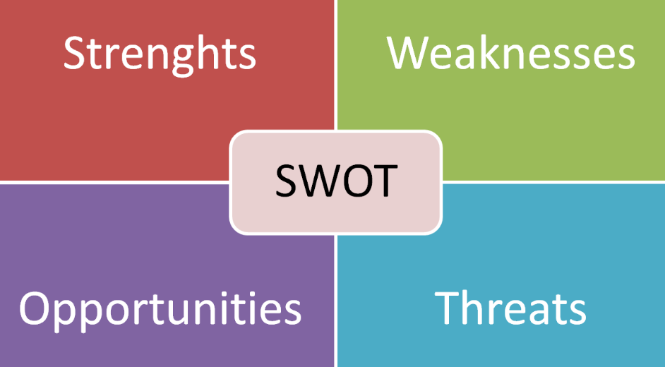
Strength
In Germany, Audi is known for precision and engineering within their cars. The design of the cars comes with precision engineering and also use the high capacity engines. The product of Audi is the key factor for the success of the company and the company has varied various series of car model. In Germany, the company is having large market segment and also known as the sales and production leader. Other than this, the company increase demand for resources which optimize the high intense competition with developed market mature. Germany will provide manufacturing facility to Asian countries which are able to control cost to manage the car company’s production system (Coman et al., 2009). In UK, the company represents the economic growth as well freedom. Audi will allow the people to work, live and travel in an effective way that were unimaginable in past years. The company is having technological and continuous product innovation. The company will able to drive research and development expenditure for driving the next phase of growth.

Weakness
Audi has to deal with the environment at local business. Audi is a German company and there brand has been associated with the identity at national level. The main weakness of Audi is that brand is dependent on the European market and it is small within North America. On the other hand, the Audi market in Europe is also declining as debts being experienced by large market. The company reminded huge controversies which is relating to recall the vehicles along with various technical functionality. The main weakness of Audi in UK is diversification towards the low cost cards and also has kept the high product portfolio (Rizzo and Kim, 2005). The company needs to pick up the frequency of promotions. There are various controversies related to recall vehicles which account for some dis-functionality towards government. The company has been generally perceived towards tier two luxury brand. On the other hand, the company will provide various different advantages. In addition to this, the cost for maintaining the product of Audi is very high and also the product of the company are the major attraction for media.
Opportunity
In Germany, there is high demand for the hybrid cars of Audi. The demand of hybrid car can help the business to achieve large market share in hybrid technology. In the market of German, the demand for the high valued and luxury car is increasing and emerged as the potential market. The company always diversify into low cost segment that will increase the sales level of the business and the company also pay its attention towards marketing. The company can introduce their product in the high emerging market by which they are covering geographical territory and improve the turnover and profit for the company itself. In UK, the company innovate its product to measure market (Charan, 2012). There are three powerful forces which are rolling the company that are shifting of customer demand, increase the regulatory requirement for safety economy and also increase the availability in order to collect information and data. Audi along with its innovative history make their investment in heavy vehicles which are low emission. Audi has become a leaner business with the help of increasing their profit as per vehicle and also reducing the level of inventory.
Threats
The level of competition within automobile market against Audi is increasing. The company will able to manage high level of pressure with the help of using elegant and unique designs. But the competition is not going to subside. In the market of German, top players of car are aggressive and they are able to market their product more aggressively as compare Audi. The company needs to make its focus on innovation for beating the competitive pressure. The overall presence of large player within Automobile industry in UK is resulted for the extensive competition (Amin et al., 2011). The market is limited which may cause for the saturation at long term. The company is not able to survive along with its home territory by which the company face risk at international market.
The advantages and disadvantages of this model
Advantages –
- it help in the getting the organization plus points
- It serves the positive response to the opportunity
- It help in achieving the strategic planning successfully (Shinno, et. al., 2006)
- It provides the useful information for the purpose of strategic planning
Disadvantages –
- It gives the subjective analysis
- It does not provide any mechanism to rank the significance of any single factor
- The high cost (Valentin, 2001)
- Inefficient skills and labour

Porters Five Force Model
Porter’s micro environmental analysis tools haveutilized the key five industry powers in the nation through which its effectiveness level can be identified. It can also serve the bargaining power of suppliers and buyer along with the existing rivalry in an industry. The scopes of these key five strengths are very significant as well as influencing in nature.
- Threat of new Entry – The threat of new entry has considered the ranges of key points like time and cost of entry, knowledge and technology, Government policies and the product differentiation. The time of Audi to enter into the market is the effective one because the trend of luxury cars was high in the nations. Thus we can say that the threat of new entry is low for the organization. However, the underlying capital is required to stand the company in the market. The government regulations are in favor because the government has served the plant to start their manufacturing along with the expenses refunds (Adamkasi 2017).
- Bargaining power of Buyers – The bargaining power of the organization Audi is higher in the market because the automobile sector gives the ranges of choices to the customers. Consequently, the other brands are also giving that luxury and innovative designs to cars due to this the customers have the high potential to bargain. Furthermore, it has been found that in Audi auto price and the quality which they offered to the customer does not make any concession in front of consumers. Thus it can be clearly stated that the bargaining power of the buyer or customer is high for the organization (Dobbs, 2014).
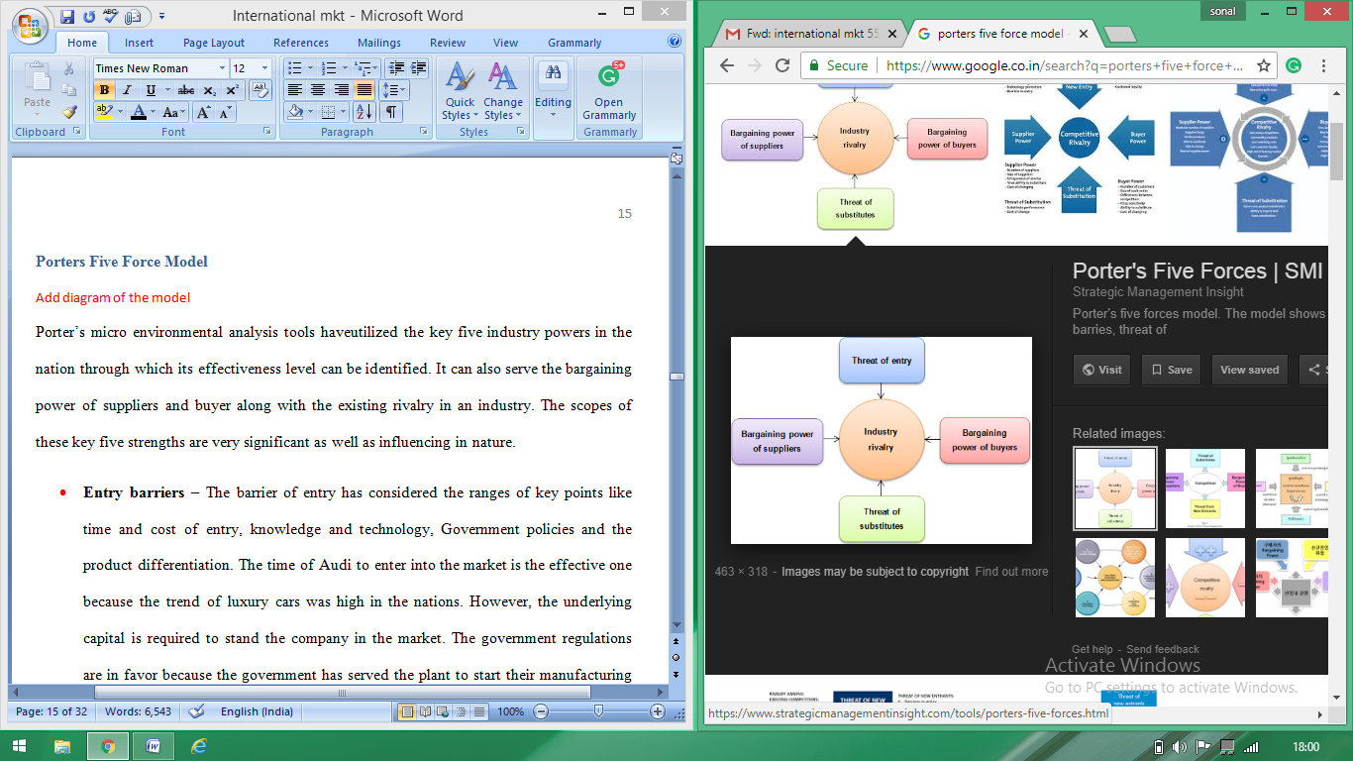
- Bargaining power of supplier–Generally the bargaining power of suppliers in the luxurious cars is moderate in nature because the supplier holds a decent amount of power in the market. However, Audi’s supplier showcases the positive reaction towards the company and also seems happy while working with it. The organization is strongly inconnection with their suppliers. Thus it can be said that the bargaining power of supplier in Audi is low because the company offers the high-end product to the customer that does not include any fake material in their cars. Thus it has been said that the brand is not only for consumer but also for the suppliers as they provide the orders with quality and volume (Adamkasi 2017).
- Threat of competitive rivalry – The threat of the rival companies are high for the high end luxurious cars because the luxurious cars companies are well established in the market. The major rivals of Audi are BMW and Mercedes in the various nations. However, the brand is majorly famous for their ranges of Audi series that can minimize the competition. Similar to the other competitive brand, Audi has made the price flexibility in their series due to this the price rivalry has mainly begain in the market. On the other hand, company is efficiently competing among the competition by serving the product quality to the customers. In this, Audi has imposes the business model in the nation due to which they can make themselves more efficient in front of their rivals (Indiatsy, et. al., 2014).
- Substitution threat – Substitution is considered as the replacement factor for that particular product. The automobile companies showcase the medium or moderate substitution threat in the context of highly luxurious branded cars. It is because the substitution car is not only a car in the market, the consumer can substitute car with train, bus and etc. Other than this, the company prices and their performance is another vital factor of substitution in the market. Thus the Audi has made the organization effective in the market and made the fundamental expected client that will not shift towards the other brand. In the case of performance, the unique features have added to the firm so that their customers can retain with them and raises the brand loyalty in the market (Adamkasi 2017).
According to the whole analysis, the company has the moderate forces in their firm because the automotive industry has been increasing rapidly in the market as the other rivals are making the strong options in order to compete with high rated brands like Audi in the different nation (Mikelsone and Liela, 2016).
The advantages and disadvantages of this model
Advantages
- It mainly suits for the simple market structure
- It identify the competitive threat by getting the existing rivals
- It makes the market structure fairly static (Dobbs, 2014)
- Assumes that the market is static
Disadvantages
- It just provide the snapshot of the environment
- The other non market are ignored in this model
- The model is unable to describe the industry (Rothaermel, 2015)

STP analysis of Audi in Germany and UK
Segmentation, targeting and positioning of the organization is the influencing marketing tool to gain the objective in the market. All the three factors generate the three focusing area that needs to be considered while achieving the desired results. Therefore, the brief analysis of these marketing tools are given below—
Segmentation – Audi has segmented their luxurious and stylish cars on the basis of geographic, psychographic factors.
- Geographic segmentation – This area is closely related to car buyers in the nation. For a case in Germany, the company has launched all its ranges however in the UK market the customer mainly drives the small cars so the short sized cars are launched in the UK market (Bhasin 2018).
- Psychographic segmentation – This segmentation has focused on to categorize of the buyer into the various groups like lifestyle, personal characteristics and the social life. Thus in this context, Audi in Germany and UK has aimed to upper middle class people or the high class people those who presser the luxury brand only.
Furthermore, the average age group citizen can drive these cars not so young and not so old cannot drive. Moreover, the high status of income people can buy this car as the prices are generally high for the brand.
Targeting – Targeting means to aim the selected market that can purchase the product of the particular brand. Audi belongs to the rich brand, hence its targets the upper class social group, Professionals & Executives from rich families as they are the people for whom Audi will be affordable. Moreover, in Germany, the company has targeted the same, like upper or high profile people. Other than that the rich business man has also been targeted in the nation. However in the UK market, the trend of the sporting cars are higher, thus on that basis, the Audi targets the rich sports man also apart from the rich business in order to have the effective sales in the nation (Liu, et. al., 2018).
Positioning – The strong position is the key factor for the luxurious cars on the market. Audi in the automotive sector has created the high branding in the nation because the company has served the quality products to the consumer.
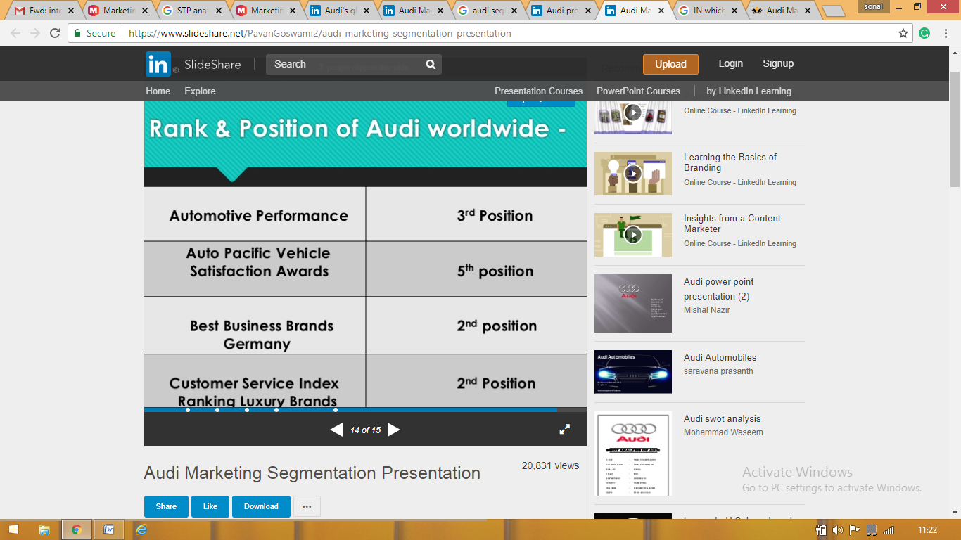
Rank and position of Audi
The organization has launched the few of Audi series that are different and impressive than the other cars present in the market. The scope of Audi in Germany is very high, as the nation itself is the sources of automotive innovation. Other than that, Audi is a German brand so the emerging market effective for the company in the nation. The organization brand loyalty got the remarkable position in the nation. In contrast to this, Audi brand in UK market has lesser scope than Germany because the overall automotive sector is not having any in a hike in the market. However, in past few years, the ratio has increased in the nation as the company produces the cars as per the UK citizens (Bhasin 2018).
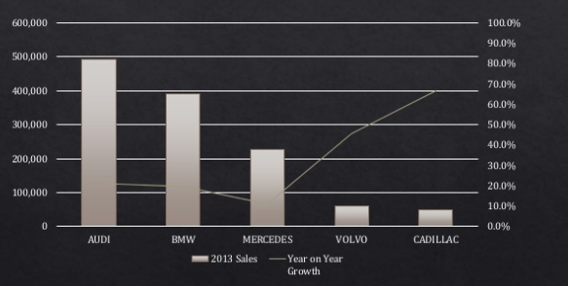
Therefore, the overall market share of Audi is profitable among the other automotive brand.

Marketing Mix strategy
Marketing mix strategies are the essential tool of marketing through the desired marketing objectives can be achieved in the nation. The analysis of the Audi marketing mix strategies are as follows-
Product – The products are the variant that has been served by the company in the market. For the purpose of Audi, the main products are their wider variety of cars that are starting from A1 to Q5 and Q7. In addition to this, the Audi A4 remains popular, as does the impressive looking Audi TT. Thus in Germany, most of the ranges are launched in the market through which organization has gained the leading position in the market. On another side, in UK the company essential products are their sports cars as the demand for these cars are higher in the UK market (Pisano, 2015).
Prices – Prices are considered as those deciding sources that can decide the company existence in the market. The effectual prices of the product give the chance to create the strong customer base from the market and achieving the desired sales. Audi has premium pricing for their cars, as A4 sedan cost of €30,650 in the German market, and the A4 is for €32,500. However, the demand of the sports car is higher in the UK market, thus the prices of Audi is higher in the market.
Place – the place is also an important factor that decides the efficiency of the organization decision because the better place selection will help in attracting more and customers to the organization. In order to reach the targeted sales, uses the indirect sale marketing channel as it will help to attract the wholesaler and retailer both. In addition to this, the German market made the intermediaries that can easily contact with the retailer and manufacturer. The UK market has also emphasizedon the same channels as it is essential for the company to maintain the relationship with dealers (Nagle and Müller, 2017). Moreover, in south and west England, Audi dealers are present in 12 different locations in the nation. Similarly, Germany is the home country for the company as it manufacturing take place over their Thus various places are present in the market as the Audi dealership as well as the manufacturing unit.
Promotion – Promoting brand in the market is the vital task of any organization. In the earlier times, the trend of automobiles is lesser but the unique promotion techniques have raises the trend in the organization. Audi has adopted integrated marketing communication in the organization. Moreover, it has uses the multifaceted promotion mix as its tools to increase the sales of its car and also achieve a higher performance. In Germany, the company has used various marketing tools like direct marketing in which firm has arranged the games and activities that can attract the consumers. Other than this sales promotion has taken place along with the public relation activity (Armstrong, et. al., 2014). In opposition to this, UK market has also made the initiation to promote the Audi series. They have made the product placement in the organization as well as the official website of the company to attract the customer.
People – In an automobile industry, it is important to select the targeted audience so that the effective results can be generated in the market. If the suitable targeted audience has selected then it becomes easier to attain the targeted goals. In the case of Germany and UK, both the country has targeted to attract the high class and the rich business man that may have the dream to have the high standard brand with them. However, Germany has aimed to attract the youngsters and the middle age group people for this. But In UK, sportsman has targeted mainly as the trend of sports cars is higher in the nation (Baker, 2014).
Process – Process in an organization is the benchmark that can give the development on the existing products for the purpose of getting the right product. Other than this, the efficient program management can be managed with the right processing system. In the context of an automobile company, the process could be a manufacturing process, management process sales process, research process and many others. In this, the company can utilize the capability of supplier and design houses. Audi has also made the processing unit in Germany is having the biggest plant of manufacturing along with the further research and development. Apart from this, UK has one research and development unit that is a Bentley plant in which all production was done by hand using traditional craftsman techniques (Bhasin 2017).
Physical evidence – the physical evidence is created by showcasing the products physically. In this, an individual can feel the presence of the product. The physical evidence is very strong for the company in the Germany market as most ranges of Audi cars are higher in the nation. Moreover, the showrooms of Audi are designed in a common platform and the Interior gives the warm feeling for the Audi series. Consequently, UK showroom also gives this physical presence in UK showroom only. Moreover, the physical evidence can be seen in the exhibitions or the automotive fair held in nation (Gillespie and Riddle, 2015).
Market entry strategy
Audi is the international brand, whose brand value is so high in the various markets. The company with strong brand recognition had decided to make the brand expansion through licensing approach. Alongside, in some nation has the company has make the joint venture with Volkswagen as it is the parent company of Audi. Hence through this the company makes the brand international and earn the high market share.

Directional development strategy
The development in the organization is important for company growth and existence because the development can enhance the recent productivity and made the further increment in the production system. The management system at Audi is also development oriented in nature because the company has the four main objectives that are financial growth, global leadership, superior and the ongoing growth in the organization. On the basis of this objective, the company aims to define the innovation, live the responsibility, create the experience and shape Audi. In this, the organization also targets to attract to attract the employer towards the organization (Audi, 2017).
Audi is an establishedbrand that is majorly famous for the remarkable brand loyalty. In this context, the company has majorly emphasized on the ranges of activities. In order to have a competitive advantage, the organization has the strategy in which they use the global buying power of parent company that is Volkswagen group. In contrast to this, the Promotional strategy is very developing in nature because it may vary as per the other competitive rivals move in the market. Audi mainly promotes through sponsorship with automobile races and brands, TV shows, video games and movies in addition to conducting many advertisement projects. Other than that the market and competitive analysis has been made in order to find the strategic competitive advantages in the firm. Thus the above are the strategies that are majorly used by Audi in order to compete in the market (Bhasin 2018).
As per the above analysis, the Audi marketing strategies related to the two strategies of the Ansoff matrix that is diversification and market development. It is because the company has adopted all the possible tools to analyse the market briefly. On the other hand. The diversification has made, by launching the different ranges of Audi series in the nation through which company can attain the desired goals and also targeted the selected market (Zeschky, et. al., 2014).

Recommendation
On the basis of the above analysis, it has been suggested that the organization should more focus on the advertisement and promotion of the company because the company is promoting the brand in the limited channels only. In the UK market, they should promote the normal Audi series in the market as the trends of sports car are higher in the market. Hence, in the UK market, the promotional activities need to be enhanced. In addition to this, the other competitive firm is serving more unique and innovative designs in the cars. Thus the company should also work on the designing improvement as the competition among the high end luxurious product is higher in the market. In the UK market, the Audi outlets are limited. Only selected outlets are found, thus they should increase the range of the outlets in the UK market so that the sales turnover can be increased in the nation.
As per the internal weakness the company needs to focus on the fuel management changes in the cars because increment in the fuel cost can lead to reduces the market share of Audi in the market. In order to continue the current market position, the company needs to maintain the product innovation and also to have the skilled engineer in the organization. This can create the effective results in the firm and their brand loyalty will also be maintained.

Conclusion
On the basis of the above results, it can be concluded that Audi is the well establishedbrand in all over the world, as it targets the high end products along with the upper class people present in the market. Generally, the prices of the company products are higher but the quality is unique and unmatchable by the other companies. Apart from that, the organization biggest drawback is regarding the competition. The competitors like BMW and Mercedes are the major rivals that can affect the existing strategy of the firm. Other than this, the marketing mix strategy is satisfactory for the company because the new and potential customers the company is providing the ranges of sources that can satisfy the customer needs. Hence the overall marketing strategy is very effective for the company as it helps in attaining the desired goals of the organization.

References
Aichner, T. (2014) Country-of-origin marketing: A list of typical strategies with examples. Journal of Brand Management, 21(1), pp.81-93.
Samaha, S.A., Beck, J.T. and Palmatier, R.W. (2014) The role of culture in international relationship marketing. Journal of Marketing, 78(5), pp.78-98.
Drauz, R. (2014) Re-insourcing as a manufacturing-strategic option during a crisis—Cases from the automobile industry. Journal of Business Research, 67(3), pp.346-353.
Hashmi, A.R. and Biesebroeck, J.V. (2016) The relationship between market structure and innovation in industry equilibrium: a case study of the global automobile industry. Review of Economics and Statistics, 98(1), pp.192-208.
Ngo, H.V., Kumar, V., Kumari, A., Garza-Reyes, J.A. and Akkaranggoon, S. (2016) June. The Role of Supply Chain Integration in achieving competitive advantage: A study of UK Automobile Manufacturers. In Proceedings of the 26th International Conference on Flexible Automation and Intelligent Manufacturing (FAIM).
Audi (2017) About us [Online] Available at: https://www.audi.com/en/company.html (Accessed on 11 August 2018).
E. Dobbs, M. (2014) Guidelines for applying Porter's five forces framework: a set of industry analysis templates. Competitiveness Review, 24(1), pp.32-45.
Indiatsy, C.M., Mwangi, M.S., Mandere, E.N., Bichanga, J.M. and George, G.E. (2014) The application of Porter’s five forces model on organization performance: A case of cooperative bank of Kenya Ltd. European Journal of Business and Management, 6(16), pp.75-85.
Mikelsone, Es and Liela, E. (2016) G-AUDI FRAMEWORK: EVALUATION OF ICT INDUSTRY IN LATVIA TO DEVELOP STRATEGIES. Journal of Business Management, (11).
Adamkasi (2017) Porters five force model [Online] Available at: https://www.porteranalysis.com/porters-five-forces-model-of-audi/ (Accessed on: 11 August 2018).
Liu, J., Liao, X., Huang, W. and Liao, X. (2018) Market segmentation: A multiple criteria approach combining preference analysis and segmentation decision. Omega.
Bhasin H. (2018) Marketing strategy of Audi – Audi marketing strategy [Online] Available at: https://www.marketing91.com/marketing-strategy-audi/ (Accessed on: 11 August 2018).
Pisano, G.P. (2015) You need an innovation strategy. Harvard Business Review, 93(6), pp.44-54.
Nagle, T.T. and Müller, G. (2017) The strategy and tactics of pricing: A guide to growing more profitably. UK: Routledge.
Armstrong, G., Adam, S., Denize, S. and Kotler, P. (2014) Principles of marketing. Pearson Australia.
Baker, M.J. (2014) Marketing strategy and management. USA: Macmillan International Higher Education.
Gillespie, K. and Riddle, L. (2015) Global marketing. UK: Routledge.
Zeschky, M.B., Winterhalter, S. and Gassmann, O. (2014) From cost to frugal and reverse innovation: Mapping the field and implications for global competitiveness. Research-Technology Management, 57(4), pp.20-27.
Tan, J., Chua, W. L., Chow, C. K., Chong, M. C., & Chew, B. C. PESTLE Analysis on Toyota Hybrid Vehicles. J]. Academia Edu.
Zhao, J. (2010). The Trend of Emission Reduction is Inevitable: Is it an Opportunity Or Challenge for Chinese Private Automotive Enterprises?.
Cox, M., Peichl, A., Pestel, N., &Siegloch, S. (2014). Labor demand effects of rising electricity prices: Evidence for Germany. Energy Policy, 75, 266-277.
Zhao, J. (2010). The Trend of Emission Reduction is Inevitable: Is it an Opportunity Or Challenge for Chinese Private Automotive Enterprises?.
Borowski, A. (2010). Report on the Toyota Company. GRIN Verlag.
Hofstede, G. (2011). Dimensionalizing cultures: The Hofstede model in context. Online readings in psychology and culture, 2(1), 8.
De Mooij, M., &Hofstede, G. (2010). The Hofstede model: Applications to global branding and advertising strategy and research. International Journal of Advertising, 29(1), 85-110.
Amin, S. H., Razmi, J., & Zhang, G. (2011). Supplier selection and order allocation based on fuzzy SWOT analysis and fuzzy linear programming. Expert Systems with Applications, 38(1), 334-342.
Coman, A., & Ronen, B. (2009). Focused SWOT: diagnosing critical strengths and weaknesses. International Journal of Production Research, 47(20), 5677-5689.
Rizzo, A. S., & Kim, G. J. (2005). A SWOT analysis of the field of virtual reality rehabilitation and therapy. Presence: Teleoperators& Virtual Environments, 14(2), 119-146.
Charan, P. (2012). Supply chain performance issues in an automobile company: a SAP-LAP analysis. Measuring Business Excellence, 16(1), 67-86.
Shinno, H., Yoshioka, H., Marpaung, S. and Hachiga, S. (2006) Quantitative SWOT analysis on global competitiveness of machine tool industry. Journal of engineering design, 17(03), pp.251-258.
Valentin, E.K. (2001) SWOT analysis from a resource-based view. Journal of marketing theory and practice, 9(2), pp.54-69.
E. Dobbs, M. (2014) Guidelines for applying Porter's five forces framework: a set of industry analysis templates. Competitiveness Review, 24(1), pp.32-45.
Rothaermel, F.T. (2015) Strategic management. USA: McGraw-Hill Education.

Appendix
PESTLE analysis
Political factor | German market  - Encouraged the producer of motor to show the car | UK market  - Favor the vehicles related to low emission
Economic Factor | - Spent billion of dollar to support and encourage the families to buy the car made in German | - New car sales has been increased from 2009 to 2010
Social Factor | - Improved its workshop condition | - Released the vehicles on the basis of preference of the customers
Technological Factor | - Four wheel car system. | - Increase their focus on the eco-friendly vehicle
Environmental Factor | - Paid more attention for CSR | - Spent high money for researching the efficiency engine
Legal Factor | - Protect the road user environment and safety | - Environmental laws, laws related to tax

SWOT analysis
Strength  - Precision and engineering  - Having large market segment  - Technological and continuous product innovation | Weakness  - Brand is dependent on the European market  - Huge controversies  - High cost for maintaining product
Opportunity  - High demand for the hybrid cars  - Diversify into low cost segment | Threat  - High level of competition  - Face risk at international market

