  Component One:  What are the key skills required when working in the housekeeping team? 750 words (+/- 10%)  Contribution to Overall Module Assessment: 25% | Student No: | 2207461
 | Module Title: | Hotel Placement - Operating Hotel Facilities
 | Module Code: | BMIH4006
 | Lecturer: | Kathryn Roberts
Introduction
Housekeeping is one of the most important departments in hospitality industry and it plays a crucial role in ranking of medium and big hotels. The main purpose of house cleaning department is to provide complete high-level cleaning services to the guests in hotel rooms and provide room attendant services. Housekeeping department directly contributes to an exceptional experience that shows that the organization truly cares for their guests. To achieve high-level house cleaning department’s goals, it is mandatory that the housekeeping team of the company such as a hotel or any hospitality institution must have the required skills.

Key skills required when working in a housekeeping team
Some of the most important skills which are required while working in a house keeping department are etiquette and good manners, politeness and civility, pleasing personality, honestly and dedication, willingness to be of genuine service, attention to detail, good communication skills, efficiency (Hurrell, 2016).
I have realized with my personal experience that good etiquettes and manners always attract guests and play major role in guest’s satisfaction (Ehlers and Wright, 2018). Guests chose a hotel or a resort to stay and spend some good quality time to feel like home or may be more than home but if they face ill mannered staff than their whole experience is ruined. No guest wants to talk to any ill mannered or person with bad etiquettes. Therefore, for housekeeping team members it is very important to be well etiquette and well mannered. Similarly, politeness and civility are other very important characteristics of a house keeping team member (Erum et al., 2020). Many times, when guests become angry due to any reason, it is the politeness and civility of the house keeping team members due to which they become calm. If any members instead of being polite shows anger than the situation got worse and guests in this scenario wants to talk to seniors of housekeeping teams. Therefore, I think that with the polite behaviour and civility housekeeping member successfully calms down the situation and provide solution to the situation.
In addition to that I also think that house keeping team members must have a pleasing personality for instance he or she should have a pleasant smile on their face while attending to the guests, similarly as stated by Boakye-Kessie, Fatawu and Boateng (2018), they should talk to them with calm temperament and assure then to resolve their issues as soon as possible with the help of showing positive energy. House keeping members are actually frontline people who represents the company and have maximum interaction with the guests therefore if they have a pleasing personality than it will be considered that company itself has a pleasing personality. Further, according to Pranayasa et al. (2018) honesty and dedication are the pivotal characteristics without which provision of good hospitality service is not possible. House keeping team members must be dedicated to their work, they should not work because they are paid but they should own the organization and provide services with intense dedication and showing positive spirit. They should be honest in their work. If they work with dishonesty than it shows their lack of dedication which will ultimately have negative effect on customer satisfaction. Due to dedication and honesty comes willingness of genuine service. The sincerity of house keeping member can be easily seen in their work, of they are dedicated and honest in their work only then they can satisfy the customers (Gupta, Sharma and Sinha, 2023). The willingness of genuine service can only be achieved when the member consider company as his own and represent it as frontline person. This willingness to be of genuine can be seen in another characteristics of house keeping team which is attention to details. Efficient room cleaning requires attention to details (Clarke, Robinson and Mayo, 2018) because there are sop many things such as furniture, carpets, windows, doors, floor, paintings, lights, bathroom, towels, bed sheets and many other things which are present in the room and focusing each and everything at the same time is actually attention to details. Furthermore, according to the study of Frantz and Misal (2016) effective communication skills is another pivotal requirement, for instance a house keeping team member must listen to the guest more as compare to speaking to them and they have to listen to the guests calmly and by giving full attention and when the guests stop talking only then he or she should reply with minimum necessary words without any argument. Lastly house-keeping team members should be efficient (Tra, 2020). They should know that how they can resolve the issue in such a way that customer becomes satisfied and the image of the organization remains intact.

Conclusion
For the effective and efficient house keeping team it is mandatory that team members must possess characteristics like etiquettes, good manners, politeness and civility, pleasing personality, honestly and dedication, willingness to be of genuine service, attention to detail, good communication skills, efficiency. Without these skills, the department would not achieve its goals for maximum customer satisfaction. Therefore, HRM department of hospitality organization must ensure periodic trainings for maximum skills attainment for house keeping teams.

Reference
Hurrell, S.A., 2016. Rethinking the soft skills deficit blame game: Employers, skills withdrawal and the reporting of soft skills gaps. Human relations, 69(3), pp.605-628.
Ehlers, A.P. and Wright, A.S., 2018. Fundamentals of Acceptable Behavior in the Operating Room (Etiquette). Fundamentals of General Surgery, pp.297-305.
Erum, H., Abid, G., Contreras, F. and Islam, T., 2020. Role of family motivation, workplace civility and self-efficacy in developing affective commitment and organizational citizenship behavior. European Journal of Investigation in Health, Psychology and Education, 10(1), pp.358-374.
Boakye-Kessie, V.A., Fatawu, A. and Boateng, R., 2018. Assessing housekeeping practices among some two and three-star hotels in Accra and Kumasi. ADRRI Journal of Arts and Social Sciences, 15(9), pp.1-34.
Pranayasa, I.W.D., Somawati, N.P., Suarja, I.K., Winia, N. and Suarta, I.K., 2018. SERVICE QUALITY APPLICATION OF BUTLER ON THE GUEST SATISFACTION AT NYAMAN VILLAS SEMINYAK-KUTA. Journal of Applied Sciences in Travel and Hospitality, 1(4), pp.332-346.
Gupta, V., Sharma, S. and Sinha, S.K., 2023. How sustainable practices influence guests' willingness to pay a price premium in Fiji. Worldwide Hospitality and Tourism Themes, 15(3), pp.269-278.
Frantz, A. and Misal, A., 2016. Essential generic skills for human resources in hospitality: A literature review. International Journal of Business and Administrative Studies, 2(5), p.124.
Clarke, J.E., Robinson, O. and Mayo, C., 2018. Trouble in Hotel Paradise Housekeeping Department: A Case Study. In SAGE Business Cases. International CHRIE.
Tra, T., 2020. Action plan for training new Housekeeping Employee: case: Hotel Indigo Helsinki.

Word Count | 811

Component Two:
Contribution to Overall Module Assessment: 25%
In this scenario – You have just been promoted to team leader for a floor within the hotel. A guest complains that on their arrival, their room had not been properly cleaned. Create an action plan and answer the following questions.

Problem | Why did it happen? | What are you going to do? | How will you prevent this from happening in the future? | What measures would you introduce to improve team effectiveness?
Unclean room | Unclean room is an ignorance of house-keeping team member (Cobbett, 2022) because it is their prime responsibility to clean the room each and every day and specially when news guests are checking in | I will ask my house keeping team member about how it had happened at first place and then instruct a team member to clean the room as soon as possible | I will give warning to the member responsible for this mistake because it is one of the basic issue due to which whole image of the hotel can be tarnished. | I will appoint one team member whose responsibility will be to check the room after it is been cleaned and then I will check the room myself before giving to my guests
Foul Smell in the room | Having foul smell in the room can be due to many reasons for example may be some food in the refrigerator got rotten, it can happen due to bathroom spill or leakage or misuse of cleaning disinfectants (Weigel, 2021). | I will send my team member to the room and get the foul smelled removed from the room and if it could not happen in short time then I will provide another room to my guests. | I will train my team to how to control any kind of smell in the room including bathroom smell and other issues. In addition to that I will make sure that there is pleasant fragrance in the room before new guests check in. | I will introduce a bonus card for my team members. Team members will get points based on their comprehensive room cleaning services and will get bonus if they will achieve required points.
Lack of efficient welcoming of guests | It happened due to ineffective and non-comprehensive training of house-keeping team (SIAW, 2018) | I myself will go to the guests and welcome them with warm heart then I will apologise for delayed welcoming and then I will ask the for their issues or how could I help them to improve their experience on my floor. | I will assure that all team members on board are properly trained and those who are not trained will join the team only after getting trained.  I will make welcoming of guests as the top priority for room attendants as well as any other relevant person as the top priority of their jobs | I will include welcoming of guests in JDs of house keeping teams and ensure that proper training will also be given to the new recruits for this purpose.
Ineffective communication | It happens when a member is ill, lack focus, is in hurry or have lack of communication skills | I will resolve the issue myself and then talk to the team member responsible for the issue. I will ask him that how the issue has arisen. | First of all, I assure that all team members have effective communication skills so that there will be no misunderstanding in communication. Secondly, if any person is not well, he should take rest instead of going to guests (Jaykumar, 2020). Thirdly, I will teach them to not to do any job in hurry. | I will introduce concept of acknowledgement in my team whenever one member asks anything from another, he would take acknowledgement from another member.
Untrained house-keeping member | In peak seasons when there is huge flow of customers and hotel is short on employees. | I will assist team members and try to supervise with more detail so that anything which will be lacked by the team member can be adjusted by myself. | I will request the HR team and senior management to hire employees few months before the on season so that they will get proper trainings and gain some experience in off season which will be useful in on season. Human resource planning will prepare company to deal with future challenges (Tuzon–Guarin, 2016) | I will pair my new members with older ones so that when old member is attending to the guests then new member can learn and similarly I will also pair them because when new member is working then old member will keep an eye on him for few days and help him when he of she is about to doing any mistake.

Reference
Cobbett, A., 2022. The English Housekeeper: Or, Manual of Domestic Management. DigiCat.
Weigel, E.A.D., 2021. Complaints about Smoking in Hotels: Information Asymmetry and Consumer Protection (Doctoral dissertation, San Diego State University).
Jaykumar, P., 2020. THE TRIUMPHS & CHALLENGES IN THE PATH OF GREEN HOTEL HOUSEKEEPING. Journal of Services Research, 20(1).
SIAW, G.A., 2018. Health hazards and working conditions on the safety of housekeeping staff in budget hotels in Eastern Region of Ghana. PhD diss., KENYATTA UNIVERSITY.
Tuzon–Guarin, J.M., 2016. Housekeeping Management Practices and Standards of Selected Hotels and Restaurants of Ilocos SUR, Philippines. International Journal of Business Management & Research (IJBMR) ISSN (P), pp.2249-6920.
Component Three:
Contribution to Overall Module Assessment: 50%
Your task is to create and prepare a presentation following the detailed scenario provided below.

As the floor housekeeping manager and given the recent guest complaints you need to put together a basic training presentation for your colleagues within the housekeeping team to get the best out of them, ensure that brand standard is being achieved and that Health and Safety procedures are also being followed.

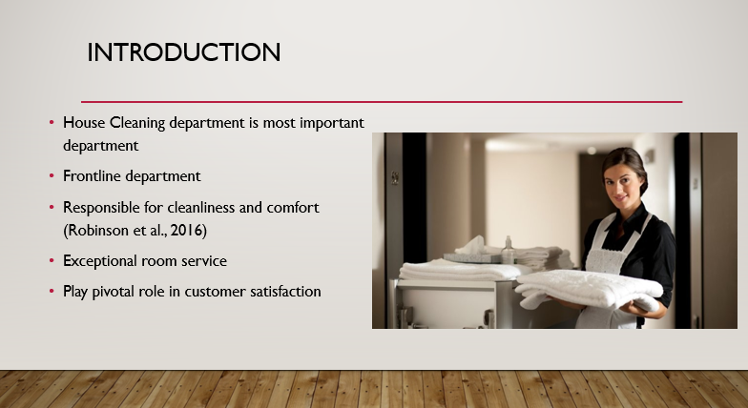

Training Notes:
Housekeeping department is one of the most important departments of hotel because they deal with the cleanliness and comfort for guests and their environment. Guests of hotel give special attention to the cleanliness and the level of comfort which results in customer satisfaction. Exceptional room service, higher level of cleanliness and detailing of room is important to attract guests and gain competitive advantage.

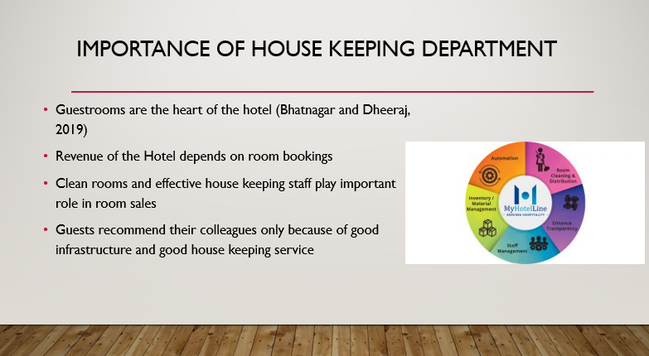

Training Notes:
Housekeeping is very important because guests give priority to housekeeping as they prefer to live in clean and charming rooms instead of untidy and dirty environment. Revenue of the hotel depends on number of rooms which are occupied and room occupancy is directly related to the image of the hotel. Guests also recommend their friends and fellows if they have good experience at hotel stay.

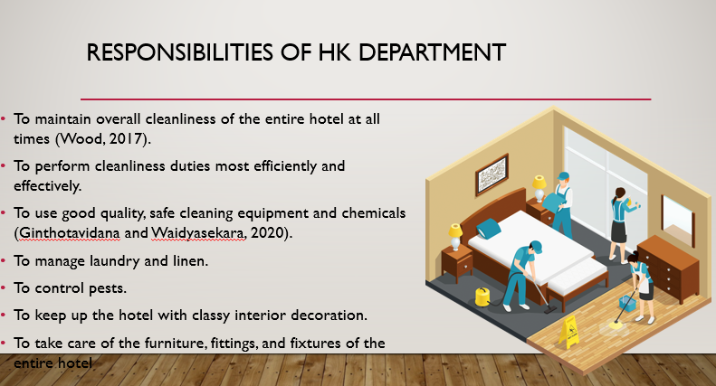

Training Notes:
Housekeeping department is responsible for cleanliness of entire hotel. They are responsible for pest control, smell control, provision of laundry and linen, interior decoration of rooms and halls and finally furniture, fittings and fixture maintenance. They use efficient tools and chemicals for this purpose.

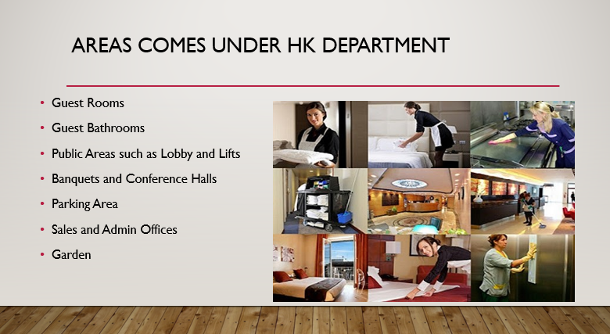

Training Notes:
Housekeeping department is responsible for keeping guest’s room and guest bathrooms clean and equipped with necessary things. They are also responsible for taking care of public areas, lobby and lifts, banquets, conference halls, parking areas, offices and gardens. Housekeeping department is responsible for cleaning and maintenance of entire infrastructure of hotel.

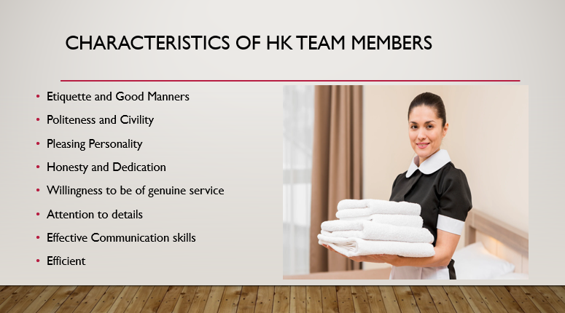

Training Notes:
There are certain skills which are essential for housekeeping team members. Without these skills, it is not possible for housekeeping team to achieve its goals of customer satisfaction. These skills include etiquette and good manners, politeness and civility, pleasing personality, honesty and dedication, willingness to be of genuine service, attention to details, effective Communication skills and finally efficiency of members. These skills help members in dealing with guest’s issues and resolving them.

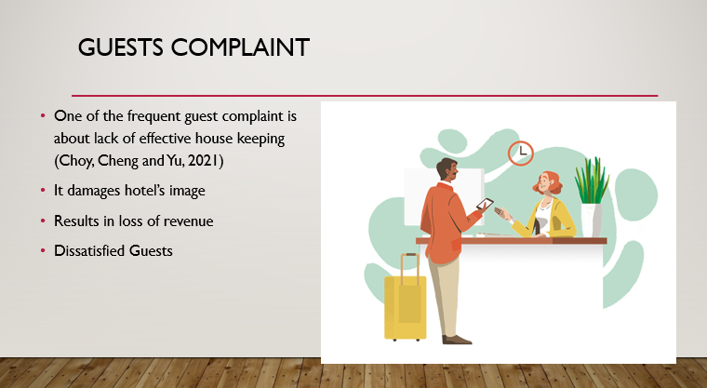

Training Notes:
In hotel industry, the largest number of complaints is concerning housekeeping and room attendants which also damages hotel’s reputation in the industry. Tarnished image of hotel may result in low room occupancy which results in loss of revenue. Therefore, housekeeping department should be very effective with minimum guest’s complaints.

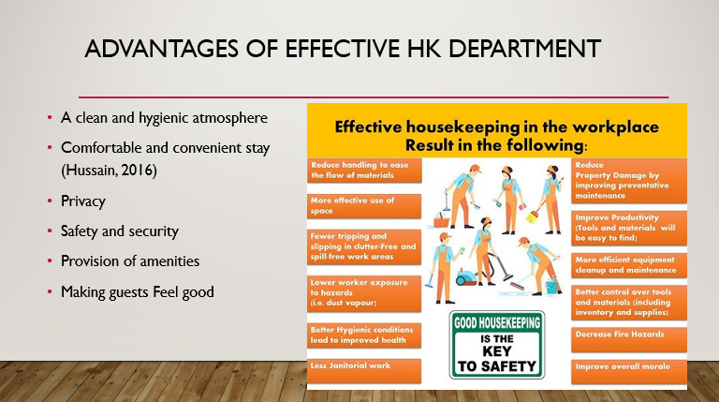

Training Notes:
There are number of advantages of effective housekeeping department. These advantages include a clean and hygienic environment for guests of the hotel with their comfortable and convenient stay along with privacy. Additionally, good housekeeping team also provides safety and security to the guests, provide amenities for their daily use. This all services contributes towards making guests feel good during their stay at hotel.

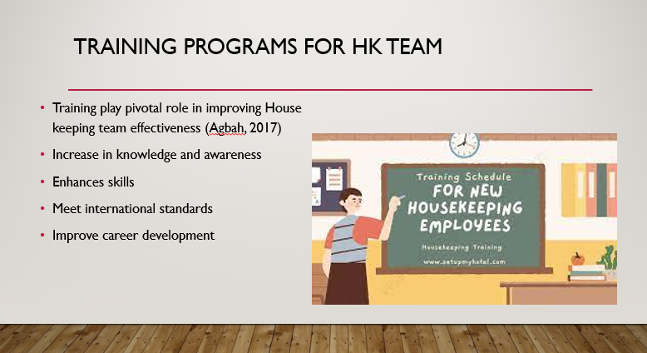

Training Notes:
Training play crucial role in housekeeping department. Housekeeping employees should have knowledge and skills which are mandatory for the job. Therefore, human resource management department should arrange training for housekeeping teams, so that their knowledge can be increased along with enhancing skills. In this way not only guests becomes happy and satisfied but these trainings also help employees in their career development.

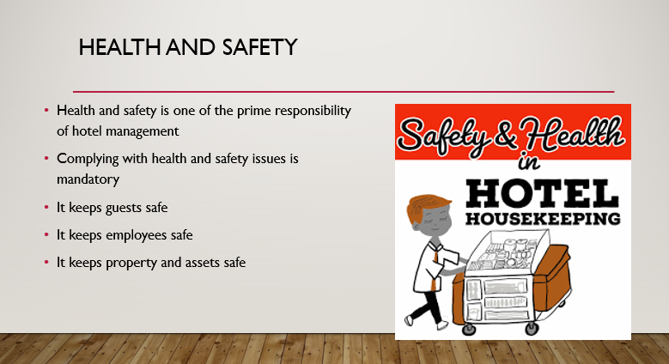

Training Notes:
Health and safety are another feature which should be taken care by housekeeping department and management of the hotel. It is mandatory to keep guests, employees and infrastructure of the company safe and secure. Therefore, compliance with health and safety standards which are applicable on hotel industry must be followed with respect.

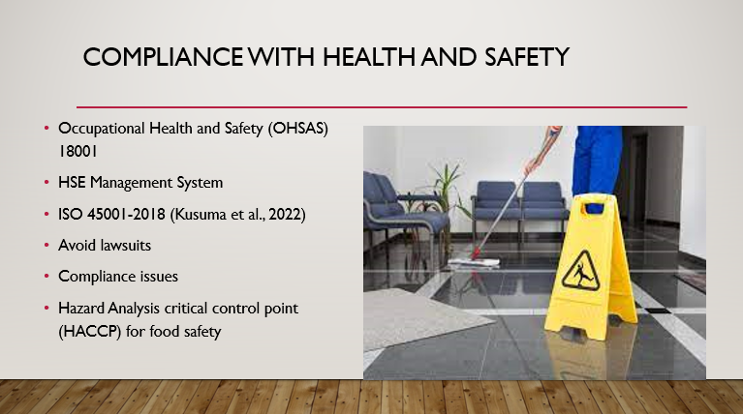

Training Notes:
There are some of the very important standards which hotel’s management should consider and train housekeeping department for these standards. For instance, occupational health and safety standards 18001 and ISO 45001-2018 are two very important health and safety standards. Similarly, for food safety hazard and analysis critical control point (HACCP) play pivotal role. Complying with these standards will not only improve hotel’s credibility but it also helps organization to avoid any kind of lawsuits or regulatory requirement.

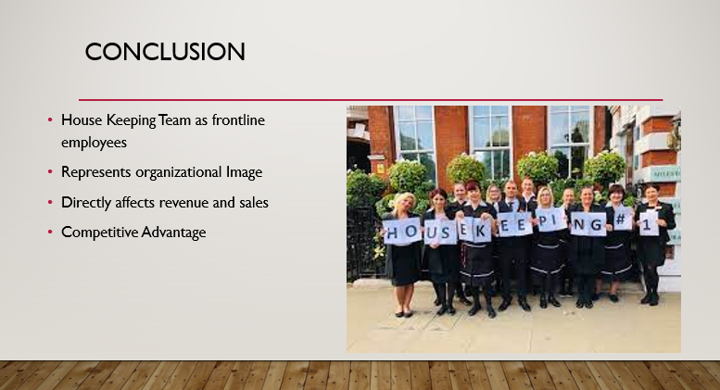
Training Notes:
Housekeeping department work as frontline employees in representing hotel to the guests. It actually represents hotel’s image to its customers which directly affects company’s revenue and sales. Good service provision will increase organizational sales to manifolds by increasing revenue. Effective housekeeping services not only helps in repeat purchase and increasing customer loyalty but it also helps organization to achieve competitive advantage.

References
Robinson, R.N., Kralj, A., Solnet, D.J., Goh, E. and Callan, V.J., 2016. Attitudinal similarities and differences of hotel frontline occupations. International Journal of Contemporary Hospitality Management.
Bhatnagar, E. and Dheeraj, N., 2019. Impact of housekeeping services and practices on customer satisfaction and repeat business. Prabandhan: Indian Journal of Management, 12(8), pp.46-57.
Wood, R.C., 2017. Housekeeping and related accommodation services. In Hotel Accommodation Management (pp. 70-82). Routledge.
Ginthotavidana, S.S.C. and Waidyasekara, K.G.A.S., 2020. An insight into the housekeeping practices of Sri Lanka healthcare facilities in private sector.
Hussain, S., 2016. Outsourcing Housekeeping: An insight into two cleaning companies, SOL and N-Clean, in Helsinki, Finland.
Choy, M., Cheng, J. and Yu, K., 2021. Evaluating the environmental sustainability strategies of the housekeeping department: the case of an international hotel chain in Hong Kong, China. Tourism Critiques: Practice and Theory, 2(1), pp.115-132.
Agbah, A.L.B.E.R.T.A., 2017. Examining the house keeping practices of students in selected schools in East Akim district (Doctoral dissertation, University Of Education, Winneba).
Kusuma, B.S., Hasibuan, A., Nasution, S.P., Utami, A.P. and Dalimunthe, A.R., 2022. AN INCREASING KNOWLEDGE ABOUT THE IMPORTANCE OF OCCUPATIONAL SAFETY AND HEALTH (K3) IN HOUSEKEEPING LABOR HOTELS. INFOKUM, 10(5), pp.424-431.

