

LEVEL 7 ASSESSMENT SPECIFICATION

Student name: | Lee Kar Wai, Alvin | Student ID number: | 1818500
Programme: | MBA
Module: | Marketing Management
Module code: | SBMA7138 | Contribution to Overall Module Assessment (%): | 75%
Lecturer: | Dr Arion WONG | Internal Verifier:
Assignment Title: | Assignment 1 | Word count (or equivalent): | 3829 words
Submission deadline: | 28 Jun 2019 | Return date of provisional marks & written feedback: | Within 20 days after submission
Submission method: | All written assessments, where practical and possible, must be submitted via Turnitin unless otherwise instructed by the Lecturer. (Please DO NOT put this assessment specification into Turnitin or it will match many similarities with other students’ submissions.)  Alternative submission method (if applicable):  Late submission of the assessment will result in a late penalty mark. Penalties for late submission: Up to one week late, maximum mark of 50%. Over one week late, 0%. Only the Extenuating Circumstances Panel may approve a change to submission dates.
Academic honesty / referencing: | Academic honesty is required. In the main body of your submission you must give credit to authors on whose research and ideas your work is based. Append to your submission a reference list that indicates the books, articles, etc. that you have used, cited or quoted in order to complete this assessment.

UWTSD MBA

Marketing Management
-SBMA7138

Assignment 1
Hong Kong biggest aesthetic medical service provider – Union Medical Healthcare Limited (UMH) Marketing Strategy and recommendation of the marketing strategies for the coming 3 years.

Prepared By: Lee Kar Wai, Alvin
Student Number: 1818500
Submission Date: 28 Jun 2019
Lecturer: Dr. Arion Wong

I Executive summary
Union Medical Healthcare Limited, Hong Kong's biggest medical aesthetic service provider presently with the biggest market share, has been successful in expanding their services and increasing their penetration to Hong Kong consumers (Union Medical Healthcare Limited,2018). I worked for this company for one and a half year from year 2011 to year 2013. This corporation was listed (stock code: 2138) in 2016 (Union Medical Healthcare Limited, 2016) and we can obtain internal and external data through their listing documents and interim report as to its customers, competitors, markets and products. We are going to discuss and analyze this company's marketing strategy, critically evaluate its adopted strategies in segmentation, target and position, as well as critically appraise the efficacy of its marketing mix. In the current situation analysis, UMH positioned their brand as high price versus high value in pricing strategy matrix, thus all their marketing strategies are to maintain its prestige over their competitors. We will also analyze for the coming three years (year 2020 to year 2022), how UMH can improve with feasible and realistic recommendations on their marketing strategies. In recommendations and conclusion, UMH can still maintain its prestigious brand and successful marketing strategy. We expect the medical aesthetic market has severe competition and UMH can build up a new brand with medium price/high quality service and use penetration pricing strategy to sustain its number one ranked position in the non-surgical medical aesthetic market.

II Table of Contents(1) Page
Chapter 1 Introduction……………………………………………......................................6
1.1 Corporation Background Information…………………………………..6
Chapter 2 Situation Analysis……………………………………………………………….8
2.1 Macro-economics index…………………………………………………8
2.1.1 Political………………………………………………………….8
2.1.2 Economic………………………………………………………..………8
2.1.3 Sociocultural (demographic) …………………………….……..11
2.1.4 Technological……………………………………………………12
2.2 Micro-economics index…………………………………………………13
2.2.1 Competitor Analysis…………………………………………….15
2.3 The likely impacts in the coming three years……………………………15
Chapter 3 Market Strategy………………………………………………………………….17
3.1 Segment of Union Medical Healthcare Limited…………………………17
3.2 Target of Union Medical Healthcare Limited……………………………17
3.3 Positioning of Union Medical Healthcare Limited………………………17
3.4 Current Marketing Mix…………………………………………………..18
3.4.1 Product……………………………………………………………18
3.4.2 Price…………………………………………………………....…19
3.4.3 Placement/Distribution of medical aesthetic services………….....19
3.4.4 Promotion Mix…………………………………………………….20
3.4.4.1 Advertising………………………………………...………20
3.4.4.2Personal selling………………………………….…………20
Table of Content (2) Page

3.4.4.3 Sales Promotion…………………………….……..………20
3.4.4.4Public relations…………………………………….………21
Chapter 4 Recommendations and Conclusion………………………………………….……22
4.1 Recommendation……………………………………………………….…22
4.1.1 Products……………………………………………………………23
4.1.2 Price………………………………………………………..………23
4.1.3 Placement/Distribution of medical aesthetic services……………..23
4.1.4 Promotion Mix………………………………………………….…23
4.1.4.1Advertising…………………………………………………23
4.1.4.2 Personal selling……………………………………………24
4.1.4.3 Sales Promotion……………………………………………24
4.1.4.4 Public relations……………………………………….……24
4.2 Conclusion…………………………………………………………………25
Chapter 5 References…………….……………………………………………..……….…….26
Chapter 6 Appendices…………………………………………………………..…………..…32

Chapter 1
Introduction
Botulinum toxin is a neurotoxin developed from a gram negative anaerobic bacterium Clostridium Botulinum (Gadhia and Walmsley, 2009), the injection of botulinum toxin (specifically DYSPORT® and BOTOX®, the two most renowned botulinum toxin brand internationally) have remained the most common non-surgical medical aesthetic procedure conducted globally, with over seven million procedures performed in 2018 (American Society of Plastic Surgeon, 2018) (Appendix 1). It remains the top revenue-generating minimally invasive non-surgical aesthetic procedure globally (Medical Aesthetic Market Analysis & Forecast, 2017). UMH was listed in 2016 and they had remained ranked number one in Hong Kong in year 2012, 2013 and 2014 in the number of cosmetic procedures of botulinum toxin injection (Union Medical Healthcare Limited, 2016). Botulinum toxin is required to be registered with the Pharmacy and Poisons Board of Hong Kong (Department of Health, 2019) before it is administered into the human body as it is categorized as a pharmaceutical product. In Hong Kong, only registered medical practitioners can perform the injections. It has many clinical and aesthetic indications. Cosmetically it helps to relieve the facial wrinkles, slims the face and particular body parts(Sundaram et al. 2016) and is a procedure more popular with female patients (Gadhia and Walmsley, 2009).

1.1 Corporation background information
UMH is the biggest aesthetic medical service provider in Hong Kong according to revenue since 2012. It has ranked first in Hong Kong in terms of the number of aesthetic injection procedures performed involving top two revenue-generating aesthetic medications including Dysport® and Botox® from year 2011 to 2016 (Union Medical Healthcare Limited, 2018a). UMH was also ranked number one in terms of brand preference when the customers search for one-stop medical aesthetic service centres, according to Frost & Sullivan consumer survey conducted in May 2015 in Hong Kong (Union Medical Healthcare Limited, 2016). UMH concentrated on high standards of customer satisfaction, professionalism and safety. With its advanced branding and marketing strategies, it successfully has the reputation of a Hong Kong aesthetic medical services premium provider.

Chapter 2
Situation Analysis

2.1 Macro-economics index

2.1.1 Political
We can anticipate more strict regulations being introduced in Hong Kong. In the previous few years, some medical aesthetic incidents happened (Lau, 2017) and they led to a changing regulatory environment in the medical aesthetic service field. The Hong Kong Government launched a Steering Committee on Review of the Regulation of Private Healthcare Facilities to examine the regulatory regime of private healthcare facilities (Research Office, 2014). Well-trained or doctor-driven aesthetic service medical providers are assumed to be advantageous as a result of compliance requirements.

The Hong Kong Zhuhai-Macau Bridge and the High Speed Rail (Hong Kong-Shenzhen-Guangzhou Link) began functioning in 2018, so there is now more room for Hong Kong retail market and medical tourism. More consumers from PRC will come to Hong Kong for the medical aesthetic services (Union Medical Healthcare Limited, 2018b).

2.1.2 Economic
The Hong Kong economic market has been on an upward trend. According to Census and Statistics Department of Hong Kong, in 2018, the per capita gross national income was $400551, compared to $289000 in 2012, which meant the CAGR was 5.5% (Table 1)

Table 1: Gross National Income (GNI), real Gross National Income (RGNI) , per capita GNI and per capita RGNI (Census and Statistics Department, 2019a)

Year | Quarter | GNI | RGNI | Per capita GNI | Per capita RGNI
Year | Quarter | At current market prices | In chained (2017) dollars @ | At current market prices | In chained (2017) dollars @
Year | Quarter | HK$ million | HK$ million | HK$ | HK$
2016 |  | 2,553,210 | 2,626,527 | 348,010 | 358,003
2017 r |  | 2,778,388 | 2,778,388 | 375,879 | 375,879
2018 r |  | 2,984,508 | 2,889,420 | 400,551 | 387,790
2018 | Q1 r | 710,527 | 692,186 | - | -
2018 | Q2 r | 731,850 | 708,562 | - | -
2018 | Q3 r | 768,078 | 739,460 | - | -
2018 | Q4 r | 774,053 | 749,212 | - | -
2019 | Q1 p | 737,045 | 700,210 | - | -

Furthermore, of the female population who are employed in Hong Kong, the department recorded in 2019, the median monthly employment earnings in this group was $14000, while in 2014 it was $11000 only, which represented a CAGR of 4.9%. It represents the female populations have growing affordability (Table 2).

Table 2: Employed persons by monthly employment earnings and sex (Census and Statistics Department, 2019b)
Sex |  | Male | Female | Both sexes
Year | Quarter | Median of monthly employment earnings  (HK$) | Median of monthly employment earnings  (HK$) | Median of monthly employment earnings  (HK$)
2014 | 1 | 15,000 | 11,000 | 13,100
2014 | 2 | 15,000 | 11,000 | 13,000
2014 | 3 | 15,000 | 11,000 | 13,500
2014 | 4 | 15,500 | 11,000 | 14,000
2015 | 1 | 16,000 | 11,000 | 14,000
2015 | 2 | 16,500 | 11,500 | 14,400
2015 | 3 | 16,600 | 11,900 | 14,500
2015 | 4 | 17,000 | 12,000 | 15,000
2016 | 1 | 17,500 | 12,000 | 15,000
2016 | 2 | 18,000 | 12,000 | 15,000
2016 | 3 | 18,000 | 12,000 | 15,000
2016 | 4 | 18,000 | 12,000 | 15,000
2017 | 1 | 18,300 | 13,000 | 15,000
2017 | 2 | 18,700 | 13,000 | 15,500
2017 | 3 | 19,000 | 13,000 | 15,500
2017 | 4 | 19,500 | 13,000 | 16,000
2018 | 1 | 20,000 | 13,200 | 16,400
2018 | 2 | 20,000 | 13,500 | 16,500
2018 | 3 | 20,000 | 13,600 | 17,000
2018 | 4 | 20,000 | 13,800 | 17,000
2019 | 1 | 20,000 | 14,000 | 17,400

The growth of aesthetic medical service market is mainly driven by the unceasingly increasing customer number and the growth of mean expenditure of consumer. In 2011, there was approximately 191000 consumers comprehending aesthetic medical service, with a CAGR of 10.7%, it was recorded 320000 consumers having this service in 2016. It is expected the consumer number will increase at a CAGR of 5.7% from 2016 to 2021 (Fameglow Holdings Limited,2018). The average expenditures per customer on medical aesthetic services in Hong Kong was 4338.7 HK dollar in year 2013, it was 7271.7 HK dollar in year 2017, with a CAGR of 13.8%, and it is expected to increase to 13318.1 HK dollar in year 2022, with a CAGR of 12.9% (Figure 1)

Figure 1: Average expenditures per customer on medical aesthetic services in Hong Kong, year 2013-2022E (Fameglow Holdings Limited ,2018)

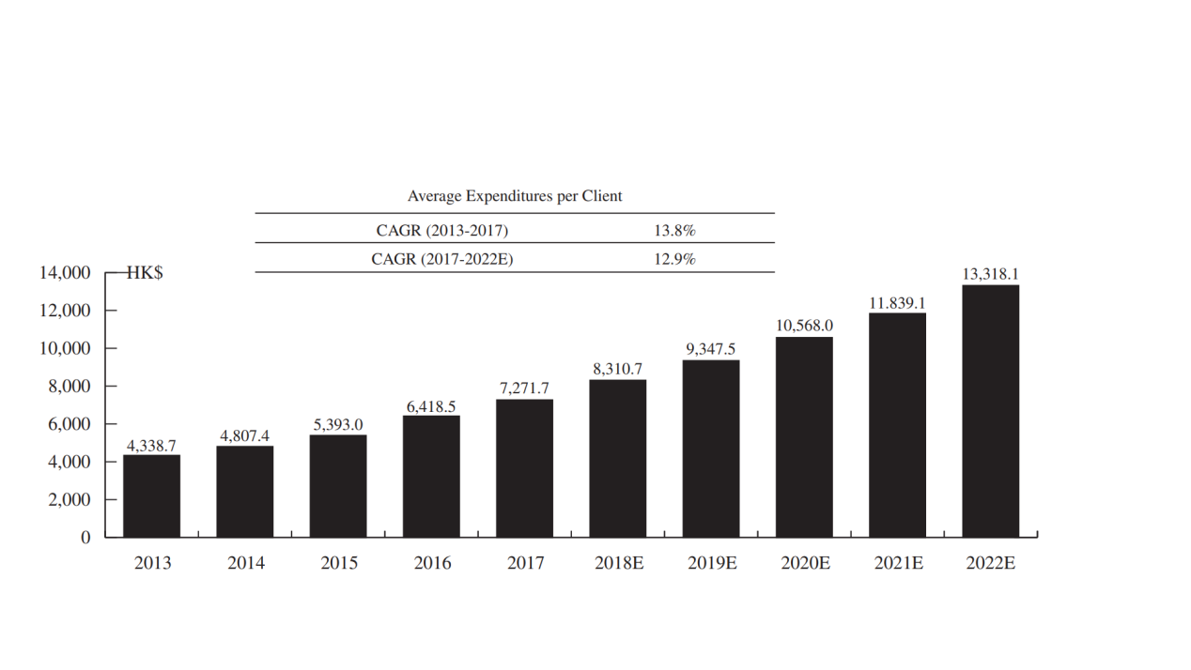
2.1.3 Sociocultural (demographic)
Firstly, we can see a rising demand for medical aesthetic service, boosted by the continuously aging population desiring medical aesthetic services (Honigman and Castle, 2006). Secondly, the force of relatively more developed medical aesthetic services markets like Japan and South Korea cannot be lowballed, it meliorates the consumers in Hong Kong to commit more medical aesthetic services (Research Office, 2019). Thirdly, the living stands of Hong Kong is continuously better, which also excites the population to pay more notice on preserving beauty and youth.
The rate of medical aesthetic services penetration in Hong Kong is anticipated to go through a speedy increase from year 2016 to 2021. The penetration rate of Hong Kong was 4.3% in year 2016, which was still significantly lower than that of South Korea (18.9%), the USA (16%) and Japan (10.6%) (Figure 2).

Figure 2: Comparison Penetration Rate of Medical Aesthetic Services (Mainland China, Hong Kong, France, Japan, The U.S. and South Korea) (Fameglow Holdings Limited, 2018)
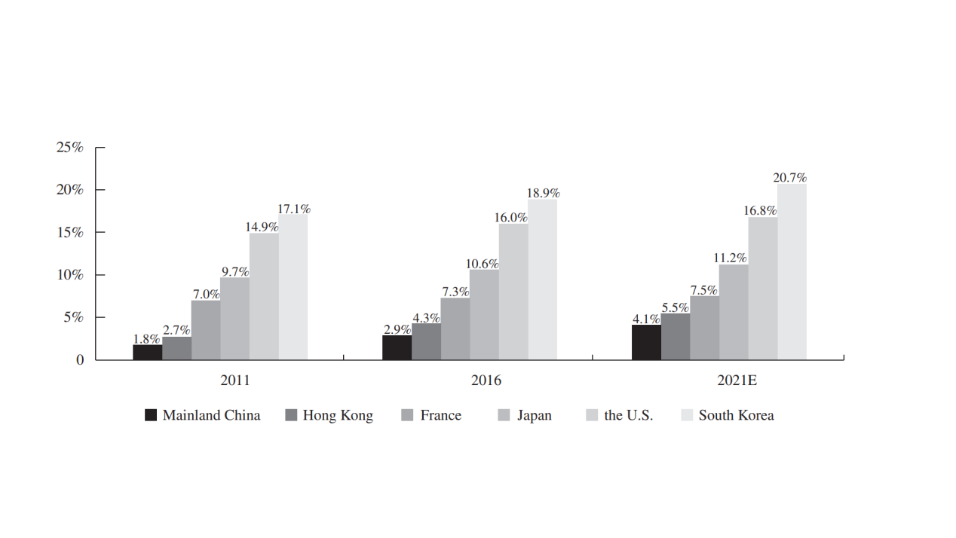
The economy of appearance is activated by social media, young generation are more volitional to osculate their minimally invasive procedures effects in social media. The flourishing recognition towards minimally invasive procedures is heightened by the social media platform, which is admitted as a positive online-to-offline strategy of promotion

2.1.4 Technological
Technology advancement of medical aesthetic services brings about improved efficacy and lower downtime of the medical aesthetic procedures. In recent decades, technologies sustain to evolve like intense pulsed light treatment for wrinkle reduction and skin rejuvenation(Ullmann, Elkhatib and Fodor, 2011), and face contouring through injectable products with transdermal delivery route (Paudel et al. 2010). These medical aesthetic services will be more accepted by the bigger community in the expected future.
2.2 Micro-economics index

2.2.1 Competitor Analysis
Medical aesthetic service providers can be classified by sector (Fameglow Holdings Limited, 2018):
Public sector is principally run by specialty clinics and medical aesthetic departments. The extremely subsidized clinics and public hospitals render suitable civilians with medical aesthetic services at comparatively reduced costs. Nonetheless, their services primarily comprise of surgeries of reconstruction surgeries for cases troubled from severe disease like skin burns. Owning to limited service provision and lengthy time of waiting, less critical patients often select private sector providers.
Private sector providers can be split into three blocks: independent medical aesthetic centers, chained-brand medical aesthetic institutions and private hospital medical aesthetic departments

Independent medical aesthetic centres are established and operated by physicians and/or entrepreneurs who work in group or individually. These centres are normally placed in commercial buildings and render non-surgical services as well as consultation. Physicians reputation of such centres is critical to pull in potential customers. These centres generally have littler proportion comparing to the latter two blocks of private sector medical aesthetic services providers.

Chained-brand medical aesthetic institutions provide extensive services, containing non-surgical services, surgical services and traditional beauty services to satisfy various wants of varied consumers. The plastic surgeons and physicians can work in stores in different places, the brand image can aid drawing in probable clients.

Medical aesthetic departments of private hospitals have a couple of internal medical teams consisting of broad medical aesthetic services specialties. Physicians in these departments usually have valuable experience, together with hospital brand reputation, they are attractive to the potential clients. Plastic surgeries outweigh the service majority.

In 2017, over 300 hundred medical aesthetic centers supplied non-surgical medical aesthetic services in Hong Kong. The best two market leaders possess more or less thirty percent of market share while the collective market share for the 3rd to 5th biggest market player accounted for 20.9% of market share in the same year. UMH possesses 16.2% market share (Union Medical Healthcare Limited, 2018b).

Furthermore, new contestants have barrier of entry, which they do not have patriotic consumer group, in which any negative incidents can take down them when their businesses are not big enough to leverage the public to offset them. The big issue for new contestants is pulling the first group of consumers to use their services, they are required to develop a positive brand appearance and extensively propagate via word of mouth. New contestants face a huge obstacle in the reputation of brand. Customers’ dissatisfaction, medical lawsuits, failure of medical aesthetic procedures incidents can gravely bother the whole industry or particularly the reputation of individual medical aesthetic service providers’ brand.

Large working capital is also a huge hindrance to new contestants. They are required to invest very much on renting service venues and acquiring cutting-edge devices. Trendy medical aesthetic service providers adore employing celebrity spokes-persons as a marketing tool, which is rather helpful in Hong Kong's medical aesthetic market. The spokespersons can let their desired target consumers instantly recognize the brand and increase the visibility of their promoting services. All of the above marketing strategies require plentiful cash flow to launch and grow their business.

2.3 The likely impacts in the coming three years
In macroeconomic index, medical aesthetic services require practitioners or doctors with verified skills and competent experience to do injections. The more strict regulations would direct to amelioration of industry standard to engage medical aesthetic practitioners. There are limited registered doctors in Hong Kong (The Medical Council of Hong Kong, 2019), where new entrants need to tackle the situation of enrolling knowledgeable practitioner with verified skills.

The requirement for Hong Kong medical aesthetic services heightened with the reclamation of the count of Peoples’ Republic of China visitors to Hong Kong.

The novel medical aesthetic devices and technology advancements promotes the procedures’ desirable result and efficacy. As the economic market can foresee an upward trend, more consumers can be expected in the medical aesthetic field.

Hong Kong population is aging, the population aged 16-45 would decline in count, medical aesthetic services targeting elder population appears to be a new way to direct to bigger market share.
We expect newer technology will direct to more secure procedures, with more consumers being drawn to move into the medical aesthetic market.

In microeconomic index, UMH has a large patriotic customer base and it can offset negative incidents better than other competitors. They have big working capital to keep their promoting services become visible. They can still keep expanding their business due to their competitive advantage over its competitors.

Chapter 3
Market Strategy
3.1 Segment of Union Medical Healthcare Limited
Segmentation helps to improve the investment return (McDonald, Christopher and Bass, 2003), and it raises market efficacy, customer fidelity by assembling the consumers on the ground of their homology in the thoughts towards heterogenous marketing factors.
According to the UMH Interim Report 2018 (Union Medical Healthcare Limited, 2018b), we can see the corporation segment its customer by demographic characteristics: 81.6% of its customer is female.

3.2 Target of Union Medical Healthcare Limited
By more incisively specifying who their target consumer is, UMH can better choose advertising vehicles that will attain more of their target consumers for less resources. The targeted female customer is aged 16 to 45, a young female population.

3.3 Positioning of Union Medical Healthcare Limited
Positioning is crucial for all business campaigns as clear and expedient position in the knowledge of the consumers promotes successful business. In the Pricing Strategies Matrix (Thakur, 2018), UMH positioned themselves over premium quarter, with high price versus high quality (Figure 3). The customer always wants the most ‘value for money products’. They require bigger commitments in terms of communications and advertising at a higher price.

Figure 3: Pricing Strategies Matrix (Thakur, 2018)
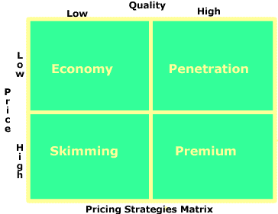
3.4 Current Marketing Mix
3.4.1 Product
As the leading player in the medical aesthetic industry, the company provides a broad variety of medical aesthetic services. Such a product mix indorses UMH's vision and mission statement. Their consumer goods classification is specialty goods and services (Gadrey, 2000), with the marketing strategy typically stressed on informing where the service available locally, advertising powerfully to promote the uniqueness of brand, price and restricted distribution.

Products are a primal decisive factor of UMH’s brand and corporate image. The company is chiefly identified for its botulinum toxin treatments. In product life cycle, they are at the growth stage, with high market growth rate, moderate technical change in product design, many competitors and high profitability (Cohen and Whang, 1997). UMH’s strategic marketing objectives is still constructing share of market, with persistent quality betterments of the treatment services, broad product line, reduced price, effortful channels of marketing and maintain high communications(Cherney, 2018)
3.4.2 Price
Price is among the highest matters for prospective consumer with the high cost of medical aesthetic services in Hong Kong, especially as this service is not under coverage of health insurance. By positioning their brand at the best choice in medical aesthetic service, the pricing objective of UMH is to conserve service and quality differentiation. They set premium pricing higher than their contenders to fortify their prestigious image, and this high price can address the costly provision, distribution and advertising costs of their medical aesthetic services(Arnold, Hoffman and McCormick, 1989)

The price for medical aesthetic service is relatively inelastic, UMH exercised customer-oriented methods instead of competition-oriented methods and cost-oriented methods to determine their service price (Singh, 2013). Their pricing method is to capture the value perceived by the customer.

3.4.3 Placement/Distribution of medical aesthetic services
UMH used selective retail coverage strategies to provide medical aesthetic services to their customers. The retail coverage is restricted, with its capability to support enough coverage but not at manufacturer-retailer cooperation expenses (Xu, 2009). This suits the corporation’s consumer as medical aesthetic services are infrequent purchased services. Their flagship stores are in the most popular retail places like Mongkok and Causeway Bay in Hong Kong. Their working hours are from 11am to 8pm. They don’t open shop on Sunday and Public Holiday, which may be explained by the corporation finding it hard to have registered doctors serving customers during that period.

3.4.4 Promotion Mix
3.4.4.1 Advertising
UMH has chosen both traditional media and new media to advertise the brand, it makes use of hierarchy-of-effect models motivate potential clients through a series of steps- awareness, comprehension, conviction, action to the final objective of purchasing their medical aesthetic services. Traditional media like exhibition, newspaper and magazine (print media), radio are their decisions of advertising. For new media, UMH used blogging, E-mail, social networks like facebook, wechat, search keywords and banner ads to publicize the brand (Mangold and Faulds, 2009).

3.4.4.2 Personal selling
UMH uses personal selling to assure their consumers continue coming back and utilizing their medical aesthetic services at their workplaces. They are efficacious and the consumers are very contented with the service provided. This industry is well-suited to a push marketing strategy (Levy, Webster and Kerin, 1983), with well-trained staffs, they can give lots of medical aesthetic information to the customers and help push the customers to utilize the services.

3.4.4.3 Sales promotion
UMH offers trade promotion like coupons and premiums. The coupons can instantaneously decrease the product price and consumers find them more desirable, and it can invoke awareness of the brand. Premiums incentivize customers to choose the medical aesthetic service with a tangible benefit (in this case, a free laser facial treatment one week after the injection without extra charge), these services become more valuable to customers (Schultz, Robinson and Petrison, 1998)

3.4.4.4 Public relations
With effective public relations, UMH can increase sales through indulgent, nonpaid coverage of media, which also help heighten the image of the corporation (Kitchen, 1996). Public relations construct good nature toward its business by cultivating corporation profile in the general population. UMH's specific objective is to shoot up sales through finer consumer service and relations, they produce a regular basis newsletter that provides useful information to their customers to know more about the corporation.

After studying these data, we can understand UMH used high price versus high quality pricing strategy, prestige placement and targeted high spending female to utilize their medical aesthetic services to maintain their prestigious brand.

Chapter 4 Recommendation and Conclusion
4.1 Recommendation
Based on the investigation from situation analysis and current marketing strategy, we know more female can afford spending more in medical aesthetic services. UMH enlarged its medical aesthetic market share by building up a new brand, penetrating the market by having a medium price, but still offering high value products. In the long run, by creating high priced variants, UMH can expand the market share. Penetration strategy is a tough strategy and UMH needs to have a close look at the product quality which is being produced with a lower cost. In order to ease making profit, conventional wisdom suggests the price should outweigh the quality of product. Nonetheless, upfront offering a lower price high-quality product can help build up word of mouth (Tellis, 1986)

4.1.1 Products
The new brand of UMH can broaden its product lines, satisfy market demand, improve its revenues, and spread risk in its business (Thomadsen, 2012). In terms of risk, a more varied mix of product minimizes the corporation reliance on just one or a few market subsections. The new brand can extend the product line by introducing new products like energy-based devices and skin care products. The new brand will not depend on one or two renowned doctors to do the injections, they can train more doctors to do the injections, and also train more consultants to consult the cases before allowing the customer to take the medical services, as well as training therapists to do energy based devices and slimming body devices. The new products with lower price can attract more customers and improve its business stability. Although these new energy-based devices have a high initial loading cost, UMH has high cash flow and it can afford to have these investments to boost the new brand.

4.1.2 Price
UMH’s new brand allows customer service to be done by therapists instead of solely registered doctors. This is customer segment pricing, with some customers enjoying medical aesthetic services done by registered doctors, while some others like using lower price to receive similar aesthetic services done by well-trained therapist. The new brand can develop more therapist based medical aesthetic services (energy-based devices like intense pulsed light and laser) with a lower price to attract more customers(Paul, Ivo and van, 2013)

4.1.3 Placement/Distribution of medical aesthetic services
The new brand can expand their working places with new clinics, centres and locations, with longer operating hours, from Monday to Sunday, from 10 am to 9pm. It can even operate on public holiday, though relatively less customers like having medical aesthetic services during this holiday, with less supporting staffs. However, this blue ocean market is worth putting resources to develop it. They can also provide walk-in and same-day appointments which offer convenience services to their consumers to stand out from the competition. With therapists instead of registered doctors, UMH can have bigger sharing of the market.

4.1.4 Promotion Mix
4.1.4.1 Advertising
It can introduce the target market to its new brand with medium price/high value products, new applications and new product features. Effective advertising can empower UMH to foster and construct brand equity, with a competitive superiority once it pioneers a distinctive characteristic in the audience. Furthermore, the new brand can replicate a message at strategic intervals. With right timing it can maximize its awareness-building efforts, replicating the message can increase the likelihood that the targeted customer will see the message at a time where she/he is open to hearing it. Moreover, by investing in a public presentation, the new brand can enhance customers’ perceptions of quality, permanence and legitimacy that they associate with the new brand.

4.1.4.2 Personal selling
UMH's current personal selling promotion strategy can suit the new brand well and they can still use the same personal selling technique to boost the market share.

4.1.4.3 Sales promotion
UMH can arrange joint promotions to promote the new brand with their old brand (Hartley and Cross, 1988). Joint promotions are simple for UMH as the new brand is in the same industry as the old brand. Packaging the products or services in bundles, then offering them at UMH business and the new brand can help both the old and new brand increasing penetration to the market.
Discounted prices also can accelerate the penetration speed to the market, especially the new brand is targeting consumers buying medium price/high quality medical aesthetic services.

4.1.4.4 Public relations
Publicity is free advertising. Through activities in the community the new brand can establish publicity. Donating goods to charities, sponsoring charitable events can aid improving the public image (Webb, Green and Brashear, 2000).
These public relations aid UMH convey to a variety of people like the suppliers, current employees, prospective employees, the community, the financial community and stockholders and the consumers.

4.2 Conclusion
UMH can still maintain its prestigious brand and keep its successful marketing strategy. Nevertheless, in the coming three years, we can foresee the medical aesthetic market is of severe competition and building up a new brand with medium price/high quality service can help it sustain its number one ranked position in non-surgical medical aesthetic market.

Chapter 5
Reference

American Society of Plastic Surgeons (2018). 2018 National Plastic Surgery Statistics. Available at: https://www.plasticsurgery.org/documents/News/Statistics/2018/plastic-surgery-statistics-report-2018.pdf/ (Accessed: 19 June 2019)

Arnold D.R., Hoffman D., McCormick J. (1989). "Service Pricing: a Differentiation Premium Approach", Journal of Services Marketing, Vol. 3 Issue: 3,pp.25-33.

Census and Statistics Department (2019a). Table 039: Gross National Income (GNI), real Gross National Income (RGNI), per capita GNI and per capita RGNI. Available at: https://www.censtatd.gov.hk/hkstat/sub/sp250.jsp?tableID=039&ID=0&productType=8/ (Accessed: 19 June 2019)

Census and Statistics Department (2019b). Table E026 : Employed persons by monthly employment earnings and sex (Table 4.9 in the Quarterly Report on General Household Survey). Available at: https://www.censtatd.gov.hk/hkstat/sub/sp200.jsp?productCode=D5250030/ (Accessed: 19 June 2019)

Chernev, A. (2018). Strategic marketing management. Cerebellum Press.

Cohen M.A., Whang S. (1997). Competing in Product and Service: A Product Life-Cycle Model, Management Science 43:4, 535-545

Department of Health (2019). List of Registered Pharmaceutical Products. Available at: http://www.drugoffice.gov.hk/eps/do/en/consumer/news_informations/reListRPP_index.html/ (Accessed: 19 June 2019)

Fameglow Holdings Limited (2018). Share Offer. Available at: https://www1.hkexnews.hk/listedco/listconews/gem/2018/0928/gln20180928001.pdf/ (Accessed: 19 June 2019)

Gadhia K. and Walmsley A.D. (2009). Facial aesthetics: is botulinum toxin treatment effective and safe? A systematic review of randomized controlled trials. Br Dent J. 12;207(5):E9; discussion 216-7. (Accessed: 19 June 2019)

Gadrey, J. (2000), THE CHARACTERIZATION OF GOODS AND SERVICES: AN ALTERNATIVE APPROACH. Review of Income and Wealth, 46: 369-387.

Hartley S.W., Cross J. (1988) "HOW SALES PROMOTION CAN WORK FOR AND AGAINST YOU", Journal of Consumer Marketing, Vol. 5 Issue: 3, pp.35-42,)
Honigman, R., and Castle, D. J. (2006). Aging and cosmetic enhancement. Clinical interventions in aging, 1(2), 115–119.

Kitchen P.J. (1996) "Public relations in the promotional mix: a three‐phase analysis", Marketing Intelligence & Planning, Vol. 14 Issue: 2, pp.5-12

Lau, C. (2017). Horrific details of a Hong Kong beauty clinic treatment gone fatally wrong. South China Morning Post. Available at: https://www.scmp.com/news/hong-kong/law-crime/article/2099227/horrific-details-hong-kong-beauty-clinic-treatment-gone/ (Accessed: 19 June 2019)

Levy, M., Webster, J., and Kerin, R. A. (1983). Formulating Push Marketing Strategies: A Method and Application. Journal of Marketing, 47(1), 25–34.

Mangold W.G., Faulds D.J. (2009). Social media: The new hybrid element of the promotion mix. Business Horizons. Volume 52, Issue 4, Pages 357-365.

McDonald M., Christopher M., Bass M. (2003) Market segmentation. In: Marketing. Palgrave, London)

Medical Aesthetic Market Analysis & Forecase (2017). Global Medical Aesthetics Industry: Injectables, Energy-Based Devices, Cosmeceuticals, Cosmetic Surgery, Facial Aesthetics, Implants, Cosmetic Tourism. Market Analysis & Forecast to 2022.
Available at: https://www.researchandmarkets.com/research/vhhpg8/global_5?w=5/(Accessed: 19 June 2019)

Paudel, K. S. et al. (2010). Challenges and opportunities in dermal/transdermal delivery. Therapeutic delivery, 1(1), 109–131.))

Paul, T., Ivo A. and van, L. (2013).Relating price strategies and price-setting practices. European Journal of Marketing, 47 (1/2): 27 – 48.

Research Office. (2014). Research Report. Regulation of aesthetic practices in selected places. Available at: https://www.legco.gov.hk/research-publications/english/1415rp01-regulation-of-aesthetic-practices-in-selected-places-20141128-e.pdf/ (Accessed: 19 June 2019)

Research Office. (2019). Fact Sheet, Beauty industry in selected places. Available at: https://www.legco.gov.hk/research-publications/english/1819fs03-beauty-industry-in-selected-places-20190123-e.pdf/ (Accessed: 19 June 2019)

Schultz, D. E., Robinson, W. A., and Petrison, L. (1998). Sales promotion essentials: the 10 basic sales promotion techniques--and how to use them. McGraw Hill Professional.

Tellis, J. (1986). Beyond the Many Faces of Price: an integration of pricing strategies. Journal of marketing, 50 (4): 146 -160.

Thakur A.(2018) Pricing Strategy -Pricing, Principles of Marketing. Available at: https://edurev.in/studytube/Pricing-Strategy-Pricing--Principles-of-Marketing/39f220d1-96bc-422c-b9e7-dba65deeae11_t/ (Accessed: 19 June 2019)

The Medical Council of Hong Kong. (2019). List of Registered Medical Practitioners. Available at: https://www.mchk.org.hk/english/list_register/index.html/ Accessed: 19 June 2019)

Thomadsen, R. (2012). Seeking an Expanding Competitor: How Product Line Expansion Can Increase All Firms’ Profits. Journal of Marketing Research, 49(3), 349–360.

Ullmann, Y., Elkhatib, R., and Fodor, L. (2011). The aesthetic applications of intense pulsed light using the Lumenis M-22 device. Laser therapy, 20(1), 23–28.

Union Medical Healthcare Limited (2016). Global Offering. Available at: http://www3.hkexnews.hk/listedco/listconews/SEHK/2016/0301/LTN20160301017.pdf /
(Accessed: 19 June 2019)

Union Medical Healthcare Limited (2018a). Annual Report. Available at: https://www1.hkexnews.hk/listedco/listconews/sehk/2018/0718/ltn20180718155.pdf (Accessed: 19 June 2019)

Union Medical Healthcare Limited (2018b). Interim Report. Available at: http://www3.hkexnews.hk/listedco/listconews/SEHK/2018/1218/LTN20181218686.PDF / (Accessed: 19 June 2019)

Singh, M. (2013). Important Pricing Methods in 4P’s. International Journal of Management and Business Studies, 3(2), 147-150.

Sundaram, H. et al. (2016). Global Aesthetics Consensus: Botulinum Toxin Type A--Evidence-Based Review, Emerging Concepts, and Consensus Recommendations for Aesthetic Use, Including Updates on Complications. Plastic and reconstructive surgery, 137(3), 518e–529e.

Webb, D. J., Green, C. L., & Brashear, T. G. (2000). Development and Validation of Scales to Measure Attitudes Influencing Monetary Donations to Charitable Organizations. Journal of the Academy of Marketing Science, 28(2), 299–309.

Xu X. (2009). Optimal Price and Product Quality Decisions in a Distribution Channel. Management Science 55:8, 1347-1352))

Chapter 6
Appendix

Appendix 1:2018 National Plastic Surgery Statistics



