Marketing Fundamentals

Student Name: CRISTINA STEFANIA CIOBOATA – 1905391
ELENA CARMEN ANGHEL – 1905217
ELENA ONIGA - 1905210
OANA FLORENTINA DUMITRIU – 1909491
Module Title: LCBB4004
Assignment Title: Marketing Fundamentals – GROUP ASSIGNMENT
Lecturer’s Name: TUSHARA BALENDRAN

Table of Contents
Task 1B 3
Introduction 3
Marketing principles 3
Planning and developing the blogs 4
Marketing models and theories 4
Conclusion 7
Reference list 8

Task 1B

Introduction
This report is based on the planning and development of the blog posts. In this report, it has been discussed how I planned to create the blogs. In order to create blogs, there are some marketing models used. These marketing models have been explained in this report and how they were beneficial for the blogs. It has also been discussed how these models support the overall marketing campaign.

Marketing principles
According to Kotler et al., (2016), marketing is the most important aspect for companies in order to generate more revenue. There are four principles (4Ps) of marketing. These principles are vital in order to do perfect marketing. The 4Ps stand for product, price, place and promotion. I have applied these principles of marketing in my blogs. Price is the most important aspect of any product in terms of marketing. Price is the primary thing that attracts people (Kotler et al., 2016). Keeping this in my mind, I have introduced discounts for every product. I have done this because when people see the price of the product is low, then they will attract to the products. It increases the sale of the products of the company.
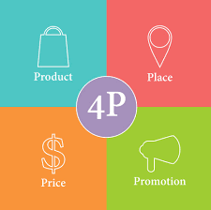
Figure1: Marketing principles
(Source: Nuseir and Madanat, 2015)
Product is equally important as the price. Adidas is a well-reputed sports brand all over the world. The product quality of Adidas is excellent. Therefore, there will be no issues regarding the marketing of their product. The place is also a vital factor. Due to coronavirus, people are not able to go outside. That is the reason I have mentioned in the blog for home delivery of the products. It will attract more customers. Promotional of the products has been done only through social media and websites. Social media and websites are the most important areas to promote products and offers. All the offers and product details regarding the sale will be on the official website of Adidas and other social media platforms. This is how marketing principles helped me to make the blogs using all the principles of marketing. I have made those blogs by following these principles. I have mentioned the low price of the products and home delivery because of the lockdown. These blogs included all the essential elements of marketing.

Planning and developing the blogs
I have searched a lot in order to make blogs. I have analysed the condition of the people. This is the first thing that I have done. After analysing, I have found that people are not able to go outside because of the lockdown until coronavirus disappears. Based on this, I have mentioned only the home delivery option instead of any other way in my blogs. Products will not be available in the retail stores of Adidas. Then I have analysed that in this situation people cannot afford high pricing of the product. That is the reason I have mentioned some discount offers for sale on my blogs. Everybody knows the product quality of Adidas. All the products such as clothes, accessories, shoes and gym equipment are excellent in terms of their quality. That is the reason I have highlighted only the name of the products. I thought that the product name is enough for the customer. Even if they wanted to see the products, then they can visit the official website of Adidas. I have found that social media is the best platform for promotion. Therefore, the sale regarding offers and information will be on the official website and social media pages that I have mentioned in the blogs. All these things are necessary for a marketing campaign. I have included all these in my blogs so that the marketing campaign can be done properly.

Marketing models and theories
Marketing mix 7Ps
This marketing model is similar to the marketing principles; however, here 3 more Ps are added. 7Ps stand for product, price, place, promotion, people, process and physical evidence. The first 4Ps are already discussed in this report. According to Boonpradub and Thechatakerng (2015), for marketing, it is essential to understand let people who will contact them. The process is the system of delivering the products to the customers. Physical evidence is the elements of customer experiences (Abedi et al., 2015). While making the blogs, I have applied this model by stating home delivery process and questioning option as feedback. Feedback will be considered as reviews of customer’s experiences.
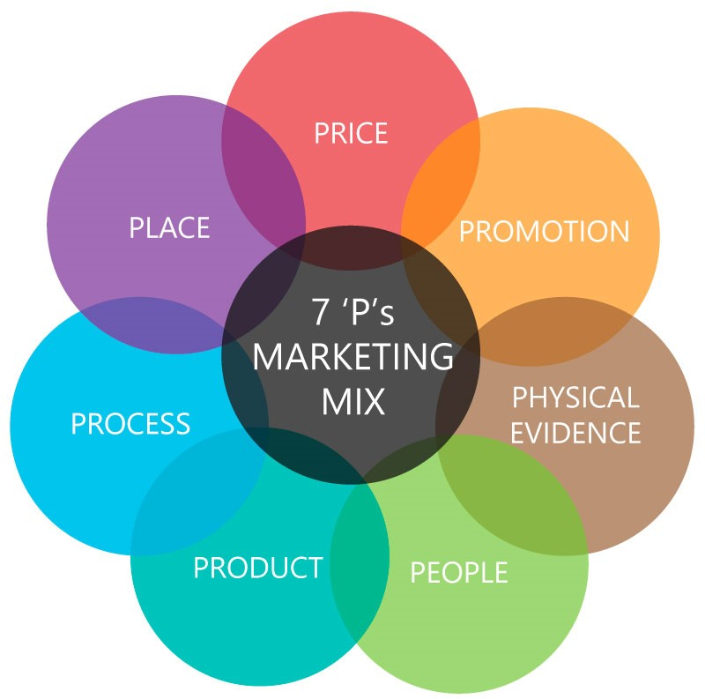
Figure2: 7Ps of marketing mix
(Source: Arif, 2016)
SOSTAC model
SOSTAC model is a well-known marketing model. It helped me a lot for making the marketing blogs for Adidas. SOSTAC model stands for situation analysis, objective, strategy, tactics, action and control (Ryan, 2015). This model also helped me to make blogs. I have analysed the situation of the company first. I have found, due to lockdown their retail stores are closed band the sale of their product almost off. The objective of the company is to sale more by satisfying their customers (WIDI et al., 2015). Based on this information, I have made strategies for marketing. They are such as huge discount and home delivery service on online shopping. As a tactic, I have mentioned that the promotion will be done through social media and official site of Adidas. In terms of action, I have mentioned a discount sale for the people, and that will be controlled by the marketing and social media operators, and website operators of Adidas. The whole plan has been made with simplicity so that the marketing will be easier for the Adidas during this situation.
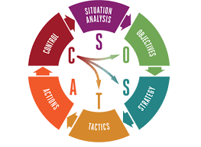
Figure3: SOSTAC Model
(Source: Wijaya and Hermawan, 2018)
In order to make the blogs, I have applied the marketing orientation theory. This theory explains that in order to be successful companies must fulfil their needs and wants to satisfy them in every situation (Kiessling et al., 2016). This theory says that customers must be satisfied in every situation so that marketing will be successful. Due to lockdown, people cannot go outside for shopping. In order to fulfil this need, I have made blogs regarding online sale with huge discount. Through this, people can order their products at a cheaper price and get delivered to their home. Therefore people will be satisfied more in this situation the selling process goes on for Adidas.
According to Network Theory, the relationship between customer and company is the most important factor for marketing. This theory also states that the company should create a broad network so that they can satisfy their customers and build a healthy relationship between them (Michael, 2016). Based on this theory, I have included the home delivery facility and online purchasing even in this situation, to make the customer satisfied. It will help to build and maintain the relationship between the company and customer in this vital situation.

Conclusion
This report reflects the planning that I have done in order to make the blogs. There were some models that have been used for creating blogs. Through this report, it has been found that the marketing mix is the best method for marketing. This method consists of four essential elements of marketing. They are such as product, price, place and promotion. Through this report, the importance of these marketing principles has been assessed.

Reference list
Abedi, G., Rahmani, Z., Abedini, E. and Rostami, F., 2015. Surveying the impact of services marketing mix components (7Ps) on patients’ disposition towards the public & private hospitals of Sari City. Journal of Hospital, 13(4), pp.63-71.
Arif, M.Z.U., 2016. Using the 7Ps of Booms and Bitner as Controllable Tactical Marketing Tools: An Exploratory Study on Selected Super Shops in Bangladesh. International Journal of Trade and Commerce-IIARTC, 5(1), pp.12-29.
Boonpradub, W. and Thechatakerng, P., 2015. Brand endorsement by celebrity in Thailand: 7Ps of marketing mix and the impact of brand alliance. International Journal of Trade, Economics and Finance, 6(1), p.8.
Kiessling, T., Isaksson, L. and Yasar, B., 2016. Market orientation and CSR: Performance implications. Journal of Business Ethics, 137(2), pp.269-284.
Kotler, P. and Armstrong, G. Parment, A, 2016. Principles of marketing: Scandinavian edition. Pearson Education Limited.
Michael, M., 2016. Actor-network theory: Trials, trails and translations. Sage.
Nuseir, M.T. and Madanat, H., 2015. 4Ps: A strategy to secure customers' loyalty via customer satisfaction. International Journal of Marketing Studies, 7(4), p.78.
Ryan, K., Communications Explored.
Seturi, M. and Urotadze, E., 2017. About Marketing Process Model and Relationship Marketing. In Proceedings of International Workshop, Model-Based Governance for Smart Organizational Future (pp. 169-171).
Widi Astuti, R.I.N.A., 2016. Pengembangan Social Media Marketing Dengan Pendekatan Sostac Model Untuk Meningkatkan Strategi Pemasaran (Studi Kasus Usaha Mikro Kecil Dan Menengah Waleu Kaos Lampung). Skripsi.
Wijaya, P.K. and Hermawan, A., 2018. E-Marketing Applications Based On Virtual Reality Using Sostac Planning Method On Sales Property. Tech-E, 1(2), pp.16-25.

