Blaenavon, a learning report

Regeneration and Distinctiveness

TUTOR Anthony Burns

Samantha Connelly 1905798

Blaenavon Iron works
Giant of the monetary age nevertheless stands tall at the shoulders of its workers Blaenavon changed the arena. These hills getting ready to the Brecon Beacons were wealthy with coal, limestone and iron ore – the gasoline of the Industrial Revolution. From right here Wales heaved and belched and blasted itself onto the global degree. Welsh iron unique trailblazing engines, tools and machines. It constructed bridges, ships and railway strains. In quick it made the modern global. (Cadw.gov.wales, 2020)
In 1789 Blaenavon Ironworks first harnessed the electricity of steam to blow air into its large blast furnaces. A century later it modified into here that Sidney Gilchrist Thomas transformed the area’s metallic industry thru inventing a manner to cast off phosphorus from iron ore. (Cadw.gov.wales, 2020)
The ruined furnaces are although visible these days along the unexpected stays of the foundry, cast residence and water balance tower that raised wagons eighty feet into the air.
Blaenavon became run via tremendous, and regularly ruthless, industrialists. But it would be now not something without its people. Explore their authentically supplied cottages and the recreated ‘truck maintain’ wherein they spent their meagre wages. Their tale, knowledgeable via cutting-edge interpretation, lies at the coronary heart of a commercial enterprise landscape so particular it’s been made a World Heritage Site. (Cadw.gov.wales, 2020)
Keeping the ever-hungry furnaces of Blaenavon burning wasn’t only a task. It became more like hard labour. (Cadw.gov.wales, 2020)
Twelve hours a day, seven days each week. In regular danger from fireplace or molten metal, toxic fumes and heavy machinery. Never high-quality if a tumble inside the charge of iron could see you turfed out of your private home. It wasn’t truly the adults who suffered. Children as young as five had been placed to artwork. In 1842 Government inspectors decided 185 children under the age of 13 strolling on the ironworks and its surrounding mines. A sector of them were girls – many breaking apart iron ore with the aid of way of hand on the bleak hills above the yard. Writer AJ Munby said approvingly that guys would address the larger lumps: ‘Then the women harm them up… lifting the hammer over their heads and bringing it down with manly capability and pressure'. There are many other heart-breaking tales. Margaret Thomas, aged 15, splashed round barefoot pushing trams underground. Eight-yr-vintage Lucretia Jones spent all day calling out commands to the person at the waterwheel. But furnace manager William Lloyd wasn’t exactly sympathetic. After all he’d been located to paintings in a Staffordshire ironworks himself on the age of 8. (Cadw.gov.wales, 2020)
‘The refinery boys artwork in some warmth inside the summer season and once in a while get burned, but now not very horrible,’ he stated. ‘I worked a bargain more difficult than the guys do here.’ (Cadw.gov.wales, 2020)

Blaenavon contains two nationally important sites preserved as examples of the area's rich industrial legacy: the Blaenavon Ironworks and the Big Pit Mining Museum, both important historical and technological components in the industrial and social landscape of Blaenavon. (Ggat.org.uk, 2020)
A water stability raise is a completely dominant shape. Built a while after 1839, it's far an excellent hydraulic carry which become used to carry tram hundreds of iron from one stage to every other so that they could be transported via tramroad to the nearby Garn Ddyrys Forge, and additionally to the Brecon and Abergavenny Canal which bureaucracy an similarly widespread element on this huge interconnecting business landscape. In addition, there's an important surviving workforce cottage at Stack Square.
The former Big Pit Colliery was sited at the easternmost aspect of the South Wales coalfield. In 1980, it closed as an operating mine and is now run by means of a charitable agree with offering visitor get entry to to descend 90m underground. The colliery changed into sunk to its present stage in 1880, even though its underground workings contain lots in advance shafts and tunnels, one example being Forge Level, which become pushed in 1812 to deliver coal especially for the Blaenavon Ironworks. Below ground, engine homes and stables nevertheless remain. On the floor, the metal headgear dated to 1921 and the associated tiers of buildings show the quantity of the former colliery. These homes consist of the pithead baths, blacksmiths' keep, lamp room, winding engine residence and tram circuit. This website remains as a well-interpreted, yet uncommon, instance of a colliery which contributed to the status quo of very distinct Welsh communities set within the landscapes they created. (Ggat.org.uk, 2020)
Associated with the industrial exploitation of the area are the stays of the transport community, required to bring the uncooked materials to the ironworks and export the completed product. The vicinity contains an expansion of delivery features, starting from small tramroads through to principal monuments including the tunnel and the dyne metal willing aircraft at Pwll Du. The tunnel become opened in 1815 to transport limestone to the ironworks from the quarries to the north. It also took pig iron from the ironworks to the forge at Garnddyrys, however it was sooner or later superseded by means of the dyne steel willing aircraft in approximately 1850. (Ggat.org.uk, 2020)

million years ago
The middle of the Devonian period, the former Welsh Basin had therefore become part of a range of mountains. The climate was arid, with occasional rainfall eroding the mountains away and generating new sediments in the process. Rivers carried debris away towards the Midlands and South Wales, depositing sands over the plains. The sands eventually consolidated, to form what is today called the Old Red Sandstone. These strata give the characteristic red colour to the soils of parts of South and East Wales. (Moodle.uwtsd.ac.uk, 2020)
The Devonian period has been called the "age of fishes". It marked the major evolutionary burst that established these creatures in their full diversity - bony fish, sharks, lungfish - in seas, lakes and rivers worldwide. And from the lungfish there evolved the first amphibians to crawl onto the land, where the colonisation by plants was already well underway.
With the onset of the Carboniferous period, shallow warm seas invaded areas of NE and South Wales, once again allowing coral reefs to flourish and lay down the limestones in which Wale's caves were later formed. (Moodle.uwtsd.ac.uk, 2020)

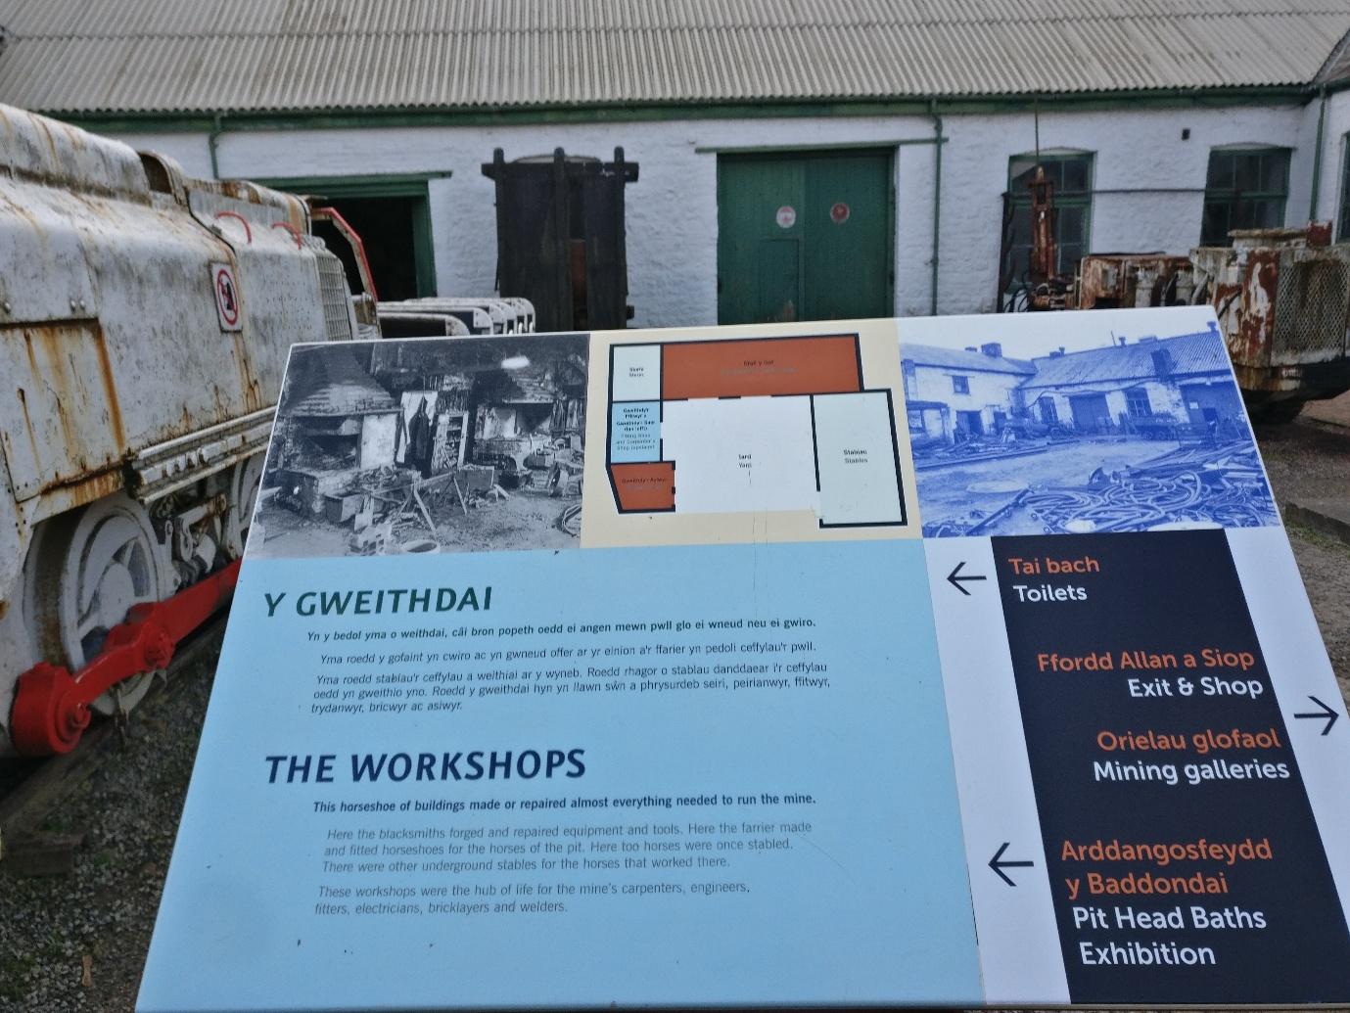

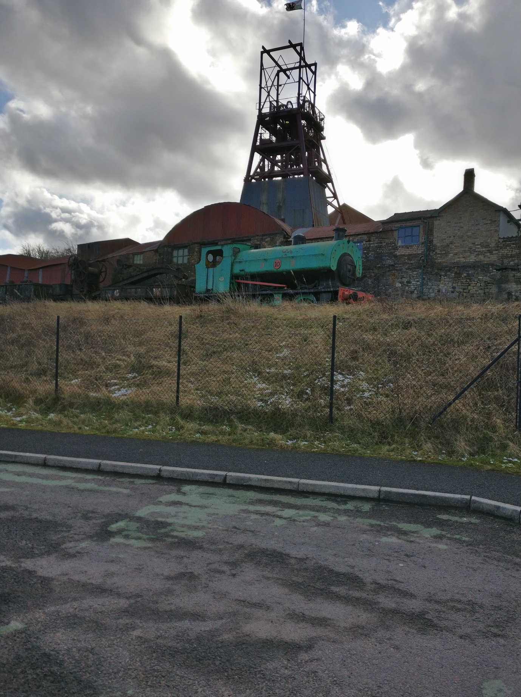

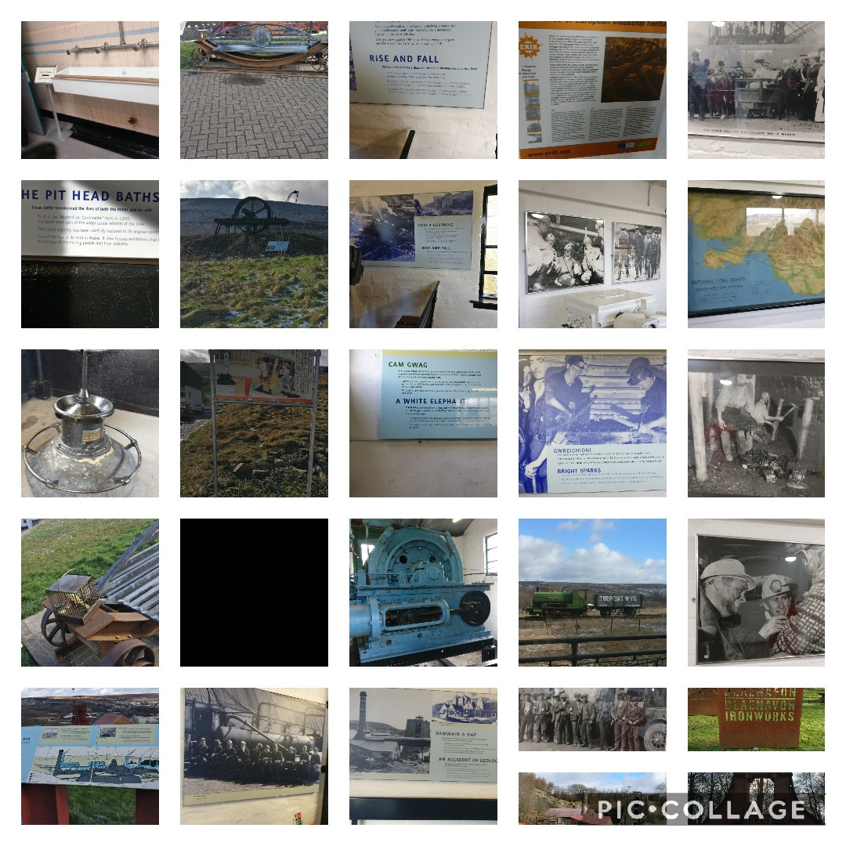


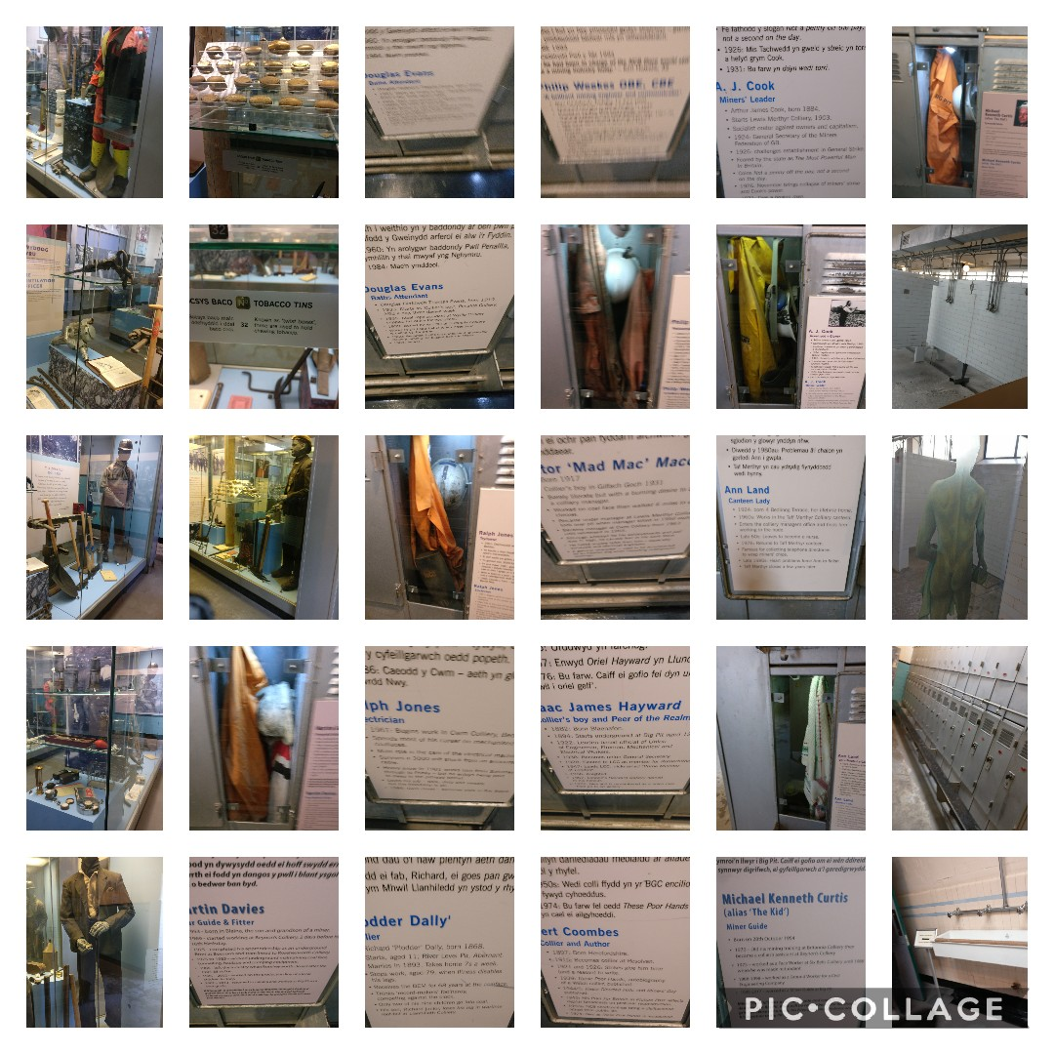
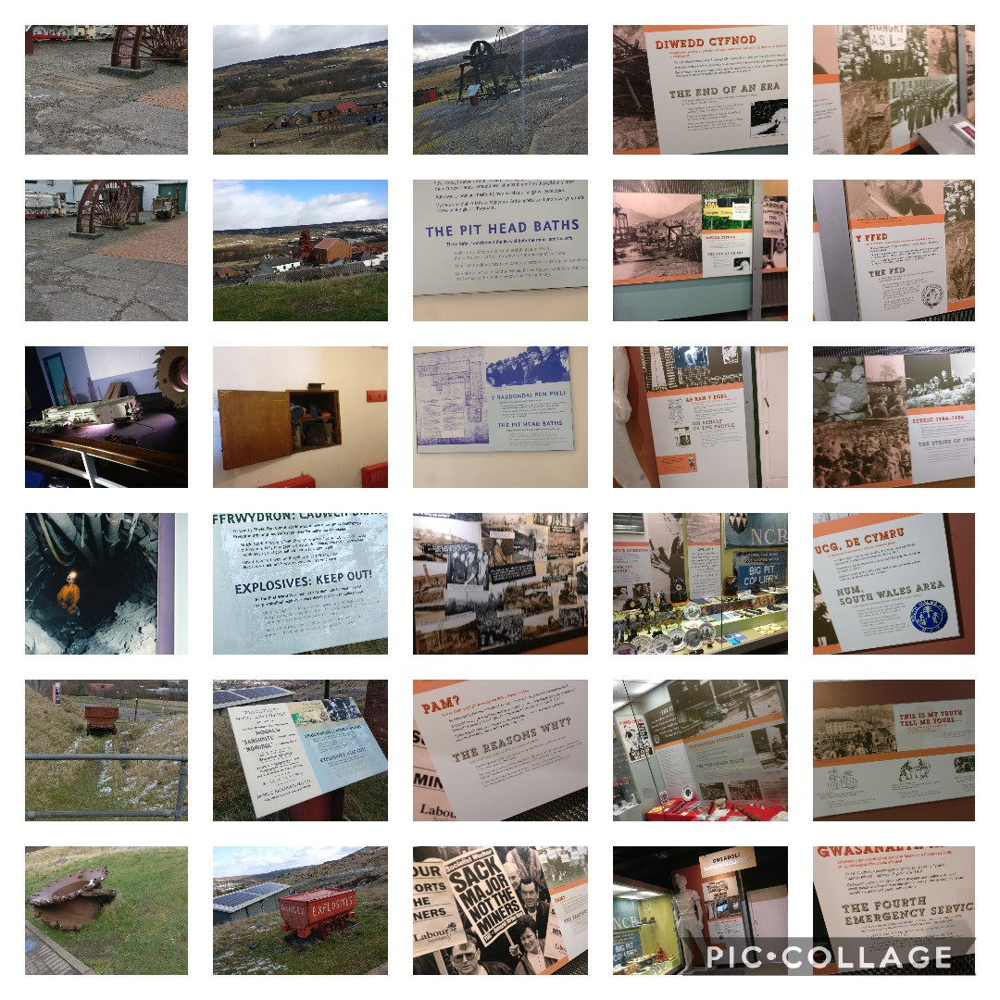
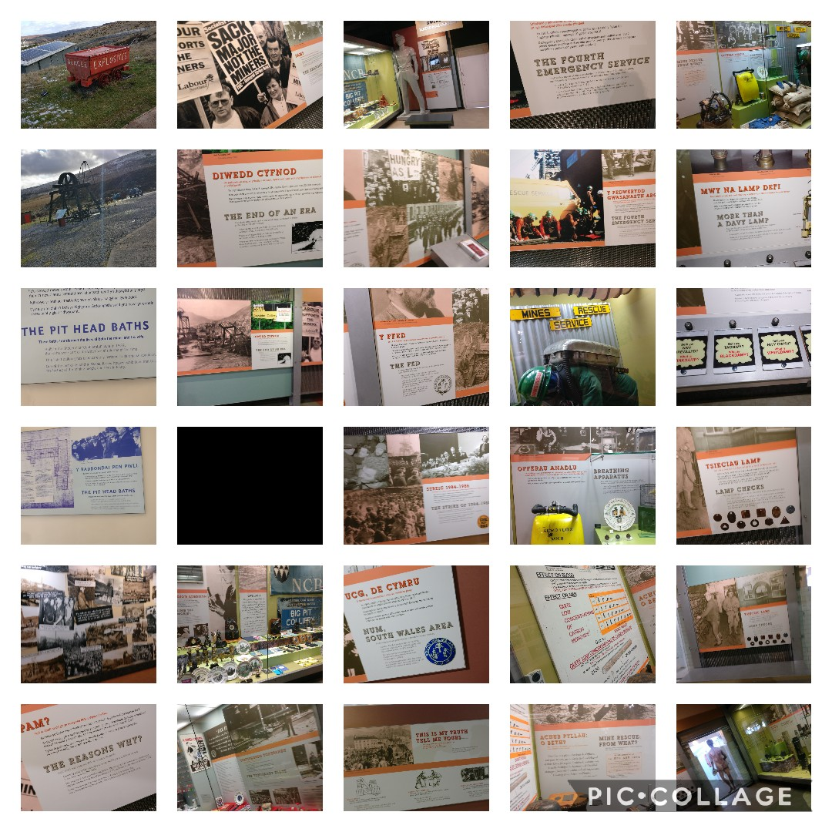

References
Cadw.gov.wales. (2020). More about Blaenavon Ironworks | Cadw. [online] Available at: https://cadw.gov.wales/more-about-blaenavon-ironworks [Accessed 6 Mar. 2020].
Cadw.gov.wales. (2020). Blaenavon Ironworks | Cadw. [online] Available at: https://cadw.gov.wales/visit/places-to-visit/blaenavon-ironworks [Accessed 6 Mar. 2020].
Ggat.org.uk. (2020). Blaenavon HLCA010. [online] Available at: http://www.ggat.org.uk/cadw/historic_landscape/blaenavon/english/Blaenavon_Main.htm [Accessed 6 Mar. 2020].
Moodle.uwtsd.ac.uk. (2020). UWTSD Moodle 2019/20: Log in to the site. [online] Available at: https://moodle.uwtsd.ac.uk/pluginfile.php/346841/mod_resource/content/2/Limestone%20lecture_no%20narrative.pptx [Accessed 6 Mar. 2020].
Moodle.uwtsd.ac.uk. (2020). UWTSD Moodle 2019/20: Log in to the site. [online] Available at: https://moodle.uwtsd.ac.uk/pluginfile.php/346841/mod_resource/content/2/Limestone%20lecture_no%20narrative.pptx [Accessed 6 Mar. 2020].

