
Academic skills for students. Module ecge4002p
A portfolio of tasks reflecting the skills, knowledge and dispositions needed for higher education study.


Amanda Gould 1909545

Contents page

Page 2 - Portfolio Task 1 – Developing your skills: vision of success as a student-teacher.
A digital mind-map of all the resources available to me as a university student.

Page 3 – Portfolio Task 1 – Developing your skills: vision of success as a student-teacher. My current skills audit.

Page 4 – Portfolio Task 1 – Developing your skills: vision of success as a student-teacher. What success would look like for me.

Page 5 – Portfolio Task 2 – Developing Critical Thinking. A short summary identifying the key points of Developing Critical Thinking.

Page 7 - Portfolio Task 3 – Developing Critical Writing. What I think about Education in Wales.

Page 10 - References

Portfolio Task 1 – Developing your skills: Vision of success as a student-teacher.

A digital mind-map of all the resources available to me as a university student.

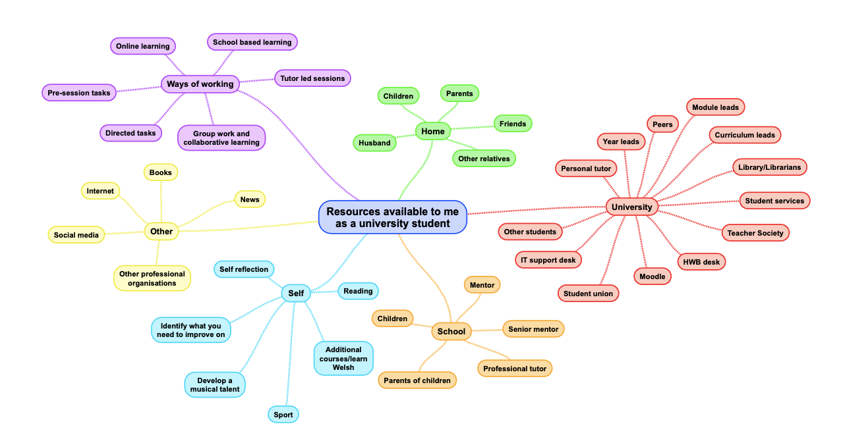
Portfolio Task 1 – Developing your skills: Vision of success as a student-teacher.

My current skills audit.
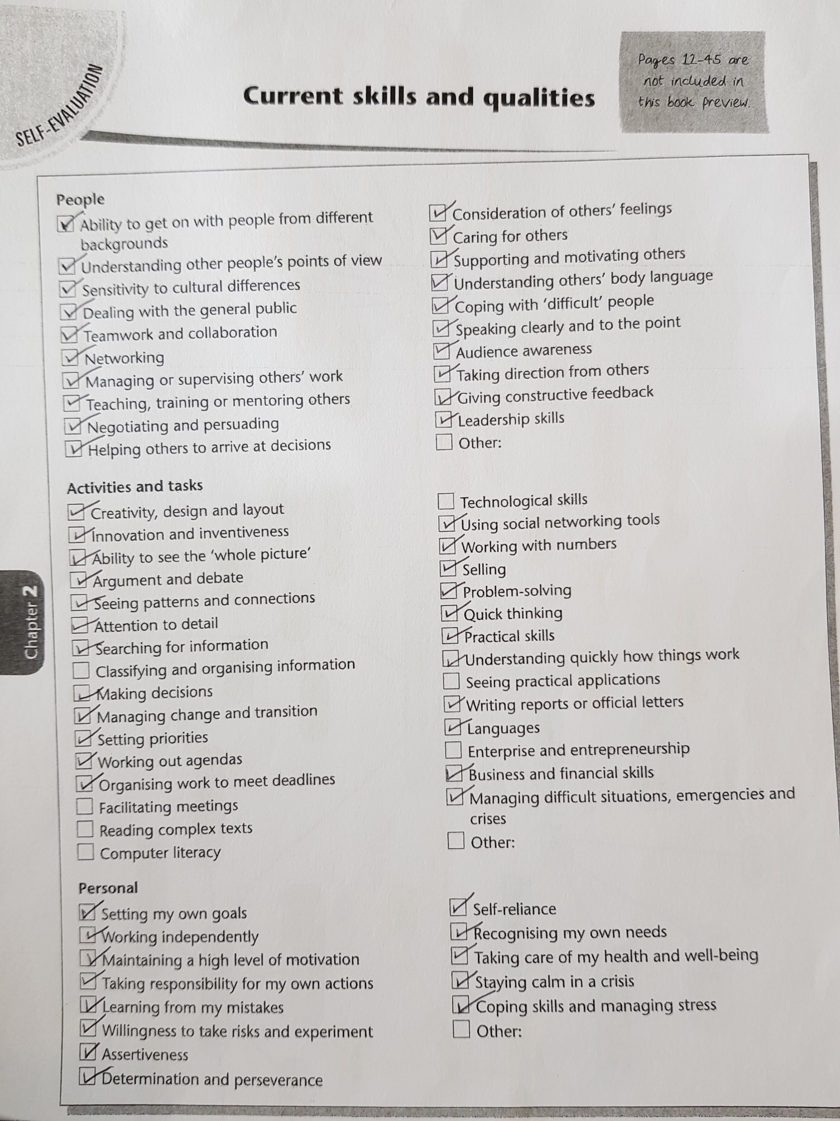
Portfolio Task 1 – Developing your skills: Vision of success as a student-teacher.

What success would look like for me

It has always been my ambition to be a primary school teacher as I believe it to be a very rewarding career. Achieving this goal would not only be the realisation of a personal ambition but it would reflect on my family. I heard my daughter talking with her friend in the back of my car. She said, “My mummy is training to be a teacher!” I could tell by the tone of her voice that she was very happy and proud. To achieve Qualified Teacher status and therefore make my children even more proud of me, would be the biggest success for me. To work hard, develop my skills, gain experience, knowledge, to be more organised, be able to do things independently and not rely on others will make me more confident, give me self-belief and motivate me to keep progressing and therefore feel successful.

Portfolio Task 2 – Developing Critical Thinking

Critical thinking is a way of thinking in a clearer and more logical way. It is looking at the full picture, listening to all opinions and arguments, whilst thinking deeper and looking at all the facts. It involves thinking about any evidence, where it is from, who is it from and establishing if it is logical and, relevant. It is believing things once you have reflected and analysed. Thinking in this way gives you the ability to identify things more accurately, in a reasoned way.

There are many qualities that you get from critical thinking. It makes you more rational. You will be able to look into evidence more deeply, and come to more accurate conclusions. You will be more observant. When reading a lengthy report or journal it will give you the skills to identify what is relevant, rather than loosing focus and concentration. Your analysis skills, judgement and decision-making skills will improve, which will assist with problem solving. Your powers of persuasion will also improve as you feel more confident. All of these qualities will help in everyday life.

For critical thinking to be successful you need to consider a number of factors. Attention to details is important because by looking at the small details it can help with viewing the whole picture. It is important to check details more than once, in case you miss something the first time. You have to look at things from an unbiased view and, consider consequences.

It is important to be self-aware, to identify your strengths and weaknesses. The same can be said for something you are thinking critically about. If you believe something is not good enough, think about why is that the case? An article on the internet will often not have enough detail or evidence to make it factual. In contrast, an academic journal would have a lot of detail and research would have been done to ensure that it is credible.

As a student it is important to use critical thinking. When writing assignments, you need to ensure that what you are reading and writing about is accurate. Persons reading your work need to trust that you have investigated your material and know that it reliable and factual.

There are barriers which prevent people from being able to think critically. If you are a sensitive person, you may take comments to heart instead of using them productively. If I had a comment on my work which suggested I need to think more critically, I would use this feedback to my advantage and look into the topic in more depth. Another barrier could be if you have problems in personal life, it is hard to stop feelings getting in the way. Some good advice I was recently given is “If subconscious thoughts arise which aren’t relevant, then think of them as clouds outside the window and move them on by.” In doing this you can concentrate more on your critical thinking. Your likes and dislikes can also affect critical thinking. Finally, lack of practise and not having a good method are barriers.

It is important to recognise how beneficial critical thinking is. Understand how to critically think. Think of your strengths and weaknesses and practise to improve your skills. (Cottrell, 2005)

Portfolio Task 3 – Developing Critical Writing

What I think about Education in Wales

The current Education system is outdated, due to the world changing so much since the last Curriculum was introduced in 1988. This has been recognised and I believe there are exciting changes ahead. Wales will start its new Curriculum reform in 2022 as a result of an independent review carried out by Professor Donaldson. His report is Successful Futures (2015)

The new curriculum will give children a great education and help them achieve successful futures. There will be four main purposes to help children become: Ambitious capable learners. Enterprising creative contributors. Healthy, confident individuals and Ethical, informed citizens. There will be six areas of learning and experience. It will be different to the current curriculum which teaches specific subjects and dictates subjects have to be taught in a certain way (Welsh Government 2019).

I believe one of the biggest changes is how technology has advanced. People used to read books, newspapers and watch documentaries for information but now people search the internet, use mobile phones and Social Media as a quicker way to find out information. The Welsh Assembly Government article Education is Changing (2018) supports my views and also in agreement is an article from the Wales Centre for Public Policy written about the Future of Work in Wales (2017) This article explains how digital competency is important because today’s children will have jobs which have not yet been created. Teachers need to have essential training to be digitally competent in order to pass these skills onto our children.

There is inadequate ongoing teacher education and assessment. A Durham University meta-analysis entitled What makes great teaching? (2014) describes how effective teaching impacts children’s futures. The new way student teachers are taught is modern and exciting, there will be regular assessments and teachers will make the most of up to date resources, A BBC article entitled Education: Draft school curriculum for Wales published (bbc.co.uk 2019) Education Minister Kirsty Williams AM explained how the curriculum and the way subjects are taught needed to be changed to modernise education.

In modern life there are many challenges for children, lack of structure at home, poverty, limited access to essential things, unhealthy eating and mental health issues to name a few. If a child is not provided with a stable loving home, they lose their sense of identity. German poet and novelist Johann Wolfgang von Goethe (1972-1832) said “There are two things children should get from their parents: roots and wings.” Roots are our happy place, where we feel safe, where you are from, good memories, support. When you have these things then you have confidence to try new things and succeed. These are the wings! I feel because identity is being neglected teachers need to be the roots for the children.

The Welsh language is part of our identity. The Welsh Government has an ambition to create a million Welsh speakers by 2050 as detailed in the Welsh assembly report Cymraeg 2050: A million Welsh Speakers (2017) It This explains how future education will teach more people to use the Welsh language.

There are many reasons why the curriculum has needed to change in Wales. I believe all children have the right to a good education and great start in life. I feel very fortunate to be a student teacher at this time.

References

Cottrell, S (2005) Critical Thinking Skills. Basingstoke:Palgrave

Coe, R, Aloisi, C, Higgins, S, Major, L E (2014) Durham University. What makes great teaching? Review of the underpinning research.

Donaldson, G (2015) Successful Futures. Independent review of Curriculum and Assessment Arrangements in Wales.

Donaldson, G. (2017) ‘A Systematic Approach to Curriculum Reform in Wales. Wales Journal of Education, 19(1), pp. 7-20

Lewis, B (2019) Educational correspondent for BBC news. Education: Draft school curriculum for Wales published
Available at: https://www.google.com/amp/s/www.bbc.co.uk/news/amp/uk-wales-48094118 (Accessed 30/10/2019)

Wales Centre for Public Policy (2017) Future of Work in Wales.
Available at: https://www.wcpp.org.uk/publication/future-of-work-in-wales/ (Accessed 29/10/2019)

Welsh Government. Cymraeg 2050 A million Welsh speakers. Available at: http://www.assembly.wales/laid%20documents/gen-ld11108/gen-ld11108-e.pdf
(Accessed 29/10/2019)

Welsh assembly government. gov.wales (2018) Education is changing. Available at: https://gov.wales/education-changing (Accessed 28/10/2019)

Welsh Assembly government. Hwb.gov.wales (2019) A guide to Curriculum for Wales 2022. Available at: https://hwb.gov.wales/draft-curriculum-for-wales-2022/a-guide-to-curriculum-for-wales-2022/ (Accessed 07/11/2019)

