Blog Submission
Student Name: Katy Grummett
Student Number: 2209790

Name of students in group:
Katy Grummett
Elizabeth Matthews
Lauren Howells
Kira Cole

Link to individual blogs:
https://supportingemmaus.blogspot.com/2022/11/emmaus-who-are-they.html - Emmaus - Who are they?
https://supportingemmaus.blogspot.com/2022/11/ways-you-can-help-emmaus-fundraising.html - Fundraising Events
https://supportingemmaus.blogspot.com/ - The groups blog as a whole

Words included in individual blogs (including reference list):
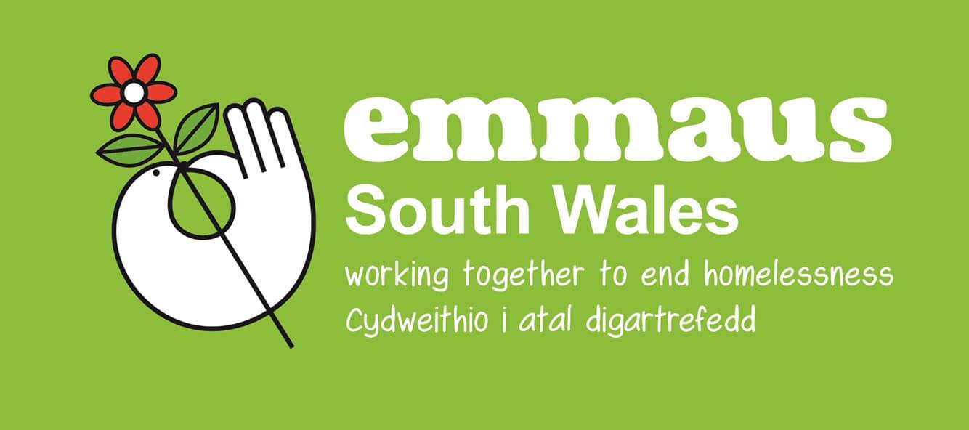
Emmaus – Who are they?
Did you have a good night sleep last night? Not everyone did. Homelessness for many people can mean losing your sense of self which can be detrimental to mental health and many other things. Being alone and having no one to lean on can be soul destroying and makes thousands of people feel as though they are worthless. Finding a way to get out of that predicament can be difficult, especially when their only options are quick fixes that just provide them with a place to sleep at night, even if that means sleeping on the pavement whatever the weather may be.
Emmaus are here to help. Emmaus are a charity who support homelessness in the UK. They don’t just give homeless people a place to stay for one night only, they give them a proper home for as long as they may need it, as well as offering multiple different jobs for them to work, and making people feel as though they belong again.

Emmaus was originally started in 1949 in Paris, but in 1991 was when Emmaus first opened in the UK, in Cambridge. Since then, they have opened 30 residential sites, known as Emmaus communities, spread across the whole of the UK. Within those 30 communities there are currently over 850 people who have been given a life worth living again, and there are so many more people all over the UK and the World who could experience the same feeling if we keep working together to make it happen. Everyone needs to become more aware of how severe homelessness has really become over the last few years in the UK, especially in the current climate with the cost-of-living crisis.
Emmaus have a current goal of providing homes to 1,100 people by 2025, and with your help we just might be able to help them achieve this goal and even increase that number. To find out more, visit https://emmaus.org.uk/about-us/.
(Emmaus UK, no date)

Ways you can help Emmaus - Fundraising Events
Today is the day for you to help make a change. There are so many different ways we can all help Emmaus to achieve their goals. The first way is through fundraising.
There are a variety of different types of fundraisers that you could participate in, and all funds go directly to Emmaus to help them provide more homes, communities, and better lives for homeless people.
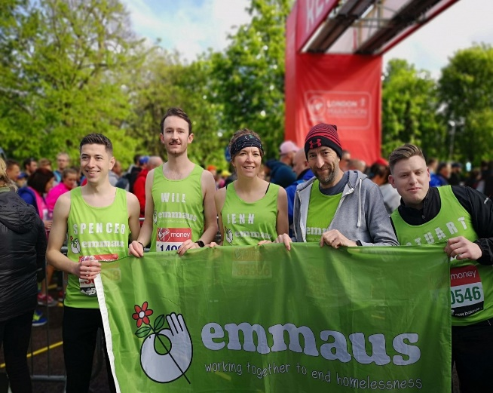
A lot of people hear the words “fundraising event” and assume that it means they need to run a marathon or bake a load of cakes and biscuits, but they couldn’t be more wrong. Yes, if you are able to run a marathon or do a bake sale that is a fantastic way of raising money, but there are lots of other options out there for the people who can’t do those things.
You can fundraise in celebrations such as birthdays, anniversaries, weddings, or basically any party where the guests can bring you gifts. All you need to do is set up a fundraising page through the Emmaus website and ask your friends and family to donate how much they would’ve spent on gifts. Once all of the donations have been received by Emmaus, they will personally send you a thank you card and let you know how much you’ve raised and how much you have helped them.

Another great way of fundraising is through gaming and streaming. All you need to do is again, set up your fundraising page, choose what game you want to play online and how long you are going to play for, let everyone know when you’re going to do it, and then play your chosen game, have fun, and raise money for a great cause at the same time!
As you can see, there are a variety of great fundraising ideas. Click on the following link to see which activity you will enjoy the most: https://emmaus.org.uk/wp-content/uploads/2019/08/A-Z-of-fundraising.pdf
So, what’s stopping you from getting involved today and doing what you can to help Emmaus end homelessness in the UK?
(Emmaus UK, no date)

Reference List:
Emmaus UK. (no date) Emmaus UK | the charity working to end homelessness. Available at: https://emmaus.org.uk/ (Accessed: 24/11/2022)

