Manifesto: How to be the best artist possible.

- Greet mess and chaos with welcoming arms.
- Positivity is admired.
- Grab new opportunities as they appear.
- Resilience is a must.
- Repeat. Repeat. Repeat.
- Evaluate Often.
- Be aware of the effects of peer pressure.
- All art is beautiful.

1.Mess and chaos is welcomed.
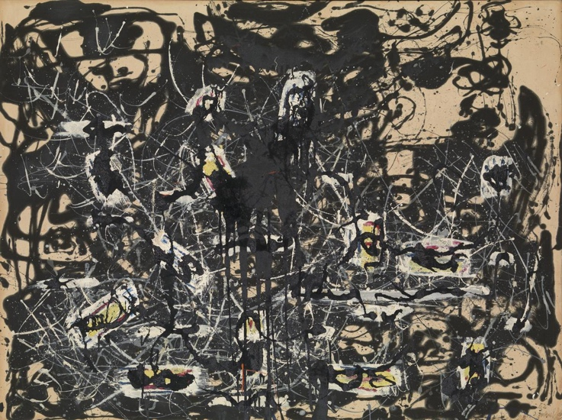

Firstly, go mad. Just enjoy yourself and if this results in lots of mess, do not be frightened. Do not shy away, indulge in it. Allow yourself to have fun within your work.Art is all about being expressive, allowing yourself to create mess and chaos and most importantly having fun whilst doing so. For example, above lies a painting by Jackson Pollock who to some appears as ‘mere unorganised explosions of random energy’. Yet others comment that it is a beautiful, heartfelt abstract painting. He has clearly expressed his emotion through art in an incredible way, whilst not being afraid of creating a mess. Thus, why should you hold back from making mess and chaos which results in art? However, do not be concerned if your art does not resemble this. If your art leads you to be as pristine as possible, that is fine also. Be brave and do not let the fear of failure stop you from creating what you love.
6. Evaluate often.
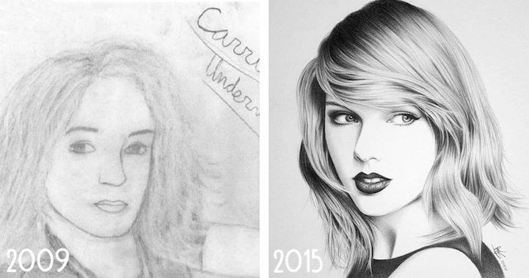

Evaluation is crucial in order to develop and improve upon your past artworks. By evaluating, you are ‘acknowledging weak spots’ and ‘creating an action plan’ in response.Thus, by recognizing your faults or weaknesses, you are able to begin to find solutions to take the next steps in developing your art further. An excellent example is these two artwork’s by Ray Sampang. These images show clearly how Sampang is analysing and evaluating their past works to improve upon them further. To be more specific, they focused on faults within their work such as the lack of shading, cartoon-likeness and lack of detail. This means that through constant resilience, you should also be able to see a clear improvement within your work, if you evaluate frequently.

8. All art is beautiful.
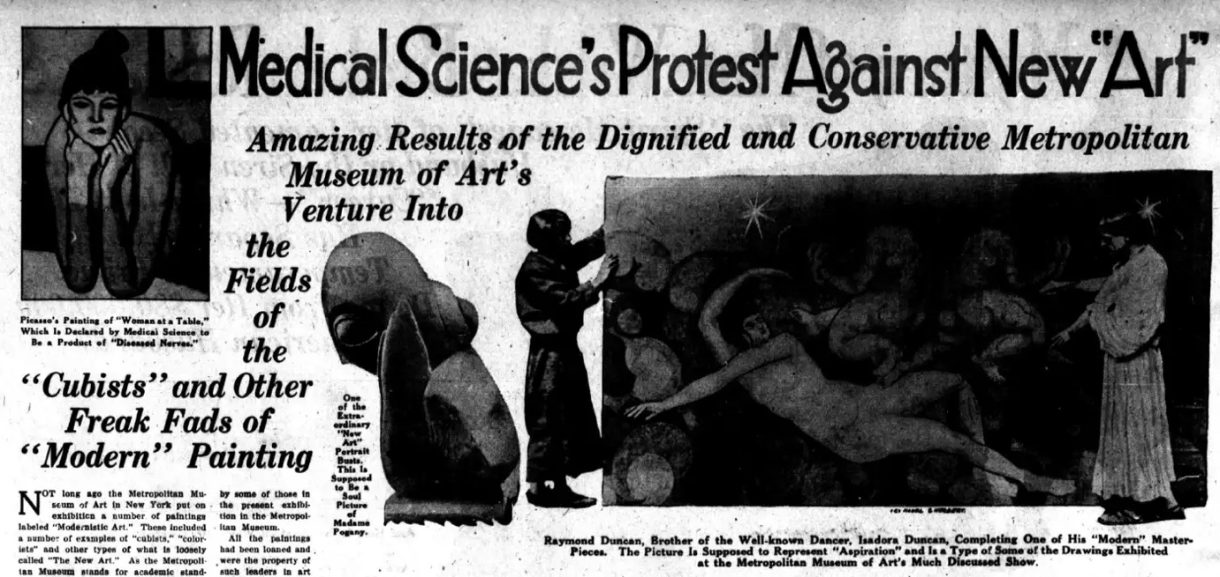
To conclude, whatever you create, how ever you create it, is beautiful. Even though you may doubt you ability and believe your work is the most horrific thing. Trust me, when I say it is not. An old saying to support this is ‘one man’s trash is another man’s treasure’. A great example of this is, the artist ‘Picasso’. Within the art world, we know and recognise Picasso as a crucial member in several art moments and never doubt his outstanding artistic ability.Yet several art critics labelled his art as 2 ‘degenerate’, ‘odd’ and ‘a product of diseased nerves’ throughout his career. Does this lead us to change our opinion’s of Picasso? No. I know, personally I still believe Picasso is an amazing artist, whose work is both inspiring and revolutionary. He was a crucial member of pop art, cubism and many other art movements. This shows that just because one person may dislike or despise your work, it will still be considered beauty in another person’s eyes. Therefore keep creating and even if you do not deem your work beautiful, trust that someone does.

Bibliography

Pollock, J. (1952) Yellow Islands (Oil paint on canvas). Tate: London.

McElroy, S. (2010) ‘If It’s So Easy, Why Don’t You Try It’, The New York Times, 3rd December.

Ross, H. (2021) 21 Ways To Improve Work Performance and Continuously Grow. Available at: https://fellow.app/blog/productivity/improve-work-performance-and-continuously-grow/ (Accessed: 12th November 2022)

Park, W.G. (2019) These Early Reviews of Picasso’s Art are Adorably Hysteric. Available at: https://medium.com/@parkwestgallery/park-west-gallery-review-picasso-147efeccdf31
(Accessed: 8th Nov 2022)

Observational Writing: ‘Andy Warhol by Federico Babina

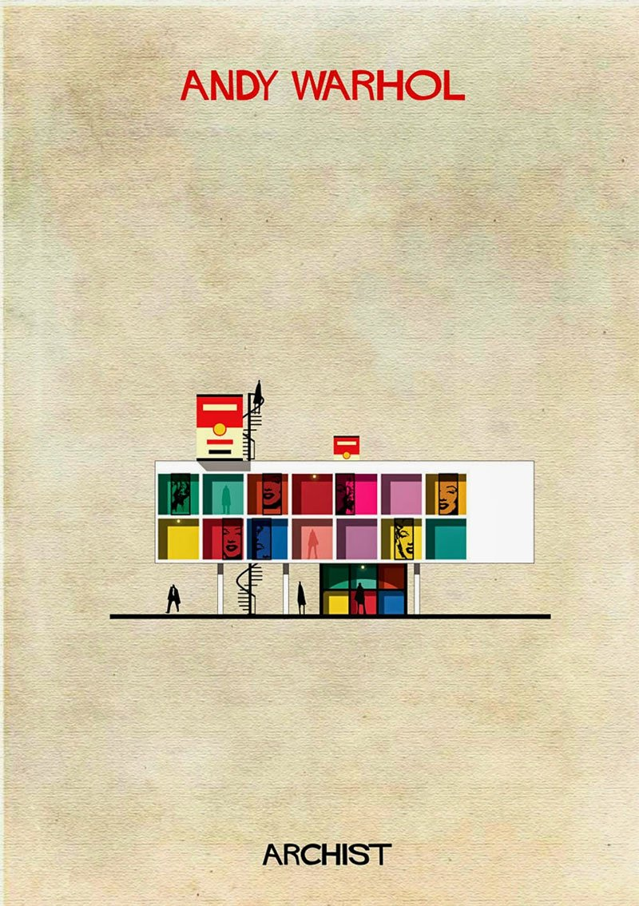

Above lies an artwork by Federico Babina. This artwork portrays a building which has the name ‘Andy Warhol’ above it. This suggests that this could be the title or perhaps name of the building. This implies that Babina is portraying architecture in the manner of a person. The person being ‘Andy Warhol’ which is placed above the image. Thus, the text clearly holds a significant semiotic meaning. This is because there are aspects within Warhol’s work which is shown in both the interior and exterior of this building. For example, Babina has been very clever and used primary colours which clearly represent the art movement ‘Pop Art’ which Warhol was a crucial figure of. Gabriella Gosha describes Pop Art’s use of colours as ‘bright’,’vivid’ and accompanied with ‘bold, simplistic shapes’. Babina also refers to these simple shapes within his use of the squares in this piece. He may have also done this to hint at the repetition of squares within many of Warhol’s pieces such as the iconic ‘Marilyn Monroe’.

Moreover, ‘Marilyn Monroe’ is one of Warhol’s most famous pieces which uses primary colours, squares and the icon ‘Marlyn Monroe’ herself. Babina has cleverly included sections of Monroe through what appears as sliding doors. Sliding doors symbolise open doors, this could refer to his work being open for the audience to view. In addition, it appears as though most of the sections are of her lips. I think this is interesting because within the pop art movement, they often portrayed woman as desirable. This could be Babina’s way of hinting at this. Two Great examples of this are ‘Girl with Hair Ribbon’ and ‘Drowning Girl’ by Roy Lichtenstein. They both depict girls with pouty lips, which could be considered ‘desirable’.

Furthermore, it would seem that Babina has used Marilyn Monroe because when Warhol focused his art on her, it heavily symbolised popular culture and was influenced by Consumerism. The main aims within the Pop Art Movement were ‘to solidify that art can be drawn from any source and no hierarchy could disrupt’ it. This is interesting because the word at the bottom reads ‘Archist’. An ‘Archist’ is the equivalent to a statist, which is a supporter of state control. Thus, is Babina referring to Warhol as someone who obeys the hierarchy, government and state control through his use of popular culture and consumerism?

Babina also gives reference to another one of Warhol’s well known pieces ‘Campbell Soup Can’ in what appears as chimneys. Chimney’s represent action and movement. This suggest that Babina feels that the ‘Campbell’s Soup Cans’ were the beating heart/fire of the pop art movement and potentially Warhol’s career in general. Warhol painted the ‘Campbell’s Soup’ because it was a well-known brand which everyone would recognise. Did Warhol know this would become an Icon for the pop Art Movement?

Lastly, Babina has placed people within the building to give the myth that this building is perhaps a Gallery. The people symbolise how anyone can view Warhol’s work, in the same way the sliding doors are a hint at his work being open to the public. Babina’s use of architecture portrays the ‘symbiotic relationship and implicit partnership’ between art and architecture. He clearly shows how art could easily influence contemporary architecture.

Bibliography

Babina, F. (2014). Andy Warhol [ Giclee prints using Epson K3 archival inks]. Archist: Spain.

Rosenfield, K. (2014, March 5th) ARCHIST: Illustrations of Famous Art Reimagined as Architecture. Available at: https://www.archdaily.com/482982/archist-illustrations-of-famous-art-reimagined-as-architecture (Accessed: 18th November 2022)

(2020, April 27th) Why Did Andy Warhol Paint Soup Cans? Available at: https://www.campbellsoup.co.uk/blog/why-did-andy-warhol-paint-soup-cans/ (Accessed: 16th November 2022)

Saul, F. (2013, March 29th) Chimney: Symbol In Tea Leaves. Available at: https://www.auntyflo.com/tea-leaf-dictionary/chimney. (Accessed: 17th November 2022)

Gosha, G. (2014, April 11th) Dial-a-style#4: Nailing the Pop Art Look. Available at: https://www.sitepoint.com/dial-style-nailing-the-pop-art-look/ (Accessed: 9th November 2022)

Art In Context. (2021, December 8th) Pop Art- A History and Analysis of the Brightly Colored Pop Art Movement. Available at: https://artincontext.org/pop-art/ (Accessed: 20th November 2022)

Custodia, M. (2020, July 19th) Why does pop art use such bright colours. Available at: https://marianacustodio.com/why-does-pop-art-use-such-bright-colors/ (Accessed: 3rd November 2022)

