

Nike: Marketing, Promotion & Brand Image

Module Code: BMMB7012
Module Name: Marketing Management
Lecturer: Gwyneth Jones
Name: Vikalp Vidish
Student ID: 2218769

Table of Contents
Executive Summary 2
1.0 Introduction 3
1.1 Nike Company Overview 3
1.2 Marketing Concept 4
2.0 Main Findings 5
2.1 The Macro and Micro Marketing Environment 5
2.2 Nike’s Macro Economic Environment Analysis Using PESTEL Framework 6
2.3 Nike’s Micro Economic Environment Analysis Using Porter’s Five Forces Framework 10
2.4 Nike’s SWOT Analysis 13
2.5 Nike Market Segmentation, Targeting and Positioning 14
2.6 The Marketing Mix 17
2.7 Marketing Media and Their Success 20
3.0 Conclusion 21
4.0 Recommendations 22
Reference List 23
Appendices 31

List of Figures
Fig 1: The Marketing Process……………………………………………………………………………………………………………..4
Fig 2: The Marketing Concept…………………………………………………………………………………………………………….5
Fig 3: Marketing Environment……………………………………………………………………………………………………………6
Fig 4: PESTEL Analysis………………………………………………………………………………………………………………………..7
Fig 5: Porter’s Five Forces………………………………………………………………………………………………………………..11
Fig 6: SWOT Analysis………………………………………………………………………………………………………………………..13
Fig 7: STP Model………………………………………………………………………………………………………………………………14
Fig 8: Nike’s Worldwide Revenue…………………………………………………………………………………………………….15
Fig 9: Nike’s Website Audience Demographics…………………………………………………………………………………16
Fig 10: Nike’s Marketing Mix (4Ps)……………………………………………………………………………………………………18
Fig 11: Total Nike Store Worldwide………………………………………………………………………………………………….19
Fig 12: Nike Customer Loyalty 2022 Stats…………………………………………………………………………………………21
Fig 13: Nike's advertising and promotion costs (Appendix A)…………………………………………………………..32
Fig 14: Nike Revenue (Appendix A.1)……………………………………………………………………………………………….37

Executive Summary
This report discusses about Nike, which is one of the top American multinational companies that is involved in the design, development, manufacturing and worldwide marketing and sales of athletic footwear, accessories and equipment. The report provides an in-depth analysis of Nike's marketing strategies, promotions, and brand image. It begins with an introduction to Nike, and then proceeds with the company overview focusing on its history, mission statement, and product offerings. It then discusses the marketing concept and the various marketing strategies employed by Nike, including the resources that are invested in marketing. It then proceeds with an in-depth analysis of Nike's macro and micro marketing environment using PESTEL and Porter's Five forces framework respectively. The PESTEL framework analyses the macroeconomic environment by considering political and legal influences, social, technological, and environmental factors affecting the company. The Porter's Five Forces framework focuses on the competitive landscape, suppliers, customers, and other key factors. SWOT analysis of Nike is also performed to determine the Strength, weakness, opportunities and threats.
Furthermore, the report explores Nike's market segmentation, targeting, and positioning strategies. Nike targets a diverse range of customers based on geographic, demographic, psychographic, and behavioural characteristics. The company strategically positions itself as a leader in the sports industry, emphasizing innovation, quality, and the endorsement of renowned and famous athletes. Moreover, Nike’s marketing mix, consisting of product, price, place, and promotion, is thoroughly examined. The company’s extensive product offerings and its use of premium and value-based pricing strategies are discussed. The report highlights Nike's global distribution network and discusses about company's promotional efforts through various media channels.
The conclusion of the report underscore Nike's successful marketing and promotional efforts, which have driven brand recognition and revenue growth. However, it also acknowledges the controversies and challenges the company has faced due to its engagement in divisive social issues. Despite these challenges, Nike's strong brand identity, consumer direct approach, and product innovation have been key factors in its success.
Based on the conclusion, the report offers recommendations for Nike. These include focusing on cultivating a strong brand identity aligned with their target audience, expanding collaborations with individuals and organizations committed to social responsibility, investing in digital marketing strategies to reach a wider audience, and carefully assessing potential outcomes and public sentiment when addressing social and political issues.

1.0 Introduction
Nike is a multinational corporation that is headquartered in Beaverton, Oregon, in the United States. As a global leader in athletic footwear, apparel, and equipment, Nike is known for introducing innovative product designs, creating effective marketing campaigns, and building a strong brand image. In the sports industry, it has maintained a dominant position by focusing on design, performance, and social responsibility.
The success of Nike can be attributed to its effective marketing, advertising, and endorsement strategies, which have significantly contributed to brand recognition. However, Nike has also been involved in a number of controversial advertisement and marketing campaigns which impacts the brand reputation of the company. The company's engagement in social issues as part of its marketing campaigns has generated both support and opposition from customers. Nevertheless, Nike's strong brand identity, consumer direct approach, product innovation, and digital advantage have played a pivotal role in its accomplishments.
Overall, Nike's marketing and promotional efforts have been instrumental in driving brand recognition and revenue growth. As the company looks to the future, its strategies and brand image will be shaped by its unwavering commitment to social responsibility, legal compliance, and innovation.

1.1 Nike Company Overview
Originally called Blue Ribbon Sports, Nike was founded in 1964 by University of Oregon track athlete Philip Knight and his coach Bill Bowerman. It is mainly known for its athletic footwear, but it also manufactures equipment, apparel, and accessories (Forbes, 2023).
Nike, Inc. is a team consisting of the Nike, Jordan and Converse brands with a common purpose: to leave a lasting impact on the world. The company’s mission statement is “To bring inspiration and innovation to every athlete in the world” (Nike, 2019). A wide variety of sports shoes are manufactured by the company, including football, basketball, baseball, golf, soccer, snowboarding, hockey, tennis, and volleyball. In addition, it manufactures consumer fashion shoe such as flip-flops and Mary Janes (SportsRec, 2019).

1.2 Marketing Concept
Creating, communicating, and delivering value to customers, as well as maintaining customer relationships to the advantage of the organisation and its stakeholders, is known as marketing. It is an organisational function (Kotler et al., 2015).

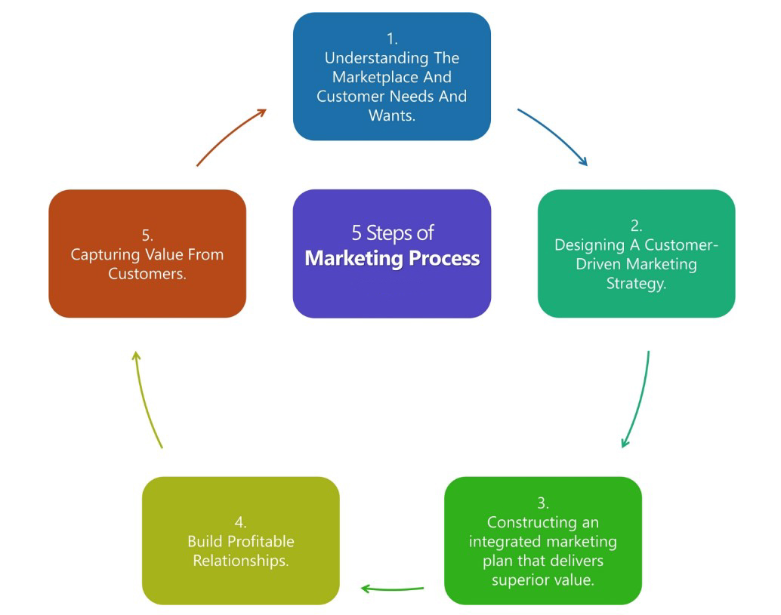
Fig 1: The Marketing Process (iEduNote, 2020)

Additionally, marketing includes any actions taken by a business to promote and sell goods and services to customers. It makes use of the four Ps (product, price, place, and promotion), which is also known as the "marketing mix" (Twin, 2023).
According to the marketing concept, accomplishing organisational goals depends on understanding the requirements and desires of target markets (Homburg, Wieseke and Bornemann, 2009). A group of customers with shared demographics who have been recognized as being the most likely buyers of a company's goods or services is known as a target market (Investopedia, 2023b).
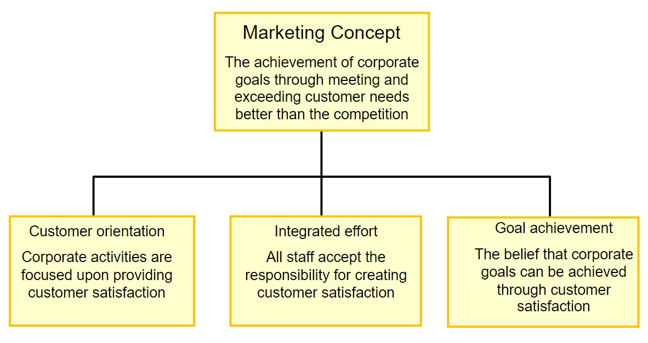
Fig 2: The Marketing Concept (Lewis, 2013)

Nike uses emotional branding, athlete sponsorships, and social media interaction to advertise their brand internationally. They also focus on unique retail experiences, innovative product development, and cause marketing to create a sense of community. Nike offers exclusivity and growth chances through its content marketing, limited edition products, and athlete development initiatives(Gitnux, 2023a).
Personalization, celebrity endorsements, and event marketing also help to reinforce their connection to sports. E-commerce optimisation ensures a seamless online shopping experience, establishing Nike as a leader in sports and lifestyle products. The average cost of selling and marketing for Nike throughout the fiscal years ending in May 2019 to 2023 was 3.674 billion U.S. dollars (Finbox, 2023).

2.0 Main Findings

2.1 The Macro and Micro Marketing Environment
The term "macro environment" describes external influences on an economy. Business operations are significantly impacted by macroenvironmental elements such as employment rates, GDP, consumer spending, fiscal policy, and inflation. Demographic, environmental, physical, economic, technological, political, legal, and sociocultural variables are examples of the external factors that make up the macro environment (WallStreetMojo, 2023).

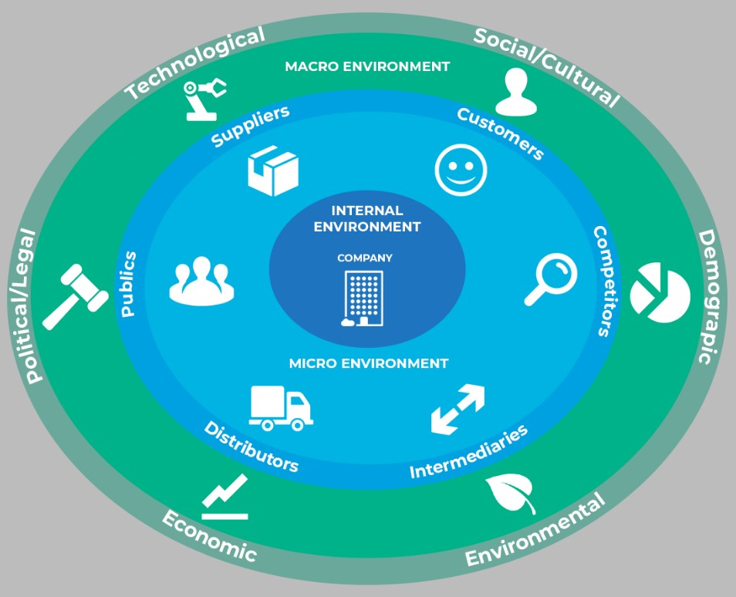
Fig 3: Marketing Environment (Professionalacademy, 2023)

The variables within a company that affect its capacity to conduct business are referred to as the micro environment. Microenvironmental components are specific to a company and can affect how well management is able to accomplish the company's Objectives. Suppliers, resellers, customers, and competitors are a few examples of these factors (Investopedia, 2021).

2.2 Nike’s Macro Economic Environment Analysis Using PESTEL Framework
A PESTEL analysis is a tactical framework widely used to evaluate the business environment in which an organisation operates. It examines the various external factors such as political, economic, social, technological, legal and environmental that affect its business (Peterdy, 2023).

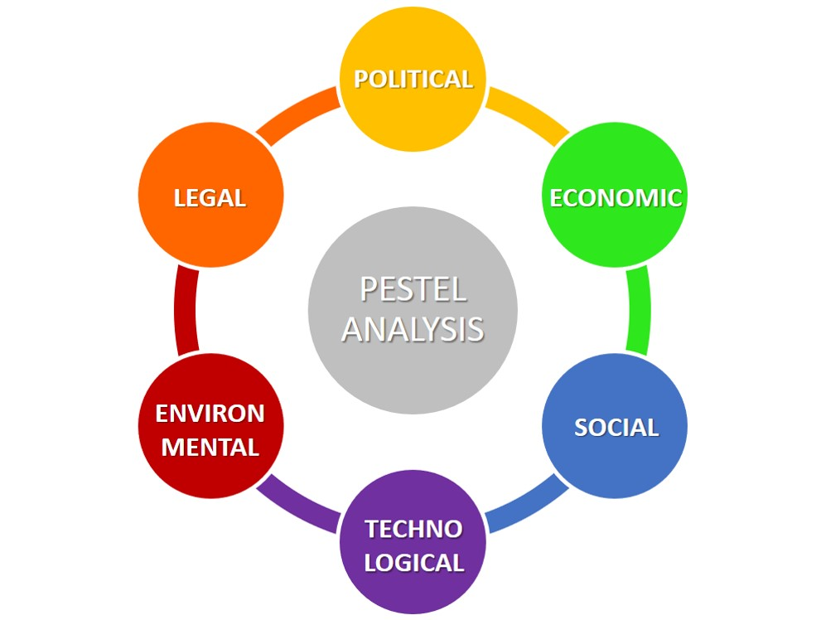
Fig 4: PESTEL Analysis (Toppr, 2018)

Below is the PESTEL analysis of Nike:
Note: The PESTEL factors are briefly discussed in “Appendix A” of the appendices

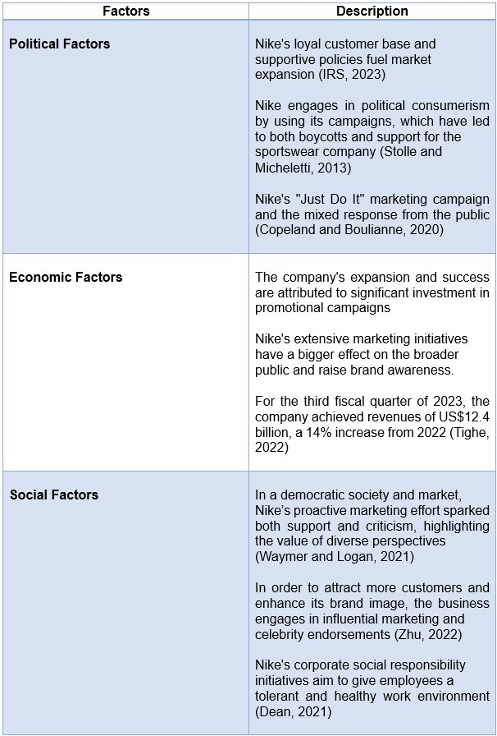

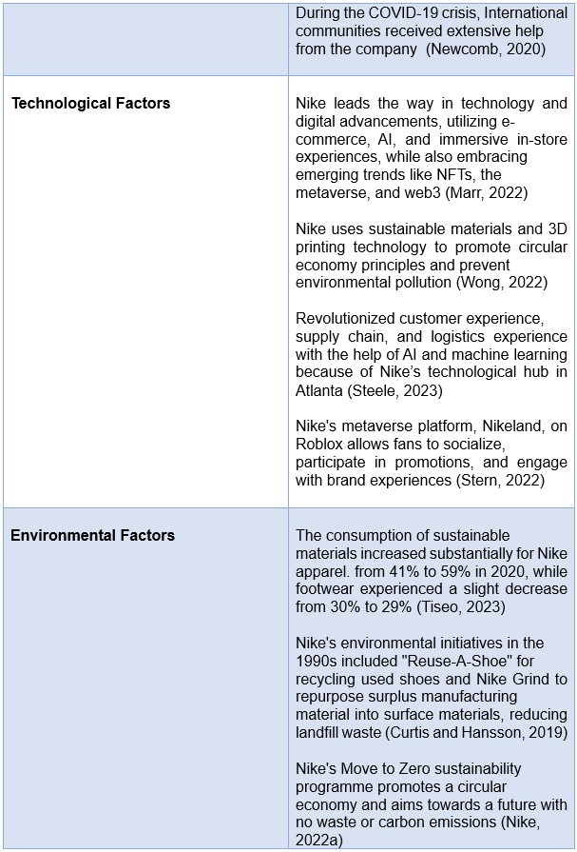

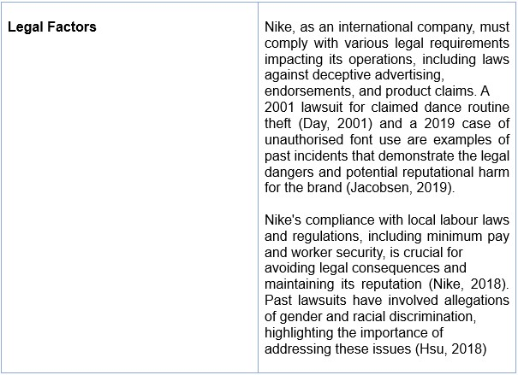

Critical Analysis as Per PESTEL Framework:
Using different marketing strategies like taking a stance on divisive social issues and by endorsing well-known sportsmen and teams, Nike has raised brand awareness. However, the company must keep concentrating on locating the ideal market for its products and services and maintaining a safe and welcoming work environment in order to further strengthen its brand image and retain its position.

2.3 Nike’s Micro Economic Environment Analysis Using Porter’s Five Forces Framework
The competitive forces at play in an industry can be understood with the help of Porter’s five forces framework. Moreover, it drives the way economic value is distributed among industry actors (Harvard Business School, 2021).
The five forces are competitive rivalry, threat of new entrants, bargaining power of suppliers, bargaining power of customers and threat of substitutes (WallStreetMojo, 2022).
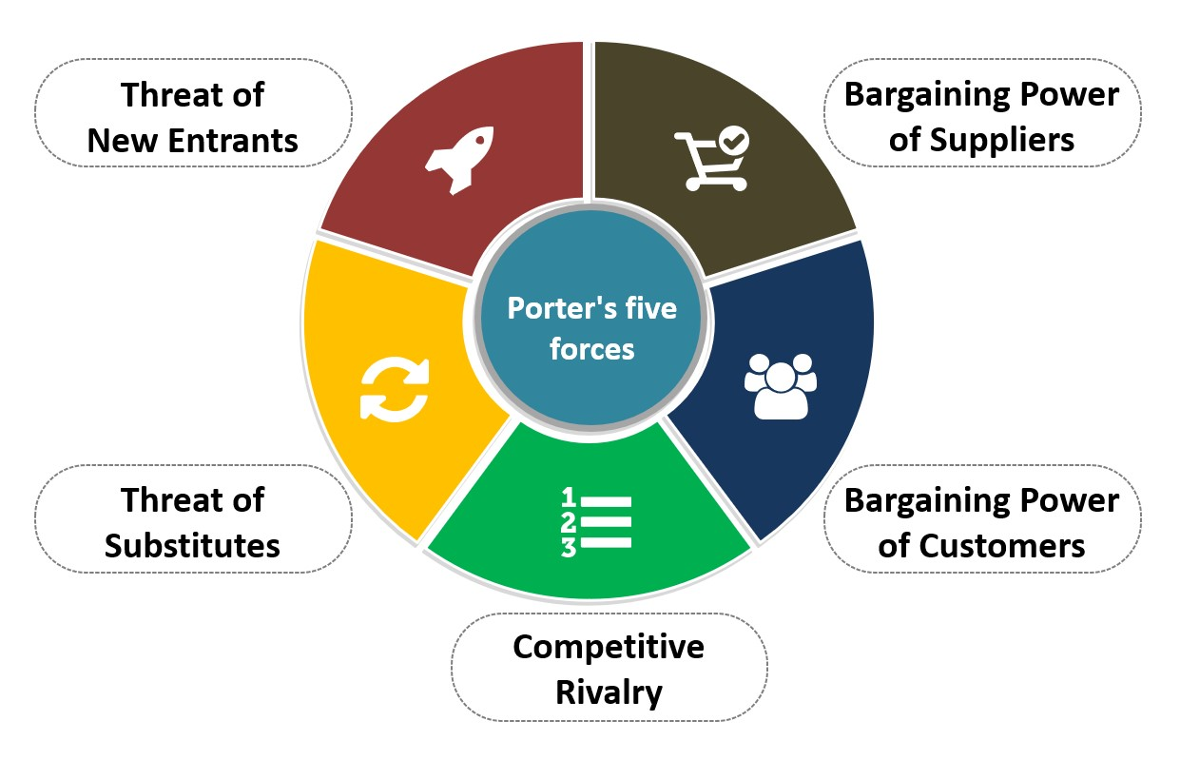
Fig 5: Porter’s Five Forces (Wowslides, 2019)

Below is the Porter’s five forces analysis of Nike:
Note: Porter’s five forces are briefly discussed in “Appendix A.1” of the appendices
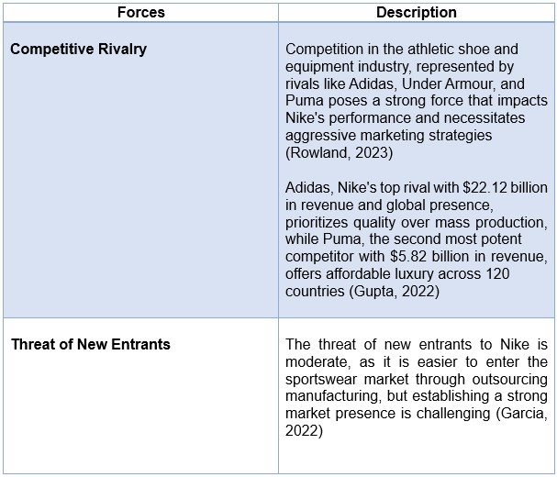
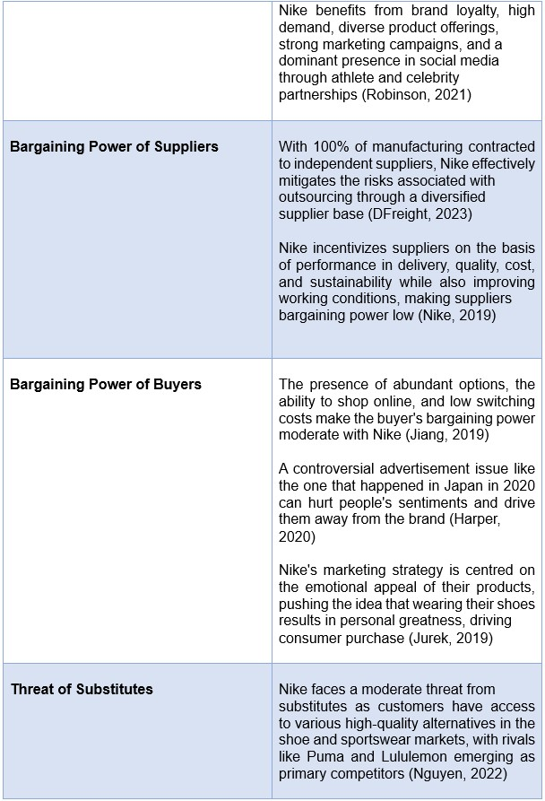

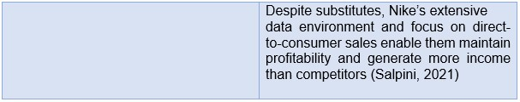

Critical Analysis as Per Porter’s Five Forces Framework:
Nike should continue to take advantage of its dominant market position and superior logistics, to keep a firm grip on the sports sector. In order to combat challenges similar to the ones that occurred in Japan, Nike should give special attention to tailoring its marketing strategies to the unique cultural environment and resonate with the target demographic. The company could boost its brand value and appeal by regularly using popular athletes in their campaigns, encouraging customer loyalty and differentiating themselves from rivals.

2.4 Nike’s SWOT Analysis
Note: The SWOT factors of Nike is briefly discussed in “Appendix A.2” of the appendices
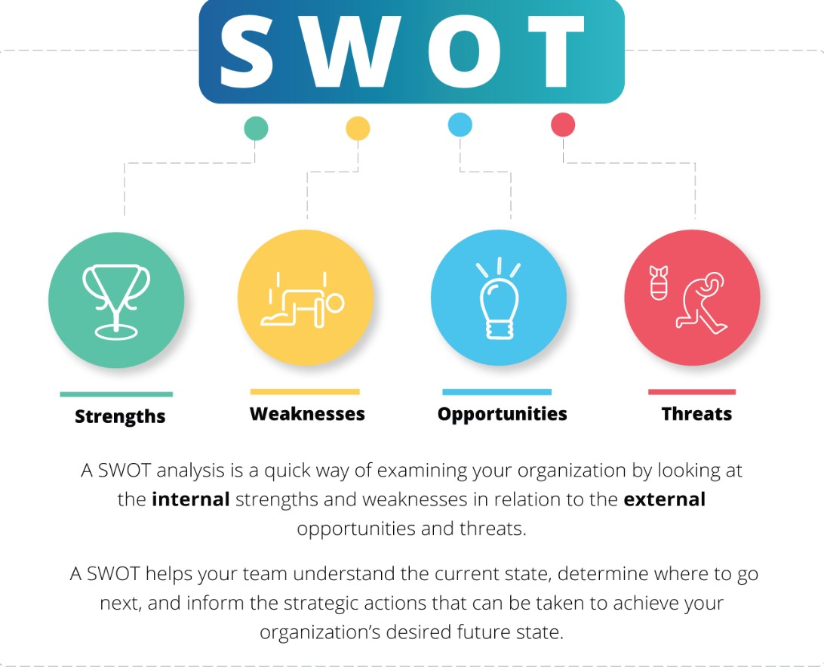
Fig 6: SWOT Analysis (OnStrategy, 2022)

2.5 Nike Market Segmentation, Targeting and Positioning
A marketing strategy that helps in identify specific segments of the population according to their common characteristics and needs, selecting the specific segments and create goods and services for this particular segment is termed as Segmentation, Targeting and Positioning or STP (BRM, 2023).

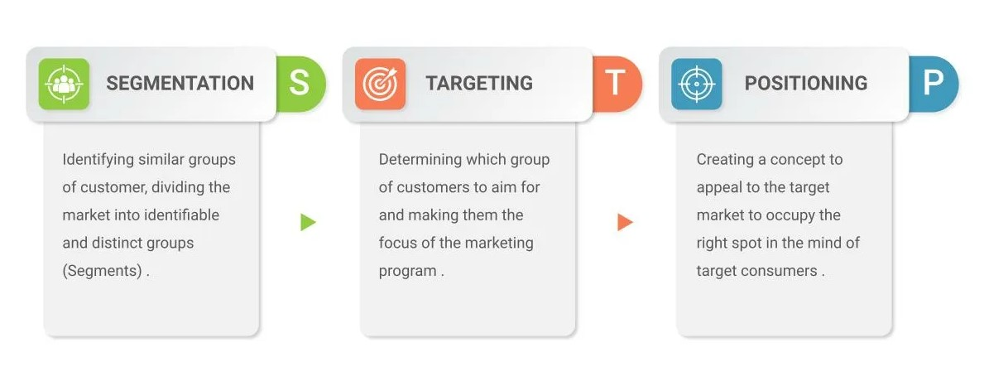
Fig 7: STP Model (SlideKit, 2023)

Segmentation:
Nike has segmented their market based on a number of demands, priorities, demographics, shared interests, and behavioural or psychographic characteristics.
Geographic Segmentation:
One of Nike's geographic segmentation initiatives is the establishment of physical stores in various regions of the world. Additionally, the business has a robust online presence that enables customers to purchase goods from any location. It has a presence in over 190 countries with over 1,000 retail stores worldwide, with the majority of them located in North America, Europe, and Asia Pacific (Shoeeffect, 2023).
Nike's North American revenue for the fiscal year that concluded on May 31, 2022, was roughly 18.35 billion dollars. The company's revenues that year in the EMEA region (Europe, the Middle East, and Africa) totalled close to 12.5 billion dollars (Statista, 2022).

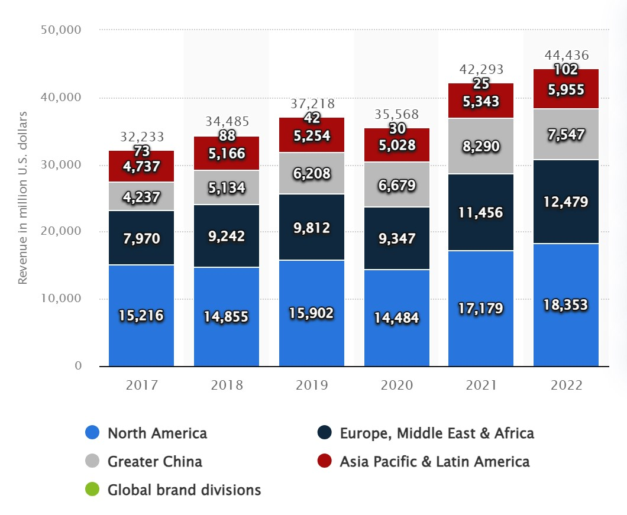
Fig 8: Nike’s Worldwide Revenue (Statista, 2022)

Nike produces different products for different customers based on their location and their specific needs, and this can also be observed in their marketing and promotional strategy. In Sydney and England, there’s a strong focus on promoting soccer and rugby products through advertisements. Whereas, in North America and in the United States, most commercials focus on football and baseball (Hodgson, 2023).

Demographic Segmentation:
Nike's customer base is divided into a number of age brackets and genders. Hence, the company has categorised their items into age categories, ranging typically between 15 and 55. The business divides its products into categories for women, men, and children. Nike offers promotions and discounts to cut costs under certain circumstances. The audience of the company's website, nike.com, is 43.15% female and 56.85% male. The largest number of visitors belong to the age group that ranges from 25–34 years (Similarweb, 2023).

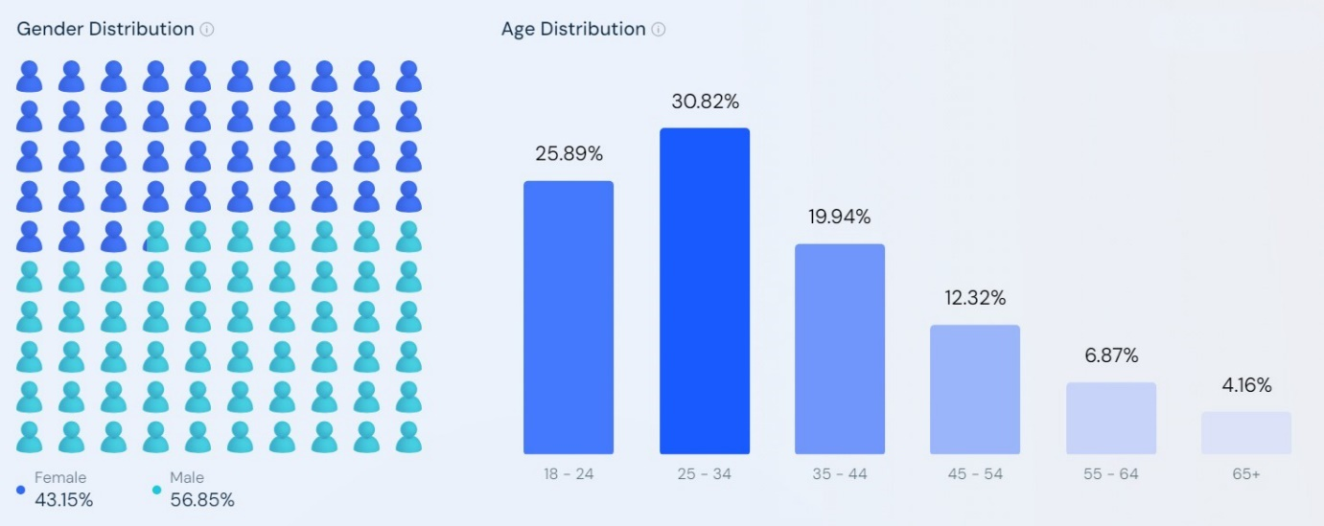
Fig 9: Nike’s Website Audience Demographics (Similarweb, 2023)

Psychographic Segmentation:
Nike's psychographic segmentation places a strong emphasis on providing its clients with a range of goods that meet their needs and appeal to their interests. The company frequently develops marketing campaigns based on the main concerns that customers in specific areas have (Thekeepitsimple, 2022).
Nike frequently joins forces with LGBT movements and campaigns like "Black Lives Matter" (Toh, 2020). Based on the connections clients have with particular thought leaders, Nike's products are additionally marketed with the help of various athletes. Lebron James and Michael Jordan are just a couple of the basketball players that Nike works with for celebrity endorsements. The business has collaborated with well-known athletes including Tiger Woods in the golfing industry (Padia, 2021).

Behavioural Segmentation:
The focus of Nike's behavioural segmentation is to provide customers benefits through comfortable footwear, apparel, and sporting goods. The one who wants to improve their health and those who are aspiring to become top athletes in the world can find products from Nike (Daniel, 2011).
Moreover, the company also encourages its customers to share their experiences with friends and family with the use of social media initiatives. Nike creates one of the best user-generated marketing effort by encouraging the customers to submit their stories and utilise the hashtag #betterforit (Stern, 2015).

Targeting:
Nike uses several strategies to reach its main target audience of athletes and other sportspeople. The targeted strategies include, among other things, the sponsorship of goods by professional sports teams, famous players, and college athletic teams (Medium, 2021). Before choosing or settling on any conceivable market segment, Nike assesses its size and growth, structural attractiveness, and the company's resources and goals. It almost always helps the company to select the correct target market (Thekeepitsimple, 2022).
Although the market for apparel and sports can be large, Nike generally targets customers who are in the 15-40 age range. In order to foster enduring brand loyalty, the organisation offers similar services to male and female athletes, and is placing an increased focus on teens to build long-term brand loyalty (Draper, 2021).

Positioning:
Placing the company's brand in the market with other competitors is termed as positioning. Nike has strategically positioned its brand as a market leader for sports equipment that provides innovative and premium-quality technology. The company has become the ultimate athletic brand by selecting the ideal target audience, championing certain values, and understanding its competition. Nike's swoosh logo, "Just Do It" slogan, and promotional initiatives to connect with the magnificent achievements of great athletes convinced its customers that it's a victorious and ambitious brand (Edrawmind, 2022).

Effective of Segmentation, Targeting and Positioning:
Overall, Nike's segmentation, targeting, and positioning strategies are effective because they demonstrate a deep understanding of their customers' diverse needs, interests, and preferences. They establish physical stores and tailor marketing efforts based on specific sports preferences in different regions. Nike targets specific demographics by categorizing their products for different age groups and genders. Moreover, they align marketing campaigns with customer concerns and interests. Nike's clear focus on athletes and sports enthusiasts as their primary target audience is evident through sponsorships and partnerships. By associating their brand with innovative and premium-quality sports equipment, using iconic symbols and leveraging the achievements of successful athletes, they position themselves as a market leader.

2.6 The Marketing Mix
A framework using the four Ps of product, pricing, placement, and promotion is referred to as a "marketing mix". With the end goal of increasing sales, the various components of a marketing mix work in conjunction with one another (Kenton, 2023). The marketing mix is a conceptual framework that identifies the key choices managers must make in order to tailor their services to the needs of customers. Both long-term strategies and short-term tactical programmes can be created using the tools (Goi, 2019).
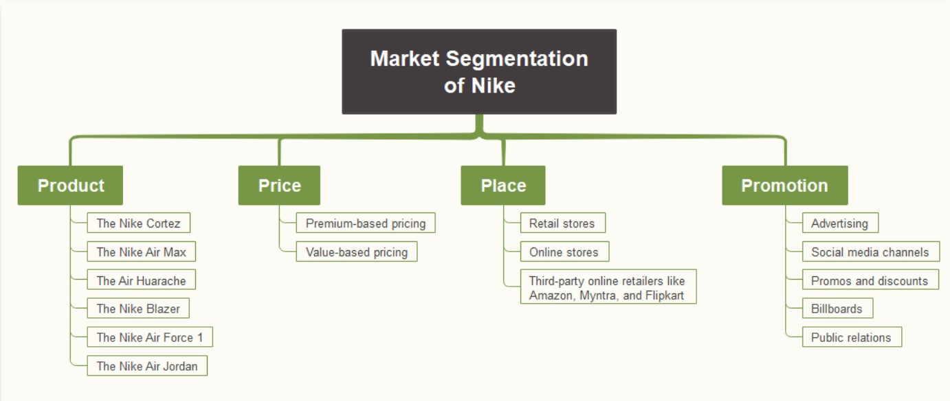
Fig 10: Nike’s Marketing Mix (4Ps) (Edrawmind, 2023)

Nike’s Products (Product Mix):
This component of the marketing mix lists the organisational outputs of the sporting goods company, sometimes referred to as the product mix, which is the collection of products offered to target consumers (Gregory, 2022).
The majority of Nike's products are gear and accessories for sports, including bags, backpacks, balls, headbands, caps, and many more. Nike provides a wide range of goods while also trying to uphold its reputation for excellence. Running, golf, football, cricket, skateboarding, tennis, cycling, and other sports are just a few of the activities for which Nike has produced a variety of shoes (Shastri, 2023).
Some of the most recognisable Nike’s footwears are:
The Nike Cortez - It is a running shoe with a retro aesthetic and a natural fit.
The Air Huarache - It is primarily popular among people under the age of 18 and is a high-tech, ultra-lightweight running shoes.
Nike Air Max - It is the crown jewel of Nike's footwear line is the. Nike’s first shoe with a visible air unit.
The Nike Blazer - It is a cool-looking, casual shoe that is also used for skating.
The Nike Air Jordan – It is the most recognisable and comfortable streetwear sneakers (Edrawmind, 2023).

Nike’s Price Market Mix:
For all of its products, Nike often uses premium and value-based pricing strategies.
Nike uses a value-based pricing strategy to determine its prices depending on how much customers think its goods are worth. Nike prioritises providing the best customer experience by offering the highest-quality products at the optimal price, as opposed to other businesses that believe that selling products for the lowest possible price will increase sales (The Strategy Watch, 2020).
Depending on the quality of the product, Nike uses the premium pricing approach to charge more for its goods than its competitors do. The founders and employees of the business are aware that these prices will reflect both the calibre of their products and the image that consumers who wear the Nike logo will convey. After developing unique products, Nike gains market recognition among consumers. Additionally, the expensive pricing of Nike's products, especially the limited-edition Air Jordans, increases their perceived value. The company adopts this pricing strategy for products with advanced technology and strong levels of brand loyalty (Melbado, 2023.).

Nike’s Place or Distribution Marketing Mix:
Since most buyers like to choose products by trying them on physically so most Nike products are available and sold in retail stores. Nike strategically places its retail shops in areas where customers can easily find its products. Nike has a total of 1,046 retail shops throughout the entire world (Statista, 2022).
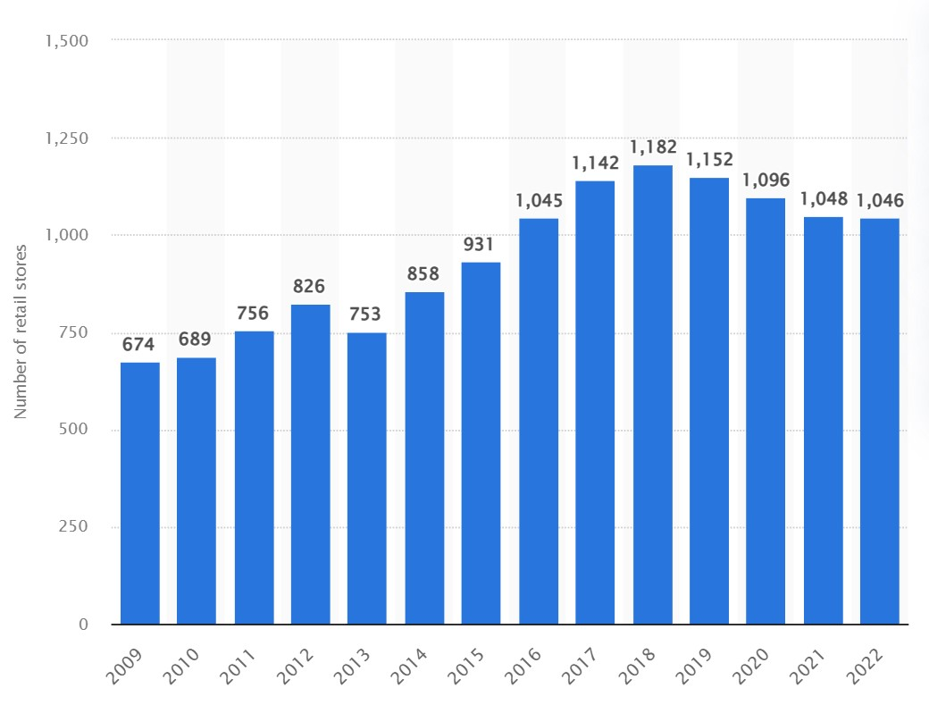
Fig 11: Total Nike Store Worldwide (Statista, 2022)
Nike has a significant presence in the logistics and distribution sectors as well. The bulk of its distribution facilities are located outside of the United States, with only a small percentage of them in the US. These distribution facilities are essential to the company's operations since they guarantee prompt product delivery to customers all around the world (Sher, 2023).
The company also sells its goods online, either through nike.com, which is its own website, or through other websites like amazon. A greater selection of options is available on Nike's website, along with ease of location and timing. Through bright graphics, in-depth filters, and smart product recommendations, it provides an effortless and enjoyable user experience (Nike, 2023).

Nike’s Promotion Marketing Mix:
Nike uses a variety of promotional strategies, including advertising, social media platforms, promotions and discounts billboards, and public relations, to inform and entice customers to buy their goods. The company has a fundamental understanding of how to engage its audience by launching campaigns that speak to their consumer's underlying desire: to improve themselves. Nike's advertising aims to inspire consumers to step up when faced with their own "Just Do It" moments. It has excelled throughout time in a range of imaginative endeavours across mediums, with Colin Kaepernick serving as the most recent illustration (Hoos, 2019).

2.7 Marketing Media and Their Success
Nike uses multiple marketing channels, such as television, online website, social media, and influencer marketing, to reach their target audience and build brand awareness. Nike's promotional campaigns often feature high-profile athletes, celebrities, and influencers, which helps to further expand the reach and impact of their marketing efforts. The company is not only selling products, but it’s also selling the emotional benefits of the products. The digital marketing strategy of Nike is supported by brilliantly successful ads. In short, it’s selling the aspiration (Erkilic, 2023).
Marketing success can be measured using Key Performance Indicators (KPIs). KPIs are specific, quantitative marketing metrics that measure progress towards a specific objective within the .marketing channels. Some of the KPI examples are customer loyalty, customer investment, customer retention, and return of investment (Gartner, 2023).

Customer Loyalty:
In order to grow repeat business and build a customer base that they can count on month after month, year after year, organisations can benefit from customer loyalty (Peek, 2022).

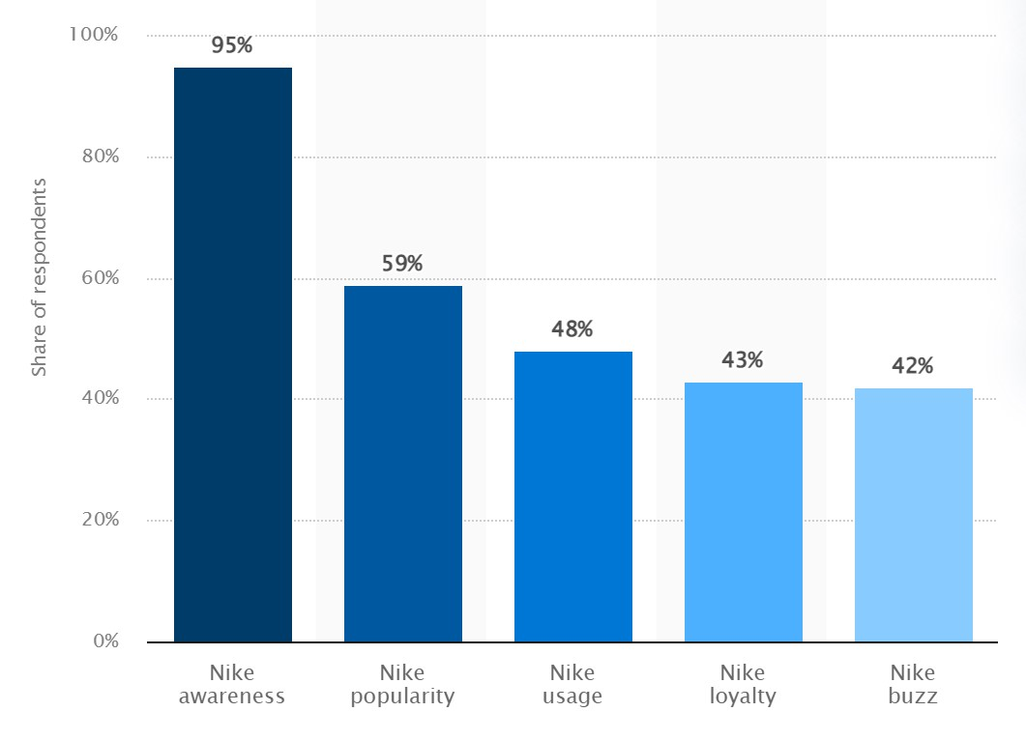
Fig 12: Nike Customer Loyalty 2022 Stats (Kunst, 2022)

As per the data available on the "statista" website, around 48% of sports and outdoor online shop users in the United States (the primary market for Nike) use Nike. That concludes the fact that out of the 95% who know the brand, 51% use it. Around 43% of sports and outdoor online shop users in the United States say they are probably going to use Nike again. This indicates that 90% of their customers are brand loyal based on the brand's 48% usage share that is shown in Fig 11 (Kunst, 2022).

3.0 Conclusion
Nike is a well-known international brand, especially in the US market. Their effective marketing, advertising, and endorsement strategies contribute to brand recognition. Nike's engagement in divisive social issues as a part of their marketing campaigns in the form of promotions and advertisements can generate both support and opposition from customers. The company's strong brand identity and consumer direct approach, along with product innovation and digital advantage, have been key to its success.
Despite competition, Nike's market domination, strong brand reputation, and customer loyalty reduce the threat from alternatives. Their sophisticated marketing and logistical techniques make it challenging for new competitors to enter successfully. Moreover, the company embraces social responsibility, using its platform to promote change, though occasionally leading to disengagement and controversy. In the past, Nike has faced criticism for poor business practices and working conditions in the supply chain however now they prioritize workplace safety. In terms of environment and sustainability, the company has goals like achieving net-zero carbon emissions by 2025.
Overall, Nike's marketing and promotional efforts have driven brand recognition and revenue growth. Their future strategies and brand image will be shaped by their commitment to social responsibility, legal compliance, and innovation.

4.0 Recommendations
The company should continue to focus on cultivating a strong brand identity that resonates with their target audience. This includes staying true to their core values of athleticism, empowerment, and innovation.
Also, Nike should strategically collaborate with groups and people who share their values and their commitment to social responsibility. The business should also broaden the scope of its advertising efforts and endorsements by collaborating with popular public figures outside of the sports sector, imitating successful partnerships like McDonald's association with Travis Scott, which led to the creation of a highly popular menu item (Mindy Weinstein, 2021).
Moreover, Nike should continue to invest in digital marketing strategies to reach a wider audience to enhance customer engagement and drive brand awareness. This includes utilizing social media platforms, creating compelling content, and leveraging influencer marketing to amplify brand messages.
Additionally, despite the varying responses it has received, the company should continue to promote social and political change through its advertisements, and campaigns. However, to minimise reputational harm, preserve customer confidence, and avoid disengagement or undue controversy, it is essential to carefully assess probable outcomes and public sentiment (Honigman, 2022).

Reference List
BRM (2023) Segmentation, Targeting & Positioning (STP). [online] Available at: https://research-methodology.net/theory/marketing/segmentation-targeting-positioning-stp/ (Accessed 17th July 2023).
Butler-Young, S (2019) Nike Hit With Racial Discrimination Lawsuit. [online] Footwear News. Available at: https://footwearnews.com/business/nike-racial-discrimination-lawsuit-employee-1202763011/ (Accessed 10th July 2023).
Copeland, L. and Boulianne, S. (2020) ‘Political consumerism: A meta-analysis’, International Political Science Review, 43(1), pp. 3-18. Available at: https://journals.sagepub.com/doi/pdf/10.1177/0192512120905048 (Accessed 2nd July 2023).
Curtis, A. and Hansson, A. (2019) ‘Examining the viability of corporate recycling initiatives and their overall environmental impact: The case of nike grind and the reuse-a-shoe program’, Case Studies in the Environment, 3(1), pp. 1-7.
Daniel, H. (2011) Nike Benefits and Innovation: Changing the Game. [online] Benefits Of. Available at: https://benefitof.net/benefits-of-nike/?utm_content=cmp-true (Accessed 16th July 2023).
Day, J. (2001) Nike fights plagiarism claims in US court. [online] The Guardian. Available at: https://www.theguardian.com/media/2001/jun/21/advertising.marketingandpr (Accessed 10th July 2023).
Dean, M. (2021) Nike Corporate Social Responsibility (CSR) and Sustainability. [online] www.thomasnet.com. Available at: https://www.thomasnet.com/articles/other/nike-csr/ (Accessed 2nd July 2023).
DFreight (2023) An Insight Into Nike’s Supply Chain Strategy. [online] DFREIGHT. Available at: https://dfreight.org/blog/an-insight-into-nikes-supply-chain-strategy/ (Accessed 10th July 2023).
Draper, D. (2021) Who is Nike’s target audience? [online] AdvertisingRow.com. Available at: https://advertisingrow.com/advertising-magazine/who-is-nikes-target-audience/ (Accessed 16th July 2023).
Edrawmind (2022) Nike Market Segmentation, Targeting, and Positioning. [online] Edrawsoft. Available at: https://www.edrawmind.com/article/nike-market-segmentation-targeting-and-positioning.html (Accessed 16th July 2023).
Edrawmind (2023) Nike Marketing Mix (4Ps) Analysis. [online] Edrawsoft. Available at: https://www.edrawmind.com/article/nike-marketing-mix-analysis.html (Accessed 11th July 2023).
Erkilic, G. (2018) 5 Brilliant Nike Campaigns Created With Effective Digital Marketing Strategies. [online] Digital Agency Network. Available at: https://digitalagencynetwork.com/nike-digital-marketing-strategy/ (Accessed 17th July 2023).
Fels, S. (2020) Nike would very much like to keep its slave labor, thank you. [online] Deadspin. Available at: https://deadspin.com/nike-would-very-much-like-to-keep-its-slave-labor-than-1845777337 (Accessed 11th July 2023).
Finbox (2023) The Complete Toolbox For Investors [online] finbox.com. Available at: https://finbox.com/NYSE:NKE/explorer/sales_marketing/ (Accessed 3rd July 2023).
Forbes (2023) Nike | NKE Stock Price, Company Overview & News. [online] Available at: https://www.forbes.com/companies/nike/?sh=5c7687ff6eb5 (Accessed 1st July 2023).
Garcia, C. (2022) Porter’s Five Forces Analysis of Nike. [online] Konsyse. Available at: https://www.konsyse.com/articles/porters-five-forces-analysis-of-nike/ (Accessed 10th July 2023).
Gartner (2023) Definition of Marketing Key Performance Indicators (KPIs) - Gartner Marketing Glossary. [online] Available at: https://www.gartner.com/en/marketing/glossary/marketing-key-performance-indicators-kpis- (Accessed 17th July 2023).
Gregory, L. (2022) Nike Inc.’s Marketing Mix (4Ps/Product, Place, Promotion, Price) - An Analysis. [online] Panmore Institute. Available at: https://panmore.com/nike-inc-marketing-mix-4ps-product-place-promotion-price-analysis (Accessed 11th July 2023).
Gitnux (2023a) Nike Marketing Strategies Exposed - Guide 2023. [online] Gitnux. Available at: https://blog.gitnux.com/strategies/nike-marketing-strategies/ (Accessed 3rd July 2023).
Gitnux (2023b) The Most Surprising Nike Vs Adidas Statistics And Trends in 2023 [online] Gitnux. Available at: https://blog.gitnux.com/nike-vs-adidas-statistics/ (Accessed 11th July 2023).
Goi, C.L. (2019) ‘A Review of Marketing Mix: 4Ps or More?’, International Journal of Marketing Studies, 1(1), pp.2-15. Available at: https://www.ccsenet.org/journal/index.php/ijms/article/view/97 (Accessed 11th July 2023).
Gupta, J. (2022) 10 Biggest Nike Competitors. [online] Feedough. Available at: https://www.feedough.com/10-biggest-nike-competitors/#:~:text=With%20annual%20revenue%20of%20%2422.12 (Accessed 10th July 2023).
Harper, J. (2020) Nike’s diversity advert causing a backlash in Japan. [online] BBC News. Available at: https://www.bbc.co.uk/news/business-55140846 (Accessed 11th July 2023).
Harvard Business School (2021) The Five Forces. [online] Harvard Business School. Available at: https://www.isc.hbs.edu/strategy/business-strategy/Pages/the-five-forces.aspx (Accessed 3rd July 2023).
Hodgson, S. (2023) How the Nike brand positioning strategy conquered all. [online] Fabrik. Available at: https://fabrikbrands.com/nike-brand-positioning-strategy/ (Accessed 16th July 2023).
Homburg, C., Wieseke, J. and Bornemann, T. (2009) ‘Implementing the Marketing Concept at the Employee-Customer Interface: The Role of Customer Need Knowledge’, Journal of Marketing, 73(4), pp. 64-81. Available at: https://journals.sagepub.com/doi/full/10.1509/jmkg.73.4.064 (Accessed 2nd July 2023).
Hong, J., Saito, Y. and Leung, A. (2022) How Nationalism in China Has Dethroned Nike, Adidas. [online] Bloomberg. Available at: https://www.bloomberg.com/graphics/2022-china-nationalistic-online-shoppers/ (Accessed 14th July 2023).
Honigman, B. (2022) Should your brand take a stance on social issues? Here’s how to decide. [online] FastCompany. Available at: https://www.fastcompany.com/90749898/brand-social-issues-stance (Accessed 17th July 2023).
Hoos, B. (2019) Four Things We Can Learn About Influencer Marketing From Nike And Apple. [online] Forbes. Available at: https://www.forbes.com/sites/forbesagencycouncil/2019/06/14/four-things-we-can-learn-about-influencer-marketing-from-nike-and-apple/?sh=457661843628 (Accessed 12th July 2023).
Hsu, T. (2018) ‘Ex-Employees Sue Nike, Alleging Gender Discrimination’, The New York Times, 10th August. Available at: https://www.nytimes.com/2018/08/10/business/nike-discrimination-class-action-lawsuit.html (Accessed 10th July 2023).
iEduNote (2020) Marketing Process: 5 Steps of Marketing Process. [online] iEduNote.com. Available at: https://www.iedunote.com/marketing-process (Accessed 13th July 2023).
Investopedia (2021) Macro Environment. [online] Investopedia. Available at: https://www.investopedia.com/terms/m/macro-environment.asp (Accessed 13th July 2023).
Investopedia (2023a) Porter’s 5 Forces Explained and How to Use the Model. [online] Investopedia. Available at: https://www.investopedia.com/terms/p/porter.asp (Accessed 3rd July 2023).
Investopedia (2023b) Target Market: Definition, Purpose, Examples, Market Segments. [online] Investopedia. Available at: https://www.investopedia.com/terms/t/target-market.asp (Accessed 2nd July 2023).
IRS (2023) United States Income Tax Treaties A to Z | Internal Revenue Service. [online] irs.gov. Available at: https://www.irs.gov/businesses/international-businesses/united-states-income-tax-treaties-a-to-z (Accessed 2nd July 2023).
Jacobsen, M. (2019) Fleet Feet Wins Advertising Case Against Nike. [online] Running Insight. Available at: https://www.runninginsight.com/fleet-feet-wins-advertising-case-against-nike (Accessed 10th July 2023).
Jiang, W. (2019) ‘Sustainable Development of Supply Chain in Footwear Industry – Take Nike as the Case’, Asian Business Research, 4(3), pp. 86-93. Available at: http://journal.julypress.com/index.php/abr/article/view/690 (Accessed 11th July 2023).
Jurek, M. (2019) Why Are Nike Shoes So Darn Popular? [online] Medium. Available at: https://medium.com/@michelejurek16/why-are-nike-shoes-so-darn-popular-fa3b5426730e (Accessed 11th July 2023).
Kasi, A. (2019). Porter’s Five Forces Analysis of Nike. [online] Porter Analysis. Available at: https://www.porteranalysis.com/porters-five-forces-analysis-of-nike/ (Accessed 4th July 2023).
Kenton, W. (2023) Marketing Mix: The 4 Ps of Marketing and How to Use Them. [online] Investopedia. Available at: https://www.investopedia.com/terms/m/marketing-mix.asp (Accessed 11th July 2023).
Killingstad, L. (2022) Nike, Nationalism, and the New Paradigm. [online] Front Office Sports. Available at: https://frontofficesports.com/nike-nationalism-and-the-new-paradigm/ (Accessed 14th July 2023).
Kotler, P., Burton, S., Deans, K.R., Brown, L. and Armstrong, G. (2015) Marketing. 9th Ed. Frenchs Forest, N.S.W.: Pearson Australia, Frenchs Forest, New South Wales.
Kunst, A. (2022). Nike brand profile U.S. 2022. [online] Statista. Available at: https://www.statista.com/forecasts/1252006/nike-sports-and-outdoor-online-shops-brand-profile-in-the-united-states (Accessed 17th July 2023).
Lewis, C. (2013) Effective Marketing for Renewable Energy Companies Dr John Thomson. [online] Available at: https://slideplayer.com/slide/6616328/ (Accessed 13th July 2023).
Mahdi, H.A.A., Abbas, M., Mazar, T.I. and George, S. (2015) ‘A Comparative Analysis of Strategies and Business Models of Nike, Inc. and Adidas Group with special reference to Competitive Advantage in the context of a Dynamic and Competitive Environment’, International Journal of Business Management and Economic Research, 6(3), pp. 167-177.
Maslow, J. (2022) A Look at Nike’s Strengths, Weaknesses, Opportunities, and Threats. [online] StreetWise Journal. Available at: https://streetwisejournal.com/nike-swot-analysis/ (Accessed 17th July 2023).
Marr, B. (2022) The Amazing Ways Nike Is Using The Metaverse, Web3 And NFTs. [online] Forbes. Available at: https://www.forbes.com/sites/bernardmarr/2022/06/01/the-amazing-ways-nike-is-using-the-metaverse-web3-and-nfts/?sh=2b0ffd4d56e9 (Accessed 2nd July 2023).
Medium (2021). Case Study: Nike’s Marketing Strategy. [online] Medium. Available at: https://leanmarketing.medium.com/case-study-nikes-marketing-strategy-a65ef035a3aa (Accessed 16th July 2023).
Melbado (2023) The Pricing Strategy of Nike and Why It Is So Effective [online] Melbado. Available at: https://melbado.com/the-pricing-strategy-of-nike-and-why-it-is-so-effective/#:~:text=Nike (Accessed 12th July 2023).
Meng, S., Wei, B., Xu, G. and Zhang, R. (2021) ‘Analysis of Enterprise Operation Under the Impact of COVID-19 Epidemic: A Case Study of Nike Inc.’, International Conference on Financial Management and Economic Transition. North China University of Technology, 18th September. Atlantis Press.
Mindy Weinstein (2021) 10 Examples of Social Media Celebrity Endorsements That Paid Off Big Time. [online] Search Engine Journal. Available at: https://www.searchenginejournal.com/social-celebrity-endorsements/415568/#close (Accessed 17th July 2023).
Nike (2018) Human Rights and Labor Compliance Standards. [online] Nike.com. Available at: https://about.nike.com/en/newsroom/resources/human-rights-and-labor-compliance-standards (Accessed 14th July 2023).
Nike (2019) Our Approach to Sourcing. [online] Nike.com. Available at: https://about.nike.com/en/newsroom/resources/supplier-relationships (Accessed 3rd July 2023).
Nike (2019) What Is Nike’s Mission? | Nike Help. [online] Nike.com. Available at: https://www.nike.com/gb/help/a/nikeinc-mission (Accessed 10th July 2023).
Nike (2022a) How to Get Rid of Old Shoes Sustainably. [online] Nike.com. Available at: https://www.nike.com/gb/a/recycle-old-shoes (Accessed 6th July 2023).
Nike (2022b) News, Events and Reports. [online] Nike.com. Available at: https://investors.nike.com/investors/news-events-and-reports/default.aspx (Accessed 2nd July 2023).).
Nike (2023) Nike. Just Do It. [online] Nike.com. Available at: https://www.nike.com/ (Accessed 12th July 2023).
Newcomb, T. (2020) Nike Announces Additional Round Of COVID-19 Response Donations, Topping $17 Million. [online] Forbes. Available at: https://www.forbes.com/sites/timnewcomb/2020/04/03/the-nike-giving-strategy-as-company-announces-additional-round-of-covid-19-response-donations-topping-17-million/?sh=18a719ea42fc (Accessed 2nd July 2023).
Nguyen, K. (2022) 33 Top Nike Competitors & Alternatives in 2022 (Best Brands Like Nike). [online] Gentleman Within. Available at: https://www.gentlemanwithin.com/top-nike-competitors-alternatives/ (Accessed 11 July 2023).
Noland, C.R. (2021) ‘Positive or negative vibes: Does mood affect consumer response to controversial advertising?’, Journal of Marketing Communications, 27(8), pp. 897-912.
OnStrategy (2022) SWOT Analysis I What is a SWOT Analysis? I OnStrategy. [online] Available at: https://onstrategyhq.com/resources/swot-analysis/ (Accessed 17th July 2023).
Padia, V. (2021) The Billion-Dollar Swoosh: Nike’s 10 Most Expensive Endorsements With Athletes. [online] TheRichest. Available at: https://www.therichest.com/rich-powerful/the-billion-dollar-swoosh-nikes-10-most-expensive-endorsements-with-athletes/ (Accessed 16th July 2023).
Pang, A. (2022) The China Challenge: The Stain of Forced Labor on Nike Shoes. [online] Discourse. Available at: https://www.discoursemagazine.com/economics/2022/01/05/the-china-challenge-the-stain-of-forced-labor-on-nike-shoes/ (Accessed 12th July 2023).
Peek, S. (2022) How to Build Customer Loyalty in 7 Steps. [online] Business News Daily. Available at: https://www.businessnewsdaily.com/16017-build-customer-loyalty.html (Accessed 17th July 2023).
Peterdy, K. (2023) PESTEL analysis. [online] Corporate Finance Institute. Available at: https://corporatefinanceinstitute.com/resources/management/pestel-analysis/ (Accessed 14th July 2023).
Pringle, J. and Huisman, J. (2011) ‘Understanding Universities in Ontario, Canada: An Industry Analysis Using Porter’s Five Forces Framework’, Canadian Journal of Higher Education, 41(3), pp. 36–58. Available at: https://eric.ed.gov/?id=EJ959453 (Accessed 3rd July 2023).
Professionalacademy (2023) Marketing Theories – The Marketing Environment. [online] Available at: https://www.professionalacademy.com/blogs/marketing-theories-the-marketing-environment/ (Accessed 14th July 2023).
Robinson, L. (2021) The Competitive Advantage of NIKE. [online] Strategic Selling. Available at: https://medium.com/strategicselling/the-competitive-advantage-of-nike-eb6d7c23b21c (Accessed 10th July 2023).
Rowland, C. (2023) Nike Inc. Five Forces Analysis (Porter’s Model). [online] Panmore Institute. Available at: https://panmore.com/nike-inc-five-forces-analysis-porters-model (Accessed 10th July 2023).
Salpini, C. (2021) How Nike is using DTC and data to expand its empire. [online] Retail Dive. Available at: https://www.retaildive.com/news/how-nike-is-using-dtc-and-data-to-expand-its-empire/596602/ (Accessed 11th July 2023).
Shastri, A. (2023) Researched Marketing Mix of Nike (4Ps ) | IIDE. [online] IIDE. Available at: https://iide.co/case-studies/marketing-mix-of-nike/ (Accessed 11th July 2023).
Sher, D. (2023) Unleashing the Power of Data: A Statistical Analysis of Nike’s Rise to the Top of the Sporting Industry. [online] Investing.com. Available at: https://www.investing.com/academy/statistics/nike-facts/ (Accessed 12th July 2023).
Shoeeffect (2023) How Many Stores Does Nike Have? [online] Shoe Effect. Available at: https://shoeeffect.com/how-many-stores-does-nike-have/ (Accessed 16th July 2023).
Similarweb (2023) nike.com Traffic Analytics & Market Share. [online] Similarweb. Available at: https://www.similarweb.com/website/nike.com/#demographics (Accessed 16th July 2023).
SlideKit (2023) STP Marketing Model Template. [online] Available at: https://www.slidekit.com/template/stp-marketing-model-template/ (Accessed 17th July 2023).
SportsRec (2019) Nike Product Information. [online] SportsRec. Available at: https://www.sportsrec.com/nike-product-information-5417106.html (Accessed 1st July 2023).
Statista (2022) Nike: Number of Stores Worldwide. [online] Statista. Available at: https://www.statista.com/statistics/250287/total-number-of-nike-retail-stores-worldwide/ (Accessed 12th July 2023).
Statista (2023) Nike’s global revenue, by region 2017 to 2019. [online] Statista. Available at: https://www.statista.com/statistics/241692/nikes-sales-by-region-since-2007/ (Accessed 16th July 2023).
Steele, B. (2023) Nike is opening a ‘technology center’ in Atlanta next year. [online] Engadget. Available at: https://www.engadget.com/nike-technology-center-atlanta-130039247.html (Accessed 15th July 2023).
Stern, C. (2015) New Nike ad reveals what some women really think while exercising. [online] Mail Online. Available at: https://www.dailymail.co.uk/femail/article-3041915/Witty-new-video-vocalizes-inner-struggle-faced-women-force-workout.html (Accessed 16th July 2023).
Stern, M. (2022) Nike steps up its game with a new tech innovation. [online] Retailwire. Available at: https://retailwire.com/discussion/nike-steps-up-its-game-with-a-new-tech-innovation-center/ (Accessed 5th July 2023).
Stolle, D and Micheletti, M. (2013) Political Consumerism: Global Responsibility in Action. New York: Cambridge University Press.
Thekeepitsimple (2022). Nike Brand Positioning. [online] Available at: https://www.thekeepitsimple.com/nike-brand-positioning/ (Accessed 16th July 2023).
The Strategy Watch. (2020) Pricing Strategies of Nike. [online] Available at: https://www.thestrategywatch.com/pricing-strategies-of-nike/ (Accessed 11th July 2023).
Tighe, D. (2022) Nike ad spend worldwide 2014-2019 | Statista. [online] Statista. Available at: https://www.statista.com/statistics/685734/nike-ad-spend/ (Accessed 2nd July 2023).
Tiseo, I. (2023) Nike’s sustainable material share by business segment 2017. [online] Statista. Available at: https://www.statista.com/statistics/861718/share-of-sustainable-materials-in-nike-s-footwear-and-apparel-segments/ (Accessed 6th July 2023).
Toh, M. (2020) ‘Black lives matter’: Facebook, Netflix, Peloton and other companies take a stand as protests sweep America | CNN Business. [online] CNN. Available at: https://www.cnn.com/2020/06/01/business/us-protests-companies-respond-intl-hnk/index.html (Accessed 16th July 2023).
Toppr (2018) PESTEL Analysis [online] Available at: https://www.toppr.com/guides/commercial-knowledge/business-environment/pestle-analysis/ (Accessed 14th July 2023).
Twin, A. (2023). Marketing in Business: Strategies and Types Explained. [online] Investopedia. Available at: https://www.investopedia.com/terms/m/marketing.asp (Accessed 2nd July 2023).
Waymer, D. and Logan, N. (2021) ‘Corporate social advocacy as engagement: Nike’s social justice communication’, Public Relations Review, 47(1), pp. 1-9. Available at: https://www.sciencedirect.com/science/article/pii/S0363811120301326 (Accessed 2nd July 2023).
WallStreetMojo (2023) Macro Environment. [online] WallStreetMojo. Available at: https://www.wallstreetmojo.com/macro-environment/ (Accessed 13th July 2023).
WallStreetMojo (2022) Porter’s Five Forces. [online] WallStreetMojo. Available at: https://www.wallstreetmojo.com/porters-five-forces/ (Accessed 3rd July 2023).
Wong, P. (2022) Nike’s D2C E-Commerce Strategy for Hitting 50% Digital Penetration. [online] Headless E-Commerce Platform | fabric. Available at: https://fabric.inc/blog/nike-ecommerce-strategy/ (Accessed 14th July 2023).
Wowslides (2019) Porter’s five forces template. [online] Free PowerPoint Templates. Available at: https://yourfreetemplates.com/porters-five-forces-template/ (Accessed 3rd July 2023).
Zhu, X. (2022) ‘A Comparative Study of Nike’s Marketing Strategies in China and the US’, International Conference on Urban Planning and Regional Economy. Fordham University, 16th May. Atlantis Press.

Appendices

Appendix A
Nike’s PESTEL Factors in Detail
Political Factors:
Nike has a large consumer base in the United States, making it a core market for the company and offers excellent growth policies that are especially beneficial to this business. These consist of favourable international tax arrangements and low interest rates (IRS, 2023). There are four reportable operating regions for the Nike Brand: North America; Europe, Middle East, and Africa (EMEA); Asia Pacific & Latin America (APLA); and Greater China (Nike, 2022b).
The company is known for practising political consumerism through its campaigns and advertisements. Political consumerism is defined as the use of the market as an arena for politics in order to reform institutional or market practises that are deemed to be unethical, environmentally harmful, or politically disagreeable, or to reward businesses for good practises. To penalise businesses for unfavourable policies or commercial practises, consumers can engage in a boycott or refrain from buying certain items or brands. As an alternative, consumers can purposefully buy or buycott goods or services to commend businesses or brands for ethical business practises (Stolle and Micheletti, 2013).
In one of the most popular and controversial Nike campaigns, where the company chose the contentious former quarterback of the American football team, Colin Kaepernick, to be the face of its 'Just Do It' campaign, many people decided to boycott Nike because of Kaepernick’s past. Conversely, people who supported Nike's decision deliberately bought Nike goods (Copeland and Boulianne, 2020).

Economic Factors:

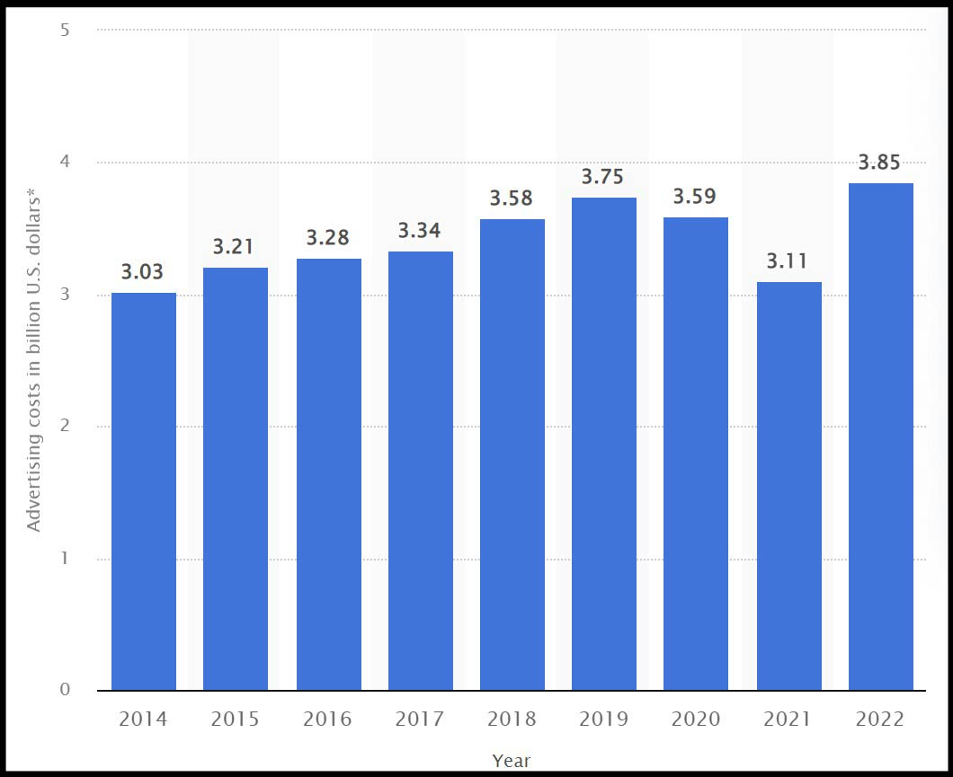
Fig 13: Nike's advertising and promotion costs (Tighe, 2022)
Nike invests significant sums into its promotional campaigns each year as one of the world's largest and most recognizable sports brands. A total of about 3.85 billion dollars was spent by Nike on advertising and promotion only in the 2022 financial year. In the same year, the company generated global revenue of more than 46 billion dollars. The success of the company can be attributed to its brand’s marketing campaigns as well as sponsorship deals with professional sports teams and celebrity athletes. A testament to Nike's marketing success and global recognition is its slogan, "Just Do It.". As a result of Nike’s campaign in marketing, almost everyone is aware of the brand’s existence. About 95% of American online consumers who purchased sporting and outdoor items in 2022 claimed to be familiar with Nike (Tighe, 2022).

Social Factors:
The company adopted a strong position on touchy social topics and created marketing campaigns around them. It also used its forward-thinking position to direct corporate activities through endorsements and sponsorships. This series of acts provided the groundwork for a variety of stakeholder and public engagements, including those who wished to distance themselves from the corporation due to its divisive positions. Counter-opinions are a crucial component of a functioning democracy and marketplace of ideas, despite the fact that some people may see disengagement or backlash negatively. Nike's fights against male patriarchy and racial injustice in society are fuelled by the right, aptitude, and capacity to protest (Waymer and Logan, 2021).
Finding the correct market for a given product is a significant component of Nike's marketing strategy. One way to do this is by using strategies like product endorsements by famous athletes, and professional sports teams . People are far more likely to purchase Nike goods when they see their favourite players, celebrities, and teams wearing the brand (Zhu, 2022).
Nike's sustainability and corporate social responsibility programmes are in line with the core belief of the company that "sports can change the world for the better." Nike takes advantage of the unifying power of sports to promote its CSR goals in three important areas: environmental sustainability, community investment, and diversity and inclusion. A healthy and accepting workplace environment for all employees is at the heart of companies CSR and corporate governance programmes (Dean, 2021). This also helps in improving the brand image of the company.
Nike's COVID-19 response was extensive, paying for food and clothing for international communities as well as providing additional support for its staff. More than $17 million has been given by Nike to COVID-19 response operations. Additionally, the business has given $1.6 million to local organizations to help them fulfil urgent needs like food aid and medical treatment (Newcomb, 2020).

Technological Factors:
In terms of technological innovation and digital transformation, Nike has always been at the forefront of the industry. The company has been using e-commerce, artificial intelligence, and in-store experiential technology for several years. It has recently moved to capitalize on the excitement across new concepts like the NFTs, metaverse, and web3 (Marr, 2022).
Nike's environmental programmes place a big emphasis on technology. In order to enhance environmental performance and establish circular economy practises, the company researches cutting-edge techniques including 3D printing and sustainable materials (Wong, 2022).
In Atlanta, Georgia, the athletic shoe company will inaugurate its technological hub in early 2023. The space will be devoted to enhancing the brand's logistics and supply chain and using artificial intelligence (AI) and machine learning to reinvent the customer experience. With a new "command centre" for the East Coast, it will also put a strong emphasis on cybersecurity (Steele, 2023).
In terms of campaigns and promotions, Nike’s purpose-built metaverse environment, Nikeland, leverages the Roblox platform to provide access to its fans to socialize, meet, participate in promotions, and engage with a variety of brand experiences (Stern, 2022).

Environmental Factors:
The consumption of sustainable materials used in Nike’s apparel stepped up from 41 percent to 59 percent in the year 2020. There was a significant increase in the use of sustainable material in clothing over just five years period as in 2015 it was just 19 percent. Comparatively, footwear saw a decrease in the percentage of sustainable materials utilised from 30 percent in 2019 to 29 percent in 2020 (Tiseo, 2023).
In the 1990s, Nike introduced the "Reuse-A-Shoe" initiative and Nike Grind to lessen the company's environmental impact on business. The “Reuse-A-Shoe” initiative was originally presented in 1993 and attempts to recycle used shoes that would otherwise contribute to landfills. Nike Grind was initially developed in 1992 to make surface materials from surplus manufacturing material (Curtis and Hansson, 2019).
Incorporating recycled materials into products like furniture, skateboards, and even running tracks, Nike has been using Nike Grind materials in product design, retail locations, and office environments worldwide for close to three decades. In fact, Nike Grind has recycled close to 59 million kilogrammes of shoe material since 1992. Nike Grind is a component of the company's larger Move to Zero sustainability initiative, which aims to help safeguard the future of sport by moving the company towards a zero-carbon and zero-waste future. The objective is to evolve towards a circular economy where nothing is wasted and everything is utilised (Nike, 2022a).

Legal Factors:
As an international company, Nike is subject to a number of legal requirements that have an impact on its business operations.
Nike must abide by a number of rules and regulations that prohibit false advertising, comparative advertising, endorsements, and assertions about the effectiveness or good qualities of its products. Legal repercussions or reputational harm to the brand could occur from breaking these rules.
In the past in 2001, a multimillion-dollar lawsuit has been filed against Nike and its advertising firm, Weiden & Kennedy for allegedly stealing the basketball dance routine from one of the company's commercials. Nike was accused of stealing Game Over's Shakin', a patented basketball dance style, move by move to use in its advertisement. Game Over is a small sportswear firm in New York (Day, 2001).
In 2019, Nike was sued for allegedly using unlicensed fonts. The company faced a lawsuit from Production Systems SAS, which conducts business under the trade name Production Type, for allegedly using the French company’s copyrighted "Kreuz" font software without permission in its advertising and marketing campaigns, causing the design business to lose significant revenue (Jacobsen, 2019).

Nike conducts business in a number of nations, each of which has its own set of labour laws and regulations. Compliance with local labour laws, including minimum pay, paid time off, and worker security, is essential for avoiding legal repercussions and maintaining the brand's good reputation (Nike, 2018). In the past, Nike has faced lawsuits over gender discrimination and alleged racial discrimination.
Two former employees, Kelly Cahill and Sara Johnston, filled a lawsuit against the sportswear giant in August 2018, less than four months after The New York Times published an exposé describing a "toxic" boys' club culture at Nike. They claimed that the company "intentionally and wilfully" discriminated against women in regard to pay and promotions, and that its majority-male executives promoted a hostile work environment at its Portland, Oregon, headquarters (Hsu, 2018).
Another case came in light in September 2018 when three Nike shareholders filed a second broad lawsuit against the company's board, founder Phil Knight, CEO Mark Parker, and former president of the Nike brand Trevor Edwards. They claimed that these individuals "facilitated and knowingly ignored the hostile work environment that has already harmed, and threatens to further tarnish and impair, the company's financial position” (Butler-Young, 2019).

Appendix A.1
Nike’s Porter’s Five Forces Explanation in Detail
Competitive Rivalry:
This force refers to the quantity of rivals and their capacity to undercut a company (Investopedia, 2023a). In Nike's example, this is a strong force that demonstrates how competition affects the industry environment and the performance of athletic shoes and equipment businesses. Competitors like Adidas, Puma, Under Armour, ASICS, New Balance, and Lululemon all employ aggressive marketing strategies (Rowland, 2023).
With annual revenue of $22.12 billion and more than 2500 locations globally, Adidas is Nike's greatest rival. The foam used in Nike's ZoomX technology boosts a runner's velocity, but its mass production has led to quality deterioration. Adidas, in comparison, places a higher priority on quality, using heaver materials and developing a special cushioning technology for improved comfort and energy in every stride. Puma, with $5.82 billion in annual revenue, is the second most potent Nike competitor, offering affordable luxury across 120 countries through 830+ stores (Gupta, 2022).

Threat of New Entrants:
New entrants to an industry bring new capacity and an ambition to increase market share that puts pressure on prices, costs, and the rate of investment necessary to compete. The threat posed by new entrants is minimal if entry barriers are kept high (Pringle and Huisman, 2011).
The threat of new entrants for Nike is a moderate force as penetrating the sportswear market through the production of sportswear products has become easier. Startups can outsource to different manufacturing companies that are present in several manufacturing hubs around the world. However, it is different to make a mark in the market (Garcia, 2022). Additionally, NIKE also has a competitive advantage in the market due to the brand loyalty shown by consumers, high demand for products, a wide range of product types, social media content and strong marketing campaigns. The company dominates in social media followers, accounting for much larger digital reach and engagement than competitors. Moreover, NIKE's marketing approach is driven by their investments in athletes and celebrities (Robinson, 2021).

Bargaining Power of Suppliers:
Nike is a global company with an extensive supply chain that includes suppliers from all over the world. The two key principles behind Nike’s supply chain are outsourcing and diversification. Nike contracts 100 percent of its manufacturing for footwear and apparel out to independent suppliers. Outsourcing is by its very nature a risky approach, but by extensively diversifying its supplier base, Nike has successfully mitigated this risk (DFreight, 2023).
Nike incentivizes its suppliers based on how well they perform in the areas of quality, cost, delivery, and sustainability. In addition to this, the company is also putting efforts to improve working conditions at its supplier factories (Nike, 2019). These positive aspects of Nike attract the suppliers to attach themselves to the company. Also, Nike put itself in a dominating position while dealing with the suppliers by the use of its brand name. Thus, making the bargaining power of suppliers low for Nike (Kasi, 2019).

Bargaining Power of Buyers:
The bargaining power of buyers is a moderate force for Nike. Due to the abundance of options, switching costs for consumers are quite minimal unless they have a very high brand loyalty. Online shopping is another way for buyers to find things. In the market, this indicates that buyers have significant bargaining power. (Jiang, 2019).
An incident involving controversial advertisements occurred in Japan in the year 2020, when Nike came under fire for an advertisement that tends to draw attention to racial inequality there. Some even made threats to stop buying and boycott Nike products in Japan. The advertisement showed the "real-life experience" of three soccer players of mixed heritage (Harper, 2020).
However, Nike frequently sells the emotional advantages of their products in their marketing campaigns, giving the impression that wearing their shoes will make consumers live healthier lives and realise their own greatness. This encourages people to buy Nike products (Jurek, 2019).

Threat of Substitutes:
This is a moderate force for Nike. Although Nike's dominance in the shoe and sportswear markets is undeniable, customers have access to a wide range of top-notch Nike substitutes. Since Nike has branched out into several market categories outside of athletic shoes, a variety of sports apparel and equipment firms have developed rivalries with Nike within their specific niches. A handful of the bigger businesses, like Puma and Lululemon, have emerged as Nike's main rivals (Nguyen, 2022).
Despite the fact that there are more substitutes now, Nike's extensive data ecosystem enables targeted marketing and assortment customisation. Nike seeks to increase profitability and preserve control over brand presentation by giving direct-to-consumer (DTC) priority. Over the past ten years, Nike has gradually increased its emphasis on direct-to-consumer (DTC) sales, with 35% of Nike's brand revenues coming from DTC in fiscal year 2020 (Salpini, 2021). Nike had overall revenues of $37.4 billion at the end of its fiscal 2020, whereas its main rival, adidas, had revenues of $23.5 billion. This demonstrates that consumers still like Nike despite the alternatives that are available (Gitnux, 2023b).

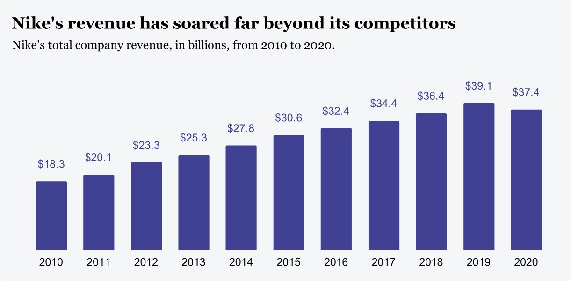
Fig 14: Nike Revenue (Salpini, 2021)

Appendix A.2
NIKE SWOT Analysis
Strength
Innovative Marketing Strategy:
Nike's excellent marketing strategies, which enable the business to sell a significant portion of its highly innovative products, have been the key to its success. The key aspect of Nike’s marketing strategy is to find the right market for a particular product by using targeting techniques like the endorsement of products by numerous different kinds of professional sports teams, collegiate sports teams, and famous athletes. When people watch their favourite athletes, personalities, and teams wear Nike gear, they become much more motivated to buy those products (Zhu, 2022).
Strong Brand Image:
In an effort to establish awareness on a global scale, Nike has moved its attention over a number of years to football. It has investigated emerging markets globally and has shops in various countries all over the world. The company's subsidiaries, licensees, and distributors all operate independently. Additionally, it provides online shopping for its products. Nike is a world leader in athletic footwear and gear because to its methods that emphasise design innovation and marketing. Because of this, Nike has a very solid brand reputation (Mahdi et al., 2015).
Low Manufacturing Cost:
Nike has a very low manufacturing cost. Since 1970, it has outsourced the production and manufacturing of its shoes, with the majority of those contracts going to Asian nations. As a result, Nike Inc. does not have a factory of its own. It enables the business to hire a large number of labourers at lower rates, allowing it to negotiate better prices with suppliers and achieve significant financial savings (Meng et al., 2021).

Weakness
Negative Publicity Due to Controversial Advertisement:
Nike has been successful in developing memorable and compelling campaigns, but they have also encountered criticism in the past due to some controversial advertisements. The Nike brand itself is not controversial, but the way some of the advertisements were executed is. In 2018, when Nike showed an advertisement with Kaepernick as the centre of attention, it raised some eyebrows among certain customers. Some customers felt Nike was taking a social and political position by using Kaepernick, and they objected to the company's choice (Noland, 2021).
Disputed Labour Practices and Impact on Brand Reputation:
For decades, Nike and other large US corporations have manufactured goods using slave labour or labour from sweatshops (Fels, 2020). In 2020, the Australian Strategic Policy Institute released a report that exposed the Chinese government's forced labour of hundreds of young Uyghur women at the Taekwang plant in Laixi City to produce Nike shoes (Pang, 2022). This damages the brand's reputation, so it must change how it checks suppliers and reconsider its approach to corporate social responsibility.

Opportunities
Market Expansion:
Nike can expand its market presence in developing countries and penetrate new markets to increase its customer base and brand awareness
E-commerce Platform Enhancement:
For greater and positive customer engagement, Nike should focus on expanding it e-commerce operations and leveraging its social media platform (Maslow, 2022).

Threat
Increased Competition:
According to a Bloomberg report on Chinese consumers, since 2018, there has been a trend away from American companies like Nike and towards a nationalistic emphasis on domestically produced consumer products (Hong, Saito and Leung, 2022).
In 2021, Nike and other international brands publicly condemned the use of cotton sourced from China's western Xinjiang province owing to human rights abuses. The result was a backlash from the Chinese population. Local businesses like Anta, Li-Ning, and Xtep soon occupied the top three positions in terms of sales following the brand protests in Xinjiang (Killingstad, 2022).

Critical Analysis as per SWOT framework:
Nike's strengths include a successful marketing strategy, a strong brand image, and low manufacturing costs. However, the company has weaknesses related to controversial advertisements and labour practices, impacting its reputation negatively. To seize opportunities, Nike can expand in new markets and enhance its e-commerce platform. Yet, it must tackle threats from increased competition and potential backlash from political issues affecting consumer preferences. To maintain its position as a leading athletic brand, Nike needs to adapt, improve strategies, and address ethical concerns in response to evolving market demands.

