Leadership, Governance and Systems Thinking in Health and Social Care: A Case Study Analysis of the HSSIB Investigation into Anticoagulation Management Before and After a Procedure

Module Code: LCHS7002
STUDENT NAME: Kashish Sunilbhai Ardeshna
STUDENT NO.: 2539014
Lecturer Name: Dr Pascal Navelle
Table of Contents
1. Introduction 3
1.1 Background and Purpose of the Case Study 3
1.2 Defining Leadership in Health and Social Care 3
1.3 Centralisation, Decentralisation and Leadership Theories 3
1.4 Importance of Selecting the Right Leadership Style 4
1.5 Structure of the Report 4
2. Main Body and Analysis 5
2.1 Identifying the Problem and Setting the System Context — Applying Systems Thinking and the Rich Picture 5
2.2 Centralisation or Decentralisation within the Case Study 9
2.3 Leadership Theories and Application to the Case Study 13
2.4 Improvement and Lessons Learned 18
3. Recommendations 21
3.1 What Should Be Done Next in the Trust 21
3.2 Most Effective Leadership Style(s) for Sustaining Improvement 21
3.3 Strengthening Governance, Communication and Systems Integration 22
3.4 Enhancing Technical and Allocative Efficiency 23
3.5 Continuous Learning, Stakeholder Engagement and Co-Production 23
3.6 Ensuring Practicality and Evidence Base 23
4. Conclusion 24
4.1 Summary of Main Findings 24
4.2 Importance of Leadership, Governance and Systems Thinking 24
4.3 Final Reflection 24
Reference List 25

1. Introduction

1.1 Background and Purpose of the Case Study
An investigation by the Health Services Safety Investigations Body in March 2025 related to a patient safety event involving an 87-year-old male who presented to an NHS acute hospital with shortness of breath and nosebleeds. Apixaban, an anticoagulant drug, was regularly prescribed to reduce his risk of stroke because of his atrial fibrillation. On admission, his apixaban was discontinued and was not resumed until approximately 10 days later, when he underwent a delayed pleural procedure. The drug was not restarted after the procedure. The patient then experienced an ischemic stroke which resulted in his death two days later. This report critically analyses the leadership, governance and systemic failures that contributed to this outcome (HSSIB, 2025).

1.2 Defining Leadership in Health and Social Care
Health and social care leadership involves influencing and motivating others to achieve common goals in an organisation, particularly in relation to patient safety and high-quality care. It encompasses clinical leadership at the bedside, managerial leadership within operational structures, and system leadership linking organisations across broader healthcare networks.

1.3 Centralisation, Decentralisation and Leadership Theories
Centralisation puts the decision-making authority at the highest point of an organisational hierarchy, whereas decentralisation distributes authority across more than one level, giving greater autonomy to local teams (Tavares, Vale and Costa, 2024). Several leadership theories apply to this analysis, including transformational leadership, which drives change through vision; transactional leadership, which is based on systematised work and rule compliance; situational leadership, which varies leadership style based on the situation; and shared leadership, in which authority is distributed across the team.

1.4 Importance of Selecting the Right Leadership Style
Choosing a suitable leadership style is particularly important during times of crisis, change, or increased risk to patients. Inadequate leadership decisions may lead to communication failure, lapses in accountability and avoidable patient harm, as seen in many NHS inquiries (Gupta, 2024). The Francis Report highlighted how hierarchical, top-down leadership cultures silenced frontline concerns, while the Ockendon Review reinforced that effective leadership must be responsive, inclusive and capable of adapting to evolving clinical demands to safeguard patient outcomes (The King’s Fund, 2024).

1.5 Structure of the Report
In this report, the problem will be examined using systems thinking and a Rich Picture; major issues related to centralisation and decentralisation in the case, leadership theories, lessons learned, and evidence-based recommendations will be provided.

2. Main Body and Analysis

2.1 Identifying the Problem and Setting the System Context — Applying Systems Thinking and the Rich Picture

2.1.1 The Central Problem in the Case Study
The HSSIB probe will focus on an 87-year-old man presenting to an NHS acute hospital with shortness of breath and nosebleeds. Apixaban was routinely prescribed to reduce his risk of stroke because he had atrial fibrillation. On Day 1, apixaban was stopped due to active nosebleeds. On Day 4, the reason changed: the drug was withheld until a pleural aspiration was done. There was no specialist review, no respiratory bed, and a delay in accessing a CT scan; consequently, the patient did not undergo the procedure until Day 10. On Day 11, a resident doctor intended to restart apixaban but did not implement the prescription. On Day 12, the patient experienced an ischaemic stroke and died on Day 14 (HSSIB, 2025). The underlying causes were systemic: no ePMA in place to re-examine a pause in medication and no system to restart anticoagulation (after the procedure), disjointed communication among the clinical teams in the ward, and no system to receive feedback to be sure that planned tasks were achieved.

2.1.2 Global Context — What WHO Data Reveal
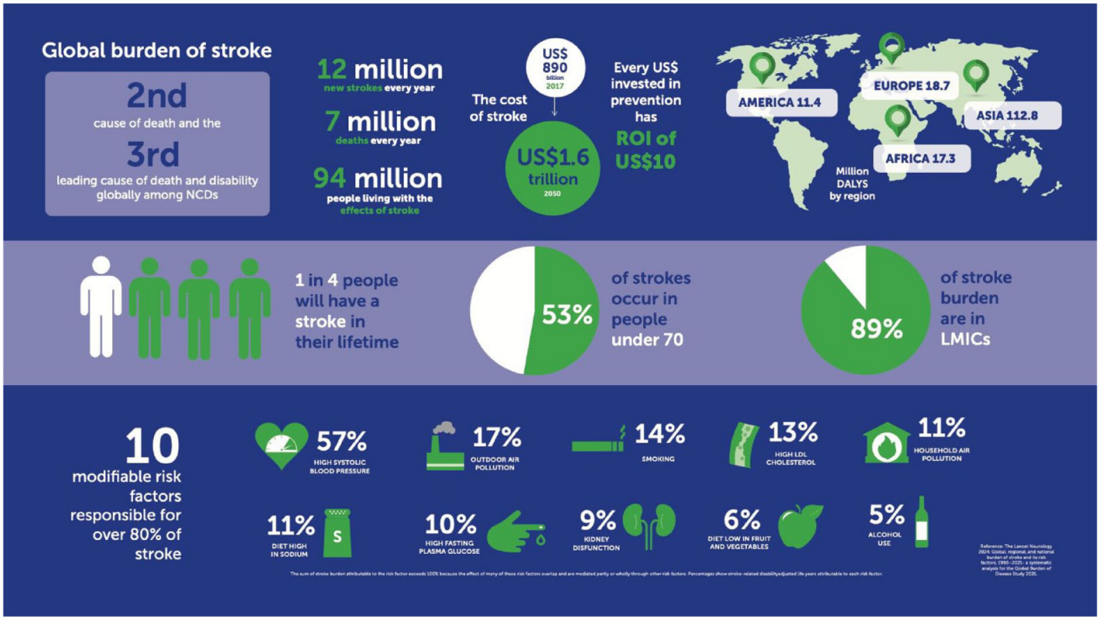
Figure 1: Global Burden of Stroke
(Source: Feigin et al., 2025)
The WHO estimates that unsafe medication practices cost the world about $42 billion every year. In the medical care of all countries around the world, about half of all preventable harm is related to the use of medicines. In 2017, the Medication Without Harm challenge, an initiative by the WHO, was aimed at reducing severe avoidable drug-related harm by 50%. The main challenge is at the heart of anticoagulants because their therapeutic window is too thin since too little may increase the risk of a stroke, whereas too much may lead to death (WHO, 2026). Stroke is one of the major causes of death and long-term disability globally, and the safe management of anticoagulation during hospitalisation is critical worldwide.

2.1.3 National Context — What NHS Data Reveal
A study reported in BMJ Quality & Safety found that 237 million errors occur every year in England alone and that 1,708 deaths occur annually due to preventable adverse drug events (BMJ, 2026). There were 809,103 incidents involving patient safety in NHS England alone in July and September 2025. In NHS incident data, anticoagulants are always at the top of the list of the riskiest forms of medication. The UK has approximately 1.4 million people with atrial fibrillation. In the UK, approximately 100,000 people experience a stroke each year, 1.3 million survivors experience a stroke, and over 50 per cent of stroke survivors live with a disability. The number of stroke cases is estimated to increase over the period 2015 to 2025 by 117,600 to about 148,700 cases (Brain Research UK, 2026).

2.1.4 Sector-Specific Evidence — IHI, BTS and BSH Data
The Institute of Healthcare Improvement cites medication reconciliation failures at the point of care transitions as one of the leading scenarios of avoidable harm in hospitals. In the BTS 2021 National Pleural Audit, 62% of the hospital sites surveyed reported patient safety events in relation to pleural procedures, 33% of which experienced severe harm, and 20% experienced catastrophic harm or death. Only 6% of hospitals and 70% of those with no pleural specialist nurses had the recommended staffing levels (Stanton et al., 2025). BSH 2024 proposes to stop apixaban 2 days before a planned procedure, but this patient had no anticoagulation over 10 days, which is 5 times as long as advised.

2.1.5 Systemic Weaknesses Reflected in the Case
Three interrelated systemic vulnerabilities are evident. First, there were disjointed communications between the acute medical unit, AGM ward and respiratory team- once the referral was received and electronically closed, there was no system to ensure that specialist input continued (Horner et al., 2023). Second, there was a loss of accountability because the AGM team remained clinically responsible but did not have the specialist knowledge of local pleural guidance from the respiratory team. Third, there was reportedly a severe lack of leadership in the AGM ward where no middle grade physician was on duty, despite the Royal College of Physicians recommending a middle grade physician on a ward of this nature and complexity (McKee, Vaughan and Russo, 2025).

2.1.6 Level of Governance Influencing the Problem
Failures of governance were multi-level. In the local area, the Trust’s interim apixaban guideline was over seven years old and was not accessible on the intranet, and the ePMA system had no alerts to indicate that time-sensitive medication had been stopped (Cleveland Clinic, 2024). Locally, the commissioning of the Integrated Care System reduced respiratory bed capacity, which could not satisfy local demand exacerbated by high local smoking and deprivation rates. Nationally, the changing BSH and NICE guidance on anticoagulation made it difficult on the frontline, and guideline review cycles were so time-consuming that they struggled to keep pace with the new evidence (Shoemaker-Hunt and Wyant, 2020).

2.1.7 Underlying Challenges — Data on Staffing, Safety and Budgets
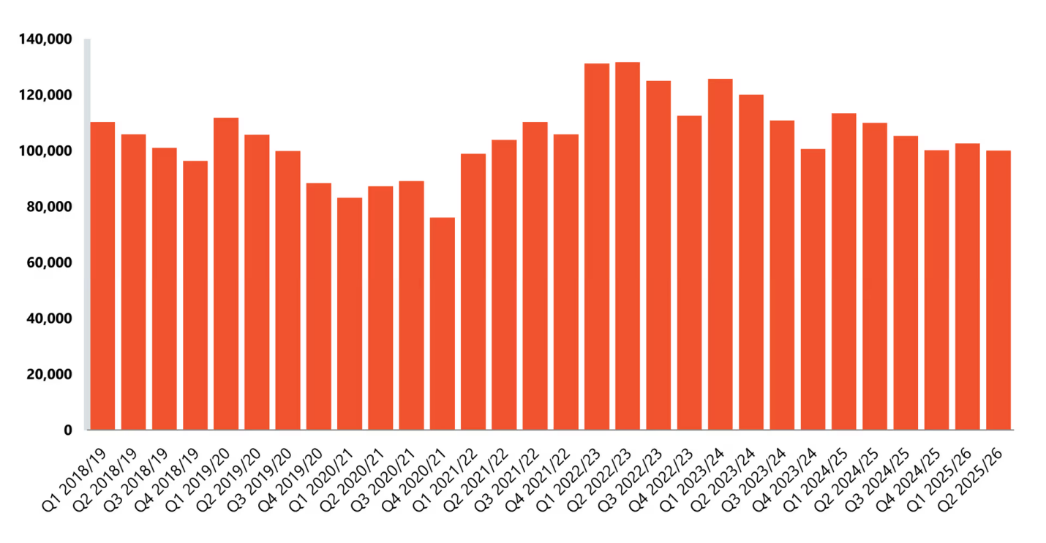
Figure 2: Vacancies in NHS
(Source: NHS Confederation, 2026)
Workforce shortages contributed to these failures. In the second quarter of 2025/26, NHS England registered 100,020 vacancies (nursing vacancies 25,500) and had a vacancy rate of 6%. The AGM ward had one consultant and three resident doctors who covered 28 beds and occasionally had other patients. A coordinating nurse was present on only six-day shifts during his stay. The specialist pleural nurse position had been eliminated because of the financial squeeze, eliminating a major coordinating job (NHS Confederation, 2026). Demand was in critical conflict with respiratory bed capacity – The data provided by HSSIB indicated that only one bed (male) was in demand in one afternoon during the entire admission.

2.1.8 Rich Picture of the Case Study
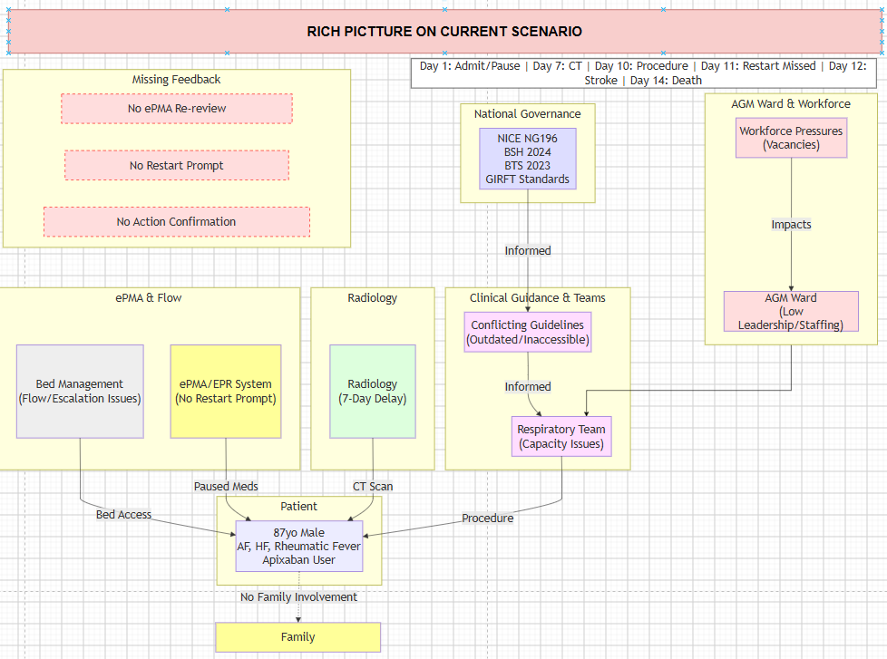
Figure 3: Rich Picture Highlighting the Issue
(Source: Self-Created using Draw.io)

2.2 Centralisation or Decentralisation within the Case Study

2.2.1 Characterising the Trust's System Structure
The Trust in the case of HSSIB was mainly a centralised organisation as all core clinical governance, information systems and patient flow decisions were centralised at senior level. One supplier provided both the EPR and ePMA systems for most adult patients, clinical advice was distributed centrally via the Trust intranet, and bed management was managed by a site matron group that coordinated the flow around the hospital. But there were areas of decentralised specialty decision-making – AGM and respiratory consultants made independent decisions about anticoagulation, and prioritisation occurred at ward level and involved individual discretion. The outcome was driven by the tensions between standardisation and responsiveness resulting from this hybrid model.

2.2.2 Centralised Elements — Analysis
How Decision-Making is Concentrated
There were three areas of centralisation of decision-making in the Trust. Ward rounding, which was led by a consultant, put clinical authority at the apex of the medical hierarchy, and the junior doctors and nurses were supposed to conform to the plan of the day as per the consultant in charge. The Trust-wide pleural procedure guideline standardised the method of pausing apixaban and other anticoagulants before pleural aspirations (Holzhüter et al., 2021). Co-ordination and monitoring within the site were led by the site matron with routes of escalation running vertically. The most prominent instance of centralisation was the guideline on the pleural procedure itself that determined the period of apixaban pauses in the entire Trust.
Advantages and Disadvantages
The benefits of such a centralised solution are that practice becomes consistent, can be aligned to regulatory standards (CQC well-led standards) and reduces variation in care between wards. But the drawbacks were quite serious, in this instance. Inflexibility implied a seven-year-old apixaban interim guideline was in circulation, guidance was not easily available on the Trust intranet, and reviews were falling behind national BSH guidelines (Louise and Kellett, 2025). The fact that AGM consultants were not even aware of the pleural guideline is an example of how central issuance does not necessarily ensure awareness.
Supporting Data
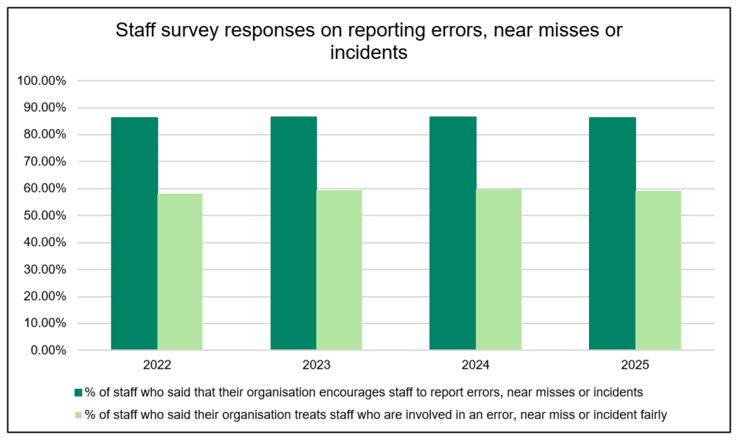
Figure 4: Staff survey responses on reporting errors, near misses or incidents
(Source: Hughes, 2026)
Compared with centralised management, which can limit autonomy in local work areas, the NHS Staff Survey 2025 results indicated that a lower percentage (around 56 per cent) of staff felt capable of improving their work area. Classifying guideline currency and accessibility remained a repeated issue across acute trusts as part of well-led inspections by CQC in 2025 (Hughes, 2026).

2.2.3 Decentralised Elements — Analysis
How Authority is Distributed
Elements of decentralisation were also evident. Specialist teams operated in a decentralised manner, with AGM consultants making individual decisions regarding the patient’s anticoagulation, and the respiratory consultation pathway being managed by the respiratory consultants. The resident doctor’s individual responsibility for specific actions, including restarting apixaban on Day 11, and task management at the ward level were managed through individual handover sheets rather than centralised digital workflows (Foth, 2025). The most obvious form of decentralisation was a workaround to transport the patient from the AGM ward to the respiratory ward, where the procedure would be performed, and then back again, a local modification developed in response to a lack of bed space.
Advantages and Disadvantages
The advantages of decentralisation are responsiveness to the local situation, immediate response to problems at the point of care, and workaround capability in the event of system failure. However, in this instance, accountability became fragmented, across ward transfers because no team had clear responsibility for the paused apixaban, and the workarounds lacked safety nets.
Supporting Data
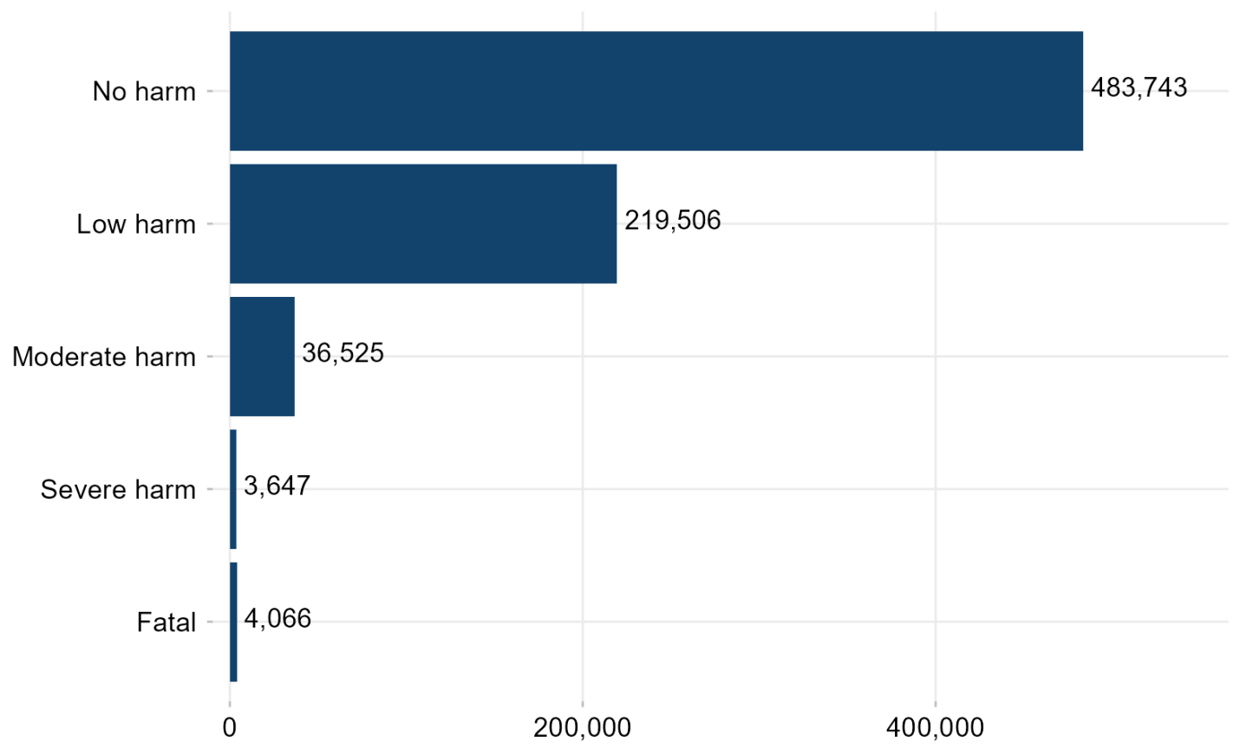
Figure 5: Count of patient safety incidents by maximum level of physical harm
(Source: NHS England, 2025)
In Q2 2025/26, NHS England reported 809,103 patient safety incidents via its Learn from Patient Safety Events service, with medication-related incidents always in the top three categories. Evidence indicates that ePMA workarounds occur in more than 60% of the medication cycles in hospitals when digital systems are not aligned with clinical processes (NHS England, 2025).

2.2.4 Critical Analysis — How Structure Supported or Hindered Crisis Management
The relationship between decentralised execution and centralised structures was a key impediment to crisis management. Evans (2023) found that centralisation produced rigidity. CT scan prioritisation was based on a routine-versus-urgent binary, which failed to account for the patient’s anticoagulation status, and guideline updates were based only on formal review cycles that were not sufficiently responsive to emerging evidence. The pleural guideline contained the duplicated apixaban guidance, which specified different pause intervals, but the reviewing mechanism failed to identify the vagueness. At the same time, decentralisation discouraged accountability. No individual team was responsible for the stalled apixaban when the patient moved from the ED to AMU and then to the AGM ward, awaiting transfer. All teams thought another team was monitoring the medication. Staff ratios revealed just how bad the system was – one consultant and three resident doctors worked in the AGM ward, without the middle-grade doctor recommended by the Royal College of Physicians (2025). On one of the six-day shifts, only one coordinating nurse was on duty.

2.3 Leadership Theories and Application to the Case Study

2.3.1 Transformational Leadership
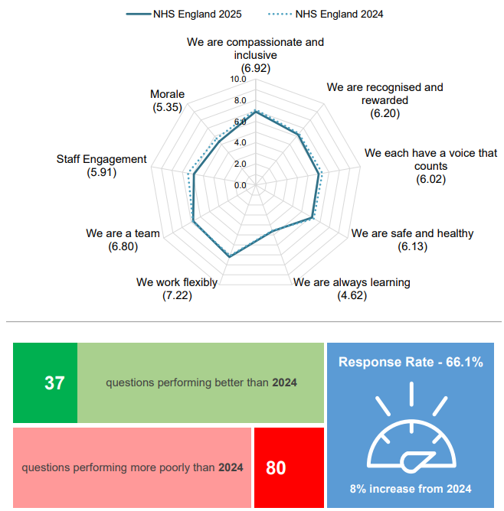
Figure 6: NHS Summary Report
(Source: NHS England, 2025a)
Transformational leadership as formulated by Bass and Avolio focuses on vision, inspirational motivation, intellectual stimulation and individualised consideration. This model uses leaders to motivate personnel to go beyond the practical expectations by uniting them around a common purpose. Transformational leadership was largely lacking at AGM ward level in the HSSIB case. Culture drift, not direct leadership, was reported by staff because of a lack of senior medical leadership. According to NHS Staff Survey 2024/2025, Trusts with the highest rank in leadership engagement reported 15 fewer serious safety incidents (NHS England, 2025a). A culture of a common professional duty of paused medication review could have been developed through transformational leadership.

2.3.2 Transactional Leadership
Transactional leadership is based on contingent rewards and managing by exception – responsibilities involve leaders checking deviations and stepping in when workers fail to deliver to the required standard. The predominant leadership approach in this situation was transactional. Ward rounds were task-based, referrals were based on electronic checklists and management by exception meant that no intervention occurred if the patient seemed clinically stable. The study by Hasan Fehmi Dirik, Chrysanthi Theiakouli and Efstathiou (2026) have repeatedly indicated that Trusts with predominantly transactional leadership styles have higher rates of medication incidents. The transactional model spots errors when they have happened and fail to prevent the underlying systemic circumstances, e.g. the missing ePMA prompt, which predisposes staff to errors.

2.3.3 Situational Leadership (Hersey and Blanchard)
Situational leadership was developed by Hersey and Blanchard and posits that successful leaders should adjust their style (directing, coaching, supporting or delegating) to fit the follower’s readiness and the demands of the task. Situational leadership was required in the HSSIB case, but it was not implemented in the case of weekend cover when the resident doctor was unsupervised and left with the task of resuming apixaban on a Friday afternoon (Marsh, 2025). Young physicians working under high workload must be more closely monitored, rather than given autonomy. The 2025 NHS Staff Survey engagement scores for the AGM ward indicated issues related to supervision and support. Missed prescriptions may have been avoided through situational awareness by the consultant (NHS England, 2025a).

2.3.4 Distributed / Collective Leadership (West et al., King’s Fund)
Promoted by Michael West and the King’s Fund, distributed/collective leadership encourages shared leadership within multidisciplinary teams as opposed to the concentration of power in specific functions. Each team member (including pharmacist, nurse, junior doctor) is given authority to be a leader in their area of expertise. Distributed leadership in the HSSIB case would have enabled of pharmacy staff to report the stopped apixaban, nursing staff to identify that the restart had not been performed, and specialist teams to retain responsibility during the transfer process. In a study of 2024 and 2025, The King’s Fund reports that the adoption of distributed leadership models in trusts significantly contributes to stronger cultures of safety and greater scores on staff engagement than their more hierarchical counterparts (Bailey and West, 2025).

2.3.5 Was the Leadership Style Appropriate for the Situation?
The prevailing transactional and hierarchical leadership styles was not suitable for the complex and dynamic situation of the patient in the clinical setting. His care involved various specialisms, wards and clinical decision points, and involved dynamic coordination and shared accountability. Transactional leadership is effective in terms of its predictability and repetitiveness of tasks and is less effective when tasks depend on cross-team communication, judgement under uncertainty and adaptive problem-solving (Ran, Rozaini Binti Rosli and Ali, 2024). Managing a 10-day interruption to anticoagulation required distributed and adaptive leadership due to its complexity.

2.3.6 Reactive (Command-Driven) vs Proactive (Purpose-Driven) Leadership
The leadership throughout the patient’s care pathway was reactive in nature rather than proactive leadership. Re-referrals to the respiratory team were made only when delays became apparent, rather than because leaders had established forward-looking review mechanisms into the care pathway. An active respiratory review was not initiated, and the patient waited on a bed. Purpose-driven leadership would have instilled a fundamental operating principle: no unreviewed time-critical medicine leaves the organisation, as part of its everyday practice. Rather, the system responded to staff alerting leaders to problems (Micco et al., 2025).

2.3.7 What Data Revealed About Leadership Effectiveness
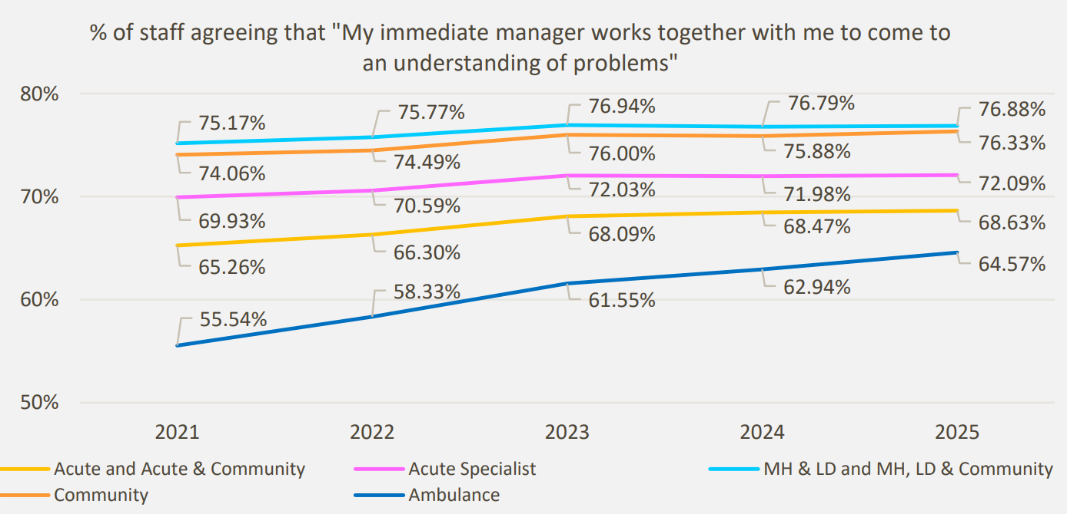
Figure 7: Percentage of staff agreeing that "My immediate manager works together with me to come to an understanding of problems"
(Source: NHS England, 2026)
Several findings indicated weaknesses in leadership. Employees reported a lack of senior medical leadership in the AGM ward, which is an explicit qualitative failure indicator. This was because there was not a feedback system to ensure that intended clinical activities were carried out and therefore leaders had no means of noticing the missed prescription until harm occurred. The national incident data shows that in the 2024 and 2025 NHS Staff Surveys, trusts with lower leadership scores disproportionately reported more incidents of medication safety (NHS England, 2026).

2.3.8 What Could Have Been Done Differently
There were a few other methods of reaching a conclusion that would have improved the outcome. It would have been possible to have a distributed leadership model that relied on pharmacy-led paused-medication review without reliance on individual memory. Emotional quotient leadership, based on the Goleman model, would have created an opportunity to the resident doctors to express their issue regarding workload and the absence of senior support, which the resident doctors had already brought up but this was ignored (DW Focus, 2023).

2.4 Improvement and Lessons Learned

2.4.1 How Leadership and Governance Interacted to Produce the Outcomes
A disconnect between leadership and governance created a significant lack of accountability. Centralised leadership supported the availability of a pleural policy throughout the Trust, but the lack of effective middle-level leadership ensured that those who took the decision on the ground at each ward worked in isolation – hence there was no one to bridge the divide between them at that level (Sadaghiani, 2023). What it brought was a system that assumed compliance without verification. Paused high-risk medication lacked closed-loop governance: no automatic flag, no daily paused-medication review, no post-procedure prompt and no escalation mechanism. Governance was on paper as opposed to practice and that is why a deadly mistake is carried out over a period of ten days without an appropriate safeguard to identify it (Shore, Brown and Hopp, 2022).

2.4.2 Missed Opportunities and Evidence-Based Solutions
Problem 1 — No re-review prompt on ePMA for paused time-critical medication
This was a weakness reported in the HSSIB investigation and the ePMA pharmacist of the Trust stated that there was no immediate mechanism to review temporarily stopped medication when a specified time limit was exceeded. This can be improved by configuring the ePMA, enabling an automatic flag of stopped anticoagulants longer than 48 hours; in accordance with the BSH 2024 guidance, which states that apixaban should not be postponed longer than is necessary (British Journal of Haematology, 2026). Such a change would establish a safety net into the system that is not solely dependent on human memory.
Problem 2 — No post-procedure cue to restart anticoagulation
The HSSIB was able to detect that, in the pre-procedure documentation, there were detailed fields focused on the blood-clotting and medications, and there was no similar prompt on the post-procedure template. Two respiratory consultants said that such a prompt would be a welcome addition. The proposed improvement is a post-procedure checklist that includes a standardised assessment of the time of apixaban administration and a standardised required presence of a required field for anticoagulation assessment which, according to BSH 2024, should be restarted 6 to 8 hours after the procedure and only when the risk of bleeding is under control (UKCPA, 2026).
Problem 3 — Outdated and inaccessible local guidance
The interim apixaban guideline was older than seven years and it was not available on the Trust intranet during the safety event. The improvement requires a structured review-cycle framework, a multidisciplinary panel of reviewers (pharmacy and haematology) and a searchable, mobile-accessible knowledge base. Guideline currency and accessibility persist as continual findings in CQC 2025 well-led inspections throughout the acute trusts.
Problem 4 — Bed capacity and specialty responsibility drift
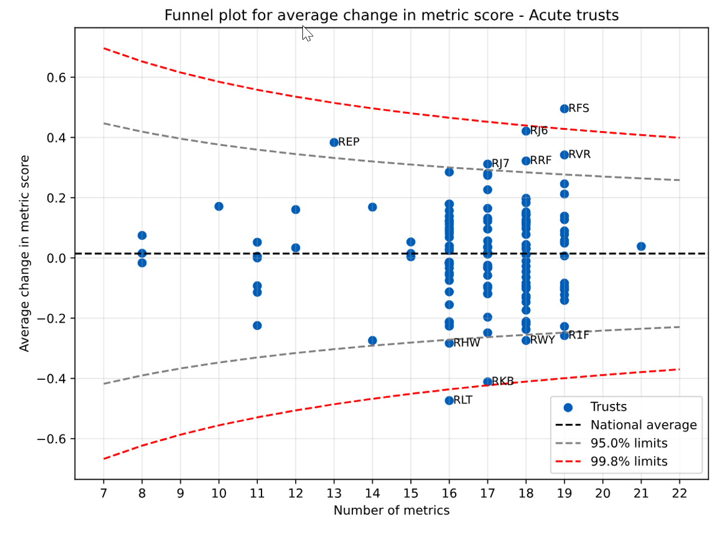
Figure 8: Acute trust funnel plot for mean change in metric score
(Source: NHS England, 2025b)
The patient remained without a respiratory bed for over eight days and did not receive specialist review until after nine days while awaiting transfer. The improvement is twofold: bed management meetings need to involve the review of patients who are waiting over 24 hours to receive specialty transfer, accepted referrals should trigger specialist input regardless of bed availability. The Q2 2025/26 data published by NHS England reveals that the number of workforce vacancies is 100,020, which indicates that the necessary strategies to address changes in processes should be complemented by structural capacity solutions (NHS England, 2025b).
Problem 5 — Weak accountability in centralised hierarchy
Audit records show approximately 40 per cent of medication errors remain unreported after 48 hours. The enhancement is both digital reporting infrastructure and the empowerment of the local teams in empowerment—a-controlled change towards decentralisation of reporting power. Associating Datix and LFPSE data with real-time leader dashboards would enable senior leaders to view incident trends in real time and close the feedback loop (Tuvor et al., 2025).

2.4.3 Linking the Findings — How System Structure, Leadership Style and Feedback Interacted
The three levels played out in a destructive manner. A rigid hierarchy with no adaptive leadership created a rigid system that failed to adapt to pressure. Decentralised implementation with no distributed leadership resulted in fragmented accountability where each of the teams thought they were not in charge of another team. There were no feedback loops in the ePMA, no post-procedure documentation, and MDT handover, and so only clinical staff could take up mistakes and correct them without the capability for self-correction. Combining these three ensured that missed restart on Day 11 could not be caught prior to the stroke on Day 12 (Naseralallah et al., 2025).

2.4.4 Lessons for Other Health Organisations
There are three important lessons. First, time-sensitive medication requires system ownership rather than individual memory – medication should be supported by the ePMA and clinical processes rather than relying on an overloaded resident doctor. Second, pharmacy, haematology and specialist voices should also be represented in guideline governance to make sure that there is cross-referenced guidance that is up-to-date and emerging evidence is incorporated as early as possible (Anderson et al., 2023). Third, digital systems should not merely store critical information; they should actively present it. Clinicians with numerous competing demands to workforce shortage will not be able to retrieve information that requires additional effort to access (Gabriel and Precious, 2025).

3. Recommendations

3.1 What Should Be Done Next in the Trust
Next steps should focus on three immediate priorities. Realign the ePMA system to provide tools to raise an alarm when time-sensitive medicines are suspended over a set threshold and particularly anticoagulants. Second, redesign post-procedure documentation to contain a required anticoagulation reconsideration alert, in accordance with BSH 2024 guidelines (Lester et al., 2024). Third, combine the disjointed pleural, bridging, and interim group of anticoagulation guidelines programmes into one accessible document, endorsed by a multidisciplinary panel of respiratory, cardiology, pharmacy and haematology representatives.

3.2 Most Effective Leadership Style(s) for Sustaining Improvement
A mixed leadership style is needed to achieve sustainable development. The primary operating model should be a distributed or a collective leadership model that enables pharmacy, nursing and specialist teams to lead in their area of expertise. Board-level leadership and directorate-level leadership should be transformational leadership and establish the cultural vision of medication safety (Hamdan et al., 2024). At the ward level, situational leadership should be implemented, and the supervisory style must be adjusted to the readiness and experience of individual employees. All leadership interactions should be guided by compassionate leadership championed by Michael West and anchored on the NHS People Plan.

3.3 Strengthening Governance, Communication and Systems Integration
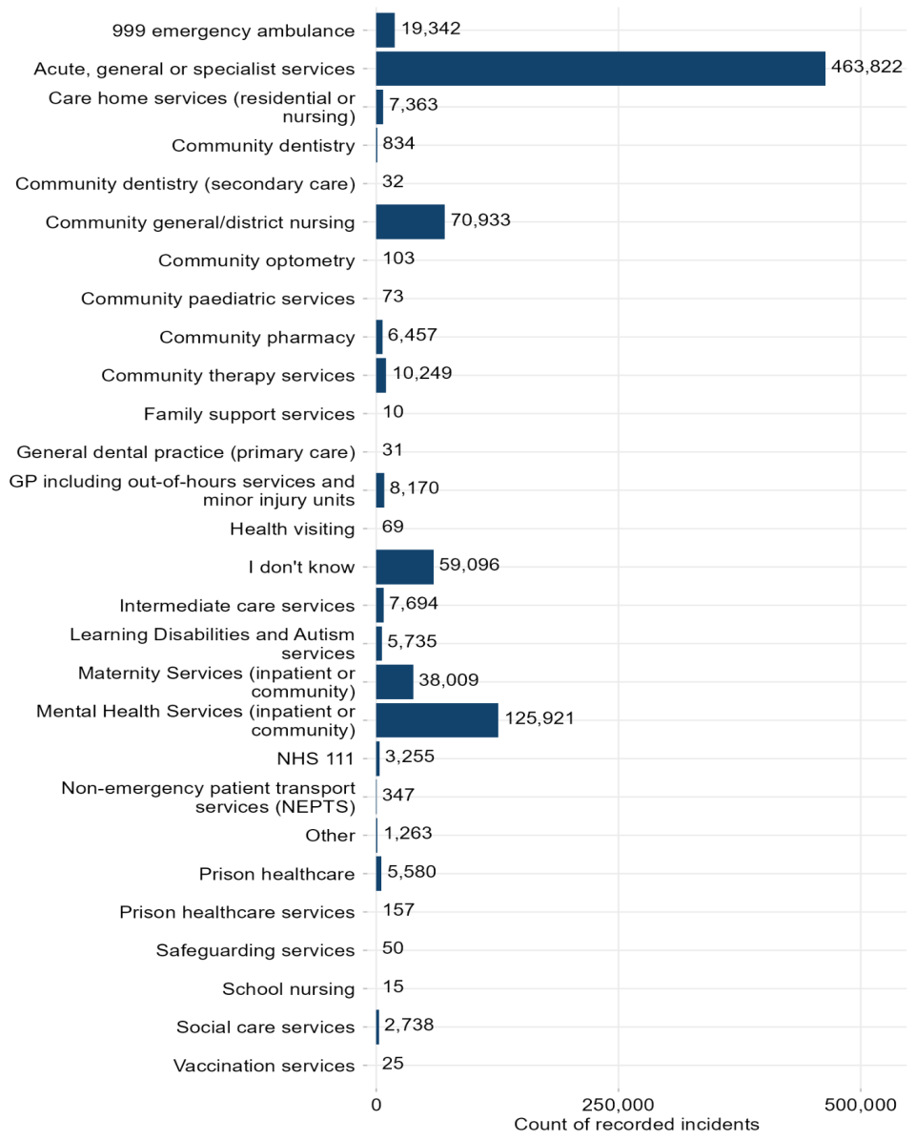
Figure 9: Count of incident records by service area
(Source: NHS England, 2025b)
Governance, communication and systems integration should be strengthened. The anticoagulation and other high-risk drugs, such as pharmacy, haematology, respiratory and acute medicine representatives, should be overseen by a cross-specialty medication safety committee. Handover procedures among AMU, AGM and specialty wards should use a closed-loop system to ensure receipt of critical information and rather than being assumed. The Trust ought to move away from paper records to electronic records. The Q2 2025/26 patient safety data released by NHS England remains with communication and handover as the most prevalent contributing factors in the reported incidents (NHS England, 2025b).

3.4 Enhancing Technical and Allocative Efficiency
Technical efficiency should include automated ePMA flags on any medication that is on hold, digital ward-round tools that are available on mobile devices, and reintroduction of computers-on-wheels to ensure that the most recent documentation is available. Allocative efficiency measures include; reinstatement of the pleural specialist nurse post, rebalancing of the respiratory bed capacity in accordance with the Trust’s demand and capacity review of the Trust, and applying a weekend medical review model (UKONS, 2022).

3.5 Continuous Learning, Stakeholder Engagement and Co-Production
Continuous learning should be embedded and continuous, rather than episodic. Multidisciplinary learning-from-incidents regular multidisciplinary learning-from-incidents forums should be guided by the Patient Safety Incident Response Framework and emphasise learning about the system rather than assigning blame (Hilde Kristin Jacobsen, Ballangrud and Gørill Helen Birkeli, 2024). Guideline review should involve patients and families through the co-production model promoted by the Patients Association. Frontline staff should be involved in the co-production of digital system usability enhancements, workarounds should be identified, addressed and not normalised.

3.6 Ensuring Practicality and Evidence Base
Each recommendation above is linked to a particular local learning prompt in the HSSIB, which are consistent with national recommendations, including NICE NG196, BSH 2024 and BTS 2023, and has a corresponding outcome indicator that can be measured (National Institute for Health and Care Excellence, 2021). Recommendations should be implemented in stages with an emphasis on its effect on patient safety and monitored by the quality and safety committee at the Trust level.

4. Conclusion

4.1 Summary of Main Findings
The HSSIB case study depicts that the fatal outcome resulted from system failure rather than individual failure. Apixaban was discontinued appropriately, the delays were understandable in the context of the system, and the resident doctor’s intention to restart the medicine was reasonable. What did not work was the system failed to detect the missed prescription: the ePMA did not have a re-review prompt, the post-procedure documentation did not contain a prompt, and there was no feedback loop to show that the intended action was done.

4.2 Importance of Leadership, Governance and Systems Thinking
The combination of leadership, systems thinking and governance determines the ability of an acute NHS environment to identify and address such failures before they cause patient harm. Depending on how leaders create a culture that either makes or breaks feedback loops and staff, it can empower them to express concerns (Foy, 2025). Governance supports safe adaptation, enabling local workarounds to stay within safe bounds. Systems thinking will ensure that the whole picture will be constructed consciously and rather than accidentally.

4.3 Final Reflection
The combination of centralisation, decentralisation and distributed leadership should be used in appropriate combinations to uphold the safety of patients in complex environments of the NHS. Centralisation provides uniformity and standardisation, decentralisation provides swiftness and problem-solving locally, and distributed leadership unites them with mutual accountability in multidisciplinary teams. The lessons learnt from this case, such as closed-loop feedback structures, empowered pharmacy, nursing and specialist voices, and access to up-to-date guidance supported by digital systems provides a pragmatic blueprint not just in this Trust but also across the wider NHS in preventing similar failures involving time-critical medication in vulnerable patients receiving complex clinical care (NHS England, 2026).

Reference List
Anderson, P., Higgins, V., Jonathan de Courcy, Katerina Doslikova, Davis, V.A., Karavali, M. and Piercy, J. (2023) “Real-World evidence generation from patients, their caregivers and physicians supporting clinical, regulatory and guideline decisions: An update on disease specific programmes,” Current Medical Research and Opinion, 39(12), pp. 1707–1715. Available at: https: //doi.org/10.1080/03007995.2023.2279679. https://doi.org/10.1080/03007995.2023.2279679
Bailey, S. and West, M. (2025) What is compassionate leadership? The King’s Fund. The King’s Fund. Available at: https: //www.kingsfund.org.uk/insight-and-analysis/long-reads/what-is-compassionate-leadership https://www.kingsfund.org.uk/insight-and-analysis/long-reads/what-is-compassionate-leadership
BMJ (2026) 237+ million medication errors made every year in England – BMJ Group, BMJ. Available at: https: //www.bmj.com/company/%20newsroom/237-million-medication-errors-made-every-year-in-england/ https://www.bmj.com/company/%20newsroom/237-million-medication-errors-made-every-year-in-england/
Brain Research UK (2026) Stroke – Neurological condition, Brain Research UK. Available at: https://www.brainresearchuk.org.uk/neurological-conditions/stroke https://www.brainresearchuk.org.uk/neurological-conditions/stroke
British Journal of Haematology (2026) “BSH ASM 2026 ePoster presentations,” British Journal of Haematology, 208(S1). Available at: https: //doi.org/10.1111/bjh.70471. https://doi.org/10.1111/bjh.70471
Cleveland Clinic (2024) What to know about Eliquis® (apixaban), Cleveland Clinic. Available at: https: //my.clevelandclinic.org/health/drugs/19106-apixaban-tablets https://my.clevelandclinic.org/health/drugs/19106-apixaban-tablets
DW Focus (2023) Leadership under pressure: What emergency medicine teaches about decision making, Medicalnews.md. Available at: https: //medicalnews.md/leadership-under-pressure-what-emergency-medicine-teaches-about-decision-making https://medicalnews.md/leadership-under-pressure-what-emergency-medicine-teaches-about-decision-making
Evans, R. (2023) QOF 2023/24: what practices need to consider gaining maximum income, Management in Practice. Available at: https: //managementinpractice.com/practice-intelligence/qof-2023-24-what-practices-need-to-consider-to-gain-maximum-income/ https://managementinpractice.com/practice-intelligence/qof-2023-24-what-practices-need-to-consider-to-gain-maximum-income/
Feigin, V.L., Brainin, M., Norrving, B., Martins, S., Pandian, J.D., Lindsay, P., Fredin Grupper, M.M. and Rautalin, I. (2025) “World Stroke Organization (WSO): Global Stroke Fact Sheet 2025,” International Journal of Stroke, 20(2). Available at: https: //doi.org/10.1177/17474930241308142. https://doi.org/10.1177/17474930241308142
Foth, T. (2025) Critical Approaches in Nursing Theory and Nursing Research. Available at: https: //www.researchgate.net/profile/Thomas-Foth/publication/313689957_Introduction_Critical_Approaches_in_Nursing_Theory_and_Nursing_Research_Implications_for_Nursing_Practice_Implications_for_Nursing_Practice/links/58a60e2c92851cf0e3ab3e46/Introduction-Critical-Approaches-in-Nursing-Theory-and-Nursing-Research-Implications-for-Nursing-Practice-Implications-for-Nursing-Practice.pdf. https://www.researchgate.net/profile/Thomas-Foth/publication/313689957_Introduction_Critical_Approaches_in_Nursing_Theory_and_Nursing_Research_Implications_for_Nursing_Practice_Implications_for_Nursing_Practice/links/58a60e2c92851cf0e3ab3e46/Introduction-Critical-Approaches-in-Nursing-Theory-and-Nursing-Research-Implications-for-Nursing-Practice-Implications-for-Nursing-Practice.pdfhttps://www.researchgate.net/profile/Thomas-Foth/publication/313689957_Introduction_Critical_Approaches_in_Nursing_Theory_and_Nursing_Research_Implications_for_Nursing_Practice_Implications_for_Nursing_Practice/links/58a60e2c92851cf0e3ab3e46/Introduction-Critical-Approaches-in-Nursing-Theory-and-Nursing-Research-Implications-for-Nursing-Practice-Implications-for-Nursing-Practice.pdf
Foy, D. (2025) Health and security: Why they must be managed together, HSE Network. Available at: https: //www.hse-network.com/health-and-security-why-they-must-be-managed-together/ https://www.hse-network.com/health-and-security-why-they-must-be-managed-together/
Gabriel, I. and Precious, A. (2025) Challenges of implementing AI in low-resource healthcare settings, ResearchGate. unknown. Available at: https: //www.researchgate.net/publication/394275718_Challenges_of_Implementing_AI_in_Low-Resource_Healthcare_Settings https://www.researchgate.net/publication/394275718_Challenges_of_Implementing_AI_in_Low-Resource_Healthcare_Settings
Gupta, P. (2024) Review article on the role of effective leadership in crisis management. Available at: https: //www.researchgate.net/publication/377700929_review_article_on_the_role_of_effective_leadership_in_crisis_management https://www.researchgate.net/publication/377700929_review_article_on_the_role_of_effective_leadership_in_crisis_management
Hamdan, M., Jaaffar, A., Khraisat, O., Issa, M. and Jarrar, M. (2024) “The association of transformational Leadership on safety practices among nurses: The mediating role of patient safety culture,” Risk management and healthcare policy, Volume 17(1), pp. 1687–1700. Available at: https: //doi.org/10.2147/rmhp.s458505. https://doi.org/10.2147/rmhp.s458505
Hasan Fehmi Dirik, Chrysanthi Theiakouli and Efstathiou, N. (2026) “The influence of nursing leadership styles on medication safety: A mixed-methods systematic review.,” PubMed, 73(1), pp. e70166-e70166. Available at: https: //doi.org/10.1111/inr.70166. https://doi.org/10.1111/inr.70166
Hilde Kristin Jacobsen, Ballangrud, R. and Gørill Helen Birkeli (2024) “Learning from patient safety incidents: The green cross method,” Nursing in critical care [Preprint]. Available at: https: //doi.org/10.1111/nicc.13114. https://doi.org/10.1111/nicc.13114
Holzhüter, F., Schuster, F., Heres, S. and Hamann, J. (2021) “Clinical decision-making during psychiatric ward rounds,” Frontiers in Psychiatry, 12. Available at: https: //doi.org/10.3389/fpsyt.2021.721699. https://doi.org/10.3389/fpsyt.2021.721699
Horner, D., Ambrose, C., Taylor, C. and Erinle, L. (2023) “intensive care society state of the art (soa) 2023 congress abstracts,” The journal of the Intensive Care Society, 24(2_suppl), pp. 1–196. Available at: https: //doi.org/10.1177/17511437231195526. https://doi.org/10.1177/17511437231195526
HSSIB (2025) Medication not given: anticoagulation before and after a procedure. Available at: https: //www.hssib.org.uk/patient-safety-investigations/medication-related-harm/second-investigation-report/pdf https://www.hssib.org.uk/patient-safety-investigations/medication-related-harm/second-investigation-report/pdf
Hughes, M. (2026) Patient Safety Learning’s response to the NHS Staff Survey Results 2025. Available at: https: //www.pslhub.org/learn/patient-safety-learning/patient-safety-learning’s-response-to-the-nhs-staff-survey-results-2025-r14190/. https://www.pslhub.org/learn/patient-safety-learning/patient-safety-learning’s-response-to-the-nhs-staff-survey-results-2025-r14190/
Lester, W., Bent, C., Alikhan, R., Roberts, L., Gordon‐Walker, T., Trenfield, S., White, R., Forde, C. and Arachchillage, D.J. (2024) “A British Society for Haematology guideline on the assessment and management of bleeding risk prior to invasive procedures,” British journal of haematology [Preprint]. Available at: https: //doi.org/10.1111/bjh.19360. https://doi.org/10.1111/bjh.19360
Louise, P. and Kellett, R. (2025) The creation and maintenance of safety in nursing medication administration practice. Available at: https: //etheses.whiterose.ac.uk/id/eprint/38566/1/MASTER%20DOCUMENT%20v1%20CLOUD%20THESIS%2022.09.25%20Final%20%282%29.pdf https://etheses.whiterose.ac.uk/id/eprint/38566/1/MASTER%20DOCUMENT%20v1%20CLOUD%20THESIS%2022.09.25%20Final%20%282%29.pdf
Marsh, J. (2025) HSSIB investigation highlights safety risks from anticoagulant medication errors, Boyesturnerclaims.com. Available at: https: //www.boyesturnerclaims.com/news/hssib-investigation-highlights-patient-safety-risks-anticoagulant-medication-errors https://www.boyesturnerclaims.com/news/hssib-investigation-highlights-patient-safety-risks-anticoagulant-medication-errors
McKee, M., Vaughan, L.K. and Russo, G. (2025) “A contentious intervention to support the medical workforce: a case study of the policy of introducing physician associates in the United Kingdom,” Human Resources for Health, 23(1). (“A contentious intervention to support the medical workforce: a case ...”) Available at: https: //doi.org/10.1186/s12960-024-00966-1. https://doi.org/10.1186/s12960-024-00966-1
Micco, De, Palma, Di, Tambone, V. and Scendoni, R. (2025) “From blame to learning: The evolution of the London protocol for patient safety,” Healthcare, 13(16), p. 2003. Available at: https: //doi.org/10.3390/healthcare13162003. https://doi.org/10.3390/healthcare13162003
Naseralallah, L., Somaya Koraysh, Alasmar, M. and Bodoor Aboujabal (2025) “The role of pharmacists in mitigating medication errors in the perioperative setting: A systematic review,” Systematic Reviews, 14(1). Available at: https: //doi.org/10.1186/s13643-024-02710-1. https://doi.org/10.1186/s13643-024-02710-1
National Institute for Health and Care Excellence (2021) Overview | atrial fibrillation: Diagnosis and management | guidance | NICE, www.nice.org.uk. Available at: https: //www.nice.org.uk/guidance/ng196 https://www.nice.org.uk/guidance/ng196
NHS Confederation (2026) NHS digital workforce statistics – November 2025, Thenhsalliance.org. Available at: https: //thenhsalliance.org/resources/nhs-digital-workforce-statistics-november-2025 https://thenhsalliance.org/resources/nhs-digital-workforce-statistics-november-2025
NHS England (2025a) 2025 NHS England Staff Survey Summary Report. Available at: https: //www.england.nhs.uk/wp-content/uploads/2026/03/nhs-england-staff-survey-results-2025-summary-report.pdf https://www.england.nhs.uk/wp-content/uploads/2026/03/nhs-england-staff-survey-results-2025-summary-report.pdf
NHS England (2025b) NHS England » NHS oversight framework: Q2 2025/26 segmentation changes, England.nhs.uk. Available at: https: //www.england.nhs.uk/long-read/nhs-oversight-framework-q2-25-26-segmentation-changes/ https://www.england.nhs.uk/long-read/nhs-oversight-framework-q2-25-26-segmentation-changes/
NHS England (2025c) Statistics » quarter 2 2025/26 (July, august, September 2025), England.nhs.uk. Available at: https: //www.england.nhs.uk/statistics/statistical-work-areas/patient-safety-data/2025-26/q2/ https://www.england.nhs.uk/statistics/statistical-work-areas/patient-safety-data/2025-26/q2/
NHS England (2026) 2025 NHS staff survey national results briefing. Available at: https: //www.nhsstaffsurveys.com/static/98fbf017ea18aad1523254e02072cd02/National-Results-Briefing-2025.pdf https://www.nhsstaffsurveys.com/static/98fbf017ea18aad1523254e02072cd02/National-Results-Briefing-2025.pdf
Ran, X., Rozaini Binti Rosli and Ali, D.A. (2024) “The impact of transactional leadership on work performance: The mediating role of work engagement,” International Journal on Recent Trends in Business and Tourism, 08(03), pp. 38–46. Available at: https: //doi.org/10.31674/ijrtbt.2024.v08i03.003. https://doi.org/10.31674/ijrtbt.2024.v08i03.003
Royal College of Physicians (2025) “Doctors are being asked to do the impossible”: Royal College of Physicians warns NHS staffing vacancies are contributing to longer hospital stays and waiting lists, Rcp.ac.uk. Available at: https: //www.rcp.ac.uk/news-and-media/news-and-opinion/doctors-are-being-asked-to-do-the-impossible-royal-college-of-physicians-warns-nhs-staffing-vacancies-are-contributing-to-longer-hospital-stays-and-waiting-lists/ https://www.rcp.ac.uk/news-and-media/news-and-opinion/doctors-are-being-asked-to-do-the-impossible-royal-college-of-physicians-warns-nhs-staffing-vacancies-are-contributing-to-longer-hospital-stays-and-waiting-lists/
Sadaghiani, L. (2023) The dark side of leadership: Mid-level managers and their experience – ProQuest, Proquest.com. Available at: https: //www.proquest.com/openview/8af3736a8959fb68403a0edaffd62edf/1?pq-origsite=gscholar&cbl=18750&diss=y https://www.proquest.com/openview/8af3736a8959fb68403a0edaffd62edf/1?pq-origsite=gscholar&cbl=18750&diss=y
Shoemaker-Hunt, S.J. and Wyant, B. (2020) Harms due to anticoagulants, www.ncbi.nlm.nih.gov. Agency for Healthcare Research and Quality (US). Available at: https: //www.ncbi.nlm.nih.gov/books/NBK555529/ https://www.ncbi.nlm.nih.gov/books/NBK555529/
Shore, C., Brown, L. and Hopp, W.J. (2022) Causes and consequences of medical product supply chain failures, www.ncbi.nlm.nih.gov. National Academies Press (US). Available at: https: //www.ncbi.nlm.nih.gov/books/NBK583734/ https://www.ncbi.nlm.nih.gov/books/NBK583734/
Stanton, A.E., Juniper, M., Bedawi, E., McNaughton, L., Clive, A.O., De Fonseka, D., Aujayeb, A. and Evison, M. (2025) “Pleural procedural safety in the UK: Is everyone’s house in order? Reflections from the BTS National Pleural Service Organisational Audit and a national review of patient safety incidents,” BMJ Open Respiratory Research, 12(1), p. e002840. Available at: https: //doi.org/10.1136/bmjresp-2024-002840. https://doi.org/10.1136/bmjresp-2024-002840
Tavares, M.C., Vale, J. and Costa, A. (2024) “The role of decentralised managers in decision-making in a large industrial company,” Administrative Sciences, 14(9), pp. 202–202. Available at: https: //doi.org/10.3390/admsci14090202. https://doi.org/10.3390/admsci14090202
The King’s Fund (2024) The francis inquiry: creating the right culture of care, The King’s Fund. Available at: https: //www.kingsfund.org.uk/insight-and-analysis/projects/francis-inquiry-creating-right-culture-care https://www.kingsfund.org.uk/insight-and-analysis/projects/francis-inquiry-creating-right-culture-care
Tuvor, D., Kumah, A., Abiti, R., Afakorzi, S.H., Agbemade, P.K., Ahiale, C., Dzodzodzi, M., Dogbedo, A.B., Peter Worlasi, A., Obot, E., Tornyi, J.M., Issah, A.-R., Dzubey, I. and Kanamitie, D.T. (2025) “Medication administration error reporting among nurses: A descriptive qualitative study,” Global Journal on Quality and Safety in Healthcare, 8(2). Available at: https: //doi.org/10.36401/jqsh-24-33. https://doi.org/10.36401/jqsh-24-33
UKCPA (2026) Apixaban, UKCPA Handbook of Perioperative Medicines. Available at: https: //periop-handbook.ukclinicalpharmacy.org/drug/apixaban-2/ https://periop-handbook.ukclinicalpharmacy.org/drug/apixaban-2/
UKONS (2022) Standards for the safer use of electronic prescribing and Medicines Administration (ePMA) systems for use in systemic anti-cancer therapy (SACT) services. Available at: https: //www.uksactboard.org/_files/ugd/638ee8_5613776913e5415f81f31610e4a4a862.pdf?index=true https://www.uksactboard.org/_files/ugd/638ee8_5613776913e5415f81f31610e4a4a862.pdf?index=true
WHO (2026) Medication without harm, World Health Organization. Available at: https: //www.who.int/initiatives/medication-without-harm https://www.who.int/initiatives/medication-without-harm

