Teodora Iftime (1816784)

A CRITICAL EVALUATIONO OF THE IMPACT “CUSTOMER RELATIONSHIP MANAGEMENT” HAS ON ORGANISATION PERFORMANCE

Lecturer: Maria Heffernan Date:25.02.2022

Executive Summary

The following report is going to investigate the Customer Relationship Management policy and practices of TESCO based on ethical policies and practises, sustainability policies and practice and also influences of segmentation and the loyalty ladder.
The report is been requested by the Chief Executive Officer of Marketing Week and is been made by Ken Murphy together with his team.
After critically analysing the organisation in contrast with its competitors it was concluded that Tesco has made huge improvements over the years, becoming one of the biggest market in the UK with shops around the world.
They also have weak points which decreased customer number and also their trust. To be able to go higher in ranking, improvements are recommended regarding their ethics and sustainability plans.

Contents

1.0 Introduction.............................................................3
2.0 Findings...................................................................4
2.1 Tesco.....................................................................4
2.1.1 Customer Relationship Management.................6
2.2 Ethics and Sustainability........................................10
2.2.1 Tesco Ethics.....................................................10
2.2.2 Tesco sustainability..........................................13
2.2.3 Tesco sustainability model...............................14
2.3 Loyalty Lader and Segmentation...........................16
3.0 Conclusion..............................................................18
4.0 Recommendation....................................................19
5.0 Appendices.............................................................20
6.0 References list........................................................22

1.0 introduction

This report was made on Chief Executive Officer of Market Week request by Ken Murphy (Tesco CEO) and his team.
Customers' satisfaction with customer service and their impact on customer retention and acquisition will be investigated in this report, which will focus on a specific business, Tesco plc in the United Kingdom. The research will also look into the factors that influence the acquisition and retention of high-quality consumers. Due to the influence of loyal customers and the maximisation of an organization's profit being intertwined, the proposed study will focus on seller and buyer interactions and management, drawing on the case study of Tesco, as well as assessing the company's consumer relationship management practices, ethics, sustainability, segmentation and loyalty ladder.

2.0 Findings

2.1 TESCO
Tesco plc, is a worldwide grocery and general merchandise retailer with operations in more than 100 countries. Jack Cohen created the company in 1919, and it has its headquarters in Welwyn Garden City, Hertfordshire. A total of 367,321 people are working for the company in UK ( approximately 420.000 people worldwide) which operates over 5,000 stores and earned revenues of nearly 57 billion British pounds in the fiscal year 2020/21. Nearly 4,000 of the company's outlets and approximately 53 billion of its total revenue were located in the United Kingdom and Republic of Ireland.
The first Tesco store was opened in Burnt Oak, Edgware, north London, in the summer of 1961. Stores such as Tesco offered outstanding value in dry goods, as well as the world's first ever branded product: Tesco Tea.
Later in the decade, Tesco would introduce new formats such as 'Tesco Express' and 'Tesco Extra,' amongst others.
With the launch of outlets in Hungary, the company is expanding into Central Europe. Within a decade, they would open stores in the Czech Republic, Slovakia, Poland, Ireland, Thailand, Malaysia, and India, as well as expand into other European countries.
After being introduced, the Tesco Clubcard quickly gained popularity, attracting roughly 5 million customers in its first year. Tesco surpassed Sainsbury's in terms of market share following the introduction of the Clubcard.
Tesco was named Green Retailer of the Year at the Annual Grocer Gold Awards, which took place in June 2012. Tesco's dedication to carbon reduction across all of its markets received high recognition from the Judges.
The Booker Group, a wholesaler, has merged with the Tesco supermarket chain. The two businesses combine their retail and wholesale capabilities to form the largest food business in the United Kingdom. The combination opens up new potential for the company wherever food is produced and consumed, whether "at home" or "away from home," and will benefit customers, suppliers, colleagues, and stockholders alike.

2.1.1 Customer relationship management (CRM)
A new concept in today's corporate environment, customer relationship management (CRM) has been revealed to be one of the most effective techniques to acquire and retain clients (Berry et al., 2009). When it comes to developing up their products and services in the marketplaces, business organizations are prioritizing this concept above all else Relationship marketing, on the other hand, provides clients with access to information and knowledge about their preferred products and services (Weinstein and Johnson, 2011). There are still many firms that struggle with the question of whether or not creating customer relationships is beneficial in helping them achieve their corporate objectives, as Li and Nicholls (2010) point out.
Marketing, sales, and customer support are all integral parts of customer relationship management (CRM), and this approach seeks to address them all at once.
Analytical RCM focuses on customer data in order to examine for a variety of purposes. One of the primary responsibilities of this CRM is to make management decisions, plan and execute marketing initiatives, forecast future trends, and analyse consumer behaviour (Krishna, 2013).
Customer relationship management (CRM) draws consumers for a lengthy period of time, increasing customer retention and motivating them to purchase more regularly. Organizations take steps in response to consumer feedback, which improves the bounding relationship and results in higher customer loyalty for the organisation (Sharp, 2018).
In the field of Customer Relationship Management, this is defined as the building of long-term mutually beneficial relationships between consumers and businesses, as well as their development, maintenance, and optimization (BT Consulting Julia Gareth 2011).
Effective customer relationship management (CRM) focuses on understanding and integrating customers' requirements into business strategy, people, technology, and operational processes (CRM UK Ltd, 2000)
For years, retailers have fought to retain clients by employing a range of strategies. One of the most widely used techniques to attain this goal has been to place a strong emphasis on pricing (Ray 2010). The creation of proper relationships with customers has, nevertheless, become increasingly important in an era characterised by social networks and global connectivity. Customer relationship management (CRM) has become a widely utilised tool by businesses to build and maintain productive relationships with their consumers.
In the United Kingdom, the company has consistently ranked first in terms of supermarket sales for several years in a row. However, from the beginning of 2015, the company's market share has been steadily declining at a very modest but consistent pace. Sales were down and capital spending was down every each of the company's financial years from 2015 through 2019. Capital expenditures have increased again in 2020.
If you take a glance through the average person's handbag or wallet, you'll most likely find at least a few branded loyalty cards. The probability that one of them is a Tesco Clubcard increases even further in this case. Since its inception in 1994, Tesco's customer loyalty programme has grown to become one of the most well-known in the industry, with more than 16.5 million active members today.
This huge pool of Clubcard holders gives Tesco the ability to record comprehensive sales data on two thirds of the shopping baskets it sells; a constantly-expanding supply of transactional information about the buying habits of its most regular shoppers.
To be useful, though, this data must first be thoroughly analyzed, and Tesco has made significant investments in this area as well. Nigel Gatehouse, their previous CEO, worked as Strategy Director at DunnHumby from 1996 to 1999 and was a major member of the Clubcard team during that time. His first-hand knowledge of the program's rollout and development of many of the CRM and loyalty programs concepts that are still in use across the world today meant that Tesco had a committed focus on consumer behaviour intelligence at the time, just as it does now for our clients.( https://insight.ikano/the-power-of-customer-loyalty-tesco-healthy-eating/)
Tesco saw a 4.5 percent increase in customer satisfaction from March 2020 to February 2021, compared to the same period the previous year, in terms of the cleanliness of the store, the price of the products, and the ease of shopping.
Customer satisfaction can also be translated as customer trust in the supermarket and their ability of providing quality products at a reasonable price.

2.2 Ethics and sustainability
2.2.1 Tesco Ethics
Ethical standards are those that should be followed in all aspects of one's life, regardless of the situation. Following ethical principles is crucial in business as well; doing so will allow the company to operate in a proper and correct manner. Organizations that adhere to ethical standards will distinguish themselves from other businesses in the market. The business strategy of an organisation is likely to be affected by ethical difficulties in a company. Employee connections and the company as a whole are impacted by an organization's ethical standards and issues.
Customer Relationship Management developed during time by organisation policies and practices in regard ethics and sustainability and made it simple and quick to find and add new leads, as well as precisely classify them. Focusing on the proper leads allows sales to prioritise opportunities that will close, and marketing to identify leads that need further nurturing and prime them to become quality leads.

The application of ethics in customer interactions increases the quality of service and helps to build strong relationships. Business ethics is about being able to distinguish between what is wrong and what is right and conducting all transactions in accordance with what is right, even when doing the wrong thing will result in more rewards in the short term, at the very least.
Critically analysing Tesco ethics, can be clearly seen that the organisation is engaging in normative ethics.
Instead of focusing on the business's success, Tesco focuses solely on the company's finances. When it comes to normative theory, the firm isn't just a mechanic, it's a vehicle that coordinates interests and has the relationship management of a judiciary, which not only looks at stakeholders but also all of the stockholders. This is a very obvious approach. It's a shame that Tesco doesn't care about its stakeholders and focuses solely on the bottom line.
Campaigns against the company's business practises have ranged from live turtle sales in China to how it treats its suppliers. Tesco claims to be committed to environmental stewardship, but how do the retailer's values measure up?
Researches are showing that Tesco is marked down in rating system in many categories all of this covers climate change, palm oil and environmental reporting, ecosystems and resources as well as pollution and hazardous waste, human and labour right violations, and the usage of controversial technologies.
On their website, Ethical Consumer found the following documents: "Our Approach to Human Rights" dated 11/4/19, "Modern Slavery Statement 2018/19," and "Supplier Code of Conduct" in September of this year. Tesco received the highest possible rating for its supply chain management.
At the same time, a three-year police probe revealed that one of its suppliers had been using slave labour. Some of its 400 victims laboured for as little as 50p a day at poultry factories, waste recycling facilities, and farms, making this the largest-ever modern slavery ring to be exposed in the United Kingdom.
However, the supermarket chains and companies involved said they did not know the workers were being exploited, and several said they only became aware of the mistreatment after being contacted by journalists. Tesco, Waitrose, Marks & Spencer, Sainsbury's and Asda were all supplied by gang-controlled farms.
ASDA is the third largest supermarket in UK is not very far from Tesco.
In addition to allegations of gender discrimination levelled by as many as 44,000 Asda employees and the possible use of tax evasion tactics, there are several ethical questions surrounding the supermarket giant.
Toxicity, climate change, pollution and toxics, habitats & resources, palm oil, factory farming, animal rights, workers' rights, irresponsible marketing... Asda has achieved the poorest Ethical Consumer rating for its response to these concerns.
After critically analysing the market it is clearly that both companies still have many things to do in order to achieve their goals regarding ethics, but Tesco has proven more interest and more efficiency regarding this topic.
2.2.2 Tesco sustainability
Regardless their fail in achieving their ethics standards Tesco is doing great in sustainability plans.
According to Tesco's sustainability plan, the company has committed to eliminating deforestation from its products by 2020 and making all of its packaging 100% recyclable or compostable by 2025. Partners are assisting Tesco in accelerating their progress toward these environmental goals as a result of their relationship.
Carroll theory (the one that Tesco is engaging with) proposed a four-tiered framework for defining corporate responsibility: economic, legal, ethical, and philanthropic obligations (Carroll, 1991 and 1998). The Pyramid framework, according to Carroll (1991), helps managers realise how the many kinds of responsibilities are constantly at odds with one another, even though the components are not mutually exclusive. However, a recent re-examination of Carroll's pyramid has uncovered numerous flaws that have contributed to its inability to serve as a useful tool for CRS performance management (Visser, 2006).
2.2.3 Tesco sustainability model- economic strategy
Tesco has announced that its 5p single-use carrier bags would be phased out in exchange of a 10p "Bag for Life"
As of August 28, the new 10 pence bag will be available in stores across the UK, with proceeds going to charity. The bag is comprised of 94% recycled plastic.
Matt Davies, Tesco's CEO for the United Kingdom and Ireland argues that "The number of bags purchased by Tesco consumers has already decreased considerably.”
Tesco has handed out 1.5 billion fewer single-use bags since the introduction of the carrier bag charge in 2015, yet the retailer continues to sell more than 700 million 5p bags every year.
It is hoped that the earnings from Bag for Life would be donated to Tesco's Bags of Help programme, which is run in partnership with Groundwork and has already donated over £33 million to more than 6,400 local community projects since it was started in 2015.
Other supermarkets have turned down the opportunity to commit to eliminating plastic bags for the time being, as well. As reported by The Grocer, Aldi and M&S said they had no intentions to reduce their use of 5p single-use plastic bags. In response to the issue, Morrisons said it would listen to its consumers, while Waitrose said it would continue to watch the situation, although it was not convinced that eliminating single-use bags would result in a reduction in overall amounts of plastic consumed.
Tesco also announced that will no longer order beer and cider in plastic bottles with plastic rings, and they will also no longer be offered in-store.
The shop hopes to reduce the amount of plastic used by 50 million pieces each year as a result of this initiative.
On the other hand one of Tesco’s bigger competitors, Asda has reinforced its 'Greener at Asda' price promise, which ensures that loose and unwrapped products will not be more expensive than their packaged counterparts in order to encourage customers to purchase more responsibly.
"Asda has always been a retailer that is at the heart of the communities in which it operates, and the past year has highlighted the essential role that they play in solving problems in society” declares Roger Burnley, Asda CEO and President.
The supermarket chain Asda recently announced the extension of its relationship with Preloved Vintage Kilo, which will now offer pre-worn clothing in 50 locations across the United Kingdom as part of its commitment to provide customers with sustainable options. Thousands of tonnes of clothes will not be dumped in landfills as a result of this initiative, which will help to minimise textile waste.
The coronavirus pandemic has presented retailers with numerous hurdles, but it's encouraging to see that sustainability hasn't fallen too far down the priority list.
2.3 Loyalty Lader and Segmentation
The Tesco Clubcard is the name of the retailer's customer loyalty system or programme. Once a transaction is completed, the card is scanned to confirm the transaction. As a result, information about each customer is 'grabbed' and recorded. As a result of Tesco's knowledge of other customers' purchasing habits, clients are sent coupons that are highly relevant to their purchasing habits. This continually adds value to your overall shopping experience as a client.
A well-designed loyalty system creates data that helps Tesco better understand its consumers while also offering them with added-value incentives and member perks. Tesco's Clubcard programme is no exception. The data collected by Tesco is being used to urge its consumers to purchase and eat more healthfully, among other things.
Years of customer behavior data analysis have enabled it to develop approximately a dozen different core lifestyle classifications, which it uses to segment its customer base into key groups based on factors such as life stage, personal interest, purchasing preferences, shopping style, and other considerations. The content of magazines follows these classifications, from the coupons that are included to the recipes that are now being included.
Customer loyalty is not a new notion; it has been around for more than 100 years; nevertheless, what Tesco has done is to construct a contemporary version of the original concept that goes far further in developing an active engagement with its consumers than the original model did.
Since its inception, Tesco Clubcard has established itself as one of the most successful loyalty programmes in the world. A significant factor in this success, and undoubtedly a key driver of its success, is that the scheme is integral to Tesco's stated core purpose and, as their advertisements state, 'Every Little Helps.'
Tesco has the opportunity to regain its personal touch with the introduction of Clubcard, which allows it to treat consumers as individuals.

3.0 Conclusion

The purpose of this report was to analyse the impact of CRM success on the performance of Tesco organisation. According to the firm's resource-based perspective, CRM success is one of the most essential resources that firms can use to improve their performance.
Tesco as an organization has both positive and negative areas.
Even if they are doing great on their sustainability plans and also on customer satisfaction they still have many things to improve when it comes to ethics.

4.0 Recommendation

Tesco loyalty program has brought to the company huge benefits which made the business be recognised as having the best loyalty and customer satisfaction strategies.
In order to go higher on the ranking is recommended to improve their ethics plans which also will help them gain more trust from their customers.

5.0 appendices
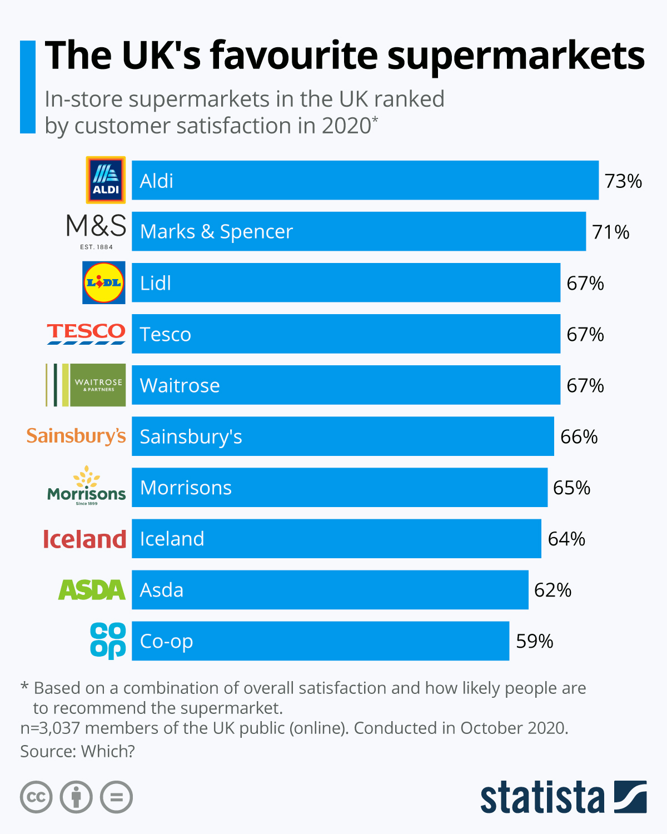

Customer satisfaction report 2021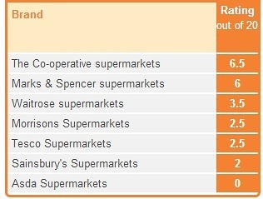

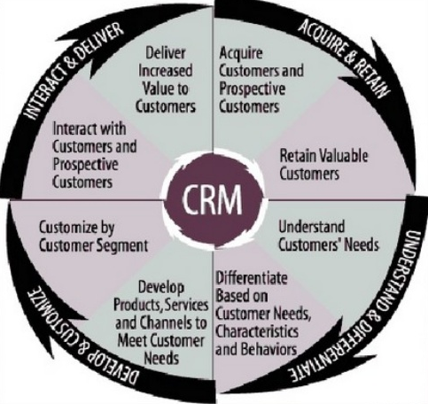

6.0 Reference list

1. Ethical consumer (2021)- Tesco Plc. Available at:https://www.ethicalconsumer.org/company-profile/tesco-plc
(Accessed:13.02.2022)
2. Tesco customer satisfaction (2021) How analytics helped Tesco improve its customer satisfaction amid Covid: An Economic Times Coverage.
Available at: https://www.tescobengaluru.com/news/how-analytics-helped-tesco-improve-its-customer-satisfaction-amid-covid-an-economic-times-coverage/
(Accessed: 15.02.2022)
3. Emily Bright (2020) Tesco scraps 5p single-use bags for 10p 'bag for life' .
Available at:https://www.thegrocer.co.uk/tesco/tesco-scraps-5p-single-use-bags-for-10p-bag-for-life/556206.article
(Accessed 17.02.2022)

4. Circular (2021) Increase in England’s plastic bag charge comes into force.

Available at: https://www.circularonline.co.uk/news/increase-in-englands-plastic-bag-charge-comes-into-force/

(Accessed 17.02.2022)

5. Rebecca Smithers (2017) Tesco to end sales of 5p carrier bags.

Available at:https://www.theguardian.com/environment/2017/aug/07/tesco-to-end-sales-of-5p-carrier-bags

(Accessed: 14.02.2022)
6. WWF (2020) Three ways we’re fighting for your world with Tesco.
Available at:https://www.wwf.org.uk/updates/three-ways-were-fighting-your-world-tesco
(Accessed 16.02.2022)

7. ASDA (2022) Asda launches first ESG report

Available at: https://corporate.asda.com/newsroom/2021/05/06/asda-launches-first-esg-report

(Accessed: 14:02.2022)

8. Sarra Gray (2021) Tesco and Asda make major changes to products including chocolate and beer - what to know?

Available at:https://www.express.co.uk/life-style/life/1433974/tesco-asda-uk-groceries-plastic-packaging-changes-latest-news

(Accessed:15.02.2022)

9. Carroll, A. B. (2016). Carroll’s pyramid of CSR: taking another look. International journal of corporate social responsibility, 1(1), 3.

10. Jamali, D., & Carroll, A. (2017). Capturing advances in CSR: Developed versus developing country perspectives. Business Ethics: A European Review, 26(4), 321-325.

11. Carroll, A. B. (1998). The Four Faces of Corporate Citizenship. Business and Society Review, 100[1] , 1-7.
12. Carroll, A. B. (1991). The Pyramid of Corporate Social Responsibility:Toward the Moral Management of Organizational Stakeholders. Business Horizons, 34 , 39-48.
13. Visser, W. (2006). Revisiting Carroll’s CSR Pyramid: An African Perspective, In E.R. Pedersen & M. Huniche (eds.), Corporate Citizenship in Developing Countries, Copenhagen: Copenhagen Business School Press, 29–56
14. Tesco Plc (2022) Our history.
Available at: https://www.tescoplc.com/about/our-history/
(Accessed: 12.02.2022)
15. C.A. Liew, Strategic integration of knowledge management and customer relationship management, Journal of Knowledge Management 12, 2008, pp. 132–147
16. G. Henning, M. Geib, L. Kolbe, W. Brenner, Knowledge-enabled customer relationship management: integrating customer relationship management and knowledge management concepts, Journal of Knowledge Management 7, 2003, pp. 107–123.
17.R. Iriana, F. Buttle, Strategic, operational, and analytical customer relationship management, Journal of Relationship Marketing 5, 2007, pp. 23–42.
18. E.W.T. Ngai, L. Xiu, D.C.K. Chau, Application of data mining techniques in customer relationship management: a literature review and classification, Expert Systems with Applications 36, 2009, pp. 2592–2602
19. S.F. King, T.F. Burgess, Understanding success and failure in customer relationship management, Industrial Marketing Management 37, 2008, p. 421.
20. D. Goodhue, B. Wixom, H. Watson, Realizing business benefits through CRM: hitting the right target in the right way, MIS Quarterly Executive 1,
2002, pp. 79–94.

