Internship and Volunteerism
  - Assignment 3 A Critical Appraisal Report -Dafydd Evans-Evans

Introduction
The BA Business management Course has been an exciting journey, not only involving the business modules but also learning about myself. Before the BA course people would describe myself as someone who ‘went with the flow’, however during my course and the internship module a dedicational approach towards tasks has been applied. The following discussion will draw upon my experience as an intern and in detail will see how and what is involved in an internship.
An internship according to Oxford (2020) is a ‘position of a student or trainee who works in an organisation, sometimes without pay, in order to gain work experience or satisfy requirements for a qualification’. Unpaid work may not be appealing in general, but when it refers to experience this helps require the skills needed for employment, which is why internships seem appealing to university students.
In the following report an internship as a ‘social media handler’ will be critically appraised and the following questions will be answered:
- Will this internship help achieve skills for the future employment?
- Does this internship help with personal financial gain?
- Can an internship progress into a career/promotion?

After applying to many companies regarding being an intern, the only company that was happy to recruit an intern was an events company based in Cardiff, called ‘Champagne Shower Events’. This is an agency providing a service in the hospitality field to night clubs and restaurants. The main issue was due to business insurance; however my experience with this events company will be discussed in the following sections.

Main findings
The internship opportunity with champagne shower events is a small company that has started in Cardiff through a gap in alcohol sales market. They have two owners/founders that started just over 10 months ago, their usual market is club clients, selling shots/alcohol but are trying to upgrade their market and move into a high end niche (the 1%).
According to Locke (2004) when joining a company there will be goals and objectives set for employees. Champagne shower events assigned certain goals to be completed in the time frame to contribute to the company’s new direction. The role was to take over the social media account for the next 20 days of the internship. The goals set by champagne shower events were as follows:
- Goal 1- Obtain 200 more followers
- Goal 2- Create at least 1 piece of content per day.
- Goal 3- Obtain new venues if possible
It is important when taking on a job role to look at achievable goals that can develop personal aims. Some professionals express, to develop ones-self is to develop an individual’s power and value, nothing says more to a company than a valuable employee, “The more value you offer, the more you become a person of value” (Adegbulu, 2018).This explains that once goals are set and achieved it shows that one can become more valuable in a company and to stand out in regards to worth in an organisation.
A personal objective that was initiated for this internship was to create a high end image of the company and attract a certain niche of high class clientele; this was done as a personal objective, to coincide with the organisations goals, whilst adding value to the intern’s time and perfecting the practise (Auken & Carraher, 2012). From this perspective, the importance of a ‘niche’ is to increase capital and provide a business plan.
When the role was established and the goals were set, the work began. However this internship was going to be different, this was a subject with some depth, so previous research was done before starting, due to the nature of the business and certain trends were needed to produce the best result. For example best post times, female trend’s, what do females drink on a night out, what do women with expensive taste buy/spend their money on? (Bancroft, 2012).
These are major trends to research when beginning an internship; otherwise one would not know where to start, what to post or what the target market is looking for. There are different methods to obtain these, one that can work is to sell as if one were the target market, in other words to embrace the market that has been segregated, learn what they are interested in and want to purchase, how they want to live and then sell that to them (Brooksbank, 1995). Find the needs and ambitions of your target market and then exploit. An old term comes to mind “A wolf in sheep’s clothing” (Mathew, 7:15). This can be a deceptive tactic, however an effective and efficient one, this means the intern becomes the consumer and thinks like a consumer.
Main Findings- 3 Key Points of Findings
The following report will now target 3 points of analysis in relation to personal future livelihood:-
- Will this internship help to achieve skills for future employment?
- Does this internship develop personal financial gain?
- Can this internship progress to a promotion or higher level in the company?
In regards to future employment there are various skills gained throughout the placement prioritised, these include; communication, organisational, marketing skills, networking, self-initiative skills, meeting deadlines and team building. According to Student News here are the skills you achieve from an internship, which agrees with the previous statement “Here are all the things you can gain from an internship: professional communication, networking is important, constructive criticism, independence, working hard and you’re more important than you think” ( Student News 2020). This demonstrates that there are various skills gained in an internship outlined and these skills will aid a person in developing a career in a business environment.

Please see below a table showing responses with employers in interns possessing these competencies from 2015 to 2017.
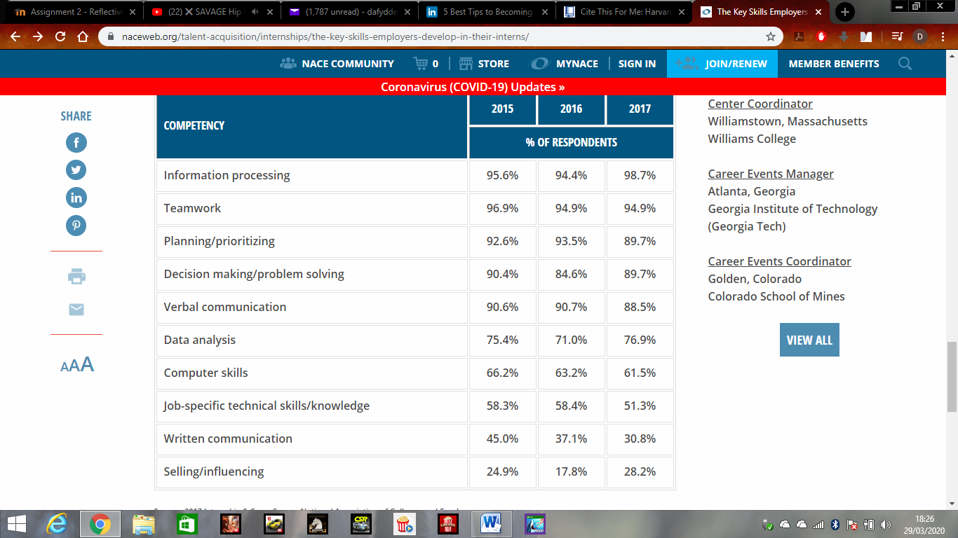

(National Association of Colleges and Employers, July 19, 2017).

In concerns with development in financial gain, the NACE describes internships as mostly unpaid or low paid. In the current internship carried out by the researcher, it was unpaid work for 28 days. However not all internships are unpaid, they are held by companies to help secure a full-time job or create insight into practical experience in a workplace. The financial circumstances for an internship is not the key initiative for participating, there are various responsibilities given to each intern in a company helping them to experience different roles to benefit them in deciding their future careers (Hughes, 2019). This highlights a work-based internship is for commitment to professional gain and technical learning to build their experience and to stand out from their peers by demonstrating some experience in their industry, rather than financial gain, although some peers are able to be paid with internships, not all are paid to the highest level (The London Institue of Banking & Finance, 2014).
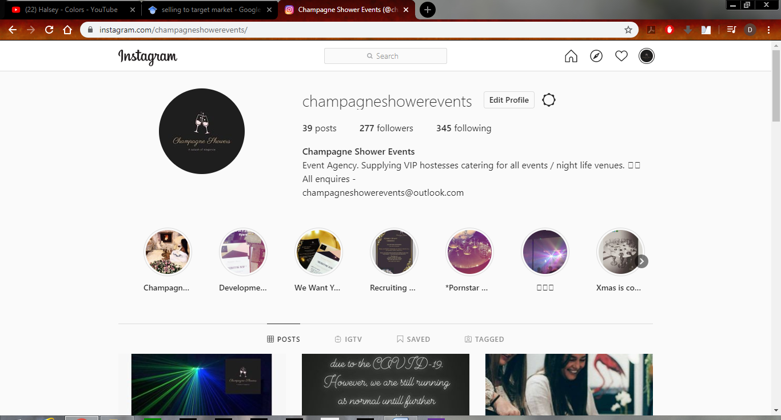
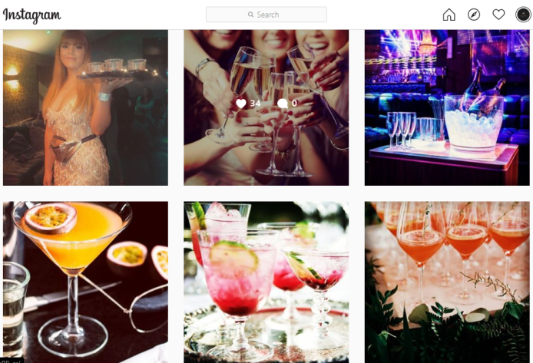
Furthermore, Joe Read recently completed his internship with the Bank of Cyprus, in which provides evidence of how the internship aids with his experience in achieving a higher position in a company or being promoted whilst in the organisation. Joe Read states “My internship provided a fascinating experience and allowed me to gain valuable insight into the thought processes of senior leaders in banking today. It has allowed me to gain practical experience and exposure to the industry and has provided the perfect platform to begin my career” (Read, 2020). This exposes that the placement is a critical factor in beginning to progress in a person’s career path, rather than financial gain in the short term, however it may create opportunities as mentioned to gain skills in knowledge of the workplace for economic achievement in the long term to be at a higher skilled level than your peers.
To conclude the Main Findings present, the number of followers gained in an image of the page (277 followers), the daily content released (posts) and the publication received by the posts (likes) (Champagne Shower Events, 2020).

Conclusion

In conclusion, one may highlight this internship and volunteerism assignment outlines skills used in the business industry and the skills that one can achieve when taking place in an internship. This internship has shown a person can develop a range of key skills, as a sustainable and socially responsible professional in critically analysing the development in participating in an internship (Hughes, 2019).
However, in participating in this role, limitations were revealed in regards to communicating with the venues to gain new business, using the “tagging “process for location or to promote a specific venue, there were further restrictions with the company, which was conveyed throughout the report. Another restriction mentioned is using some products of the company to promote ‘Champagne Showers ‘service such as “Jägermeister”, as the company felt this was a competitive advantage for other similar companies to target their own products. These restrictions did limit the resources to specifically target an area and to initially set up a new relationship building process, as it was difficult for new customers to approach the company, which was limiting the company to initialise the competitors to target their venues. These issues examined by the researcher, were highlighted previously in the main body and in blogs carried out, there were limits that is outlined by the researcher and throughout the process for the internship (National Association of Colleges and Employers, July 19, 2017).
The next section of the conclusion to address, is that the questions that are presented in the main body. Firstly, “Would this internship help to achieve skills for future employment?”, there are many skills that were developed in this internship including; communication, organisational skills, marketing, using self-initiative, team building and meeting deadlines, which are all skills that would improve characteristics of future livelihood in gaining the correct experience and knowledge for employment. Secondly, “Would this internship develop financial gain for future livelihood”, in completing the internship as previously discussed, this internship had no financial gain in the short term, as it was unpaid, however in the future, this internship may prepare skills to achieve a higher skilled and paid role in the business industry (Read, 2020). Thirdly, “Would the internship progress to a promotion or a higher role in a company “, in conduction of this internship it has been revealed that, when interning for ‘Champagne Showers ‘the role of dealing with social media was the basis of the position in which progression in the role was unavailable, as this role was expected through the participation of the internship. Nevertheless, the report highlights that the skills gained throughout the development process of an internship, can have an impact on successfully applying for a higher level expertise professionally and to be in a more qualified based position closer to a person’s career path (The London Institue of Banking & Finance, 2014).
Finally, to conclude this report, through participating in this internship a range of skills have been developed personally for future livelihood and as a sustainable /socially responsible professional. It is certain that placement is vital in gaining the experience needed for future employment and to gain knowledge of the working environment, some people may find employment in their placements or at least find skills to improve their professional skills for the workplace practice (Auken & Carraher, 2012).

Recommendations
After completing 20 days of the internship, developmental needs must be considered in order to be successful on the programme. As Locke (2004) explains a critical analysis is imperative to evaluating performance and can add to character building and justify strengths and weaknesses of individuals. Personally the internship experience is unique to the individual, however the findings appear to highlight that other people can have similar needs, some needs met and other identified, which is a part of learning and growing to meet targets for personal development and business professionalism. For example the following are some development needs that are expanded upon from the conclusion:

Identified Development Needs
Sustain Motivation levels and recognise that it can be personally achievable to work to deadlines. This can be used to improve grades within the business course and meet targets within the internship course.
Emotion regulation is vital, anger and disappointment can lead to poor decisions and this way of thinking can sometimes affect the work that needs to be done. This means concentration is important and can be done productively in order to progress within work ethics and the work place in general.
Taking feedback in an effective way and improve to be a more valuable worker. If something isn’t understood then doing your own research could help personal development.
Prepare for individual work and team work and make sure your social media skills are up to date as this can be used as a great marketing tool within business.
Apply for a business consultant job in a local company to give me the reassurance I need. If unsuccessful, the feedback will help improve skills for the next application and real work- life situations, to deal better with criticisms.
The table below reflects on what was learned from specific activities during the internship and explains what was learnt with an evaluation. The activity may be related to a training session, a particular feature of a topic, something involving the employer or a task that was done independently. This reflective evaluation was done on completion of the internship programme (Smith & Bergstrom, 2004). The following table highlights the activity timeline and evaluation of each outcome during my journey through the internship:
Date | Specific Activity | Learning Outcome and Reflective Evaluation | Key learning skill | Hours
01/02/20 | Virtual Induction day. | It was a nervous experience at the beginning of the internship as the internee had new faces to contend with as contacting bosses via facetime and new skills to learn in order to be an effective intern. Having a virtual induction was new to me but seemed to be operative when it came to the discussion as there was no time period of waiting between meetings etc. The intern was given the following two set goals on induction 1) achieve knowledge of the company ‘Champagne Shower Events’ and 2) gain understanding of social media in order to gain followers for the company. Instantly this felt like a practical test, the internee found understanding the procedure and pressure to get this process correct. As time went on throughout the day, doing things in steps meant understanding the training quicker and then producing things slower in the process of ‘breaking down’ the longer more difficult tasks. This induction day highlighted that one should not be afraid to learn the start of the process again as it takes longer than others, nonetheless in order to get the task complete effectively it is better to learn the process properly. | Problem solving such as learning in steps and Time keeping. | 3
07/02/20 | A discussion occurred on the ethical issues involved in the internship and the targets that need completing. | It was interesting to hear from the events industry that like other businesses they took ethical issues into consideration such as; Accounting (making sure tax/financial reporting is accurate), Social Media ( free speech issues), harassment/discrimination (recruitment), Health & Safety (employees) and Technology (Aral, 2013).  The accounting ethics was something already known to myself, making sure finances were correct was not part of the internship, however if needed the general knowledge of accounting legislations would be shared. The topic of social media, questions if it is ethical for companies to fire or otherwise punish employees for what they post about? It must be taken into consideration that social media could be counted as “free speech”? This hypothetical line is complicated, but it is drawn when an employee’s online activities are considered disloyal to the employer, meaning that a Facebook post would go beyond complaining about work and instead do something to reduce business (Jussila, 2014). This made it more aware to the internships of what to be aware of when dealing with marketing for a company. When it comes to conversing about harassment and discrimination it is important to be diverse and discrete when it comes to recruitment. It is not a direct ethical issue; however health and safety was discussed to underline what the employees go through when in the venues of the company. Technology is surprisingly used within ‘Champagne Shower events’ as the first initial communications tool for the company. As Westerman et al (2014) suggests technology is one of the main advantages to any company’s communications and marketing. This company entices its customers through social media and if it wasn’t for the development of social media applications then recruitment would be much more difficult. Understanding how to use the settings within the applications can affect marketing and this appears to be something that interns need to research and fellow social media handlers. This said privacy and understanding the image that ‘champagne shower events’ wanted to present was a major part of my internship.  It is frustrating in this restriction that this ethical issue is raised within business and within ‘Champagne Showers’. Personally this is when it came to front that any business contains risks and they must be looked at in order to make effective evaluations of a company not only for the employer but the employee. It appeared that a step back is needed and not to allow emotions to affect and rather concentrate on the solutions and how to overcome these ethical issues, which would be to do the best to abide by the guidance of the directors. This encouraged me to do my own research and hopefully aid me to work more effectively in future circumstances (Baker & Comer, 2012). Restrictions within the organisation as previously stated by the ‘privacy of the company’, made it difficult to network and built up frustration when coming across these marketing barriers and appeared to prohibit exposure of the company when trying to reach discussed goals. | Emotional stability and ethical issues considered. | 4
12/02/20 | Hitting targets | Champagne Shower Events wanted me to achieve 3 goals through my internship, which were the following; 1)reach above 200 followers on Instagram, 2) Upload daily content on Instagram account and 3) Obtain venues if possible for staff to work in and gain more profit for the company. Champagne shower directors (Sabrina & Charlotte) briefed and updated me daily via WhatsApp messenger group (Champagne Shower Events, 2020). Most of the communication was positive feedback from the directors regarding the amount of followers that were collected, however it was difficult at times to get the follower’s I wanted, as the directors didn’t want locations tagged, this was apparently due to competition tracking their venues. In target making, it must be highlighted that the opinion of your directors must be underlined as not only is it crucial for the intern to take in the customer opinions, but also the perspective the people involved in the hierarchy above the position. This highlighted that organisation and decision making is imperative to the role of the social media internship and helping take the burden off the directors and make the role of the internship more productive and essential. The targets gave me a sense of a mission and helped me focus on what I needed to do on a daily and weekly basis. Regardless the directors have the right to keep certain restrictions (Hiller & Belanger, 2001), these were a real burden when trying to create content as well as trying to network and obtain other venues (no tagging venues due to privacy regulations).This created a loop of recurring cycle when it came to attracting/approaching new venues, as they wanted exposure, but the directors wanted privacy, hence restrictions hindered the process. Recommending that a company looking for exposure must have a public outlook, rather than a private one. | Creating Targets and Organisation. | 3
20/02/20 | Virtual Meeting to Discuss Targets | Progress of targets discussed, 213 followers obtained via Instagram and daily content of employees on shift at events were publicised to gain followers. Also social gatherings were uploaded to target people in general (in main findings). However, the most difficult part of the role was speaking to venue managers over the phone as they appeared to be busy and wanted questions answered immediately. After my first phone call I made a ‘criteria’, it helped bullet point answers for target 3 of obtaining venues. One of the main questions involved profit and this meant asking the directors for figures, in order to look professional and give venue managers a good impression and realistic confidence in the service provided. Relative to future employment, it appears that sometimes it is a learning process and making a ‘criteria’ or ‘tools’ to help you in that process can not only help your own state of mind but initiate improvements in the way you complete tasks and achieving deadlines, agreeing with Akkerman & Filius (2011) business ethics. | Communications and tools within business target keeping. | 4
01/03/20 | End of Internship Feedback Meeting – debrief | The directors thanked the participation for the hard work and mainly explained how the internship helped alleviate stress and time management problems for them (Tyssen, et al., 2005). Both Directors evaluated the performance (please see post placement review and feedback forms in appendices) and they were thanked for providing me with the experience that many other companies turned down. If this role opens in the future paid then the position would be available for the internee. This was appreciated and helped to provide a reflection for future references. Recommendations for future internships would be for ‘Champagne Shower Events’ to have a full training procedure in appealing to venues as further knowledge was needed on the brewery industry and licencing around alcohol and events. | Self-Value and improving on skills. | 3

Keeping a log of my development such as the table shown above, highlights the strengths and weaknesses of the personal experience achieved through the internship and gives a detailed evaluation of the volunteerism process involved in working for an events company and the recommendations that must be considered into internships and future livelihood work goals.

References
Akkerman, S. & Filius, R., 2011. The use of personal digital assistants as tools for work-based learning in clinical internships.. Journal of Research on Technology in Education, 43(4), pp. 325-341.
Aral, S. D. C. a. G. D., 2013. Introduction to the special issue—social media and business transformation: a framework for research.. Information Systems Research, 24(1), pp. 3-13.
Auken, V. H. & Carraher, S., 2012. An analysis of funding decisions for niche agricultural products.. Journal of Developmental Entrepreneurship, 17(2), p. 12500012.
Baker, S. D. & Comer, D. R., 2012. “Business Ethics Everywhere” An Experiential Exercise to Develop Students’ Ability to Identify and Respond to Ethical Issues in Business.. Journal of Management Education, 36(1), pp. 95-125.
Bancroft, A., 2012. Drinking with and without fun: Female students’ accounts of pre-drinking and club-drinking.. Sociological Research Online, 17(4), pp. 142-152.
Brooksbank, R., 1995. Selling and sales management in action: The new model of personal selling: micromarketin. Journal of Personal Selling & Sales Management,, 15(2), pp. 61-66.
Champagne Shower Events, 2020. Champagne Shower Events. [Online]
Available at: https://www.instagram.com/champagneshowerevents/
[Accessed 01 feb 2020].
Hiller, J. S. & Belanger, F., 2001. Privacy strategies for electronic government.. E-government, 200(2001), pp. 162-198.
Hughes, E., 2019. The benefits of an internship in financial services. London Institute of Banking & Finance.
Jussila, J. K. H. a. A.-I. H., 2014. Social media utilization in business-to-business relationships of technology industry firms. In: Computers in Human Behavior. s.l.:s.n., pp. 606-613.
Locke, A. E., 2004. Linking goals to monetary incentives. Academy of Management Perspectives, 18(4), pp. 130-133.
National Association of Colleges and Employers, July 19, 2017. THE KEY SKILLS EMPLOYERS DEVELOP IN THEIR INTERNS. s.l.:NACE Staff.
Read, J., 2020. The London Institiue of Business and Finance. [Online]
Available at: https://www.libf.ac.uk/news-and-insights/news/detail/2014/10/21/the-benefits-of-an-internship-in-financial-services
[Accessed 01 01 2020].
Smith, A. M. & Bergstrom, K., 2004. Methods and systems for evaluation of business performance.. 10 ed. US: Gartner Inc.
The London Institue of Banking & Finance, 2014. The benefits of an internship in financial services. The benefits of an internship in financial services, 21 October.
Tyssen, R., Vaglum, P., Gronvold, N. T. & Ekeberg, 2005. The relative importance of individual and organizational factors for the prevention of job stress during internship: a nationwide and prospective study. Medical Teacher, 27(8), pp. 726-731.
Westerman, G., Bonnet, D. & McAfee, A., 2014. Leading digital: Turning technology into business transformation.. 1 ed. s.l.:Harvard Business Press.
Oxford, 2020. Internship Definition - Google Search. Google.com. Available at: https://www.google.com/search?sxsrf=ALeKk00IRW6eXpaoYjQrvJ4h4Xzs8XT9dw%3A1585422717170&ei=faF_Xqb8Cd2b1fAPuLGv8AY&q=internship+definition&oq=internship+&gs_lcp=CgZwc3ktYWIQAxgCMgQIIxAnMgQIIxAnMgQIABBDMgQIABBDMgcIABCDARBDMgQIABBDMgIIADICCAAyAggAMgQIABBDOgQIABBHUOkOWOkOYMQpaABwAngAgAFBiAFBkgEBMZgBAKABAaoBB2d3cy13aXo&sclient=psy-ab
Adegbulu, A., 2018. 5 Best Tips To Becoming A Person Of VALUE. Linkedin.com. Available at: https://www.linkedin.com/pulse/5-best-tips-becoming-person-value-adesoji-adegbulu
Matthew, 2020. Matthew 7:15. [online] king james version of the bible. Available at: https://en.kingjamesbible.org/bible/Matthew_7:15

Appendices
POST-PLACEMENT REVIEW AND FEEDBACK

Dear Participant

Many thanks for your involvement in the work placement. I hope that the experience was a valuable and rewarding one, whether you were a Placement Provider, Student or Placement Tutor. The University of Wales Trinity Saint David reviews the provision annually for enhancement purposes and so we would be pleased to hear your feedback on any aspect of the placement.

If you wish to participate, please use this form to record your views. I’d be grateful if you would return the form either in person, by postal mail or email to the contact details below.

Yours sincerely

Placement Coordinator: Davina Evans

Placement Coordinator’s address, email and telephone number
:Trinity Saint David’s,Carmarthen CAMPUS, SA31 3EP
01267 6767 67

Name of provider’s organisation: |  | Champagne Shower Events
Name of student: |  | Dafydd Evans-Evans
What were the positive aspects?
Dafydd was very productive in his method of communicating; we set up a WhatsApp group to confirm any procedures and posts to use on our events page. We set up 3 specific points to target in his placement, which were 200 followers, daily content and stories twice a day. Dafydd communicated with us daily and achieved these outcomes, in which we were very happy with.

Marketing material was approved by us through WhatsApp (uploaded daily). We found that the material Dafydd used was very effective and professionals, as we would instruct a subject to promote towards and Dafydd would create a post or story to target this audience.

Dafydd created his own methods to advertise to achieve followers; he decided to message ‘Influencers’ on our Instagram page to find more followers and use their images to bring in custom for Champagne Showers. We were very impressed with taking his own initiative when we spoke about gaining our clientele. Dafydd shows good problem solving skills when dealing with marketing situations and does well under pressure once we gave him daily targets and weekly.

Dafydd had a goal to achieve new venues for our company. He did this by contacting venues through researching the venue on social media and messaging the company. He also tagged venues to promote their establishment if we used they would use our service. This was very difficult for Dafydd to achieve as the management of the venues would have to speak to us once contacted and they had busy schedules.

Were there any problems?
Dafydd was very effective in his methods, as we created goals to achieve at the beginning of his internship. However the problems we faced was more to our restrictions in tagging companies that we were unable to use unless notified by the establishment. Another challenge is that we all have competitors in the industries we are in, a method mywork partner and I agree on is not tagging venues we supply our service to , which competitors can target. This is something that we feel can restrain any marketing intern in full completion of their goals.

Do you have any recommendations for enhancement for the future?
In recommendation, Dafydd was a great intern and we as a company would be happy to employ him. I do believe that Dafydd could improve on his patience on finalising tasks, as they do take time and It would take some pressure off his shoulders when faced with tasks.

In the future, Champagne Showers would recommend Dafydd to other companies wishing to improve their marketing in a short period of time, he works very well independently. However We would like to mention that Dafydd could improve on his team work skills , as he tends to bring on a leadership role, when working in a group. Dafydd has good drive and does not lack motivation, as you can tell all efforts go into each task and we as a company were impressed with his hard work and in achieving his goals we set.
Signed: | C. Lawrence
Name in block capitals: | CHARLOTTE LAWRENCE
Position (please tick one): | ☒ Placement Provider  ☐ Student  ☐ Placement Tutor |  | Date: | 01/03/2020
Thank you for completing this questionnaire. Please return it as soon as possible to the Placement Coordinator.
INTERNSHIP & VOLUNTEERISM
Assessment 1 – Pre-Placement Skills Audit
Name: Dafydd Evans-Evans

Placement Provider: Champagne shower events

Date: January 18th 2020
The purpose of this skills audit is to assess your skills set prior to you undertaking your placement to establish what skills you need to improve on during your placement. Please be honest, take some time for self-reflection and when responding to each skill try to think of an example of when you may have done this.
Skill | Already there | Well on the way | Gathering speed | Not currently
I think about the whole system when working to solve problems and developing ways of doing things |  | 
Example: such as doing a business plan, you have took at both internal and external issue’s that could affect the business

I have the ability to ability to address current and future problems creatively |  | 
Example: analyzing goals

I am confident in assessing and critiquing a range of information sources
Example: using social media and researching.

I have a critical understanding of connections between environment, social and economic factors
Example: Research and Communication with directors.

I am capable of engaging in self-reflection and analysis
Example: Feedback forms used and discussions.

I have a commitment to life-long learning
Example: future goals reflected upon.

I am committed to supporting and encouraging others with life-long learning
Example: Team building exercise with directors.

I am innovative and adaptable, proactive rather than reactive
Example: Situational tasks.

I am an engaging and dynamic communicator (written)
Example: Whatsapp group communications.

I am an engaging and dynamic communicator (oral)
Example: Social media posts.

I am an effective networker

Example: communicating with venues.

I am an effective facilitator
Example: Targets met.

I work well in cooperation with others
Example: Networking achieved.

I am a well-practiced and effective active listener
Example: Team exercises and goals understood.

I can organize myself and manage my time effectively
Example: I can work effectively by myself, but can forget to plan efficiently

I understand how to act as a responsible citizen
Example: responsibilities involved.

I have a clear vision of forthcoming change and how to act to realize a sustainable future
Example:

I feel competent in leading on change for social, environmental and/or economic benefit
Example: using different resources.

I feel comfortable speaking openly about my values
Example: Opinions demonstrated in report writing and within communications with directors.
I can lead with integrity driven by my own values
Example: personal goals.

INTERNSHIP & VOLUNTEERISM
Assessment 3 – Post-Placement Skills Audit
Name: Dafydd Evans-Evans

Placement Provider: Champagne shower events

Date: 1st of march 2020
The purpose of this skills audit is to assess your skills set prior to you undertaking your placement to establish what skills you need to improve on during your placement. Please be honest, take some time for self-reflection and when responding to each skill try to think of an example of when you may have done this.
Skill | Already there | Well on the way | Gathering speed | Not currently
I think about the whole system when working to solve problems and developing ways of doing things | 
Example: Own initiative used

I have the ability to address current and future problems creatively
Example: Research conducted.

I am confident in assessing and critiquing a range of information sources
Example: Evaluating evidence and sources.

I have a critical understanding of connections between environment, social and economic factors
Example: Researched issues and completed reports.

I am capable of engaging in self-reflection and analysis
Example: Opinions and reflection given through the report.

I have a commitment to life-long learning
Example: Goals achieved.

I am committed to supporting and encouraging others with life-long learning
Example: Teamwork.

I am innovative and adaptable, proactive rather than reactive
Example: I have won multiple innovative product competitions.

I am an engaging and dynamic communicator (written)
Example: Multiple Social media sources used.

I am an engaging and dynamic communicator (oral)
Example: Presenting within the project and class.

I am an effective networker
Example:
I have connections to any supplies I will ever need, or any future business will need.
I am an effective facilitator
Example: Used various resources.

I work well in cooperation with others
Example: Working with directors.

I am a well-practiced and effective active listener
Example: Goals set and achieved.

I can organize myself and manage my time effectively
Example: getting better, still a short attention span.

I understand how to act as a responsible citizen
Example: Understanding what is required, still in the process of learning.

I have a clear vision of forthcoming change and how to act to realize a sustainable future
Example: trading trends show the downfall of brick and mortar companies.

I feel competent in leading on change for social, environmental and/or economic benefit
Example: Adaption and Leadership skills learnt.

I feel comfortable speaking openly about my values
Example: Opinion was important when it came to speaking to the directors.
I can lead with integrity driven by my own values | 
Example: Personal goals and values set in the report.

