

Methods and Search Strategy Academic Poster

Student name:
Student ID:

Module name: Independent Project
Module code:BMHP6020

Dissertation Title: Examining Economic and Geographic Barriers to Healthcare Access in Rural England: Challenges and Solutions
- Introduction and Research Aims  A methods chapter is a roadmap of a study outlining the exact methods of identifying, selecting and analysing information to make the research reproducible and rigorous. This poster lists the secondary research methodology that was deployed to explore the topic of rural healthcare (Shah et al., 2017).  Research Aim: The study aims to address the problem of geographic or economic constraints to healthcare in rural England. | 02 Search Strategy  A second research search strategy refers to a systematic method of locating the appropriate literature and data by using special keywords, databases, and filters.  Strategy: In this project, the search terms were operated with Boolean operators (AND/OR) with the terms such as: Rural England, Healthcare Access, and Economic Barriers.  Execution: This guaranteed the retrieved high-quality sources in academic and governmental repositories.
03 Searching for Information  The search process was based on retrieving the most applicable data on the current health issues in rural areas.  Step 1: Discovery of important databases such as Google Scholar, PubMed, and the UWTSD Library.  Step 2: Narrowing the search to only articles within the past decade to obtain up-to-date information.  Step 3: Screening abstracts and executive summaries to see how much it is relevant to the English rural context. | 04 Picture / Graph / Visual Aid / Statistics  The information lays emphasis on four key obstacles to access to healthcare in rural England. The most extreme limitation is Specialist Access that indicates a great challenge in getting intricate medical treatment (Gobburi et al., 2025). Both Travel Distance and Transport Option are rated high, demonstrating the way geographic distance and the lack of infrastructure compel residents to travel longer distances with less money. Lastly, Practitioner Availability implies that the ratio of the number of medical staff is lower than in cities. All these combined contribute to the current unequal healthcare conditions and require a radical change in policies (Afni, 2023).  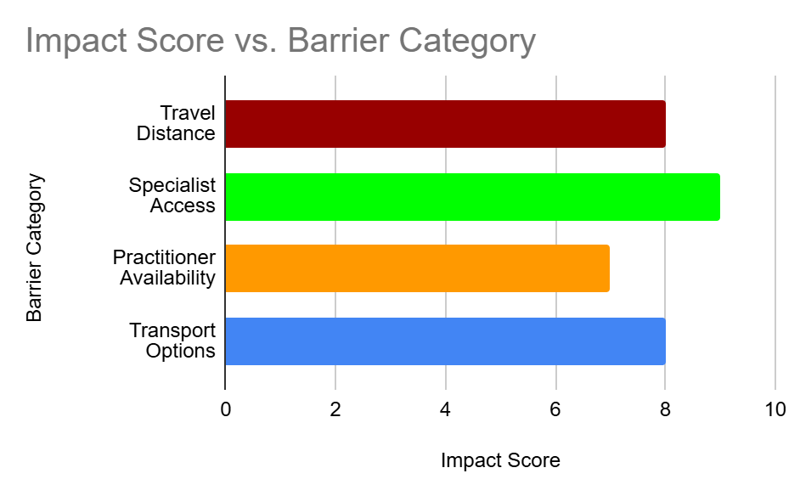  Figure: Impact score vs Barrier Category (self-made)
05 Research Validation and Analysis
Validation in secondary research can be described as checking the accuracy, credibility and authoritative source of the data collected.
Significance: Reliability is essential in coming up with effective policy recommendations.
Analysis: Thematic Analysis has been applied in this study.
Process: The literature was coded and trends observed to determine widespread themes (like the "urban-rural divide" and the "gap in specialist care) that will constitute the findings chapter.

06 Inclusion Criteria  Recency: The sources published are not older than 10 years (2015-2025).  Geography: Data narrowed down to the UK/England.  Accessibility: Online, fully accessible peer-reviewed journal articles and government reports. | 07 Exclusion Criteria  Old Data: Any sources that are above 10 years old.  Inapplicable Scope: Experiments that were carried out in cities or other countries, other than the UK.  Limited Access: Sources that could not be accessed by the university or another publicly available databases.
08 Ethical Considerations
In secondary research, the ethical issue concerns the responsible utilisation of already existing data, making sure that the work of the original authors is not violated and that no additional damage is produced.
Intellectual Property
All original sources have the UWTSD Harvard referencing so that no plagiarism can occur.
Data integrity
The integrity of the study was ensured by using peer reviewed, trustworthy and official governmental sources.
Confidentiality
No human participants were involved, but all the secondary data were managed according to GDPR and privacy principles.

References

Afni, N., 2023. Disparities in Healthcare Access: Addressing Systemic Barriers in Urban and Rural Communities. Journal of Health Literacy and Qualitative Research, 3(2), pp.112-122.
Afni, N., 2023. Disparities in Healthcare Access: Addressing Systemic Barriers in Urban and Rural Communities. Journal of Health Literacy and Qualitative Research, 3(2), pp.112-122.
Cyr, M.E., Etchin, A.G., Guthrie, B.J. and Benneyan, J.C., 2019. Access to speciality healthcare in urban versus rural US populations: a systematic literature review. BMC Health Services Research, 19(1), p.974.
Gobburi, R.K., Olawade, D.B., Olatunji, G.D., Kokori, E., Aderinto, N. and David-Olawade, A.C., 2025. Telemedicine use in rural areas of the United Kingdom to improve access to healthcare facilities: A review of current evidence. Informatics and Health, 2(1), pp.41-48.
Gobburi, R.K., Olawade, D.B., Olatunji, G.D., Kokori, E., Aderinto, N. and David-Olawade, A.C., 2025. Telemedicine use in rural areas of the United Kingdom to improve access to healthcare facilities: A review of current evidence. Informatics and Health, 2(1), pp.41-48.
Huot, S., Ho, H., Ko, A., Lam, S., Tactay, P., MacLachlan, J. and Raanaas, R.K., 2019. Identifying barriers to healthcare delivery and access in the Circumpolar North: important insights for health professionals. International journal of circumpolar health, 78(1), p.1571385.
Shah, T.I., Milosavljevic, S. and Bath, B., 2017. Measuring geographical accessibility to rural and remote health care services: Challenges and considerations. Spatial and spatio-temporal epidemiology, 21, pp.87-96.
Shah, T.I., Milosavljevic, S. and Bath, B., 2017. Measuring geographical accessibility to rural and remote health care services: Challenges and considerations. Spatial and spatio-temporal epidemiology, 21, pp.87-96.
Woods, M., 2025. Rural recovery or rural spatial justice? Responding to multiple crises in the British countryside. The geographical journal, 191(4), p.e12541.

