Name: Nurjahan Begum

Student number:1912210

Program: BA (Hons) Management and Leadership – Skills for the Workplace

Module: Workplace Culture and its impact on Organizational Efficiency

Module code: BMSW_5105

Module lecturer Ugu Ugochukwu

Assignment Title: Individual project report task one

TITLE: ACADEMIC REPORT BASED ON WORKPLACE
CULTURE AND CONTEXT AT RUSHCLIFFE
BEAUMANOR CARE HOME



CONTENTS

Introduction……………………………………………………………………………………………4

Part one: Porter’s 5 Forces analysis and identifying key drivers for changes at beaumanor care homes environment……………………………………………………………………….5-6

Concluding the attractiveness at Beaumanor care home………………………………………7

Part two: Interview regarding culture at beaumanor………………………………………………………….7-8-9

Part three: Definition of ethical dilemma…………………………………………………………………………………10

Two ethical dilemmas and actions taken from an ethical point of view………………………11

Conclusion………………………………………………………………………………………………………………………….……12

Recommendation………………………………………………………………………………………………………………………12

References………………………………………………………………………………………………………………………13-14-15

Appendix………………………………………………………………………………………………………………………………18-19

INTRODUCTION

My name is nurjahan begum I am a student at Birmingham university studying BA (Hons) Management as well as leadership-skills for the workplace. Here at Birmingham university, I have been assigned a task to produce an academic report and show how I can demonstrate my knowledge of my chosen workplace culture and context, as I am not working, my report will be based around my daughter Reema’s workplace at Beaumanor nursing and residential care home. Her job role as a support worker is to take care of the elderly everyday needs such as bathing, toileting, dressing, shopping, doctors etc. (Kiljunen,2019) addresses that “The physical environment is supposed to be as homely as possible in Finnish care homes. There are common spaces in these facilities in addition to residents’ rooms and the residents are allowed to bring their own furniture and wear their own clothes”. Beaumanor care home is a private nursing and residential care home based in Leicestershire which has been open since 1977 with fifty-three single rooms. Beaumanor care home are demonstrated with a broad array of caring such as cancer, epilepsy, Huntington disease and many more. Beaumanor care homes mission is to provide twenty-four-hour care, high quality service, first class customer care and cater to each clients individual needs and help them maintain a stimulating independent, trustworthy, safe lifestyle maintaining their dignity and self-respect. (Murray,2017) “Registered care homes in England are mostly operated by the independent sector. Health and social care are funded separately but most residents and/or families pay part of the costs”.

In my essay I will be addressing three issues. Firstly, I will be carrying out a porters five forces analysis at Beaumanor care home and will be identifying the key drivers for changes and the attractiveness of the business environment. Secondly, I will be developing a detailed analysis of the culture at Beaumanor care home and will be interviewing two employees about culture at the workplace, with questions based around the cultural web. Thirdly, I will be looking into and identifying two ethical dilemmas at the workplace which need to be solved and will be explaining the choices of my actions and justifying my actions from an ethical point of view.

PART ONE
Porters 5 forces analysis and identifying key drivers for changes at Rushcliffe Beaumanor care home and concluding the attractiveness of the business environment.

The five forces analysis is an analytical model a framework which recognizes and evaluates five competitive forces which shapes a business and identifies their strengths and weaknesses. Five forces evaluation is commonly applied to detect company’s arrangement to determine a business approach. The study of five forces is utilised by companies to comprehend the amount of rivalry they are facing inside the business then improve a business’s lengthy-term productivity for example, competition amid current participants is, Risk of fresh competitors, trading influence of buyers, risk of substitute goods, negotiating power of traders. Isabelle et al (2020) comments” Porter introduced his five forces framework in 1979 to understand an industry’s attractiveness. His framework revolutionized the way managers and entrepreneurs analyze their industry’s competitive environment by examining specific forces driving industrial competition. It has become one of the most popular business strategy tools”. Below I have provided a link to a video that explains in detail The five competitive forces which form a approach explained by Michael E Porter himself. And a model of five porters analysis.
https://www.youtube.com/watch?v=mYF2_FBCvXw
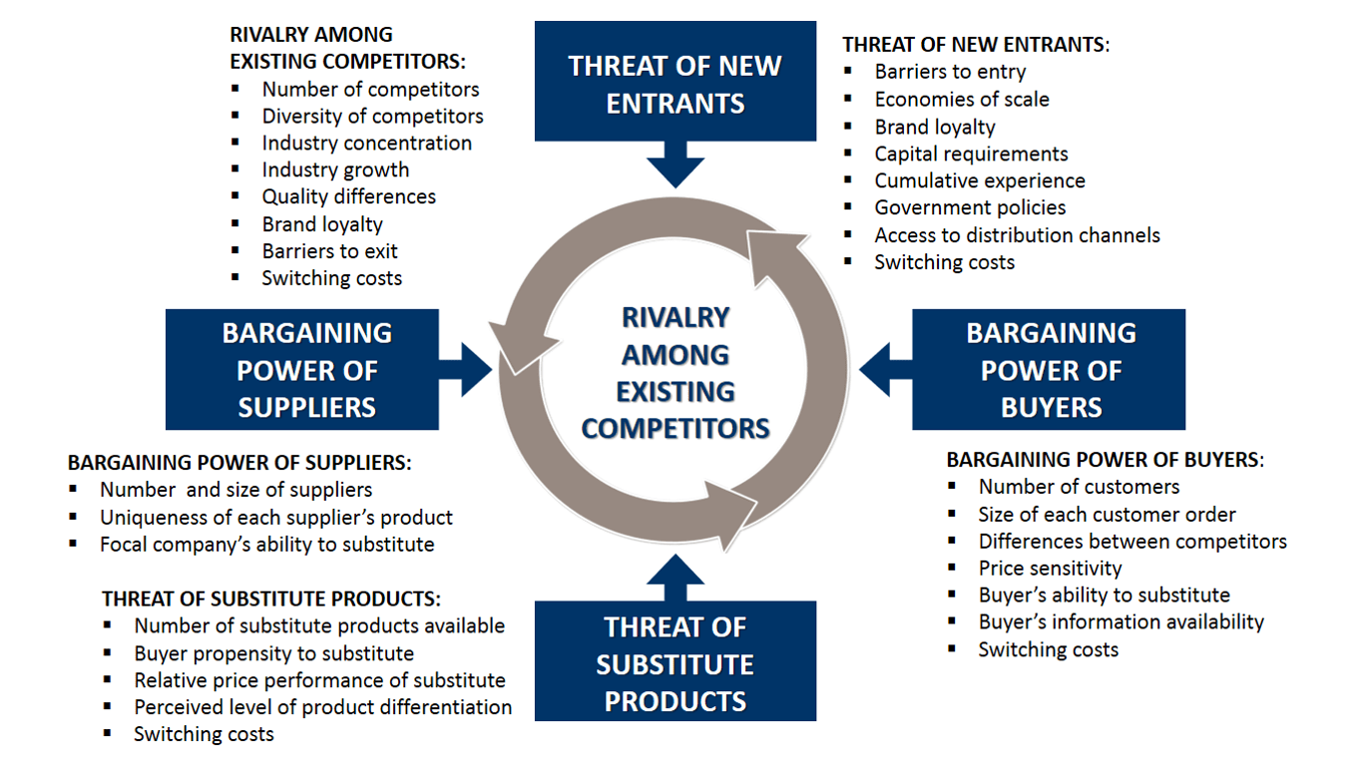
Source: B2U (2016)

Threat of new entrants
Beaumanor care home faces a threat of new entrant because new Care homes might have high pay strategies that entice support workers, nurses, the quality of new entrants teaching could be high and as such, employees will leave and join new companies leaving beaumanor care home with a bad reputation a loss of profit, loss of clients, nurses, and support workers.
Bargaining power of suppliers:
Beaumanor care home have many suppliers of products from beds, chairs, training material personal protective equipment (PPE) most of their products are supplied from China as it is cheaper than UK market. Due to Brexit, problems can arise having no access to EU market and dealing with exchange rates.

Threats of substitute products or services:
Rather than working for a Care home, individuals could prefer to be employed by a Care agency leaving Beaumanor with restricted amount of workforce and fewer clients with care homes heading to a drop in their profits.

Rivalry among the existing competitors:
Beaumanor care home faces competition from other care homes like Jasmine courthouse who offer equal services as them, and for Beaumanor care home to be top level players, they must deliver top quality customer services to their clients and salary should be competitive. (Bruijl,2018) Findings establish that,” the framework allows organizations to obtain not only a glimpse of the industry at a particular point in time, but a view of the dynamics of the industry and potential changes in the future”.

Bargaining power of buyers:
If customers remain unsatisfied with the value of provision offered through Beaumanor care home staff, they have the option to end their agreement with them and change to another care home. which become as loss to Beaumanor care homes profits and their character because of the poor response that will be given by clients and their families.
Key drivers of change
- Strategic plan
- Vision and admission
- Service delivery charter
- Staff commitment

Concluding the Attractiveness of Beaumanor care home
- Nurses, Support workers, quality of service and care has a large impact on how clients and their families make decisions about keeping their loved ones in the care home long term.
- Price of care homes attracts customers.
- End of life care service
- Health and safety

Reis et al, (2017) comments that “An employer’s attractiveness depends largely on the beliefs that jobseekers hold about an organization’s different attributes (i.e., employer image), as well as on their actual familiarity with the employer’s brand and its reputation”. (Cable and Turban, 2001).

Part two
A detailed analysis of culture at Rushcliffe Beaumanor care home surrounding the cultural web model with an interview guide.

The second part of my assignment will be me interviewing two employees at Rushcliffe Beaumanor care home and providing an analysis about the culture, character, and their personality within the organisation. My interview will consist of six questions based around a cultural web model. Gerry Johnson and Kevan Scholes formed the cultural web model in 1992 identifying six elements that categorises six related elements of organisational culture that clarify what Johnson and Scholes say about the "paradigm” and model of the work environment. (UWTSD Birmingham 2021) verifies that (Cacciattoole et al 2014) implies that ‘The Paradigm’ represents the purpose of the organisational business, its mission, and its values. The ‘Control Systems’ are the procedures set to control what happens in the organisation (Johnson 2000:405)”.
Johnson and Scholes cultural web is structured for management, and organisational means utilized to represent the culture of an establishment as well as seeing and acknowledging the distinct impacts which alter organisational cultures inside and outside the organisation. It is used to assess current and upcoming culture based on situation of what culture needs to look like, what needs to be done, what works and what doesn’t work. Also, where and how changes can be implemented for improvement. My research and analysis of the culture at Beaumanor care home is to understand how leaders and managers embrace and implement culture along with how they influence employees engagement, satisfaction, and performance. (Meng, J et al 2019) favours the statement “Following this argument, our study focuses on supportive organizational culture and excellent leader performance as two related and essential conditions for fostering professionals’ work engagement, trust, and job satisfaction”. Below I have provided a brief explanation on Johnson and Scholes cultural web. A full guide of the interview with employees at the care home is provided in the appendix. A video link has been provided below to understand organisational culture.
https://www.youtube.com/watch?v=PHmoYAzpchU, (2020)

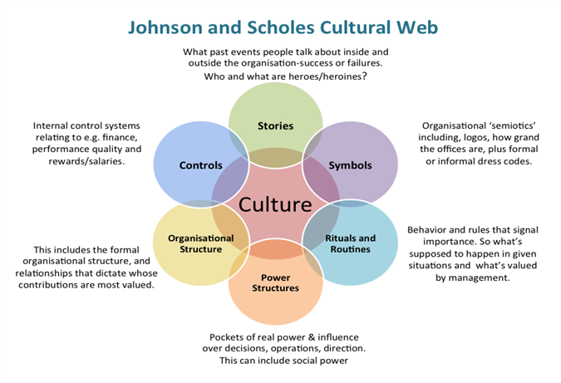
Source: The management centre (2021)

Stories is when you share and tell a story and describe the social and cultural activity, stories also serve a purpose such as education, cultural preservation or instilling moral values.
Rituals is defined as the attitude behind the action, routines are defined as the action that need to be done like having a shower, brushing your teeth, having breakfast.
Symbols is an entity representing a culture, something that signifies or implies something else. Symbols often take the form of words, visual images, or gestures that are utilized to express views and beliefs.
Organizational culture defines how people should behave appropriately within an organization. culture is shared beliefs and values generated through leaders communication and reinforced through several methods, influencing employee perceptions, behaviours and understanding.” Doherty& Stephens(2020) claimed that “Schein (2004, p 17) defines culture as a pattern of shared basic assumptions that is learned by a group as it solves its problems and that is considered valid and is, therefore, taught to new members. However, this notion that culture is a shared phenomenon is questioned by Martin (2002), who suggests that different values may be displayed by people of the same culture”.
Control Systems is a system which allows executives to follow up on the organizations performance, identify areas that need to be considered and take action to resolve the problem.
Power Structure can be defined as is a order of competence based on authority amongst a person and other individuals in a company. A power structure focuses on the way being in charge and influence is associated among individuals within groupings like government, nation, society and businesses.
In relation to the interview of two employees at Rushcliffe care home my analysis on stories based around cultural web identifies that employee number one’s story is about their inspection report that was presented to Rushcliffe Beaumanor care homes employees for good practices during the Covid-19 in 2021. This is an excellent recognition and a positive impact on the organisation culture and reputation. My analysis based on Symbols was about company uniform which is purple with a logo with the letter R in black which represents the company and identifies the individual as an employee at Rushcliffe care home. My third question and analysis on culture controls talked about the reward system and says she has been able to climb the career ladder through their reward systems and training which means their strategies of keeping employees focused and engaged is helpful. My fourth question was on organisational culture, my analysis is that the manager has good leadership qualities and good systems in place for employees performance, productivity, promotion, and engagement. My analysis question number four was on Power structure is that full power is on owner of company then down to CEO, leaders ad managers, supervisors who the influencers and directors of employees are. Finally, my analysis on routine and rituals is that these two elements put together powers the daily work routine in employees performance. The manager provides a clear structure, timeframe of tasks to be performed by employees so that they can work effectively and efficiently in the daily care and wellbeing of residents at the care home. Their Rituals guides employees to keep their attention where it is most likely needed and helps them through the day to stay motivated and focused to allow them to improve on good quality performance. (E4J, 2018) states that “The values of leaders influence the culture of an organization or society, and whether it behaves ethically or not. Leaders set the tone, develop the vision, and their values and behaviours shape the behaviour those involved in the organization or society”.

Part three
Definition of ethical dilemma and two ethical dilemmas at Rushcliffe beaumanor care home which need to be resolved with an explanation of my choices and action with an ethical point of view.

Definition of ethical dilemma
An ethical dilemma is when we are faced with a difficult situation in which we must make a choice between two or more options. Neither of which solves the situation in a way that is consistent with accepted ethical rules. This could be religious teachings, codes of law, or with their internal ethical insights of right and wrong. (Nayak 2017) expressed that “Ethical dilemma is a difficult situation for the individual as it cannot be solved in a mathematical precision to safeguard your interest and yet follow ethically right choice.” For example, ethical dilemma could be something at work which is something that goes against one’s personal ethics, morals, and values. It could be a colleague or manager or even yourself that is doing something which is wrong. Ethical dilemmas can strengthen and sway your decision to decide whether you should be honest or dishonest or even play on your thinking of right and wrong. Below is an ethical decision-making model, a tool for critical thinking provided by Hodges and stein Holtz, (2018) which can be used for a variety of situations and support grow the capacity to reflect through an ethical dilemma and attain at an ethical verdict which requires trust, responsibility, fairness, considerate, being respectful and being responsible to the given situation and the individual.

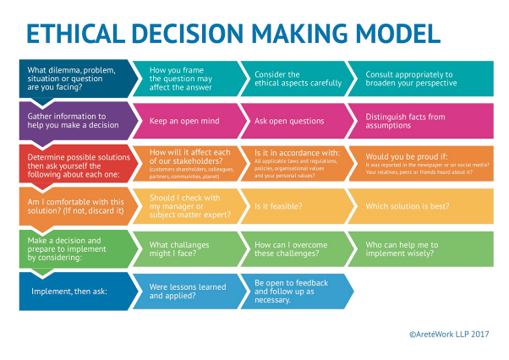
Source: E4j (2018)
I have provided a video link to understand ethical decision making: (2020),Ethical Decision Making - YouTube
Two ethical dilemmas and actions taken from an ethical point of view

Ethical dilemma one: Sexual harassment
My first choice of ethical dilemma is about sexual harassment at a workplace by a close male friend who repeatedly spoke and touched another female member of staff inappropriately and my concerns would be this is sexual harassment. (Tinkler and Zhao, 2020) clarifies that” In support of this supposition, research has shown that those with lower status, that is those who have less structural power, are often targets of sexual harassment. Women are more likely to be harassed than men and young women are significantly more likely than older women to experience sexual harassment.” Despite this being my friend, I would look at my choices. Firstly, I would determine why a decision is needed, identifying the outcome, define the problem which will then help shape my understanding of its causes and search for solutions. My action would be to speak to my colleague and tell them this is wrong and what they are doing goes against our beliefs and values and remind them of the consequences of their action. If raising my concerns with my friend doesn’t make a change in their actions, then I would make an anonymous complaint to a supervisor, manager, or human resources department, where my identity would be concealed, and hopefully the problem would be solved. This ethical point of view will help save this person from emotional suffering and save my friend from being dismissed from work and me being able to keep my friendship intact.

Ethical dilemma two: Abuse of Leadership Authority
Michael et al. (2017) emphasized that “The role of ethical leadership in influencing the performance of the employees rests on the pedestal of behavioural motivation, inspiration and individualized consideration”. My second choice of ethical dilemma would be if a manager abused their power of authority that would go under discrimination if I had witnessed the manager constantly swearing, humiliating employees in front of others, making abusive comments and jokes, my thoughts would be to approach the manager and raise my concerns, but it could backfire, and I could become a target of her abuse or even lose my job. My choice would be to report her to a higher rank like Human resources or to the boss. Before I do that, I would take notes and times, names of employee and witnesses and even ask the employees to keep a journal too. This ethical point of view would give Human resources (HR) grounds to come to a solution and resolve the matter and as a result, employees will be able to come to work without being intimidated or fearful and we all get to keep our jobs.

CONCLUSION

In conclusion to this report and research based on workplace culture at Beaumanor care home, I now understand that the company culture is important at the care home as well as employee engagement and business productivity. This is shown through the use of various tools such as, the five porters five main competitive forces which has helped Beaumanor care home identify the competitive situation, the figures and power of a organizations competitive rivals which help them to understand their own strengths and weaknesses and identify factors affecting profitability. This gives leaders an advantage to make informed decisions and make changes before-hand and stop any losses occurring and stay ahead with trends. In relation to my analysis and questions I had for employees culture at the care home based around the cultural web was found to be positive as leadership was perceived to be of a high standard with good structure strategies and has a strong impact on the organisational culture through teamwork, care, rewards, motivation, communication, feedback from clients and employees. This suggests that organisational culture has an impact on the residents wellbeing. My analysis and understanding on ethical dilemma of sexual harassment and abuse of leadership emphasizes that when an individual or manager makes a decision from an ethical point of view, one considers the feelings and needs of others which helps maintain an honest, supportive, and fair workplace culture. All things considered Beaumanor care home strategies have been successful in high standard, quality performance towards the wellbeing of the residents. Overall, my analysis is that understanding and implementing the various tools/framework and being able to assess key factors is a successful strategy in employee engagement, profitability, and attractiveness of the company.

RECOMMENDATION

Summarising my key findings of my report based around porters five forces are if Beaumanor care home want to have power over their rivals the organization must improve on its services to provide better value and quality which their staffs provide to its clients and deliver high standards of attention and client provision. To achieve this, beaumanor care home must provide high standard training to its carers and nurses. Regards to a positive culture at the care home, Beaumanor leaders and managers must empower and reflect unity through their leadership skills and share the companies values, vision, purpose, practice, and goals. The residents’ all in one experience received from care workers and staff will have a big impact and influence on the organisation and culture of the home. Implementing a solid constructive culture will help incorporate expectations, ethics, and values strengthening high quality care and support for residents. The final recommendation on ethical dilemma and ethical point of view is that managers and leaders must think critically through an ethical dilemma and be honest, fair, respectful and responsible towards the individual and be able to resolve the situation from an ethical point of view. Only then can managers maintain a positive loyal, happy workforce and avoid legal problems and attract and retain talented employees.

REFERENCES

Birmingham University, (20221) understanding organisational culture [online] available at:https://moodle.uwtsd.ac.uk/pluginfile.php/284575/mod_resource/content/0/Activity%204.3%20Understanding%20organisational%20cultures.pdf (Accessed: 17th June 2020)

B2U, (2016).Porter's Five Forces EXPLAINED with EXAMPLES | B2U (business-to-you.com)[Online image] Available at: https://www.business-to-you.com/porters-five-forces/ (Accessed: 10th June 2020)
Bruijl, G.H.T., 2018. The relevance of Porter's five forces in today's innovative and changing business environment. Available at SSRN 3192207.[Google scholar] Available at: https://www.researchgate.net/profile/Gerard-Bruijl/publication/326026986_The_Relevance_of_Porter%27s_Five_Forces_in_Today%27s_Innovative_and_Changing_Business_Environment/links/5c14165c299bf139c7593f03/The-Relevance-of-Porters-Five-Forces-in-Todays-Innovative-and-Changing-Business-Environment.pdf (Accessed: 29th June 2021)

Chikeleze, M.C. and Baehrend Jr, W.R., 2017. Ethical leadership style and its impact on decision‐making. Journal of leadership studies, 11(2),pp.45-47.Available at:https://www.researchgate.net/profile/Naser-Almutairi- ( Accessed:15th June 2020)

Doherty, O. and Stephens, S., 2020. The cultural web, higher education and work-based learning. Industry and Higher Education, 34(5), pp.330-341.[Google scholar] Available at:
https://scholar.google.co.uk/scholar?hl=en&as_sdt=0%2C5&a (Accessed: 5th June 2021)

E4J (2018), University Module Series:Integreity and ethics,[online image]Available at https://www.unodc.org/e4j/en/integrity-ethics/module-4/key-issues. (Accessed: 18th June 2021),

The five competitive forces that shape strategy (2008) [ video]
Available at:https://www.youtube.com/watch?v=mYF2_FBCvXw (Accessed:16th June 2021)

Isabelle, D., Horak, K., McKinnon, S. and Palumbo, C., 2020. Is Porter's Five Forces Framework Still Relevant? A study of the capital/labour intensity continuum via mining and IT industries. Technology Innovation Management Review, 10(6) .[google scholar] Available at: Is Porter's Five Forces Framework Still Relevant? A study of the capital/labour intensity continuum via mining and IT industries | TIM Review (Accessed:16th June 2021)
Kiljunen, O., 2019. Care home nursing professionals' competence in older people nursing (Doctoral dissertation, Itä-Suomen yliopisto).[Google scholar] Available at:https://erepo.uef.fi/bitstream/handle/123456789/20448/urn_isbn_978-952-61-2949-5.pdf (Accessed: 25th June 20121)
Murray, L., 2017. The role of the registered nurse managing pro re Nata (PRN) medicines in the care home (nursing): a case study of decision-making, medication management and resident. [Google scholar]Available at: https://uhra.herts.ac.uk/bitstream/handle/2299/17989/01001964%20Murray%20Lorraine%20final%20DHRes%20submission.pdf?isAllowed=y&sequence=1 (Accessed: 25th June 2021)

The management centre(2021) Culture eats strategy for breakfast - The Management Centre.[online image] Available at:https://www.managementcentre.co.uk/management-consultancy/culture-eats-strategy-for-breakfast/ (Accessed:16th June 2021)

Reis, G.G., Braga, B.M. and Trullen, J., 2017. Workplace authenticity as an attribute of employer attractiveness. Personnel Review. [Google scholar ] Available at: https://pesquisa-eaesp.fgv.br/sites/gvpesquisa.fgv.br/files/arquivos/2_pr-07-201(Accessed:2ndJuly 2021).

Tinkler, J.E. and Zhao, J., 2020. The sexual harassment of federal employees: Gender, leadership status, and organizational tolerance for abuses of power. Journal of Public Administration Research and Theory, 30(3), pp.349-364.[Google scholar]Availableat: https://www.icos.umich.edu/sites/default/files/lecturereadinglists/Tinkler%26ZhaoJPART2020.pdf (Accessed:28th June 2021).

Leadership and organisational culture[video] Available at: Johnson and Scholes Cultural Web Model | Analysis | Cultural Web ACCA SBL | Paradigm | Analysis - YouTube (Accessed:28th June 2021)

Meng, J. and Berger, B.K., 2019. The impact of organizational culture and leadership performance on PR professionals’ job satisfaction: Testing the joint mediating effects of engagement and trust. Public Relations Review, 45(1), pp.64-75.[Google scholar] Available at:hhttps://fardapaper.ir/mohavaha/uploads/2020/09/Fardapaper-The-impact-of-organizational-culture-and-leadership-performance-on-PR-professionals%E2%80%99-job-satisfaction-Testing-the-joint-mediating-effects-of-engagement-and-trust.pdfttps://journals.sagepub.com/doi/pdf/10.1177/1741143218788580(Accessed: 18th June 2020)

Nayak, S.V., 2017. Ethical Dilemma at Workplace-A Case Study. DHARANA-Bhavan's International Journal of Business, 10(2), pp.18-20. [Google scholar] Available at:16063-17777-1-SM (2).pdf (Accessed:28th June 2021)

You tube, (2019) Ethical decision making [video] Available at:
https://www.youtube.com/watch?v=n0uwTBrgqx I (Accessed:25th June 2021)

Appendix
Interview with two employees from Rushcliffe Beaumanor care home based on organisational culture to identify stories, symbols, controls, organisational culture, power structure, rituals, and routines.

Employee number one:
Question no 1: What can you tell me about culture based on stories at the workplace?
A Our manager held a meeting to let us know of our team effort and success, a story I can tell you recently that we are proud of, during the covid-19 pandemic our inspection report from 11th March 2021 was outstanding for good practice:
Staff wearing personal protective equipment (PPE), Staff received training on PPE and had access to the services and policies and procedures on covid-19 and how to work safely, cleaning schedules were in place, cleaned regularly and chlorinated products were used throughout the service. The manager rewarded the staff with appraisal which feels good to be part of something and make a change and an accomplishment is nice as our work didn’t go unrecognised. We couldn’t have accomplished this without our manager .
Question no 2: What can you tell me about culture based on symbols what your dress code is at work?
Our uniforms are formal it consists of black trousers, purple shirt jacket with an embroidered white logo with the letter R which means Rushcliffe. Our uniform represents us as employees at Rushcliffe care home.
Question no 3: What can you tell me about controls, the reward system at the workplace?
There is a good reward program in place here at the care home we have a workforce appreciation platform it is created to recognize and prize exceptional effort such as high-level punctuality record, hardest working employee, staff who go beyond helping residents and employee of the month. we get rewarded with pictures vouchers, food coupons, dinning vouchers, Holiday for two. The reward program for me has been motivating, kept me driven and focused on meeting Rushcliffe care homes vision and goals as my own because of the recognition and feedback I have got from my manager which has had a very influential impact on me. As I like my job as a support worker and wish to pursue my career here at Rushcliffe care home through their training programmes and support. I have been employee of the month several times through feedback from other colleagues feedback system which is employee of the month feedback by, and we must put our input in why we think this person should be rewarded for employee of the month I have been given recognition of helping residents above and beyond through feedback system that is given by residents and their families. The manager has been reviewing and holding meetings once a month recognising our hard work, giving out rewards, and providing us with feedback and full support.
EMPLOYEE NUMBER TWO
Question number four: What can you tell me about organisational culture?
We have good organizational culture, as our manager gives us a clear understanding of the companies beliefs and values and expectations in our daily tasks and roles, to provide quality, exceptional standards of care to all residents. Organizational culture provides us with platforms for improvement for example, meetings once a month for all employees to reflect and give feedback, all the data is collected, and managers make changes where necessary for improvement within the organisation. rewards and recognition, training and development, promotion. I have been lucky to have climbed the career ladder here through the training development platform and I have completed my NVQ level two in maths and I am working towards becoming a health care assistant at the care home as I wish to stay their long term.
Question no 5: What can you tell me about power structure at the workplace?
Where we work, I would say the full power is at the person who owns the company they send down rules and regulations missions and goals through CEO, managers, then down to supervisors and team leaders who give us direction of our tasks.
Question no 6: What can you tell me about rituals and routines, rules at the workplace?
My daily routine at Rushcliffe care home starts off by logging in, then I go to employee meeting room held by the manager and are given our roles and tasks for the day regarding residents care, then i go straight to residents room start my daily chores from changing their nappies bathing and clothing them and getting them ready for breakfast /dinnertime/teatime/evening dinner and in-between activities and taking them shopping doctors etc when and whatever the resident needs. We have rules at work prior to covid-19, no phones, refrain from touching residents as much as possible unless necessary, wear personal protective equipment (PPE), gloves and masks and apron. We must shower every day, wear clean uniform and shoes every day and take a covid test daily for our own safety as well as residents.

