Changemakers: Creativity and value creation
Assignment 2: Project Management & Innovation
ACCA5033
Carlos Yanez | 2413875
BSc: Computing (Computer Networks & Cybersecurity)

Table of Contents
Introduction 2
Task 1: Project Management 3
Q1. Project Management & Planning 3
Project scope and proposed solution 3
Technologies / Resources 3
Timeline & Schedule 4
Constraints and assumptions 4
Development method 4
Stakeholders, RACI, acceptance criteria, and risks 5
Q2. Project Design 5
(A) Requirements specification (expanded) 5
(B) Flow/Sequence, ERD, and security architecture 5
Task 2: Enterprise & Innovation 7
Q1. PEST & SWOT (Cisco Systems, Inc. as exemplar) 7
Q2. Concepts, methods, practices, and tools for enterprise deployment 8
Task 3: Project Reflection 9
Conclusion 10
References 11

Introduction

This proposal presents the planning, design, and evaluation of a C# application that integrates with Forescout Network Access Control (NAC) to automatically generate interactive logical and physical network visualisations enriched with endpoint attributes (e.g., operating system, patch level, and security posture). The aim is to improve organisational visibility, accelerate compliance reporting, and support controls aligned with ISO/IEC 27001’s information security management system (ISMS) requirements and the broader ISO/IEC 27000 family. The project is motivated by a genuine operational need to maintain continuously updated, audit‑ready network diagrams and demonstrable endpoint controls.

The solution leverages Forescout’s Web API plugin to extract device and posture data, normalises it into a graph model, and renders a drill‑down visualisation that supports filtering, search, and export.

From a governance perspective, the proposal addresses GDPR/UK GDPR through data minimisation and protection‑by‑design and recognises EU NIS2 obligations for essential and important entities.

Technically, the solution is implemented in .NET/C#, instrumented with OpenTelemetry for observability, and delivered iteratively with CI/CD. The feasibility of .NET‑based network visualisation is evidenced by the NodeXL ecosystem, which provides established precedents for robust graph drawing and analyst‑friendly workflows.

Task 1: Project Management

Q1. Project Management & Planning

Project scope and proposed solution
Scope. Build a Windows desktop (or cross‑platform) C# application that: (1) connects to Forescout NAC via the Web API plugin; (2) ingests endpoint and connection data; (3) normalises into a graph data model; (4) renders interactive logical and physical maps with zoom/pan/filter; (5) overlays compliance signals (e.g., missing patches, end‑of‑life operating systems); and (6) exports diagrams and evidence to support ISO/IEC 27001 audits [1], [3]-[5]. The scope explicitly includes privacy controls (anonymisation/pseudonymisation toggles, masked IPs in exports) to align with GDPR/UK GDPR principles [9], [10]. Out of scope are identity governance features, ticketing workflows, and bespoke SIEM correlation (these can be integrated later via APIs).

Technologies / Resources
- Language/Framework: C# (.NET 8) (or current version when development starts).
- Data access: Forescout Web API plugin (CounterACT) for endpoints and posture [3]-[5].
- Visualisation: WPF/WinUI graph control with force-directed and Sugiyama layouts; lessons from NodeXL’s .NET approach [7], [8].
- Data storage: SQLite for persistence plus in-memory graph structures.
- Observability: OpenTelemetry traces, metrics, and logs [6].
- Security/compliance: ISO/IEC 27001 for ISMS alignment; GDPR/UK GDPR data minimisation; NIS2 awareness [1], [9]-[11].

Timeline & Schedule
A 13-week plan (two-week sprints) spans discovery through handover. The plan includes discovery, API proof-of-concept, data modelling, visualisation prototype, compliance engine, security hardening, pilot testing, performance tuning, and documentation. Assumptions: stakeholder access is available; the NAC provides sufficient attributes; and pilot scope is ~50 endpoints.
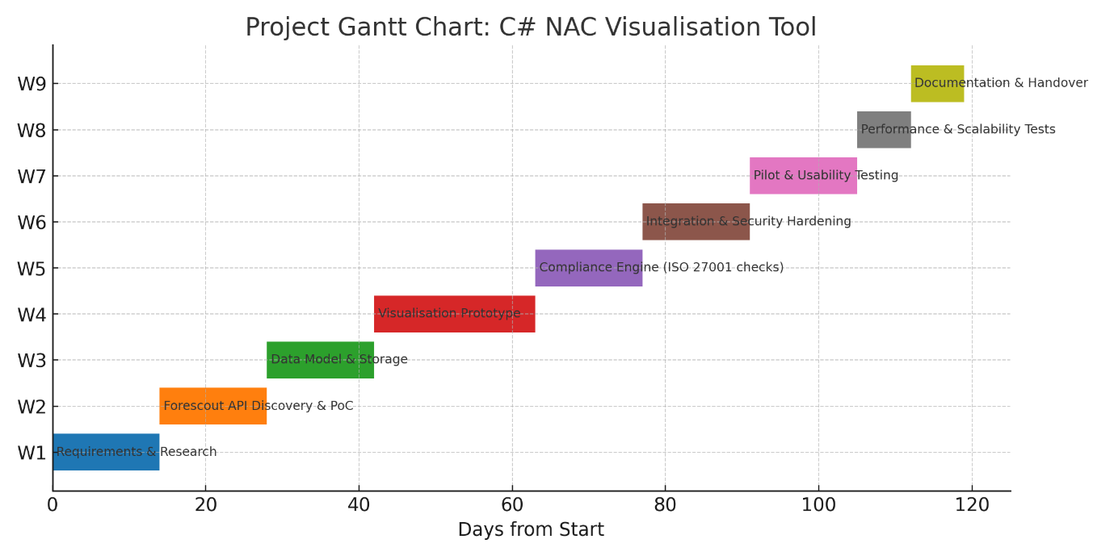
Figure 1. Project Gantt Chart: C# NAC Visualisation

Constraints and assumptions
- API constraints: Forescout rate limits, pagination, and permission scopes [3]-[5].
- Data protection: Minimise or obfuscate personal data in labels and exports; provide privacy modes [9], [10].
- Performance: Layout computation for large topologies (10k+ nodes) requires progressive rendering and caching; instrument and observe with OpenTelemetry [6].
- Assumptions: Stable API endpoints; test network segments representative of production; stakeholder availability for feedback.

Development method
A dual-track Agile approach (discovery + delivery) will be used with a light Scrumban (Scrumban combines the structure sprints of Scrum with the continuous workflow of Kanban) cadence. Discovery delivers validated backlog items through interviews, compliance mapping, and API experiments. Delivery builds increment in the following order: ingest model visualise compliance overlay reporting. CI/CD pipelines enforce static analysis, unit/integration tests, and signed builds; feature flags enable safe rollouts. Observability uses OpenTelemetry to trace ingest, layout, and render steps. Governance aligns artefacts (backlog, Definition of Done (DoD), test evidence, and audit logs) with ISO/IEC 27001 documentation needs [1].

Stakeholders, RACI, acceptance criteria, and risks
Stakeholders include: (a) Network Engineering (service owners); (b) Security Operations (compliance reporting); (c) IT Risk & Audit (evidence consumers); and (d) Data Protection/Legal (privacy assurance). A lightweight Responsible, Accountable, Consulted, and Informed (RACI) ensures clear accountability for API access, pilot execution, and approvals. Acceptance criteria: (1) the system renders a topology with ≥95% of endpoints seen by NAC; (2) compliance flags match ground truth with ≥90% accuracy; (3) visual interactions remain responsive (<250 ms median filter latency) for up to 5k nodes; and (4) one-click export produces audit-ready evidence [1]. A risk register captures privacy exposure (GDPR/UK GDPR) [9], [10], data quality, performance bottlenecks (progressive layouts/caching with OTel) [6], regulatory drift (ISO updates) [12], and organisational adoption; each risk has mitigations (privacy-by-default, validation rules, progressive layouts and caching, policy configuration, and pilot champions).

Q2. Project Design

(A) Requirements specification (expanded)
Functional requirements (sample):
- F1 Authenticate via service identity.
- F2 Pull endpoints (OS, patch, posture, VLAN, switch/port), links, and device categories.
- F3 Build logical/physical graphs; F4 Provide search, filters (e.g., OS family, VLAN, posture), and drilldowns.
- F5 Compute compliance signals against configurable policies (e.g., OS EOL list, minimum patch level).
- F6 Export diagrams (PNG/PDF) and CSV/JSON evidence.
- F7 Provide privacy toggles for hashing usernames and masking IPs.

Non-functional:
- N1 Handle ≥5k nodes with typical filters under 250 ms.
- N2 Privacy by design (data minimisation defaults).
- N3 Robust telemetry for reliability and usage.
- N4 Accessibility guidelines (keyboard navigation, high-contrast mode).
- N5 Maintainability (modular architecture; documented interfaces).

(B) Flow/Sequence, ERD, and security architecture
Sequence: Admin authenticates App retrieves tokens Scheduled ingest calls NAC endpoints Normaliser validates and densifies attributes Graph builder maintains node/edge store Visualisation engine renders progressively Compliance engine applies rules Exports generated (diagram + evidence).

ERD (simplified): Endpoint(endpoint_id PK, hostname, os, patch_level, posture, vlan, switch, port); Link(link_id PK, src_endpoint_id FK, dst_endpoint_id FK, link_type, medium); ComplianceRule(rule_id PK, name, criteria, severity); EndpointCompliance(endpoint_id FK, rule_id FK, status, last_checked_at).

Security architecture follows least privilege for API service accounts, encrypted secrets at rest, audit trails for data pulls and export actions, and privacy-by-default labelling. Network egress is locked down to NAC endpoints and update feeds; code signing assures build integrity. Data retention is configurable, with purging of raw logs after evidence extraction.

Task 2: Enterprise & Innovation

Q1. PEST & SWOT (Cisco Systems, Inc. as exemplar)
Cisco serves as an exemplar due to its breadth in networking and security portfolios, partner ecosystem, and comprehensive risk disclosures.
The PEST below reflects a UK/EU-centric context relevant to adoption of NAC-adjacent solutions.
Figure 2. PEST Summary

Overall, this SWOT suggests a receptive enterprise context for our C# NAC visualisation tool—provided it differentiates on simplicity, privacy, observability, and measurable compliance value while navigating large-vendor ecosystems and controls.
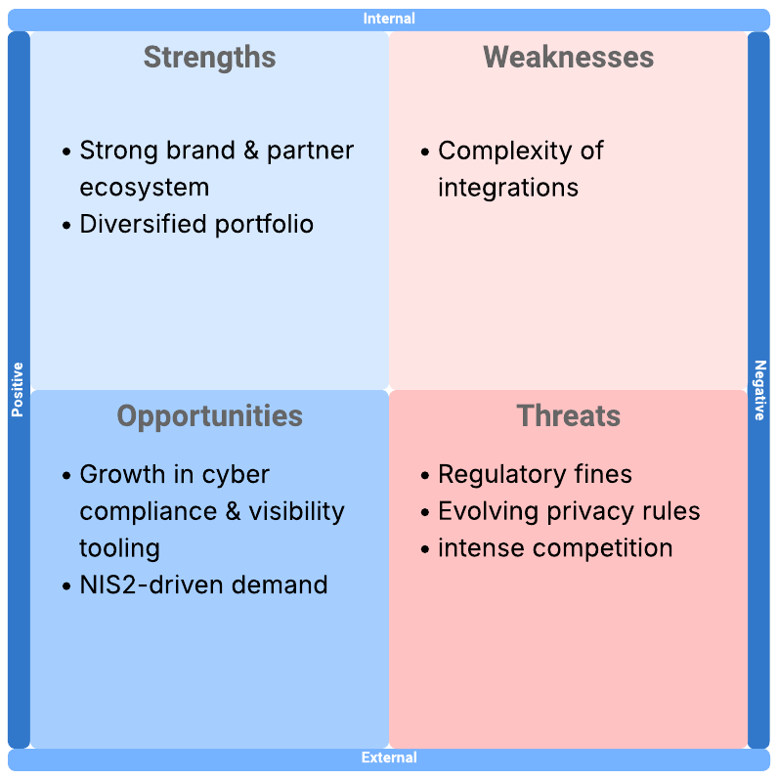
Figure 3. SWOT Summary

Q2. Concepts, methods, practices, and tools for enterprise deployment
Architecture & integration. Use an API-contract-first approach, least-privilege service identities, and versioned data schemas. Observability with OpenTelemetry ensures traces/metrics/logs are correlated with ingest, layout, and UI events; this supports site reliability engineering practices and rapid incident response.

Software delivery. CI/CD pipelines enforce static analysis, unit/integration tests, and signed releases; trunk-based development and feature flags enable safe, incremental delivery.

Performance gates (render time, memory ceilings) and security gates (dependency and secret scanning) protect quality at scale.
Operations & scaling. Horizontal scaling of ingest workers handles spikes; caching and subgraph pre-computation improve responsiveness. SLOs for latency and freshness guide capacity planning; error budgets align risk with release cadence. Change management integrates with service catalogues and configuration management databases (CMDBs).

Compliance & privacy. Align with ISO/IEC 27001 controls and ISO/IEC 27002 guidance; observe GDPR/UK GDPR principles of data minimisation, integrity/confidentiality, and purpose limitation. NIS2 obligations raise resilience requirements [1], [2], [9], [11]; the tool’s audit-ready exports support evidence production during assessments.

Visualisation precedent. The NodeXL ecosystem demonstrates mature .NET-based-network analysis and visualisation; lessons—such as efficient layout strategies and Excel-style data preparation—can be adapted to improve analyst adoption and training [7], [8].

Task 3: Project Reflection
Developing new skills. The project deepens competencies in API engineering and data modelling (idempotent polling, back-off, delta detection), graph visualisation (level-of-detail rendering, dynamic layout stabilisation, semantic zoom), and observability (defining spans and metrics that reflect real user journeys). It also fosters security and compliance literacy—interpreting ISO/IEC 27001/27002 and encoding rules into testable policies [1], [2], [6]—alongside professional skills in stakeholder communication and audit-ready documentation.

Social contribution. Improved network visibility and compliance reduce the likelihood and impact of cyber incidents affecting critical services (healthcare, transportation, utilities). By operationalising privacy-by-design (masking identifiers, data minimisation), the tool strengthens public trust in digital infrastructure [9]-[11]. In education and workforce development, the project promotes upskilling in modern observability and compliance automation, areas with persistent skills gaps.

Risks and mitigations. Privacy exposure is managed via anonymisation/pseudonymisation defaults, role-based access control, and comprehensive audit logs. Data quality risks are tackled by validation rules and clear ‘unknown’ states; where permitted, reconciliation with secondary systems addresses gaps. Performance risks are mitigated through progressive rendering and caching; scalability testing sets realistic SLOs and error budgets. Regulatory drift is addressed by externalising compliance rules as configuration and maintaining a policy test suite; periodic standards review ensure currency. Organisational adoption risks are reduced through a champion-led pilot, training materials, and interoperable exports.

Evaluation approach. Quantitatively, the study will measure detection accuracy against ground truth, render latency, and administrator task completion times. Qualitatively, interviews and open-ended survey responses will be analysed using Braun and Clarke’s thematic analysis to derive robust themes (usability, clarity, compliance utility, integration challenges). Mixed-methods triangulation enhances credibility y converging telemetry insights with administrator narratives. This approach ensures that knowledge produced by the study is valid, reproducible, and actionable for organisations seeking to modernise compliance workflows [1], [6], [9].

Conclusion

This project sets out a practical, standards-aligned approach to convert NAC telemetry into actionable network visualisations and auditable compliance evidence. Task 1 established a clear scope, realistic schedule, governance model, and concrete design artefacts (requirements, sequence/ERD, security architecture), underpinned by Agile delivery and observability. Task 2 located the solution within an enterprise and regulatory landscape through PEST/SWOT, and detailed the architectural, operational, and compliance practices required for secure, observable, and maintainable deployment. Task 3 reflected on skills development, societal value, and explicit risk mitigations, coupling quantitative benchmarks with qualitative evaluation to ensure findings are credible and transferable.

Collectively, these strands yield a coherent roadmap that balances technical feasibility, organisational readiness, and regulatory expectation. The proposed acceptance criteria—≥95% topology coverage of NAC-seen endpoints, ≥90% accuracy of compliance flags against ground truth, and <250 ms median filter latency up to 5k nodes—provide measurable outcomes that translate directly into operational value: faster insight, fewer blind spots, and clearer, audit-ready proof of control effectiveness. Privacy-by-design defaults (masking, minimisation), least-privilege integration, and full audit trails reduce legal and reputational exposure while supporting continuous assurance.

In summary, the project delivers a defensible path from telemetry to trusted knowledge. It operationalises compliance, improves, resilience, and provides a sustainable framework for ongoing modernisation—turning complex network data into clear, timely, and ethically handled evidence that organisations can act upon with confidence.

References

[1] ISO, “ISO/IEC 27001:2022 — Information security management systems — Requirements,” 2022. [Online]. Available: https://www.iso.org/standard/27001.html
[2] ISO, “ISO/IEC 27002:2022 — Information security, cybersecurity and privacy protection — Information security controls,” 2022. [Online]. Available: https://www.iso.org/standard/75652.html
[3] Forescout, “Forescout Documentation Portal,” Web API Plugin Guides, 2024–2025. [Online]. Available: https://docs.forescout.com/
[4] Forescout, “RESTful Web Service Interaction,” CounterACT Web Service, 2024. [Online]. Available: https://docs.forescout.com/
[5] Forescout, “Configure Web API Plugin,” 2024. [Online]. Available: https://docs.forescout.com/
[6] OpenTelemetry, “OpenTelemetry Specification — Overview & APIs,” 2024–2025. [Online]. Available: https://opentelemetry.io/docs/specs/otel/
[7] Social Media Research Foundation, “NodeXL — Your Go‑to Network Analysis and Visualisation Tool,” 2025. [Online]. Available: https://www.nodexl.com/
[8] Wikipedia, “NodeXL,” 2025. [Online]. Available: https://en.wikipedia.org/wiki/NodeXL
[9] EUR‑Lex, “General Data Protection Regulation (EU) 2016/679,” 2016. [Online]. Available: https://eur-lex.europa.eu/
[10] UK Information Commissioner’s Office (ICO), “A Guide to the Data Protection Principles — Data minimisation,” 2025. [Online]. Available: https://ico.org.uk/
[11] EUR‑Lex, “Directive (EU) 2022/2555 — NIS2,” 2022. [Online]. Available: https://eur-lex.europa.eu/
[12] ISO, “ISO/IEC 27001:2022/Amd 1:2024 — Climate action changes,” 2024. [Online]. Available: https://www.iso.org/

