UNIVERSITY OF WALES
Trinity Saint David

Explain the way in which leadership and management style shape the behaviour of employees in a selected organisation of your choice and explain the responsibilities and functions of a line manager in meeting the needs of the selected organisation.

Individual Assignment

Elena Rumenova Sotirova
2028225
Introducing the Modern Workplace LCBB4003
Uju Ugochukwu
25th June 2021

Table of Contents:
Introduction……………………………………………….……………………….………p.3
How leadership and management style shape the behavior of the employee at Apple ………………………………………………………………………………….……p.3
The relationship between organisational structure, culture, and organisational performance………………………………………………………………………………..p.3
The nature of managerial work……………………………………………….…………..p.5
Behavioral approach to management…………………………………………………...p.6
The responsibilities and functions of a line manager…………………………....p.8
The responsibilities and functions of a line manager at Apple Inc……………….….p.9
Conclusion………………..…………………………………………………….…….….p.9
Reference ………………………………………………………………………….…….p.10

Introduction
Due to the triumph of the globalization and continuous development in the technological sector, the business environment has become very competitive, and businesses are trying very hard to stay ahead of their competition by developing a competitive edge, based on the concept of leadership and management. Leadership “it is the process of influencing people - getting them to do their best to achieve a desired result” (Armstrong,2012, p.4). The main purpose of leadership is how to motivate, influence and guide the members of an organisation and to shape their behaviour. Management is the process of making things happen. The classic definition of “management” belongs to Henry Fayol (1916): “To manage is to forecast and plan, to organize, to command, to coordinate and to control” (Cole,2011, p.12). The most important factor, in this case, is the leadership and management style of the organisation as it shapes the behavior of the employees. In order to understand that better, we have to recognize the relationship between the organisational structure, culture, and organisational performance. In addition, the nature of managerial work and behavioral approach to management has also been discussed. Lastly, the functions and responsibilities of the line manager have been added as well and discussions have been around Apple Inc.

How leadership and management style shape the behavior of the employees at Apple
In order to develop an understanding of how the leadership and management style shapes the behavior of the employees in an organisation, it is important to first assess the relationship shared between the structure and culture of the organisation and how it affects the employees and their organisational performance.
The relationship between organisational structure, culture, and organisational performance
Organisation must always have a formal structure to achieve their objectives successfully. It is critical to divide jobs into various groups so that no two employees are working on the same project or job at the same time. This is done in order to ensure that we get the most out of our resources. Because the undeniable truth is that organisations cannot function without people, distinct informal structures or environments emerge inside them, resulting in a wide range of attitudes, perceptions, behaviors, and personalities, as well as a wide range of aptitudes (Frost et al.,2015). So there are particular ways to communicate and engage when employees are intended to work together on a task inside confines of a formal framework to achieve a certain goal. As a result, organisational culture is formed, which may be produced consciously or unconsciously by personnel. It has been often noticed that the culture of the organisation is influenced by the structure of the organisation in a number of ways and sometimes, the structure of the organisation also has influence over the organisational culture. Now the structure of the organisation is often recognized as the framework through which the culture of the organisation can be built and the newly determines how the firm should be built. So regardless of the size of the firm, if the culture deteriorates, the structure of the firm is bound to follow that road (Alvesson,2012).
The structure of the business and organisational culture play an important role in determining the organisational performance of the company. The time that the structure of the organisation takes in communicating the strategies down the hierarchical steps defines the type and level of motivation the employees will possess (Schein,2020). In a wider sense, this will also impact the employee relations affecting the employee morale which will have a further effect on the business performance.

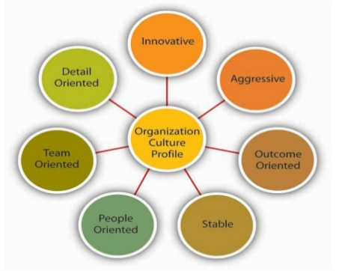
Figure: Organisational culture profile at Apple (McCrey et al.,2011)
Apple Inc. is one of the most successful organisations in the world and much of this huge success is due to the organisational culture of the organisation. The innovation and sleek and futuristic design of the products of the company are the result of the elements of the organisational culture of the organisation. These elements not only help to establish the business philosophy, beliefs, and values but also allows the company to develop business competitiveness. The elements are innovative, aggressive, stable business structure, people-oriented, team-oriented, outcome-oriented, and detail-oriented.
The nature of managerial work
Management is referred to as the set of activities that includes planning, organizing, leading, decision making, and controlling the resources of the organisation such as human, financial, information, and resources with the aim of achieving the organisational goals in an effective and efficient fashion (Weick,2014). Now these two words different meanings in management as efficient refer to the use of resources wisely which excludes the unnecessary waste of resources. Again, being effective means doing the right things in a successful manner.
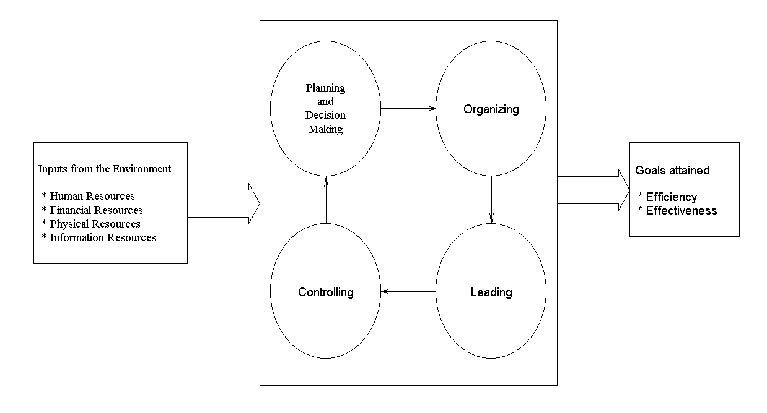
Figure: The Management Process (Folley,2018)
The key roles of the managerial position include planning and decision making, coordinating different activities and aligning them with the available resources, managing people, monitoring and evaluating the activities of the employees. Along with those, the manager of an organisation like Apple has to play different kinds of roles such as interpersonal roles, informational roles, and decisional roles. In order to effectively perform and excel in these roles, the manager has to have a number of skills such as technical skills, conceptual skills, interpersonal skills, and diagnostic and analytic skills.
The leadership style adopted by the organisation plays a huge role in managerial work as a huge portion of the organisational performance and output depends on the type of leader and the leadership style. Leadership is a result of three main variables: first the leader’s traits, second the followers’ qualities, and the third the qualities of the circumstance in which the leader and followers are involved (De Waal,2013). These are three wide variables that determine how effective the leadership style will be for the organisation. The most famous leader of Apple, Steve Jobs was successful in controlling these three variables and as a result, during his reign, Apple touched the peak of success.
Behavioral approach to management
The theory mainly focuses on the types of work that are related with human aspects and this is the reason why behavioral management theory is often recognized as the human relations movement. As per the theorists, the representation of having greater knowledge regarding human behavior at the workplace would result in increased productivity.

Figure: Behavioral Management Approach (Levinthal,2011)
The behavioral approach to management has been classified into two sections and they are the human relations approach and the behavioral science approach.
Human relations approach: The phrase “human relations” refers to how managers interact with their subordinates (Turk and Flor,2016). Managers encounter several challenges since employees rarely adhere to established and balanced behavior patterns. The theorists who support the human relations approach believe that top-level management should recognize employees’ desire for social approval and acknowledgment. The workgroup should be viewed by management as a constructive force that can be put to good use. As a result, managers must be skilled in both human relations and technical capabilities. The Hawthorne experiments provided the first impetus for the movement:
- Experiments with illumination
- Test room for relay assembly
- Program for conducting interviews
- Financial institution wire

Behavioral science approach: It is said that the behavioral science approach is the extended part of the human relation approach. The attitudes, performance, and behavior of the employees and the groups working in the otganisation are valued by this approach. One unique thing brought to the light by this approach is that humans are considered as a much more complex entity than described in the classical theory as the economic man description and social man description that has been put in the human relations approach (Backer,2013). After clarifying the concept of humans, this approach narrows down its focus on the characteristics of work and the degree that will be needed to satisfy the needs of the employees which will be brought up the required skills and expertise of the employees.
In an organisation like Apple Inc. where the environment is very fast-paced and the organisation requires the best output from its employees, the behavioral approach to management is very necessary. The behavioral approach to management enables the management of the company to assess and understand the needs of employees and what sort of incentives, recognition, and positive force will bring out the best of the employees and enhance employee morale and productivity of the employees. As a result, the managers integrate better ways of communication, motivation, leadership, and participative management in the organisation.
The responsibilities and functions of a line manager
A line manager is a person of the organisation who reports to senior management and is responsible for overseeing other personnel and procedures. A line manager is normally placed in charge of supervising and managing the subordinates that result in the achievement of the company’s objectives. One of the key aspects of the line manager‘s duty is that they serve as the primary interface between management and employees (Renwick and MacNeil,2012). On a daily basis, they also give employees with advice, incentive, and feedback. Thus, it becomes the duty of the line manager to implement plans and strategies that have been developed by the top-level management.
The responsibilities of a line manager typically include the following:
Attract and engage talents: Attracting and engaging new talents is one of the key responsibilities of the line manager as this will enable the organisation to have the best available talents in the market with their organisation. Thus, hiring the best talents from the market and handle their training and development sessions, and assigning them to the team are the key areas of responsibilities of a line manager.
Setting the expectation of work output: The line managers are the individuals who set the bar of expectation from the employees such as KPA and KRA. But the responsibilities do not end with just the announcement of the bar of expectations (Hales,2015). In addition, they also have to continuously track and measure the progress of the goals and maintain through the status update and providing constructive feedback. In case of facing bottlenecks, the managers also need to analyze the reports and take a corrective measure that will deviate towards the achievement of the goal.
Increasing the employee engagement rate: In the fast-paced environment of the corporate world, the top-level executive expects a high level of employee engagement, and the HR department formulates a number of strategies in order to push this engagement rate. But the duty of executing these strategies to enhance the employee engagement rate falls upon the shoulders of the line manager.
Creation of successful working relationship: Studies have found that when the line managers spend more time with their team members and process their requests, the employees have found to be more effective, and their efforts have been in alignment with the organisational goal. Around 80% of the employees consider that the approach of the line managers is a very big determinant of their work output (Mogensen,2018).

The responsibilities and functions of the line manager at Apple Inc.
Apple inc. has its own organisational structure and they do not have any mid-level managers. So, in the organisation, the top-level manager and the first-line managers share the role of the mid-level managers and they directly communicate with each other (Westly and Mintzberg,2019). The line managers at Apple Inc. are responsible for setting the bar of expectation from the employee morales, adopting different tactics to increase employee engagement, creating successful working relationships, etc. In addition, they are also responsible for making plans and allocating resources that will meet the objectives of the CEO.
Conclusion
The leadership and management style adopted by Apple Inc. has always been a key factor for the huge success of the organisation. In the era of Steve Jobs, the organisation had hugely profited from the leadership and managerial attributes of Steve, and even now under the guidance and leadership of Tim Cook, the oraganisation continues to prosper (McCray et al.,2011). Due to not having middle-level managers, the line managers have always been recognized as one of the key contributors to Apple’s success. They play a huge role in the production areas and making sure that the performance and output of the employees are perfectly aligned with the plans and organisational goals.

Reference:
Armstrong, M.(2012). Armstrong’s handbook of management and leadership: Developing effective people skills for better leadership and management. 3rd ed. Kogan Page
Alvesson, M. (2012). Understanding organisational culture. Sage
Backer, L. C. (2013). Transnational corporations’outward expression of inward self-constitution: The enforcement of human rights by Apple Inc. Indiana Journal of Global Legal Studies, 20(2),805-879.
Cole, G.A., & Kelly, P. (2011). Management theory and practice. South – Western
De Waal, A. (2013). Strategic performance management: A managerial and behavioral approach. Macmillan International Higher Education
Folley, R. R. W. (2018). Management in fruit growing: The origins and Nature of Managerial Decisions (No.1930-2017-2776).
Frost, P. J., Moore, L. F., Louis, M. R. E., Lundberg, C. C., & Martin, J. E. (2015). Organisational culture. Sage Publications Inc.
Hales, C. (2015). Rooted in supervision, branching into management: Continuity and change in the role of first-line manager. Journal of Management Studies, 42(3), 471-506
Levinthal, D. A. (2011). A behavioral approach to strategy – what’s the alternative?. Strategic Management Journal, 32(13), 1517-1523
McCray, J. P., Gonzales, J. J., & Darling, J. R. (2011). Crisis management in smart phones: The case of Nokia vs apple. European Business Review.
Mogensen, B.G. (2018). Managing corporate legitimacy through CSR reporting: A qualitative case study of Apple Inc.’s supplier responsibility reports (Master’s thesis).
Renwick, D., & MacNeil, C. M. (2012). Line manager involvement in careers. Career Development International.
Schein, E. H. (2020). Organisational culture (Vol. 45, No.2, p.109). American Psychological Association.
Turk, D. C., & Flor, H. (2016). A cognitive – behavioral approach to pain management.
Weick, K. E. (2014). The nature of managerial work.
Westley, F., & Mintzberg, H. (2019). Visionary leadership and strategic management. Strategic management journal, 10(S1), 17-32.

