
Module Assignment Submission
Student Name: | Emma Stevens
Student Number: | 2025270
Module Code: | BMSK5008/C
Module Title: | Changemakers: Building your Personal Brand for Sustainable Employment

Statement of Confirmation of Authenticity
By the act of making this submission, the student declares that this is the work of the student named above. The work has not, in whole or in part, been knowingly presented elsewhere for assessment, or where assessment has been built on a previous assessment, this has been identified. Where materials have been used from other sources it has been properly acknowledged. If this statement is untrue, the student acknowledges that an assessment offence has been committed.
Attention is drawn to the plagiarism and unfair practice policies of the University.

Table of Contents
Changemakers: Building your Personal Brand for Sustainable Employment 1
Introduction 3
Brand You 3
It is a small world 4
Opportunity Knock 5
Pursuit of happiness 6
Conclusion 7
References 8
Appendix 1 9
Use the strategy pyramid to create structure. 11

Introduction

This reflection report focuses on brand you, it’s a small world, opportunity knocks and the pursuit of happiness. It reflects on my two years studying with Trinity Saint David’s university while working full time and having my first child. The report discusses what I have achieved and want I want to achieve going forward and how I will accomplish this. The subjects are designed to get me reflecting and making an action plan going forward.

Brand You

Ailes (1960) said that “it only takes seven seconds for someone to make their first impressions of you”.
According to Hogeson (2017) personal branding is anything, from your name to your tone of voice, your reputation, your manifesto, the symbols you use, and so much more – that separate you from the crowd. Your brand is what makes you unique and stand out – it’s the thing that ensures you’ll always be valuable, no matter how many other companies try to copy your ideas, products, or services.
Through studying the Gibbs theory (1988) (Appendix one), I have been able to process and reflect on my thoughts and feelings on the past two years of my studies and the job title I am looking to achieve as a career is a Money Confidence Supervisor. This position entails: supervising a small team in the high street branch that I work in, I will be responsible for motivating and monitoring the performance on my team and showing the business satisfactory results. I also want to achieve my degree with a good grade.
By producing part one of this assignment, it helped me to reflect on how I am going to get to that position in my studies and career. Through writing the zander letter and reflecting on the way I have felt and managed my emotions over the past two years it has shown me that it is possible to achieve my goals, as I have achieved all the goals, I set out to achieve when starting university. I evaluated the whole experience and discussed my high and lows of the process in my zander letter and I enjoyed this reflection and self-praise. By analysing I can clearly see where I struggled at times and what I need to do moving forward in my studies and how to achieve my career goals. This leads to my conclusion, action plan and personal development plan that I created during part one of this assignment. (Appendix one).
Indeed (2020) says that a personal brand statement is a brief statement that summarize what you do, why you do it and what differentiates you from others in your field. In other words, it's your unique selling proposition. These statements are typically between one and two sentences and should be attention-grabbing, compelling, and memorable. In many ways, a personal brand statement can resemble a slogan.
For example, my personal statement would be I am a hardworking, accomplished, and enthusiastic local banker, with a solid history of achievement in customer service roles. I always strive to achieve the highest standard possible, at any given task and in any situation. I am a motivated leader and collaborator with strong organisational and prioritisation abilities. I am accustomed to working in a challenging and demanding environment, particularly when dealing with multiple projects and priorities at the same time. I am currently studying a degree in Business and Management and look forward to achieving this and graduating in 2024. Stevens (2022)

It is a small world

According to Kagan (2019) Networking is the exchange of information and ideas among people with a common profession or special interest, usually in an informal social setting. Networking often begins with a single point of common ground.
Professionals use networking to expand their circles of acquaintances, find out about job opportunities in their fields, and increase their awareness of news and trends in their fields or the greater world.
Personal branding is how you build and maintain your reputation not only in a workplace environment but also how we make and maintain new relationships with people whether that is in the workplace or out with the workplace. It really is a small world and by holding onto a good reputation this will help with networking and lead to opportunities.
Personal branding has ways of following you through life and when you least expect it can catch up with you at the worst times – not for the good. For example, when you go for an interview for a job the company aren’t only judging and evaluating you on how well or bad you have done during your interview or job application they now have ways to look through social media platforms such as LinkedIn, Instagram, Facebook, Twitter and all social media platforms where people share their lives with friends, family and if not private profile anyone can view these pictures, posts and statements. Even if your profile is private, you will find there will normally be a friend of a friend who can have a look for the employer if they really did want to see what you are posting. Especially if you are applying or interviewing for a serious job.
For example, you may come across well in a job application and do well in the interview – however your new employer could be looking at these social media platforms to get an understanding of your personal branding. Which could result in you not getting the job if the organisation were to see something they did not like.
Therefore, it is so important to take care and build on your personal branding from a young age and network whether that be in your work life with colleagues or out with work on LinkedIn. Which can be hard to do when your young and carefree – but the research shows pictures, posts and statements have ways of creeping on you when you least expect it to.
LinkedIn is considered one of the world's largest professional networks on the internet. LinkedIn can be used to find the right job or internship, to connect, stay connected and strengthen professional relationships, and learn the skills that you may need to succeed in your career. LinkedIn can be accessed from a desktop, LinkedIn mobile app, mobile web experience, or the LinkedIn Lite Android mobile app. A complete LinkedIn profile can help you connect with opportunities by broadcasting your unique professional story through experience, skills, and education. A LinkedIn profile is like an online CV for employers to view and reach out to if you have advertised that you are looking for new job or opportunity.

I am definitely a lot more cautious and aware of what I post on social media even though all the social media platforms I use are set to private. Networking and promoting yourself has never been more important to either move up the chain or even start at the bottom knowing that you one day want to move up the chain.

Opportunity Knock

There are many potential opportunities knocks due to threats or barriers such as:
Childcare:
I have just had my first child, she is six months old, I could potentially and have faced barriers with childcare issues as the classes are now face to face and none are online. This means I will need to ask family or friends to help with childcare or potentially look for paid childcare this could then result in financial barriers.
This barrier can be overcome by asking family members or friends to help with childcare when in university – if they are unable to help on the particular day we would both need to look into childminders in our local areas and or asking the university if they know of any childcare providers for studying parents.

Financial Barriers:
I have been fortunate enough where I have been given the opportunity to apply for a student loan to pay for the university course. This payment back will be deducted from my salaries therefore I will need to take this into consideration when negotiating a salary with a my current or new employer. As Mentioned above children care could become a potential financial barrier if unable to secure childcare through a family member. Childcare costs will also need to be planned into household costs and possibly child benefit may be able to pay for a childminder a few hours a week when studying or in a class. This will need to be something that we both research carefully.

Work-Life-Balance:
I will also need to consider work responsibilities, home life, caring for my child, taking holidays and so on. By keeping to a routine and schedule I will be able to maintain a healthy work-life-balance.
Geographical Barriers:
As mentioned above I was currently studying from home due to the COVID-19 outbreak – however classes are now back for face-to-face session this may be a geographical barrier for me. This will be a potential barrier for me as I do not currently drive therefore, I will need to rely on public transport to get to class on time after work (when I return to work after my maternity leave).

All of these threats and barriers can lead to missed opportunities or simply not been given the opportunity, this is something that I am aware of and want to work hard to stop this from happening. I want to show that I will and can manage my working life and personal life as separates and progress in my studies and career.

Pursuit of happiness

The pursuit of happiness is defined as a fundamental right mentioned in the Declaration of Independence to freely pursue joy and live life in a way that makes you happy, as long as you don't do anything illegal or violate the rights of others. Rodgers (2012).
The pursuit of happiness in academic terms means what do I really want in life. I feel I have been very vulnerable and exposed during part one of the assignment and this report. I have opened up about my struggles during year one and year two and have acknowledged what has gone wrong and how to improve going forward into level six of the degree and what my next steps are in my career when I go back to work once my maternity leave finishes in the new year.
All I want in life to be able to have a balance of work, university and personal life which I feel I will be able to achieve if I stick to a routine and keep myself motivated through actively using the action plan and reflecting on what has worked/not worked in the past.
My actions plan goals are to earn a professional degree in business and management which will be reviewed at the end of this academic year and the following academic year when I am due to graduate and have my full business and management degree. I would like to increase my performance metrics when I go back to work after my maternity leave to show I am willing to improve and build the business and show my capabilities. I would also like to secure a managerial position within my workplace, I have made this known to my manager and made an inhouse action plan of how I am going to achieve this by the end of 2023.
Deming (1953) discusses how to sustainably deliver products and services that satisfy customers, and that the customer is the most important part of the production line. This is a statement that fits with my place of work and certainly a statement that I agree and live by while working.

Conclusion

In conclusion, by using Gibbs (1988) module and researching several other theorists I have been able to reflect on my time at university so far. I have been able to identify what at times did not work well and what changes I need to make going forward in my studies to level six and in my professional career all while keeping a healthy balance of personal life also. By creating an action plan and keeping this alive has helped clearly outline what I need to do to achieve these goals and aspirations.

References

Alux.com. (2018, December 20). Why is NETWORKING so important? Www.youtube.com. https://www.youtube.com/watch?v=kgwqrqKrox8
Baldwin, M. (2020, September 15). LinkedIn Networking Tips (How To Cold Message and Build Connections). Www.youtube.com. https://www.youtube.com/watch?v=Pe5O3POTQEA
Council, Y. E. (2014, July 28). How To Network The Right Way: Eight Tips. Forbes. https://www.forbes.com/sites/theyec/2014/07/28/how-to-network-the-right-way-eight-tips/?sh=49911f206d47
Fleishman, H. (2012). How to Master Non-Awkward, Effective In-Person Networking. Hubspot.com. https://blog.hubspot.com/marketing/the-ultimate-guide-to-non_awkward-effective-networking
Frictionless. (2020, November 16). The importance of action plans and why your business needs one to grow. Breakthrough Business Techniques. https://chrysalisgrowth.com/the-importance-of-action-plans-and-why-your-business-needs-one-to-grow/
Hodgson, S. (2017, May 25). What Is Personal Branding? Building Your Personal Brand. Fabrik Brands. https://fabrikbrands.com/what-is-personal-branding/#:~:text=%20What%20is%20personal%20branding%3F%20%201%20The%20
Indeed. (2020, November 23). 10 Effective Personal Brand Statement Examples (With Tips). Indeed Career Guide. https://www.indeed.com/career-advice/career-development/personal-brand-statement-examples
Indeed. (2022, September 15). How To Brand Yourself in 7 Steps | Indeed.com. Indeed Career Guide. https://www.indeed.com/career-advice/career-development/how-to-brand-yourself
Kagan, J. (2019). Networking. Investopedia. https://www.investopedia.com/terms/n/networking.asp
Peters, T. (2010, April 14). Brand You: First Impressions. Www.youtube.com. https://www.youtube.com/watch?v=3JGGT-5WIFg
Plann. (2020, June 4). How To Brand Yourself: 10 Steps To A New Personal Brand. Plann. https://www.plannthat.com/how-to-brand-yourself/
Rodgers, J. (2012 6). The Meaning of “the Pursuit of Happiness” | James R. Rogers. First Things. https://www.firstthings.com/web-exclusives/2012/06/the-meaning-of-the-pursuit-of-happiness#:~:text=In%20this%20sense%20%E2%80%9Cpursuit%E2%80%9D%20means%20occupation%20or%20practice.
Stevens, E. (2022). Emma Stevens CV.
The Deming Institute. (2022). Dr. Deming’s 14 Points for Management - The W. Edwards Deming Institute. Https://Deming.org/. https://deming.org/explore/fourteen-points/
World Government Summit. (2015). The Pursuit of Happiness. In YouTube. https://www.youtube.com/watch?v=6dArDQYFjC4

Appendix 1

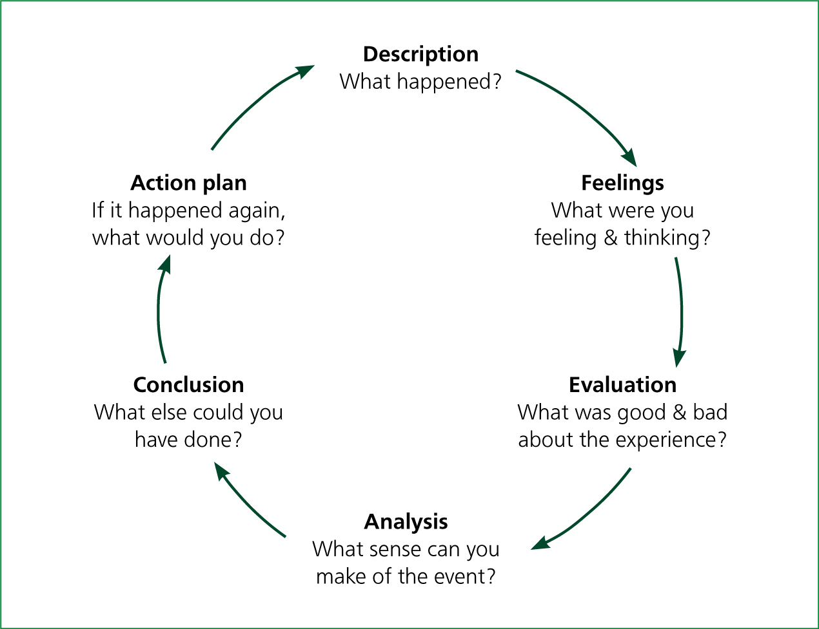
Gibbs (1989)
What do I want to learn? | What do I have to do? | What support and resources will I need? | How will I measure success? | Target Date for Review
Earning a Professional Degree or Certificate | Continue studying with Swansea university. | I will need support from my lecturer and a new laptop to complete my assignments. | I will measure this monthly when I receive my marks at the end of each module | Yearly. 1st review Jan 2023.
Securing a Managerial Position | Continue showing my manager willingness and interest in managerial activities. | I will need support from my manager and colleagues. I will need time to shadow managers in other branches and my own branch. | I will measure this success by feedback from manager and applying for a managerial position. | Dec 2023.
Increase my performance metrics at workplace | I need to stay focused on my job and do my best. | I will need support from my manager and the correct resources in my workplace. | I will measure this in a weekly basis when my manager gets the data. | Review monthly in 121s with line manager and personally want to achieve by end of Q2 (2023).

I have created a table showing my own personal action plan to achieve my goals. These are personal and specific to me and actions that I think I need to work on not only when producing a personal development plan but can be used for any assignment with adjustments.
ACTION PLAN
ACTION | OBJECTIVE | ACCOUNTABLE/RESPONSIABLE
Identify all tasks/areas required in application process | To understand what details are needed. | Myself
Identify resources. How, who, what, where, when and why do we need resources. | To gather the information and knowledge. | Myself
Time management | Create a time plan and add contingency when estimating duration for activities you have never done before. | Myself
Strategic planning | Use the strategy pyramid to create structure. | Myself

