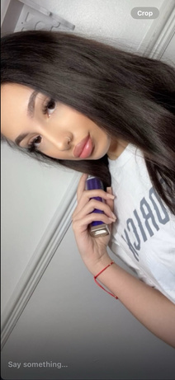

Ionela Radescu
Phone: 07397804204
Email: elenastoican89@yahoo.com
Address: 79 Netley Road, IG2 7NP

Personal Statement

A motivated and adaptable individual with strong communication skills and a positive attitude. Eager to apply my experience in customer-facing roles and my proven ability to work well in a team to a reception position. I am a quick learner with a keen attention to detail and a commitment to providing excellent service.

Education
2025 – University of WalesStudying Business ⁷Management
2022–2024 – Newham College, East HamDiploma, Level 2
2020–2022 – Hornchurch High SchoolDiploma, Level 1
2013–2020 – School in Romania

Key Skills

• Customer Service: Friendly, active listener, and positive attitude.
• Communication: Fluent in English and Romanian.
• Teamwork & Collaboration: Proven ability to work effectively with others.
• Adaptability: Flexible and able to thrive in dynamic environments.
• Attention to Detail: Meticulous and highly organized.

Professional Development

2021 – Accredited Diploma in Nail TechnologyThis course demonstrates hands-on skills and direct customer interaction, which are valuable in a reception role.

Additional Information
• Languages: English, Romanian
• IT Skills: Proficient with Microsoft Office Suite (Word, Excel, PowerPoint)

