TITLE OF THE ASSIGNMENT- ACADEMIC AND EMPLOYABILITY SKILLS
STUDENT NAME-ANNA KIRVEJOVA
STUDENT ID- 1921532

Table of Contents
Introduction 3
Article 1: Employability Skills as Perceived by Employers and University Faculty in the Fields of Human Resource Development (HRD) for Entry Level Graduate Jobs 3
Article 2: Building soft skills in the creative economy: Creative intermediaries, business support and the “soft skills gap” 4
Article 3: A Study on Self-Perception towards Basic Employability Skills among Post Graduates Students 5
Article 4: The Covid-19 crisis as a career shock: Implications for careers and vocational behaviour 6
Evaluation of personal academic and employability skills 6
Academic skills 7
Critical thinking and problem-solving skills 7
Note-making and referencing skills 7
Time management skills 7
Conclusion 8
References 9
Appendices 10

Introduction
Higher education is observed as the stepping stone for the graduates seeking prestigious jobs in the competitive age of employment. The employers, while recruiting these graduates, look for specialized skills like impactful communication, practical analytical skills, impressive decision-making and problem-solving and managing an organization being competent in approach. The universities and educational institutions offering growth and development in academics also provide scope to enhance the employability skills highly essential in the job market. Thecourses offered in recent times come with embedded professional programs catering the need of the candidates seeking employment just after the completion of the higher education.
The report creates an outline for the employability skills merged with academic skills discussed in various articles, portrays the significance of the skills to be cultivated and applied in the right juncture. The versatility of the skills multiplies the opportunities for the students to comprehend their position in the job market while evaluating the demands of the employers from the potential candidates, apart from the subject matter expertise in the trade.

Article 1: Employability Skills as Perceived by Employers and University Faculty in the Fields of Human Resource Development (HRD) for Entry Level Graduate Jobs
The article presents the view of developing academic and employability skills that help in acquiring the transferable skills and competence to be represented as a potential candidate seeking employment in any country. The employability concept is discussed with a wide range of variety in its definitions. The practical concept states that employability skills refer to the abilities possessed by an individual that support to maintain the quality of task performed by him as expected by the employer (El Monsour and Dean, 2016). The amalgamation of subject-based expertise, knowledge of current affairs and skills required to manage an organization sustainably and successfully represent the employability skills obtained by a graduate at his higher education.
The authors present the practical scenario prevailing in the current job market as segregated among the developed and developing markets and their demands regarding the employability skills possessed by a potential graduate candidate fulfilling the criteria of being an employee in the reputed companies. It is evident in the study that by 2020 the European countries will seek 20% more qualified labours conforming to the language skills, technical skills, soft skills, analytical and problem-solving skills with a focus on robust and convincing written communication. The capabilities vary according to the requirement of the industries however the necessary skills prevailing in all of them refer to the creative skills, communication skills, cultural awareness, leadership skills, presentation skills, analytical and problem-solving skills and digital competency that has been perceived as most essential skills across the globe. The supporting article also provides information where the classroom sessions help in developing the work-readiness skills as arranged in the curriculum alongside the academics (Fraser et al. 2019). Employability Skills Framework as advised by the Ministry of Education designs the framework with seven characteristics like self-management, willingness in learning, problem-solving skills development, positive attitude, better teamwork coordination and communication.

Article 2: Building soft skills in the creative economy: Creativeintermediaries, business support and the “soft skills gap."
The creative economy notion is set for the rapidly progressing United Kingdom, which has created the current decade as innovative with the implementation of soft skills. The article explores the gap in the soft skills through extensive research involving the Cultural Enterprise Office (CEO) to determine the real gap created in the set of skills needed and the actual expertise shown without the skills (Munro, 2017) The respondents in the research mentions about their practical knowledge on the subject matter however they are devoid of the skills to be entrepreneurs as they lack the skills of presentation, interaction through efficient written communication like a blog or report, and planning and organizing skills required to establish their business.
The conflict arises in the supporting article where the soft skills cannot substitute the efficacy of the technical skills of a graduate which is immensely required to complete a business process successfully. The graduate having both the skills is perceived as a threat for the employees who only have soft skills as possession and lacks in technical abilities. It is argued in the article that only having soft skills is often associated with low salaries while additional technical skills may improve the compensation in an enhanced way (Cacciolatti et al. 2017). Even the employees possessing only soft skills are often discriminated from those who have a mixture of both.
The article provides evidence that UK universities have recognized the gaps in the skills that are required by employers from the graduates who have just passed the higher education. The collaboration between the industries and the universities lack the understanding of providing the right direction to the students in attaining the skills that are demanded by the employers. The lack of training from the universities often results in the weaker workforce to be compatible with the current changes in the industry.

Article 3: A Study on Self-Perception towards Basic Employability Skills among Post Graduates Students
The intense competition in the world of business management and similar industries has raised the concern of possessing transferable skills by the students pursuing higher degrees. The research undertaken by the authors of the article presents the fact that very few students are able to solve group problem based on the allocated tasks and internal conflicts arising out of it. The ability to work independently while making an important decision is also less evident among fresher graduates as compared to the employed people (Gowsalya and Elavarasan, 2018). The least tendency observed among the graduates is updating the daily information and identifying the root cause of conflict, as seen in the groups while working together in an organization.
The literature review of the supporting article presents the view that the top soft skills expected by the employers are determined as work ethics, flexibility, critical thinking and problem-solving, leadership skills, culture awareness, awareness of diverse workforce, collaborating teamwork and interpersonal communication (Stewart et al. 2016). The deciding factor for hiring candidates for the trainee position provides an edge for the soft skill holders which the managers are hiring the potential graduates to perceive as essential qualities in the competitive world. However, it is argued in the article by the authors that many higher education institutions and universities lack the proficient curriculum embedded with the training programs that help the graduates to exhibit the skills while they prepare for employment in their final years at the graduation or post-graduation level. The academic abilities also matter here like authentic research on the content, paraphrasing the content, interpreting information from the material, report or essay writing, compiling and presentation and communicating the underlying message of the content to the receivers.
The article also discusses the essence of feedback from the employers regarding the portrayal of soft skills. There lies the gap where the employers do not find it necessary to inform the potential candidates on their level of expertise displayed during the interviews or interaction with the employers. Even when the graduates remain uninformed do not find the environment to exhibit their skills which leads in the creation of a gap of communication.

Article 4: TheCovid-19crisisasacareershock:Implicationsforcareersandvocationalbehaviour
The recent outbreak of coronavirus in 2019 has affected several million people across the globe, which had adverse consequences in the job market. Many employees lost their jobs due to the impromptu decision-making of employers. It is evident that resilience is shown by the employees during their lay-off by the reputed organizations (Akkermans et al. 2020). However, COVID 19 has impacted the industries while the recent strategy opted by the employees is to look for a sustainable career prospect that addresses the time and space required to flourish in an organization. The stress is mostly on being flexible with the schedule of work, increase the production capacity and establishing strong networking to help in the profit earning of the business.
The article suggests in practising self-care that indicates the improvement of physical, emotional and spiritual need satisfaction of an individual. Additionally, it is also required to promote cultural diversity in the workplace as people from different locations will migrate in search of better jobs that guarantee the security of a job in the host countries. The digital space has been considered safe during and post-COVID 19 (Hite and McDonald, 2020). Hence the skills that need to be adopted by the potential scholars preparing for the final years in their higher education reflects the tech-savvy attitude and execution, implementing artificial intelligence in their vocational training and being creative amidst the competitive world.

Evaluation of personal academic and employability skills
The academic and employability skills that I perceive have a wide range of meaning and application in the real-world situation in the job market. The skills are highlighted in the points below:

Academic skills
The academic skills require well-structured contents, planned and focused answers of the assignment and assessment questions, well-evidenced from authentic resources and must maintain formal tone and style. I have always tried to keep the information trustworthy from different sources while retaining the formal structure as required in the academic style of writing. The plagiarism aspect is also nuanced where the contents need to be paraphrased or totally changed while keeping the meaning intact. This also requires the references of the authors of the original contents while incorporating their contents in the assignments.

Critical thinking and problem-solving skills
As a scholar, it is essential to build up interest in the content which might be a carrier of good grade as read by the tutors. Critical thinking involves interpreting the content from all the aspects counting its benefits and challenges while providing possible solutions, as discussed in the journals and articles (Tang, 2019). As a student and as a potential manager, it is also required to understand the critical point of view and provide solutions to solve the problems or conflicts arising out of it.

Note-making and referencing skills
The essential part of academic skills also highlights note-making from the classroom sessions, workshops or seminars arranged by the department. The lecture and reading sessions need active attention from the scholars that help in remembering essential notes provided by the lecturers and suggestion of reading materials (Di Gregorio et al. 2019). The key point must be highlighted in the note-making, which may come in handy as a manager while working on search engine optimization in the real-time workplace. There are various referencing styles which have to be accurately followed while preparing for assignments or projects.

Time management skills
Time management skills come in handy in both academic and employment situations where well-planned schedule helps in minimizing the wastage of activities, organize the tasks as per their priorities and help in avoiding any sort of distractions. The universities set their curriculum in such a way where the scholars get tuned with the process while managing their time efficiently.

Conclusion
In conclusion, it may be summarized that being a scholar I got the opportunity to explore the skills that can be helpful in seeking better career prospect soon after the completion of the degree course which will help me to focus on my strength and rectify my weakness. The pandemic crisis has opened new avenues of skills to be explored and amalgamated with the current job market demands. The intense competition will invoke the practice of academic skills as well as employability skills to fulfil personal expectation in acquiring a substantial position in a reputed organization.

References
Akkermans, J., Richardson, J. and Kraimer, M., (2020). The Covid-19 crisis as a career shock: Implications for careers and vocational behavior.
Cacciolatti, L., Lee, S.H. and Molinero, C.M., (2017). Clashing institutional interests in skills between government and industry: An analysis of demand for technical and soft skills of graduates in the UK. Technological Forecasting and Social Change, 119, pp.139-153.
Di Gregorio, A., Maggioni, I., Mauri, C. and Mazzucchelli, A., (2019). Employability skills for future marketing professionals. European management journal, 37(3), pp.251-258.
El Mansour, B. and Dean, J.C., (2016). Employability skills as perceived by employers and university faculty in the fields of human resource development (HRD) for entry level graduate jobs. Journal of Human Resource and Sustainability Studies, 4(01), p.39.
Fraser, C.J., Duignan, G., Stewart, D. and Rodrigues, A., (2019). Overt and Covert: Strategies for Building Employability Skills of Vocational Education Graduates. Journal of Teaching and Learning for Graduate Employability, 10(1), pp.157-172.
Gowsalya, G. and Elavarasan, G., (2018). A Study on Self-Perception towards Basic Employability Skills among Post Graduates Students. International Journal, 6(7).
Hite, L.M. and McDonald, K.S., (2020). Careers after COVID-19: challenges and changes. Human Resource Development International, pp.1-11.
Munro, E., (2017). Building soft skills in the creative economy: Creative intermediaries, business support and the ‘soft skills gap”. Poetics, 64, pp.14-25.
Stewart, C., Wall, A. and Marciniec, S., (2016), July. Mixed signals: Do college graduates have the soft skills that employers want?. In Competition Forum (Vol. 14, No. 2, p. 276). American Society for Competitiveness.
Tang, K.N., (2019). Beyond Employability: Embedding Soft Skills in Higher Education. Turkish Online Journal of Educational Technology-TOJET, 18(2), pp.1-9.

Appendices
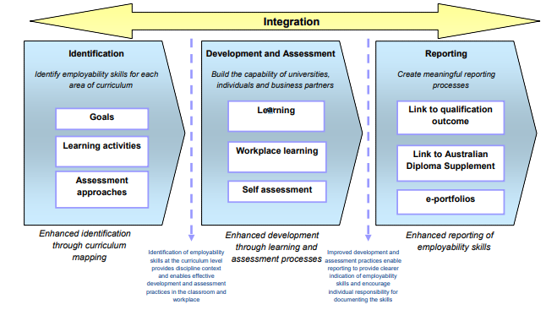
Figure 1: The integrated approach presenting the enhancement of learning of the students while developing their skills
(Source: Fraser et al. 2019)
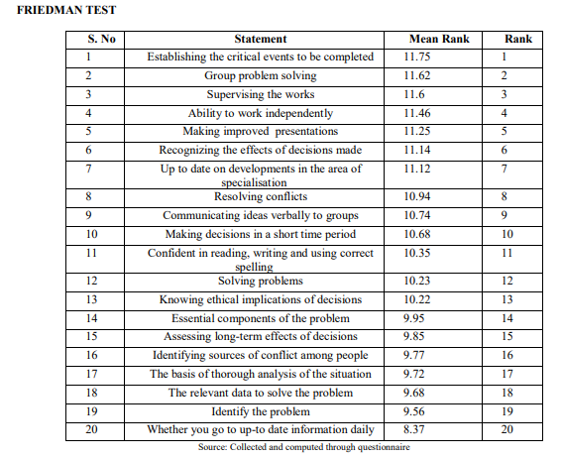
Table 1: The evidence collected from the respondents based on their answers to questions regarding the skills displayed at work
(Source: Gowsalya and Elavarasan, 2018)
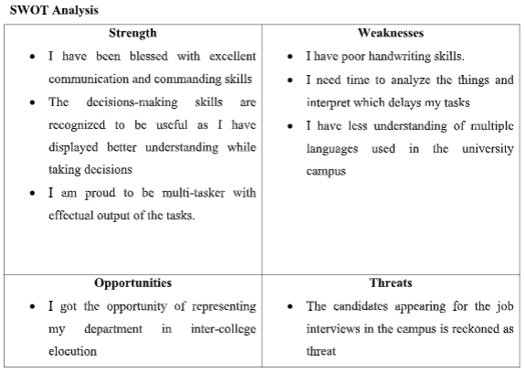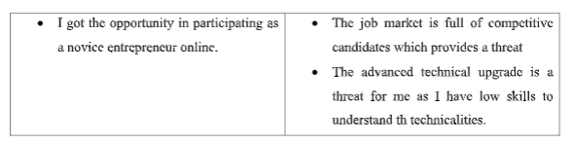
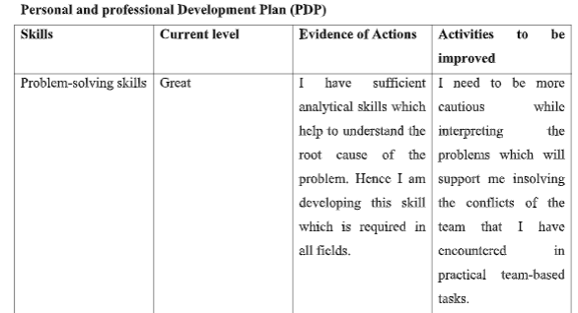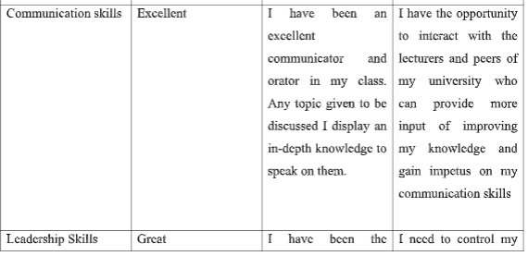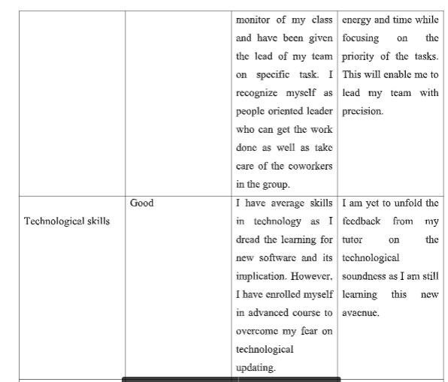

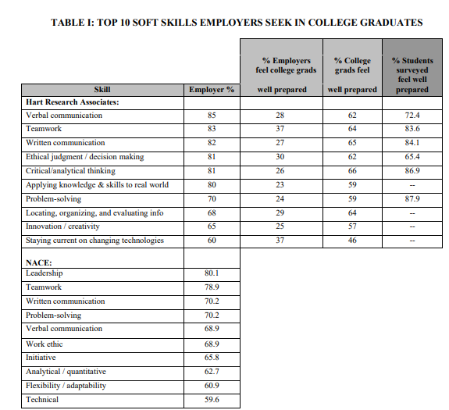

Table 2: The soft skills sought by the employers among the college graduates.
(Source: Stewart et al. 2016)

