Educational Initiative in Entrepreneurship
Within education, pupils need to be able to develop a range of skills on top of the subjects they are educated about to help them in real-world scenarios such as job opportunities. Entrepreneurship can help children develop these skills, entrepreneurship is defined as
“Entrepreneurship education equips students with the additional knowledge, attributes and capabilities required to apply these abilities in the context of setting up a new venture or business.”
(QAA. 2012, cited in UNESCO)

Educational entrepreneurship can help young people be more innovative thinkers and allows them to use their creative understanding to think of solutions to problems at hand. There are different types of educational initiatives that practitioners can use for pupils to develop more reasoning on what it is to be an entrepreneur. Using different models, theories and practices, practitioners can create lessons based on the ideas of entrepreneurs and help them become initiative learners and risk-takers.
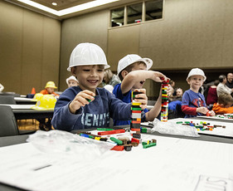
Young Enterprise “Helps young people develop the life skills, knowledge & confidence they need to succeed in the changing world of work” (Young Enterprise Charity) the goal of the young enterprise is to help young people make sure they have all the knowledge and skills they need when they face the world of work.
(COD Newsroom, 2017)
The Young Enterprise initiative looks to increase the number of skills children have within their skillset. Different employability skills such as problem-solving, teamwork and time management. The new curriculum looks to improve the curriculum through their four purposes one of them being “enterprising, creative contributors” (Welsh Government 2020) within this purpose is a range of different ways for children to be able to develop. they look at the idea of developing things such as
“Think creatively to reframe and solve problems, take measured risks, lead and play different roles in teams, express ideas and emotions and give off their energy and skills so that other people will benefit”
(Welsh Government 2020)

They believe by developing these points a child will be able to step into the world with the skills that they need to be bold, confident entrepreneurs. As an educator, we can make sure children have all the necessary resources and tools they will need to enable their students. Allowing children to take measured risks that can allow them to see what works and what doesn’t.

The ACRO Model can help children to be innovative and creative learners, it is split into four different sections to showcase important areas of entrepreneurial development. Those being Attitude, Creativity, Relationships and Organisation.
“They highlight the skills and attitudes needed by young people to succeed, whilst Wales’ entrepreneurs demonstrate how these are applied in their everyday lives.” (Big Ideas Wales, N/A) each sector plays an important role for young people in learning about entrepreneurship. Attitude allows a person to try and understand themselves allowing them to become confident and motivated learners, creativity opens opportunities for children to be innovative and use their ability to problem solve to figure out the world around them. Relationships link with the idea of teamwork being able to effectively work with other people and communicate effectively. Finally, the organisation allows a young person to be able to make their own decision on the task at hand, allowing them to take necessary risks.

LLanyrafon Primary School teaches entrepreneurship within their educational setting, all years stemming from age 4-11. Ideals from the young enterprise can be seen in the way they teach students about certain aspects of a business. Allowing students to “work independently, choose who they wish to work with and contribute to the planning and assessment processes.” (Estyn 2020) they have the choice in how they work but also get the opportunity to try different ways to work with others. If working independently the child learns how to be a leader in their learning, while they are working in a group, they can learn different roles and responsibilities, making sure they work together to get deadlines done and manage their time well. On top of that,
“Pupils of all abilities participate and have the opportunity to take a leading role. This greatly enhances their life skills and, and improves their confidence and well-being.” (Estyn 2020)

Linking to the new curriculum children and one of the points they state is important for a child to learn. “Being able to lead as well as play different roles in a team” (Welsh Government 2020). children are given a chance to express their opinions with others they can develop the confidence to communicate with others even outside of an educational setting, giving them their voice and opinions.
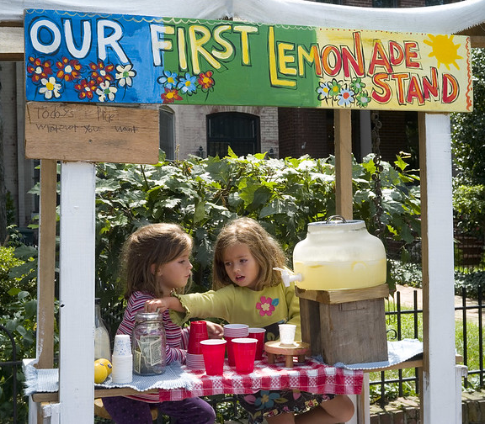
The Young Enterprise can also develop other employable skills such as financial capability, by teaching children the importance of money and being able to help them identify important decisions when faced with financial issues. Children can develop mathematical as well as problem-solving skills to solve and evaluate the best outcome.
(Davis, 2009)
The Youth Entrepreneurship Strategy (YES) in 2004, looked at an action plan they wanted to accomplish for 2010-15, YES aims to
“Equip young people aged 5-25 with entrepreneurial skills and attitudes to raising aspirations so they can fulfil their potential whatever choices they make in their future working life.” (Welsh Assembly Government 2004) by using YES children can be taught essential life skills that can help them when they are older and decide to pursue work, by being taught about the importance of finance it can help a young person understand the basics of things such as saving, budgeting, taxes, loans etc…

One school Ysgol Y Byena branches out to the local community that is supportive of the school and helps enrich the pupils’ experiences by providing life experience within their education. The school created a project where they were to design and make an outdoor learning village (Estyn 2017) the pupils were able to lead the project by themselves allowing them to work with the community to create their perfect learning space.
“Pupils had an original budget of fifteen thousand pounds and because they were responsible for the whole budget they had to keep accurate accounts for every penny they spent. They calculated the cost and quantity of materials they needed and looked at value for money.”
(Estyn 2017)
The pupils were to take the lead in learning how to budget their money, making sure every penny was used to find the best equipment to design their outdoor learning village. They gained many skills such as leadership, teamwork, communication and problem-solving as they tried to spend their money wisely, calculating and researching not only costs but types of material and the quantity they would need.
As well as being able to budget they were also taught the importance of saving money for other important reasons such as payment for those helping the project, “Leaders gave them a budget of five thousand pounds and made it clear that they needed to keep the money for labour and foundations for their structures.” (Estyn 2017) being able to see first-hand what it is like to be the leader and being able to structure how they split or save their savings.
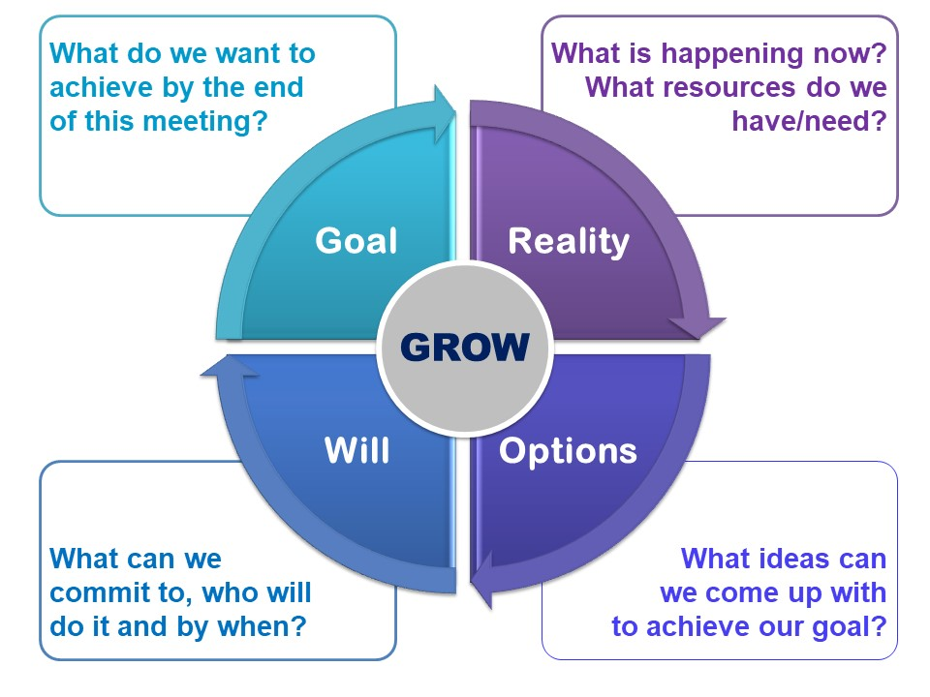
Young enterprise can also be assisted by not only using models such as ACRO but by using the GROW model, the grow model means goal, reality, options and will. “Effective tool for problem-solving and goal setting” (Ash 2013) each part of the grow method makes you think about the task at hand and the steps you need to take to complete or get to your end goal. To use the model effectively “Each of the four distinct stages was represented by a simple question, or a series of questions to help develop people and discover their potential” (Kamarudin et al, 2020) questions for each section can be things such as for your goal, what do you want to achieve? For the reality section, what is the current situation? Options, what could you do? And finally, will, what will you do to reach the end goal? The questions can be recycled and used consistently until the pupil has reached their desired outcome.
(Culture at Work, N/A)

Using young enterprise can be useful in the way that it broadens a child’s mind to new possibilities and new ways of thinking, although it can be debated that within a school setting being entrepreneurial doesn’t work all that effectively one reason for this may be due to the lack of time practitioners may have to plan and supply the pupils with this type of learning. Due to standardised testing and a semi-structured teaching guideline to follow teachers don’t have time to cover the range that entrepreneurial education requires while also keeping on top of their guidelines for what needs to be taught and when. “Entrepreneurship in education has actually rather resulted in a value clash where teachers are reacting negatively on contradicting goals” (OECD, 2015) trying to find the time to be able to allow pupils to fully develop each skill to its full potential may be difficult for a practitioner as the curriculum and time spent in the classroom just isn’t enough to complete this effectively.

Another reason why the young enterprise may not work within education is due to funding and resources. Practitioners may not have the funding for day trips or for crafts or other resources that would enhance a child’s learning. In an article released in 2020, they surveyed schools on how they felt their financial situation was. They responded that “they felt under significant financial pressure” (Spielman, 2020) due to different reasons such as budget cuts, cost of living crisis and other instability, some schools suffer by having to make different cuts to help them these can range from things such as “Reducing staffing, cutting back on non-essential building maintenance, and limiting additional provision for pupils” (Spielman, 2020) schools simply don’t have enough money to add to this list of resources they need to provide for students. Some schools as it states struggle to provide additional provisions. So, while schools may want to add young enterprise to the list of provisions they can’t due to not receiving enough money to add any new changes to an already busy curriculum,

In conclusion, the young enterprise can be used to help children’s skills that be used later on in life, by allowing children to take measured risks they can learn from successes and mistakes to develop. children need to be allowed to explore the world on their own with the practitioner as a guide to help them. While reasons such as time and resources may be an issue for being able to use the technique of young enterprise effectively due to the lack of time a practitioner has to teach all these lessons while fitting it into the current curriculum as well as not having the correct resources provided to them due to funding. The young enterprise can be used with the help of the community, so if funding or time becomes an issue families, outside companies or other schools have the opportunity to support each other, this allows for children to learn about key skills such as teamwork and communication. Overall, the young enterprise develops a large range of useful skills and techniques that schools can use to further help develop children’s knowledge and life skills for when they move on from education.

References

Ash, E. (2013) Using Goals to GROW. [Video] Melbourne, Victoria: Seven Dimensions.
Big Ideas Wales (N/A) Understanding Entrepreneurship – The ACRO Model [Blog], Available at: https://businesswales.gov.wales/bigideas/understanding-entrepreneurship-acro-model, (Accessed 23 January 2023)
COD Newsroom (2017) COD Hosts Block Kids Building Competition 2017 31, [Photo], Available at: https://www.flickr.com/photos/codnewsroom/38044289671/in/photostream/,
(Accessed 22 January 2023)
Culture at Work (N/A) The Grow Model [Photo], Available at: https://www.coachingcultureatwork.com/the-grow-model/, (Accessed 28 January 2023)
Davis B (2009) Lemonade Stand [Photo] Available: https://www.flickr.com/photos/brettdavis/6043804449 (Accessed 24 January 2023)
Estyn (2020) Business Enterprise Improving skills, Effective practice [blog], available at: https://www.estyn.gov.wales/effective-practice/business-enterprise-improving-skills (Accessed 23 January 2023)
Estyn (2017) Developing learners’ skills through real life experiences, Effective Practice [blog], Available at: https://www.estyn.gov.wales/effective-practice/developing-learners-skills-through-real-life-experiences (Accessed 27 January 2023)
Kamarudin, M. binti, Kamarudin, A. Y. binti, Darmi, R. binti, & Saad, N. S. binti M. (2020). A Review of Coaching and Mentoring Theories and Models. International Journal of Academic Research in Progressive Education and Development, 9(2), 289–298. (Accessed 28 January 2023)
OECD (2015) Entrepreneurship in education: What, Why, When, How., Available at: https://www.oecd.org/cfe/leed/BGP_Entrepreneurship-in-Education.pdf (Accessed 28 January 2023)
UNESCO (2012), Enterprise and entrepreneurship education: Guidance for UK higher education provider, Available at: https://unevoc.unesco.org/home/TVETipedia+Glossary/filt=all/id=206 (Accessed 22 January 2023)
Young Enterprise, what we do [Charity site], Available at https://www.young-enterprise.org.uk/what-we-do/, (Accessed 22 January 2023)
Spielman A,. and OFSTED (2020) HMCI commentary of school funding, school and academy funding, Available at: https://www.gov.uk/government/speeches/commentary-on-school-funding, (Accessed 28 January 2023)
Welsh Government (2020) Let’s get started, A New Curriculum in Wales, Available at: https://hwb.gov.wales/api/storage/44b74558-5d89-4a5b-bf54-32bd6dcad1c0/a-new-curriculum-in-wales-a-guide-for-children-young-people-and-families.pdf (Accessed 24 January 2023)

