
Employee Engagement in a Multigenerational Workforce


Introduction - The aim of this research is to identify key influencing factors for employee engagement across a multigenerational workforce, with the following objectives:
- Evaluate current literature to identify key engagement drivers that most significantly impact a multigenerational workforce.
- Evaluate the current literature to establish future considerations for employee engagement in a multigenerational workforce.
- Conduct primary research to understand the key engagement factors across the operational workforce.
- Make recommendations on the key considerations for employee engagement in a multigenerational workforce.

This research is based on Dimensions Cymru, a social care not-for-profit organisation supporting people with learning disabilities and autism. Age diversity has increased rapidly, and organisations tend to know little about the impact on engagement or how to differentiate and address issues in consideration of specific generations (Kunze et al., 2013; Gilbert, 2015).
Literature Review
62.9% of the overall population is currently of working age (i.e. 16-64 years old) (ONS, 2023), resulting in 5 generations active in the workplace (Kelly, 2023).
Flexible Working

Studies show that colleagues achieving flexibility at work was a positive indicator of engagement for all ages (Pitt-Catsouphes & Matz-Costa, 2008; Wilson et al., 2008).
Career Development
Studies show that for Gen Z and millennials, career advancement was one of the biggest engagement drivers (Schullery, 2013; Gilbert, 2015). In addition, one of the top dissatisfiers for older workers is the lack of learning opportunities (Smyth, 2023).
Future of a multigenerational workforce
The evidence points to an ageing workforce with economic factors causing people to remain in employment for longer (Swan, 2012). Shifts in the economy and labour
References
Gill, J. and Johnson, P. (2010) Research Methods for Managers. London: Sage Publications Ltd.

Gilbert, J. (2015) The millennials: A new generation of employees, a new set of engagement policies, Ivey Business Journal. Available at: https://iveybusinessjournal.com/publication/the-millennials-a-new-generation-of-employees-a-new-set-of-engagement-policies/ (Accessed: 29 August 2023).

Kelly, J. (2023) Can 5 generations coexist in the workplace?, Forbes. Available at: https://www.forbes.com/sites/jackkelly/2023/03/01/can-five-generations-coexist-in-the-workplace/ (Accessed: 03 September 2023).
Kunze et al. (2013) ‘Organizational Performance Consequences of Age Diversity: Inspecting the Role of Diversity-Friendly HR Policies and Top Managers’ Negative Age Stereotypes’, Journal of Management Studies, 50(3), pp. 413–442. doi:https://doi-org.ezproxy.uwtsd.ac.uk/10.1111/joms.12016.
Perna, M.C. (2021) Why skill and career advancement are the way to gen-Z’s heart, Forbes. Available at: https://www.forbes.com/sites/markcperna/2021/03/02/why-skill-and-career-advancement-are-the-way-to-gen-zs-heart/ (Accessed: 24 September 2023).
Pitt-Catsouphes, M. and Matz-Costa, C. (2008) ‘The multi-generational workforce: Workplace flexibility and Engagement’, Community, Work & Family, 11(2), pp. 215–229. doi:10.1080/13668800802021906.
Saunders et al. (2016) Research Methods for Business Students. Harlow: Pearson.
Schullery, N. (2013) ‘Workplace engagement and generational differences in values’, Business Communication Quarterly, 76(2), pp. 252–265. doi:10.1177/1080569913476543.
Smyth, A. (2023) How should you go about developing a multigenerational workforce ..., HR Grapevine. Available at: https://www.hrgrapevine.com/publications/guide/guide-to-career-management-2019/how-should-you-go-about-developing-a-multigenerational-workforce (Accessed: 17 September 2023).
Swan, J. (2012) ‘Why are multi generational workplaces important, and what benefits can they bring?’, Quality in Ageing and Older Adults , pp. 270–274. Available at: https://www.proquest.com/docview/1223523772?accountid=130472&parentSessionId=Sbp8Gf%2FQA9Mywy3f88szF3qtQdkoCavN8BkvAxLxTqs%3D&pq-origsite=primo.


market means there is becoming less likelihood of a job for life with careers becoming more dynamic (Kelly, 2023). Recent societal pressures have forced all generations to reconsider what is required to remain relevant with reskilling and upskilling becoming a priority (Perna, 2021).
Methodology - The method of data collection was a web-based questionnaire. The questionnaire included open, closed and rating questions to achieve different types of responses. This resulted in a mix of quantitative and qualitative data. The research population was the operational workforce (Gill & Johnson, 2010).
The use of descriptive statistics and correlation analysis was applied to the qualitative data and thematic analysis was utilised to identify reoccurring themes within the quantitative data (Saunders et al., 2013).
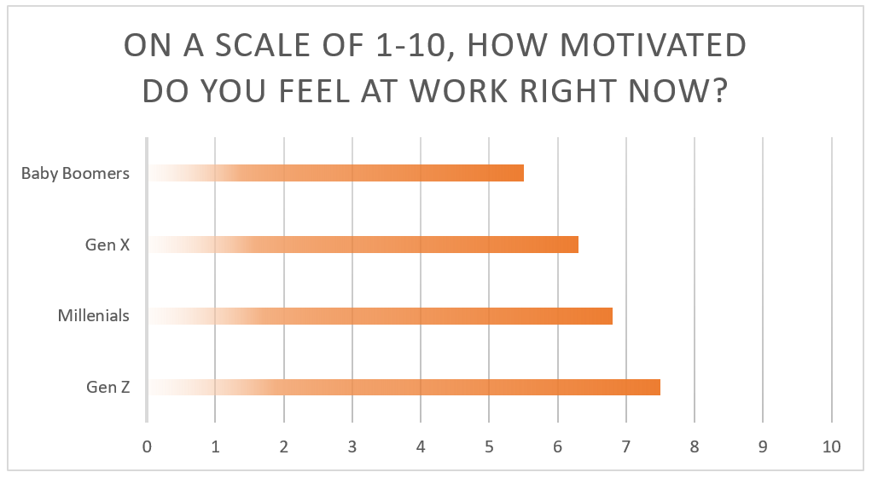
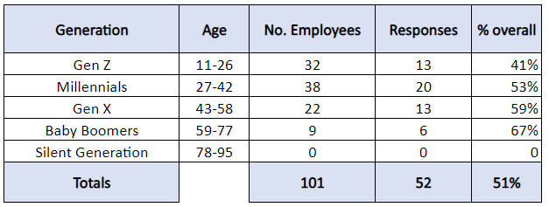
Each question is linked with the objectives set, and covers all areas identified within the literature review (Kumar, 2019). The instrument chosen for the research was Google forms.
Figure 2.
..
Figure 1.
Findings - The primary research obtained a 51% response (Figure 1). It also identified the younger generation were more motivated than the older generation (Figure 2). All generations bar Gen Z cited flexible working as an key engagement factor. Despite this, 80% of Gen Z colleagues who did not have an agreement in place, felt flexibility would support them.

All generations bar baby boomers identified development and progression as a motivating factor. Despite this, out of those baby boomers who felt they had opportunities to learn, 100% did not feel confident about developing their career, and scored an average of 6/10 in feeling motivated at work. They also cited they are motivated by challenging work, suggesting their desire to develop.
Conclusion - In summary, with current talent shortages and increased age diversity, priority to engage all age ranges has become even more critical (Smyth, 2023). The literature review identified that different generations are aligned on flexible working styles and opportunities for growth, development and career-advancement (Kelly, 2023). This is supported by the primary research, identifying flexibility and career development as key factors contributing to overall engagement of the workforce surveyed.


