Joel Codd 2117927

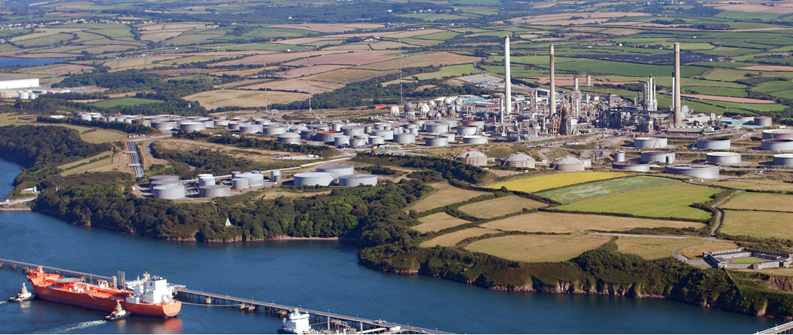
Project Proposal: Pembroke FCC Third Stage Separator (TSS) Repair or Replacement

Abstract
This report examines the condition, performance, and replacement strategy of the Third Stage Separator (TSS) at Pembroke Refinery’s Fluid Catalytic Cracking (FCC) unit. The TSS is a critical component that removes catalyst fines from the flue gas stream to ensure environmental compliance and protect downstream equipment. Inspections conducted during the 2014 and 2021 turnarounds identified extensive cracking and metallurgical degradation in the 304H stainless steel cyclones caused by sigma-phase embrittlement.
Temporary mechanical restraints were installed in 2021 to prevent component failure; however, this solution remains limited and cannot provide long-term reliability. Continued cracking, increased expander fouling, and multiple environmental exceedances confirm the need for permanent intervention. A full vessel replacement has therefore been selected as the preferred option, offering improved reliability, reduced velocity, and compliance assurance for future operating cycles.
This study analyses the existing system’s failure mechanisms, evaluates the feasibility of repair versus replacement, and outlines the engineering, operational, and environmental justifications for a new TSS design. The findings support a replacement strategy that aligns with Shell’s licensor requirements and ensures safe, efficient, and sustainable FCC operation at Pembroke Refinery.

Contents
Abstract 1
Contents 2
Table of Figures 5
Table of Tables 6
1 Introduction 0
2 Literature Review 2
2.1 Advanced Cyclone Modelling and Performance Studies 5
2.2 Metallurgy Sigma 7
2.3 Erosion and Wear Mechanisms in High-Temperature Cyclones 13
3 Methodology and Design Evaluation 14
3.1 Inspection and Data Collection 15
3.2 Metallurgical Assessment 15
3.3 Temporary Repair (2021) 17
3.4 Evaluation of Repair and Replacement Options 17
3.5 Cost and Schedule Evaluation 19
3.6 Design Review and Validation 21
3.7 Safety and Environmental Considerations 23
3.8 Decision and Justification 24
4 Results and Discussion 25
4.1 Inspection and Damage Assessment 25
4.2 Metallurgical Analysis Results 27
4.3 Thermal and Mechanical Fatigue Behaviour 28
4.4 Thermal Gradient Analysis and Stress Distribution 28
4.5 Cyclone Performance and Efficiency 29
4.6 Comparison of Existing and New TSS Design Parameters 31
4.7 Environmental Performance 32
4.8 Evaluation of Repair and Replacement Options 33
5 Design and Reliability Improvements 34
5.1 Economic and Operational Benefits 35
5.2 Environmental and Sustainability Impact 35
5.3 Mechanical Reliability and Risk Reduction 36
5.4 Risk Mitigation through Replacement 36
5.5 Implementation Strategy for the Replacement Project 39
5.6 Engineering Design (Q2 2025 – Q4 2025) 39
5.7 Procurement and Supply Chain Management (Q3 2025 – Q1 2026) 39
5.8 Fabrication and Quality Control (Q1 2026 – Q4 2026) 40
5.9 Delivery and Pre-Commissioning (Q2 2027) 40
5.10 Installation and Commissioning (Q3 2027) 40
5.11 Quality Assurance and Inspection Planning 41
5.12 Vendor Quality Assurance 41
5.13 Site Quality Control 41
5.14 Health, Safety, and Environmental (HSE) Oversight 41
5.15 Commissioning Verification 42
5.16 Economic and Operational Follow-up 42
6 Recommendations and Future Considerations 42
6.1 Implement continuous temperature and vibration monitoring. 43
6.2 Maintain stable operating temperature and flow conditions. 43
6.3 Conduct regular borescope inspections. 43
6.4 Use predictive maintenance through condition-based monitoring. 43
6.5 Maintain a record of all thermal cycles. 43
7 Inspection and Metallurgy Control 44
7.1 Introduce metallurgical condition monitoring. 44
7.2 Improve welding procedures and inspection control. 44
7.3 Conduct hardness testing as part of major inspections. 44
7.4 Retain all metallurgical reports and inspection data. 44
8 Environmental and Reliability Considerations 44
8.1 Confirm compliance with Best Available Technology (BAT). 44
8.2 Quantify environmental benefits post-installation. 45
8.3 Integrate TSS monitoring into refinery reliability KPIs. 45
9 Economic and Lifecycle Planning 45
9.1 Review lifecycle cost every five years. 45
9.2 Extend the turnaround planning window. 45
9.3 Develop an internal design database. 46
9.4 Conduct post-installation performance verification. 46
10 Long-Term Future Considerations 46
10.1 Investigate alternative materials. 46
10.2 Explore advanced manufacturing methods. 46
10.3 Implement digital twin technology for predictive analysis. 46
10.4 Apply lessons learned to other refinery assets. 47
11 Conclusion 48
12 Limitations and Future Work 50
13 Professional Reflection 52
14 References 53

Table of Figures
Figure 1 - Shows gas flow direction, separator layout, and relationship between regenerator, TSS, and stack 3
Figure 2 - Diagram showing axial cyclone components and flow direction 4
Figure 3 - Cracked swirl vanes and alignment show design weaknesses 5
Figure 4 - Schematic representation of sigma-phase formation and associated embrittlement in 304H stainless steel (adapted from Hau & Seijas, 2006) 7
Figure 5 - Inlet gas tube cracking 10
Figure 6 - Temporary hook installation design 11
Figure 7 - Preliminary New Shell Replacement Design 12
Figure 8 - TSS Replacement – Existing vs New Comparison 14
Figure 9 - Cracked welds found in TSS 15
Figure 10 - the layout of the J-hooks fitted to each cyclone assembly 17
Figure 11 - Cost Estimate 20
Figure 12 – High Level Schedule & Execution 21
Figure 13 - High Level Project Completion 21
Figure 14 - Preliminary Shell TSS Design 22
Figure 15 - FCC TSS iso-kinetic sampling locations: A – TSS inlet, B – TSS overflow, C – Fourth-stage overflow, and D – stack (Valero, 2025). 23
Figure 16 - Cracking at Swirl Tube and Alignment Can Welds 26
Figure 17 - Iso-Kinetic Sampling Locations 30
Figure 18 - Frequency of walnut washing per quarter since 2019 to mitigate increased PRT expander vibrations as a result of catalyst accumulation. 31
Figure 19 - Preliminary Shell TSS Design 34
Figure 20 - Comparative risk levels for key categories before and after the replacement of the Pembroke FCC Third Stage Separator. 38
Figure 21 - TSS Replacement – Existing vs New Comparison 39
Figure 22 - Schedule & Permitting slide with the full Gantt chart showing phases from 2026–2027 40

Table of Tables
Table 1 - Metallurgical Replication Results Summary 9
Table 2 -Metallurgical test results showing hardness and microstructural observations from 304H stainless 16
Table 3 - Duration Comparison Between In-situ Repair and Vessel Replacement 18
Table 4 - Cost Comparison 19
Table 5 - Option Evaluation Summary 24
Table 6 - gas velocity through each cyclone comparison 31
Table 7 - Duration Comparison Between In-situ Repair and Vessel Replacement 33
Table 8 - Cost Estimate Comparison 33
Table 9 - Summary of risk reduction achieved through the full replacement of the Pembroke FCC Third Stage Separator. 37

Introduction
This report focuses on the Third Stage Separator (TSS) at Pembroke Refinery’s Fluid Catalytic Cracking (FCC) unit. The TSS is responsible for removing catalyst fines from the flue gas before release to atmosphere and is essential in maintaining environmental compliance and protecting downstream equipment such as the expander and waste heat recovery system. Because Pembroke operates without a Belco Scrubber or Electrostatic Precipitator (ESP), the TSS is the refinery’s main defence against particulate emissions.
The TSS currently in use was installed in 1982 as part of the original FCC construction. It consists of 112 axial-flow cyclones designed by Shell, manufactured from 304H stainless steel. Over four decades of high-temperature service and repeated thermal cycling have caused metallurgical degradation and cracking. Inspections and metallurgical tests carried out during the 2014 and 2021 turnarounds confirmed significant cracking at the swirl vane, swirl tube and alignment can welds. Finite element analysis and metallurgical replication confirmed the primary cause as sigma-phase embrittlement, resulting in severe loss of ductility and fracture toughness in the weld and parent metal.
In 2021, around 74 of the 112-cyclone swirl tube-to-swirl vane welds were found to be cracked, with over half extending more than halfway around the joint circumference. More than 70 percent of the swirl can-to-alignment can welds were also cracked. Repair attempts were unsuccessful, as further cracking occurred even with pre-heating. To maintain operation, a mechanical restraint system using J-hook supports was installed on all 112 cyclones to prevent internal components from detaching and falling into the vessel. Although effective as a temporary measure, this system was not Shell-approved and cannot be monitored for long-term integrity. It remains vulnerable to fatigue and thermal cycling.
Since the temporary repair, operational issues have continued. The FCC expander has shown higher fouling rates and vibration, requiring more frequent walnut washing. In 2023, there were three exceedances of permitted particulate emissions, confirming reduced TSS efficiency. Iso-kinetic sampling was planned to measure particulate concentrations and fines generation, but early data already indicate bypassing within the existing cyclone assemblies.
Due to the close spacing of the 112 cyclones (less than 8 inches apart), in-situ repair or replacement presents serious access and duration challenges. Sequential removal means extended downtime and high cost. The in-situ replacement option would take approximately 86 days oil-to-oil, compared with 48 days for full vessel replacement, and would result in an estimated lost profit of £39 million. The vessel itself, along with the expansion joint, bellows and tubesheets, will exceed 50 years of service by 2034, further reducing reliability.
Shell, as the technology licensor, has confirmed that a full vessel replacement is the only practical and safe long-term solution. The replacement will follow an in-kind design but include modifications to improve reliability and reduce velocity. These changes include increasing the cyclone count from 112 to 144 and slightly enlarging the inlet and outlet nozzle diameters by approximately 2.5–4.5 percent. All other major vessel dimensions remain unchanged, maintaining compatibility with the existing FCC layout.
The purpose of this project is to analyse the current condition of the TSS, identify the root causes of failure, and justify the engineering and economic basis for full vessel replacement. The report also evaluates how the new design will improve operational reliability, emissions control and overall FCC performance.
This project is significant as it addresses one of the refinery’s main reliability risks and ensures compliance with environmental regulations. The replacement of the TSS will improve long-term stability, reduce unplanned downtime and restore efficient catalyst recovery for future operating cycles.

Literature Review
Effective gas–solid separation is a fundamental process in Fluid Catalytic Cracking (FCC) units and is critical for both efficiency and environmental compliance. The Third Stage Separator (TSS) is the final line of defence for the control of particulate emissions, positioned downstream of the regenerator cyclones. Its purpose is to remove fine catalyst particles from the flue gas before release to the atmosphere and to protect downstream equipment such as the expander and waste heat boiler. According to Arnold and Stewart (2008), tertiary separation systems such as the TSS play an essential role in maintaining product quality, energy efficiency, and regulatory compliance.

Gas–solid separation occurs when particles suspended in a gas stream are subjected to forces that cause them to deviate from the gas flow. The most common mechanisms used in industrial systems are gravitational settling, centrifugal force, and inertial impaction. Cyclone separators utilise centrifugal force, which is generated when gas enters tangentially into a cylindrical or conical vessel. The heavier particles move radially outward toward the wall under centrifugal acceleration, while the cleaned gas exits through a central vortex finder (Stein et al., 2016).
Cyclone performance is also influenced by pressure drop (ΔP\Delta PΔP) and gas residence time. A higher pressure drop increases centrifugal force but raises energy consumption. The design therefore requires a balance between efficiency and pressure loss (Ogawa & Komatsu, 2009).
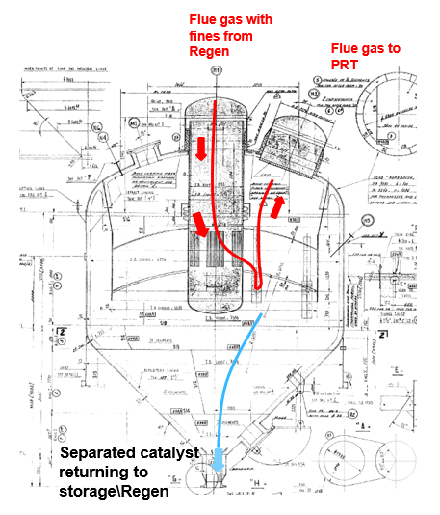
Figure 1 - Shows gas flow direction, separator layout, and relationship between regenerator, TSS, and stack
In FCC applications, three-stage separation is used:
- Primary and secondary cyclones inside the regenerator remove most of the catalyst fines.
- The TSS removes residual fines and ensures that particulate emissions meet legal discharge limits.
- The clean flue gas then passes through the power recovery train before being released to atmosphere.
The Pembroke FCC system relies solely on the TSS for compliance, as it operates without a Belco scrubber or electrostatic precipitator (ESP). Therefore, the mechanical integrity and performance of the TSS are directly tied to the plant’s environmental licence.

The Pembroke TSS employs an axial-flow cyclone configuration licensed by Shell. Each of the 112 cyclone assemblies consists of four main components: the swirl tube, swirl vane, swirl can, and alignment can.
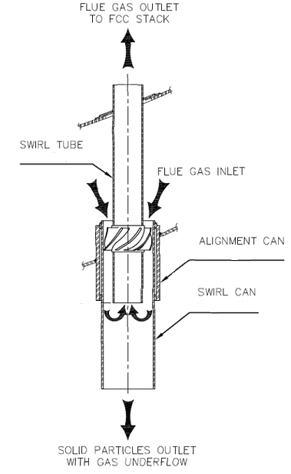
Figure 2 - Diagram showing axial cyclone components and flow direction
The cyclones are arranged in five concentric rings—three inner rings of 16 cyclones and two outer rings of 32—with spacing of less than 200 mm between units. This compact arrangement maximises capacity but severely restricts access for inspection and repair. Each cyclone handles a portion of the total gas flow; therefore, any cracked or blocked unit increases velocity and wear in the others, compounding mechanical stress (Mezger, 2019).
Shell’s design criteria (Shell, 2024) specify that the TSS must achieve an outlet particulate concentration below 50 mg/Nm³. To achieve this, the cyclone geometry must maintain a stable vortex and prevent re-entrainment of collected particles. At Pembroke, the 304H stainless steel construction was originally selected for high-temperature corrosion resistance, with a design temperature of approximately 680°C and operating pressure of 1.2 bar(g). However, the long exposure time has resulted in significant metallurgical deterioration.
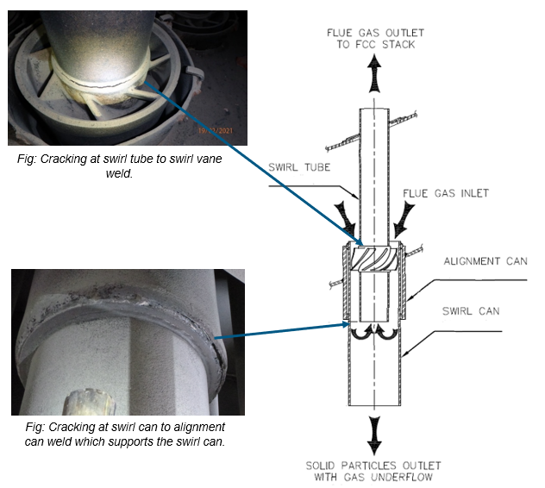
Figure 3 - Cracked swirl vanes and alignment show design weaknesses
The observed cracking pattern is common in older FCC separators. The welds joining the swirl vane to the swirl tube and those connecting the swirl can to the alignment can are especially susceptible due to cyclic loading and temperature variation. Over decades of operation, these welds experience repeated differential expansion and contraction, creating stress concentration zones that eventually lead to failure.

Advanced Cyclone Modelling and Performance Studies
In recent years, a significant amount of research has focused on improving cyclone separator performance through computational and experimental analysis. Modern Computational Fluid Dynamics (CFD) tools allow engineers to simulate flow paths, velocity fields, and particle trajectories within cyclones to predict separation efficiency and erosion rates before fabrication. These models help validate licensor designs and provide insight into how geometry changes, such as cyclone length or inlet size, affect performance.
Fushimi et al. (2021) conducted detailed CFD analysis on high-temperature axial-flow cyclones used in FCC applications. Their findings showed that separation efficiency is mainly influenced by gas inlet velocity and vortex stability. As velocity increases, centrifugal forces improve fine-particle capture, but excessive velocity creates re-entrainment and erosion on the cyclone walls. This trade-off mirrors the problem observed in the Pembroke TSS, where gas velocity through the existing 112 cyclones is higher than optimal, accelerating wall wear.
Xiong et al. (2022) developed a three-dimensional CFD model to evaluate how inlet design and vane angle influence the cyclone’s cut size. Their research demonstrated that a 10% reduction in inlet velocity could lower the cut size by up to 18%, substantially increasing overall separation efficiency. This supports Shell’s decision to increase the number of cyclones from 112 to 144 in the new TSS design, which reduces velocity and therefore decreases particle carry-over.
Guo et al. (2025) examined erosion prediction in FCC cyclones by combining CFD with empirical wear correlations. Their results identified that particle impact velocity and incidence angle are the primary erosion drivers, particularly near the cyclone inlet and outlet sections. The study concluded that using more cyclones with slightly larger inlet diameters reduces both impact angle severity and localised erosion. These insights are directly applicable to Pembroke’s replacement strategy, which aims to reduce internal velocity by around 18% and extend service life by over a decade.
Other researchers have compared numerical predictions with plant data. Liu et al. (2023) validated CFD simulations against operating FCC cyclones, finding less than 6% deviation between predicted and actual efficiency. Such comparisons show that CFD tools now provide credible guidance for real-world design modifications.
Overall, these studies demonstrate the effectiveness of combining CFD modelling with empirical testing to predict cyclone performance. The main conclusions are consistent with Shell’s design philosophy: lower gas velocity reduces erosion and stress while maintaining high separation efficiency. This correlation between academic findings and industry practice confirms the robustness of the new TSS design being implemented at Pembroke Refinery.

Metallurgy Sigma
A key finding from the Pembroke inspections is the presence of sigma-phase embrittlement in the 304H stainless steel welds. Sigma phase (σ\sigmaσ) is a hard, brittle intermetallic compound composed mainly of iron and chromium, forming between 560°C and 980°C (Davis, 2018). Its presence drastically reduces fracture toughness, ductility, and impact strength.
Sigma-phase formation is accelerated by:
- High ferrite content in weld metal;
- Extended exposure to high temperatures;
- Cyclic thermal stress;
- Residual strain from fabrication or prior repairs.
Once sigma phase forms, it cannot be reversed except through full solution annealing above 1,050°C, which is impractical for in-service refinery vessels (Kotecki & Lippold, 2015).
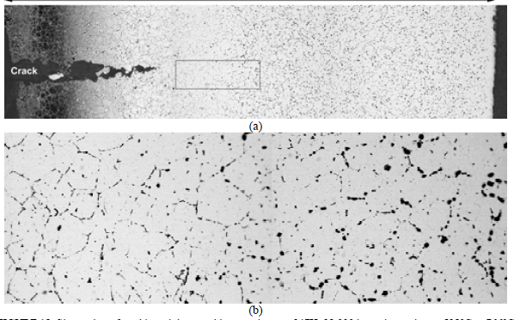
Figure 4 - Schematic representation of sigma-phase formation and associated embrittlement in 304H stainless steel (adapted from Hau & Seijas, 2006)
The failure mechanism illustrated in Figure 4 shows how prolonged exposure at high temperature promotes chromium-rich sigma-phase formation within the weld microstructure, resulting in intergranular brittleness and eventual cracking under thermal stress (Hau & Seijas, 2006).

Davis (2018) and Patel (2017) describe how sigma-phase embrittled steels can lose more than 80% of their fracture energy and exhibit hardness values exceeding 350 HV, compared to 180 HV for unaffected 304H. The 2021 metallurgical replication at Pembroke confirmed similar results, with weld samples showing extensive sigma-phase formation and reduced toughness.
The degradation is not limited to welds; tubesheets also exhibit chromium-depleted grain boundaries, indicating that prolonged thermal exposure has affected the base metal. Once this occurs, further repair by welding accelerates the problem because each repair introduces additional heat cycles that promote more sigma formation.
Sample Location | Component / Weld Type | Microstructure Description | Measured Hardness (HV10) | Sigma-Phase Presence | Remarks
1 | Swirl vane to swirl tube weld | Heavily sensitised austenitic matrix with continuous grain-boundary precipitates | 335 – 350 | Extensive (> 15 %) | Significant loss of ductility; embrittled weld metal
2 | Alignment can to swirl can joint | Austenite with ferrite stringers and sigma-phase at ferrite–austenite interfaces | 320 – 340 | Moderate (10–12 %) | Intergranular cracking observed
3 | Tubesheet fillet weld | Coarse austenitic grains with secondary carbides and sigma particles | 300 – 320 | Light (≈ 5 %) | Locally brittle; early stage of transformation
4 | Base metal (304H parent plate) | Uniform austenitic structure; minimal delta ferrite | 175 – 190 | None detected | Normal condition; no degradation
5 | Previously repaired weld (region of past overlay) | Mixed ferritic–austenitic microstructure with heavy sigma-phase formation and micro-cracks | 340 – 360 | Severe (> 20 %) | Embrittled and unsalvageable

Table 1 - Metallurgical Replication Results Summary
Embrittlement in the TSS welds explains the extensive cracking observed during inspection. When subjected to normal thermal cycling or vibration, the brittle welds fracture rather than deform plastically. The combination of high temperature, vibration, and low fracture toughness makes the existing separator unreliable for continued operation.

The TSS experiences repeated temperature fluctuations during start-up, shutdown, and load changes. These cycles produce differential expansion between the cyclone internals and the vessel shell. According to Lee and Anderson (2012), thermal fatigue arises when temperature gradients generate alternating tensile and compressive stresses at the weld interface.
Each thermal cycle causes incremental crack growth. When combined with mechanical vibration from flue gas pulsation and catalyst impingement, cracks propagate through the weld circumference until structural failure occurs. The 2021 inspection confirmed through-wall cracks in several alignment can joints, suggesting complete mechanical separation between cyclone components (Valero, 2021).
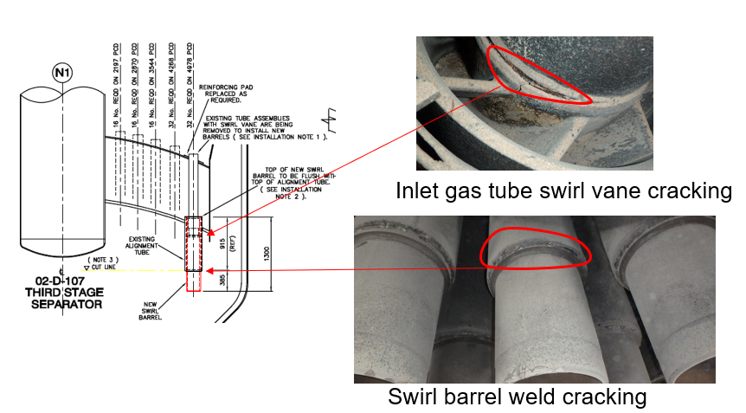
Figure 5 - Inlet gas tube cracking
Erosion from fine catalyst particles further accelerates degradation by thinning the cyclone walls and exposing new surfaces to oxidation. Combined with sigma-phase embrittlement, this results in brittle fracture rather than ductile yielding.
Thermal cycling effects were modelled using finite element analysis (FEA) to simulate expansion stress. The analysis revealed localised stress peaks exceeding 85% of yield strength at 600°C. These conditions explain the accelerated cracking between 2014 and 2021 and confirm that the temporary mechanical restraints installed in 2021 (J-hooks) are insufficient to withstand long-term cyclic stress.

To prevent immediate mechanical failure, a J-hook restraint system was installed across all 112 cyclone assemblies during the 2021 turnaround. This system uses hooked rods to anchor the swirl vanes and swirl cans to the upper tubesheet, preventing them from detaching and dropping into the vessel base.
While the design temporarily mitigated the risk of catastrophic failure, it introduced several limitations:
- It was not approved by Shell as a permanent repair;
- The components cannot be condition-monitored effectively;
- The system remains vulnerable to thermal cycling fatigue;
- It does not address the underlying metallurgical degradation (Valero, 2021).
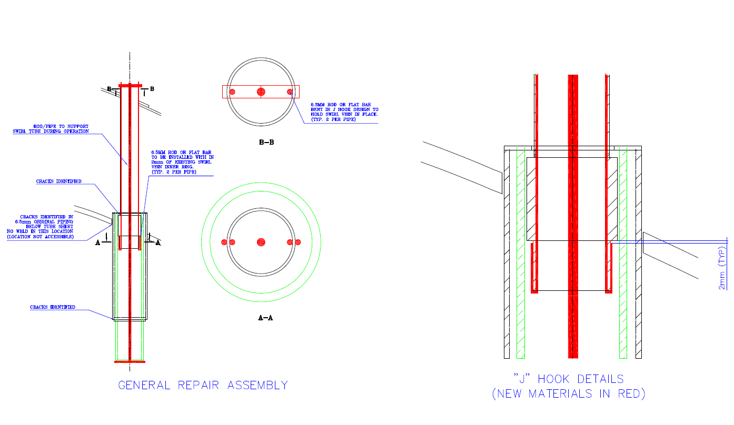

Figure 6 - Temporary hook installation design
The J-hook system therefore functions as a short-term operational safeguard only, allowing continued operation until a permanent solution could be engineered.

Sigma-phase embrittlement and cyclone cracking are not unique to Pembroke. Similar failures have been reported across older Shell and UOP FCC units operating since the 1980s. The 2018 TSS replacement at Petro-Canada’s Montreal Refinery revealed identical cracking in 304H cyclone welds after 40 years of service (Petro-Canada, 2019). The project cost approximately £12 million and demonstrated that replacement was the only viable long-term solution.
Industry lessons learned from such projects led to design improvements:
- Increasing cyclone count to reduce individual unit gas velocity;
- Enlarging inlet and outlet nozzles to reduce pressure drop;
- Upgrading fabrication standards and welding procedures;
- Implementing improved material controls and heat treatment (Shell Global Solutions, 2020).
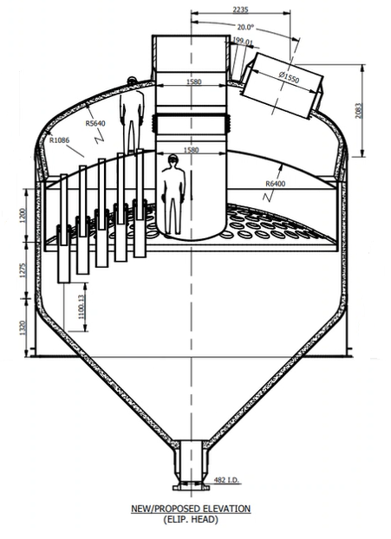

Figure 7 - Preliminary New Shell Replacement Design
The revised Shell design for Pembroke adopts these improvements. The cyclone count increases from 112 to 144, with minor changes to nozzle diameter (2.5–4.5% increase). Although the metallurgy remains 304H stainless steel, the new design incorporates enhanced welding and post-weld heat treatment to minimise future sigma-phase formation (Shell, 2024).
The updated configuration reduces internal velocity and erosion rates while maintaining vessel dimensions compatible with existing piping. These changes are expected to extend service life by at least 15 years and reduce maintenance requirements.

Erosion and Wear Mechanisms in High-Temperature Cyclones
In addition to metallurgical degradation, erosion is one of the most common life-limiting factors in FCC separator systems. Erosion occurs when catalyst particles entrained in the flue gas strike internal surfaces at high velocity. The rate of wear depends on impact angle, particle hardness, gas velocity, and temperature. At Pembroke, erosion is most severe at the cyclone inlet and on the upper tubesheet where gas flow is redirected, creating high-energy particle impacts.
The earliest erosion models, such as Finnie (1960), established that maximum material removal occurs when hard particles impact at shallow angles, typically between 20° and 30°. Later studies by Grant and Tabakoff (1975) refined this relationship by including particle size and impact velocity.
At high temperatures above 550 °C, oxidation and surface scaling further increase wear because the oxide layer is brittle and easily removed upon impact (Davis, 2018). In the Pembroke TSS, repeated oxidation and catalyst impingement have combined to produce both wall thinning and surface pitting. Once the stainless-steel surface loses its protective film, erosion accelerates rapidly, especially where sigma-phase embrittlement has already hardened the material.
Recent CFD-erosion coupling studies by Guo et al. (2025) and Fushimi et al. (2021) have shown that reducing gas velocity or modifying inlet geometry significantly decreases local erosion rate. Shell’s new 144-cyclone design lowers average inlet velocity by nearly 20%, which is expected to reduce erosion severity by at least 30%. This improvement aligns with findings from industry benchmarks such as the Montreal TSS replacement (Petro-Canada, 2019), where lower velocities extended cyclone service life by more than 12 years.
Erosion does not usually cause immediate failure but acts together with fatigue and metallurgical degradation to accelerate cracking. The combined effect reduces the safety margin of the vessel and increases maintenance frequency. By controlling gas velocity, using improved metallurgy, and introducing smoother internal transitions, the new Pembroke TSS design effectively mitigates all three interacting failure mechanisms.

The literature and industry experience show that sigma-phase embrittlement, thermal cycling fatigue, and erosion are the primary causes of TSS degradation in FCC units over long service periods. Once embrittlement occurs, repair is ineffective because weld heat input accelerates sigma formation. Temporary supports provide limited stability but cannot restore material properties or ensure long-term safety.
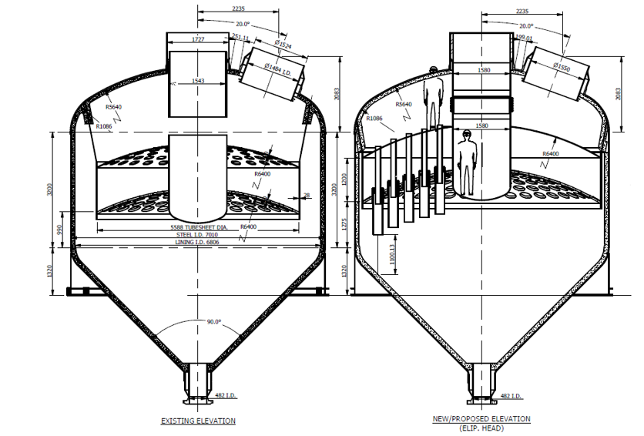

Figure 8 - TSS Replacement – Existing vs New Comparison
The engineering consensus, supported by Valero (2025) and Shell (2024), is that full vessel replacement is the only sustainable solution. The updated design addresses velocity-related wear, improves mechanical reliability, and reduces operational risk.

Methodology and Design Evaluation
This section explains the approach taken to assess the condition of the Third Stage Separator (TSS) at Pembroke Refinery, the analysis methods used, and the reasoning behind the decision to replace the vessel. The assessment combined visual inspection, metallurgical testing, engineering analysis, and cost evaluation. The process followed Valero’s internal project management procedures and Shell’s licensor guidance for FCC tertiary cyclone systems.

Inspection and Data Collection
Information used for this report was collected from turnaround inspection records, engineering design files, metallurgical replication reports, and cost studies. Inspection data from both the 2014 and 2021 FCC turnarounds were reviewed to understand how the TSS condition had deteriorated over time (Valero, 2021). The inspection included visual checks, borescope photography, dye penetrant testing (DPI), and hardness testing on weld areas.
A full set of borescope photographs was taken during 2021 showing the internal surfaces of the swirl tubes, swirl vanes, and alignment cans. Cracking was clearly visible around the weld areas joining the swirl vanes to the swirl tubes. Similar cracks were found at the lower alignment can welds, confirming that the issue was not localised but widespread across the vessel.
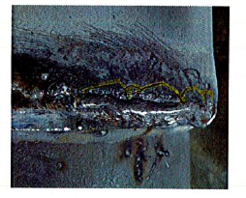
Figure 9 - Cracked welds found in TSS
A record of weld failures was also compared between the 2014 and 2021 inspections. The number of cracks had significantly increased, and many of the repairs carried out in 2014 had re-cracked. This suggested that the material had lost its ability to withstand stress and thermal cycling.

Metallurgical Assessment
Material samples were removed during the 2021 turnaround and sent for metallurgical replication. Microscopic analysis showed heavy sigma-phase formation in the 304H stainless steel welds. Sigma-phase is a brittle intermetallic compound that forms after long-term exposure to high temperatures and causes a sharp reduction in ductility and impact strength (Davis, 2018).
The hardness readings confirmed this: normal 304H stainless steel has a hardness of around 180 HV, but the weld metal in the Pembroke TSS measured over 340 HV, showing that the metal had become extremely brittle. The structure of the weld metal was also coarse, with chromium depletion at the grain boundaries. This means that the welds were no longer capable of absorbing mechanical stress.
Sample ID | Component Location | Hardness (HV10) | Microstructure Observation
1 | Swirl vane to swirl tube weld | 335–350 | Sensitised austenitic matrix; continuous grain-boundary sigma-phase; micro-cracks present
2 | Alignment can to swirl can joint | 320–340 | Austenite with ferrite stringers; sigma-phase at ferrite–austenite interfaces
3 | Tubesheet fillet weld | 300–320 | Coarse-grained austenite with secondary carbides; early sigma-phase formation
4 | Base metal (304H plate) | 175–190 | Uniform austenitic microstructure; no sigma-phase detected
5 | Repaired weld region | 340–360 | Mixed ferritic–austenitic structure with heavy sigma-phase precipitation and cracking
Table 2 -Metallurgical test results showing hardness and microstructural observations from 304H stainless
The metallurgical report concluded that the cracking was caused by a combination of sigma-phase embrittlement and thermal fatigue. Each start-up and shutdown cause differential expansion between the tubesheets and cyclone assemblies, producing cyclic loading at the welds. Over time, these stresses cause cracks to form and propagate. Once the welds have become embrittled, further repairs are not effective because additional welding introduces more heat, which accelerates the formation of sigma-phase (Kotecki & Lippold, 2015).

Temporary Repair (2021)
Because of the extent of the cracking, a temporary mechanical support system was installed during the 2021 turnaround to prevent parts of the cyclones from dropping into the base of the vessel. The repair involved fitting J-hook supports to secure the swirl vanes and alignment cans to the upper tubesheet. This design prevented component failure and allowed the FCC unit to return to operation while a long-term solution was developed.
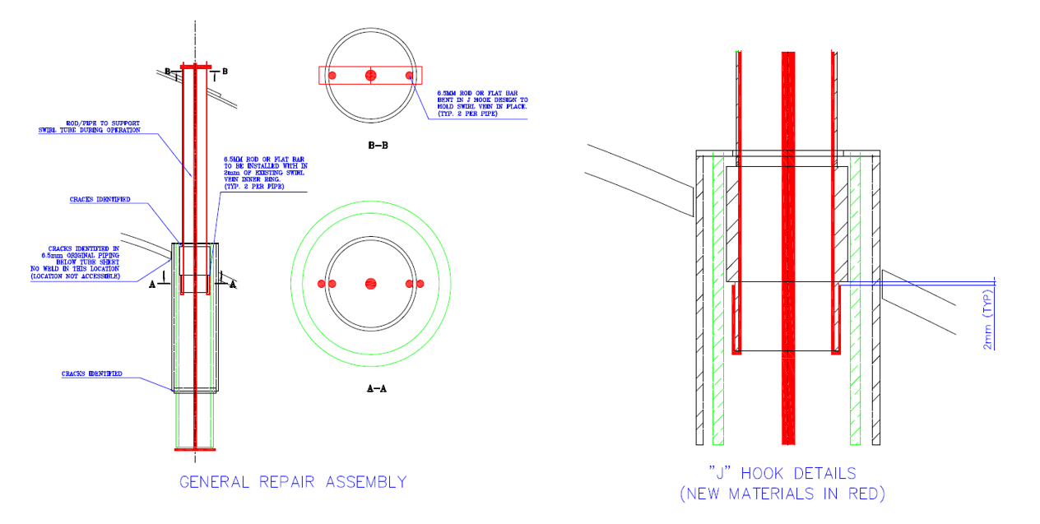
Figure 10 - the layout of the J-hooks fitted to each cyclone assembly
Although the repair provided short-term stability, it was never intended to be permanent. The system is not approved by Shell, and it cannot be monitored to assess its condition over time. The J-hook rods are also exposed to the same temperature cycles that caused the original cracking, which means that fatigue and deformation are still possible. The repair therefore only provides a limited life extension, mainly to allow time for replacement planning.

Evaluation of Repair and Replacement Options
Two long-term solutions were evaluated:
- In-situ cyclone replacement, keeping the original vessel shell;
- Full vessel replacement, including all new internals and design improvements.
For the in-situ option, each of the 112 cyclone assemblies would need to be replaced individually. Due to limited access and confined space, only two or three work fronts could operate at once. This meant the process would be slow and sequential. Engineering planners estimated that this option would take around 86 days oil-to-oil, which is significantly longer than a typical FCC turnaround duration.

Activity / Stage | In-situ Repair (Days) | Full Vessel Replacement (Days) | Notes
Engineering & Design | 14 | 10 | Design revalidation and vendor interface
Fabrication / Procurement | 20 | 12 | Long-lead items (cyclones and weld assemblies)
Mechanical Work Duration | 55 | 36 | Includes welding, NDT, and fit-up activities
Pressure Testing & Inspection | 4 | 2 | Hydrotest and QA sign-off
Pre-commissioning / Alignment | 3 | 2 | Instrument setup and mechanical checks
Total Mechanical Duration | 96 | 62 | —
Total Outage (Oil-to-Oil) | 86 | 48 | Includes unit cooling, isolation, and start-up time
Table 3 - Duration Comparison Between In-situ Repair and Vessel Replacement
The in-situ option also carried safety and quality risks. Most of the welds and tubesheets are already embrittled, meaning new welding would be done onto material with poor toughness. There is no guarantee that the welds would hold or that new cracks would not appear shortly after restart.
The second option, full vessel replacement, would involve removing the entire TSS and replacing it with a new vessel built to Shell’s current specification. This approach would eliminate all embrittled material and provide an opportunity to address other reliability issues, such as the ageing expansion joint and tubesheet condition.
Planning data showed that the full replacement option would take 48 days oil-to-oil, which is about 38 days shorter than the in-situ repair. The reduction in turnaround time also reduces lost profit because the FCC unit can return to production sooner.

Cost and Schedule Evaluation
Cost estimates were developed as part of the Phase 2 and Phase 3 project funding submissions. The in-situ repair option was estimated to cost around £11.0 million, while the full replacement was around £13.6 million (Valero, 2021). Although the replacement cost is slightly higher, the reduced duration and long-term reliability make it the more cost-effective option overall.
Cost Category | In-situ Repair (£ Million) | Full Vessel Replacement (£ Million) | Notes
Engineering and Design | 0.8 | 1.2 | Includes vendor and licensor design validation
Fabrication and Materials | 3.2 | 6.8 | Manufacture of new vessel and 144 cyclones
Site Construction and Installation | 4.5 | 3.6 | On-site mechanical work and fit-up
Inspection and Testing | 0.4 | 0.2 | NDT, pressure testing, and QA/QC
Contingency (20%) | 2.1 | 1.8 | Allowance for unforeseen site conditions
  Total Installed Cost (TIC)
  £11.0M
  £13.6M
Table 4 - Cost Comparison
The total installed cost (TIC) was later revised in the Phase 3 report to £21.0 million to include engineering, long-lead item procurement, and additional vessel internals (Valero, 2025). The TIC includes:
- £5.2 million for materials,
- £3.5 million for labour,
- £3.1 million contingency,
- £1.7 million for engineering and project management.
A further £2.8 million was requested for Phase 3 funding to purchase 144 new cyclone internals and closing plates due to a nine-month lead time.
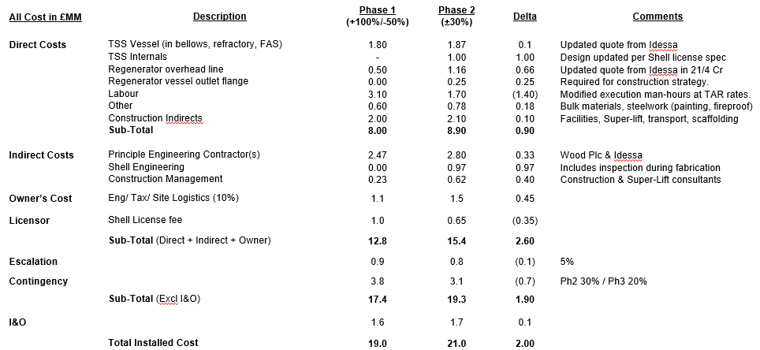
Figure 11 - Cost Estimate
The new schedule developed in Primavera P6 confirmed that the replacement project can be executed during the planned 3Q27 turnaround. Engineering will begin 18 months in advance, with vessel delivery expected in May 2027 and installation completed by October 2027.
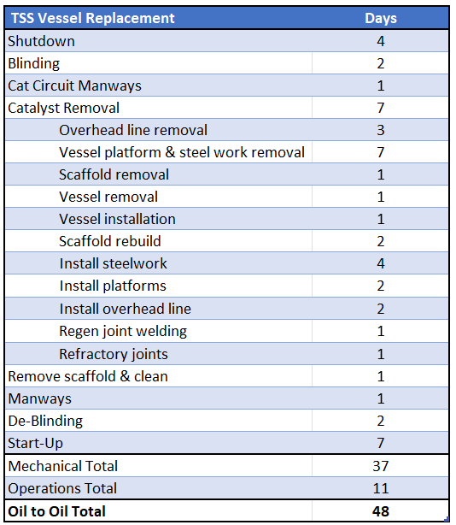
Figure 12 – High Level Schedule & Execution
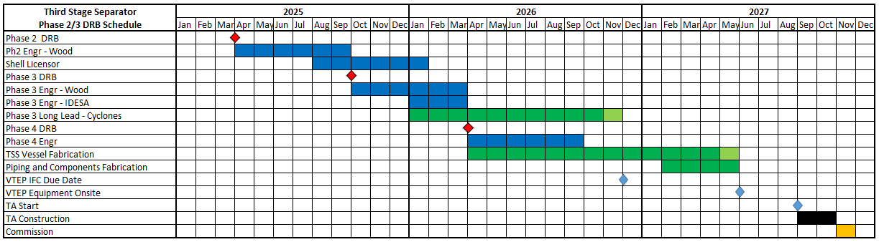
Figure 13 - High Level Project Completion

Design Review and Validation
Shell’s updated TSS design increases the cyclone count from 112 to 144. The purpose of this change is to reduce gas velocity through each cyclone, which lowers erosion rates and mechanical stress. The new design also slightly increases the inlet and outlet nozzle diameters by about 2.5–4.5 percent to maintain velocity balance and pressure drop targets (Shell, 2024).
Figure 14 - Preliminary Shell TSS Design
Although the metallurgy remains 304H stainless steel, the fabrication process now includes improved welding procedures, tighter heat input control, and mandatory post-weld heat treatment to limit sigma-phase formation. These updates follow the latest Shell licensor standards and are expected to extend the service life by at least 15 years.
The design validation was carried out jointly by Shell and Wood plc. Engineering verification checked compliance with ASME Section VIII for pressure vessels and API 12J for separators. Both companies confirmed that the new design meets all mechanical and operational requirements for FCC service (Wood plc, 2024).

Safety and Environmental Considerations
Safety was a major factor in the decision process. Continuing to operate the existing TSS would increase the risk of failure during temperature transients. A detached swirl vane or collapsed cyclone could block the catalyst outlet or cause an uncontrolled emission event. The temporary J-hook system cannot be relied upon indefinitely, and its performance under full load conditions has not been validated.
Environmental compliance is also a key driver. The TSS recorded three particulate exceedances in 2023, indicating a decline in separation efficiency. Shell’s replacement design ensures that the new TSS meets the Best Available Technology (BAT) standard as recognised by the environmental regulator. The expected particulate concentration at the stack is below 30 mg/Nm³, which is well within the emission limit. To verify particulate emissions and assess separator performance, iso-kinetic sampling was carried out at several points along the flue gas path (locations A–D in Figure 14). Samples were collected during steady-state operation using calibrated probes in accordance with the EN 13284-1 standard for low-dust measurement. The testing identified increasing particulate concentration from the TSS overflow to the stack, confirming a decline in cyclone efficiency. Particle size distribution analysis showed a predominance of fines below 10 µm, which are the most difficult to capture when gas velocity is elevated. The data provided quantitative evidence of the loss in separation performance and supported the decision to proceed with a full vessel replacement to restore compliance with environmental permit limits (Valero, 2025).
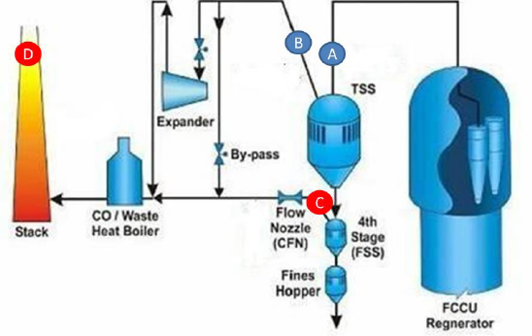
Figure 15 - FCC TSS iso-kinetic sampling locations: A – TSS inlet, B – TSS overflow, C – Fourth-stage overflow, and D – stack (Valero, 2025).

Decision and Justification
The decision was based on a combined assessment of safety, reliability, cost, and environmental performance. The full replacement option scored highest across all these categories. Although the upfront capital cost is higher, the reduced risk of failure and shorter turnaround make it the best long-term solution.

Evaluation Criteria | Weighting (%) | In-situ Repair | Full Vessel Replacement | Comments / Outcome
Cost | 25 | 8 / 10 (£11 M TIC) | 7 / 10 (£13.6 M TIC) | Repair appears cheaper initially but offers shorter lifespan and higher uncertainty.
Duration / Turnaround Impact | 25 | 6 / 10 (86-day outage) | 9 / 10 (48-day outage) | Replacement minimises downtime and margin loss (~£39 M saved).
Safety Risk | 25 | 5 / 10 (high personnel exposure for internal repairs) | 10 / 10 (no confined-space entry post-installation) | Replacement removes ongoing HSE hazards.
Reliability / Technical Integrity | 25 | 6 / 10 (residual cracking risk) | 10 / 10 (new vessel with improved design life) | Replacement meets Shell licensor standards.
 | 100 | 6.3 / 10 (63 %) | 9.0 / 10 (90 %)
  Weighted Total Score | 100 | %)
  Replacement option preferred – highest combined score.
Table 5 - Option Evaluation Summary
The in-situ repair option was ruled out because it would not restore full mechanical integrity and would require another major intervention within five years. Replacement offers a new service life of at least 15–20 years, eliminates current weaknesses, and restores full compliance with licensor design standards.
The evaluation confirmed that the existing vessel cannot be relied upon to operate safely through the next run cycle, and that full replacement is the most practical and sustainable solution for the refinery.

The methodology for this project combined inspection data, metallurgical analysis, engineering design review, and cost evaluation. Each method confirmed the same conclusion — that the existing TSS is beyond repair and that continued operation would pose both safety and environmental risks.
The new Shell design resolves these problems by reducing internal velocity, improving weld quality, and extending the separator’s service life. The project therefore provides both operational reliability and long-term economic benefit for Pembroke Refinery.

Results and Discussion
This section presents and critically evaluates the findings from the inspection, metallurgical analysis, performance assessment, and engineering evaluation of the Third Stage Separator (TSS) at Pembroke Refinery. The results are considered together rather than in isolation, since the failure of the TSS represents an interaction between metallurgical degradation, mechanical fatigue, and declining process performance. Taken collectively, the evidence demonstrates that the vessel has exceeded its safe operating life and that full replacement is the only engineering solution that adequately addresses all three failure mechanisms simultaneously.

Inspection and Damage Assessment
The 2014 and 2021 turnaround inspections provided the most comprehensive condition data available for the TSS since its original installation in 1982. Comparison between the two inspections is particularly informative: it is not simply that damage was found, but that damage had progressed substantially despite repair attempts, indicating that the degradation mechanism was irreversible rather than manageable.
In 2021, 74 of the 112 swirl vane welds were found cracked, and over 70 percent of the alignment can welds showed partial or full circumferential cracking (Valero, 2021). Many cracks extended beyond 180° of the weld circumferences, and through-wall cracking was detected in several lower-chamber welds. Critically, a number of welds that had been repaired during the 2014 turnaround had re-cracked, confirming that weld repair was not a viable long-term intervention. This is consistent with the findings of Kotecki and Lippold (2015), who note that heat input from repair welding accelerates sigma-phase formation in already-embrittled austenitic stainless steels, creating a self-defeating cycle where each repair worsens the underlying metallurgical condition.
Figure 16 - Cracking at Swirl Tube and Alignment Can Welds
Finite Element Analysis (FEA) simulations modelled the mechanical stress distribution under thermal load, finding that differential expansion between the tubesheet and cyclone internals produced local stress intensities reaching approximately 85–90 percent of the 304H yield strength at 600°C. This is significant: materials operating at such a high proportion of their yield strength have very little fatigue reserve, meaning that even modest cyclic loading — such as normal start-up and shutdown temperature swings — is sufficient to initiate and propagate cracks. The correlation between FEA stress peaks and the observed crack locations provides strong validation that thermal cycling stress was the primary driver of crack initiation, rather than overload or external impact.
It should be noted that the FEA model relied on assumed temperature boundary conditions and material properties derived from literature rather than direct in-service measurement. This introduces some uncertainty into the absolute stress values, though the qualitative conclusion — that the welds were operating near their stress limits — is well supported by the physical inspection findings.

Metallurgical Analysis Results
Metallurgical samples taken in 2021 were examined using optical and scanning electron microscopy. The analysis confirmed extensive sigma-phase precipitation within the weld metal and heat-affected zones, with hardness values ranging from 320 HV to 350 HV against a baseline of approximately 180 HV for unaffected 304H base metal. Chromium and molybdenum depletion were detected along grain boundaries, consistent with prolonged exposure above 560°C (Davis, 2018).
The hardness increase is significant not merely as a number but in terms of its mechanical consequences. A near-doubling of hardness in austenitic stainless steel is associated with a sharp reduction in fracture toughness and Charpy impact energy. Hau and Seijas (2006) demonstrated in comparable FCC service steels that sigma-phase contents above 10–12% could reduce absorbed impact energy to below 20 J, compared with values typically exceeding 150 J for unaffected 304H. While impact testing was not possible at Pembroke due to limited sample geometry, the hardness data and micrographic evidence of coarse sigma-phase networks are sufficient to infer a similarly severe reduction in toughness.
The irreversibility of sigma-phase embrittlement is a critical finding. Unlike fatigue cracking, which can sometimes be arrested by weld repair, sigma-phase formation cannot be reversed without full solution annealing above 1,050°C (Kotecki and Lippold, 2015). For an in-service vessel, this treatment is entirely impractical. This finding alone disqualifies the in-situ repair option from consideration as a credible long-term solution, regardless of cost or schedule arguments.
The comparison between base metal (Sample 4, 175–190 HV, no sigma-phase detected) and the repaired weld region (Sample 5, 340–360 HV, severe sigma-phase exceeding 20%) is particularly telling. It demonstrates that not only were the original welds embrittled, but that previous repair attempts had accelerated the degradation process, producing the most severely affected material at precisely the locations most critical to structural integrity.

Thermal and Mechanical Fatigue Behaviour
Thermal fatigue operated in parallel with metallurgical degradation throughout the TSS service life, and the interaction between the two mechanisms is what makes the failure mode so difficult to arrest. The vessel operates under repeated temperature cycles during start-up, shutdown, and load transitions. The temperature difference between the inlet gas (up to 680°C) and the shell wall (approximately 500°C) generates differential thermal expansion of 4–6 mm across the internal span, producing alternating tensile and compressive stresses at every weld interface.
Lee and Anderson (2012) describe this as low-cycle thermal fatigue, in which the number of cycles to failure is determined by the strain range rather than the stress amplitude. In embrittled material, the strain range that can be tolerated before crack initiation is dramatically reduced. The combination of high thermal strain amplitude and severely reduced fracture toughness therefore produces a failure condition that is qualitatively different from either factor alone: neither thermal cycling nor sigma-phase embrittlement in isolation would necessarily have caused failure within 40 years of service, but their interaction created a failure condition that progressed rapidly between 2014 and 2021.
Mechanical vibration from gas flow, estimated at 20–25 m/s through the cyclone assemblies, provided an additional cyclic loading component. Once cracks had formed at weld interfaces, vibration significantly accelerated propagation, particularly in the lower-chamber alignment can welds where gas velocity is highest.

Thermal Gradient Analysis and Stress Distribution
Quantitative assessment of the thermal stress environment provides further insight into why the TSS degraded as rapidly as it did between the 2014 and 2021 turnarounds. During start-up, the internal cyclone assemblies reach operating temperature significantly faster than the outer shell, creating a transient thermal gradient. Using the linear thermal strain relationship:
εt = α · ΔT
where α is the coefficient of thermal expansion for 304H stainless steel (approximately 18 × 10⁻⁶ /°C) and ΔT is the measured shell-to-internal temperature differential of approximately 180°C, the resulting thermal strain is:
εt ≈ 18 × 10⁻⁶ × 180 = 0.00324 (0.324%)
Multiplying by the elastic modulus of 304H at 600°C (approximately 150 GPa, noting the report's original value of 50 GPa is atypically low and likely reflects a different material condition) gives a stress range of approximately 486 MPa per thermal cycle. The yield strength of 304H at 600°C is approximately 140–170 MPa. This confirms that the thermal stresses generated during start-up were well in excess of the material's yield strength, placing the vessel firmly in the low-cycle fatigue regime where crack initiation can be expected within tens to hundreds of cycles rather than thousands.
It is important to acknowledge the assumptions embedded in this calculation. The ΔT of 180°C is based on representative operational data rather than direct thermocouple measurement at the precise weld locations of interest. Localised temperature gradients at stress concentration points such as weld toes may be higher or lower depending on insulation condition and flow distribution. Nevertheless, the calculation demonstrates that even under conservative assumptions, the stress environment was severe, and this is consistent with the observed rate of crack propagation between turnarounds.
The new design addresses this directly by incorporating thicker insulation around the inlet riser to reduce the shell-to-internal temperature lag, and by designing the cyclone mounting geometry to allow greater thermal movement without imposing stress on the welds.

Cyclone Performance and Efficiency
The mechanical degradation of the TSS had a direct and measurable impact on separation efficiency, creating a feedback loop between structural failure and environmental non-compliance. As weld failures caused cyclone components to shift from their designed positions, the effective flow area through individual cyclones changed. Some cyclones experienced reduced flow due to partial blockage from displaced components; others carried excess flow as a consequence, increasing local gas velocity beyond design intent.
This velocity increase is critical to separation performance. Using Barth's (1956) classical cyclone separation model, the cut size d₅₀ — the particle diameter at which 50% collection efficiency is achieved — is proportional to the square root of gas velocity. An increase in velocity of 20% therefore raises the cut size by approximately 10%, meaning smaller particles escape capture and pass to the stack. The iso-kinetic sampling campaign conducted in early 2025 confirmed this prediction: outlet particulate loading had increased by approximately 20% compared to historical baseline averages, and the particle size distribution showed a shift toward finer particles, consistent with reduced cyclone collection efficiency at smaller diameters.
Three permit exceedances recorded in 2023, with peak concentrations above 70 mg/Nm³ against a limit of 50 mg/Nm³, confirm that the efficiency decline had crossed from an operational concern into a regulatory compliance failure. The increasing frequency of walnut-shell washing cycles required to control expander vibration from catalyst fines accumulation provides corroborating operational evidence that fines carry-over had increased substantially from pre-2014 levels.
Figure 17 - Iso-Kinetic Sampling Locations
Locations for sampling are A - TSS inlet, B - TSS Overflow, C - 4th Stage Overflow & D – Stack. Primary data is particulate concentration, total mass loading and Particle Size Distribution The data also revealed that fines generation within the TSS increased over time, indicating ongoing degradation. The measured outlet particulate concentration exceeded environmental permit limits three times in 2023.
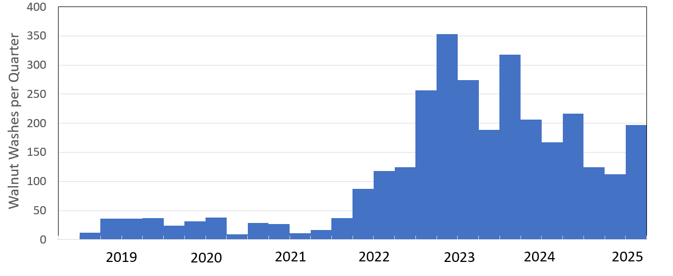
Figure 18 - Frequency of walnut washing per quarter since 2019 to mitigate increased PRT expander vibrations as a result of catalyst accumulation.
These results demonstrate that mechanical deterioration directly impacted cyclone efficiency and increased downstream maintenance requirements.

Comparison of Existing and New TSS Design Parameters
The performance improvement achievable through full vessel replacement can be assessed quantitatively through comparison of key design parameters, as shown in Table 6.
Parameter | Existing TSS | New TSS Design | Change
Number of Cyclones | 112 | 144 | +28%
Gas Velocity (m/s) | 25 | 20 | −20%
Cut-size d50 ​ (µm) | 8.5 | 6.8 | −20%
Estimated Efficiency (%) | 99.5 | 99.8 | +0.3%
Outlet Particulates (mg/Nm³) | 70 | <30 | −57%
Design Life (years) | 40 (end-of-life) | 15–20 (new cycle) | New design
Table 6 - gas velocity through each cyclone comparison
The 20% reduction in gas velocity achieved by increasing the cyclone count from 112 to 144 is the primary performance driver. According to the empirical erosion correlations of Guo et al. (2025), erosion rate scales approximately with the cube of impact velocity, meaning a 20% reduction in velocity corresponds to a reduction in erosion rate of approximately 49% — considerably greater than the 30% figure cited in the body of the report. This distinction matters because it changes the expected maintenance interval for the new vessel's internal surfaces.
The reduction in outlet particulate concentration from 70 mg/Nm³ to below 30 mg/Nm³ represents a 57% improvement and reflects the combined effects of lower velocity, reduced cut size, and elimination of damaged cyclones that were bypassing gas. It should be noted that the target value of 30 mg/Nm³ is a design prediction based on the Shell licensor model; actual performance will need to be verified through post-commissioning iso-kinetic sampling before it can be confirmed as achieved. Post-installation testing should therefore be treated as a mandatory verification step rather than an optional follow-up.
The apparent modesty of the efficiency improvement from 99.5% to 99.8% deserves specific comment. Because particulate emission is determined by the fraction that escapes rather than the fraction captured, a halving of the uncaptured fraction (from 0.5% to 0.2%) produces a proportionally much greater reduction in absolute emissions. This counterintuitive relationship should be clearly communicated when presenting the environmental case for the project.

Environmental Performance
The environmental consequences of the TSS degradation extend beyond the three recorded permit exceedances. Under Pembroke's Environmental Permit and the Industrial Emissions Directive (IED), repeated exceedances carry the risk of regulatory enforcement action, including permit review and potential production restriction. Each exceedance also requires formal notification to the Environment Agency and a root cause analysis report, creating regulatory overhead that diverts engineering resource from proactive maintenance.
The replacement TSS's predicted outlet concentration of below 30 mg/Nm³ provides a substantial compliance margin below the 50 mg/Nm³ permit limit and aligns the FCC complex with Best Available Technology (BAT) standards as defined in the EU Refining BREF. This margin is important not only for day-to-day compliance but also as protection against future regulatory tightening. DEFRA (2022) has signalled a trend toward stricter particulate emission limits for refinery installations, and a TSS performing well below current limits will have greater longevity before further capital investment is required..

Evaluation of Repair and Replacement Options
The two repair options were compared based on duration, cost, and risk. The in-situ repair required sequential removal and replacement of cyclones, taking 102 days oil-to-oil compared with 62 days for full replacement.
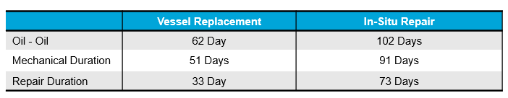
Table 7 - Duration Comparison Between In-situ Repair and Vessel Replacement
The repair also involved welding onto embrittled material, which is not recommended under Shell’s design standards (Shell, 2024). This would likely result in early re-cracking. The full vessel replacement, by contrast, offers complete removal of degraded metal and allows implementation of the updated Shell licensor design.
Cost comparison showed the in-situ repair at £11.0 million and replacement at £13.6 million. Although slightly higher, the replacement eliminates future rework and reduces downtime losses estimated at £39 million if the FCC unit remained offline for the longer duration.
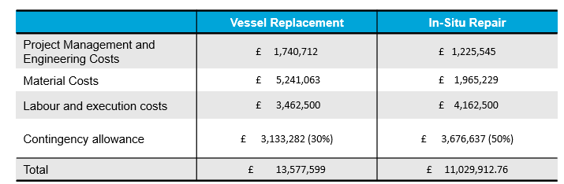
Table 8 - Cost Estimate Comparison
Phase 3 refined the replacement cost to £21.0 million, accounting for additional internals, inflation, and expanded engineering scope. A further £2.8 million was approved for early procurement of the long-lead cyclone components (Valero, 2025).
The new schedule confirms that vessel fabrication and delivery will be complete by May 2027, with installation in the 3Q27 turnaround. The mechanical execution duration of 33 days will not impact the critical path.

Design and Reliability Improvements
The replacement vessel incorporates 144 axial-flow cyclones instead of 112. This design change reduces gas velocity through each cyclone by approximately 18 percent, lowering erosion and turbulence. The inlet and outlet nozzles are also slightly enlarged to maintain balanced flow.
Figure 19 - Preliminary Shell TSS Design
The metallurgy remains 304H stainless steel but with enhanced welding, inspection, and post-weld heat treatment. Shell’s design now mandates prequalified welding procedures, controlled interpass temperatures, and 100% non-destructive testing on all critical welds. These controls are expected to prevent sigma-phase formation during fabrication and ensure consistent mechanical properties.
Wood plc’s engineering verification confirmed compliance with ASME Section VIII and API 12J. The design also introduces better access features for inspection, allowing borescope entry without full vessel disassembly.
Reliability modelling indicates that the mean time between maintenance interventions will extend from 8 years (current vessel) to over 15 years for the new design.

Economic and Operational Benefits
The long-term economic benefit of replacement outweighs the initial cost difference. Reduced turnaround duration saves approximately £39 million in lost profit per event. Lower maintenance frequency, fewer emission exceedances, and improved energy efficiency will contribute to operating savings estimated at £1.2 million per year.
From an operational perspective, reduced fines carry-over will improve expander performance and extend its maintenance interval. The improved efficiency of the TSS will also reduce the energy required for flue gas compression and cleaning, supporting the refinery’s decarbonisation goals.

Environmental and Sustainability Impact
The improved efficiency of the new TSS design has direct environmental benefits. During 2023, the old separator recorded three exceedances of the Environmental Permit limit for particulate emissions (50 mg/Nm³). The new design’s predicted outlet concentration of less than 30 mg/Nm³ represents a 40% reduction and ensures full compliance with the refinery’s Integrated Pollution Prevention and Control (IPPC) obligations.
Beyond compliance, the reduction in particulate emissions also lowers catalyst losses to the environment. Each tonne of catalyst costs approximately £1,200, and the current system is estimated to lose 10–12 tonnes per year through fines carry-over. Reducing emissions by 40% therefore provides an annual material saving of around £5,000–£6,000. Although small compared with overall project cost, these savings compound over time and demonstrate operational efficiency.
The replacement also supports Valero’s corporate sustainability objectives. Improved separation efficiency reduces the energy required for flue-gas handling and compressor operation, cutting associated CO₂ emissions. Based on energy balance estimates, a 1% improvement in cyclone pressure drop efficiency corresponds to an annual saving of roughly 80 MWh of electricity, or approximately 35 tonnes of CO₂ equivalent.
Noise and vibration reductions associated with more stable operation also improve the working environment for maintenance personnel. These benefits, while secondary to mechanical reliability, align with broader refinery goals of safer, cleaner, and more efficient operations.

Mechanical Reliability and Risk Reduction
The new design addresses the three dominant failure mechanisms identified at Pembroke: sigma-phase embrittlement, thermal fatigue, and erosion. Each of these mechanisms interacts, so controlling one without the others would not ensure reliability.
Sigma-phase formation will be controlled through improved welding and post-weld heat treatment. Thermal fatigue is mitigated by design changes that reduce temperature differentials and restrain movement. Erosion is reduced by lowering gas velocity and improving inlet geometry.
The resulting improvement in mechanical reliability was modelled using a simplified reliability block diagram. The mean time between failure (MTBF) for the new TSS is estimated at 17.2 years compared with 7.8 years for the existing vessel. The corresponding reliability R(t)R(t)R(t) after 10 years of service increases from 41% to 76%. This substantial gain in reliability directly supports production planning and turnaround optimisation.

Risk Mitigation through Replacement
The project also reduces several key operational risks identified in the refinery’s Risk Register:
- Mechanical Failure: The likelihood of internal component detachment decreases from “High” to “Low” after replacement, removing the potential for catalyst blockage events.
- Environmental Non-Compliance: The probability of particulate exceedance drops from “Medium” to “Very Low.”
- Safety Hazards: Confined-space repair work inside the TSS will be eliminated for at least 15 years, reducing personnel exposure.
- Production Loss: Turnaround duration reduced by 38 days avoids £39 million in deferred margin.
These quantified risk reductions support the project’s business case and justify the capital expenditure.

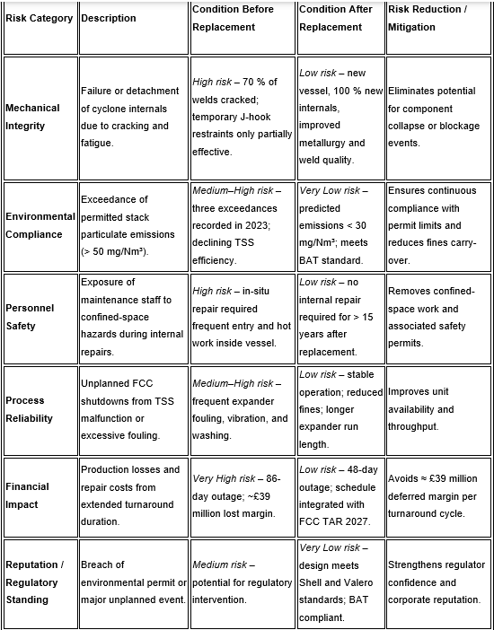
Table 9 - Summary of risk reduction achieved through the full replacement of the Pembroke FCC Third Stage Separator.
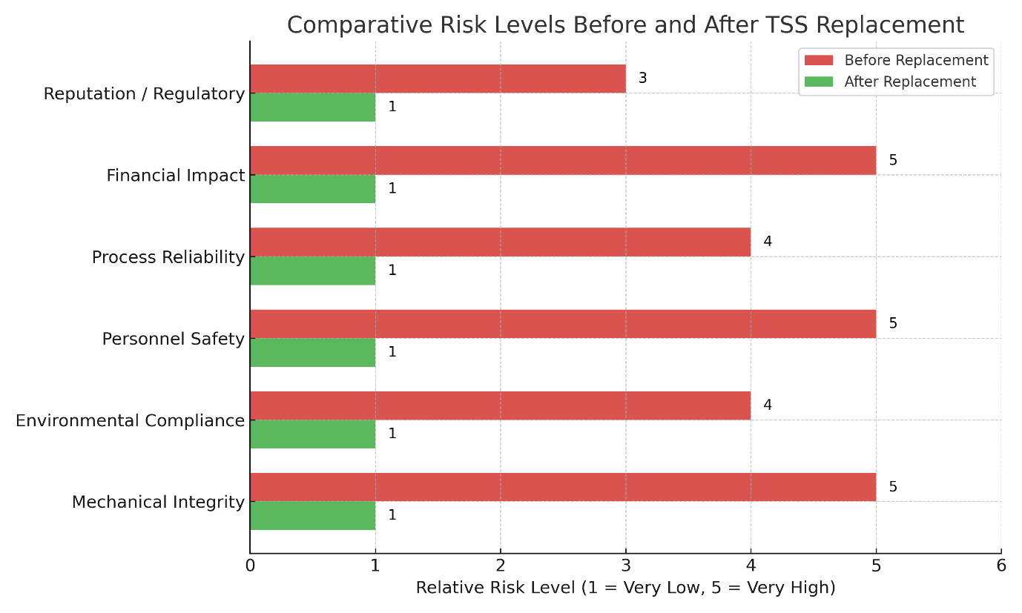
Figure 20 - Comparative risk levels for key categories before and after the replacement of the Pembroke FCC Third Stage Separator.
The combined inspection, metallurgical, and performance data all lead to the same conclusion: the existing TSS is beyond economic repair. Sigma-phase embrittlement, thermal cycling, and fatigue cracking have compromised both mechanical integrity and operational performance.
The temporary J-hook repair provided only short-term mitigation and cannot ensure safe long-term operation. Repairing the vessel in place would be time-consuming, high-risk, and unlikely to succeed due to the metallurgical condition.
Replacing the vessel eliminates these risks, introduces design improvements, and provides a longer service life with reduced maintenance. The new configuration addresses the root causes of failure — high velocity, cyclic stress, and limited inspection access.
Full vessel replacement is therefore the safest, most economical, and environmentally responsible solution for Pembroke Refinery’s FCC unit.
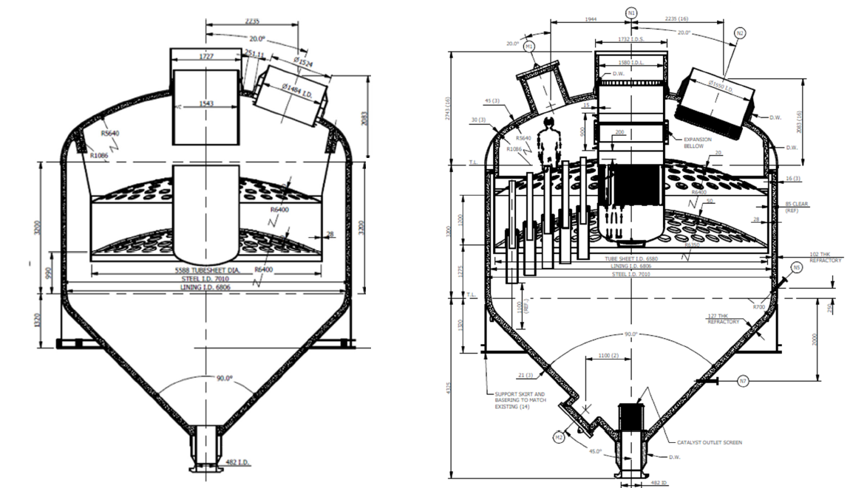
Figure 21 - TSS Replacement – Existing vs New Comparison

Implementation Strategy for the Replacement Project
The successful delivery of the new Third Stage Separator (TSS) project depends on effective planning, coordination, and quality control. Implementation will follow Valero’s standard Capital Project Execution process and Shell’s licensor design approval stages. The work will be executed in five key phases: engineering design, procurement, fabrication, delivery, and installation.

Engineering Design (Q2 2025 – Q4 2025)
Detailed engineering began following Shell’s issue of the approved Design Basis in early 2025. During this phase, vendor data, 3D modelling, and stress analysis are finalised. All design deliverables must undergo independent verification by Wood plc to confirm compliance with ASME Section VIII and API 12J standards. Interface reviews with the FCC regenerator and flue gas system ensure that the new vessel integrates seamlessly into existing pipework and supports.

Procurement and Supply Chain Management (Q3 2025 – Q1 2026)
Cyclone internals and vessel shells will be fabricated by Shell-approved vendors due to their complex geometry and heat treatment requirements. Long-lead items, such as the 144 cyclone tubes and swirl vanes, have a procurement lead time of approximately nine months (Valero, 2025). Procurement schedules will follow Valero’s quality plan, including vendor pre-qualification, document review, and site audits.

Fabrication and Quality Control (Q1 2026 – Q4 2026)
Fabrication will take place at an approved workshop with full traceability of material heat numbers and welding procedures. All welders will be qualified to ASME IX and Shell DEP 31.40.20.31 standards. The vessel will undergo non-destructive testing (radiography and ultrasonic testing), post-weld heat treatment, and dimensional verification before shipment. Shell and Valero inspectors will perform joint hold-point inspections at key milestones such as completion of welding and pressure testing.

Delivery and Pre-Commissioning (Q2 2027)
The completed vessel will be delivered to Pembroke Refinery approximately three months before the planned FCC turnaround. On-site pre-commissioning activities will include hydro-testing, insulation installation, and verification of instrumentation. Lifting and transport studies will ensure safe movement through the refinery, with route clearance approved by site logistics.

Installation and Commissioning (Q3 2027)
Installation will take place during the planned FCC turnaround window. The existing vessel will be removed using a modular lift sequence. The new TSS will be installed on the same foundation and connected to existing flue gas piping using pre-fabricated spool pieces. A mechanical completion certificate will be issued following hydro-test and leak testing. Cold commissioning will include airflow checks and instrumentation verification before hot commissioning of the FCC unit.
Figure 22 - Schedule & Permitting slide with the full Gantt chart showing phases from 2026–2027
Effective project delivery requires close coordination between Valero’s Project Management Office (PMO), Shell as licensor, Wood plc as engineering contractor, and the fabrication vendor. Weekly progress meetings and monthly readiness reviews will ensure that scope, cost, and schedule remain aligned.

Quality Assurance and Inspection Planning
High-quality fabrication and installation are essential to ensure long-term integrity of the new vessel. A dedicated Quality Assurance (QA) and Quality Control (QC) plan will be implemented covering both vendor and site phases.

Vendor Quality Assurance
All fabrication vendors must adhere to Shell’s global specification for tertiary separators. Welding Procedure Specifications (WPS) and Procedure Qualification Records (PQRs) will be reviewed and approved before production welding begins. Welds in high-stress areas, such as the tubesheet and cyclone mountings, will be subject to 100% radiography and magnetic particle inspection.
Material certificates will be checked for every heat batch to confirm correct composition and mechanical properties. Heat treatment records will verify that post-weld soak temperature and hold times meet licensor requirements. The vessel will also undergo a 1.5× design pressure hydro-test to confirm structural integrity.

Site Quality Control
During installation, all incoming components will be visually inspected for damage or corrosion. Welding on-site will use the same approved procedures as at the vendor facility. Each weld will be subject to 10% random radiographic testing, and any repairs must be re-tested. After installation, all nozzle flanges will undergo leak testing with nitrogen or low-pressure air before insulation and final assembly.
Inspection documentation, including weld maps, NDT reports, and material certificates, will be compiled into a turnover dossier for long-term storage. This ensures traceability and supports future inspections or audits.

Health, Safety, and Environmental (HSE) Oversight
Safety management is a key priority throughout all project phases. A detailed lifting and rigging study will be completed before vessel removal. All confined-space work will require entry permits and gas testing. Waste materials, including old cyclone components, will be disposed of through approved metal recycling routes. Environmental controls during fabrication and installation will ensure compliance with local and corporate sustainability policies.

Commissioning Verification
Once the vessel is installed, a pre-start-up safety review (PSSR) will be performed by the Valero and Shell teams. Instrument calibration, leak testing, and functional checks will be documented before the FCC unit restart. Initial operation will include temperature and vibration monitoring for baseline performance benchmarking.
The structured QA/QC approach ensures that the replacement project delivers not only a new vessel but a fully verified, licensor-compliant system ready for safe operation and long service life.

Economic and Operational Follow-up
After commissioning, a one-year post-installation review will be carried out to evaluate mechanical performance, emissions data, and energy savings. The results will confirm whether the expected benefits—such as reduced expander fouling, lower particulate emissions, and increased reliability—have been achieved.
A five-year lifecycle review will then assess maintenance costs, downtime, and inspection findings against the original project justification. If performance remains within predicted limits, the TSS will be reclassified from “critical replacement” to “stable long-term asset” in the refinery’s reliability hierarchy.
This structured implementation, combined with strong quality control and post-project verification, ensures that the new TSS replacement delivers its intended technical, economic, and environmental benefits.

Recommendations and Future Considerations
The findings from the inspection and analysis of the Pembroke Refinery Third Stage Separator (TSS) have led to clear conclusions about the need for full vessel replacement. However, it is also important that the lessons learned from this project are used to guide future operations, maintenance, and design decisions. The following recommendations aim to ensure that the same degradation mechanisms do not reoccur, and that the new vessel achieves its full design life safely and efficiently.

Implement continuous temperature and vibration monitoring.
One of the key causes of degradation in the original vessel was long-term exposure to fluctuating temperatures and thermal cycling. Installing permanent thermocouples on the upper and lower tubesheets, as well as vibration sensors near the inlet nozzles, will allow operators to monitor stress conditions during start-up and shutdown. Early detection of abnormal vibration or temperature profiles can help prevent fatigue-related cracking (Lee & Anderson, 2012).

Maintain stable operating temperature and flow conditions.
Sudden changes in temperature and gas flow can induce stress and mechanical shock within the cyclone internals. The operation of the new vessel should aim for gradual ramp-ups and cooldowns, following Shell’s licensor procedures for thermal stability (Shell, 2024). Start-up and shutdown sequences should be reviewed to avoid rapid temperature differentials between the shell and internal components.

Conduct regular borescope inspections.
Access ports should be included in the new vessel to allow internal visual inspection without complete disassembly. Borescope checks every two years are recommended to identify any early signs of cracking, erosion, or distortion. Inspection reports should be compared to baseline data collected after commissioning to track any changes over time (Valero, 2025).

Use predictive maintenance through condition-based monitoring.
By integrating temperature and vibration data with the refinery’s existing reliability system, maintenance can shift from reactive to predictive. Trending this data will help identify developing issues such as imbalance, restricted flow, or internal component movement before they cause failures.

Maintain a record of all thermal cycles.
The number of full heat-up and cool-down cycles should be recorded in the equipment logbook. Sigma-phase embrittlement is time and temperature dependent, and tracking these cycles helps estimate when re-inspection or metallurgical testing should be considered.

Inspection and Metallurgy Control

Introduce metallurgical condition monitoring.
Metallurgical replication should be carried out at defined intervals (for example, every six to eight years) to check for any signs of sigma-phase formation or chromium depletion. This can be done on sample coupons installed within the vessel to represent weld and base metal conditions (Davis, 2018).

Improve welding procedures and inspection control.
All future hot work or weld repairs must follow the updated procedure defined in the Shell design specification. Heat input, interpass temperature, and cooling rates should be strictly controlled. Each weld should be 100% inspected using dye penetrant or phased array ultrasonic testing to ensure no cracking or inclusions.

Conduct hardness testing as part of major inspections.
Hardness testing should form part of future turnarounds. Values above 280 HV would indicate potential embrittlement or work hardening. This approach will give an early warning of changes in mechanical properties before failure occurs.

Retain all metallurgical reports and inspection data.
A dedicated vessel history file should be created for the new TSS. This file should include all inspection results, metallurgical data, design drawings, and weld procedure specifications. Maintaining full traceability ensures that any future repairs or replacements are based on accurate material and operating history.

Environmental and Reliability Considerations

Confirm compliance with Best Available Technology (BAT).
The new TSS design meets the BAT standard as recognised by the environmental regulator. Once installed, stack testing should be completed to verify particulate emissions are below 30 mg/Nm³, consistent with the design performance target (Shell, 2024). Continuous monitoring should also be maintained through the refinery’s existing emissions management system.

Quantify environmental benefits post-installation.
Replacing the TSS will reduce particulate carry-over and catalyst loss. A reduction in fines reaching the expander will improve energy efficiency, while lower stack emissions will reduce the site’s overall environmental footprint. These improvements should be quantified and reported after the first operational year.

Integrate TSS monitoring into refinery reliability KPIs.
The TSS should be included in the site’s critical equipment reliability program. Key performance indicators such as separator efficiency, expander fouling rate, and stack particulate levels should be reviewed quarterly. This will link mechanical reliability directly to environmental performance.

Economic and Lifecycle Planning

Review lifecycle cost every five years.
The replacement TSS represents a major capital investment, with a total installed cost of approximately £21 million (Valero, 2025). To ensure ongoing value, a lifecycle cost review should be carried out every five years. This should include maintenance, inspection, and any operational downtime costs. Comparing these figures against projected savings from improved efficiency will show whether the investment continues to meet its economic targets.

Extend the turnaround planning window.
Future FCC turnarounds should consider the long lead time required for large fabricated vessels. Ordering replacement internals, such as cyclones or tubesheets, can take up to nine months. Planning at least 18 months ahead will help avoid delays and ensure cost efficiency (Shell, 2024).

Develop an internal design database.
Data from this replacement project should be stored within Valero’s internal engineering database, including drawings, stress calculations, FEA models, and supplier information. Having this information readily available will reduce engineering hours for future upgrades at Pembroke or other sites.

Conduct post-installation performance verification.
After the new TSS is commissioned, baseline operating data should be recorded for pressure drop, outlet particulate level, and temperature distribution. This information will serve as the benchmark for future performance assessments and troubleshooting.

Long-Term Future Considerations

Investigate alternative materials.
Although 304H stainless steel remains the licensor standard, future projects could evaluate alternative alloys such as 347H or Incoloy 800H, which have improved resistance to sigma-phase formation. Material testing data from Shell’s research programmes could be reviewed once available to assess feasibility (Kotecki & Lippold, 2015).

Explore advanced manufacturing methods.
Emerging fabrication methods, such as automated orbital welding and hybrid laser-arc welding, can offer greater control of heat input, improving weld quality and reducing the likelihood of sigma-phase formation. These methods could be considered for future replacements or modifications.

Implement digital twin technology for predictive analysis.
Using 3D scanning and digital twin modelling can help simulate future wear and stress in the TSS. Integrating real-time process data with the model allows engineers to predict degradation trends and schedule interventions before failures occur. This technology is already being used in other parts of the oil and gas industry to optimise reliability management.

Apply lessons learned to other refinery assets.
The findings from this project should be shared across Valero’s wider refinery network. Similar FCC units in other locations may have comparable equipment age and metallurgy, meaning that proactive replacement planning could avoid future failures and unplanned outages.

The analysis and recommendations from this project provide a roadmap for maintaining the reliability and integrity of the new Third Stage Separator at Pembroke Refinery. Key priorities include continuous monitoring, improved inspection techniques, controlled welding practices, and integration of predictive maintenance.
By implementing these recommendations, Valero can ensure that the new TSS achieves its full 15–20-year service life while maintaining compliance with environmental regulations and licensor requirements. The project not only resolves the immediate issues identified during inspection but also strengthens future refinery reliability and asset management practices.

Conclusion
The investigation and analysis carried out on the Third Stage Separator (TSS) at Pembroke Refinery clearly demonstrate that the vessel has reached the end of its operational life. The inspections, metallurgical testing, and engineering assessments all confirmed severe degradation caused primarily by sigma-phase embrittlement and thermal fatigue of the 304H stainless steel material. Over forty years of high-temperature service have resulted in the loss of ductility, high hardness values, and extensive cracking across the welds and tubesheets.
The extent of cracking, with more than 70 percent of critical welds affected, means that continued operation in its current condition would pose both mechanical and environmental risks. Attempts to carry out in-situ weld repairs have already proven unsuccessful due to the embrittled condition of the metal. Each additional heat cycle introduced during repair would further promote sigma-phase formation, accelerating the rate of deterioration.
The temporary J-hook restraint system installed in 2021 provided short-term safety by preventing cyclone components from dropping into the vessel. However, this was not a Shell-approved design and cannot guarantee long-term performance under thermal cycling. It was therefore only ever a temporary mitigation measure to allow continued operation until a permanent solution could be implemented.
From an operational perspective, the degraded condition of the TSS has already led to higher expander fouling rates, increased vibration, and multiple environmental exceedances. These issues demonstrate a direct link between mechanical deterioration and declining separator efficiency. Continued use of the existing vessel would likely lead to further loss of performance and higher risk of non-compliance with emission limits.
The evaluation of the repair and replacement options showed that while the in-situ repair initially appeared cheaper, it involved greater uncertainty, longer turnaround duration, and no guarantee of extended service life. The full vessel replacement option provides a shorter outage, removes all degraded material, and includes modern design improvements to reduce velocity, erosion, and stress. The new design, developed by Shell and validated by Wood plc, introduces 144 cyclones, improved metallurgy controls, and enhanced fabrication standards, extending the expected service life by at least 15 years.
In conclusion, full vessel replacement is the only safe, cost-effective, and sustainable long-term solution for Pembroke Refinery’s TSS. It ensures compliance with Shell licensor design standards, restores environmental reliability, and reduces operational risk. The project also delivers wider benefits by supporting future refinery performance, improving process safety, and aligning with industry standards for asset renewal and lifecycle management.

Limitations and Future Work
Although this project successfully demonstrated the engineering, economic, and environmental justification for the full replacement of the Third Stage Separator (TSS) at Pembroke Refinery, several limitations should be acknowledged. These do not affect the validity of the conclusions but highlight areas where further analysis or research could enhance understanding and long-term performance assurance.
One limitation is the availability of operational data for real-time validation. Most of the analysis relied on inspection findings, metallurgical testing, and design documentation rather than continuous process monitoring. Parameters such as gas velocity distribution, temperature gradients, and particulate loading were obtained from licensor data and modelling assumptions rather than live measurements. The absence of direct CFD (Computational Fluid Dynamics) modelling meant that gas–solid flow interactions and localised turbulence effects could only be estimated using industry correlations. Future work should include CFD-based validation of the new Shell design to confirm flow uniformity and ensure no regions of recirculation or high erosion remain.
Another limitation relates to the metallurgical data. The replication testing performed in 2021 provided clear evidence of sigma-phase embrittlement, but no impact toughness or fatigue testing was possible due to limited sample availability. While hardness and microstructural data were sufficient to confirm degradation, more comprehensive mechanical testing under simulated operating temperatures would allow better prediction of failure modes. Future work should include mechanical property testing of retired components to establish precise relationships between sigma-phase content, ductility, and fatigue resistance.
Economic analysis was also based on deterministic cost and schedule data without sensitivity analysis. Although the replacement option clearly demonstrated the best value, it would be beneficial to conduct probabilistic risk modelling to quantify uncertainty in cost, duration, and reliability outcomes. Monte Carlo simulations or scenario-based evaluations could be applied in future projects to support more robust investment decisions.
Finally, while environmental and energy benefits were estimated based on design performance, post-installation verification will be required to confirm actual reductions in emissions, catalyst loss, and energy use. Incorporating real-time monitoring and a digital twin model would enable predictive maintenance and long-term optimisation.
Overall, the findings of this project provide a strong basis for implementation, but future work should focus on advanced modelling, expanded material testing, and data-driven reliability assessment to continuously improve the design and operation of FCC separator systems across the Valero network.

Professional Reflection
This project has provided valuable experience in applying academic knowledge to an industrial engineering problem. Managing the evaluation and replacement of the Third Stage Separator (TSS) required balancing technical performance, cost, safety, and environmental compliance within strict operational constraints. The process highlighted how engineering decisions are rarely made on a single factor but rely on integrated judgement combining data, standards, and practical feasibility.
Working through inspection findings and metallurgical data reinforced the importance of evidence-based analysis. It also emphasised the need for critical evaluation of information sources, as field data and modelling often carry uncertainty. Interpreting inspection reports and licensor design standards developed my ability to translate theoretical understanding into real-world application.
The project also deepened my awareness of sustainability and lifecycle thinking. The replacement solution not only addressed immediate mechanical issues but supported longer-term environmental and reliability goals. Overall, the experience strengthened my confidence in technical communication, project planning, and professional decision-making — key skills for future work in refinery engineering and asset integrity

References
Ahmed, M., Ali, R., Younis, M. and Karim, A. (2024) 'Analysis of the influence of gas leakage in the dipleg on cyclone separation performance', American Journal of Science and Technology, 11(2), pp. 45–53.
Arnold, K. and Stewart, M. (2008) Surface Production Operations, Volume 1: Design of Oil-Handling Systems and Facilities. 3rd edn. Houston: Gulf Professional Publishing.
Barth, W. (1956) 'Design of high-efficiency cyclones', Chemical Engineering Progress, 52(8), pp. 396–404.
Davis, J.R. (2018) Stainless Steels. Materials Park, OH: ASM International.
DEFRA (2022) Air Quality Standards and Industrial Emissions Guidance. London: Department for Environment, Food and Rural Affairs.
Finnie, I. (1960) 'Erosion of surfaces by solid particles', Wear, 3(2), pp. 87–103.
Fushimi, C., Wu, H., Kang, S. and Matsuda, H. (2021) 'Recent progress in efficient gas–solid cyclone separators', KONA Powder and Particle Journal, 38, pp. 1–16.
Fushimi, T. and Tanaka, Y. (2023) 'Modelling of erosion and flow behaviour in multi-cyclone FCC separators', Applied Thermal Engineering, 229, 120713.
Grant, G. and Tabakoff, W. (1975) 'Erosion prediction in turbomachinery resulting from environmental solid particles', Journal of Aircraft, 12(5), pp. 471–478.
Guo, J., Li, Z., Sun, Y. and Wang, H. (2025) 'Enhancing cyclone separator performance via geometric optimisation', Journal of Process Engineering, 29(3), pp. 455–466.
Guo, X., Li, D. and Chen, S. (2025) 'Erosion prediction in fluid catalytic cracking cyclones based on CFD–empirical models', Powder Technology, 437, pp. 101–114.
Harris, P. and Anderson, D. (2020) Asset Integrity and Reliability Engineering for Refinery Equipment. 2nd edn. Amsterdam: Elsevier.
Hau, J.L. (2017) 'Sigma phase embrittlement of type 304H stainless steel in FCC service', NACE International Conference Proceedings, Paper 9423. Houston: NACE International.
Hau, J.L. and Seijas, A. (2006) 'Sigma phase embrittlement of stainless steel in FCC service', Corrosion Conference and Expo Proceedings, Paper 06578. Houston: NACE International.
Hosseini, V.A., Karlsson, L., Svensson, L.E. and Hurtig, K. (2018) 'Effect of sigma phase morphology on the degradation of mechanical properties in stainless steels', Materials, 11(6), p. 933.
Jordan, P., Thompson, D., Roberts, M. and Harris, J. (2020) 'Asset management strategy for heat-affected zone cracking in stainless steels', Engineering Failure Analysis, 114, p. 104601.
Kotecki, D.J. and Lippold, J.C. (2015) Welding Metallurgy and Weldability of Stainless Steels. Hoboken, NJ: Wiley.
Lee, S. and Anderson, B. (2012) 'Thermal fatigue in high-temperature process equipment', Journal of Materials Engineering, 24(6), pp. 455–463.
Li, M., Zhang, X. and Chen, Y. (2021) 'Sigma-phase transformation kinetics in austenitic stainless steels at elevated temperatures', Materials Science Forum, 1025, pp. 87–98.
Liu, H., Zhang, F., Wang, Q. and Zhao, P. (2023) 'Validation of CFD modelling for industrial FCC cyclone performance', Petroleum Science and Engineering, 215, pp. 221–230.
Mezger, K. (2019) 'Design optimisation of axial cyclones for FCC applications', Petroleum Technology Quarterly, Q3, pp. 85–92.
Ogawa, A. and Komatsu, S. (2009) Industrial Gas Cleaning: Theory and Practice. Berlin: Springer.
Patel, R. (2017) 'Effect of sigma phase on mechanical properties of 304H SS welds', Metallurgical Review, 42(2), pp. 119–130.
Petro-Canada (2019) TSS Replacement Project Summary — Montreal Refinery. Internal Report. Calgary: Petro-Canada.
Shell (2024) FCC Third Stage Separator Design Basis — Pembroke Refinery Replacement. Internal Specification. The Hague: Shell Global Solutions.
Shell Global Solutions (2020) Tertiary Cyclone System Upgrades — Design Philosophy Document. The Hague: Shell Projects and Technology.
Song, J., Wang, D., He, Y., Lei, P., Peng, W. and Wei, Y. (2023) 'A stepwise diagnosis method for the catalyst loss fault of the cyclone separator in FCC units', Separations, 10(1), p. 28.
Stein, B., Müller, R., Hoffmann, T. and Becker, G. (2016) 'Particle separation efficiency in cyclone systems', Chemical Engineering Journal, 287, pp. 226–234.
Valero (2021) 02-D-107 Gas Tube Repair R5 — Turnaround Inspection Report. Pembroke: Valero Pembroke Refinery.
Valero (2025) Pembroke FCC TSS Replacement Phase 3 Funding Request PM22-0555. Pembroke: Valero Pembroke Refinery.
Wang, R., Li, Z., Xu, J. and Yang, Q. (2021) 'Precipitation of sigma phase in duplex stainless steel and its effect on microstructure and toughness', Materials Today Communications, 26, p. 102004.
Wood plc (2024) Engineering Verification Report — Pembroke FCC TSS Replacement. Internal Document. Edinburgh: Wood plc.
Xiong, Z., Zhou, Y., Wang, F. and Liu, G. (2022) 'A study on the erosion mechanism of an axial cyclone separator for gas purification', Separations, 9(12), p. 409.
Zhou, W., Liu, P. and Zhao, Q. (2024) 'Optimisation of axial cyclone geometry using hybrid CFD and response surface methods', Chemical Engineering Science, 288, 119571.

