Distinctiveness and regeneration of Blaenavon
Ebony Goddard
1910397
Introduction
Blaenavon is small town with a big history, its main story is of the coal and iron making factories which is situated at the heart of Blaenavon the coal mines are still open today as historical museum called the big pit, it was a town which one had a lot of job opportunities for families, but also created a lot of health problems due to the smog which left the factories and covered the town, children as young as 6 and 7 would also work with in the coal mines they were small and it was easier for them to get through the small underground doors they had, they would also use horses to cart coal from one area to another and load trains to transport outside of Blaenavon. As a town now it doesn’t have a lot to offer for people who are living there, shops are quite sparse there are a lot of abandoned buildings and run-down housing. The Blaenavon Town Centre Conservation Area was designated in 1984 and covers 19 hectares around the historic core of the town. The Conservation Area was extended to include Old Queen and Phillips Street in 2011. The Conservation Area includes 26 listed buildings and one Scheduled Ancient Monument – Blaenavon Ironworks which is the raison for the development of the town and for the areas wider World Heritage site. (world heritage, Blaenavon’s story)
Blaenavon may be a small town but in regards to its status it could have a lot to offer, with some development and growth added to the town it could make a massive difference for people who are currently living there today, the new generation of children growing up in Blaenavon don’t seem to have a lot to do there not many out of school activity centres to keep them occupied throughout this assignment I will be concentrating on the history of Blaenavon and what it has to offer to attract tourists and also a plan to help engage the younger generation into a more positive growth of activities.
Historical development
The story of Blaenavon bears witness to the human effort. This tells the story of 100 migrant families moving around the region from the 18th to the 19th centuries to the spectacular scenery of this historic town. The Blaenavon story covers several human experiences through time, from industrial ironmasters and entrepreneurs to the people who worked beneath the floor or worked so hard in the home. This view of Blaenavon spans the valleys of southern Wales during a time of great transition. Throughout the nineteenth century, the region had dramatically changed socially, culturally, economically and physically as it became the world's leading manufacturer of iron, coal and steel. It is a regional story for Blaenavon. The town sent people and ideas around the world as well as the export of coal, iron and steel. Many Blaenavon moved to remote places and took their expertise and knowledge with them in the 19th and 20th century. And two new cousins, Gilchrist and Thomas, discovered at Blaenavon during the 1870's a innovative method of steel production that transformed the European and American steel industries.( Blaenavon story,2020)
The industrial revolution for Britain was the start of the production of iron and coal which was the main products exported from heart of the town Blaenavon. The materials which were exported were also used to build the railways, factories and engines all round the world the main material used for this was pig iron. The steam train was one of the biggest inventions of the industrial revolution they used it to get deeper in the mine pits and transport materials between towns and cities. In the factories with the new machinery which was made, men, woman and children as young as 8 worked the machines spend long days working in dangerous conditions the factories had poor lighting, and filthy conditions, some people died during work in these conditions.( UK industrial revolution, 2020) Although people worked in these poor conditions the industrial revolution was a great way for Britain to obtain a capital, with the rails expanding to different areas of exporting this also boosted the population in Britain.
Because of all the history the town holds any regeneration plans need to include the history as it is a very sensitive area especially for the older generation who still live at Blaenavon the people of the town fought hard to keep the big pit going, the main tourists which come to visit the big pit are school children and families for days out but the people of Blaenavon would like to see these tourists visit in the town as well as the museums, keeping this in mind with my idea for a regeneration plan I have an idea to entwine with what the people would want
Tour train
With this idea of a tour train I would like to see the railway lines opened up as the people who live at Blaenavon only have buses as another source of transport unless they drive and the buses and very few and far between, the tour train would open up this idea for the town and also when tourist come to visit the town they can hop onto the train an it would take them around to the big pit the iron works steel works and other historical parts of the town, I think an old style train would fit in with the historical aspect of the town too, I kno the people of the town would be open to this as they would like to see more life brought into the town and to end the tour the train could stop in the town for people to have lunch in the hearty restaurants or to stay within the hotels located in the town.

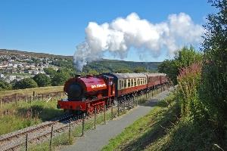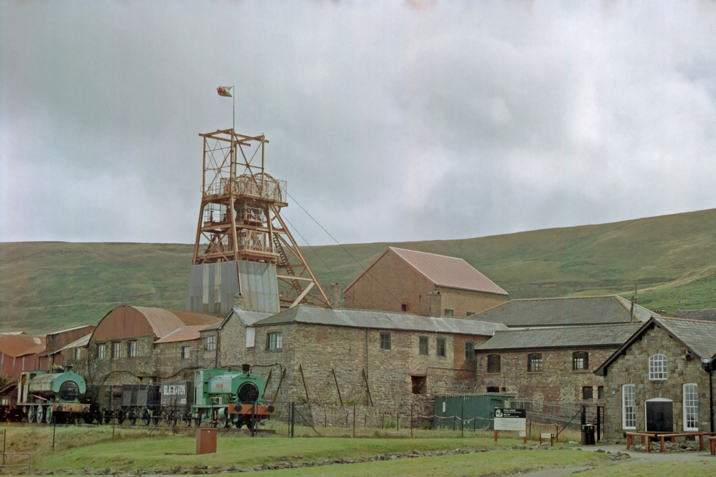

Friendly farming
For my second regeneration idea, again I will be concentrating on the historical side of the town with friendly farming this concentrates on the younger generation giving them job opportunities helping out on farms this gives farmers the opportunity to regenerate money and also the people of the town can buy fresh produce from their local farms as shops are quite sparse in the area farmers can grow fresh fruit and vegetables and fresh meat produce the younger generation would be able to help the farmers with these duties, they could open a café shop along side the farm for tourist to visit to eat wholesome fresh meals the idea of this is when people do visit the town they feel like they have had that full historical feel and view of the town, and to build on job opportunities with in the town without making to many drastic changes.
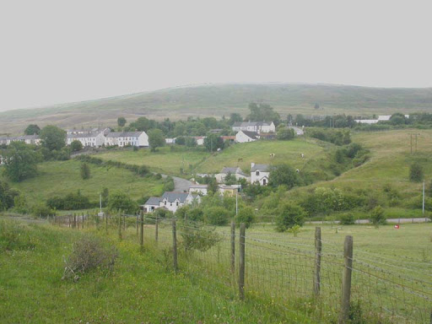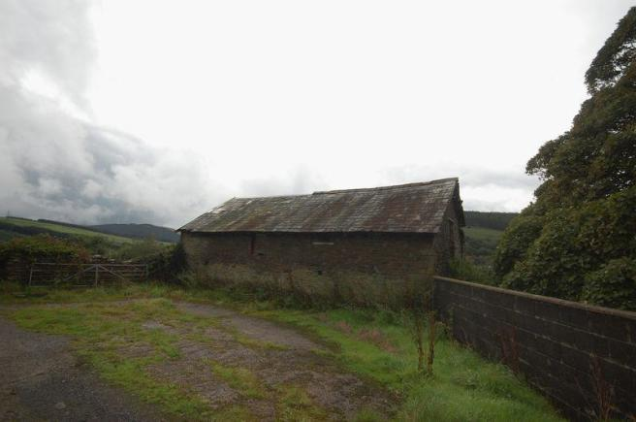

Within the 2 ideas I have presented, i think along side these regeneration plans I would like to see the outside of shops being redecorated adding to the historical side of the town maybe having canopies placed on the outside of shops re painting and to make the town look more attractive to tourists adding new hotels, more shops to encourage more job opportunities within the town, and re open abandoned buildings to take away the desolate feel which is currently there now, these ideas im hoping will reduce boredom among the younger generation and reduce vandalism which is currently happening with in the town.
Conclusion
To conclude Blaenavon is a beautiful town situated in south wales, which has a lot to benefit from regenerating the town and building on job opportunities and expansion without ignoring the historical aspect of the town. The people of the town would be happy to see regeneration including the historical aspects like the big pit and the iron works but also the town itself they want to see life within their town again and with the ideas I have presented I have included what the people want to see in their town, one of the biggest aspects missing from the town now is the job opportunities and activities for the younger generation of Blaenavon.
References
The UK Industrial Revolution video link
https://www.visitblaenavon.co.uk/en/WorldHeritageSite/TheBlaenavonStory/BlaenavonStory.aspx
https://www.visitblaenavon.co.uk/en/Publications/Blaenavon-Townscape-Heritage-Programme/Blaenavon-Town-Centre-Conservation-Area-Appraisal-and-Management-Pl
https://www.visitblaenavon.co.uk/en/WorldHeritageSite/TheBlaenavonStory/BlaenavonStory.aspx
https://www.google.co.uk/search?q=farms+in+blaenavon&tbm=isch&ved=2ahUKEwit1L7y_5DrAhUj-YUKHTk7BiAQ2-cCegQIABAA&oq=farms+in+blaenavon&gs_lcp=CgNp
https://www.google.co.uk/search?q=big+pit+blaenavon&tbm=isch&ved=2ahUKEwjf7Y38gZHrAhUKPxQKHfZvDk4Q2-cCegQIABAA&oq=big+pit+blaenavon&gs_lcp=CgNpbWcQAzICCAAyBAgAEBgyBAgAEBg6BAgAEEM6BQgAELEDOgYIABAIEB5Qy-YFWPWeBmDMpgZoAHAAeASAAa0BiAHgEJIBBDE1LjiYAQCgAQGqAQtnd3Mtd2l6LWltZ7ABAMABAQ&sclient=img&ei=R3AxX5-uMIr-UPbfufAE

