
Master of Business Administration
International Business pathway



Contemporary employability skills
Assessment 1: Individual report. Weight: 50%

Module name: International Business Concepts

Module Code: LCMB7034

Lecturer Name: Gladius Kulothungan

Student Name: Muskhanbi Multani

Student No.: 2531718

Word Count: 5153
Submission Date: 14th August, 2026

AI Use Acknowledgement
I acknowledge the use of ChatGPT (https://chatgpt.com/c/6a7ccbe7-c7b0-83ee-bd5d-f0a6af209fa6) on 13 August 2026 to support research, proofreading and visual development activities for my International Business Concepts assignment. I used the prompt(s):
- Suggest credible academic and industry sources relevant to Decathlon’s potential entry into Nigeria, without writing any part of my assignment.
- Check my own written text for grammar, spelling, clarity and sentence structure, while keeping my original meaning and arguments unchanged.
- Suggest a simple visual concept or infographic idea to illustrate Decathlon’s internationalisation and proposed Nigerian market-entry strategy.

Table of Contents
1. Introduction 1
2. Decathlon's Internationalisation and Global Strategic Configuration 2
2.1 Organisational classification 2
2.2 Global configuration and ownership advantages 2
3. Macro-environmental Appraisal of Nigeria 3
3.1 Political environment 3
3.2 Economic environment 4
3.3 Legal and regulatory environment 5
3.4 Cultural environment 5
4. Integrated Market Attractiveness and OLI Analysis 6
5. Entry-Mode Strategy and Historical Pattern Recognition 8
5.1 Decathlon's historical internationalisation pattern 8
5.2 Suitability for Nigeria 9
6. Recommended Entry Strategy 9
6.1 Strategic recommendation 9
6.2 Phase 1: Digital market testing 10
6.3 Phase 2: Controlled Lagos operation 11
6.4 Phase 3: Local sourcing and operational localisation 11
6.5 Phase 4: Selective urban expansion 11
7. Strategic Synthesis 13
8. Gibbs' Reflective Cycle 13
8.1 Description 13
8.2 Feelings 13
8.3 Evaluation 14
8.4 Analysis 14
8.5 Conclusion 15
8.6 Action plan 15
9. Conclusion 15
References 16

Internationalisation Strategy and Proposed Market Entry of Decathlon into Nigeria

1. Introduction
The decision to enter the international market is more than a simple choice of countries that have big populations or potential economic growth. The multinational enterprise (MNE) faces the challenge of deciding whether their firm-specific resources can be effectively transferred into a new institutional, economic and cultural context, and what degree of control and resource investment is warranted in the face of uncertainty. This challenge is especially prevalent in emerging markets, where there is demographic opportunity, but also a lack of purchasing power, institutional distance, currency volatility and infrastructure. For a given market, therefore, it could be popular in the aggregate but unattainable for a specific multinational.
The situation at Decathlon is a good one to consider when looking at this. The company was established in France in 1976 and has grown from a sporting goods retailer to an integrated global sports business, with product design, development, sourcing and manufacturing relationships, distribution and retail. The results of its 2025 activity reveal the extent of this international platform: Decathlon reported €16.8 billion in net sales, €20.7 billion in gross merchandise volume, 1,902 stores, 82 countries/regions of operation, and 1.23 billion products sold. Sales from digital channels were 20.2%. These qualities give the owner significant advantages, especially in terms of buying scale, own-brand expertise, product innovation, supply-chain coordination and accumulated international expertise.
Nigeria is a strategically important target market due to its population size, urbanisation, sporting culture and future prospects. According to the World Bank, Nigeria is expected to have a population of around 237.5 million people in 2025 with a growth rate of 2.1% per year. But, the size of the population does not automatically convert to demand. While the World Bank's April 2026 Nigeria Development Update indicates macroeconomic stability and economic growth, it also highlights that household incomes are not fully recovered and that poverty levels are still high. Similarly, the African Development Bank forecasts real GDP growth of 4.1% for 2026 and notes that poverty and inflationary pressures will persist.
That poses a strategic dilemma for Decathlon. While it offers a more affordable sporting products proposition, some of the same economic factors also have the potential to drive up landed cost, lower discretionary spending and cut margins. Whether or not Nigeria is large enough to accommodate entry is not the issue, rather is Decathlon able to create an economically viable operating model to create sustainable demand out of Nigerian sporting interest.
This report aims to critically analyse Decathlon's internationalisation strategy and the appropriateness of Nigeria as a new market. The global configuration of Decathlon is classified using Bartlett and Ghoshal's (1989) model, Nigeria's environment is evaluated using Political, Economic, Legal and Cultural (PELC) analysis and ownership, location and internalisation advantages are assessed using Dunning's (1988) eclectic paradigm. Next, the historical entry pattern of Decathlon is analysed and then the different types of entry modes are critically compared. The report states that Nigeria offers high potential, but high constraint, and suggests that a partnership or joint-venture may be best through a staged approach that starts with testing the digital market and a small operation in Lagos. This is the right balance of control, learning, flexibility and risk as compared to investing in the country all at once and controling it entirely.

2. Decathlon's Internationalisation and Global Strategic Configuration

2.1 Organisational classification
It would seem that Decathlon can be termed as an MNE with high transnational characteristics. Bartlett and Ghoshal's (1989) model categorises international strategies based on the pressures for global integration and the pressures for local responsiveness. Efficiency and standardization are the core concepts of a global strategy, local responsiveness is central to a multidomestic strategy, transferring home country capabilities overseas is the focus of an international strategy, and the transnational strategy is an attempt to integrate global, local and knowledge transfer elements.
The transnational configuration is the most similar to Decathlon's business model since they would rely on maintaining a global scale but adapting some elements of their offering to local markets. Global operations mean the company can purchase economies and product-development efficiencies and can standardise the management of the brand. Concurrently, its ubiquity in 82 countries and regions illustrates the fact that a one-size-fits-all European retail format is not necessarily applicable in each market.
What is important is not whether Decathlon should standardise or localise, but what should be standardised and what should be adapted. Product-development capability, quality and core own-brand architecture and technological systems should continue to be centrally managed as this is important to the competitive advantage. On the other hand, the product mix, pricing system, promotional communication, store types and procurement system need to be flexible to the Nigerian environment.
This is an interpretation that resonates with current developments of the Uppsala internationalisation model. But international growth calls for organisational change because of the accumulation of knowledge and the establishment of relationships in foreign markets (Liesch and Welch 2024). Internationalisation is thus not just a process of geographic duplication but a continuous learning process.
This is a boon and a bane to Nigeria. Decathlon's global platform will enable it to offer things that a new local business would struggle to duplicate – but integrated supply chains will also bring advantages and disadvantages to Decathlon, such as the risk of delays in customs clearance, currency fluctuation and transportation costs. The transnational model is therefore suitable just because it lets Decathlon maintain the strengths it possesses globally and customise the aspects of the business that it needs to adapt to local realities – the customer-facing and operational aspects.

2.2 Global configuration and ownership advantages
It is not just the retail scale that generates value for Decathlon, but the interconnection of several abilities. Built-in model connects product design, sourcing, production relations, distribution and retail to enable the organization to coordinate various stages of the value chain. The 2025 performance, according to Decathlon, is a result of "an integrated model based on design, production and distribution for value for money".
This system is large in size, offering clear ownership benefits. First, buying volumes allows Decathlon to negotiate prices with suppliers and share costs with a wide international customer base for the development of its product line. Second, that own-brand products offer more control over product specification, pricing and brand positioning than a retailer who has a primary reliance on third-party brands. Third, foreign expansion can benefit from the experience of other organisations, which is captured in the form of organisational knowledge.
These resources, however, are not readily transferable. Dunning (1988) stressed that location advantage of a firm, along with the internalisation advantage, needs to be combined with ownership advantage to make the foreign investment economically justifiable. This is the issue that can be shown by the low-cost proposition of Decathlon. It is possible for a product to be competitively priced in its production market but, after freight, duties and taxes, and currency movement is added to the Nigerian landed cost, the product becomes very expensive.
This is true also of product width. The wide range of products that Decathlon has in its portfolio is an ownership advantage that allows cross-selling and offers sporting customers a one-stop sports offer. But, keeping a wide product mix in a market where there is not a definite demand may lead to an escalation of inventory risk and working capital needs. Thus, the introduction of the Decathlon model in Nigeria should not be a total implementation, but a careful selection of what can and what cannot be adopted.
The geographical development of Decathlon can also be observed as a general trend of localisation. More specifically its Indian operation is relevant. Decathlon has been in India since 2009 with a cautious cash and carry approach which was enabled by the regulatory change to allow direct consumer retailing. As of 2014, the modern reportage had the business as a fully owned subsidiary of the Indian business, and over the years, the company's local sourcing and manufacturing base grew. Decathlon plans to invest an additional €100 million into the Indian store network and manufacturing over the next five years and aims to reach 68% local production (and 85% by 2024).
This is not to say that Nigeria should emulate India; the importance of India is that it should take note of the approach Nigeria has taken. Instead, it is a typical Decathlon experience: market learning and then growing involvement in operations and supply chain localisation. This is a good model for Nigeria.

3. Macro-environmental Appraisal of Nigeria

3.1 Political environment
Nigeria's political landscape offers some opportunities, but it is also fraught with uncertainty. The country is fairly open to foreign investors from a formal investment point of view. The NPC says foreign investors have the freedom to own 100 per cent stake in business enterprises engaged in activities not included in the negative list. The investment framework also offers safeguards on capital and returns.
This is an important consideration because the government of Nigeria does not require foreign ownership of a joint venture. On the contrary, a local partner should be chosen as the partner brings in skills which Decathlon don't have: local regulatory and logistics knowledge, property expertise and institutional understanding etc.
The political climate still impacts on operating risk. Consistent regulation, physical infrastructure, security, and transportation and access to commercial property are all essential for retail businesses. Any uncertainty in these areas may raise operating costs and make long-term capital investment more challenging to assess.
So, the correct answer isn't market avoidance, but commitment staging. A small start-up costs means Decathlon can learn before putting up a significant amount of cash. This is in line with the rationale of the Uppsala model, which states that the process of knowledge acquisition affects later decisions to commit (Johanson and Vahlne, 2009). Recent studies also find that institutional distance may affect the type of ownership choice that is made by MNEs when they enter into foreign markets. The findings of Zhang et al. (2023) reveal that institutional distance and equity-based commitment are overall negatively related, but this relationship is different in different contexts. Nigeria's political context thus bolsters and does not diminish Decathlon's reasons to take a ‘Phased Approach'.

3.2 Economic environment
The economic factors are the most crucial hindrance to Decathlon's Nigeria strategy, as cost is a key element in the company's business proposition.
Nigeria has significant long-term market opportunities. As of 2025, its population was over 237 million and is still increasing. However, aggregate population is not an accurate indicator of retail opportunity, as sporting goods are primarily discretionary items. The determining factor is not just the number of people who could be consumers, but effective purchasing power.
The World Bank's assessment in April 2026 is of special importance. It indicates meaningful advances towards macroeconomic stabilisation, characterised by improved external and fiscal positions and ongoing growth but warns that household incomes still have not recovered sufficiently and poverty remains high. According to the African Development Bank, in 2025, about 31% of the population is still living in extreme poverty, projected to grow by 4.1% in 2026.
The results of these findings have a two-fold strategic impact. On the other hand, better macro-economic parameters can help in the development of the consumer-market in the longer term. The other, however, is that expensive living costs prevent households from spending on non-core sports products.
Decathlon's business model could offer some protection as it positioning is based on value and not luxury. But, as is often the case with everything, it's a relative thing. When currency depreciation or logistics costs results in imported products being more costly, Decathlon is likely to have to make a decision on increasing prices or decreasing margins. The two possibilities could result in a reduced value proposition.
Thus, the Nigerian approach should focus on products that have high price-value perceptions and somewhat wide usage. A start-up portfolio might be made up of football equipment, low-level fitness products, running accessories and basic sportswear, as opposed to an extensive selection of specialist equipment.
Local sourcing has the potential to be significant in the experience of India. The Indian expansion by Decathlon is increasingly associated with local manufacturing and sourcing, and retail growth. In its 2024 report, the company said its Indian sales are 68% made in India and will be increased to 85%.
The lesson for Nigeria is thus not one of imitation, but one of strategic investment to build the local sourcing capability, provided that the quality, scale and cost competitiveness of the suppliers can be established.

3.3 Legal and regulatory environment
Nigeria has a relatively good foreign-investment rights regime. The NIPC makes it clear that foreign ownership is allowed in open sectors and guarantees protection of capital and profit repatriation.
This is one way to lower one of the entry barriers. However, ownership rights are just part of the regulatory framework.
These are problems that Decathlon would have to solve:
- customs procedures;
- trade restrictions and taxes;
- product standards;
- consumer protection;
- employment regulation;
- intellectual property;
- contractual arrangements;
- property and retail regulation; and
- needs for data and digital-commerce.
Cost of customs and taxation is of utmost significance for Decathlon since landed cost is directly related to its price-value proposition. If the logistics, duties and taxes exceed the retail price, the manufacturing cost is not as significant.
The care of intellectual property is also of major importance. Trademarks, product designs, customer data and trademarks standards become key elements of Decathlon's own-brand model. The local partnership must thus include clear agreements on intellectual property rights, data management, procurement, pricing authority and quality standards and dispute resolution.
The legal climate, in turn, facilitates entry but also creates the value of local legal expertise.

3.4 Cultural environment
Nigeria's sporting culture is an important source of potential demand. The government of Nigeria considers sport as one of the most important and binding social activities and football has tremendous cultural visibility. This will give Decathlon a chance to build its brand on areas that are culturally relevant.
But, cultural interest does not equal commercial demand. One consumer might be very attached to football, but still not have enough money to buy the branded football gear on a regular basis. This separation is important for Decathlon because they don't just want to have people who are excited about it, they want people who can afford to buy it.
A football-inspired start, however, might help lower the cultural barriers between company and consumers. Football products may be used as an entry category followed by running, fitness, cycling and more as consumer awareness and purchasing power increases.
Localisation should be selective. However, it is important for Decathlon not to change the core of the brand proposition as too much localisation might result in a loss of brand strength and operational economies. Rather, Nigerianisation is to be done in assortment, pricing, communication, store format and community engagement.
This is yet another confirmation of the transnational configuration: the global competences should remain intact and the customer-oriented work should be adjusted where local differences have a significant impact on demand.

4. Integrated Market Attractiveness and OLI Analysis
Nigeria is thus considered a high-potential high constraint market and must therefore be treated as such.
Dimension | Opportunity | Constraint | Strategic implication
Political | Open foreign-investment regime | Institutional and operating uncertainty | Staged commitment
Economic | Large and growing population | Poverty, inflation and purchasing-power constraints | Value-focused assortment
Legal | Foreign ownership generally permitted | Customs, taxation and IP requirements | Local regulatory capability
Cultural | Strong sporting and football culture | Cultural interest does not equal purchasing power | Football-led market development
Supply chain | Potential future localisation | Current import and logistics exposure | Gradual local sourcing
Ownership advantages
The ownership criterion of OLI is largely met.The ownership criterion of OLI is well fulfilled by Decathlon. It possesses:
- global brand recognition;
- proprietary product development;
- own-brand capabilities;
- purchasing scale;
- retail expertise;
- digital capabilities;
- supply-chain knowledge; and
- international experience.
Its gross sales of €16.8 billion and net sales of €1,902 stores on a scale of 2025 (as of 2014) present a significant resource base.
The ownership advantage should not be a kind of carte blanche for FDI, however. The question is: can those resources generate value in Nigeria?
Location advantages
Nigeria enjoys tremendous geographies; market size, population growth, urbanisation and sporting demand. These benefits are, however, dependent on the condition.
High population size means large market size, but poverty means smaller market size that can be addressed. Growth makes a longer-term sweet deal, but inflation can create a short-term headache. A healthy sporting culture will help attract customers, while infrastructure constraints can make distribution costly.
Therefore, Nigeria's advantage in location has to be seen as dynamic, not static.
Internalisation advantages
For Decathlon, internalisation is beneficial due to the necessity of managing brand standards, product quality, pricing, and customer experience, as well as managing their supply chain. Licensing would help minimize financial investment and increase quality variability and IP theft.
Wholly owned investment would be the maximum level of control but also would move almost all the Nigerian market risk to Decathlon.
New studies back up this trade-off. Silva, Ogasavara and Pereira (2024) show that the advantages and disadvantages of equity-based entry modes are affected by the institutional distance. Similarly, Donnelly et al. (2024) demonstrate the interaction between institutional distance and firm resources in foreign-market entry decision.
The OLI conclusion is then:
Ownership advantages are good, location advantages are significant, but depend on the project; internalisation benefits are good, but the cost of internalisation to the extent is high under uncertainty.
This is enabling a gradual investment rather than a 'full scale' investment.

5. Entry-Mode Strategy and Historical Pattern Recognition
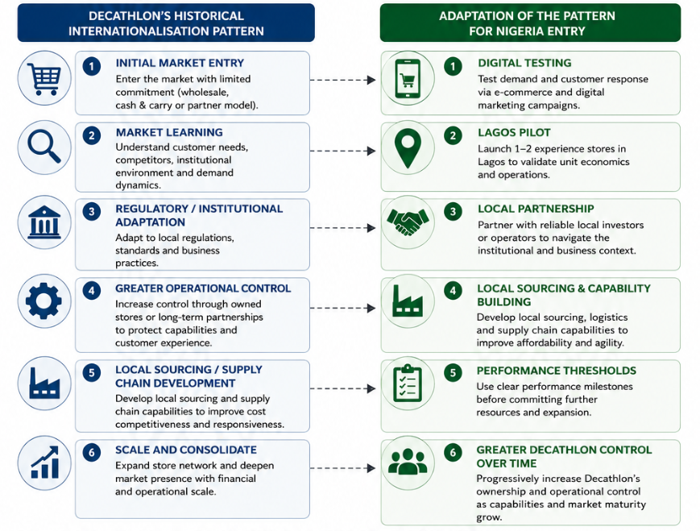
Figure 1:Proposed Adaptation of Decathlon's Historical Internationalisation Pattern for Nigeria

5.1 Decathlon's historical internationalisation pattern
The first major mistake in the previous analysis was to equate Decathlon's actual behavior with the theoretical playing field that is available.
Internationalization has generally been achieved through wholesale rather than traditional franchising, and has been quite extensive from Decathlon's point of view. The company's international development has been driven by its own retail format, own brands and more and more integrated supply chain. It has a history of expansion from France to European markets, and then to Asia and other markets. According to Decathlon, its international development is a crucial aspect of its development since its inception in 1976.
India is one such country that gives a very useful illustration. Decathlon's entry into India was in 2009 with a ‘cash and carry’ approach and this enabled the company to learn under regulatory constraints. It evolved its direct retailing business and its wholly owned structure as the regulatory environment evolved.
Thus, the pattern indicates: This progression of limited initial commitment to regulatory adaptation, then greater ownership or control, to operational localisation, to expansion is applicable to any family.The progression of limited initial commitment, regulatory adaptation, then greater ownership or control, to operational localisation, to expansion, applies to any family.
This is significant because it shows that Decathlon is not faced with the dichotomy of learning versus control. It can arrange them in order.
Localisation of the supply chain is also a critical aspect of the Indian experience. In 2024, Decathlon's investment strategy was clearly tied to growing its manufacturing capacity to support its expansion strategy.
For that reason, the historical trend is more a model of control-based internationalisation, than of a model of low-control franchising.

5.2 Suitability for Nigeria
It would be not be strategic to replicate a completely local model, in Nigeria, right away.
There are differences between the regulatory structure, industrial capacity, logistics, income distribution and market development between Nigeria and India. What's more important: Nigeria is a less proven business case for Decathlon than India, with years of development.
A wholly owned subsidiary would give Decathlon the most control and put it at risk of being exposed to:
- demand uncertainty;
- currency risk;
- logistics risk;
- regulatory costs;
- property commitments;
- inventory risk;
- security expenditure; and
- possibly slow the capital recovery.
Exports would diminish the commitment and enhance the costs of imports and currency conversion. Franchising would lower investment but decrease the control of the integrated customer proposition for Decathlon.
The acquisition might help speed market access, provided that a suitable target was identified that could have complementary logistics, retail and property capabilities. If you don't have a direction to work towards, acquisition can cause unnecessary integration expenses.
A strategic partnership or joint venture provides a more suitable level of commitment option.

6. Recommended Entry Strategy

6.1 Strategic recommendation
The recommended approach is:
A gradual strategic alliance or joint venture with the first phase being digital demand-testing, and a limited operation in the city of Lagos, after reaching certain performance levels, local sourcing and targeted urban expansion.
It is not a rejection of the historically control oriented model of Decathlon. Rather, it is a provisional accommodation of the timing and sequencing of control.
The cooperation should involve local market expertise and Decathlon to keep control on strategic aspects.
Decathlon should keep control over:
- brand identity;
- product quality;
- core assortment;
- intellectual property;
- customer experience;
- strategic pricing principles;
- technology;
- supplier standards.
The Nigerian partner should contribute:
- regulatory expertise;
- local logistics knowledge;
- property expertise;
- recruitment;
- market intelligence;
- institutional relationships; and
- distribution capabilities.
The governance structure should establish clear decision rights, financial responsibilities, performance measures, dispute-resolution procedures and exit mechanisms.

6.2 Phase 1: Digital market testing
The first phase should seek to avoid capital commitments that can't be reversed.
Decathlon needs to measure demand via digital channel, specifically some of its products, and not the entire global range.
Consider including the following key variables:
- category demand;
- price sensitivity;
- conversion rates;
- customer acquisition cost;
- preferred payment methods;
- delivery cost;
- return rates;
- basket size;
- customer demographics; and
- repeat purchase.
Football should be a major acquisition category as it is culturally relevant and fitness and running products should widen customer base.
The intention of Phase 1 should be to learn, not to necessarily earn money.
Such a strategy aligns with the modern Uppsala view of internationalisation, which views internationalisation as a process of building knowledge and dealing with 'tolerable' risks, and not an 'investment'.

6.3 Phase 2: Controlled Lagos operation
In the event that digital evidence points to the fact that there is a demand for a limited physical operation in Lagos, Decathlon should consider opening one there.
Lagos is a suitable starting point because of its ability to access a big commercial ecosystem and can serve as a learning ground before extending the geographical range.
The first store should be smaller, and more flexible in terms of format, than a mature European Decathlon store. Test should be the goal:
- customer behaviour;
- category preferences;
- pricing;
- inventory levels;
- store productivity;
- service expectations; and
- delivery integration.
This prevents the commitment to infrastructure across the country before unit economics are proven.

6.4 Phase 3: Local sourcing and operational localisation
If the demand is verified, Decathlon should look to local or region sourcing.
Potential benefits include:
- reduced foreign-exchange exposure;
- lower import dependence;
- shorter lead times;
- improved responsiveness;
- Reduce landed costs; and
- greater supply-chain resilience.
Localisation should not, however, be an end in itself. Suppliers will be judged on Decathlon's quality, price, reliability and sustainability requirements.
The Indian experience proves that Decathlon can expand its stores and still produce locally. This experience is a learning tool that should not be transferred to Nigeria as a template, in view of the different abilities of Nigerian suppliers.

6.5 Phase 4: Selective urban expansion
Expansion should only be made if the Lagos operation meets certain desired conditions.

KPI | Strategic purpose
Revenue growth | Validate demand
Gross margin | Test pricing and landed-cost economics
Customer acquisition cost | Assess marketing efficiency
Repeat purchase | Measure retention
Inventory turnover | Evaluate supply-chain efficiency
Stock-out rate | Assess availability
Delivery cost/order | Control digital economics
Local sourcing percentage | Reduce FX/import exposure
Store contribution margin | Validate physical expansion
Customer satisfaction | Protect brand proposition

The value of stage gates is that they turn a wide strategic recommendation into a decision system.
For instance, Decathlon shouldn't open more stores just because the store in Lagos makes sales. A scale up should be based on evidence that demand is repeatable, margins sustainable and logistics are manageable.
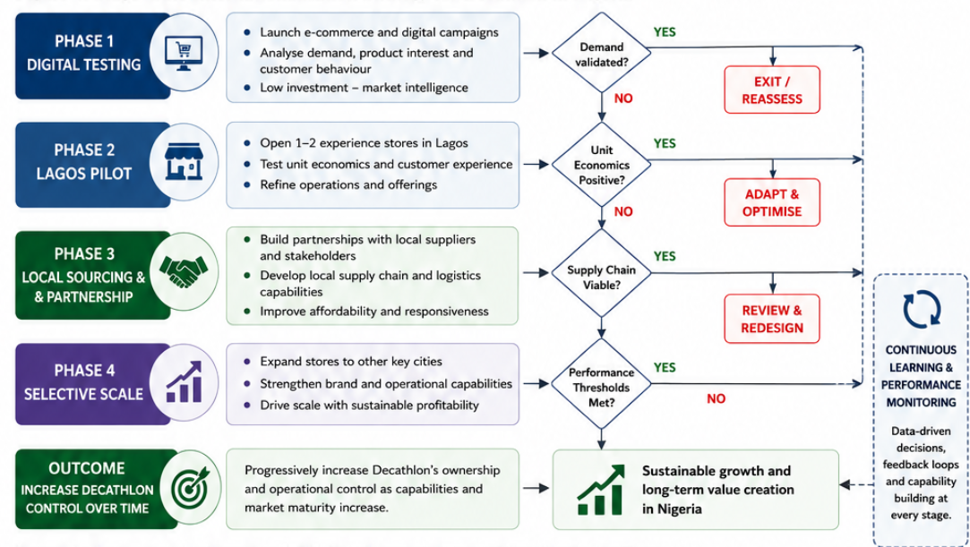
Figure 2: Stage-Gate Internationalisation Strategy for Decathlon in Nigeria

7. Strategic Synthesis
There is no analysis to support either extreme.
It is not the best thing to say that Nigeria will be rejected outright because it will underestimate its long term demographic and sporting potentials. On the other hand, expansion nationally on the spot would overestimate the effective purchasing power and would underestimate currency and institutional risk and logistics costs.
The best way to have that controlled, then, is to have optionality.
Nigeria may be considered as a strategic real option: Decathlon's strategy would be to keep the option open for significant future growth, and minimize irreversible commitment during the most uncertain period. This logic is supported by the Uppsala model as knowledge growth can lead to increasing levels of commitment (Johanson and Vahlne, 2009; Liesch and Welch, 2024).
It is therefore not advisable to view the partnership as a long-term replacement for ownership. It should work as an uncertainty reduction device.
The planned route is:
Test → Learn → Localise → Scale → Increase control
This establishes a consistent linkage among the three main theoretical approaches that are employed in the report.
Bartlett and Ghoshal outline what should be integrated at a global level, and adapted at a local level.
For Decathlon, OLI describes its advantages that are transferable, while for Nigeria, it describes the uncertainty of the location conditions.
Uppsala provides reasons for greater commitments the more that is known.
The recommendation is not a standalone synthesis of three frameworks, but rather the combination of three frameworks applied to the challenge.

8. Gibbs' Reflective Cycle

8.1 Description
Assessment was done on Decathlon's potential internationalisation into Nigeria based on Bartlett and Ghoshal's strategic configuration, PELC analysis, Dunning's OLI paradigm and entry-mode theory. Secondary data was collected from various sources including world bank, Decathlon, academic literature and Nigerian government sources. The research then proceeded from country level analysis to implications for the firm and finally to an entry recommendation.

8.2 Feelings
Nigeria seemed an interesting country at the outset of the research, due to its people and sporting culture. But as time went on, this first idea was questioned by the research. I understood that size of the population does not equal to size of the addressable market when the purchasing power of the population is limited.
This revolutionized my concept of internationalisation. Initially, I thought the most important variable would be market size; however, the analysis showed this only becomes strategically useful when it could be transformed into profitable demand.

8.3 Evaluation
The use of different categories of evidence was a great strength of the research. Corporate information was used to build Decathlon's resources, and the World Bank and Nigerian government resources were used to obtain independent information on the macroeconomic and regulatory environment in Nigeria.
The study also discovered the drawbacks of secondary evidence. Decathlon's corporate information is helpful to understanding the capabilities of an organisation but is likely to be subjective. On the other hand the macroeconomic indicators are national indicators which indicate the overall state of the country but cannot predict the performance of any particular retailer.
This introduced a significant methodological problem: national evidence had to be interpreted for the implications on the firm level while maintaining the non-causal aspect. For instance, an increase in GDP does not necessarily lead to an increase in sports good demand.

8.4 Analysis
The key lesson gained was the difference between description and strategic interpretation.
Population, inflation, foreign-investment regulations, sporting culture were relatively easy to identify. The more challenging analytical work was figuring out what these variables meant to Decathlon.
Buying power can be a factor in creating an opportunity, but can also cause the illusion of opportunity if not considered a factor in a large population. Likewise, inflation will affect the prospects since the operating costs will rise, but it can also cause value-oriented retailers to be somewhat more appealing. It is thus possible that the same environmental factor may be an opportunity or a threat depending on how it affects a firm's resources.
There was another important thing that the entry-mode analysis revealed. My first impression of joint ventures was that of minimizing risk. But the analysis revealed that the greater gain was in having local knowledge. This is especially relevant when there is the uncertainty of institutional distance. Recent studies have shown that the distance between the institutions of home and host countries has the potential to affect the level of equity commitment chosen by multinational corporations.
This study also influenced my notion of control. Having "full ownership" of an investment does not necessarily mean that it is the optimal choice. Having a financial cost that is associated with control. When in doubt, a smaller initial investment can offer more strategic options.

8.5 Conclusion
The research helped me to have a different perspective on internationalisation from a size of the market decision to a strategic fit and sequence decision.
The main takeaway was that host-market uncertainty is not eradicated by strong organisational resources. Rather, there must be some way for firms to learn about uncertainty, which at the same time avoids irreversible commitments.
I also found out that theory shouldn't be used on its own. Bartlett and Ghoshal provided an explanation of adaptation, OLI gave an explanation of the economic basis of investment and Uppsala explained the timing of commitment.

8.6 Action plan
The analysis would be enhanced by further study in three areas:Further research would enhance the analysis in three areas:
Primary research with Nigerian consumers and the logistics companies and sporting-goods retailers should be conducted to validate assumptions made based on secondary data.
Secondly, financial modelling should be integrated to calculate landed costs, break-even sales, currency sensitivity and store level profitability.
Third, theoretical findings need to be accompanied by earlier stage gate-like quantitative thresholds in the future strategic analysis process, so that the theoretical results directly influence the investment thresholds.
I would also start out with conflicting evidence and work through the positive assumption later on instead of the first time. This is a benefit to future international-business studies because it would make the studies more objective and analytical.

9. Conclusion
Nigeria is a market where Decathlon could have a long-term chance, but this chance is not guaranteed. The population, urbanisation and sports culture in the country make it appealing for demand, and macroeconomic stabilisation offers a degree of long-term optimism. Household purchasing power is still limited, however, and poverty and inflation, currency risks and logistics costs are significant commercial risks.
Decathlon has high ownership benefits. It has a global scale, business model, own-brand portfolio, product-development capabilities and global experience which can be transferred into Nigeria. The extent of these capabilities is reflected in its 2025 results: €16.8 billion in net sales, 1,902 stores and operations in 82 countries and regions.
However, OLI analysis proves that if there are high ownership advantages, this is not guarantee for immediate full scale foreign investment. Nigeria's location benefits are significant, but limited, with benefits of internalisation having to be weighed against the expense of taking on all market risk.
What Decathlon's experience in the international market also indicates is that learning and gaining control can be a step by step process. The Indian experience shows that from a first step of cautious approach to direct business operations and increased local sourcing, as markets and capabilities evolve.
The suggested approach is thus a ‘phased strategic partnership' or ‘joint venture' which starts with ‘digital demand testing', progresses to a ‘controlled Lagos operation' and concludes with ‘selective local sourcing and urban expansion'. It is not a rejection of the model of a historically control-oriented Decathlon. Instead, it is a temporary sequencing mechanism which is meant to minimize uncertainty prior to a higher level of ownership commitment.
The strategic route is thus:
Test → Learn → Localise → Scale → Increase control.
This will help to ensure the alignment of the transnational logic of Bartlett and Ghoshal's with the OLI paradigm of Dunning and the internationalisation theory of today. Most importantly, it acknowledges that internationalisation's goal is not just to gain entry to a vast market, but to build a viable alignment of the firms' resources, host country conditions, risk exposure, and the extent of control needed to achieve value creation.

References
Bartlett, C.A. and Ghoshal, S. (1989) Managing Across Borders: The Transnational Solution. Boston: Harvard Business School Press.
Decathlon (2020) ‘Our sports “startup” turns 45 years old’. Available through Decathlon corporate communications.
Decathlon (2026a) DECATHLON Group's 2025 Performance. Decathlon United Media.
Decathlon (2026b) Key Figures: 31 December 2025. Decathlon United Media.
Donnelly, R., Purkayastha, S. and Manolova, T.S. et al. (2024) ‘Institutional distance, slack resources, and foreign market entry’, Journal of International Business Studies, 55, pp. 194–211.
Dunning, J.H. (1988) ‘The eclectic paradigm of international production: A restatement and some possible extensions’, Journal of International Business Studies, 19(1), pp. 1–31.
Johanson, J. and Vahlne, J.-E. (2009) ‘The Uppsala internationalization process model revisited: From liability of foreignness to liability of outsidership’, Journal of International Business Studies, 40(9), pp. 1411–1431.
Liesch, P.W. and Welch, C. (2024) ‘Asynchronicities of growth: a process extension to the Uppsala model of internationalisation’, Journal of International Business Studies, 55, pp. 796–804.
Liu, J., Lee, E.-S. and Ding, J. (2024) ‘How Do MNEs Choose Entry Modes for Emerging Markets? The Importance of Distance and International Experience’, Business Convergence Research, 9(4), pp. 109–118.
Nigerian Investment Promotion Commission (2026) Investment Policies and Protections. Abuja: NIPC.
Nigerian Investment Promotion Commission (2026) About Us: Investor Protections and Investment Framework. Abuja: NIPC.
Silva, F.M., Ogasavara, M.H. and Pereira, R. (2024) ‘Institutional distances and equity-based entry modes: a systematic literature review’, Management Review Quarterly, 74, pp. 1723–1790.
Welch, C. and Liesch, P.W. (2024) Research on internationalisation processes and organisational growth, Journal of International Business Studies.
World Bank (2026a) Nigeria Development Update: April 2026. Washington, DC: World Bank.
World Bank (2026b) Nigeria: Data. Washington, DC: World Bank.
Zhang, W., He, X., Wang, T. and Wang, K. (2023) ‘Institutional distance and the international market entry mode: A meta-analysis’, Journal of International Management, 29(1), 100990.
Reuters (2024) ‘Sporting goods retailer Decathlon to invest $111 mln in India expansion plan’. 21 August.
U.S. Department of Commerce (2025) Nigeria – Logistics Sector. International Trade Administration.
African Development Bank (2026) Nigeria Economic Outlook. Abidjan: African Development Bank.

