

Programme: Master of Business Administration
Module: Marketing Management

Module code: LCMB7024
Assignment Title: Assessment component 1: Marketing Environment Analysis

Topic: Strategic Marketing Analysis of BHP’s Transition Towards a Lower-Carbon Business Model

Lecturer: Taonga Kaonga Sobere-Snithers

Name: Parth Bhadreshkumar Lukhi
Student ID: 2611145

Word Count: 2683

Submission Date: 22nd October 2026

AI Declaration
I declare that this is my own assignment, that I have not used any artificial intelligence (AI) tools to prepare, write, analyse or edit this assignment. This report contains only my own ideas on the subject and my interpretation of the sources that I have used and any research, critical evaluation, strategic recommendations and conclusions that I have made are my own.

Executive Summary
This report has critically evaluated BHP's marketing environment, as well as its strategic growth opportunities in its path towards a lower carbon business model. The external environmental actors studied are, Environmental factors, Customer expectations and Technological developments. Environmental pressures pose challenge to BHP's market position while there will be challenges that will create opportunities for BHP to improve its market reputation. The factors that influence the customer decision-making process are no longer just price, product quality and supply reliability and environmental performance has become an important one. Technological innovation is helping to achieve emission reductions and optimise operations. Four growth strategies of Ansoff Matrix namely Market penetration, Market development, Product development and Diversification are analysed in the report.
The strategy recommended for product development is a primary strategy and market development and market penetration are recommended as secondary strategies. BHP needs to invest in low carbon technology for production, renewable energy and digital emissions monitoring and partnerships with customers, at a reasonable price. In addition to the commercial interest there are some potential avenues of diversification to recycling and advanced mineral-processing activities. The sustainable technologies, mineral resources, know-how and customer relationships are also pointed out as assets that can be leveraged to establish the competitive advantage, within the Resource Based View (RBV) framework. This requires investment, evidence and sound risk management, however. To conclude, BHP needs to make environmental performance a part of the cost efficient, innovative and customer value to make themselves more competitive and sustainable in long-term.

Table of Contents
Introduction 5
Task 1: Marketing Environment Analysis 5
1.1 Environmental Factors: Climate Change and Sustainable Production 5
1.2 Social Factors: Demand for Lower-Carbon Metals 7
1.3 Technological Factors: Innovation in Low-Carbon Mining and Processing 9
Task 2: Strategic Growth and Competitive Positioning 11
2.1 Application of the Ansoff Matrix to BHP 11
2.2 Product Development: Investing in Lower-Carbon Minerals and Production 11
2.3 Market Development: Expanding into Emerging Low-Carbon Markets 12
2.4 Market Penetration and Diversification: Supporting Long-Term Growth 13
2.5 Achieving Competitive Advantage Through Sustainable Innovation 13
2.6 Implementation and Strategic Recommendation 14
Task 3: Managerial and Professional Reflection 14
3.1 Rationale for Company Selection and Environmental Analysis 14
3.2 Reflection on Strategic Growth Recommendations 15
3.3 Limitations of the Analysis 15
3.4 Further Investigation and Professional Learning 15
Summary 16
Reference List 17
Appendices 20
Appendix 1: Value Chain of CHG emissions by BHP 20
Appendix 2: Renewable electricity power purchase by BHP 21
Appendix 3: PESTLE Analysis 22

Introduction
The report critically evaluates Broken Hill Proprietary Company’s (BHP) marketing environment and strategic growth opportunities as it moves towards a lower carbon business model. It analyses the environmental, customer and technological considerations, derives growth strategies with the help of the Ansoff Matrix and analyses the sustainability of innovation to enhance the competitive advantage.

Task 1: Marketing Environment Analysis

1.1 Environmental Factors: Climate Change and Sustainable Production
BHP is engaged in the global mining industry where environmental issues are a growing influence on the way mining is produced as well as the way customers expect it to be produced and its competitive position (Shanmukha, Vinayaka and Lokeshappa, 2024). Climate change, loss of biodiversity, greenhouse gas emissions along with water scarcity are just some of the pressures that mining companies are under to increase their sustainability. The environmental aspect of BHP is especially significant as it consumes significant amounts of energy and resources to exploit and process minerals (bhp.com, 2026). This should be a responsibility to the environment but also a marketing opportunity to tie customers to products which may have been produced in a responsible way and to support the move towards carbon reduction in production (as per Appendix-3). BHP may be able to enhance its environmental value proposition in several ways, by electrifying all its electric consumption, by upgrading equipment, by replacing the equipment with more energy efficient and environmentally friendly technologies; and by electrifying mining operations and innovation (Ertugrul, 2024).
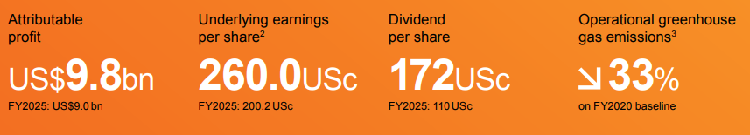
Figure 1: Sustainability Targets of BHP
(Source: bhp.com, 2026)
In case of operational greenhouse gas emissions, the company has reduced them by almost 33% in 2026 to that in the year 2020 (bhp.com, 2026). BHP's operational greenhouse gas (GHG) emissions is the relevant real-life indicator (RLI) and are around 9.5 million tonnes of carbon dioxide equivalent (CO2e) for FY2024 (bhp.com, 2026). This reflects the continuing importance of emission reductions related to direct emissions. BHP has a plan to decarbonise its operations and engage suppliers and customers to help tackle emissions throughout its value chain.
BHP's Scope 1 and 2 emissions decline from 14 CO2 equivalent in FY2020 to approximately CO2 equivalent by FY2030 (bhp.com, 2026). For instance, BHP can make a connection between its mineral products and the world's shift towards a cleaner energy source through the electricity network, renewable energy plants and electric vehicles (as per Appendix-1). However, environmental advantages of extraction cannot be just taken for granted based on the ultimate use of minerals. As a result, they must be evaluated throughout extraction, processing and transportation (Yu et al., 2023). Infrastructure, clean energy as well as new technologies, however, are much more an investment in sustainable production. For customers focused on price rather than environmental performance, costs may have an impact on competitiveness. Secondly, even if an environmental claim is not supported by independent evidence, BHP may be liable to the charge of greenwashing.
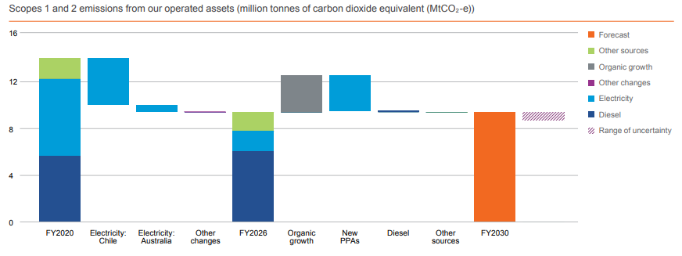
Figure 2: CHG Emissions Data of BHP
(Source: bhp.com, 2026)

1.2 Social Factors: Demand for Lower-Carbon Metals
The social factors mainly represents the customers, who are one of the most external actors to BHP's marketing environment that may have an impact on BHP's journey to reduce carbon products. The commodity business BHP is selling to the industrial customer has more change than ever before in the production because of sustainability concerns, emissions restrictions, as well as shifting investor preferences (Pollard and Buckley, 2025). There is also industry pressure to reduce emissions, for steel manufacturers, which are under pressure to reduce emissions as the most prevalent method of steel production is highly carbon intensive. Suppliers' environmental performance is the other concern of industrial customers besides quality and price along with reliability of supply (bhp.com, 2026). This may be able to help BHP continue to reinforce its market leadership by supporting its customers to decarbonise through environmental data transparency, development and improvement. However, the commercial return will rely on the recognition and rewards of customers with regards to lower emission production.
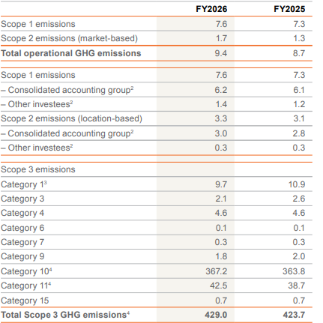
Figure 3: Total Scope 3 CHG Emissions of BHP
(Source: bhp.com, 2026)
Total operational GHG emissions has increased from 8.7 to 9.4 CO2 equivalent between FY2025 and FY2026. On the other hand, total Scope 3 GHG emissions rise from 423.7 to 429.0 CO2 equivalent (bhp.com, 2026). BHP's efforts to reduce emissions from the steelmaking process are another prime example of this. They are engaged in a meeting with other steelmakers, China Baowu, POSCO and ArcelorMittal, in order to discuss potential pathways and technologies. The partnerships are a part of BHP's transition from commodity to longer term business relationship and business innovation (bhp.com, 2026).
Customer research, market segmentation as well as relationship management may be used by the marketing team to target industrial buyers who have ambitious decarbonisation targets. Emissions tracking and product information systems based on computers are also available for communicating with customers to actively help informed procurement decisions along with the assessment of suppliers' environmental performance (Zampou et al., 2022). There are variations in markets, however, in terms of the priorities of the customer. While some steel companies may be interested in low cost and good quality iron ore, others may be interested in low emissions to meet the regulations or their sustainability policies. There may also be a lack of infrastructure, financial capital and/or a lack of customer willingness to invest in production technology which will lead to emission reductions (Shanmukha, Vinayaka and Lokeshappa, 2024). It may be deduced that there is no automatic premium on the low carbon products, therefore no universal growth of the market for low carbon products. BHP needs to demonstrate success and sustainability of its Environmental work and maintain quality and reliability.

1.3 Technological Factors: Innovation in Low-Carbon Mining and Processing
BHP's decision to make the transition towards low carbon products has been influenced by an external marketing environment factor, technological developments. Renewable energy, electrification, automation and artificial intelligence, emissions-monitoring systems, among others may have contributed to more efficient mining operations and is helpful to reduce the greenhouse gas emissions (as per Appendix-2). The technologies could impact BHP's switching costs and reliability and their ability to satisfy the customer's requirement for more sustainable materials (Pollard and Buckley, 2025). Technological innovation can also be an opportunity, however, from a marketing point of view, to be different from BHP and provide better environmental performance, transparent and verifiable product information as well as a reliable supply. Steelmaking pathways has transitioned to low-emission end states, reducing carbon intensities from 1.2–2.6 down to 0.3–0.4.
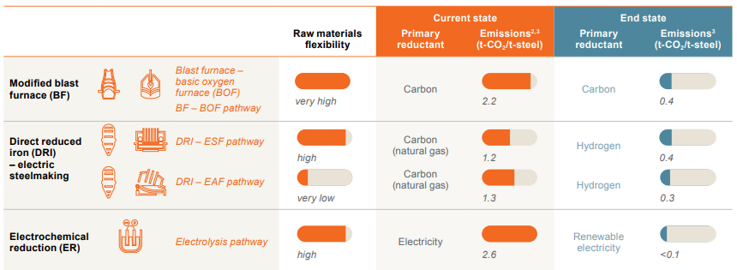
Figure 4: Decarbonisation Technology Used by BHP
(Source: bhp.com, 2026)
For example, BHP has implemented trolley-assist technology at its Spence copper mine in Chile, where mining trucks are able to get electricity from an overhead power line on specific uphill courses. This could help to cut down on the use of diesel fuel and emissions from those vehicles on appropriate haulage routes and could offer an improved operational efficiency (Balazadeh Meresht et al., 2023). These are a few of the technological developments that reveal that technology can have the power to enhance the environment and business processes. BHP has the opportunity to dive into renewable electricity, battery electric equipment and digital monitoring and advanced data analytics to enhance energy management along with the potential for emissions reductions (Yu et al., 2023). The marketing department might be able to offer some quantifiable efficiencies of operations as proof to the customers, investors, and others. However, it may be stated that technology does not necessarily bring environmental or economic benefits. Electrification is possible but requires electricity supply, equipment specifications and operating conditions (Shanmukha, Vinayaka and Lokeshappa, 2024).

Task 2: Strategic Growth and Competitive Positioning

2.1 Application of the Ansoff Matrix to BHP
The Ansoff Matrix offers a helpful guide to consider the options for growth in terms of product/line and market/service. The framework may enable BHP to make strategic decisions to scale its lower carbon business model, while meeting environmental pressures, customer expectations as well as technological advances (Ferreira and de Sá, 2024). Market penetration, market development, product development and diversification are the 4 types of strategies. Product development and market development should be the two top priorities for BHP's growth, with product penetration and strategic diversification as other growth areas of BHP pursued selectively and carefully.

2.2 Product Development: Investing in Lower-Carbon Minerals and Production
BHP should aim to minimise the emissions of its mineral operations and continue to invest in lower emission technology and equipment for its operations, such as renewable electricity, energy efficiency in mineral processing, and emissions reduction from its mineral operations On an additional note, Copper also has a special role to play in the power infrastructure, Renewable energy systems and in Electric vehicles (Kotler et al., 2024). BHP may properly enhance the environmental characteristics of the copper products production and share the information on the emissions produced by the copper products with customers in a transparent way, strengthening the bond between the two. It also must engage steel companies in order to discover new methods of treating iron ore to create new steel products with reduced pollution. These may vary BHP in terms of responsible production, operational efficiency as well as environment performance (Zugay, 2023). Carbon reduced materials may cost more if there is investment in technology, but the consumer may not be willing to pay more.
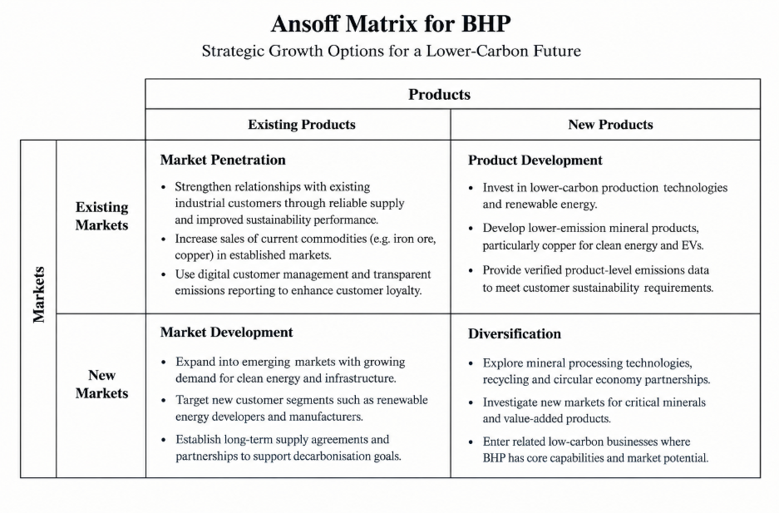
Figure 5: Ansoff Matrix Application
(Source: self-developed, idea from Ferreira and de Sá, 2024)

2.3 Market Development: Expanding into Emerging Low-Carbon Markets
Market development is the process of an organisation's marketing a similar or the same product into a new geographical market or to a new market segment. There has been an increasing number of manufacturers and renewable energy infrastructure providers and industrial consumers increasingly targeting decarbonisation of their energy use (Fose et al., 2024). Hence, BHP could look at some terms for these arrangements. New opportunities for the use of copper and other critical minerals are provided by the expansion of the electricity networks, energy storage and electrification. BHP has the opportunity to enhance its market position through long-term supply contracts, industrial customer relationships as well as participation in markets where environmental performance is becoming a major factor in procurement.

2.4 Market Penetration and Diversification: Supporting Long-Term Growth
Market Penetration is growth in the sale of existing products in existing markets. BHP can utilise this by improving their current industrial customer network, making it more reliable, through digital systems to better manage customers and by demonstrating operational emissions reduction (Zugay, 2023). Customers are paying more and more attention to their supply chains' performance, and transparency and sustainability for improving engagement. However, unless the environmental product is of better quality, available and less expensive than other products, these ads will not be fruitful. Diversification involves entering into new markets, with new products, and thus is more uncertain. BHP may wish to further explore opportunities in mineral processing technologies and mineral recycling partnerships and services to facilitate more efficient use of minerals, on a selective basis.

2.5 Achieving Competitive Advantage Through Sustainable Innovation
BHP may be competitive because it has the opportunity to operate in the environment well and be cost effective, and in terms of technological ability, product reliability and good customer relationships. A differentiation strategy is possible in case of verified emissions data and it is necessary when responsible emission sources and cooperation in decarbonisation (Lorenc et al., 2023). The operating changes will also be helpful to become cost competitive due to the reduction of fuel consumption and energy use simultaneously while reducing the production processes from being inefficient. This will be very technology intensive.
Resource/Capability | Competitive Advantage
Sustainable technologies | Reduce emissions and improve operational efficiency.
Mineral resources | Support reliable supply to industrial customers.
Digital emissions monitoring | Improve transparency and customer trust.
Customer partnerships | Strengthen collaboration on decarbonisation.
Operational expertise | Reduce energy costs and improve productivity.
Table 1: RBV Application for competitive advantage
(Source: self-developed, idea from Lubis, 2022)
The RBV framework suggests that BHP may be able to achieve sustainable competitive advantage by the development of valuable capabilities that differentiate its operations and support long-term environmental as well as commercial performance (Lubis, 2022).

2.6 Implementation and Strategic Recommendation
BHP should gradually begin to implement the growth strategy in a proper manner. It should first improve the existing operations, in terms of energy efficiency, electrification and emission monitoring. It will then increase its product range for lower carbon materials and expand its customer relationships with those that are interested in more sustainable materials. Finally, it should analyse markets as well as other diversification opportunities regarding the feasibility of their business and their environmental impact (Davies, 2024). The series is not new and potentially risky ventures that are added to the business but skills that have already been proven to be successful.

Task 3: Managerial and Professional Reflection

3.1 Rationale for Company Selection and Environmental Analysis
I chose BHP because it is a large multinational company and is facing increased pressure to be profitable and competitive, and to minimize their environmental impact. My thinking was that BHP was a good case to examine because it was the combination of the mineral requirement, and how they were able to balance the expectations of all stakeholders and the changing environment (Almusaed et al., 2024). In this analysis I have included more the environmental aspects, emphasized more due to the impact of climate change, GHGs and sustainable use of the resources on the company in the long term and direct impact on the company's actions and image.

3.2 Reflection on Strategic Growth Recommendations
My choice for the Ansoff Matrix is due to the fact that the Matrix is a structured way of analysing BHP's opportunity for growth. I have proposed that product development will be the primary strategy and market development and market penetration will be the secondary one. As long as I could convince them that they could tweak the stuff they already have, and as the BHP could do that as their needs evolved, not the risk of going into some business that wasn't related (Vincent, 2023). On an additional note, I have gained experience on my own in the long run, in diversification, particularly in the area of recycling arrangements as well as processing minerals.

3.3 Limitations of the Analysis
I have a couple of gaps in my analysis. One, I didn't do any first-hand research with BHP's customers, BHP's managers or BHP's sustainability experts. This is because it is not directly possible to observe the value customers would place on the lower carbon minerals and/or willingness to pay for improved environmental performance (Liu et al., 2024). Second, all the influences of the environment, customers and technologies were not considered and not always in the same depth. The proposed growth strategies could also be impacted by political events, economic factors, competitor actions and issues in the supply chain. Thirdly, financial details of the different alternative technologies were not considered that will allow us to compare investments cost, monetary return and implementation time.

3.4 Further Investigation and Professional Learning
As a consultant I would want to know more about the impact BHP is making on carbon emissions, capital expenditure plans, customer buying priorities as well as carbon activity of the competition. I would also review market forecasts of copper and some key minerals, regulatory changes in key markets and the technical viability of new decarbonisation technologies (Işıldar, 2026). The barriers and assumptions to implementation would be confirmed by customer interviews and industry expert interviews. More specifically, I would run a variety of scenarios to assess potential commodity price and carbon regulation impacts, and technology costs along with benefits to strategic results. I have learned to realize that instead of making marketing decisions according to what the general trend of the industry is, they should be made on evidence-based evaluations.

Summary
In conclusion, BHP has the opportunity to leverage sustainability, technological innovation, as well as optimizing its operations and operations and collaboration with customers to gain a competitive advantage. Product development continues to be the core business growth strategy with the complement of market development. Requires measurable, credible environmental communication, financial viability and routine evaluation of new market opportunities.

Reference List
Almusaed, A., Yitmen, I., Myhren, J.A. and Almssad, A., (2024). Assessing the impact of recycled building materials on environmental sustainability and energy efficiency: a comprehensive framework for reducing greenhouse gas emissions. Buildings, 14(6), p.1566. https://www.mdpi.com/2075-5309/14/6/1566
Balazadeh Meresht, N., Moghadasi, S., Munshi, S., Shahbakhti, M. and McTaggart-Cowan, G., (2023). Advances in vehicle and powertrain efficiency of long-haul commercial vehicles: A review. Energies, 16(19), p.6809. https://www.mdpi.com/1996-1073/16/19/6809
bhp.com (2026). BHP. Available at: https://www.bhp.com/ (Accessed: 9 October 2026).
bhp.com (2026). BHP Sustainability. Available at: https://www.bhp.com/sustainability/community-sustainability-reports (Accessed: 9 October 2026).
Davies, M., (2024). The Role of Strategic Mine Planning in Decarbonising the Mining Industry. Mining, Metallurgy & Exploration, 41(6), pp.2783-2785. https://link.springer.com/content/pdf/10.1007/s42461-024-01083-2.pdf
Ertugrul, N., (2024). Mine Electrification and Power Electronics: The roles of wide-bandgap devices. IEEE Electrification Magazine, 12(1), pp.6-15. https://ieee-pes.org/wp-content/uploads/2024/03/Electrification_March_2024_Open_Article.pdf
Ferreira, A.P.P.F.S. and de Sá, M.M.B.P., (2024) The importance of the Ansoff matrix for the study of the information services market. The Canadian Journal of Information and Library Science, 47(2), pp.78-84. https://ojs.lib.uwo.ca/index.php/cjils/article/download/17432/15874
Fose, N., Singh, A.R., Krishnamurthy, S., Ratshitanga, M. and Moodley, P., (2024). Empowering distribution system operators: A review of distributed energy resource forecasting techniques. Heliyon, 10(15). https://www.cell.com/heliyon/pdf/S2405-8440(24)10831-6.pdf
Işıldar, A., (2026). Energy transition metals: supply and demand dynamics in a geopoliticised market. Academia Green Energy, 3(3). https://www.academia.edu/2998-3665/3/3/10.20935/AcadEnergy8558/pdf
Kotler, P., Armstrong, G., Harris, L.C. and He, H. (2024). Principles of marketing. 19th edn.
Liu, Y., Yang, Y., Zhang, X. and Yang, Y., (2024). The impact of technological innovation on the green digital economy and development strategies. Plos one, 19(4), p.e0301051. https://journals.plos.org/plosone/article/file?id=10.1371/journal.pone.0301051&type=printable
Lorenc, S., Leśniak, T., Kustra, A. and Sierpińska, M., (2023). Evolution of Business Models of Mining and Energy Sector Companies according to Current Market Trends. Energies, 16(13), p.5212. https://www.mdpi.com/1996-1073/16/13/5212
Lubis, N.W., (2022). Resource based view (RBV) in improving company strategic capacity. Research Horizon, 2(6), pp.587-596. https://journal.lifescifi.com/index.php/RH/article/download/85/72
Pollard, M. and Buckley, T., (2025). Transition tax incentive: reforming fuel tax credits into a decarbonisation tailwind. http://climateenergyfinance.org/wp-content/uploads/2025/08/CEF_Transition-Tax-Incentive-Report-FINAL_20August2025.pdf
Shanmukha, N.T., Vinayaka, M. and Lokeshappa, B., (2024). Biodiversity loss due to mining activities. In Impact of societal development and infrastructure on biodiversity decline (pp. 166-191). IGI Global Scientific Publishing. https://www.researchgate.net/profile/Vinayaka-m/publication/381428628_Biodiversity_Loss_Due_to_Mining_Activities/links/66900cf1b15ba559075366ff/Biodiversity-Loss-Due-to-Mining-Activities.pdf
Vincent, E., (2023). Who cares?: life on welfare in Australia. Melbourne Univ. Publishing. https://books.google.com/books?hl=en&lr=&id=q7mvEAAAQBAJ&oi=fnd&pg=PA7&dq=long+as+I+could+convince+them+that+they+could+tweak+e,+and+as+the+BHP+could+do+that+as+their+needs+evolved,+but+not+the+risk+of+going+into+some+business+that+wasn%27t+related.&ots=C9bejcpIyD&sig=6jeMUEJk90cSH645zH8eogsO6Xs
Yu, Z., Ridwan, I.L., Tanveer, M. and Khan, S.A.R., (2023). Investigating the nexuses between transportation Infrastructure, renewable energy Sources, and economic Growth: Striving towards sustainable development. Ain Shams Engineering Journal, 14(2), p.101843. https://www.sciencedirect.com/science/article/pii/S0313592623001649
Zampou, E., Mourtos, I., Pramatari, K. and Seidel, S., (2022). A design theory for energy and carbon management systems in the supply chain. Journal of the Association for Information Systems, 23(1), pp.329-371. https://www.academia.edu/download/112787226/490778314.pdf
Zugay, B., (2023). Ansoff matrix. SAGE Publications, Inc.. https://sk.sagepub.com/foundations/ansoff-matrix

Appendices

Appendix 1: Value Chain of CHG emissions by BHP
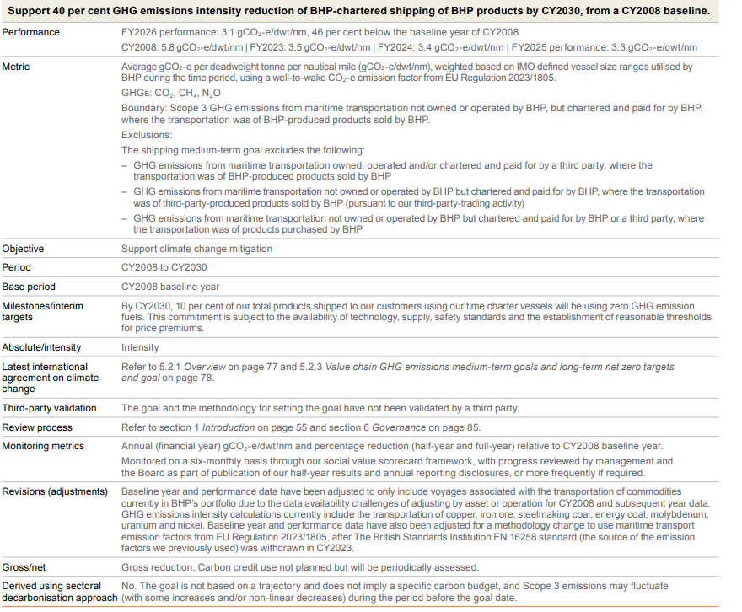

Appendix 2: Renewable electricity power purchase by BHP
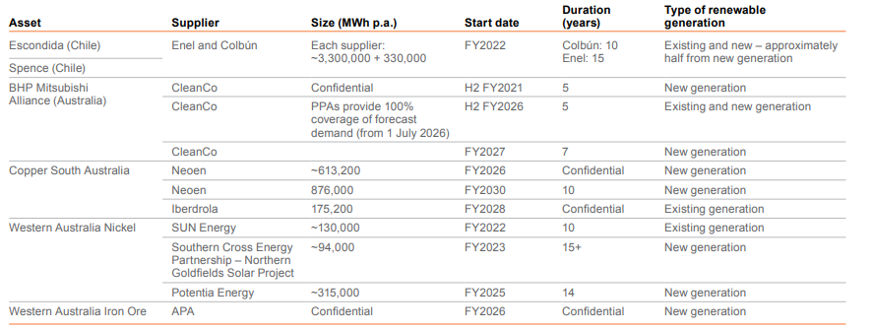

Appendix 3: PESTLE Analysis
PESTLE Factor | External Influence | Impact on BHP
Political | Government climate policies | Influences investment decisions.
Economic | Transition and energy costs | Affects profitability.
Social | Sustainability expectations | Shapes customer preferences.
Technological | Electrification and digitalisation | Supports emissions reduction.
Legal | Environmental regulations | Increases compliance requirements.
Environmental | Climate change and emissions | Encourages lower-carbon production.

