Name : Iosif Tcaciu
Student ID: 2022775
Module : Professional Career Development
Module code :BMSW4005
Lecturer : AFZAL MUNNA
Program :Cert HE Skills For The Workplace

Professional career development report and role play (interviewee and interviewer) Task 1 and Task 2

Table of Contents
Task – 1: Roleplay 3
Task 2: Report 5
Introduction 5
Experience and learning from the role pay activity 6
Application of Gibbs reflective cycle 7
Conclusion 10
References 11
Appendix 12
Job advertisement 12
Cover letter 14
Job application form 15

Table of Figures
Figure 1: Gibb's reflective model 7

Task – 1: Role play
Question 1: Tell me about yourself.
Hello, This is Iosif Tcaciu. I am a graduate of the University of Wales. I have completed my graduation in Marketing. I was a bright student from my college days. I had overcome all the previous hurdles of my educations and I had joined this university to learn about marketing. Marketing is a very high demand subject. So I have read subject so that I can get a good job after completing my education. Besides my educational qualification, I have lots of other issues about me which I have to tell you. I had worked in two organizations before and now I am working with one. In all of those organizations, I had worked with the marketing sector. So I have previous working experience in the marketing department. I have some experience of organizing various events at the University. So I know how to deal with the people, manage them to get a thing done. I have good skills in communication and negotiation with people as I am an extrovert person.
Question 2: Why should we hire you?
I've gained appropriate abilities and expertise throughout the years, which I'll contribute to your company. I've also spent a lot of time honing my communication and collaboration skills, which I'll utilize in my future career, which will be with your company if I'm chosen for the role. In previous firms, I have given my all, and this has allowed me to understand my strengths and weaknesses. If I channel them further, they will provide positive benefits for both myself and your prestigious company. In this marketing manager position, I am convinced that I would be a rock star. It's not simply my experience directing successful projects for businesses or my people skills that have allowed me to form strong bonds with developers, suppliers, and senior executives. But I'm also enthusiastic about this field and determined to produce high-quality work.
Question 3: Why do you want to work here?
I am a great believer in approaching each task collaboratively, so when I spotted a job opening with your organization to join the marketing team, I knew I had to apply. I've seen your work in theatre, and your behind-the-scenes film impressed me since it showed cooperation in action. I like working as part of a team to reach a shared objective, and I am certain that my experience in production has equipped me for this position. I'm excited to join this incredible team as a valuable contributor. I also want to work with you for some other reasons. Previously I had been working for two small companies. Now in your big organization, I think I can perform more effectively. As there are lots of highly experienced workers are working here, so I will have got a huge chance of learning from them. I can also learn lots of new things about marketing jobs from here which will give me huge support in future.
Question 4: When were you most satisfied with your job?
I was most happy in my prior employment as a retail shop manager when both the personnel and the consumers in the store had a positive experience. I recall a situation when a consumer requested assistance because a cashier had made an error. I was able to satisfy the client by correcting the error and teaching the employee how to utilize the system properly. They both appreciated my assistance, and I was relieved to have solved the issue. When I was working at another company, I was having trouble meeting sales targets, so I asked everyone in the sales team what tactics they used to succeed. I made a few tweaks to my method, and in a short period, I was able to achieve my objectives. Realizing that I'm functioning at or beyond my owner's expectations makes me so happy at work, and it motivates me to keep searching for ways of improving until I reach that.
Question 5: What are your goals?
My short-term aim is to get employment with a reputable firm such as yours, where I may further my career while also contributing to the organization. My long-term objectives include working for a firm where I can continue to learn, take on more responsibilities, and bring as much contribution to the company as possible. Your company's emphasis on professional growth possibilities is fantastic. I would use all of the educational tools accessible to me. I'd want to be able to go from a technical role to management after I've gained more expertise. This has been a regular route for many individuals in this position, and I believe it would be a reasonable next step for me in the future.

Task 2: Report

Introduction
A personal reflective report is a report that is used for evaluating someone’s personal experiences and learning materials from a particular area (Ryan, 2011). It is very crucial too for an individual because through personal reflective assignment a person can find out his core strengths and weaknesses which have helped that man to develop his future career (Farrell, 2020). This reflective report is written to describe the experiences from the role-play activities under this module. It will also describe the ways by which I can develop various skills so that I can get my desired job and become a successful person. To do this report, I am going to use the Gibbs reflection model. Gibbs Reflective Cycle is a self-reflection and organizational technique that assists individuals in thinking clearly and methodically about the many encounters they have had during a certain task or comparable scenario and drawing a conclusion (Gibbs' Reflective Cycle: Helping People Learn From Experience, 2021). Graham Gibbs intended to characterize the issue and make an understanding of the cycle by using distinct stages. He felt that individuals learn from their mistakes and that if they did not take into account how to improve for the next time, they were not acquiring anything. Gibbs Reflective Cycle is a significant teaching and learning strategy that describes the scenario and assists individuals in making sense of it, understanding it and reflecting on how to improve their performance in the future (Husebø, O'Regan and Nestel, 2015). There are some other reflective models which can be used for reflective writing such as Kolb’s learning cycle, Reflection-in-action and reflection-on-action. Those models can be used in different contexts and for reflection about ones owns learning from a particular context.

Experience and learning from the role pay activity
I have performed the role-play activities with one of my classmates and we have tried that event as much real as possible. In the role play my part was to play as an interviewee. I have performed that role to get a job as an interviewee. The role of my friend was the interviewer. He was supposed to ask me various questions which are too common for an interview board has planned to ask me five general questions. I have answered all those questions like a real interviewee. To make sure that I am going to perform in an interview with my friend, I took very good preparation. Taking interview preparation is so crucial because by talking proper interview related preparation one person can achieve success in the interview (Cooper, 2011). It is also necessary to make an impact on the job givers mind because today's job market is highly competitive. And the job givers always find out the best candidates among lots of others. So it will be very crucial for an interviewee to read the job description and should take preparation for that interview (Schudlik, Reinhard and Müller, 2021). I have shown that I wanted to become a marketing manager in a reputed organization. So I had known that I must have given an answer relating to the current trends and challenges of this profession. So I take some preparation on that. I was expecting that my interviewer would ask me more questions about marketing, but he did not do that. He asked me some of the common questions in terms of the interview.
In every interview, the interviewee must have to answer about representing him or her in front of the interviewer. an interviewee must be careful when he is going to answer that question. From my preparation of giving an interview, I have identified that the employers have my CV in their hands but why are asking this question? Then I get to know that the interviewer always asks this question to know beyond the CV information. So here, I have provided all those factors and habits of me that were not in the CV. I have also faced another more common question in terms of giving a job interview. The interviewer always asks this question that why they should hire me. So here I have to become more strategic. I have provided lots of information relating to my personal, academic and professional experiences. In answering this question I have provided information in such a way that I have the highest quality to do this job. I also express humble that I want to learn from their organization and I also want to share my experiences. Then I disclose that I have come here because I have all the essential skills that will be needed for completing this job. Then I also had to answer three more questions. Those questions were related to my experience of working in several other organizations. I showed that I have worked in two other companies for this role and I was quite successful there. I also give the answer about my future short and long term goal related to my career.

Application of Gibbs reflective cycle
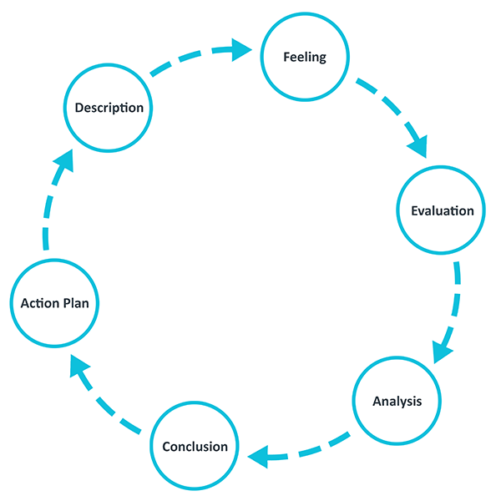
Figure 1: Gibb's reflective model
Source: (He, Parkinson and Doyle, 2018)
Description: I had to perform a role-play to focus on my interview giving abilities. I had chosen the role of marketing manager as my future profession. So to get the required position in a reputed organization I know that I have to develop various skills. This course and university level education have provided me with lots of options to learn and develop various skills so that I can use those skills for developing my career. I have identified some of the skills that will be so crucial to help me to achieve my desired goal. First of all, I am trying to develop my communication skill. Communication is the process through which a person interacts with others in order to communicate his or her thoughts and emotions (Muyeen, 2017). By finishing this course, I attempted to improve my communication abilities. I acquired the proper technique to interact with people through classroom exercises and group discussions. Through classroom discussion, I improved my communication abilities. With my friends and mentors, I will participate in debates on many topics. As a result, I'll be an excellent speaker by covering a variety of themes. It would help me improve my writing abilities so that I could prepare an analytical document. Both of these academic certifications assist me in honing my employable abilities in order to acquire the desired job.
One of the most common job and academic skills is the use of information and communication technology (ICT). At least some personnel with the bare minimum of ICT abilities have been hired by all firms (Philpot, Curnick, Soars and Soars, 2013). These activities will allow us to learn how to utilize software efficiently and arrange them. In my educational courses, I may also rely on simple office tool kits for assistance. This important employability skill will be developed by enhancing my professional technological developments. In addition to my academic goals, I've begun to improve my Microsoft Excel proficiency. For both students and managers, problem-solving is a valuable talent. I gained the fundamentals of problem-solving abilities as a result of completing this project. In terms of information collecting and task analysis, I've run across a variety of issues. I need to understand the data gathering program in order to improve my problem-solving abilities. Any data that is causing an issue should be rectified. As a result, I'll start by gathering information from a variety of sources, both main and secondary. I may then use various application forms to examine these data and arrive at the required result.
Feelings: I have developed several skills like communication, ICT and problem solving for getting my desired job. I had both good and bad experiences of developing those skills. In this course, I have learn a very important concept of role-playing and taking preparation for interviews for getting a job. For the interview purpose, I had used one of my friends and we did the conversation like the real-life job interview. This thing was very important for me as we have tried to make the simulation as real as possible. That's why it was very interesting. I have tried to develop various skills like communication problem solving and information communication technology. All of those skills are highly preferable for getting a job as a marketing manager. I have also identified that I have some weaknesses regarding some of the skills like networking, negotiating, and teamwork. Overall this journey was so interesting for me and challenging as well because I have to learn various things which were unknown to me. And I think with the skills I will be able to get a good job in the Marketing department.
Evaluation: The experience that I gathered from this course and learning materials was both interesting and challenging. I think if I can get more time I will develop some more skills which will help me to get a job in the marketing sector. I have identified some basic bad things of this course like I did not have access to many resources and at the beginning, I couldn't understand some terms for proper suggestions from my instructor. But after some time with the help of my teacher and peer group members, I became able to understand all the terms and conditions of this course of career development and I also identified my personal weakness on which I have to focus on.
Analysis: I have paid the career development related issues for the reflection in the context of this report. I have chosen it because I know that all career development-related skills are highly essential for an individual. After all, it will help him or her to get a position in their desert job. From this reflection, I can make sense of the necessity of professional development related skills for getting a good job. I have also learned about interviewing to get a good job.
Conclusion: In summary, the overall learning from this course and module was highly interesting for me. This course makes me able to identify my personal weakness relating to my career development. I have identified my strength skills like communication, problem-solving and technology-based skills which are essential for a marketing-based job. But I think I should have developed more to improve my professional skills like negotiating, networking, and statistical skills because this skill can make me able to get marketing-related information about the continuous changes in this sector.
Action plan: To develop my personal skills I have made an action plan. According to my action plan, I will focus on developing my negotiating skills because in the profession of marketing manager the negotiating skill is highly important. I will also increase my statistical and numeracy skills so that I can get information about all the recent trends of the marketing sector so that I can beat my competitors. I will also try to develop my skills regarding teamwork so that I am able to lead a team with full professionalism.

Conclusion
In summary, the reflective report can provide us with information about our personal skills and weakness. So to develop our personal and professional skills, proper and effective application of the Gibbs reflective model can help us because it will provide us information about our weaknesses and also we can make action Plan so that we can develop the required skills for getting a good job. In this report, I have reflected on my personal experience in role-playing. The role-play has been discussed to show my knowledge about common interview questions. And with the application of Gibb’s reflective cycle, I have shown my learning from the role-play activities.

References
Cooper, H., 2011. Interview skills. Richmond: Trotman.
Farrell, T., 2020. Reflective Teaching, Revised. Chicago: TESOL Press.
He, K.N., Parkinson, L. and Doyle, A.K., 2018. Gibbs’ Reflective Cycle.
Husebø, S.E., O'Regan, S. and Nestel, D., 2015. Reflective practice and its role in simulation. Clinical Simulation in Nursing, 11(8), pp.368-375.
Mindtools.com. 2021. Gibbs' Reflective Cycle: Helping People Learn From Experience. [online] Available at: <https://www.mindtools.com/pages/article/reflective-cycle.htm> [Accessed 15 November 2021].
Muyeen, S., 2017. Communication. Stevenage, Herfordshire, UNKNOWN: The Institution of Engineering and Technology.
Philpot, S., Curnick, L., Soars, L. and Soars, J., 2013. Academic skills. Oxford: Oxford University Press.
Ryan, M., 2011. Improving reflective writing in higher education: A social semiotic perspective. Teaching in Higher Education, 16(1), pp.99-111.
Schudlik, K., Reinhard, M.A. and Müller, P., 2021. Prepared to fake? The relationship between applicants’ job interview preparation and faking. International Journal of Selection and Assessment, 29(1), pp.29-54.

Appendix

Job advertisement
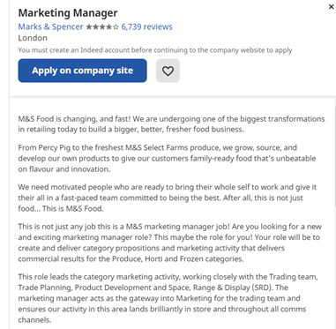
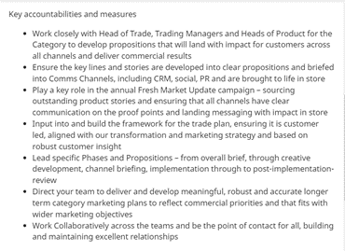
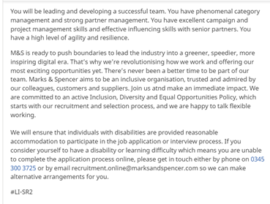

Cover letter
To,
Darren McCabe (FCIPD)
Group Head of HR
Clothing, Home & International Sourcing Offices
Marks and Spencer
London, England, United Kingdom
Dear sir,
Recently I have found a job advertisement for recruiting human resources in the Marketing Department as the Marketing Manager in Marks and Spencer. I am highly interested to apply for the post of Marketing Manager in your organization.
I have both the academic and professional experiences to work as the marketing manager in your company. I am a graduate in Marketing and I have already performed my job roles in the marketing department of two reputed company. So, I can handle all the challenges of your marketing department.
I am interested in this job because the responsibility that I must have to perform in Marks and Spencer is most interesting and well known to me. I am looking forward to hearing something from you in response to my interest. I am also highly confident in my skills and experiences that I will be the best for this position.
Sincerely
Iosif Tcaciu

Job application form
Marks and Spencer
JOB APPLICATION FORM
APPLICANT SECTION
Position applied for Marketing Manager
Personal details

Given name: Iosif Tcaciu  L | Family name: Tcaciu
Preferred name: Iosif

Address: 33, Royal Street, London, the United Kingdom

Telephone Daytime: | Mobile:077168XXXX
Email: iosiftcaciu@XXXX.XX.XX
Current qualifications
Qualifications title | Institution/Training provider | Year completed
Graduate | University of Wales | 2021
Training to Marketing and customer management | Marketing Training Centre | 2021

Are you currently undertaking study/training? (tick one) | - Yes | - No

