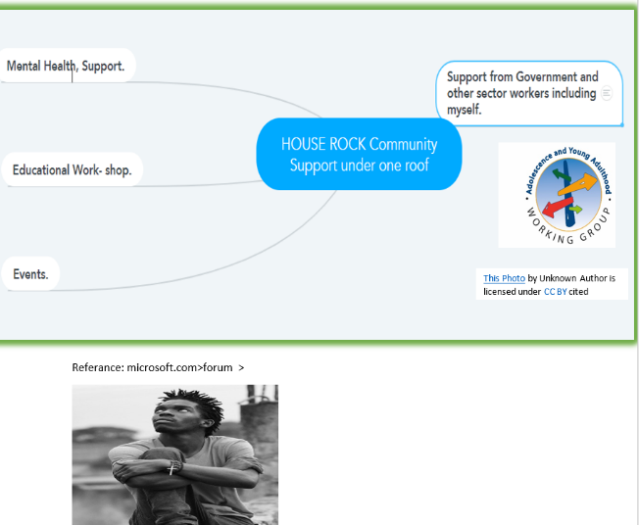
Title: Changemaker Creativity and Value Creation, Presentation
Module: Code BMHP5014 – BIRM, Part 1 – 2
Student: Monica Dormer, 1907095

Lecture: Azora Hurd

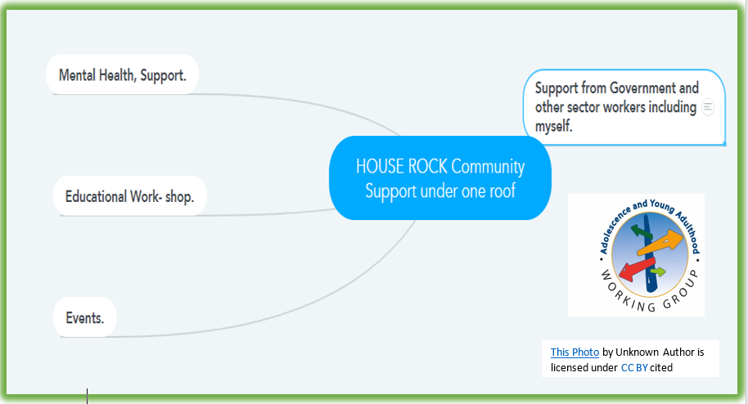

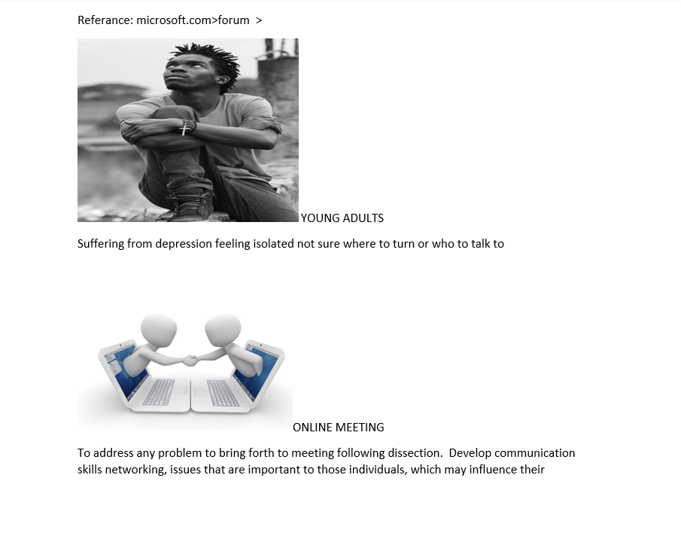

Behaviour, changing to their mindset
Welcome to my innovation House Rock a community support network which aims to bring together equality to the young adult of society. This will be done with a cognitive approach for engaging those individuals, which will be held online for now because of the pandemic.

My ideas came from witnessing from family members to friends alike the hardship which surrounds young adults. This will help the most vulnerable, and dis advantage a fairer opportunity that will have a positive impact on their future, due to many areas being affected because of the pandemic, such as Health and social care, mental health, adult service which has seen a lot of their funding being cut impacting on peoples standards of living which includes their wellbeing. Research show that prior to the pandemic people was living much longer, due to the fact there was more service and support available to all ages and there was more support for the elders which had a positive effect on their wellbeing, However we still need to address those issue which young adults face on a daily basis. They are the next generation, so we need to help to maintain in valuing those individuals has there are going to be the one that we depend on.
I aim to use my experience to help observing and planning support according to the help their need. When looking at areas that surrounds mental health there have been a rise more so since the lock down of the covid19 pandemic research has high-lighted the challenge that teacher face with online learning because of some pupils suffering due to the remote learning and not socialising with their friends. So, at the Great Barr academy two teacher decided to start doing physical excise routine daily so that their can help with the children well-being they both are in one class to give more of an incentive / motivates. This is just to show how much of those service his needed. House rock aims to bring about the unity in society which have been missing for some time saving our communities bring back some normally and values.
Reference List:
1) https://wwwmindmeister.com/1773185487?e=turtle.com
2) Mr. Grigg and Mr Jones, stream PE. www.greatbarracadermy.org.uk>s cited: (05/02/2021)
3) www.Microsoft.com>forum> pictures: cited (07/02/2021)

Community development and support working for young adults.
This study aims to highlight the lack of services and the impact it has on Young adults. And what I aim to do. Plans I will address, by using technology will help to bridge the gap allowing those services to keep connected.
Young adults have been facing a lot of problems surrounding social care ranging from them getting them-self-involved with the wrong crowd of people. My purpose is to bring those support under one roof, with a range of services motivating and empowering workshop online (for now because of the pandemic). Those workshops will be aimed on life and guidance trying to avoid them falling to crime. Some of the workshop will be done individually targeting the most vulnerable, as their personal needs will enables us to provide a better service. When looking at research on young adults the problem normal evolves around them being restricted from certain things because of this current pandemic.
There are a number of problems that has impacted the way young adults face issues in society such as Employment paying less, not getting the right amount of funding as well as getting the support they need considering many of them are single parents. That’s why my innovation his to improve social relation to connect those victims of society getting them back on track will help a lot. By using more technology, it will bring about different ways we connect with each other for instance Virtually calling them. The way we socialize all influences self-esteem. Carl Rogers therapy is a good way to boost your self-esteem by using what you already have and making the most of it too increase your behaviour in a positive way. Should young Adults get more support?
Yes, because Not too long ago I witnessed a young male being murdered on the streets of Birmingham from an act of violence. He didn’t have anyone to talk to and if he did maybe this incident wouldn’t have occurred. And many other young people have had the support they need at the time of trouble deaths crime would be less likely to happen have been so exponential. People supporting others can have a massive effect on the person them or just being they’re for them almost like a SafetyNet this will give reassurance. Corresponding to this circumstance of events I think creativities workshops to bring those in need closer giving guidance in society will positively impact. However, research show many people have said and stated that young adults shouldn’t get more support because they need to mature, and this will help them to more with independent. Even though this is true to a certain extent I wouldn’t say fully because the
individual wouldn’t be able to mature or be independent if they are currently facing personal problems that need to be sorted to allow growth within the person. A single voice could save millions of lives.

Reference List:
1) Literature review Academic performance (2008) cited (4/02/2021)
2) Carl R. Rogers, Personal power, first published in Great Britain (1978)
3) http: www.bloggr/youngadults.com

