Task 1 : Record your reflection

- List out the options which are available in your virtual machine menu.

- File
  - Preferences
  - Network Operations Manager
  - Reset All Warnings
  - Close
- Machine
  - Settings
  - Take snapshot
  - Session information
  - File manager
  - Pause
  - Reset
  - ACPI Shutdown
- View
  - Full screen mode
  - Seamless Mode
  - Scaled Mode
  - Auto-resize Guest Display
  - Take screenshot
  - Recording
  - Virtual Screen 1
- Input
  - Keyboard
  - Mouse Integration
- Devices
  - Optical Drives
  - Audio
  - Network
  - Shared Folders
  - Shared Clipboard
  - Drag & Drop
  - Insert Guest Additions CD Image
- Help
  - Contents
  - VirtualBox Website
  - VirtualBox Bug Tracker
  - VirtualBox Forums
  - Oracle Web Site
  - About VirtualBox
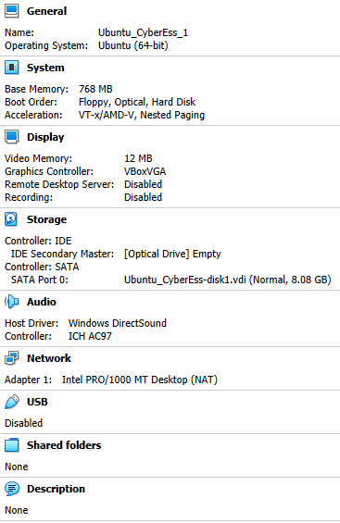

- Find out the IP address of your virtual machine.
10.0.2.15
- Could you browse through the internet.
Yes
- In your own words, share your experience on setting up the virtual machine.
Very straightforward as I am used to setting up virtual machines for development and training purposes so Oracle VirtualBox is not new to me. Working with images is common knowledge for me, so experience was a good one
- What do you think as the pros and cons of using virtual machines.
Pros
Can spin up baseline images and share with others for consistent set ups, eg in a dev team so everyone is running off the same version of software with the same settings enabled.
Can easily delete entire images if no longer required.
Can easily increase size of images if more storage is required.
Can transfer data on/off them easily.
No need to worry about physical hardware, like carrying multiple laptops around with you.
Cons
Not the easiest thing to set up from scratch for non-technical people.

