Data Analysis and Visualisation ACCB4017

Assessment 2

Lecturer: Student:
Koushik Modak Eduard Stefan
(2114821)

Contents
Introduction 3
Visualisation 3
Description of dataset 4
Analysis 5
Outliers in the dataset 7
Factors affecting Hypotheses testing 8
Results 9
Conclusion 9

Figure 1 – Charts before and after using the application
Figure 2 – Descriptive Statistics
Figure 3 – Hypotheses and T-test
Figure 4 Hypotheses and T-test
Figure 5- Datasheet – outliers

Introduction

Statistical analysis involves making educated guesses known as hypotheses and testing them to see if they hold up. I will demonstrate what I learned in this course by applying hypothesis testing to the given data how to examine the use of descriptive statistics to summarize data and inferential statistics to draw conclusions, how parameters differ from summary statistics. Discover how to perform hypothesis testing on sample data, construct null and alternative hypotheses, and interpret the results of statistical tests. Investigate the significance a statistical test and how it can be interpreted using the significance level. .Advanced data visualization software offers new ways to view data, through visuals such as bubble charts, word clouds and geospatial heat maps. Used correctly, visualization technology can deliver business insights to users faster than they can get it with traditional BI tools, and visualizing data can also simplify the process of analysing big data sets. Once data processing is completed, it demands rich visuals to reflect those trends and hence advanced data visualization performs a vital role here. However advanced visualization tools are somehow complex to deploy and use, requiring support from outside consultants or the services of internal data scientists.[1]

Visualisation
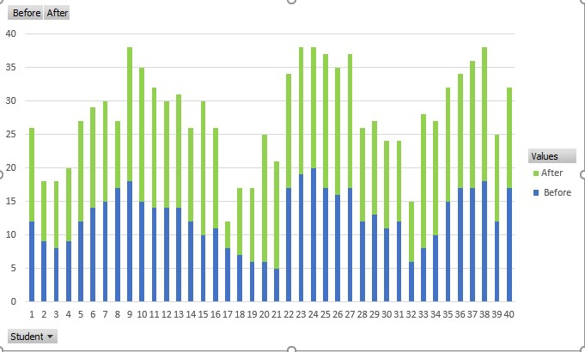
Figure 1 – Charts before and after using the application

Description of dataset

In our study case we have a set of data representing 40 children math results before and after using a testing learning app from a learning application development company. The company wants to get enough data to allow them to decide about the application they are developing. The positive impact that the application has on students' test scores can result in the large-scale production of the application. Descriptive Statistics tries to give you an overview of the data as it exists. There are two broad categories of quantitative measures that can be used to describe your data. The first of these is referred to as Measures of central tendency. These try to give you a central or typical value for your dataset. This can be the one value around which your entire data is centered. The second category of quantitative measures, which are part of Descriptive Statistics, are Measures of dispersion. Measures of dispersion serve to explain how your data is scattered or spread This is the kind of information that you can get when you use Measures of dispersion. The most common of these is the Mean, or the average of your dataset. When you work with data, one of the first things that you might do is compute the average of your values. The average represents a central location around which your data is distributed. You get the average by simply summing up all of the values and dividing by the number of data points that you have. The second commonly used Measure of Central Tendency is the Median of your data. The Median represents the data point that is at the very middle of all of the values that you are of working with. This has to be the data point at the 50th percentile, because 50% of your data points lie below this value and 50% of your data points lie above this value. A third commonly used Measure of Central Tendency is the Mode. The Mode represents the most common data point in your dataset. That is the data point that occurs the most frequently or the most number of times. Let's discuss a few examples of the Measures of Central Tendency that we just discussed. Measures of Central Tendency, try to capture the central position of the frequency distribution and this central position can be expressed in different ways, giving you different Measures of Central Tendency.

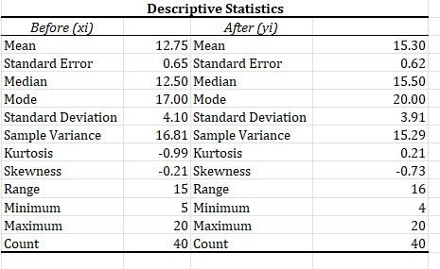
Figure 2 – Descriptive Statistics

Analysis

When you are exploring, visualizing and understanding your data, you may develop some kind of intuition about that data. This intuition can be thought of as an educated guess. This is why you would use hypothesis testing. In hypothesis testing, you'll start off with an educated guess made about the data that you're working with. You will then express this guess as a statistical hypothesis that should be testable on your sampled data. And this testing can be performed either by experiment or observation. And this way you can prove or disprove your educated guess. In statistics, this educated guess or informed proposition that you make about your data is referred to as the hypothesis. The hypothesis can be thought of as a statement that you posit to be true and which needs to be tested on observed data. You you're not 100% sure it's true. You posit that it'll be true. And then you need to test your assumptions. You need to test your hypothesis. Let's understand what a hypothesis means by considering a few examples.
We're clearly indicating that the new application is what we believe to be the cause will affect of results of our participants. And if you are trying to boost the learning technics , we might phrase our hypothesis statement in this manner: if our application is provided on a particular time of the year, improvements for that year will be significantly higher for our students test results. Cause and effect.
The very first step is you state what you are trying to prove in the form of a hypothesis statement. This is an extremely important step. You need to articulate and be very clear about what it is that you're trying to prove. This articulation will basically drive all of the remaining steps in the process. Next, you'll run a statistical test on the sample data that we have.
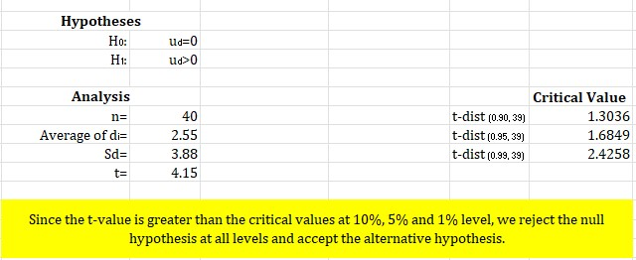
Figure 3 – Hypotheses and T-test
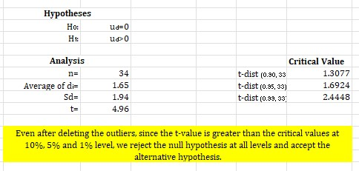
Figure 4 Hypotheses and T-test
The statistical test will give you a result that you'll be able to interpret to see whether the null hypothesis was true or the alternative hypothesis was true.
Once we run the statistical test on our data, we'll use the result of the statistical test to see whether the application had a meaningful impact on results. We check to see whether the result of using the application was significantly different than the result before that. What we need to do is first set up our null hypothesis and alternative hypothesis. Null hypothesis states that the application does not have a significant effect on result. The alternative hypothesis will state that the application does have a significant impact on test results. I interpret the test results by comparing the values to the significance level and I used this information to reject the null hypothesis.
The t-tests is used to compare the averages between two groups or categories. This is what a t-test is used for. The test result when you run the t-test will be a t-statistic. The t-test will compare averages. So average results of the students math test after they used the application vs. average students test results after before they used the application. We already know how to set up the null hypothesis and alternative hypothesis to test this. Once we've done that, we'll run the statistical test on our data to compare sales on the two categories. We'll get a t-score.
The t-score or the t-statistic which we get as a result of running our students t-test, is the ratio of the difference between the two groups and the difference within groups. Now, larger the t-score, the larger the difference between your groups or categories. A small value of the t-score indicates that the difference between your groups or categories is small. So large t-score, the groups are very very different. A small t-score implies that the groups are similar.

Outliers in the dataset

Range, which is the simplest measure of dispersion. The Range is the difference between the largest and smallest values in your data. If you're measuring heights, this is the difference in height between the tallest child and the shortest child. The Range you should know is very susceptible to the presence of outliers in the dataset. Let's say we have one child who has a very poor result before using the application or one child who happens to have a very good result after he used the math application.
Well, this will affect the Range. Even the presence of a single outlier in either direction will change the Range of your data, which may not accurately reflect how your data is actually spread out.
If you have a few outliers, that does not affect the middle 50% of values in our data.
Variance makes it hard to compare values across variables, which is why we often use the standard deviation, which is just the square root of the variance. Variance and Standard deviations are popularly used measures of dispersion, but they are also very sensitive to the presence of outliers in our data.
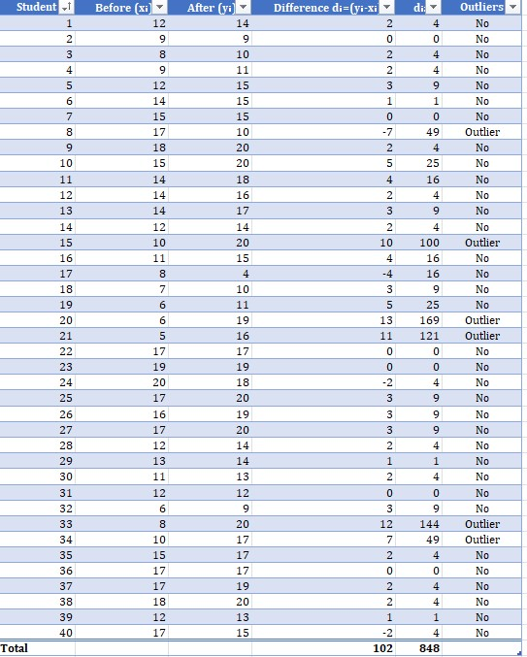
Figure 5- Datasheet – outliers

Factors affecting Hypotheses testing
Sample size, significance level, the "true" value of the parameter being tested.

Sample size.
There are a different sub-variety of the independent two sample test based on the sample sizes and the variances of the two samples. If the samples that were drawn were not actually independent, then what we've got to perform is a paired difference test.
Significance level
In order to interpret the results of your statistical test to see whether it proves or disprove your hypothesis, you need to compare the p-value that you've got from the test to a significance level alpha. And this comparison is what you'll use to accept or reject the null hypothesis. You need to interpret the results of your test to see whether it proves or disproves your hypothesis.
You interpret your test results by comparing the p-value to the significance level alpha and you'll use this information to accept or reject the null hypothesis.

The “true” value of the parameter being tested.
There are two broad categories of quantitative measures that can be used to describe your data. The first of these is referred to as Measures of central tendency. These try to give you a central or typical value for your dataset. This can be the one value around which your entire data is centred.

Results

Before you actually run the statistical test, you'll set the alpha level that you'll use to accept or reject the evidence that you get as a result of the statistical test. What is the threshold you're willing to accept for the probability that the result was purely due to chance. We've already stated the null hypothesis, and alternative hypothesis to test whether our application had an impact on on students test results. The right statistical test for this particular impact that we are trying to measure is the two-sample t-test. The test result when you run the t-test will be a t-statistic and a p-value. And the test result will tell you whether the difference in the averages that we saw is significant or purely due to chance.

Conclusion

We saw the role of statistics, which are used to estimate the test result of using a math application by verify hypotheses using sample data. We saw that parameter estimates involves the specification of confidence intervals which tell us the percentage measure of the confidence that we have in our estimate.
We then moved on to hypothesis testing, which involved running statistical tests to prove or disprove educated guesses that we made based on our data. In this context, we discussed how exactly statistical tests are set up, the null hypothesis and the alternative hypothesis, and how we could use the results of statistical tests to accept or reject these hypotheses.

Bibliography

[1] | M. Nigam, Data Analysis with Excel, BPB Publications © 2019, 2019.
[2] | R. Rasmussen, Data Analyst: Careers in Data Analysis, BCS, 2019.
[3] | H. H. G. S. Min Chen, Foundations of Data Visualization, Springer, 2020.
[4] | P. M. Greg Harvey, Data Visualization and Statistical Literacy for Open and Big Data, John Wiley & Sons, 2020.

