
Academic and employability skills(bmsk4001)


Lecturer name: Anita nan
Student name: Fahmida rahman
Student number:1808700

Contents
Introduction…………………………………………………………2
Gibbs’ Reflective Cycle…………………………………………….2-3
Description……………………………………………………………3-4
Evaluation……………………………………………………………4
Feelings………………………………………………………………..4-5
Analysis………………………………………………………………..5-6
Conclusion…………………………………………………………….6
Action plan…………………………………………………………….6-7
References……………………………………………………………..7.

Academic and employability skills
Introduction
Skills are defined by the ability of doing something in an expertise way. Skills can be of many types-academic skills, employability skills, recreational skills. Academic skills are generally trained by educational institutions. Sometimes, employability skills are also guided by schools, colleges or universities. Both form of skills is being learned by following disciplinary curricula.
Academic skills are consist of knowledge and application of other study skills. (Gettinger & Seibert, 2002) Weak study skills make students facing bad experience in their educational life. Some employability competencies are sometimes included in academic curriculum. It helps students not only study in a proper way but also provide a guideline for students regarding their work life.
The purpose of this report is to reflect several skills, I have improved or learnt in this module. I will also discuss about which skills need to be improved more.

Gibbs’ Reflective Cycle
Graham Gibbs was the creator of ‘Gibbs’ reflective cycle’ in 1988. It is a structure of reflection of psychological situation while solving a problem individually or in a group. By the term ‘reflection’ in case of solving a problem is, to form a judgemental and analytical thinking and following them to get the result. (Quinton & Smallbone, 2010) That indicates that, the practise leads a student to think critically and reflect the thought in his or her work. The reflection framework is divided into six different stages. Following they are
- Description
- Feelings
- Evaluation
- Analysis
- Conclusion
- Action plan
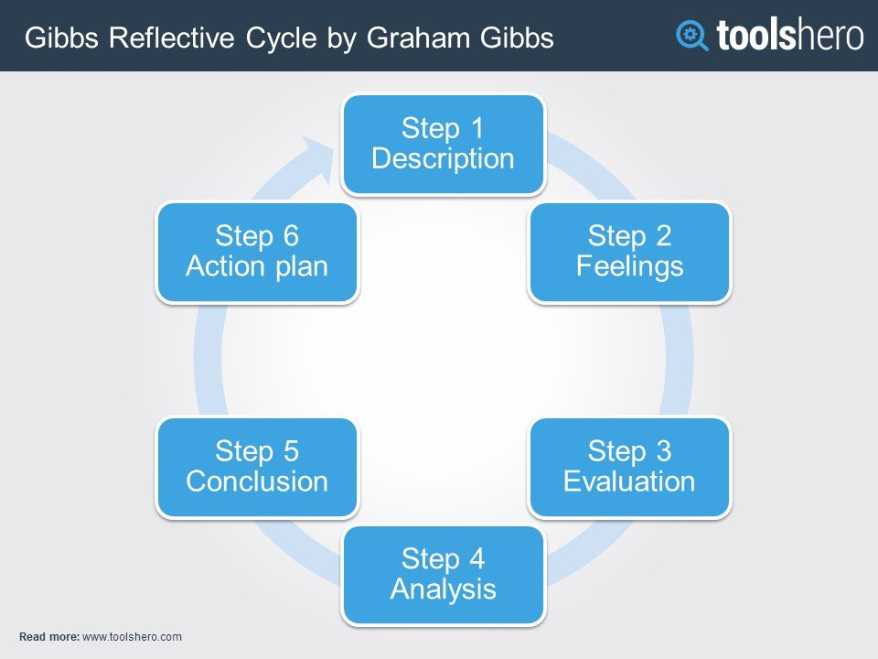
Gibbs’ reflective cycle
https://images.app.goo.gl/maQdnqGWQtNUtYvF9
The whole essay will be attempted, based on Gibbs’ reflective cycle. By thinking about each stage while linking with my previous module of last term, I will be more engaged in critical thinking. In the description stage I will share about what happened, what was the situation and crisis I faced while studying the course. Feelings phase will describe about how I felt at initial stage, at the end and in the intermediate stage. In evaluation phase, I will tale about what worked out properly and what did not work well. What happened during solving the problem and how I dealt with them. Analysis will be the extract from evaluation. Performance analysis helps to understand the main faults and get a precaution for the next assignment. Analysis makes the application of learning easier. (Oh, 2000) In conclusion, I will be describing about what I learnt and what could be improved. What else I could have done. These aspects will be described. In action plan section, I will talk about what will I improve If I have to do the same kind of work again. What steps will be taken to avoid unwanted problems in the middle of completing my task.

Description
As a student of “University of Wales Trinity Saint David” I have been required to submit a report reflecting the learning of last term. I have used Gibbs’ reflective cycle to write the report. When I started my course work, I did not know academic writing process. Academic writing requires paraphrasing, summarising, referencing and doing a lot of research. Firstly, I faced problem with research. I did not know how to do research for academic purpose. I did not think that; It would be that much tough. I decided to do the work one week before the deadline. But as it was my first academic writing, I faced a lot of problems and at the end I understood that, one week was not enough for me to finish the work in a disciplinary way. My next problem I faced when we were assigned to do the curriculum vitae. But the teacher helped to know the process of writing a cv. But I felt the main challenge with the essay. However, I finished my work under stress at the end, but it was a good piece of work.

Feelings
When I first got the assignment, I was at a fix what to do with it. Because I did not have any idea about doing academic writing. Then eventually I got some ideas about my work. I felt confident when I started doing my research work. It was not that much easy. But as I was getting the information, I was being confident that, at least I got something to write about. After my teacher gave me clear instruction, I was able to plan the whole work as a list. I got the structure of the essay. I was very happy about my progress of the work. But I felt confused when I needed to do the referencing. I was just like losing my patience that time. But my teacher helped me that time and I felt confident about my work again. The most tough part of the assignment was doing the right referencing. Looking back, the last time before deadline was stressful for me. Now I think, I should have started the work two weeks before the deadline. I was really worried about my vocabulary. I used Collins dictionary looking for suitable word with my work.

Evaluation
Evaluation is very important to upgrade individuals work quality. Evaluation of individuals work allows each to maintain their standpoint. (Stake, 1967) I am going inform about what good and what bad things I faced during my assignment. The first thing I faced was, how to plan for the essay and what the structure would be. I was very worried about it. But after my teacher’s help this problem was solved. Next problem was about the referencing. I was really scared about plagiarism. And my referencing was not going well. I was being confused about the title of the article and the journal name. But after trying for couple of times, it was being clear to me and I could easily differentiate about these things. I felt proud that I solved the problem by practising by myself alone. I understood the necessity of practise something hard.
The most irritating thing was, I took one week to write the assignment, though we got more time than that. I did not evaluate and use my time carefully. That is why I faced difficulty at the end. It was way too hard to me to finish the work before deadline. I decided that, next time, I will not take this risk. But the good thing is, I learnt how to write in a formal academic way. I have developed my critical thinking by doing this work. I have learnt about research before doing a work and the most important thing to me was to plagiarise. To me, it was alright not to make an excellent piece of work, than copy someone else’s work. I am proud of myself because I did not copy anyone else’s work.

Analysis
I have learnt a lot from this assignment. The most important thing is I did not know how to manage my time. Though I couldn’t help myself doing a work in proper timing, I got to know what to do next time. Pareto’s 80-20 rule helped me doing my work as well. I focused on my attempt more than wasting time. Eisenhower method for time-management was read by me but I could not maintain it properly. I learnt about doing research. Actually, I am very happy about that. I searched for articles in the library account and then used google scholar to find some information about my topic. At the last I looked for google. But I needed to be very cautious about the source of the information I was using. While writing the essay, I learnt a new thing called paraphrasing. Paraphrasing is an alternative way to write the same thing in a new language. To avoid plagiarism, I had to do plagiarism. Many of the cases of plagiarism happen because of the understanding of difference between paraphrasing and summarising (Roig, 2001) . I think I completely understood difference between paraphrasing and summarising. I have learnt to write a cv as well. It will help me creating my future carrier in my job. I kept failing to use proper words for my essay. But I used dictionary to know more words, antonyms and synonyms. It helped me to paraphrase my information.
Conclusion
This report aimed to reflect all the skills acquired and skill gaps. I have done my first academic piece of work last term. It was an essay. I learnt a lot from this one. It helped me being punctual, gain knowledge about the language and being true to my own work. First thing I have learned is making structure of my own work and then work over it. I planned and tried to maintain it. I divided my work in small portions and at last integrated all of them.
I saw my skill gap in time management. It was very poor. I thought it would be easier for me and allotted only one week for it. Maybe I will be able to do an essay in one week after practising more. I faced difficulties in word count. My word count was not reaching my goal. After analysing and thinking about it, I think I did not have enough information to share in this essay. That thing alarmed me of my time management. As I did not get enough time, my research was to enough to gather needed information. So I think my biggest weakness was time-management. While one student face excessive stress, he or she experience psychological and physical damage. (Misra & McKean, 2000) I think as a lot of work was not done in time I got stressed for the last moments and it deteriorated my work quality. An action plan has been given to highlight how I will improve my skills.

Action Plan
I must work a lot on my skills to improve my academic writing. Firstly, I have to learn and implement my time-management. From my previous work I got to know that this thing should be prioritized. I will plan according to my time frame and will start working immediately after getting it. I will choose my title according to my subject of essay. Then second most important thing is research. Because without doing research properly I will not gather enough information to write my essay or report. I will search in google scholar or google or some verified source. I must ask my tutor to give me enough information about the work. Because last time after Anita helped me, the problem got a lot easier to me. And teacher can help giving feedbacks of my draft as well. I will also read a lot of news paper to improve my vocabulary skill before getting another essay. I think it will help me with my paraphrasing and my work will be more specific and better. Overall, I must work on my time-management, vocabulary skill and research skill. I think focusing on these particularly will help me a lot for my next assignment. I will be able to think critically and will quote and paraphrase successfully next time.

References
Gettinger, M., & Seibert, J. K. (2002, January). Contributions of Study Skills to Academic Competence. School Psychology Review, 31(3), 350-365.
Misra, R., & McKean, M. (2000). College students' academic stress and its relation to their anxiety, time management and leisure satisfaction. American Journal of Health Studies, 41-51.
Oh, H. (2000, Februaury 3). Revisiting importance–performance analysis. Tourism Management 22, 617–627.
Quinton, S., & Smallbone, T. (2010, Februaury 08). Feeding forward: using feedback to promote student reflection and. (T. &. Francis, Ed.) Innovations in Education and Teaching International, 47(1), 125–135.
Roig, M. (2001). Plagiarism and Paraphrasing Criteria of College. Ethics & Behavior, 307-323.
Stake, R. E. (1967). The Countenance Of Educational Evaluation.

