  LOCATION London | LLEOLIAD London
LEVEL 4 | LEFEL 4
EXAMINATION PERIOD | CYFNOD ARHOLIADAU
2026 | 2026

MODULE CODE: ACCA4022
COMPUTER ARCHITECTURE
TIME: 2 Hours TOTAL: 100 MArks
answer all questions

Equipment or materials required – None
The Candidates are not permitted to bring dictionaries; text books/case studies or any other reference materials into the exam room.
The Candidates are only permitted to use calculators.
Show all your calculations in your exam book

ANSWER ALL FOUR QUESTIONS

QUESTION ONE (Total: 30 marks)

Attempt all of the following. Electronic Calculators are not permitted. Write down and show all your manual calculations in your exam book.

- Convert the following numbers to Binary (Base 2):
(a) (624)₁₀ (4 marks)
(b) (7B2)₁₆ (4 marks)

- Convert the following numbers to Octal (Base 8):
(c) (215)₁₀ (3 marks)
(d) (B3A)₁₆ (3 marks)

- Convert the following numbers to Decimal (Base 10):
(e) (1101101110)₂ (5 marks)
(f) (7E3)₁₆ (3 marks)

- Convert the following numbers to Hexadecimal (Base 16):
(g) (3295)₁₀ (4 marks)
(h) (472)₈ (4 marks)
QUESTION TWO (Total: 5 marks)

Categorise the following hardwares based on its usages into the following catagories:
- CPU (b) Memory (c) Input Device (d) Output Device (e) Storage Device (f) Communication Device

- Microphone
- USB Flash Drive
- Monitor
- RAM
- Ethernet Card

QUESTION THREE (Total: 5 marks)
Determine the time required to complete 100000 instructions by a dual core CPU (Perform two instructions per clock cycle) with a clock frequency of 2.5 GHz.

QUESTION FOUR (Total: 20 marks)

  - Draw a logical circuit from the given logical expression. Use only the basic logic gates (NOT, AND, OR) (10 marks)
X = (A + B)' + (C · D)

  - Create a truth table for output Q of the following logic diagram. 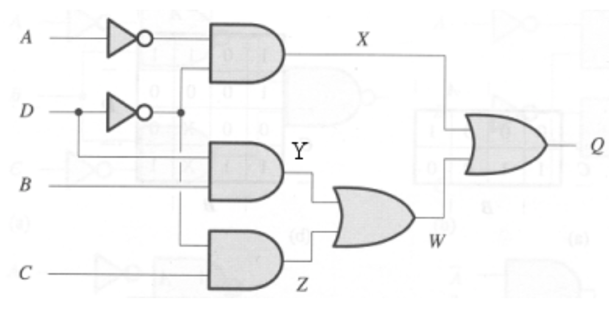 (10 marks)

QUESTION FIVE – RAID Technology (Total: 20 marks)
(a) State two characteristics and two benefits of RAID. (5 marks)
(b) Describe RAID 1 with a suitable diagram. (10 marks)
(c) Mention one advantage and one disadvantage of RAID 5. (5 marks)

QUESTION SIX – Fetch-Execute Cycle (Total: 10 marks)
(a) Draw a labelled diagram of the Fetch-Execute Cycle. (5 marks)
(b) Briefly describe the steps involved in the Fetch-Execute Cycle. (5 marks)

QUESTION SEVEN – Von Neumann Architecture (Total: 10 marks)
(a) Draw a labelled diagram of the Von Neumann architecture. (6 marks)
(b) State 2 advantages of Von Neumann architecture. (2 marks)
(c) State 2 disadvantages of Von Neumann architecture. (2 marks)

