Reconstruction projects are by necessity both time consuming and research intensive. This independent history project I set about reconstructing a high medieval saddle. My aim was to reconstruct a saddle that would date to the late 12th or early 13th centuries. This project would allow for a close investigation of the technology that allowed for this, and of the reasons that the high medieval saddle was the shape that it is. Saddles vary quite a lot, not only in style or in decoration but also in both structure and in purpose. Its immediately obvious to even the most casual observer that the equipment of a draught horse, who’s sole responsibility is pulling wagons or carriages must have different tack and equipment than a riding horse. The difference between different saddle styles can be hopelessly complicated especially at a cursory glance. Reconstructing a high medieval saddle helps in opening up the pages of history and allowing for a much, much more in depth understanding of the period and its equestrian culture. In order to accurately reconstruct a saddle, its very important to understand what the original saddle looked like and what their purpose was, and what type of saddle is being reconstructed. With Saddles of this period there is very little that survives archeologically, meaning that most of the best sources are either artistic depictions, or written records. The saddle style or type that I chose to reconstruct was a late 12th century war saddle. This is because of all the types of saddle in this period the war saddle is the most prominently displayed and depicted. This vast quantity of primary sources in some ways makes up for the holes in the historical record. Horses are secondary in art, almost never the centre of the depicted scene, and therefore their tack, including the saddle is even less likely to be depicted. The number of horses depicted in scenes of battle allows for a better understanding of the war saddle than almost any other form of saddle from the high medieval period.
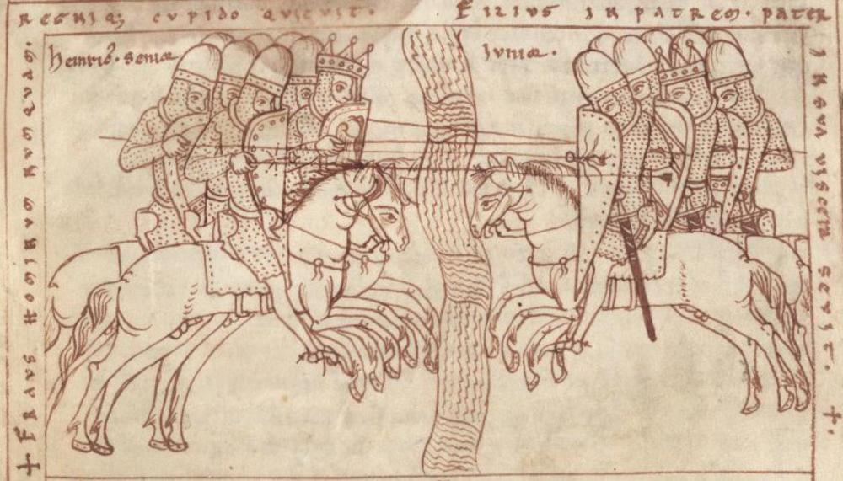
The warfare of the 12th century was characterised by cavalry action. More than any other period of history the 12th and 13th century are dominated by mounted combatants. Battles such as Hastings, Dorylaeum and Bouvines, were won through the use of cavalry. Even in the popular imagination knights are almost always thought of as horsemen, depicted mounted on armoured horses. One of the main tactics of this period was the armoured charge. The difficulty of doing this sort of attack is immense, the knights would line up in close order, and charge toward the enemy in an attempt to break their formation.
Figure 1 ThULB Ms. Bos. q.6 Chronicle of Otto of Freising
Figure 1 of a depiction of this sort of cavalry action. It depicts two cavalry formations charging at each other, lances levelled. While they are by no means prominent the saddles that each riders is mounted on have been consistently drawn. This piece is an excellent example of why the saddle is such an interesting topic. The saddles are secondary, like much of their individual equipment the image is focused on the energy of the charge. The mounted warfare of this period in Europe was focused on hand to hand combat with the lance. The horse equipment was made to compliment this form of warfare in all of its small details. There was going to be huge strain on the medieval war saddle, in The Medieval War Saddle and its Accessories Ann Hyland comments on this:
“Other than archery, all weapon usage, especially that of the huge jousting lance, put an immense strain on the rider’s saddle; the vigorous movements of the rider and horse soon revealed and weaknesses in a saddle’s construction. We have contemporary evidence about the construction of such saddles. The 1403 Statues of the Saddlers’ Company of Limoges stipulated that the tree’s joints were to be well glued and reenforced with rivets, that is be ‘well sinewed above and bellow and underneath be will covered so that the horse’s sweat shall not damage the sinews.”
The medieval saddle was well made and highly damage resistant. And as a crucial part of the knights equipment it opens for us a window into the martial culture of the time. The reconstruction had to keep in mind the strain and problems that the saddle would have been going through in the medieval period.
While beginning the research for this reconstruction I ran into a piece of information that helped me immediately from making a crucial error. In his work "On divers arts; the treatise of Theofilus Presbyter. The eponymous Theofilus Presbyter provided a crucial piece of information.
“Horse-Saddles… and other objects which are carved and cannot be covered with leather or cloth should be rubbed with shave-grass as soon as they have been scraped with an iron tool; then covered with two coats of white [gesso] and, when they are dry, smoothed again with shave-grass. After this measure them with a compass and a rule and arrange your work, namely, figures or animals or birds and foliage or whatever you may wish to portray. After doing this, if you want to embellish your work, apply gold leaf, which you should make in the following way.”
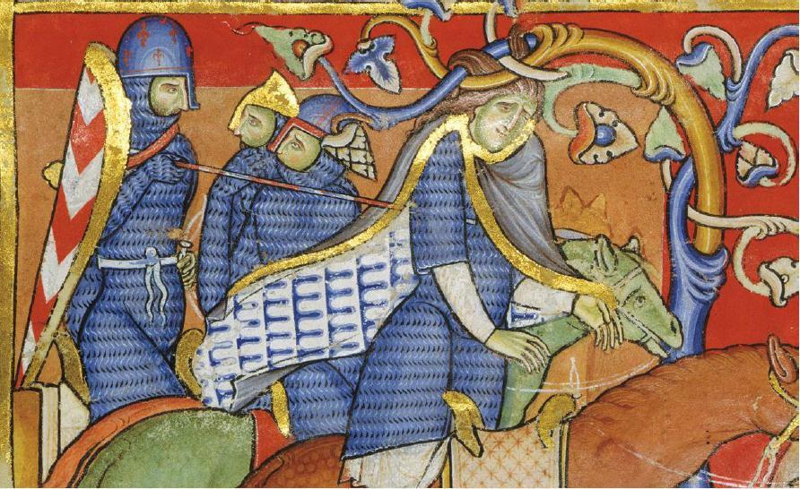
Most modern saddles are covered in leather, as is the funerary saddle of Henry 5th and while I was aware that some of the depictions of saddles didn’t match colours achievable with leather dying techniques available for this time period, I had previously attributed this to artistic license. Depictions such as the one in figure 2. Figure 2 is a scene from the biblical story where Absalom traps his hair in a low hanging tree and is slain. Prior to reading the quote from Theofilus presbyter I had thought this was artistic liscene used to depics him as a king’s son, if even his saddle is golden. This changed the way I had originally planned on reconstructing this saddle and helped me to avoid the pitfalls of looking at this topic through a modern lens.
Figure 2 Morgan M.619 Winchester Bible
One of the most invaliable pieces of evidence that exist for the study of medieval saddles is the funerary saddle of henry the 5th. It is held at Westminster Abby. Lynda Hickling says in her paper on the saddle that it was almost certainly used.
“It has sometimes been suggested that funeral achievements, when carried, were made especially for that purpose. This was probably the case by the late 17th century, but in the 14th century when these objects were in almost daily use there would have been no need to create them. The Sword and helm accompanying the saddle are contemporary with the date of the funeral and genuine, used articles, both showing signs of ware. Thus there is good reason to believe that the saddle had also been used prior to the funeral and is contemporary with the rest.”
The Saddle, is part of the armorial achievement of Henry the 5th and is held in Westminster abbey. It’s a lightweight high saddle with characteristic 15th century high pommel and cantle. For the reconstruction it was interesting because it is covered with blue velvet, and passed with hessian However when I compare it with the quote from “On Diverse Arts” a problem is encountered. One source, Theofilus Presbyter, is portraying saddles as not being leather covered, and a second one, that being a surviving saddle, as being covered.
As I was reconstructing a 12th-13th century saddle I decided that I would ere on the side of Theofilus presbyter, although the fact it is a written work, rather than archaeological counts against it, the nature of the source. As an artistic guide book, means that it is very likely to be trustworthy, and relevant for this source and in addition to this, Theofilus is a 12th century source, only around thirty years removed from the saddle I was trying to reconstruct.

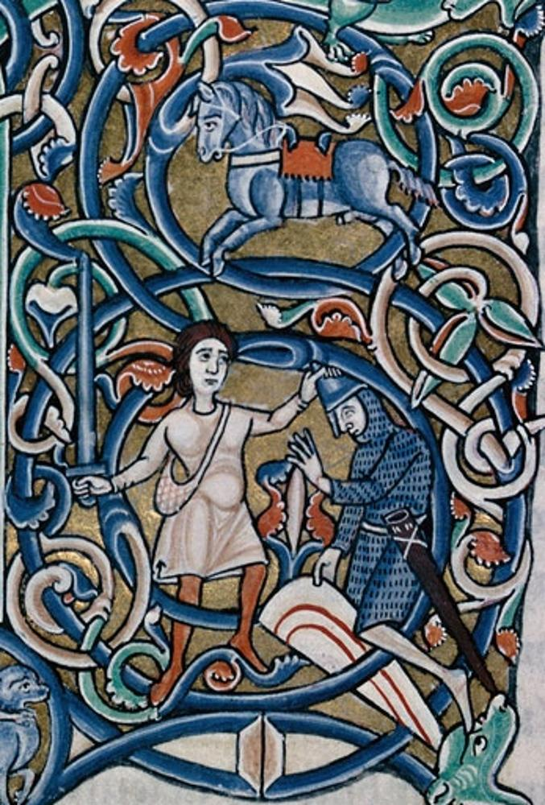
While looking through the pictorial sources one emerged as the one I would like to reconstruct. Figure 3 is the illumination, one pitfall is the number of royal saddles depicted, reconstructing a royal saddle is not without its merits, however it is less useful than reconstructing what could be considered a ‘run of the mill’ saddle. Figure 3 sprung out to me as a good saddle to reproduce, allowing my to try and replicate Theofilus Presbyters process.
The Horse is depicted with a blue saddle and a red saddle cloth, this is fairly simple compared to some of the other depictions from this period.
The scene in figure 3 depicts the beheading of Goliath, by the image context the horse belongs to Goliath, who is a champion of the philistines. To me this seemed the correct social level to reconstruct to allow for the larges range of applicability. Rather than the insanely expensive and luxurious royal saddles.
Figure 3 Troyes BM MS.28 Bible
Figure 4 Stripped and Sanded Saddle Tree
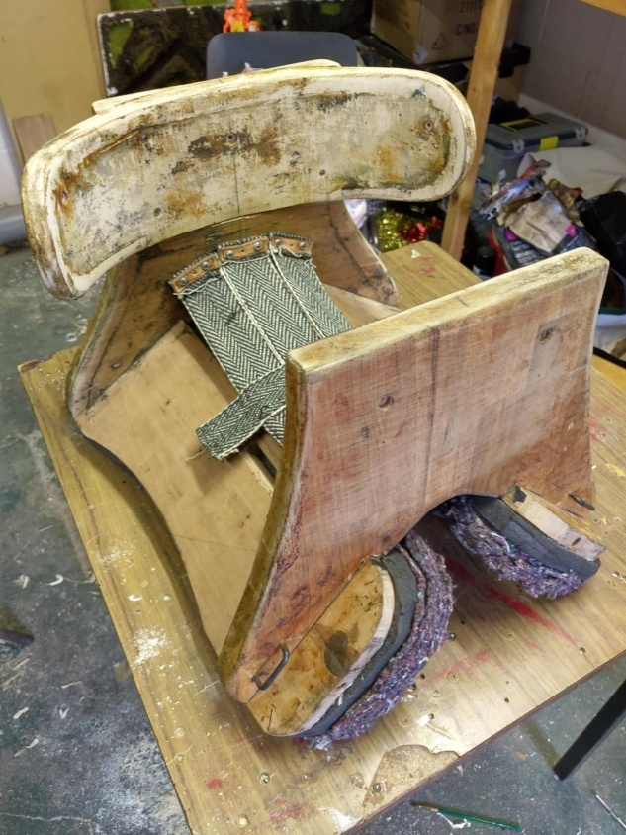
The beginning of this reconstruction started with following the instructions in Theofilus Presbyter. I took the saddle frame, the saddle tree and sanded it smooth. Theofilus suggests using shave grass. This is the plant “Equisetum hyemale” or rough horsetail. It is a silica rich plant, plant that was and is still used as a sandpaper substitute. Sanding the rough wood to a smooth finish ready for the next step in the process.
The next step in the process is applying two layers of white. White is the medieval term for gesso. Gesso is a substance that allows medieval paints to adhere to wood. Its is a combination of rabbit hide glue, water and chalk. Without the use of gesso the paint would not adhere to the saddle.
To properly apply gesso dried hide glue granules are soaked overnight in water, the ratio is usually 1 part hide glue to 20 parts water. The exact measurements for glue are not specified by Theofilus Presbyter that would be too much to hope for what is already an incredibly rare and crucial work, an art guide written by a practicing artist.
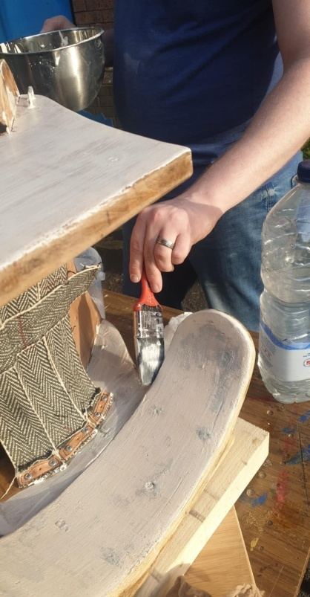
I searched far and wide, but as the use of more traditional paints is fading in the art world it was fairly difficult to find a good guide, especially as pre-made acrylic gesso is much easier to use and less time consuming and it is ever harder to find a teacher who used medieval methods. I eventually found a guide written by a Mr. James King, which he published to his YouTube channel. With his help I found out that unless the wood is treated with hide glue before the gesso is applies it will not adhere to the surface properly.
Figure 5 Applying the first layer of white

The application of the white, although very simple in the description by Theofilus Presbyter is actually quite labour intensive and difficult, it includes a number of coats each coat takes about an hour to complete while lying completely flat, this means that a saddle with three vertical faces would take just over 6 hours or applying to be properly covered. Figure 5 demonstrates how this is done; the layers are incredibly thin as can bee seen by the staining of the wood being viable through the gesso.
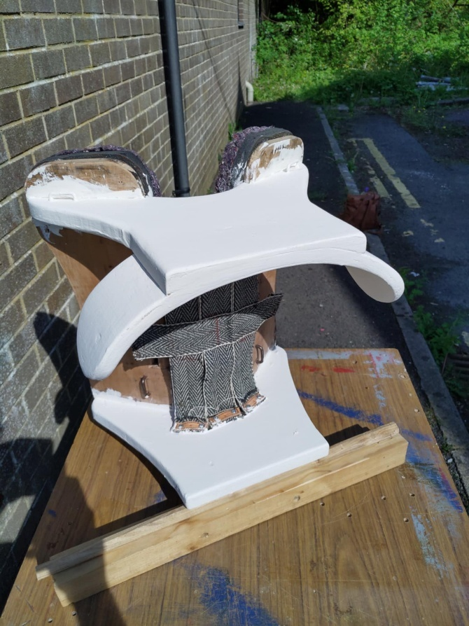
Because of the wood my saddle was made from it became necessary to do more than two layers of gesso as Theofilus prescribes. The wood was stained which meant that I had to do 6 layers of white on each side of the saddle. This provided an even coat, that was ready to paint.
Figure 6 layer of White
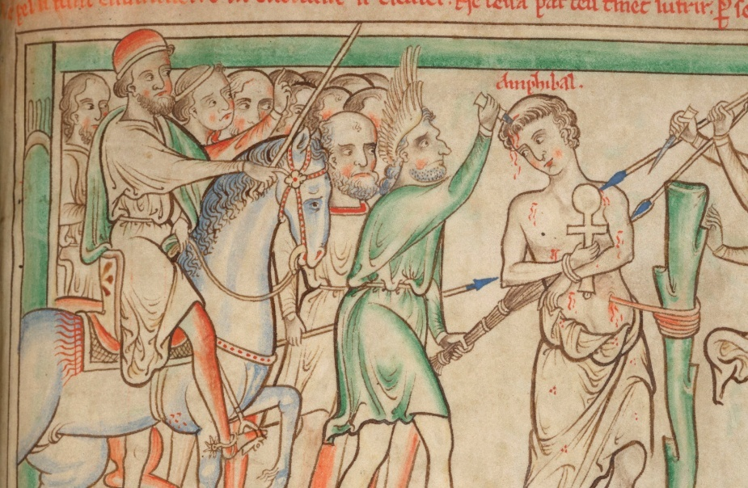
Painting is an interesting topic for this period, Theofilus doesn’t state that the saddle is to be painted, he says to carve them with geometric shapes or other decorations. Gesso left on its own is simply a bare white colour, this is not reflected in the manuscripts, as saddles he colour, as the one is figure 3. In my search for images of saddles I came across one in a manuscript by Matthew Paris, it depicts a decorated saddle. The rider in figure 7 has what looks like a flower painted on the back of his saddle, this is backed up by some written sources such as those written by Chretien de Troyes. This allowed me to move beyond the description written by Theofilus Presbyter and to experiment with some paints.
Figure 7 Matthew Paris

After examining the manuscript illumination I used for inspiration I decided to go with Azurite for the reproduction. Azurite is a copper carbonite material, when crushed and mixed into egg tempura paints it provides a brilliant blue hue, however it is known to darken over time as it oxidises. This is a medieval pigment that was used for paintings and would have made an excellent choice for the saddle, however, this was where I first encountered a problem, one that no number of sources could account for. The azurite I had purchased for this reproduction would not be delivered in time. I determined that in order to continue with my reproduction I would order some synthetic azurite instead. While it would look right it wouldn’t be entirely the same chemical compound that would have been originally used.
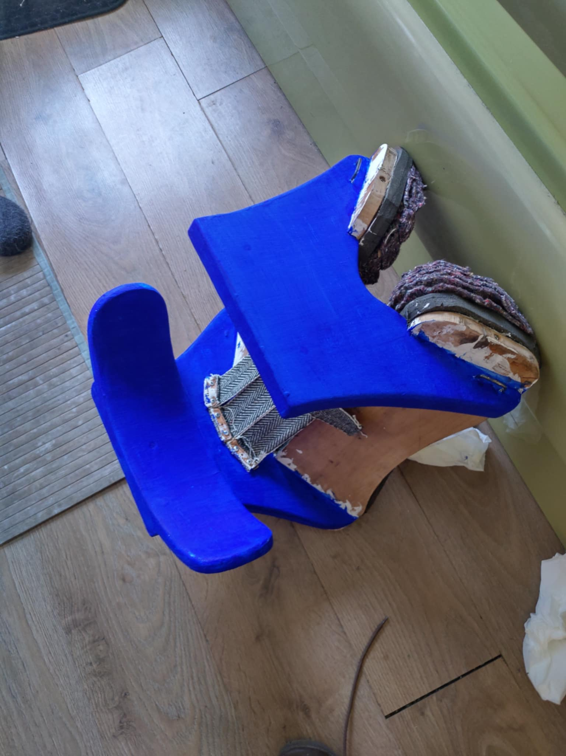
After that arrived I applied the paints in an egg tempura mixture I made. The paint is a much more brilliant blue than the reference image, this is most likely because this azurite was synthetic and wouldn’t oxidise like the real azurite would. The paint was applied in two layers for full coverage. This provided an even coat and made sure that no white gesso showed through to interrupt this beautiful colour.
Figure 8 The Finished Saddle painted with the synthetic azurite paint.
In order to reproduce the red cover that figure 3 so prominently displays red wool was used, in the period this wool would have been dyed with either madder roots, or cochineals to produce this colour.
This reconstruction provided a fascinating insight into the reason for the shape of the saddle and its use. These saddles were deigned for mounted warfare. They are high cantle and with a high front for battle, the high back allows the rider to brace their back on the saddle. One unique development from this period are the ears that extend around the side of the rider. This is very different form the standard modern saddle. These ears allow the rider to stay firmly planted in the seat of the saddle even through the violent movements of combat. Another peculiarity of this style if saddle is the high seat, figures 6 and 8 show this off well, the herringbone woven wool straps that are suspended between the pommel and the cantle are the high seat, they are sometimes padded, as with the funerary saddle of Henry the 5th. In his reconstruction of a later period saddle Arne Koets a noted jouster and medieval style equestrian with over a decade of experience in the field examined earlier, 12th to 14th century high seated war saddles such as the one have reconstructed.
“This style of saddle does help greatly to get a good lower leg connection with the horse, especially when riding smaller horses. The raised seat makes it much easier for men over 180cm(apx 6') tall(not uncommon for nobility of the period, as archeological evidence from grave sites clearly shows) to ride horses under 15 hands high(so common in medieval times). However, the rider does lose the contact between the horse and the rider's inner thigh, meaning that the rider must depend more on the effect of the bit. Of course, guiding a horse using only the bit can be done to a high degree, as long reign work from classical dressage(and higher driving dressage, for that matter) clearly shows.”
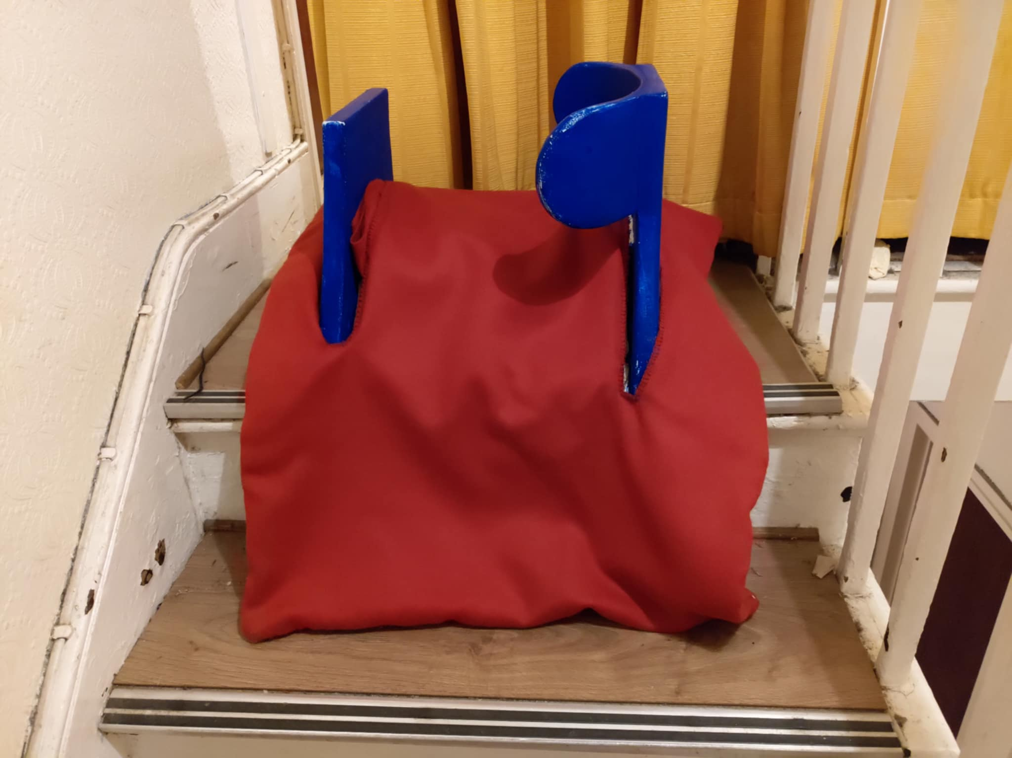
This is reflective of the problems of large men riding horses. This shows ingenuity on the part of the medieval nobles in tacking these problems. The ears effectively locking the rider into the saddle and the high seat aiding in controlling the horses, shows a picture of how the medieval noble would have handled the mounted warfare of their period. The colours and expense that went into making these saddles in the period should also be noted, azurite is not cheap, nor is the dye used to dye the wool of the cover to a brilliant red. These factors together paint a picture of how the medieval noble classes tackled the problems facing them with their style of warfare. The final saddle is both comfortable to sit in and highly supportive.
Figure 9 The finished saddle
This reconstruction has illuminated some of the interesting factors and traits that the saddles of the high medieval period is characterised by. The colour and ingenuity on display is fascinating, especially when compared to the brutality of the reputation this period has garnered in the modern popular culture.

Bibliography
Carey-Bunning, Jessica, ‘KING HENRY V’S ARMORIAL FUNERAL ACHIEVEMENTS’, Tudor Treasures & Medieval Musings, 2022 https://tudortreasures.net/henry-vs-armorial-funeral-achievements/ [accessed 27 April 2025].
Chronicle of Otto of Freising, Thüringer Universitäts- und Landesbibliothek, Ms. Bos. q.6, fol. 91v (Hagenau, 1157–1185) http://archive.thulb.uni-jena.de/hisbest/receive/HisBest_cbu_00019205 [accessed 1 May 2025].
Gilmour, Lauren, ed., In the Saddle: An Exploration of the Saddle through History (London: Archetype, 2004).
Hickling, Lynda, ‘The Saddle of Henry V at Westminster Abbey Library’, in In the Saddle: An Exploration of the Saddle through History, ed. by Lauren Gilmour (London: Archetype, 2004),
Hyland, Ann, ‘The Medieval War Saddle and Its Accessories’, in In the Saddle: An Exploration of the Saddle through History, ed. by Lauren Gilmour (London: Archetype, 2004),
King, James, [Title of Video], YouTube, 4 April 2016, https://www.youtube.com/watch?v=1xHJ90Gx4B8 [accessed 20 April 2025].
Koets, Arne, ‘Re-Creating Medieval and Renaissance Saddles: Part One’, The Jousting Life, 2016 http://www.thejoustinglife.com/2014/03/re-creating-medieval-and-renaissance.html [accessed 4 May 2025].
Ministere De La Culture, ‘Recherche - POP’, Gouv.fr, 2025 https://pop.culture.gouv.fr/search/mosaic?base=%5B [accessed 3 May 2025].
Morgan Library, Winchester Bible, MS M.619 (Winchester, 1160–1180) http://www.themorgan.org/collections/collections.asp?id=79 [accessed 2 May 2025].
Médiathèque de l'Agglomération Troyenne, Troyes BM MS.28 Bible (France, 1150–1165), fol. 111v http://www.enluminures.culture.fr/documentation/enlumine/fr/BM/troyes_033-01.htm [accessed 28th April 2025].
O’Hanlon, George, ‘Most Important Blue Pigment in European Painting’, Naturalpigments.eu (Natural Pigments Europe), 2022 https://www.naturalpigments.eu/artist-materials/most-important-blue-pigment-european-painting-azurite?srsltid=AfmBOopzkPph6OR0W5aMaNm3XpbGn0sKXvlNsQMLC6RGOQQjf8shG87a [accessed 2 May 2025].
Phillips, Charles, ‘Battle of Bouvines | Summary’, Encyclopedia Britannica, [n.d.] https://www.britannica.com/event/Battle-of-Bouvines-1214.
The Editors of Encyclopædia Britannica, ‘Battle of Hastings | Summary, Facts, & Significance’, Encyclopædia Britannica, 2018 https://www.britannica.com/event/Battle-of-Hastings.
1 Samuel 17 (New International Version).

The Editors of Encyclopedia Britannica. 2018. ‘Battle of Hastings | Summary, Facts, & Significance’, Encyclopædia Britannica https://www.britannica.com/event/Battle-of-Hastings
Phillips, Charles. [n.d.]. ‘Battle of Bouvines | Summary’, Encyclopedia Britannica https://www.britannica.com/event/Battle-of-Bouvines-1214
Thüringer Universitäts- und Landesbibliothek, Chronicle of Otto of Freising, Ms. Bos. q.6, fol. 91v (Hagenau, 1157–1185) http://archive.thulb.uni-jena.de/hisbest/receive/HisBest_cbu_00019205 [accessed 1 May 2025].
Ann Hyland, ‘The Medieval War Saddle and Its Accessories’, in In the Saddle: An Exploration of the Saddle through History, ed. by Lauren Gilmour (London: Archetype, 2004), p. 37
Theophilus, On Divers Arts: The Treatise of Theophilus, ed. and trans. by John G. Hawthorne and Cyril Stanley Smith (Chicago: University of Chicago Press, 1963).
Morgan Library, Winchester Bible, MS M.619 (Winchester, 1160–1180) http://www.themorgan.org/collections/collections.asp?id=79 [accessed 2 May 2025].
2 Samuel ch. 13–18 (New International Version).
Lynda Hickling, ‘The Saddle of Henry V at Westminster Abbey Library’, in In the Saddle: An Exploration of the Saddle through History, ed. by Lauren Gilmour (London: Archetype, 2004), p. 39
Carey-Bunning, Jessica. 2022. ‘KING HENRY V’S ARMORIAL FUNERAL ACHIEVEMENTS - Tudor Treasures & Medieval Musings’, Tudor Treasures & Medieval Musings <https://tudortreasures.net/henry-vs-armorial-funeral-achievements/> [accessed 27 April 2025]
Médiathèque de l'Agglomération Troyenne, Troyes BM MS.28 Bible (France, 1150–1165), fol. 111v http://www.enluminures.culture.fr/documentation/enlumine/fr/BM/troyes_033-01.htm [accessed 28th April 2025].
1 Samuel ch. 17
Theophilus, On Divers Arts: The Treatise of Theophilus, ed. and trans. by John G. Hawthorne and Cyril Stanley Smith (Chicago: University of Chicago Press, 1963).
Theophilus, On Divers Arts, ed. and trans. by John G. Hawthorne and Cyril Stanley Smith (1963)
James King, How to Make traditional Gesso(YouTube, 4 April 2016) https://www.youtube.com/watch?v=1xHJ90Gx4B8 [accessed 20 April 2025
James King, How to Make gesso, 2016
Theophilus, On Divers Arts, ed. and trans. by John G. Hawthorne and Cyril Stanley Smith (1963)
O’Hanlon, George. 2022. ‘Most Important Blue Pigment in European Painting’, Naturalpigments.eu (Natural Pigments Europe) <https://www.naturalpigments.eu/artist-materials/most-important-blue-pigment-european-painting-azurite?srsltid=AfmBOopzkPph6OR0W5aMaNm3XpbGn0sKXvlNsQMLC6RGOQQjf8shG87a> [accessed 2 May 2025]
O’Hanlon, George. 2022. ‘Most Important Blue Pigment in European Painting’, Naturalpigments.eu (Natural Pigments Europe)
O’Hanlon, George. 2022. ‘Most Important Blue Pigment in European Painting’, Naturalpigments.eu (Natural Pigments Europe)
Hyland, Ann, The Medieval Warhorse: From Byzantium to the Crusades (Stroud: Alan Sutton, 1994)
Koets, Arne. 2016. ‘Re-Creating Medieval and Renaissance Saddles: Part One’, The Jousting Life <http://www.thejoustinglife.com/2014/03/re-creating-medieval-and-renaissance.html> [accessed 4 May 2025]

