Introduction
In this document I will be discussing IPv4 and IPv6 addressing. This document will have sections dedicated to the different type of addressing.

IPv4
IPv4 is the fourth version of the internet protocol (IP). IP version four addresses are 32-bit integers which can be expressed into hexadecimal, in order to allow people to be able to understand what the binary represents. The 32-bit numbers are used to uniquely identify a network frame or a machine which is located on the network. An IPv4 is usually written in decimal digits, this is then formatted into four 8-bit fields which are separated by periods. Each 8-bit field is used to represent a byte of the IPv4 address. The hexadecimal format for IPv4 addresses as they are known as dotted quad or dotted decimal, which looks like this x.x.x.x and each x can be any number between 0 and 255. An example of an IPv4 192.0.2.146 the image below also explains how the dotted-decimal system works.
[1]
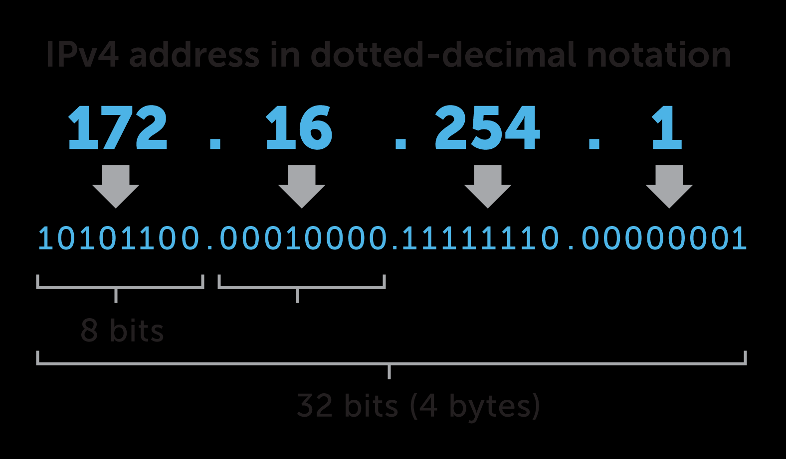
Pros
[2] ‘IPv4 protocols have simple prefixes.’ This means that they can easily fit into customers topologies drawings when they choose IPv4. Unlike IPv6 protocols which have complicated prefixes, this could cause problems for people when they are trying to fit IPv6 into their topology.
One of the best things about IPv4 protocols is that [2] ‘all systems have no problem have no problem handling IPv4 routing’. Unfortunately, the same cannot be said about IPv6 addressing although most computer are able to handle IPv6 routing there is a large amount of computer that won’t. If a user has to manually type in an IP addresses then things would get even worse as IPv6 addresses as these are larger and more complicated. This means that there a higher chance of human error which means it won’t work as the person intended.
Cons
[1] ‘IPv4 still routes most of today’s internet traffic.’ However, IPv4 has some limitations. One of limitation is that IPv4 only has 32-bits of address space, this limits the amount of unique host to [1] ‘232, which is nearly 4.3 billion’ IPv4 addresses for the world to use 4,294,967,296, to be exact.
Another issue with IPv4 is that [1]’about 18 million addresses’ got set aside for private addressing, these where drawn from a range which is known as RFC 1918. Most organizations do use a private address in order to protect their own internal networks. However, these devices which have private address on the local network won’t have any direct path to the public internet. This could be an issue for a company as their staff might need to access the internet, by having these private addresses would stop their devices from connecting to the internet. In order for the public internet the devices on a private network would require a complex and resource-intensive workaround called [1] ‘network address translation (NAT)’. Using NAT would limit the performance of the network or the devices located on the network.

IPv6
IPv6 is the six version of the internet protocol, [3] ‘this is a set of specification form the Internet Engineering Task Force (IETF)’ this is an upgrade version of IPv4 which is a category of IP addresses in IPv4-base routing. The basic version of IPv6 is similar to IPv4 devices which can use IPv6 as a source and destination addresses to pass packets over a network. [3] ‘Tools like ping work for a network testing’ in a similar way they do in IPv4 but there are some slight variations.
IPv6 addresses are 128 bits long (16 bytes), this includes 64 bits for a network numbers and 64 bits for the host numbers. The host versions of IPv6 are often derived from a [3] ‘media access control (MAC) address or other interface identify.’ Depending on the subnet prefix, IPv6 is more complicated than IPv4 as the number of IPv6 is 1028, which is (79 228 162 514 264 337 593 543 950 336) times larger than IPv4. This can be displayed like this xxxx:xxxx:xxxx:xxxx:xxxx:xxxx:xxxx:xxxx, where each x is a hexadecimal digit, representing 4 bits.
Pros
Additional address space is one of the pros which comes with IPv6. When compared to IPv4, IPv6 has [4] ‘more than doubling the length if network and host components.’ Meaning more devices can connect on one network which maximise the network potential.
IPv6 eliminates subnetting word problems. The new IPv6 protocols allows for [4] ‘stateless automatic configuration’ this is a replacement for static IP addresses or the DHCP. Even though these options are still available and user can still purchase them if they wanted to. This change is a considerable shift and it can win user over.
Automatic links to addressing is another positive feature that IPv6 has. With the introduction of IPv6 this process had become streamlined. IPv6 has allowed [4] ‘something that previous versions simply didn’t have the kind of room for.’ Until this protocol was released.
Cons
System issues are one of the cons which come with IPv6. [4] ‘IPv6 routing depending upon the kind of system that you are running.’ Older system might not be compatible with IPv6 which can cause issues. User will also have to type longer address when they enter data manually. This is time consuming and human error is more likely to occur dude to the length.

Conclusion
This document has discussed IPv4 and IPv6, I have also included some of the advantages and disadvantages of each encryption type. The changes made between these two versions have also been discussed within the document.

References

[1] | BLUECAT, “What is IPv4?,” BLUECAT, 2020. [Online]. Available: https://www.bluecatnetworks.com/glossary/what-is-ipv4/. [Accessed 5 April 2020].
[2] | IPv4Mall, “IPv4 Vs IPv6—Pros and Cons,” IPv4Mall, 25 June 2018. [Online]. Available: https://ipv4mall.com/blogs/ipv4-vs-ipv6-pros-cons/. [Accessed 6 April 2020].
[3] | M. Rouse, “IPv6 (Internet Protocol Version 6),” SearchNetworking, [Online]. Available: https://searchnetworking.techtarget.com/definition/IPv6-Internet-Protocol-Version-6. [Accessed 6 April 2020].
[4] | B. Miller, “5 Pros and Cons of IPV6,” Green Garage, 15 February 2017. [Online]. Available: https://greengarageblog.org/5-pros-and-cons-of-ipv6. [Accessed 7 April 2020].

Bibliography

[1] | BLUECAT, “What is IPv4?,” BLUECAT, 2020. [Online]. Available: https://www.bluecatnetworks.com/glossary/what-is-ipv4/. [Accessed 5 April 2020].
[2] | IPv4Mall, “IPv4 Vs IPv6—Pros and Cons,” IPv4Mall, 25 June 2018. [Online]. Available: https://ipv4mall.com/blogs/ipv4-vs-ipv6-pros-cons/. [Accessed 6 April 2020].
[3] | M. Rouse, “IPv6 (Internet Protocol Version 6),” SearchNetworking, [Online]. Available: https://searchnetworking.techtarget.com/definition/IPv6-Internet-Protocol-Version-6. [Accessed 6 April 2020].
[4] | B. Miller, “5 Pros and Cons of IPV6,” Green Garage, 15 February 2017. [Online]. Available: https://greengarageblog.org/5-pros-and-cons-of-ipv6. [Accessed 7 April 2020].

Subnetting and VLSM
NOTE: To complete this part you would need full understanding of Lab 10 to 14.


Using the Network address 172.16.2.0/24, VLSM the network to support the following requirements:
Subnet A: 16 hosts
Subnet B: 2000 hosts
Subnet C: 6 hosts
Subnet D: 500 hosts
Subnet E: 60 hosts
Subnet F: 180 hosts and Serial links between routers

Subnet | Network Address | Subnet mask | First Address | Last Address | Broadcast Address
B | 172.16.0.0 /21 | 255.255.248.0 | 172.16.01 | 172.16.7.254 | 172.16.7.255
D | 172.16.8.0 /23 | 255.255.254.0 | 172.16.8.1 | 172.16.9.254 | 172.16.9.255
F | 172.16.10.0 /24 | 255.255.255.0 | 172.16.10.1 | 172.16.10.254 | 172.16.10.255
E | 172.16.11.0 /26 | 255.255.255.192 | 172.16.11.1 | 172.16.11.62 | 172.16.11.63
A | 172.16.11.64 /27 | 255.255.255.224 | 172.16.11.65 | 172.16.11.94 | 172.16.11.95
C | 172.16.11.96 /29 | 255.255.255.228 | 172.16.11.97 | 172.16.11.102 | 172.16.11.103
G | 172.16.11.104 /30 | 255.255.255.252 | 172.16.11.105 | 172.16.11.106 | 172.16.11.107
H | 172.16.11.108 /30 | 255.255.255.252 | 172.16.11.109 | 172.16.11.110 | 172.16.11.111

