Global Tourism & Destination Management

Course Number: M6X01932
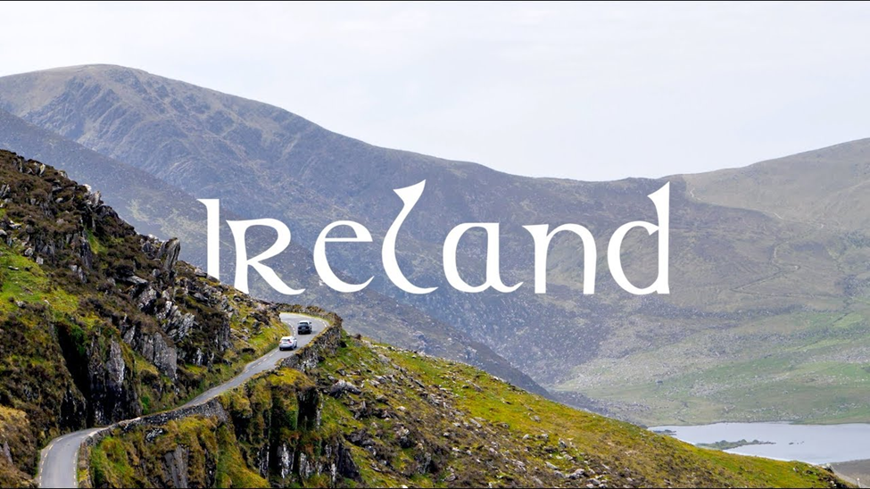

Student’s name: Peev
Student’s number: 1815104
Lecture: Dale Clarke
Table of Contents

INTRODUCTION 3
Strategic Tourism Planning Model 3
Effectiveness of the implemented Strategic Tourism Planning Model 5
Issues and implications’ of implemented Strategic Tourism Planning 7
Future development and improvement 8
Strategic Tourism Planning Model 8
CONCLUSION 9
REFERENCES 10

INTRODUCTION
Tourism planning is a process of considering the requirements of visitors to specific destinations, with the intention of attracting tourists as well as ensuring that local businesses and places benefit from them. It involves several activities, coordinated with local governments, to create, build upon and improve infrastructure related to tourism. Participation also extends to private organisations, hospitality organisations, and travel agencies. This report will discuss strategies for tourism planning and the model. Strategic tourism planning is a process for determining the destination and it’s tourism locations, and developing a tourism plan to achieve objectives determined in the most effective and efficient manner. Ireland is a popular tourist destination, which is effectively managed and hence is being contextualised for this report.

Strategic Tourism Planning Model
Ireland is an attractive destination for tourism, and the reason behind this is it’s location and it’s various sites that can be visited. It has some important and attractive geographic locations, which make it worth being a tourist destination. Among all the destinations for tourism, Dublin is the most visited (Saarinen, Rogerson and Hall, 2019). The culture of Ireland also has a significant influence on other cultures. This means that Ireland offers several elements that attract tourists which include its geographical locations, culture, and activities. Some of the strategies that have been adopted by Ireland tourism are-
Brand and Marketing
This is an important strategy, which focuses on creating a sale increasing brand. This effort is made to create brand distinctiveness to increase the attractiveness of the brand and product. In this case, this is creating attractiveness for the tourism destination. Ireland to increase tourism places importance on marketing in different ways. In this Ireland also undertake practices through which diverse holiday experiences are communicated that are available in the country. Marketing involves communicating and presenting Ireland as an exciting destination and promote the experience.
Distribution and Purchas ability
This strategy for tourism planning involves focusing on strengthening presence and efficacy at all stages through the path, so customers and tourists can make a purchase (Milano, Novelli and Cheer, 2019). This means that the tourism plan ensures that tourism and tourist activities in Ireland is easily purchasable. Purchase ability also ensures that the monetary aspect of the purchase is motivating and competitive.
Product and Experience
This means creating a world-class experience that appeals to customers, along with devising and delivering a product and experience that support regional and seasonal development of the tourism destinations and locations. This strategy also involves leveraging and involving different products and services that are available in the context of Ireland tourism. The product plays an important role in selling and therefore focusing on this aspect is very important, however tourism experience is equally important.
Market and Experience
This is another strategy in the tourism plan of Ireland. This strategy focuses on involving all different stakeholders of the tourism within Ireland and creating an environment in which stakeholders can share data, insights, research, and sales toolkits. This also includes developing an understanding of the consumer segments along with understanding a dynamic understanding of the path of consumer’s purchase (McLoughlin and Hanrahan, 2019). This strategy also involves developing an understanding of competitor’s activity and its effect on consumers and their decision making.
Access
This involves exploiting new routes and sustaining strategically important routes. This strategy of tourism planning also includes the implementation of cooperative campaigns and share market research and intelligence with carriers to encourage new strategic routes.
Regional and Seasonal Development
This mainly involves the development and implementation of product and experience. This strategy also focuses on regional development initiatives. In this Ireland focuses on tourism and improving and enhancing regional services (Healy, van Riper and Boyd, 2016). This strategy in the plan also involves promoting specific seasonal and regional proposition and ensuring the opening of products and experiences, accommodation, restaurants, etc. to enhance the experience and improve product.
Industry Activation and Collaboration
This means driving collaboration and activation in all the areas that are connected to relevant to tourism and the overall experience of the tourist. Continuing offering value for money and incorporating trade and industry offerings into the marketing content. This means that when Ireland and its tourism is promoted and marketed at that time regional offerings are also associated with tourism in Ireland and its different destinations. For example, promoting local specialties along with attractive destinations of Ireland.
Sustainable Tourism
This is a concept and model which is based on analysing and identifying long term impact on the tourism destination, local people of the destination and the impact on the environment because of tourism activities (McLoughlin and Hanrahan, 2016). Ireland in its tourism planning has focused on sustainability standards. Other than this some of the activities that are included in sustainable tourism are globally recognised eco-certification programs, green travel marketing toolkit, naturalist-guided tourism activities, and environmentally conscious hotels. These are some of the elements and activities that are part of the sustainable tourism of Ireland. In the context of tourism planning and management, sustainability has become a key issue because of the increasing negative impact on the environment and tourism destinations. Many organisations are also taking active participation in ensuring sustainable tourism in Ireland in which their focus is on planting trees, respect towards nature and wildlife, partnering with local communities for sustainable tourism, avoid printing, saving water and recycling waste (McLoughlin and et.al., 2018).

Effectiveness of the implemented Strategic Tourism Planning Model
The strategies in tourism planning and development model of Ireland suggest a holistic model for tourism planning in which all the aspects and strategies have been considered (Saarinen, Rogerson, and Hall, 2017). This involves strategies that are focusing on the aspect to attract consumers and tourists as well as strategies and elements that are focusing on ensuring the satisfaction of the customers of tourism. This also focuses on the long term impact of the tourism and environment and local communities. Some of the benefits of the strategies and model of the Ireland tourism plans are-
- Focuses on different areas of the tourism and effective collaboration of the different areas concerned with tourism in the model and its different strategies
- Understand the importance of marketing, promotion, and employ an effective business approach to tourism in Ireland.
- Focuses on consumer satisfaction which is important for the success of the experience of the consumers and tourists in Ireland (Higgins-Desbiolles, 2018).
- Another benefit of this plan and strategies involved in the plan is that this presents all aspects of tourism and destination in front of the customers.
- Sustainability of tourism is also one of the models of tourism and considering the increasing importance of sustainability, this aspect must be valued by the tourism plan. This becomes important for Ireland because it houses geographical destinations and attractions.
Several advantages and benefits of tourism planning were discussed, but this also has some of the disadvantages that are as follows-
- This plan does not have any kind of focus on infrastructure development which is one of the most important aspects of tourism.
- This also does not have an extensive focus on tourism-related sustainability and areas that are covered in its sustainability model are general to sustainability rather than having any specific focus on tourism sustainability (Pan and et.al., 2018).
- This is mainly based on a business approach in which major focus has been placed on customer attraction and customer satisfaction rather than tourism activities.
Overall, the plan for tourism in Ireland is effective and capable of showing long term results in all aspects including sustainability and tourism activities and their engagement with local activities and communities.

Issues and implications’ of implemented Strategic Tourism Planning
Strategic planning for tourism planning has several issues. One of the main reasons for having issues is that planning is extensive and includes several aspects related to tourism. Issues that can be experienced while implementing this strategic tourism planning are-
Difficulty in understanding customer perspective and preferences
This planning of tourism places specific attention on customers and identifying their taste and preferences. This is important and helpful, yet it is difficult to identify and understand the preference and taste of customers in the context of tourism (Pa and et.al., 2018). This is because customers are from different cultures and nations and therefore their choice and preference also differ, making it is very difficult to understand customer’s perspectives and preferences regarding tourism.
Maintaining collaboration
Extensive tourism planning also requires effective collaboration and this is another issue involved in this planning. This is because collaboration includes collaborating with a single focus on tourism and tourist and this can increase complexities and create issues for the planning and its implementation.
Implications of tourism planning
Tourism planning has several significant implications on Ireland tourism and these are some of the implications of the planning area.
Long term impact on the success of tourism
This planning will have long term implications on tourism, and this will result in long term success of the tourism planning of Ireland (Saarinen, Rogerson, and Hall, 2017). The reason is that the tourism planning of Ireland involves several aspects that have an impact on the success of tourism in Ireland.
Sustainability
This is another implication of tourism planning and development in Ireland. This involves the sustainability model adopted by Ireland tourism. This has a positive impact on the local communities of Ireland and along with that it also creates a positive impact and influence on tourism and tourist.
The discussion identifies that Ireland has managed to effectively plan their tourism to maintain and enhance the satisfaction of tourists and those with local communities living at tourist destinations. The planning of Ireland here is being compared with New Zealand. This means that there are several differences in practices of different global destinations. Many of the global destinations focus on the technological aspects of tourism and the development of tourism destinations (Dinica, 2017). Many of the destinations are focusing on the environment and sustainability aspect of the tourism and product development of tourism. This means that different destinations are following different approaches and focusing on different areas of the tourism and development of tourism products. Ireland is focusing on sustainability and marketing aspects of tourism.
Tourism planning and development in Ireland is the responsibility of the Department of Transport, Tourism, and Sports. This department is responsible for ensuring the development of Ireland as a tourism product. However, in the context of New Zealand, its tourism strategy is led by the Ministry of Business, Innovation, and Employment along with the Department of Conservation. This differentiates in their approach towards tourism focus of the destinations.
In the context of Ireland, their centre of focus is marketing and promoting tourism in the country along with creating a tourism product to attract the tourists. The centre of tourism planning and strategy in New Zealand is sustainability (Albrecht, 2017). Focusing on sustainability in tourism strategy is aimed at creating clean, green, and carbon-free New Zealand.
Some other aspects that differentiate the New Zealand from the Ireland tourism strategy and planning are values of the New Zealand tourism planning and strategy, such as-
- Guardianship and protection of cultural and natural features which will benefit current and future generation
- Showing hospitality, generosity, respect, and care for others
- Feeling of family connections and sense of belongingness which is built on work.
These are some of the elements and features that differentiate in the tourism strategy and planning of Ireland and New Zealand. It is also considered that strategies of tourism in New Zealand not only focuses on tourism destination but also focuses on the mindset and feelings of people.

Future development and improvement
There are several positive and favourable elements in the tourism planning of Ireland. This extends to severe aspects related to tourism planning and considers the sustainability of Ireland and its tourism. In the context of possible future development of tourism, it can be considered that Ireland can focus more on infrastructure sustainability because the overall analysis and evaluation of tourism planning do not reflect on sustainable infrastructure. This is important and many of the tourism destinations are focusing on different aspects of developing sustainable infrastructure (Rutty and Richardson, 2019). Ireland is focusing on sustainable tourism, but its focus is limited in some areas and sustainable infrastructure is not included in the planning of Ireland tourism. However, this is one of the areas where Ireland tourism can focus on and some of the major activities that are included in this are sustainable transportation. Ireland needs to undertake activities and practices for sustainable tourism.

Strategic Tourism Planning Model
There are several approaches for strategic tourism planning, the above discussion about planning and strategies developed by Ireland is based on the business approach of tourism. Other than this some of the approaches are Boosterism, physical-spatial approach and community-oriented approach. On the basis of these models and approaches of strategic tourism planning, it can be said that Ireland tourism planning is based on two approaches, which are the business approach and the physical-spatial approach. This is because a focus on development and enhancement has also been provided by tourism planning. Another strategic tourism planning model is Boosterism, a model which does not consider the negative aspect of tourism and focuses solely on increasing tourism. However, while this model of strategic planning is practical and can have short term advantages and benefits, it is not suitable for the long term benefits for tourism (Esfehani and Albrecht, 2019). The model and approach for strategic planning that Ireland can utilise is a community-oriented approach. This approach of tourism planning promotes local tourism development schemes in which residents get a significant benefit and conflicting situations can be avoided. A community-based approach will also contribute to overall economic development and the extended economic contribution of tourism in Ireland.

CONCLUSION
Based on the above discussion, it can be concluded that strategic tourism planning and development play an important role in ensuring the attainment of tourism goals and objectives. This report discussed the tourism planning of Ireland and based on the discussion it can be said that Ireland has very effective tourism planning which covers wide areas related to tourism planning and development. Later some of the issues were also discussed which are experienced and faced by Ireland tourists while implementing tourism planning along with implications of the planning. Followed by this discussion also included is a comparison of tourism planning of Ireland with tourism planning of some other destinations and later discussion involved future development and improvement in Ireland tourism. Lastly, some other models were discussed which can be adopted and applied by Ireland tourism.

REFERENCES
Books and Journals
Albrecht, J.N., 2017. Challenges in National‐level Tourism Strategy Implementation–A Long‐term Perspective on the New Zealand Tourism Strategy 2015. International Journal of Tourism Research. 19(3). pp.329-338.
Andriotis, K., Stylidis, D. and Weidenfeld, A. eds., 2018. Tourism policy and planning implementation: Issues and challenges. Routledge.
Dinica, V., 2017. Tourism concessions in National Parks: neo-liberal governance experiments for a Conservation Economy in New Zealand. Journal of Sustainable Tourism. 25(12). pp.1811-1829.
Esfehani, M.H. and Albrecht, J.N., 2019. Planning for Intangible Cultural Heritage in Tourism: Challenges and Implications. Journal of Hospitality & Tourism Research. 43(7). pp.980-1001.
Healy, N., van Riper, C.J. and Boyd, S.W., 2016. Low versus high intensity approaches to interpretive tourism planning: The case of the Cliffs of Moher, Ireland. Tourism Management. 52. pp.574-583.
Higgins-Desbiolles, F., 2018. Sustainable tourism: Sustaining tourism or something more? Tourism management perspectives. 25. pp.157-160.
McLoughlin, E and et.al., 2018. European tourism indicator system for sustainable destination management in county Donegal, Ireland. European Journal of Tourism Research. 20. pp.78-91.
McLoughlin, E. and Hanrahan, J., 2016. Local authority tourism planning in Ireland: An environmental perspective. Journal of Policy Research in Tourism, Leisure and Events. 8(1). pp.33-52.
McLoughlin, E. and Hanrahan, J., 2019. Local authority sustainable planning for tourism: lessons from Ireland. Tourism Review.
Milano, C., Novelli, M. and Cheer, J.M., 2019. Over tourism and tourism phobia: A journey through four decades of tourism development, planning and local concerns.
Pan, S.Y and et.al., 2018. Advances and challenges in sustainable tourism toward a green economy. Science of the Total Environment. 635. pp.452-469.
Rutty, M. and Richardson, R.B., 2019. Tourism research in Cuba: Gaps in knowledge and challenges for sustainable tourism. Sustainability. 11(12). p.3340.
Saarinen, J., Rogerson, C.M. and Hall, C.M. eds., 2019. Tourism planning and development: contemporary cases and emerging issues. Routledge.
Saarinen, J., Rogerson, C.M. and Hall, C.M., 2017. Geographies of tourism development and planning.
Sedarati, P., Santos, S. and Pintassilgo, P., 2019. System dynamics in tourism planning and development. Tourism Planning & Development. 16(3). pp.256-280.

