Artificial Intelligence

Jake Russell

1602835

Table of Contents
Task 1 3
Important Algorithms and Data structures 3
User Guide 4
Tests 4
Screenshots of working Program 7
Task 2 10
Task 3 11
Task 4 13
References 15

Task 1

Important Algorithms and Data structures
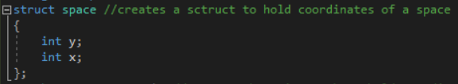
Figure 1:Struct 1
A struct named space which holds two integers representing an x coordinate and a y coordinate.
Figure 2: Stack 1
A stack named MapStack which hold data that is of type “Space”, space being the struct above.
Figure 3: Check Above Algorithm
Here is an if statement to check whether the space above is traversable. It uses the algorithm (Width * (y – 1) + x) where width is the width of the map, x is the agents current x coordinate on the map and y is the agents current y coordinate. To get the number for the location in the array “text” that houses the data for the space above the agent’s current position.
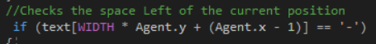
Figure 4:Check Left Algorithm
This is the same as above except that it checks the left space using the algorithm (width * y + (x – 1)) instead.
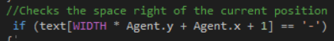
Figure 5:Check Right Algorithm
This is the same as above except that it checks the right space using the algorithm (Width * y + x + 1) instead.
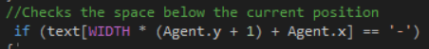
Figure 6:Check Below Algorithm

This is the same as above except that it checks the space below using the algorithm (Width * (y + 1) + x) instead.

User Guide
Choose whether you want to load a map with objectives or without objectives. If you wish to load a map with objectives, then type the number “1” and press enter. If you wish to load a map without objectives, then type “2” and press enter. Once the map is loaded, press or hold enter to have the Agent traverse the map until the program says whether or not it found objectives or not.

Tests
Test: 1
Test summary: Check whether the AI is capable of moving on the map and it its route is shown to the user
Method: On the options page input 1 or 2, then press enter to see whether the ai moves
Results: Success
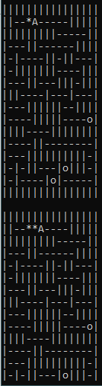
Figure 7:Test 1

Test: 2
Test summary: Check whether the AI is capable of moving through the map while abiding to its walls and boundaries
Method: On the options page input 1 or 2, then press enter until the ai moves through the entire map to see whether the ai moves through a wall
Results: Success
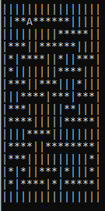
Figure 8:Test 2
Test: 3
Test summary: Check whether the AI is capable of finding all the objectives and displaying their coordinated to the user
Method: On the options page input 1, then press enter until the ai moves through the entire map and displays the coordinates of the objectives, then compare the coordinates given to the original map.
Results: Success
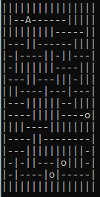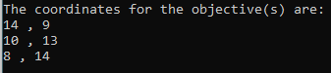
Figure 9: Test 3 part 1 Figure 10:Test 3 part 2

Test: 4
Test summary: Check whether the AI is capable displaying to the user that no objectives were found for a map with no objectives
Method: On the options page input 2, then press enter until the ai moves through the entire map and tells the user whether it found objectives or not.
Results: Success
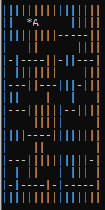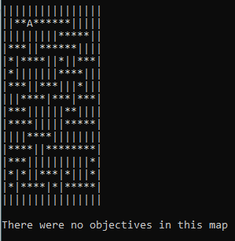
Figure 11: Test 4 part 1 Figure 12: Test 4 part 2

Screenshots of working Program
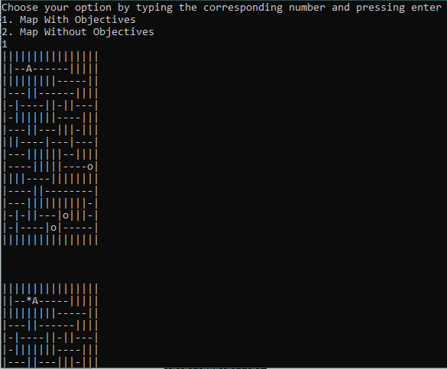
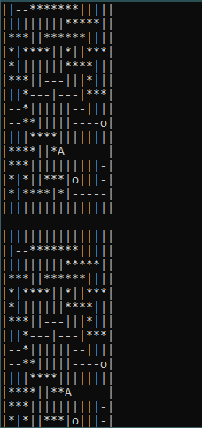
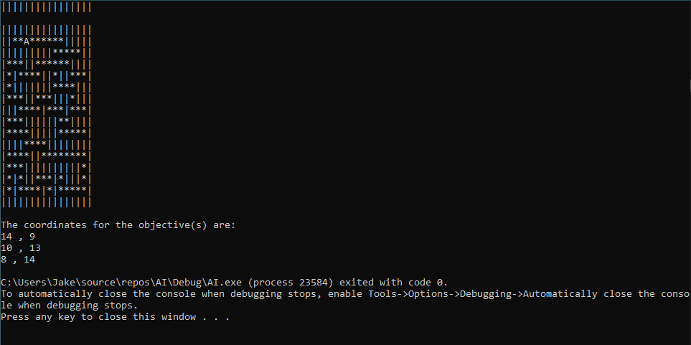
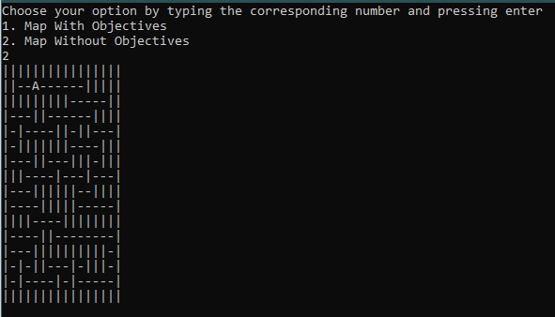
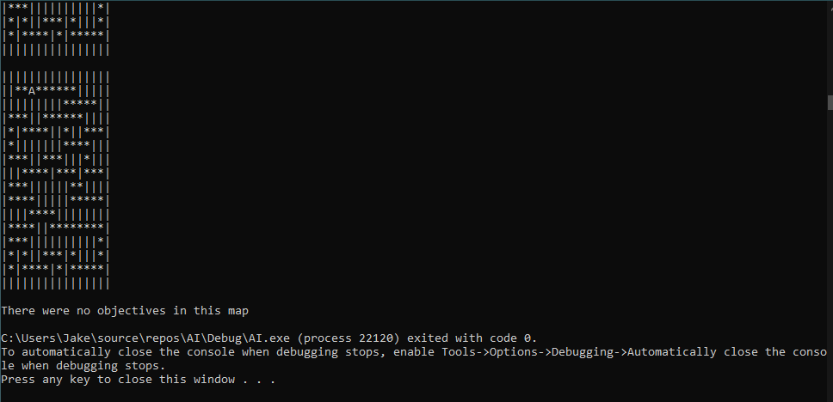

Task 2
According to Norvig And Russell the hill climbing algorithm is as follows:
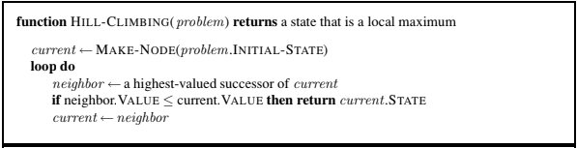
Figure 13: Figure 4.2 from Norvig and Russell (1)
They then stated the following: “The hill-climbing search algorithm (steepest-ascent version) is shown in Figure 4.2. It is simply a loop that continually moves in the direction of increasing value—that is, uphill. It terminates when it reaches a “peak” where no neighbor has a higher value. The algorithm does not maintain a search tree, so the data structure for the current node need only record the state and the value of the objective function. Hill climbing does not look ahead beyond the immediate neighbors of the current state” (1). There are also versions of hill climbing in which it’s a descent rather than an ascent, so instead it would continuously move in a direction of decreasing value until it reaches the bottom where no neighbour has a lower value in which it would then terminate. Norvig and Russell also has this to say: “Hill climbing is sometimes called greedy local search because it grabs a good neighbor state without thinking ahead about where to go next. Although greed is considered one of the seven deadly sins, it turns out that greedy algorithms often perform quite well. Hill climbing often makes rapid progress toward a solution because it is usually quite easy to improve a bad state” (1). According to them hill climbing has one big flaw and that is that it can often get stuck, they stated the reasons for this are as follows:
- “Local maxima: a local maximum is a peak that is higher than each of its neighboring states but lower than the global maximum. Hill-climbing algorithms that reach the vicinity of a local maximum will be drawn upward toward the peak but will then be stuck with nowhere else to go”. (1)
- “Plateaux: a plateau is a flat area of the state-space landscape. It can be a flat local maximum, from which no uphill exit exists, or a shoulder, from which progress is possible. A hill-climbing search might get lost on the plateau”. (1)
Because of this, using hill climbing to solve a problem can occasionally come up in failure, a way to prevent this is to have it so when it gets stuck, it will make a move in a random direction. This will make it far more likely to successfully complete but at the cost of its efficiency as there is a chance it will repeat the same actions multiple times.

Task 3
Initial State
3 | 1 | 2
4 | 5 | 8
6 |  | 7

Goal State
 | 1 | 2
3 | 4 | 5
6 | 7 | 8

H = Amount in the wrong position
H = 5 (Numbers 3,4,5,8,7)
6 swap = H = 6
5 swap = H = 5
7 swap = H = 4
3 | 1 | 2
4 | 5 | 8
6 | 7

H = 4 (Numbers 3,4,5,8)
8 swap = H = 3
7 swap = H = 4

3 | 1 | 2
4 | 5
6 | 7 | 8

H = 3 (Numbers 3, 4, 5)
5 swap = H = 2
2 swap = H = 4
8 swap = H = 4
3 | 1 | 2
4 |  | 5
6 | 7 | 8
H = 2 (Numbers 3,4)
4 swap = H = 1
1 swap = H = 3
7 swap = H = 3
5 swap = H = 3
3 | 1 | 2
 | 4 | 5
6 | 7 | 8
H = 1 (Numbers 3)
3 swap = H = 0
6 swap = H = 2
4 swap = H = 2

 | 1 | 2
3 | 4 | 5
6 | 7 | 8
Goal reached
The issue with using the hill climbing method to solve this that it can get stuck if the following occurs:
- Local Maxima: where each possible movement would make h() worse, such as h=4 but each move would make it h>4
- Plateaux: Where each possible move does not change h() at all, such as h=4 with every possible move
Even though hill climbing comes with these issues that can prevent it from solving the 8-tile puzzle, it still will have relatively high success rate. It is also a very fact way to solve this puzzle if it succeeds as it is a greedy search algorithm, meaning it doesn’t consider any future moves before simply taking the best presented to it at any given time.

Task 4
Another suitable distance measure to use with this task would be an informed search called Manhattan distance, in which it calculates the total amount of moves that would need to be done to reach the goal state for each state being the Manhattan distance, and only explores the states with the lowest Manhattan distance. For example:
Initial State
3 | 1 | 2
4 | 5 | 8
6 |  | 7

Goal State
 | 1 | 2
3 | 4 | 5
6 | 7 | 8

3 | 1 | 2
4 | 5 | 8
6 | 7
3 | 1 | 2
4 |  | 8
6 | 5 | 7
3 | 1 | 2
4 | 5 | 8
 | 6 | 7

h=0+0+1+1+1+0+0+1 h=0+0+1+1+2+0+1+1 h=0+0+1+1+1+1+1+1
h=4 Explore h=6 Don’t explore h=6 Don’t explore
3 | 1 | 2
4 | 5 | 8
6 |  | 7
3 | 1 | 2
4 | 5
6 | 7 | 8

h=0+0+1+1+1+0+1+1 h=0+0+1+1+1+0+0+0
h=5 Don’t explore h=3 Explore

3 | 1 | 2
4 | 5 | 8
6 | 7
3 | 1
4 | 5 | 2
6 | 7 | 8
3 | 1 | 2
4 |  | 5
6 | 7 | 8

h=0+0+1+1+1+0+0+1 h=0+1+1+1+1+0+0+0 h=0+0+1+1+0+0+0+0
h=4 Don’t explore h=4 Don’t explore h=2 Explore
3 |  | 2
4 | 1 | 5
6 | 7 | 8
3 | 1 | 2
 | 4 | 5
6 | 7 | 8
3 | 1 | 2
4 | 5
6 | 7 | 8

h=1+0+1+1+0+0+0+0 h=0+0+1+0+0+0+0+0 h=0+0+1+1+1+0+0+0
3 | 1 | 2
4 | 7 | 5
6 |  | 8
h=3 Don’t explore h=1 Explore h=3 Don’t explore

h=0+0+1+1+0+0+1+0
h=3 Don’t explore
 | 1 | 2
3 | 4 | 5
6 | 7 | 8
3 | 1 | 2
6 | 4 | 5
 | 7 | 8

h=0+0+0+0+0+0+0+0 h=0+0+1+0+0+1+0+0
h=0 Goal h=2 Don’t explore

References
1. Norvig, Stuart J. Russell and Peter. Artificial Intelligence A Modern Approach Third Edition. s.l. : Pearson, 2009.

Appendix
#include <iostream>
#include <string>
#include <sstream>
#include <fstream>
#include <stack>
#define WIDTH 16 //defines the map's width to 16
#define HEIGHT 16 //defines the map's height 16
using namespace std;
struct space //creates a sctruct to hold coordinates of a space
{
int y;
int x;
};
stack<space> MapStack; //Creates the main stack to hold coordinates of spaces on the map
stringstream stream;
string input;

int main(void) {
int option;
cout << "Choose your option" << endl; //Outputs a menu for the user to choose whether-
cout << "1. Map With Objectives" << endl;//-they want to load a map with objectives-
cout << "2. Map Without Objectives" << endl;//-or a map without objectives
getline(cin, input); //converts the user's input from type string to an integer
stream.str(input);
stream >> option;
stream.clear();
char text[WIDTH * HEIGHT]; //creates an array to store the map
string line;

switch (option) //Switch statement for the user's options
{
default:
break;
case 1:
{
//Loads the map with objectives into the program
ifstream myfile("WithOB.txt");
if (myfile.is_open())
{
int count = 0;
while (getline(myfile, line))
{
cout << line << endl;

line.copy(&text[WIDTH * count], WIDTH, 0);
count++;
}
myfile.close();
}
else cout << "Unable to open file";

cout << endl << endl << endl;

break;
}
case 2:
{
//Loads the map without objectives into the program
ifstream myfile("WithoutOB.txt");
if (myfile.is_open())
{
int count = 0;
while (getline(myfile, line))
{
cout << line << endl;

line.copy(&text[WIDTH * count], WIDTH, 0);
count++;
}
myfile.close();
}
else cout << "Unable to open file";

cout << endl << endl << endl;

break;
}
}
space Agent;
Agent.x = 4; //Sets the-
Agent.y = 1; //-starting coordinates
space StackAdd; //Creates variable of struct type space
stack<space> StackOb; //creates a stack to hold the coordinates of found objectives
MapStack.push(Agent); //initialise MapStack with start coordinates
while(!MapStack.empty()) //Main while loop that runs as long as the stack is not empty
{
//Checks the space above the current position
if (text[WIDTH * (Agent.y - 1) + Agent.x] == '-') //Checks if it's an empty space
{
//pushes the new position onto the stack
StackAdd.x = Agent.x;
StackAdd.y = Agent.y - 1;
MapStack.push(StackAdd);
}
else if (text[WIDTH * (Agent.y - 1) + Agent.x] == 'o') //Checks if it's an objective
{
//pushes the new position onto the stack
StackAdd.x = Agent.x;
StackAdd.y = Agent.y - 1;
MapStack.push(StackAdd);
StackOb.push(StackAdd); //pushes the position of the objective onto the objectives stack
}
//Checks the space Left of the current position
if (text[WIDTH * Agent.y + (Agent.x - 1)] == '-')
{
StackAdd.x = Agent.x - 1;
StackAdd.y = Agent.y;
MapStack.push(StackAdd);
}
else if (text[WIDTH * Agent.y + (Agent.x - 1)] == 'o')
{
StackAdd.x = Agent.x - 1;
StackAdd.y = Agent.y;
MapStack.push(StackAdd);
StackOb.push(StackAdd);
}
//Checks the space right of the current position
if (text[WIDTH * Agent.y + Agent.x + 1] == '-')
{
StackAdd.x = Agent.x + 1;
StackAdd.y = Agent.y;
MapStack.push(StackAdd);
}
else if (text[WIDTH * Agent.y + Agent.x + 1] == 'o')
{
StackAdd.x = Agent.x + 1;
StackAdd.y = Agent.y;
MapStack.push(StackAdd);
StackOb.push(StackAdd);
}
//Checks the space below the current position
if (text[WIDTH * (Agent.y + 1) + Agent.x] == '-')
{
StackAdd.x = Agent.x;
StackAdd.y = Agent.y + 1;
MapStack.push(StackAdd);
}
else if (text[WIDTH * (Agent.y + 1) + Agent.x] == 'o')
{
StackAdd.x = Agent.x;
StackAdd.y = Agent.y + 1;
MapStack.push(StackAdd);
StackOb.push(StackAdd);
}
text[WIDTH * Agent.y + Agent.x] = '*'; //makes the current position char '*' to indicate the route taken
Agent = MapStack.top(); //Makes the agent position the new position
text[WIDTH * Agent.y + Agent.x] = 'A'; //makes the new position char 'A' to indicate where the agent is
MapStack.pop(); //pops the top of the main stack

for (int y = 0; y < HEIGHT; y++)
{
for (int x = 0; x < WIDTH; x++)
{
cout << text[WIDTH * y + x];
}
cout << endl;
}

cin.get();
}

int count = StackOb.size(); //sets count to the size of the objectives stack
if (count != 0) //checks that there were objectives found
{
//Outputs the coordinates of the objectives found
cout << "The coordinates for the objective(s) are: " << endl;

for (int i = 0; i < count; i++)
{
cout << StackOb.top().x << " , " << StackOb.top().y << endl;
StackOb.pop();
}
}
else
{
cout << "There were no objectives in this map" << endl;
}

return 0;
}

