

LCLM 5004
BA (Hons) Leadership and Management Skills for the Workplace
Managing Business Information
Component 2- Individual report- Information Systems Improvements
Student Name: Ana Capatina
Student ID: 2408124
Word count: 2078
Table of Contents
1. Introduction 2
1.1 Business Case Overview 2
1.2 Key challenges faced by Kalori Ltd. 2
2. Evaluation of Existing Systems 2
2.1 Analysis of the current information systems 2
2.2 Identification of inefficiencies and gaps 3
3. Recommended Solution 4
3.1 Proposal of an information system 4
3.2 Justification based on business needs, efficiency, cost, and scalability 6
3.3 Improvement of operations, data management, and decision-making 6
4. Implementation Plan 7
5. Conclusion 8
Reference list 10

1. Introduction

1.1 Business Case Overview
The business case is mainly focused on Kalori Ltd., which is operating in the consumer electronics market with its e-commerce platform and 30 other physical stores. The company is experiencing significant issues even after increasing its sales volume in the last couple of years. The role of the information system is essential to support the organisational activities. Information systems and technology benefit companies by maximising the quality of decision-making, increasing operational effectiveness and improving communication to drive innovation (Renaldo, 2022). All these aspects are closely related to the current business case, which will be analysed in this report to propose a suitable solution for the improvement of the information system.

1.2 Key challenges faced by Kalori Ltd.
Kalori Ltd. experiences a range of operational issues due to the limited integration of the information system. The company mainly encounters challenges due to its manual inventory management system and disintegrated CRM process (as per case study). Employees encounter difficulty accessing customer data from several disconnected systems, which leads to ineffective delivery of personalised marketing campaigns. The law decision-making is due to the utilisation of spreadsheets and manual sales reports, which consumes huge amount of time to evaluate sales trends in real time.

2. Evaluation of Existing Systems

2.1 Analysis of the current information systems
As per the business case, Kalori Ltd. currently maintain its operations based on manual information systems that are largely disconnected from other departments. It reduces the ability of the company to handle the operational growth effectively. Currently, modern organisations use an information system which can facilitate operational activities while also supporting strategic decision-making and data management by accessing information from other departments (Bocij, Greasley and Hickie, 2019). However, the current system of Kalori Ltd is not capable of integrating data in real time and offers fragmented outcomes between the e-commerce platform and physical stores. In this context, the types of information systems models need to be evaluated to perceive the situation of the organisation. The transaction processing system (TPS) mainly helps in capturing, storing and processing routine transactions of the business (Wahsheh et al., 2023). Kalori Ltd mainly uses the manual process to track inventory, which indicates the unavailability of an appropriate TPS.
At the management level, companies mainly use management information systems so that managerial planning can be developed and monitored by generating reports regularly. However, currently the chosen organisation mainly depends on spreadsheets to compile sales data and reports. Manual handling of essential data leads to inefficiency and potential for errors (Adepoju et al., 2022). It also delayed the overall decision-making process. On the other hand, the CRM system needs to be advanced with digital technologies so that businesses can easily manage personalised marketing by tracking customer data and purchase history (Naim, Rajuddin and Ansyori, 2024). However, Kalori Ltd mainly stores information about customers across various disconnected systems, which creates inconsistency and an inefficient CRM process.

2.2 Identification of inefficiencies and gaps
After analysing the current systems used by Kalori Ltd, there are several gaps and inefficiencies identified which adversely impact the performance of the company. One of the primary issues is developed due to the manual inventory tracking, which creates delays and stock discrepancies. The need for an integrated and automated system for inventory management is mainly fulfilled so that stock levels can be tracked in real time (Haider and Lucas, 2024). The inconsistency observed in the organisation leads to Customer dissatisfaction and a growing turnover rate.
The unavailability of the unified CRM system also develops operational issues. Kalori Ltd uses multiple systems to store customer data, which creates difficulty for marketers to evaluate consumer purchase history and design targeted marketing activities. The absence of an integrated CRM system reduces the ability of an organisation to develop strong relationships with customers (Odionu, Bristol-Alagbariya and Okon, 2024). It has also minimised the efficiency of targeted promotional strategies.
A lack of adequate decision support capabilities impacted the organisation due to not having an advanced analytical tool that allows managers to automatically generate reports. Moreover, the current system is inefficient, fragmented and outdated, which needs to be addressed immediately to synthesise the increasing sales of the organisation. Additionally, data security and ethical data management concerns are observed as the company failed to comply with GDPR. Every organisation needs to take responsibility and protect customer data by maintaining strong compliance with the respective data protection regulations (Labadie and Legner, 2023). However, Kalori Ltd depicted a major gap in implementing strong data protection measures that could develop financial losses, reputational harm and legal penalties.

3. Recommended Solution

3.1 Proposal of an information system
In accordance with the operational issues encountered by Kalori Ltd, it is important for the organisation to adopt a combination of ERP, CRM and BI systems. All these tools directly contribute to the modern information systems by which the organisation can easily integrate data from sales, inventory and fines into a unified platform. The modern information systems improve organisational decision-making and operational efficiency through digital technologies (Seun et al., 2023). It will help Kalori Ltd to address its existing gaps systematically.
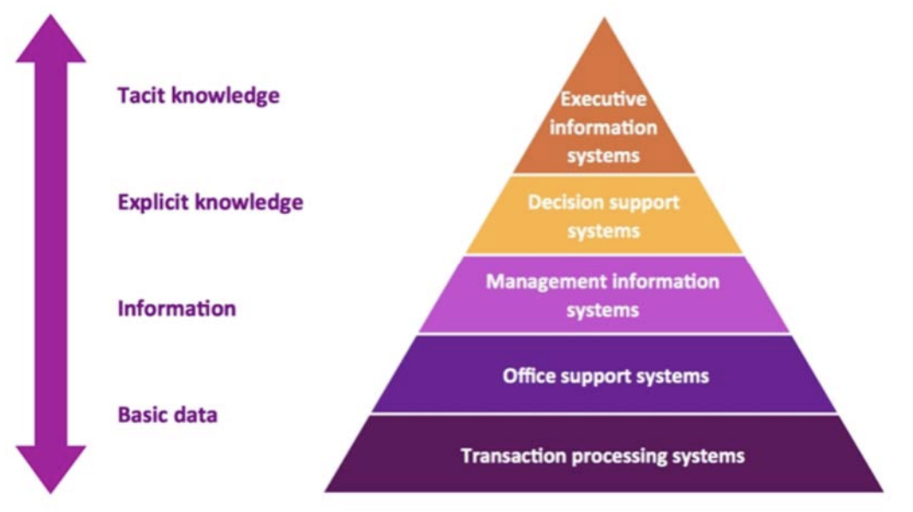
Figure 1: Pyramid for different types of Information Systems
(Source: Seun et al., 2023)
Martins and Belfo (2024) stated that ERP systems mainly optimise business processes by integrating them into other systems, which enables optimising business operations to maximise organisational competitiveness. It will allow the organisation to manage regular functions such as inventory tracking, financial documentation, supply chain activities and order processing in e-commerce within the unified database. Along with the ERP, Kalori Ltd needs to implement a centralised CRM system. Maaitah (2023) highlighted that CRM solutions are essential to enable organisations to professionally handle Customer data across multiple channels by consolidating and optimising procedures to offer a cohesive perspective to the company. It can support the company to capture and evaluate consumer information, such as product preferences, purchase behaviour, and history, to improve engagement and implement strong marketing strategies.
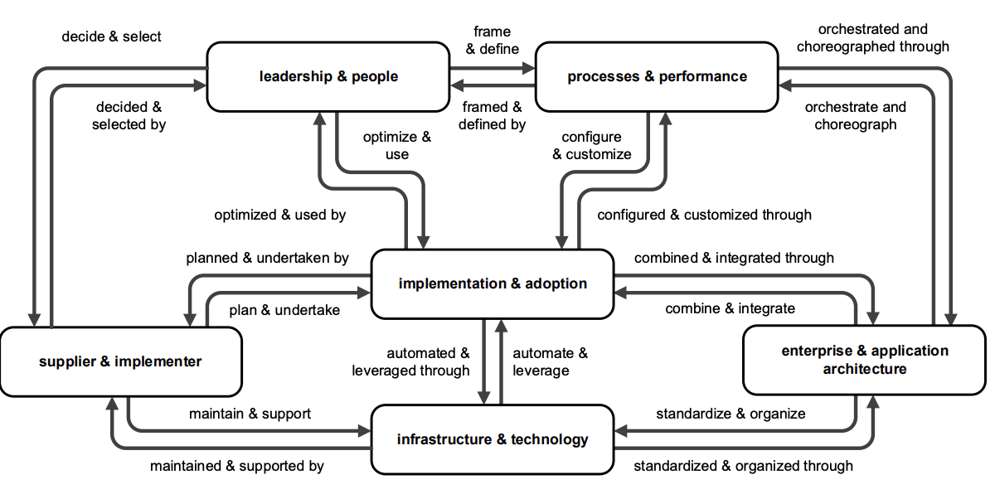
Figure 2: A systematic overview of the ERP system
(Source: Martins and Belfo, 2024)
Apart from the unified CRM platform, Kalori Ltd needs to adopt certain business intelligence tools such as Tableau and Power BI from Microsoft. The role of BI tools in decision-making efficiency can be perceived where it transforms raw data into interactive insights that support data-driven decision-making (Mwikali Helen, 2024). Therefore, these tools are capable of offering real-time insights through a dashboard where visualisation of data will enable managers to track sales performance while focusing on demand forecasting and evaluating market trends in an accurate manner. While implementing these systems in an integrated manner, digital technologies will enable Kalori Ltd to fundamentally strengthen business performance while improving overall organisational processes.

3.2 Justification based on business needs, efficiency, cost, and scalability
The integrated information system is mainly proposed as per the existing gaps and requirements of the organisation related to cost reduction, improved customer experience, operational efficiency and scalability. Primarily, the implementation of the ERP system will allow the organisation to eliminate the need for manual inventory tracking. The automation of inventory operations helps in gaining real-time data accurately while predicting demand and automating routine tasks to reduce understocking and overstocking issues (Daniel and Archie, 2024). Secondly, the solution proposed to the organisation will maximise operational effectiveness by decreasing reliance on manual and repetitive activities. Currently, employees of Kalori Ltd waste their time transferring data between multiple departments and compiling sales documents regularly. However, the organisational information processing theory has helped in combining the requirements of information processing of an organisation to maximise its capabilities (Fu et al., 2022). For that reason, the integrated digital system not only allows the ERP system to automate the majority of activities but also maximises the productivity of the company by minimising human errors.
Thirdly, cost-related justification can be offered by prioritising initial investment for the adoption of CRM and ERP systems, which provide benefits and efficiency in the long-term. The cloud-based ERP solutions offer subscription-based pricing, which can ensure affordability for the company (Pfajfar et al., 2022). Finally, the implementation of the CRM system will allow the marketing team of the organisation to organise targeted marketing campaigns. As per Relationship Marketing Theory, brands need to build mutually beneficial and trusted relationships in the long run to gain repeat business while fostering loyalty (Romero and Abad, 2022). It will help Kalori Ltd to address concerns regarding data security for customers, along with strengthening the relationship by protecting sensitive customer data from cyber-attacks.

3.3 Improvement of operations, data management, and decision-making
From the operational context, the use of the ERP system will optimise the inventory management and real-time order processing with improved visibility. The issues related to stock discrepancies can be addressed by maintaining visible stock to improve the accuracy of order fulfilment (Vaka, 2024). It directly contributes to the satisfaction level of customers.
From the perspective of data management, Kalori Ltd will be capable of maintaining a centralised database by integrating its CRM and ERP systems, through which customer and operational data can be accessed easily. The centralised data management minimises errors and duplication, ensuring improved accuracy of data (Adepoju et al., 2022). All departments of the organisation will have equal access to information in a consistent manner. For instance, the marketing team can easily access the sales data to perceive current trends and develop targeted campaigns to attract more customers.
From the context of decision-making, the use of BI tools will offer data-driven insights to make decisions. The use of KPIs in the BI dashboards can help in identifying major patterns and rapidly responding to market changes (Yerra, 2025). Therefore, the overall improvement will be reflected in the optimised inventory level, targeted marketing strategy and the resilient business performance.

4. Implementation Plan
The proposed solution for Kalori Ltd can be implemented by using a systematic and structured approach so that minimal disruption can be ensured in the existing business operation. In this context, the systems development life cycle (SDLC) model can be used to implement the new system in an effective way. Abduljabbar and Jalil (2023) stated that the SDLC is a structured process by which high-quality information systems can be developed through functional and technical guidance. It mainly includes seven essential stages by which user requirements are aligned with technical products to maximise efficiency and minimise risks. This model will allow the organisation to focus on the first stage of system analysis by identifying specific operational requirements of Kalori Ltd. For instance, this phase can allow important stakeholders such as marketing teams, store managers and the IT team to consult and perceive the system requirements. The next stage is to design and develop the system solution in accordance with the operational structure of the organisation.
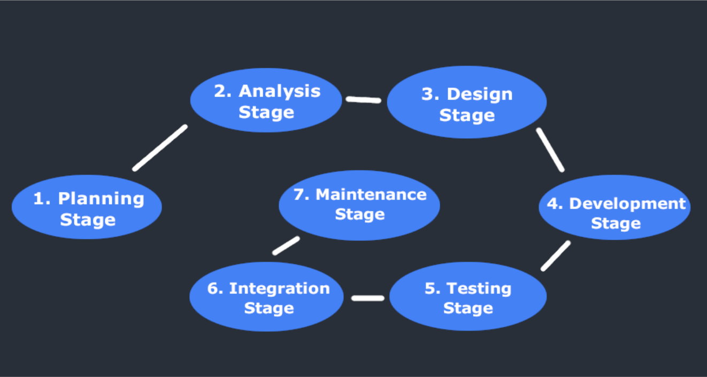
Figure 3: Stages of the SDLC model
(Source: Abduljabbar and Jalil, 2023)
In this stage, Kalori Ltd needs to confirm that the integration of the new system with other digital tools and the current e-commerce platform is performing effectively. Appropriate integration of the new system is important so that streamline flow of data can be ensured across various units (Alfawair, 2022). It will help the organisation to focus on the next stage, where the IT team will conduct pilot testing in some selected physical stores so that any technical problems can be identified. This phase helps in ensuring the effectiveness of the new system’s functionality. Finally, adequate training for employees needs to be provided while following a change management framework. In accordance with Kotter’s change management model, the sense of urgency is mainly created to develop a guiding coalition by which the strategic vision can be implemented through the voluntary army and generate short-term wins through pilot testing (Mouazen et al., 2024). It will help the company to manage challenges such as employee resistance, initial expenses for implementation and issues related to data migration.

5. Conclusion
The overall analysis of the business case related to Kalori Ltd has highlighted various operational issues such as limited integration between departments, manual inventory tracking, inefficiency in decision-making and fragmented customer data. While addressing these issues, this proposal has suggested the introduction of an integrated ERP system combined with BI tools and a CRM platform. It will provide benefits such as the improvement of accurate inventory management, enhanced Customer Relationship and data-driven decision-making based on real-time insights generated from digital technologies and platforms. Finally, the proposed Solution is projected to improve the organisational performance in the long run while positively contributing to customer satisfaction and operational efficiency.

Reference list
Abduljabbar, R. and Jalil, M.A. (2023) ‘Network-Centric Approaches in Systems Development Life Cycle (SDLC): A Comprehensive Survey’, Babylonian Journal of Networking, 2023, pp.77-81.
Adepoju, A.H., Austin-Gabriel, B.L.E.S.S.I.N.G., Eweje, A.D.E.O.L.U.W.A. and Collins, A.N.U.O.L.U.W.A.P.O. (2022) ‘Framework for automating multi-team workflows to maximize operational efficiency and minimize redundant data handling’, IRE Journals, 5(9), pp.663-664.
Adepoju, A.H., Austin-Gabriel, B.L.E.S.S.I.N.G., Eweje, A.D.E.O.L.U.W.A. and Collins, A.N.U.O.L.U.W.A.P.O. (2022) ‘Framework for automating multi-team workflows to maximize operational efficiency and minimize redundant data handling’, IRE Journals, 5(9), pp.663-664.
Alfawair, M. (2022) ‘Internet-of-things: A system development life cycle (sdlc)’, Journal of Theoretical and Applied Information Technology, 100(6), pp.1643-1653.
Bocij, P., Greasley, A. and Hickie, S. (2019) Business information systems: technology, development, and management for the modern business. Sixth edition. Harlow, England: Pearson.
Daniel, M. and Archie, O. (2024) ‘Optimizing SME inventory operations: IoT and automation for cost-effective stock management’, Journal of Supply Chain Innovation and Technology, 12(4), pp.55-70.
Fu, Q., Abdul Rahman, A.A., Jiang, H., Abbas, J. and Comite, U. (2022) ‘Sustainable supply chain and business performance: The impact of strategy, network design, information systems, and organizational structure’, Sustainability, 14(3), p.1080.
Haider, G. and Lucas, E. (2024, December) ‘Smart Inventory Management for SMEs: Leveraging IoT and Automation to Streamline Stock Control and Minimize Costs’, In Proc. Int. Conf. Ind. Eng. Innov. (pp. 88-95).
Labadie, C. and Legner, C. (2023) ‘Building data management capabilities to address data protection regulations: Learnings from EU-GDPR’, Journal of Information Technology, 38(1), pp.16-44.
Maaitah, T. (2023) ‘The Role of Business Intelligence Tools in the Decision Making Process and Performance’, Journal of intelligence studies in business, 13(1), pp. 43-52.
Martins, E.J. and Belfo, F.P. (2024) ‘A systemic framework for enterprise resource planning systems: A bibliometric networking analysis’, Procedia Computer Science, 239, pp.1549-1559.
Mouazen, A.M., Hernández-Lara, A.B., Abdallah, F., Ramadan, M., Chahine, J., Baydoun, H. and Bou Zakhem, N. (2024) ‘Transformational and transactional leaders and their role in implementing the Kotter change management model ensuring sustainable change: An empirical study’, Sustainability, 16(1), p.16.
Mwikali Helen, K. (2024) ‘The Role of Comprehensive Customer R-elationship Management (CRM) Systems in Achieving High Retention Rates’, International Digital Organization for Scientific Research, 10(1), pp. 33-35.
Naim, I., Rajuddin, W.O.N. and Ansyori, A. (2024) ‘Customer relationship management in the digital era to enhance customer experience through technology’, Transforma Jurnal Manajemen, 2(2), pp.120-128.
Odionu, C.S., Bristol-Alagbariya, B. and Okon, R. (2024) ‘Big data analytics for customer relationship management: Enhancing engagement and retention strategies’, International Journal of Scholarly Research in Science and Technology, 5(2), pp.050-067.
Pfajfar, G., Shoham, A., Małecka, A. and Zalaznik, M. (2022) ‘Value of corporate social responsibility for multiple stakeholders and social impact–Relationship marketing perspective’, Journal of business research, 143, pp.46-61.
Renaldo, N. (2022) ‘Benefits and challenges of technology and information systems on performance’, Journal of Applied Business and Technology, 3(3), pp.302-305.
Romero, J.A. and Abad, C. (2022) ‘Cloud-based big data analytics integration with ERP platforms’, Management Decision, 60(12), pp.3416-3437.
Seun, E.B.I.E.S.U.W.A., Babajide, G.E.G.E.L.E.S.O., Taye, F.A.L.A.N.A., Aderonke, A.D.E.G.B.E.N.J.O. and Olabode, B.A.M.I.S.I.L.E. (2023) ‘Impact of information systems on operational efficiency: A comprehensive analysis’, Indian journal of computer science and engineering, 14(4), pp.661-673.
Vaka, D.K. (2024) ‘Integrating inventory management and distribution: A holistic supply chain strategy’, the International Journal of Managing Value and Supply Chains, 15(2), pp.13-23.
Wahsheh, F.R., Marie, Z., Farea, M.M., Al-Haithami, W.A., Mohamad, F.S. and Bisht, N. (2023, October) ‘Operational Level System: Transaction Processing System and Decision Making’, In 2023 International Conference on Computer Science and Emerging Technologies (CSET) (pp. 1-7). IEEE.
Yerra, S. (2025) ‘Enhancing inventory management through real-time Power BI dashboards and KPI tracking’, International Journal of Scientific Research in Computer Science, Engineering and Information Technology, 11(3), pp.810-815.

