Component 2: Written Assignment (Report)

A Critical Analysis of Global, National and Local Policies Supporting SDG 3 (Good Health and Wellbeing) and SDG 4 (Quality Education)

Student Name: Salma Bibi
Student ID: 2315819
BMHP6030 - Health, Wellbeing and Sustainable Development
lecturer name: Philip Jones

Contents
1. Introduction 3
2. Section 1: SDG 3 - Good Health and Wellbeing 3
2.1. Overview of SDG 3 3
2.2. Global Policies 4
2.3. UK National Policies 5
2.4. Local Policies 6
2.5. Critical Evaluation 6
2.6. Recommendations 6
3. Section 2: SDG -4: Quality Education 7
3.1. Overview of SDG 7
3.2. Global Policies 8
3.3. UK National Policies 9
3.4. Local Policies 9
3.5. Critical Evaluation 10
3.6. Recommendations 10
4. Conclusion 10
References 11

Introduction
In 2015, the United Nations adopted the 17 Sustainable Development Goals (SDGs) as a global pledge to build a more sustainable equitable and prosperous world by 2030 (United Nations, 2015). These aims tackle interrelated issues like poverty, inequality, health, education and environmental sustainability. However, recent global disruptions, including the COVID-19 pandemic, geopolitical conflicts, and economic instability, have limited progress. According to recent global assessments, only 17% of SDG targets are currently on track, while many have stalled or even regressed (United Nations, 2024).
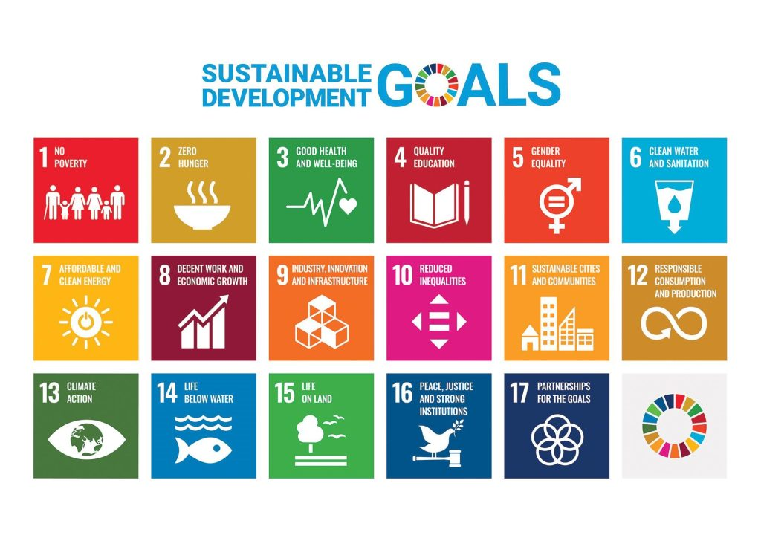
Figure 1 17 SDGS (United Nations, 2015)
This report analyses the importance of SDG 3: Good Health and Wellbeing and SDG 4: Quality Education and its potential impact on citizens wellbeing at global, national and local level and how this impact can be stronger if these two SDG are considered as interdependent. This report sets out to evaluate the effectiveness of international, national (UK) and local initiatives on these two SDGs and to provide theoretically appropriate recommendations for improvement based on evidence.

Section 1: SDG 3 - Good Health and Wellbeing

Overview of SDG 3
SDG 3 aims to ensure healthy lives and promote wellbeing for all at all ages (United Nations, 2022). It includes several targets like reducing global maternal mortality, ending preventable deaths of newborns and children, combating infectious diseases, reducing premature mortality from non-communicable diseases (NCDs), and achieving universal health coverage (UHC). Health is not just the result of biological factors; it is influenced by a variety of social, economic and environmental factors. The Dahlgren and Whitehead (1991) model represents these determinants in a layering approach: individual lifestyle factors, social networks, living conditions and wider socio-economic conditions.
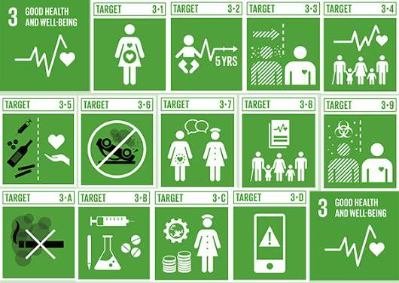
Figure 2 SDG 3 (United Nations, 2022)

Global Policies
On a global scale, there are various initiatives working towards SDG 3. The World Health Organization (WHO) has formulated a strategy to attain Universal Health Coverage (UHC), which aims to ensure that all individuals have access to essential health services without facing financial hardship (World Health Organization, 2025). Similarly, the Global Vaccine Action Plan (GVAP) has contributed to the worldwide enhancement of immunisation, saving 2.5 million lives annually from diseases like measles and polio (UNICEF, 2021). Furthermore, WHO Mental Health Action Plan considers the rising burden of mental health disorders, which are now one of the top causes of disability worldwide (WHO, 2025).
Yet, despite these advances, there are significant challenges. Almost 4.6 billion people globally lack access to key health services, and many are struggling to afford health care payments (World Bank Group, 2025). These limitations indicate that policies around the world have traditionally focused on the provision of health care services rather than the social determinants of health such as poverty and education.

UK National Policies
In the UK, SDG 3 is delivered through the National Health Service (NHS), supported by the NHS Long Term Plan (2019), which emphasises prevention, early diagnosis, and integrated care. It focuses on significant health issues such as cancer, cardiovascular diseases, and mental health, as well as increasing community-based services and digital healthcare access. NCD prevention strategies such as smoking cessation programmes and obesity reduction policies are also focused on reducing the burden of NCDs. Despite these initiatives, health inequalities persist across the UK. The life expectancy at birth is approximately 79.1 years for males and 83.0 years for females, but differences across regions are significant as illustrated in figure 2 (ONS, 2025). Those living in the most deprived areas suffer significantly poorer outcomes: male life expectancy is as low as 73.2yrs compared to 83.6yrs in affluent areas (ONS, 2025).
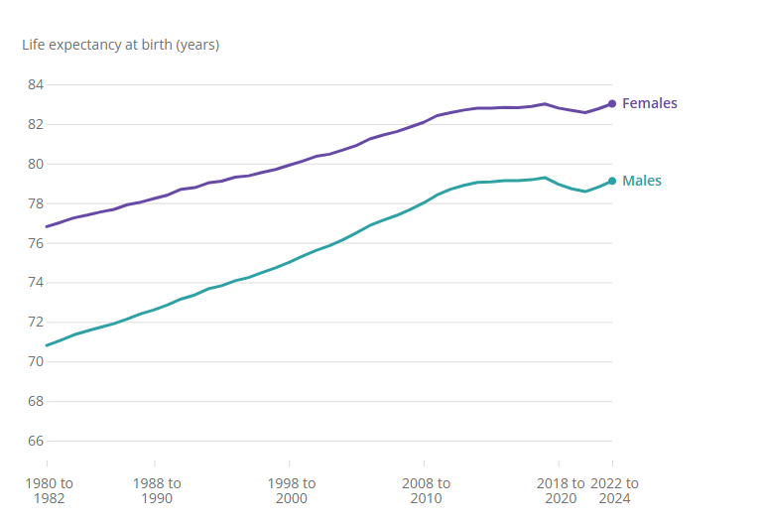
Figure 3 Life Expectancy UK (ONS, 2025)
In addition, the difference in healthy life expectancy between the most and least deprived is up to 19 years (NHS, 2025). The differences indicate that many health inequalities are structural, like poverty, housing and education and are in the outer layers of the Dahlgren and Whitehead model (Dahlgren & Whitehead, 2021). Thus, although NHS policies increase access to health services, they cannot be enough to tackle deep-rooted inequalities and integrated cross-sector approaches are needed.

Local Policies
Local authorities and the Greater Manchester Integrated Care System illustrate how SDG 3 is implemented, with targeted interventions against obesity, inequality and wider determinants of health. Manchester City Council's Making Manchester Fairer strategy is particularly focussed on addressing preventable ill health and includes a strong focus on social determinants of health, such as poverty, housing, employment and education (Manchester City Council, 2022). Further, the Manchester Healthy Weight Strategy (2020-2025) targets obesity reduction by addressing the issue through community-based interventions and identifies obesity as a key determinant of diabetes and cardiovascular disease (Manchester City Council, 2023).
Even with these efforts, health issues continue to be a big problem. Adult obesity in England stands at 26.6%, with higher prevalence in deprived urban areas (NHS, 2026). Local tools such as Joint Strategic Needs Assessment (JSNA) can be used to identify health needs and guide targeted interventions, allowing more responsive policymaking (Collins et al., 2019). Yet, since the local policies are not reflected in persistent inequalities, the community and living condition layers of the Dahlgren and Whitehead model are limited to a certain extent by funding constraints and structural socio-economic disparities.

Critical Evaluation
At the global, national and local level, SDG 3 programmes have helped to improve life expectancy, prevent diseases and increase access to healthcare overall. But there are still disparities in progress toward achieving the 2030 goals. One is the over-emphasis on downstream interventions which are solutions for a symptom of the problem, not solutions for the problem (upstream). Despite this, there are structural inequities in the UK linked to inequalities in health, with evidence of disparities in health systems within deprived communities, indicating that health systems alone are insufficient (Parbery et al., 2024). Also, health systems have been undermined by global crises like COVID-19 pandemic, and regression.

Recommendations
The journey towards SDG 3 needs a more integrated, preventative approach at all levels. Firstly, governments should boost investments in public health and prevention policies, including in efforts to tackle risk factors such as obesity, smoking, and poor mental health (Garg, 2025). Secondly, policies should be wider social determinants of health policies, including poverty, education, housing and employment, and require cross-sector working. Locally, it requires more funding and manpower support to enhance community-based interventions and to narrow down the gaps in the regions (Diyaolu, 2025). Also, there should be a strong focus on increasing access to mental health services and waiting times should be reduced. International cooperation and an equitable distribution of resources is crucial for low-income countries.

Section 2: SDG -4: Quality Education

Overview of SDG
SDG 4 aims to ensure inclusive and equitable quality education and promote lifelong learning opportunities for all (United Nations, 2023). Its targets include universal access to primary and secondary education, equal access to higher education, improved literacy and numeracy, and eliminating gender disparities. As education is a major social determinant of health, SDG 4 has a relationship with SDG 3. Increased education fosters health literacy, which helps people comprehend health information, adhere to treatment regimens, and make healthier living choices, and seek treatment more effectively (Zajacova & Lawrence, 2018). In contrast, limited education increases the risk of poor health outcomes due to low health literacy. In 2024, 273 million children and young people remained out of school, particularly in low-income and conflict-affected countries (UNESCO, 2026). Moreover, low health literacy is linked to poor disease management practices, decreased vaccination rates and increased hospital attendance, underscoring education in achieving SDG 3 (WHO, 2024).
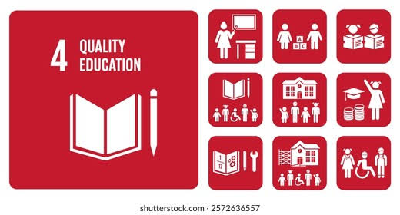
Figure 4 SDG 4 (United Nations, 2023)
The Health Belief Model (HBM) addresses how education impacts health behaviour. It proposes that individuals are more inclined to change unhealthy behaviours when they perceive the risks of diseases, the benefits of prevention, and self-confidence in acting (Annuar et al., 2020). Education can contribute towards the health literacy of a person by helping them to comprehend health information, adhere to therapy, and make health decisions. Thus, SDG 4 has direct linkages to SDG 3, for better health behaviours and health outcomes.

Global Policies
The SDG 4 is supported at the global level through different initiatives such as UNESCO Education 2030 Framework and Global Partnership for Education (GPE), which seek to increase access, enhance quality, and ensure equity for all learning systems globally (UNESCO, 2023). These structures have helped to boost enrolment: primary completion rates are at 88% at the global level. But the pace of progress has been slowed. Evidence shows that mothers with secondary education are more likely to vaccinate their children, practise good hygiene, and seek timely healthcare, contributing to lower child mortality up to 50% (ChildFund Alliance, 2025). Still, poverty, gender inequality, and conflict mean that 251 million children are out of school (UNESCO, 2024). In nations like Afghanistan, the lower education rates for girls limit understanding of childbirth, sanitation and family planning, leading to avoidable illness and death. Over a million girls denied the right to learn since ban imposed on secondary education in 2021 (UNICEF, 2026). Using the HBM, education improves health literacy and encourages healthier behaviours, but limited educational quality and persistent inequalities continue to restrict progress towards achieving SDG 3.
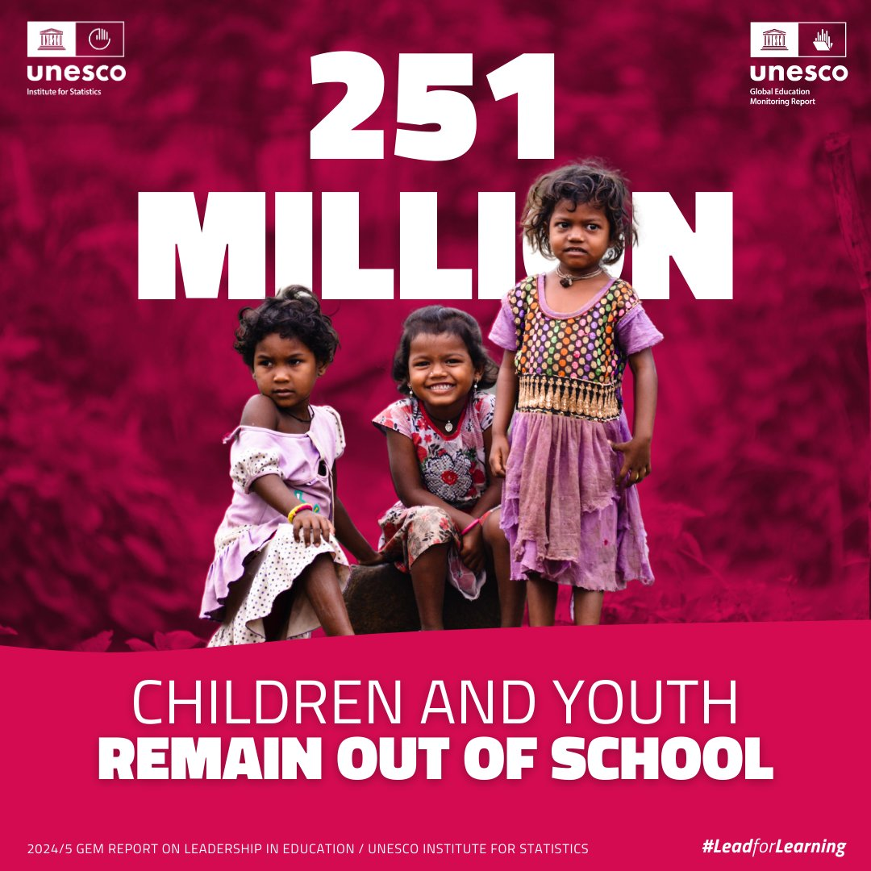
Figure 5 Childre remained out of School (UNESCO, 2024)

UK National Policies
In the UK, SDG 4 is promoted through policies like Pupil Premium, Skills for Jobs Strategy, and Adult Education Budget, which improve literacy, numeracy and learning (Department for Education, 2023). In addition to literacy this also helps SDG 3 to develop health literacy and understand health information. Individuals with higher education are more likely to attend health screenings, receive vaccinations and adopt healthier lifestyles, while those with limited literacy struggle to understand prescription labels, appointment letters and public health advice (Jordão et al., 2025). For example, people with diabetes who have poor health literacy are more likely to misunderstand dietary guidance and medication instructions, leading to poorer disease management and increased hospital admissions. Likewise, language barriers can lead to difficulties accessing health care or cause medication errors for migrants. According to HBM, education improves individuals' understanding of health risks and confidence in following medical advice (Shao et al., 2018). Yet, policies in the UK remain focused on education rather than on health literacy, and this limits their impact towards SDG3.

Local Policies
Locally, SDG 4 is supported through targeted initiatives like National Tutoring Programme (NTP), implemented across schools to reduce learning loss and attainment gaps following the COVID-19 pandemic. The programme offers small group and one to one tutoring especially amongst the disadvantaged pupils. As of 2023–24, 1.07 million pupils have been supported with tutoring, approximately 45.2% of whom had a disadvantaged background, which proves that educational inequality is being reduced (GOV.UK, 2024). Many local authorities also provide English for Speakers of Other Languages (ESOL) classes which allow migrants and refugees to communicate with healthcare providers, comprehend prescription information, and gain better access to NHS services. Community-based health education programmes educate parents on childhood immunisation, healthy nutrition, breastfeeding and prevention of diseases, education and health-related education (Awofala & Bilikis, 2024). However, inequalities remain. Funding constraints affected participation in educational support programs, with disadvantaged populations having less education and lower health indicators. According to HBM, improving access to education alone is insufficient unless individuals receive appropriate health education that enables them to understand risks, interpret medical advice and adopt healthy behaviours (Koelen & Van, 2023).

Critical Evaluation
Access to education and literacy were increased through SDG 4, which reflected a global positive impact in health literacy and health promotion. However, progress is not yet at a level that is sufficient to meet 2030 targets, and progress varies across areas. While school enrolment has risen, there are many who still do not have knowledge and skills to access medical information, adhere to treatment regimes, and adopt health prevention practices (Auld et al., 2020). Poverty, gender inequality, conflict and language barriers are reducing educational and health outcomes due to structural limitations. In terms of HBM, policies had a positive effect on access to education but not individuals' awareness of health risks, health benefits, and self-efficacy (Taba et al., 2022). Therefore, the education gaps remain a significant hindrance to SDG3, affecting ability to prevent disease, access health services and to maintain long-term health.

Recommendations
To support SDG 3 progress SDG 4 policies must be accompanied by health promotion to in turn bolster education policies. Governments need to refine and boost funding for communities in need, enhance literacy programmes and incorporate health literacy in educational curricula for adults and learners (Aidoo, 2023). More support to ESOL programmes and culturally appropriate health communication would lead to less language barrier and better access to health care (Pandey et al., 2021). Lastly, greater integration between education and health and local government is required to address broader social determinants of health and ensure that better learning results in longer health spans.

Conclusion
There are tight links between SDG 3 and SDG 4, with education affecting health literacy, access to health and health behaviour, and good health enhancing participation in education and life-long learning. Although global, national and local initiatives have improved healthcare and educational access, persistent inequalities related to poverty, gender, language and deprivation continue to limit progress towards the 2030 Agenda.

References
Aidoo, E. M. (2023). Social determinants of health: examining poverty, housing, and education in widening US healthcare access disparities. World Journal of Advanced Research and Reviews, 20(1), 1370-89. https://doi.org/10.30574/wjarr.2023.20.1.2018
Auld, M. E., Allen, M. P., Hampton, C., Montes, J. H., Sherry, C., Mickalide, A. D., ... & Parson, K. (2020). Health literacy and health education in schools: collaboration for action. NAM perspectives, 2020, 10-31478.
Awofala, T. B., & Bilikis, L. A. (2024). Parental health education and its influence on early childhood learning. World Journal of Biology Pharmacy and Health Sciences, 20(3), 241-247. https://doi.org/10.30574/wjbphs.2024.20.3.1004
Anuar, H., Shah, S. A., Gafor, H., Mahmood, M. I., & Ghazi, H. F. (2020). Usage of Health Belief Model (HBM) in health behavior: A systematic review. Malaysian Journal of Medicine and Health Sciences, 16(11), 2636-9346.
ChildFund Alliance (2023). Education: A Beacon for Child Survival and Thriving Communities - ChildFund Alliance. [online] ChildFund Alliance -. Available at: https://childfundalliance.org/blog/2023/11/21/education-a-beacon-for-child-survival-and-thriving-communities/.
Collins, R., Silarova, B., & Clare, L. (2019). Dementia primary prevention policies and strategies and their local implementation: A scoping review using England as a case study. Journal of Alzheimer’s Disease, 70(s1), S303-S318.
Dahlgren, G., & Whitehead, M. (1991). Policies and strategies to promote social equity in health. Stockholm: Institute for future studies, 27(1), 4-41. https://doi.org/10.3233/jad-180608
Dahlgren, G., & Whitehead, M. (2021). The Dahlgren-Whitehead model of health determinants: 30 years on and still chasing rainbows. Public health, 199, 20-24. https://doi.org/10.1016/j.puhe.2021.08.009
Department for Education (2025). Pupil Premium: Overview. [online] Gov.UK. Available at: https://www.gov.uk/government/publications/pupil-premium/pupil-premium.
Diyaolu, C. O. (2025). Advancing maternal, child, and mental health equity: A community-driven model for reducing health disparities and strengthening public health resilience in underserved US communities. World J Adv Res Rev, 26(03), 494-515. https://doi.org/10.30574/wjarr.2025.26.3.2264
Garg, R. K. (2025). The alarming rise of lifestyle diseases and their impact on public health: A comprehensive overview and strategies for overcoming the epidemic. Journal of Research in Medical Sciences, 30(1), 1. DOI: 10.4103/jrms.jrms_54_24
GOV.UK (2025). National Tutoring Programme, Academic year 2023/24. [online] explore-education-statistics.service.gov.uk. Available at: https://explore-education-statistics.service.gov.uk/find-statistics/national-tutoring-programme/2023-24.
Gul, S., Fatima, B., & Akhtar, N. (2025). Gender equality in education: Addressing structural barriers and social norms Asian context. The Critical Review of Social Sciences Studies, 3(1), 2839-2854.
Jordão, I., Paiva, P., Dias, P., António, N., & Parente, F. (2025). Health literacy and medication adherence in polypharmacy: a systematic review for clinical practice. Cureus, 17(7). DOI: 10.7759/cureus.88301
Koelen, M. A., & Van den Ban, A. W. (2023). Health education and health promotion. Brill.
Manchester City Council (2022). Making Manchester Fairer | Making Manchester Fairer | Manchester City Council. [online] Manchester.gov.uk. Available at: https://www.manchester.gov.uk/health-and-wellbeing/public-health/making-manchester-fairer.
Manchester City Council (2023). Manchester Health and Wellbeing Board Report for Resolution. [online] Available at: https://democracy.manchester.gov.uk/documents/s36129/manchester%20healthy%20weight%20declaration.pdf.
NHS (2025). NHS England» Health inequalities and equality legal duties: A reference document for NHS commissioners and providers. [online] England.nhs.uk. Available at: https://www.england.nhs.uk/long-read/health-inequalities-equality-legal-duties.
NHS (2026). Adults’ overweight and obesity. [online] Digital.nhs.uk. Available at: https://digital.nhs.uk/data-and-information/publications/statistical/health-survey-for-england/2024/adults-overweight-and-obesity.
ONS (2025). National life tables – life expectancy in the UK. [online] Ons.gov.uk. Available at: https://www.ons.gov.uk/peoplepopulationandcommunity/birthsdeathsandmarriages/lifeexpectancies/bulletins/nationallifetablesunitedkingdom/2022to2024.
Pandey, M., Maina, R. G., Amoyaw, J., Li, Y., Kamrul, R., Michaels, C. R., & Maroof, R. (2021). Impacts of English language proficiency on healthcare access, use, and outcomes among immigrants: a qualitative study. BMC health services research, 21(1), 741. https://doi.org/10.1186/s12913-021-06750-4
Parbery-Clark, C., McSweeney, L., Lally, J., & Sowden, S. (2024). How can health systems approach reducing health inequalities? An in-depth qualitative case study in the UK. BMC Public Health, 24(1), 2168. https://doi.org/10.1186/s12889-024-19531-5
Shao, C., Wang, J., Liu, J., Tian, F., & Li, H. (2018). Effect of a Health Belief Model-based education program on patients’ belief, physical activity, and serum uric acid: a randomized controlled trial. Patient preference and adherence, 1239-1245. https://doi.org/10.2147/PPA.S166523
Taba, M., Allen, T. B., Caldwell, P. H., Skinner, S. R., Kang, M., McCaffery, K., & Scott, K. M. (2022). Adolescents’ self-efficacy and digital health literacy: a cross-sectional mixed methods study. BMC Public Health, 22(1), 1223. https://doi.org/10.1186/s12889-022-13599-7
UNESCO (2023). Home | #LeadingSDG4 | Education2030. [online] www.unesco.org. Available at: https://www.unesco.org/sdg4education2030/en.
UNESCO (2024). 251M children and youth still out of school, despite decades of progress (UNESCO report). [online] Unesco.org. Available at: https://www.unesco.org/en/articles/251m-children-and-youth-still-out-school-despite-decades-progress-unesco-report.
UNESCO (2025). 2026 GEM Report. [online] Unesco.org. Available at: https://www.unesco.org/gem-report/en/publication/equity-and-access.
UNESCO (2026). Out-of-school rate. [online] Unesco.org. Available at: https://www.unesco.org/en/education/view/outofschool.
Unicef (2026). Restrictions on girls’ education and women’s employment in Afghanistan could lead to a loss of over 25,000 female teachers and health workers by 2030 - UNICEF. [online] Unicef.org. Available at: https://www.unicef.org/press-releases/restrictions-girls-education-and-womens-employment-afghanistan-could-lead-loss-over.
UNICEF (2021). Title of Section (TK) Global Vaccine Action Plan. [online] Available at: https://www.unicef.org/mena/sites/unicef.org.mena/files/press-releases/mena-media-GVAP_single_pages_PRINT.pdf.
United Nations (2015). The 17 sustainable development goals. [online] United Nations. Available at: https://sdgs.un.org/goals.
United Nations (2022). Goal 3: Ensure healthy lives and promote well-being for all at all ages. [online] United Nations Sustainable Development Goals. Available at: https://www.un.org/sustainabledevelopment/health/.
United Nations (2023). Goal 4: Ensure inclusive and equitable quality education and promote lifelong learning opportunities for all — SDG Indicators. [online] unstats.un.org. Available at: https://unstats.un.org/sdgs/report/2017/goal-04/.
United Nations (2024). With Less than One Fifth of Targets on track, World Is Failing to Deliver on Promise of the Sustainable Development Goals, Warns New UN Report | United Nations. [online] United Nations. Available at: https://www.un.org/en/with-less-than-one-fifth-of-targets-on-track.
WHO (2025). WHO EMRO - Mental health and substance use. [online] Who.int. Available at: https://www.emro.who.int/mnh/mental-health-action-plan/.
World Bank Group (2025). Universal Health Coverage | World Bank Group. [online] Worldbank.org. Available at: https://www.worldbank.org/ext/en/topic/health/universal-health-coverage.
World Health Organization (2025). Universal Health Coverage (UHC). [online] World Health Organization. Available at: https://www.who.int/news-room/fact-sheets/detail/universal-health-coverage-(uhc).
Zajacova, A., & Lawrence, E. M. (2018). The relationship between education and health: reducing disparities through a contextual approach. Annual review of public health, 39, 273-289. https://doi.org/10.1146/annurev-publhealth-031816-044628

