Black Dragon STudios
Market Analysis Document
Creative Video Game Design
Module: Creative Enterprise and Practice
Lecturers: Al Kang, Jessica Lacombe
Word Count: 2159
Ben Long
P144121

Declaration

All work is written by Ben Long and any work that isn’t has been correctly referenced by the Harvard referencing system. ‘The Scraptown Showdown’ is licensed and owned by Black Dragon studios and any work that has been conducted belongs to the studio.

Signed:

Print: Ben Long
Date: 10/12/18
Contents
Abstract 3
Product Overview 4
Brief Summary 4
Unique Selling Points 4
Demographics 5
Primary Audience 5
Secondary Audience 5
Market Analysis 6
VR Market 6
Software Market 6
Marketing Strategy 8
Conclusion 9
References 10
Bibliography 12
Appendices 15
Appendix A 15
Appendix B 16
Appendix C 17
Appendix D 18
Appendix E 19
Appendix F 20

Abstract
This report analyses the current VR market by using reports published from over the last few years. It shows an opening in the market to release ‘The Scraptown Showdown’, a VR shooter set in a sci-fi western. It hypothesises the units sold by looking at current VR games on the market, some of which have been successful and sold over 150,000 units and made over $2 million in revenue. This report also highlights the potential of the VR market with some headsets selling over 3 million units. The target audience has been identified and separated into primary and secondary audiences, which have been hypothesised by looking at similar titles. The report will show the current market strategy for ‘The Scraptown Showdown’ which is aiming for release in Q3 2019 with the additional release of extra content post launch.

Product Overview

Brief Summary
‘The Scraptown Showdown’ is a VR shooter set in a science fiction western, with arcade styled gameplay coming to the Oculus Rift, PSVR and HTC Vive. The player is a bounty hunter and will have to fight their way through classic western settings with a sci-fi twist, upgrade their arsenal with various weapons and rid the west of the murderous Scrap-bots.

Unique Selling Points
The main logline for the game is ‘Tin can alley gone mad’ as one of the main draws of the game is to bring the feeling of a tin can alley game to virtual reality. The main hook is the quick shot, quick draw aspect, in which players will always have two guns on their hip holsters, like you’d see in classic western films, ready to be drawn and ready to be used. ‘The Scraptown Showdown’ offers fast paced action, so the player will be constantly moving forward, in and out of cover, with their guns at the ready. The game aims to have very few moments of nothing to shoot at or interact with. ‘The Scraptown Showdown’ offers arcade styled gameplay by having high scores in the millions and over the top multipliers, it is offering a recreation of the classic arcade setting.
Interactivity, or more commonly known as affordance in the game industry, is another main hook of the game. Affordance refers to an action an object can communicate a way use it (McBride-Charpentier, 2011). For example, a desk with a drawer handle creates an affordance to open it (Game Development Stack Exchange, 2016). In ‘The Scraptown Showdown’, if an object looks like it can be picked up, it should be able to be picked up. Mitch McCaffrey (2017) states, ‘Failing a player’s expectation in a game is almost never a good thing; however failing a player’s expectations in a VR experience is completely immersion breaking.’ And ‘The Scraptown Showdown wants to keep that immersion. Lastly, the game is going for a pick up and play with a low bar for entry. The game should be easy to get into and easy to get out of, offering simple controls that players can quickly get used too.

Demographics

Primary Audience
According to the Entertainment Software Association (2017) the average age of a person who owns a VR headset is 31 (Appendix A), so the main target audience will be between the ages of 30 – 40. Of that audience the most common VR activity is playing a single player video game (ESA, 2017). The primary audience would be looking for a quick, fun experience, which ‘The Scraptown Showdown’ can provide as it aims for the pick up and play aspect. The game will be something the audience can play between chores or after they have come home from work. The primary audience should have disposable income due to the price of a VR headset, and as they are more likely to be in a full time job at that age they should have the disposable income. They will also be interested in technology as VR is a relatively new technology and the audience will want to keep up with current trends.

Secondary Audience
The secondary audience would be between the ages of 15- 25 year olds. According to a poll on Reddit, asking about the demographics for ‘Red Dead Redemption 2’ (Rockstar Games, 2018), out of over 2000 votes around 83% of the audience were under 19 to 29 years old (Appendix B). Though it may have been through Reddit, so the results may seem more skewed depending on the people who use the platform, it does show that between these age groups that they are going to be playing a western themed game. This could be due to the fact that it is a sequel to the original ‘Red Dead Redemption’ (Rockstar Games, 2010), however this doesn’t deny the fact that this audience is interested in the genre in the first place. The audience will be interested and enjoy shooters as that is the main genre of ‘The Scraptown Showdown’. They will also enjoy the fast paced gameplay of ‘The Scraptown Showdown’. Lastly they must also be interested in technology, as they don’t have the disposable income compared to the primary audience, if they are interested in tech they would get it through other means.

Market Analysis

VR Market
According to the Superdata 2017 review (2017) VR generated $4 billion in 2017 and console generated $8.3 billion. VR made almost half of what console made which is higher compared to the Superdata 2016 review (2016), which had console generating $6.6 billion and VR generating $2.7 billion (Superdata, 2016). 55% of VR software revenue out of a total of $554 million, came from video games in 2017 (Appendix C) and roughly four in five headset owners’ use or plan to use VR to play video games (Superdata, 2018). According to the Consumer Technology association (Business Wire, 2018) the US alone will see $1.2 billion alone in VR revenue which will grow by 10% each year. If this estimation is correct then the US will have ¼ of the global VR market in 2018.
UKIE (2018) claim that by 2022 VR content will generate $21.2 billion a year with $12 billion of the revenue from video games. UKIE (2018) state that the UK’s fastest growing entertainment and media sector is VR and it’s expected to grow by 34% annually to reach $1.2 billion a year in revenue by 2022 (UKIE, 2018). In 2018 Sony announced that they had sold over 3 million headsets and over 21.9 million PSVR games and experiences from its initial launch (Yee, 2018), which has almost doubled the 1.6 million units sold in 2017(Appendix D).

Software Market
In 2016, ‘Raw data’ (Survios, 2016), a sci-fi themed, VR ‘wave shooter’, became the first VR game to make $1 million dollars in revenue (Handrahan, 2016), retailing at $39.99 it currently has over 152,000 owners on Steam (Galyonkin, 2015) and in 2017 we can see that it made around $2.5 million on PC (Appendix E). ‘Beat Saber’ (Beat Games, 2018), a score based, fast paced rhythm game with impressive visuals, had sold over 100,000 copies in its first month and made over $2 million in revenue (Lang, 2018), retailing at $19.99 it currently has over 282,000 units on steam (Galyonkin, 2015).
Similar titles of the same genre, ‘Arizona Sunshine’ (Vertigo Games, 2016), a zombie shooter, has sold over 168,000 units on steam retailing currently at $19.99 (Galyonkin, 2015) and it also made $2.4 million on PC (Appendix C). ‘Superhot VR’ (Superhot Team, 2017), a shooter game which time only moves when the player moves, has sold over 158,000 units on Steam, retailing at $24.99. From the Superdata report on XR (2018) we can also see that ‘Superhot VR’ (Superhot Team, 2017) made $3 million in revenue through PC sales and an additional $1.1 million through PSN in 2017 (Appendix C). All the games stated are currently on PSN, Oculus Store, Viveport and Steam. Where these figures only take into account the Steam figures, excluding the data taken from Superdata (2018), their actual figures are possibly much higher among all platforms.
Other VR titles sometimes suffer in sales due to exclusivity on the platform. For example ‘Borderlands 2 VR’ (Gearbox Software, 2018) is currently exclusive to PSVR, however this title may also boost the sales of the PSVR platform, and ‘Robo Recall’ (Epic Games, 2017) is only available on the Oculus Rift. By targeting all VR platforms it will increase the overall product sales.
‘Red Dead Redemption 2’ (Rockstar Games, 2018) announced that within its first 8 days of launch it had sold over 17 million units (Take-Two Interactive, 2018). This may be a non VR game and a sequel but it does not subtract from the fact that it is a western themed game which has sold very well, implying that there is a large target audience. If you use this data with the poll from taken from Reddit (Appendix B) it is clear that the second target audience will be interested in ‘The Scraptown Showdown’.

Marketing Strategy
The game will start development in the Q3 of 2018, so development has already started, and the game will be aiming for a Q3 2019 launch (See Appendix F for visual timeline). With ‘Red Dead Redemption 2’ (Rockstar Games, 2018) releasing in Q4 of 2018, Q3 2019 would be a good time to release a western themed VR game as the subject should still be fresh within the proposed audience’s minds. ‘John Wick 3’ (Summit Entertainment, 2019) is due for release in May 2019, so the proposed audiences will be focused on fast paced shooting action, which “The Scraptown Showdown” can provide.
In Q1 of 2019 an early taster demo will be released, titled ‘The Scraptown Carnival’. The demo will be an early showcase of the game to generate interest and create a community. Constant interaction with this community will give feedback for the future development and also from the players, a few will be chosen to become regular game testers.
The production cycle will last approximately nine months, with the last three months focusing on post production. During the post production period there will be a strong marketing push to show the game, the game will also be shown at conventions such as PAX East, Eurogamer, and London Comic Con. A demo of the full game will be available one month before release, which will be a more updated version compared to ‘The Scraptown Carnival’ as it will be more representative of the final version. Before the game is launched, as part of the marketing push, the 1st free content update will be announced prior to launch so players will be aware of upcoming content.
‘The Scraptown Showdown’ will be launched on PSN, Steam, Oculus Store and Vive Port retailing at £14.99 per unit. Epic Games also announced their own video game service so it is another possibility to look into if they allow VR support. The game will be download only as this will cost less money than making it a physical release. The primary sales period will be over the next twelve months, post launch, while also offering regular game updates to fix bugs, balance weapons.
After a month break post launch, a six month downloadable content (DLC) production cycle will begin. The DLC will then be launched halfway through the sales period, around Q1 of 2020 which will be close to the winter holiday period. The DLC would have been announced before the game launch to the audience will be expecting and looking forward to it. Regular social media updates will also keep the community in the loop. On the 1st anniversary of the games launch, Q3 2020, a free anniversary update will be available to existing and future players. This will be possibly adding new weapons, a new level etc. After this there will be a review on where how to continue with the series, such as possible sequels or spin off games.

Conclusion
From the Superdata reports (2017, 2018) it is clear that the VR market is increasing, where it may not be increasing as much as the console sales it still generates up to half the revenue of console (Superdata, 2018). Unfortunately a lot of reports that were critical to this research were not free so accessing certain data was not available. The data that was available was adequate to prove that VR titles can sell and that the VR market will be a good source of revenue that will increasing. Using the other VR games as a reference, quality VR titles sell well and by expanding to each market, Oculus store, PSN, Vive Port and Steam, it will only further increase the sales. Where Steam’s marketplace does have a lot of titles, PSN and Oculus store have more quality control, and ‘The Scraptown Showdown’ is more likely to sell better on these stores. The release date of ‘The Scraptown Showdown’ is adequate, it does feel if it was closer to the release of ‘Red Dead Redemption 2’ (Rockstar Games, 2018) then the sales would be better. However the online capabilities of ‘RDR2’ (Rockstar Games, 2018) means that they will have regular updates so the life span of their game will be longer and it will still be in the minds of the demographic. By offering a VR shooter set in a western setting, where ‘The Scraptown Showdown’ will not get the same sales as ‘RDR2’ (Rockstar Games, 2018), it will gain momentum from a player base looking for other western experiences. Scheduling regular game updates and constant community contact will ensure that ‘The Scraptown Showdown’ will offer the best possible experience for the player and the future DLC content will allow players to anticipate more content. ‘The Scraptown Showdown’ will be a viable product that can achieve a good amount of sales and revenue.

References
Businesswire.com. (2018). AR/VR Will Open Eyes in 2018: Record-Setting U.S. Sales Projected, Says CTA. [online] Available at: https://www.businesswire.com/news/home/20180104005814/en/ARVR-Open-Eyes-2018-Record-Setting-U.S.-Sales [Accessed 5 Dec. 2018].
Entertainment Software Association (2017). 2017 SALES, DEMOGRAPHIC, AND USAGE DATA. ESSENTIAL FACTS ABOUT THE COMPUTER AND VIDEO GAME INDUSTRY. [online] Entertainment Software Association. Available at: http://www.theesa.com/ [Accessed 5 Dec. 2018].
Entertainment Software Association (2018). 2018 SALES, DEMOGRAPHIC, AND USAGE DATA. ESSENTIAL FACTS ABOUT THE COMPUTER AND VIDEO GAME INDUSTRY. [online] Entertainment Software Association. Available at: http://www.theesa.com/ [Accessed 5 Dec. 2018].
Galyonkin, S. (2015). Games sales. [online] SteamSpy - All the data about Steam games. Available at: https://steamspy.com/ [Accessed 9 Dec. 2018].
Game Development Stack Exchange. (2016). What are "affordances" in game design?. [online] Available at: https://gamedev.stackexchange.com/questions/128479/what-are-affordances-in-game-design [Accessed 5 Dec. 2018].
Handrahan, M. (2016). Raw Data the first VR game to make $1m in a month - report. [online] GamesIndustry.biz. Available at: https://www.gamesindustry.biz/articles/2016-09-16-raw-data-the-first-vr-game-to-make-usd1m-in-a-month-report [Accessed 5 Dec. 2018].
Lang, B. (2018). 'Beat Saber' Sells 100K Units in First Month for $2 Million in Revenue. [online] Road to VR. Available at: https://www.roadtovr.com/beat-saber-sells-50k-units-first-week-1-million-revenue/ [Accessed 5 Dec. 2018].
McBride-Charpentier, M. (2011). Affordance Design in Half-Life 2. [Blog] Gamasutra. Available at: https://www.gamasutra.com/blogs/MichelMcBrideCharpentier/20110102/88710/Affordance_Design_in_HalfLife_2.php [Accessed 9 Dec. 2018].
McCaffrey, M. (2017). Unreal engine VR cookbook. Boston [etc.]: Addison-Wesley.
Pettit, N. (2014). What Are Affordances in Web Design?. [Blog] Treehouse. Available at: https://blog.teamtreehouse.com/affordances-web-design [Accessed 9 Dec. 2018].
SuperData (2016). 2016 Year in Review. Digital Games in Interactive Media. [online] Super Data Research.
SuperData (2017). 2017 Year in Review. Digital Games in Interactive Media. [online] Super Data Research.
Superdata (2018). Nowhere to go but up: The Future of XR. Superdata Research.
Take-Two interactive (2018). Take-Two Interactive Software, Inc. Reports Strong Results for Fiscal Second Quarter 2019. [online] New York: Take-Two Interactive. Available at: http://ir.take2games.com/phoenix.zhtml?c=86428&p=irol-newsArticle&ID=2375981 [Accessed 5 Dec. 2018].
UKIE (2018). UK Video Games Fact Sheet. UKIE, pp.24-32.
Yee, M. (2018). Celebrating 3 Million PS VR Systems Sold. [Blog] Playstation Blog. Available at: https://blog.us.playstation.com/2018/08/16/celebrating-3-million-ps-vr-systems-sold/ [Accessed 5 Dec. 2018].

Bibliography
Buckley, S. (2017). 'From Other Suns' lets players move in VR however they want. [online] Engadget. Available at: https://www.engadget.com/2017/02/28/from-other-suns-lets-players-move-in-vr-however-they-want/?guccounter=1 [Accessed 6 Dec. 2018].
Barker, S. (2018). Soapbox: PSVR Has Quietly Had an Outstanding Year. [online] Push Square. Available at: http://www.pushsquare.com/news/2018/11/soapbox_psvr_has_quietly_had_an_outstanding_year [Accessed 6 Dec. 2018].
Best Buy (2018). Aperçu du casque Vive Pro de HTC - Blogue Best Buy. [online] Blogue Best Buy. Available at: https://blogue.bestbuy.ca/en-vedette-chez-bestbuy/htc-vive-pro-overview [Accessed 6 Dec. 2018].
Cashin, R. (n.d.). John Wick: Chapter 3 has cast its villain | JOE.ie. [online] JOE.ie. Available at: https://www.joe.ie/movies-tv/john-wick-chapter-3-cast-villain-613323 [Accessed 6 Dec. 2018].
Dvorakova, M. (2018). Hit Rhythm Action Game Beat Saber Coming to PS VR. [online] PlayStation.Blog. Available at: https://blog.us.playstation.com/2018/06/10/hit-rhythm-action-game-beat-saber-coming-to-ps-vr/ [Accessed 6 Dec. 2018].
Dwan, H. (2017). Killing Floor: Incursion for the Oculus Rift is out now. [online] PCGamesN. Available at: https://www.pcgamesn.com/killing-floor-incursion/killing-floor-incursion-vr-release-date [Accessed 6 Dec. 2018].
Epic Games' Fortnite. (n.d.). Epic Games' Fortnite. [online] Available at: https://www.epicgames.com/fortnite/en-US/home [Accessed 6 Dec. 2018].
Expert Reviews. (2018). How to download Amazon Prime Video for offline playback. [online] Available at: https://www.expertreviews.co.uk/tvs-entertainment/media-streamers/1404653/how-to-download-amazon-prime-video-for-offline-playback [Accessed 6 Dec. 2018].
Facebook.com. (n.d.). Netflix. [online] Available at: https://www.facebook.com/netflix/ [Accessed 6 Dec. 2018].
Hayden, S. (2017). 'Raw Data' Early Access Review, Now with Oculus Touch Support – Road to VR. [online] Road to VR. Available at: https://www.roadtovr.com/review-raw-data-htc-vive-vr-shooter/ [Accessed 6 Dec. 2018].
King, J. (2018). House of the Dead is making a comeback to arcades after a decade of absence | Trusted Reviews. [online] Trusted Reviews. Available at: https://www.trustedreviews.com/news/house-of-the-dead-making-comeback-arcades-decade-absence-3372071 [Accessed 6 Dec. 2018].
Magee, M. (2017). 'Robo Recall' Review – Road to VR. [online] Road to VR. Available at: https://www.roadtovr.com/robo-recall-review/ [Accessed 6 Dec. 2018].
McWhetor, M. (2018). Borderlands 2 coming to PlayStation VR. [online] Polygon. Available at: https://www.polygon.com/2018/10/9/17954910/borderlands-2-vr-ps4-playstation-vr [Accessed 6 Dec. 2018].
Microsoft Store. (2018). Buy Call of Duty®: Black Ops 4 - Microsoft Store. [online] Available at: https://www.microsoft.com/en-us/p/call-of-duty-black-ops-4/c19n0723phfl?activetab=pivot%3Aoverviewtab [Accessed 6 Dec. 2018].
Newell, A. (n.d.). How to Stream on Twitch from a Console. [online] Dot Esports. Available at: https://dotesports.com/news/news/how-to-stream-twitch-console-20556 [Accessed 6 Dec. 2018].
Newell, A. (n.d.). How to Stream on Twitch from a Console. [online] Dot Esports. Available at: https://dotesports.com/news/news/how-to-stream-twitch-console-20556 [Accessed 6 Dec. 2018].
PlayStation. (2018). Shooty Fruity. [online] Available at: https://www.playstation.com/en-us/games/shooty-fruity-ps4/ [Accessed 6 Dec. 2018].
Prescott, S. (2016). The American Dream is a game about performing menial tasks with guns. [online] pcgamer. Available at: https://www.pcgamer.com/the-american-dream-is-a-game-about-performing-menial-tasks-with-guns/ [Accessed 6 Dec. 2018].
VR Focus. (2017). Preview: Guns’n’Stories: Bulletproof VR – A Rootin’ Tootin’ Gunslinger. [online] VRFocus. Available at: https://www.vrfocus.com/2017/09/preview-gunsnstories-bulletproof-vr-a-rootin-tootin-gunslinger/ [Accessed 6 Dec. 2018].
Regan, T. (2017). Arizona Sunshine Review | Trusted Reviews. [online] Trusted Reviews. Available at: https://www.trustedreviews.com/reviews/arizona-sunshine [Accessed 6 Dec. 2018].
Rockstar Games. (2018). Red Dead Redemption 2 Extended Previews - Rockstar Games. [online] Available at: https://www.rockstargames.com/newswire/article/60606/Red-Dead-Redemption-2-Extended-Previews [Accessed 6 Dec. 2018].
Steam. (2018). Wanted Killer VR on Steam. [online] Store.steampowered.com. Available at: https://store.steampowered.com/app/759540/Wanted_Killer_VR/ [Accessed 6 Dec. 2018].
Ventor, J. (2016). Oculus Spotlight: Time is on Your Side in the Visually-Mesmerizing FPS, SUPERHOT VR | GeForce. [online] Geforce.com. Available at: https://www.geforce.com/whats-new/articles/vr-supershot [Accessed 6 Dec. 2018].
Windows Central (2018). Red Dead Online: Everything we know about Red Dead Redemption 2 multiplayer. [online] Windows Central. Available at: https://www.windowscentral.com/red-dead-online [Accessed 6 Dec. 2018].
YouTube. (2017). Oculus Rift | Step into Rift – now only $399. [online] Available at: https://www.youtube.com/watch?v=5q6BcQq_yhw [Accessed 6 Dec. 2018].

Appendices

Appendix A
The Virtual Reality page taken from the 2017 SALES, DEMOGRAPHIC, AND USAGE DATA. ESSENTIAL FACTS ABOUT THE COMPUTER AND VIDEO GAME INDUSTRY (ESA, 2017).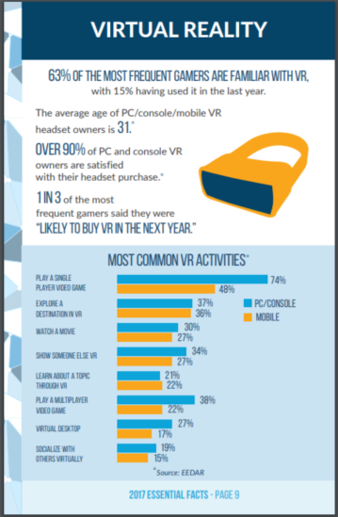

Appendix B
The poll asking about the demographics for Red Dead Redemption 2 (Rockstar Games, 2018), taken from https://www.strawpoll.me/16553539 . (Original Reddit Post - https://www.reddit.com/r/reddeadredemption/comments/9k4s8p/age_demographic_playing_this_game_and_uses_this/)
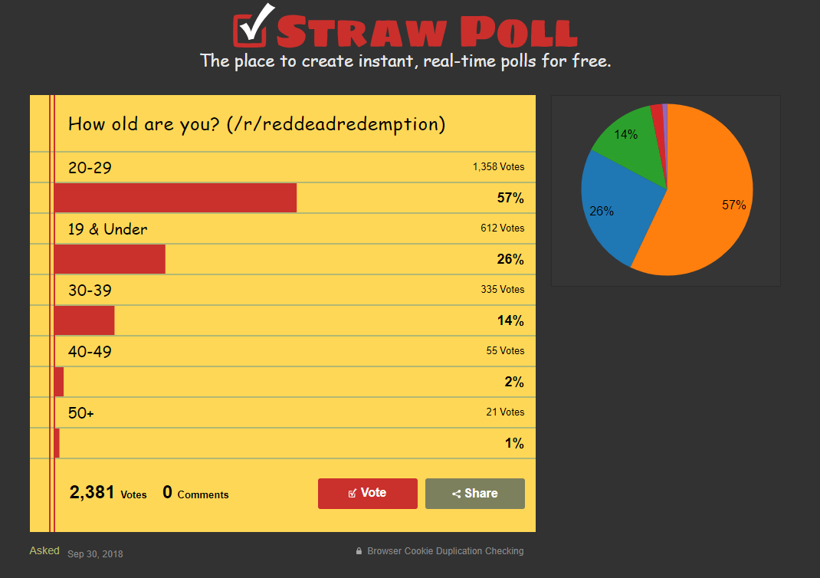

Appendix C
The sales of VR headsets and the virtual reality forecast (Superdata, 2016).
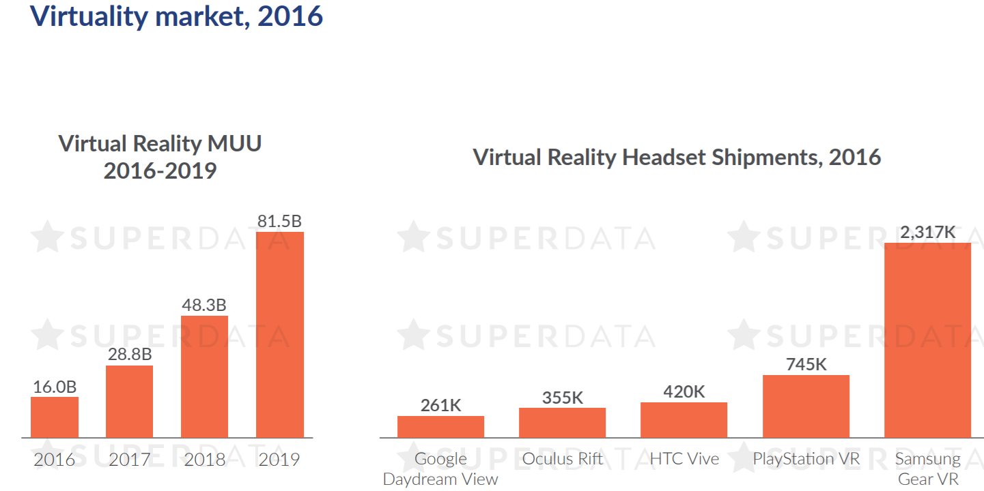

Appendix D
Comparing the VR shipments in 2016 to 2017 (Superdata, 2017)
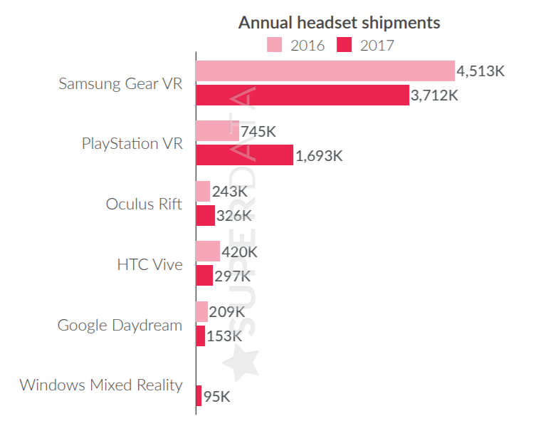

Appendix E
The top earning PC VR games and PSVR games in 2017 (Superdata, 2017).
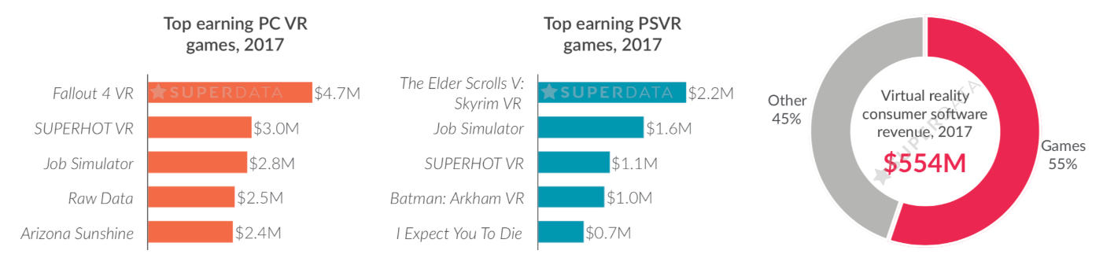

Appendix F
The timeline for the development of ‘The Scraptown Showdown’.


