Assignment 1
OO Programming

Kalan Hughes
1902299

Master of Science: Computing (Software Engineering)
Object-Oriented Programming
24 April 2023

Introduction

This report contains a variety of information. It contains a section that analyses the recommendations for best practices in the implementation of C++ concepts that are to be used in the design and implementation of the car park program. There will also be examples of how the car park program that was developed adheres to these recommendations. There will also be a section that describes each class’s attributes, methods, and relationships to other classes. There will be a section that talks about the differences between static and dynamic memory allocation. This section will also talk about why the chosen data structure was the best approach for the car park application.
There will also be a section showing all of the tests carried out for the car park application. There will be a brief user guide that explains how to run the code for the car park application. There will also be a link to a video which is a demonstration of the working program. There will also be an appendix that provides all of the code that was created for the car park program.

Table of Contents
Introduction 2
Implementation of Concepts Report 5
Recommendations for Best Practice When Implementing Concepts 5
Classes 5
Abstract Classes 6
Composition and Aggregation 6
Inheritance 7
Polymorphism 7
Virtual Methods 8
Storage Structures 8
Classes Attributes and Methods 9
Barrier Class 9
FullSign Class 9
Sensor Class 9
IDReader Class 10
Numberplate Class 10
Serialnumber Class 10
CarPark Class 11
Static & Dynamic Memory Allocation 12
Software Testing 13
Enter Car Park: 13
Leave Car Park: 15
Display Car Park: 16
Quit the Car Park Program: 17
User Guide 18
Video Demonstration 21
References 22
Appendix 23
Header Files 23
Barrier.h 23
FullSign.h 23
Sensor.h 23
IDReader.h 23
Numberplate.h 24
Serialnumber.h 24
CarPark.h 24
Source Files 26
Barrier.cpp 26
FullSign.cpp 26
Sensor.cpp 26
IDReader.cpp 26
Numberplate.cpp 27
Serialnumber.cpp 27
CarPark.cpp 27
Source.cpp 29

Implementation of Concepts Report

This report is going to contain a section that talks about recommendations for best practices in the implementation of various concepts that were used in the car park application. Examples will show how the application adheres to the best practice recommendations. There will be a section that describes each class’s attributes and methods that were developed in the program. Finally, there will be a section that explains the differences between static memory allocation and dynamic memory allocation in the context of C++ data structures. It will then be determined which data structure would be the best approach for the car park application.

Recommendations for Best Practice When Implementing Concepts

Classes
The first concept that will be talked about is classes. The first recommendation for best practice when implementing classes is to put all data that is related into a class [1]. This is because it can help to make it easier to comprehend. The car park application that was developed adheres to this recommendation. For example, the ‘CarPark’ class has a variety of related functions as they all have something to do with the cars in the car park, which is why they were placed in the same class.
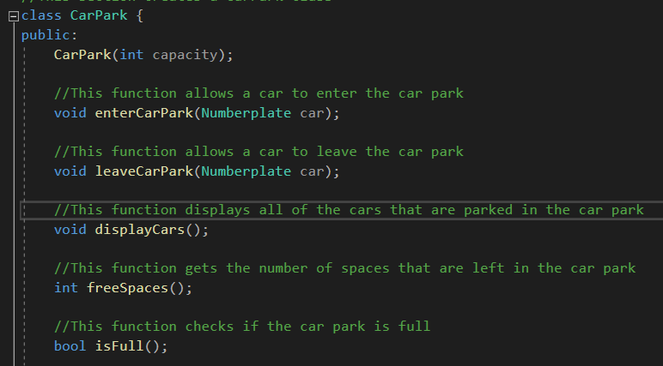

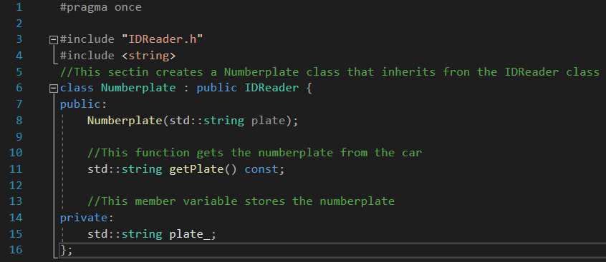
Another recommendation for best practice when implementing classes is to use class rather than struct if a data type has private or protected members [1]. The car park application that was developed adheres to this recommendation. For example, the ‘Numberplate’ class has a private member, so it is made a class.

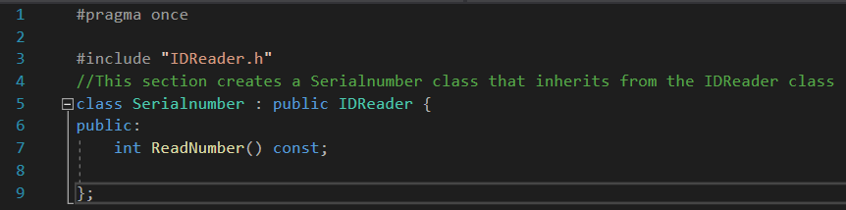
The final recommendation for best practice when implementing classes is to use the ‘const’ keyword to ensure that a variable’s value is constant which will tell the compiler to prevent the programmer from changing the value [2]. The car park application adheres to this recommendation. For example, the ‘Serialnumber’ class uses const to prevent the compiler from changing the value of the Serialnumber that the user inputs.
These are some of the recommendations for best practices when implementing classes.

Abstract Classes
The second concept that will be talked about is abstract classes. One recommendation for best practice when implementing abstract classes is to use them as a base class for concrete classes [3]. The car park application adheres to this recommendation. This is because the ‘IDReader’ class is used as a base class for the ‘Numberplate’ and ‘Serialnumber’ classes. It also has a virtual destructor which allows it to be an abstract class.
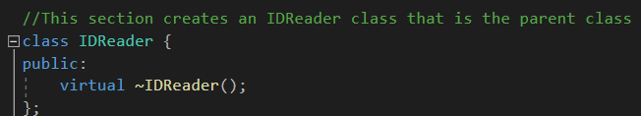

This is one recommendation for best practice when implementing abstract classes.

Composition and Aggregation
The third concept that will be talked about is composition and aggregation. One recommendation for best practice when implementing composition and aggregation is to build complex objects from simpler ones [4]. The car park application adheres to this recommendation. This is because the ‘CarPark’ class contains an object of the ‘Barrier’ class to control whether the barrier is raised or lowered.
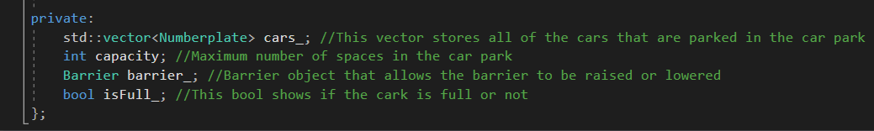

This is one recommendation for best practice when implementing composition and aggregation.

Inheritance
The fourth concept that will be talked about is inheritance. One recommendation for best practice when implementing inheritance is to define a class in terms of another class [5]. Inheritance allows a new class to inherit members of an existing class. The existing class is the base class, and the new class is the derived class [5]. The car park application adheres to this recommendation. This is because the ‘Numberplate’ and ‘Serialnumber’ classes are both derived from the ‘IDReader’ base class using public inheritance.
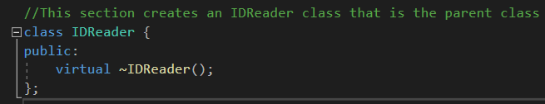

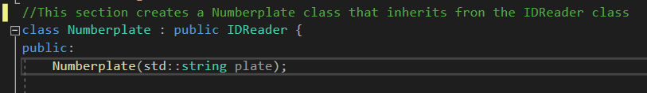

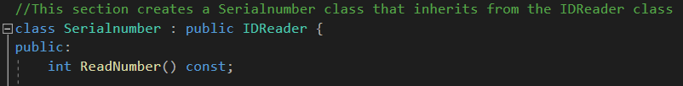

This is one recommendation for best practice when implementing inheritance.

Polymorphism
The fifth concept that will be talked about is polymorphism. One recommendation for best practice when implementing polymorphism is to use the methods that have been inherited from another class to perform different tasks [6]. Polymorphism is good for code reusability as it lets you reuse methods and attributes on an existing class in a new class. The car park application adheres to this recommendation. This is because the ‘IDReader’ class is used as a base class for the ‘Numberplate’ and ‘Serialnumber’ derived classes. The ‘CarPark’ class also has a vector of number plate objects which stores the cars that are parked in the car park.

This is one recommendation for best practice when implementing polymorphism.

Virtual Methods
The sixth concept that will be talked about is virtual methods. One recommendation for best practice when implementing virtual methods is to define the base class with a virtual destructor to prevent undefined behaviour [7]. Anytime a virtual function is in a class, a virtual destructor should be added. The car park application adheres to this recommendation. This is because the ‘IDReader’ class has a virtual destructor.
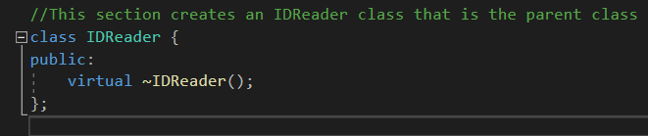

This is one recommendation for best practice when implementing virtual methods.

Storage Structures
The final concept that will be talked about is storage structures. One recommendation for best practice when implementing storage structures is knowing which storage structure would be best suited for the situation. The car park application adheres to this recommendation. This is because it uses a vector to store the number plates. The reason why it uses a vector to store the number plates is that vectors are good for frequent insertions and deletions of data [8]. This suits the program because number plates are constantly inserted and deleted from the vector.
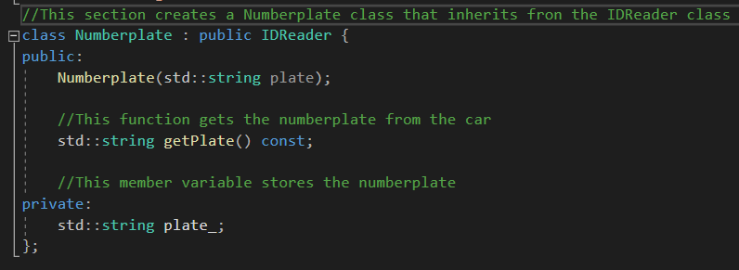

This is one recommendation for best practice when implementing storage structures.

Classes Attributes and Methods
This section is going to talk about each class’s attributes and methods, including their relationship with other classes.

Barrier Class
The first class that is going to be talked about is the ‘Barrier’ class. The ‘Barrier’ class has two methods. These are ‘raise’ and ‘lower’. These methods are used to raise and lower the barrier to let a car enter and leave the car park. The ‘Barrier’ class has a relationship with the ‘CarPark’ class. This is because the ‘CarPark’ class contains a barrier object that allows for the barrier to be raised or lowered.
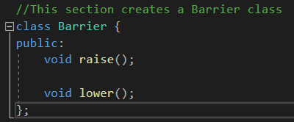

FullSign Class
The second class that is going to be talked about is the ‘FullSign’ class. The ‘FullSign’ class has two methods. These are ‘SwitchOn’ and ‘SwitchOff’. These methods are used to turn the full sign on or off. The ‘FullSign’ class has a relationship with the main function. This is because the main function contains a section that turns the sign on or off depending on if the car park is full or not.
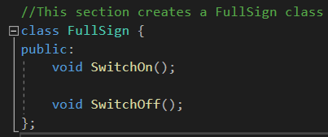

Sensor Class
The third class that is going to be talked about is the ‘Sensor’ class. The ‘Sensor’ class has one method. This is ‘carPresent’. This method is used to detect when a car is present at the sensor. The ‘Sensor’ class has a relationship with the main function. This is because the main function contains a section that says when a car is present at the sensor.
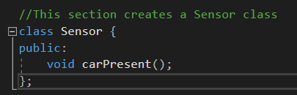

IDReader Class
The fourth class that is going to be talked about is the ‘IDReader’ class. The ‘IDReader’ class has one method which is a virtual destructor. The ‘IDReader’ class has a relationship with the ‘Numberplate’ and the ‘Serialnumber’ classes. This is because the ‘IDReader’ class is a base class, while the ‘Numberplate’ and ‘Serialnumber’ classes are derived classes.
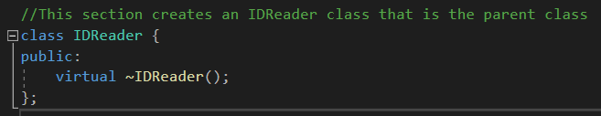

Numberplate Class
The fifth class that is going to be talked about is the ‘Numberplate’ class. The ‘Numberplate’ class has one attribute. This is the ‘Plate_’ attribute. This attribute is a private member variable that is responsible for storing the number plate. The ‘Numberplate’ class also has two methods. The first method is ‘Numberplate(std::string plate)’. This method is a constructor that takes the string ‘plate’ and initialises ‘Plate_’. The second method is ‘getPlate() const’ which is a const member function that returns the value of ‘Plate_’. The ‘Numberplate’ class has a relationship with the ‘IDReader’ class. This is because it is a derived class while the ‘IDReader’ class is the base class. It also has a relationship with the ‘CarPark’ class as the ‘CarPark’ class contains a vector for all the stored number plates.
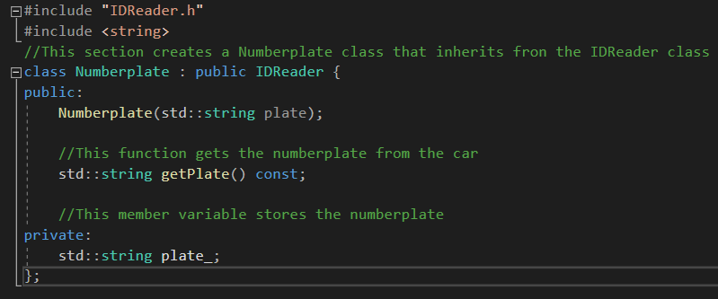

Serialnumber Class
The sixth class that is going to be talked about is the ‘Serialnumber’ class. The ‘Serialnumber’ class has one method. This method is ‘ReadNumber()’. This method is used for reading the six-digit number that the user enters. The ‘Serialnumber’ class has a relationship with the ‘IDReader’ class. This is because it is the derived class while the ‘IDReader’ class is the base class.
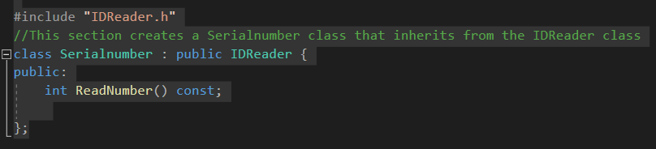

CarPark Class
The final class that is going to be talked about is the ‘CarPark’ class. The ‘CarPark’ class has four attributes. The first attribute is ‘cars_’ which is a vector that stores all of the cars that are parked in the car park. The second attribute is ‘capacity’ which is an integer that contains the maximum number of spaces in the car park. The third attribute is ‘barrier_’ which is an object that allows the barrier to be raised or lowered. The final attribute is ‘isFull_’ which is a Boolean that shows if the car park is full or not. It also contains six methods. The first method is ‘CarPark(int capacity)’ which is a constructor that initialises the capacity of the car park. The second method is ‘void enterCarPark(numberplate car)’ which is a function that allows a car to enter the car park. The third method is ‘void leaveCarPark(numberplate car)’ which is a function that allows a car to leave the car park. The fourth method is ‘void displayCars()’ which is a function that displays all of the cars that are parked in the car park. The fifth method is ‘int freeSpaces()’ which is a function that gets the number of spaces left in the car park. The sixth method is ‘bool isFull()’ which is a function that checks if the car park is full.
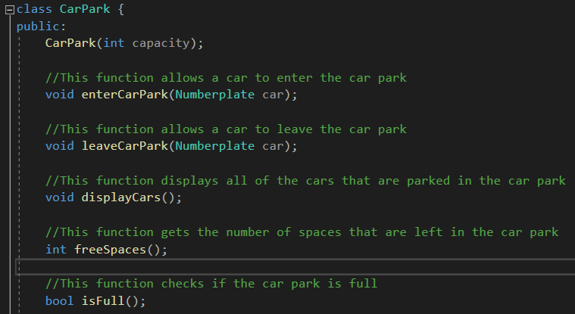

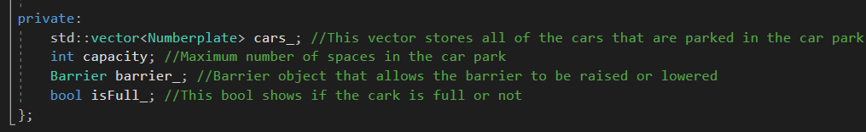

These are all of the classes that are in the solution.

Static & Dynamic Memory Allocation

This section is going to talk about the differences between static and dynamic memory allocation. It is then going to talk about which data structure would be the best approach for the car park application.
Static memory allocation uses the compiler to allocate static memory for declared variables and the memory is allocated during the compile time [9]. Dynamic memory allocation is done at the time of execution. Dynamic memory is allocated by using the functions ‘calloc()’ and ‘malloc()’. These functions are used when the value is returned by functions and assigned to pointer variables [9].
One difference between static and dynamic memory allocation, is that static memory allocation is done before the program is executed. Whereas dynamic memory allocation is done during the execution of the program [9].
Another difference between static and dynamic memory allocation, is that static memory allocation does not allow memory size to change once the memory has been allocated. Whereas dynamic memory allocation allows the memory size to change when memory is allocated [9].
A third difference between static and dynamic memory allocation, is that there is no memory re-usability in static memory allocation. Whereas in dynamic memory allocation, there is re-usability and memory can be freed when it is not required [9].
The final difference that will be talked about between static and dynamic memory allocation, is that allocated memory remains from the start to the end of the program when using static memory allocation. Whereas allocated memory can be released at any time during the program when using dynamic memory allocation [9]. These are some of the differences between static and dynamic memory allocation.
The best approach for the car park application was dynamic memory allocation. A vector was used to store the number plates of the cars because a vector is a dynamic data structure [10]. The reason why a vector was used is that it can be resized automatically when an element is inserted or deleted [11]. This means that it would allow cars to enter and leave the car park without having to manage memory allocation. This is why a vector and dynamic memory allocation was the best approach for the car park application.

Software Testing

This section is going to document the testing of the software to ensure that the software works correctly and to make sure that there are no errors in the software.

Enter Car Park:

The first section that is going to be tested is entering the car park. To enter the car park, the user must enter the word ‘enter’. If they type the word ‘enter’, the program continues to the next step. If they do not type the word ‘enter’ or one of the other three commands, the program asks the user to enter a valid command. This shows that this section of code works correctly.
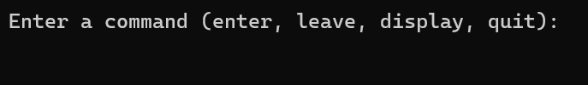

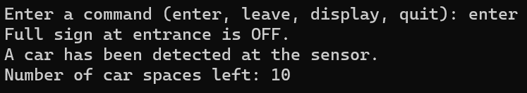

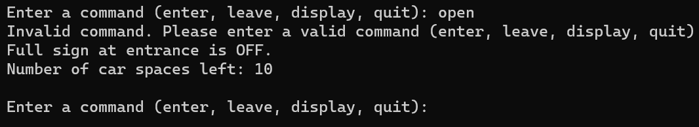

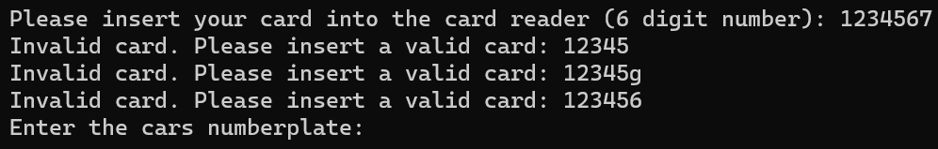
The next step asks the user to enter their card into the card reader which is a six-digit number. If the user enters a six-digit number, the program moves on to the next step which asks them to enter their number plate. If the user does not enter a six-digit number, the program says that the card is invalid, and it asks the user to enter a valid card again until they enter a six-digit number. This shows that this section of code works correctly.
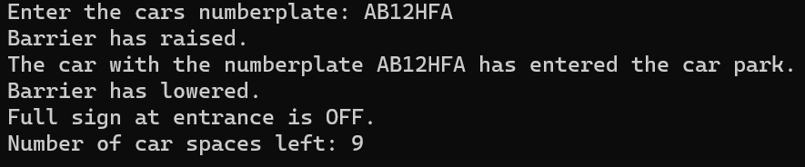
The next step asks the user to enter the number plate of the car. Once the user enters the number plate, the barrier raises, the car enters the car park and then the barrier lowers. The number of car spaces left goes down by one. This shows that this section of code works correctly.

If there are no spaces left in the car park, then a car should not be able to enter the car park. When there are spaces available, the full sign is off, and it displays that there are spaces available. When a car enters the last available space, the full sign turns on which shows that the car park is full, and it says that there are no spaces left. If a car tries to enter the car park when there are no spaces available, it tells the user that there are no spaces available, and that the car cannot enter the car park. This shows that this section of code works correctly.
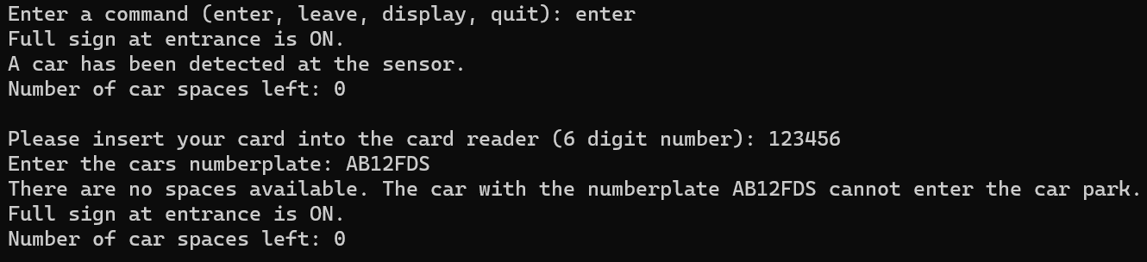
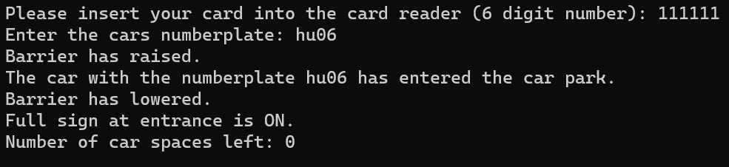
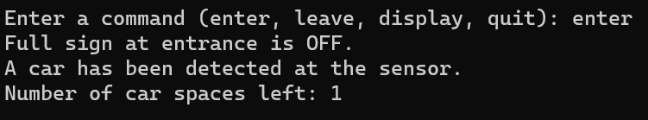

This shows that all of the code that allows a user to enter the car park works correctly and there are no errors.

Leave Car Park:

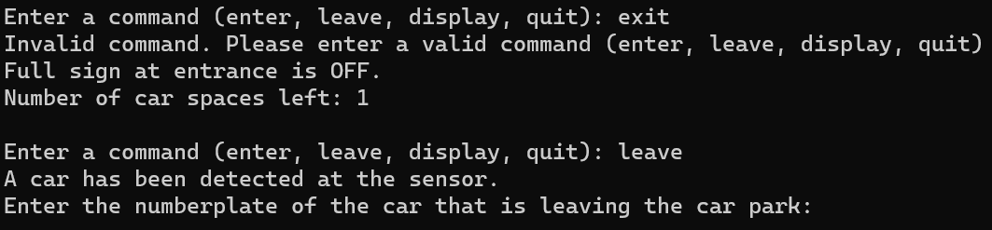
The second section that is going to be tested is leaving the car park. To leave the car park, the user must enter the word ‘leave’. If they type the word ‘leave’, the program continues to the next step. If they do not type the word ‘leave’ or one of the other three commands, the program asks the user to enter a valid command. This shows that this section of code works correctly.

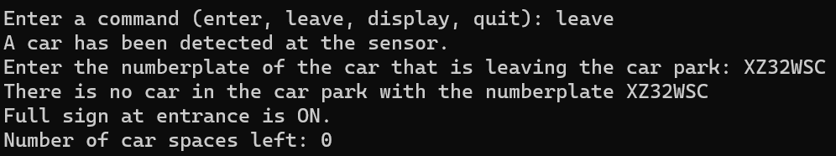
The next section asks the user to enter the number plate of the car that is leaving the car park. If the user enters a number plate that is not in the car park, the program tells the user that there is no car in the car park with that number plate. This shows that this section of the code works correctly.

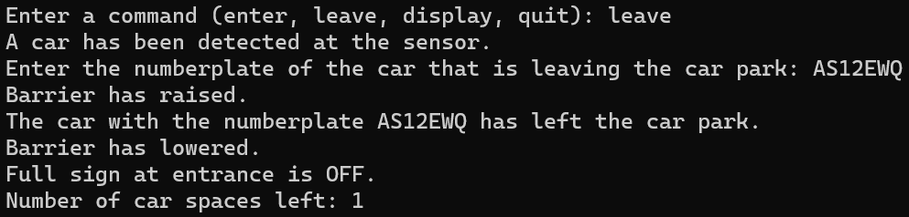
If the user enters a number plate that is in the car park, the barrier raises, the car leaves the car park, and then the barrier lowers. Before the car left the car park, there were no spaces available, and the full sign was on. Once the car left, one space became available, and the full sign turned off. This shows that this section of code works correctly.

This shows that all of the code that allows a user to leave the car park works correctly and there are no errors.

Display Car Park:

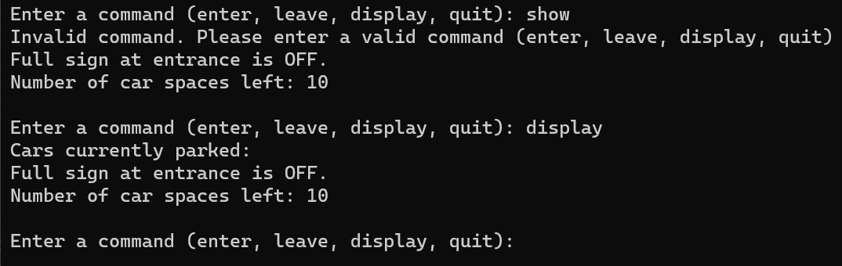
The third section that is going to be tested is displaying the car park. To display the car park, the user must enter the word ‘display’. If they type the word ‘display’, the program continues to the next step. If they do not type the word ‘display’ or one of the other three commands, the program asks the user to enter a valid command. This shows that this section of code works correctly.

Once the user types the ‘display’ command, the program displays all of the cars that are currently parked in the car park. The image below shows that there are no cars parked in the car park.
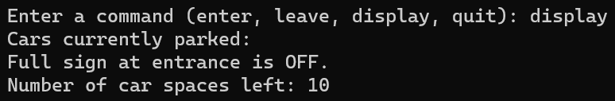

The image below shows that two cars have entered the car park. Once the user enters the ‘display’ command, it displays the two cars that are currently parked in the car park. This shows that this section of code works correctly.
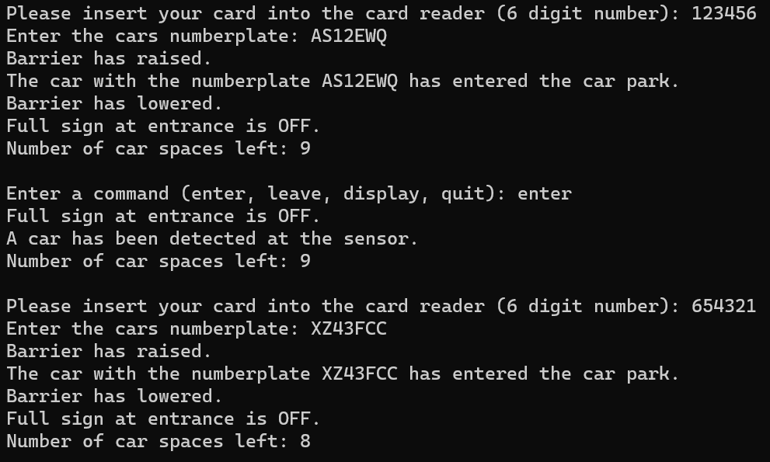
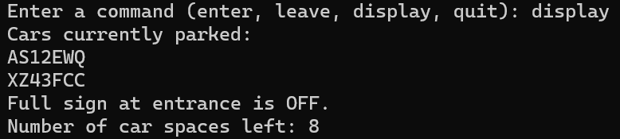
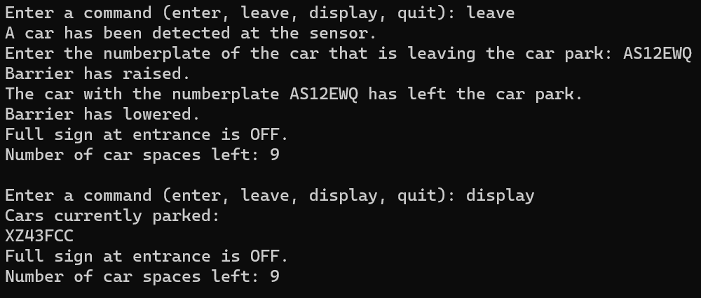
The image below shows that one of the cars has left the car park. Once the user enters the ‘display’ command, it displays the one car that is currently parked in the car park. This shows that this section of the code works correctly.

This shows that all of the code that allows a user to display the cars currently parked in the car park works correctly and there are no errors.

Quit the Car Park Program:

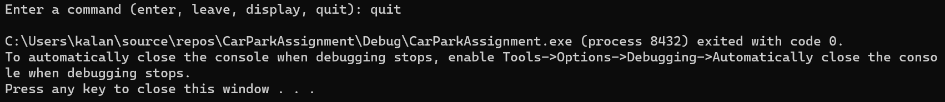
The fourth section that is going to be tested is quitting the car park program. To quit the car park program, the user must enter the word ‘quit’. If they type the word ‘quit’, the program closes. If they do not type the word ‘quit’ or one of the other three commands, the program asks the user to enter a valid command. This shows that this section of code works correctly.

This shows that all of the code that allows a user to quit the car park program works correctly and there are no errors.
This testing has shown that all of the classes are utilised correctly and that all of the code works correctly with no errors or issues. This concludes the software testing.

User Guide

This section will contain a brief user guide explaining how to run the code. The first step is to extract the zip file to a location of your choice.

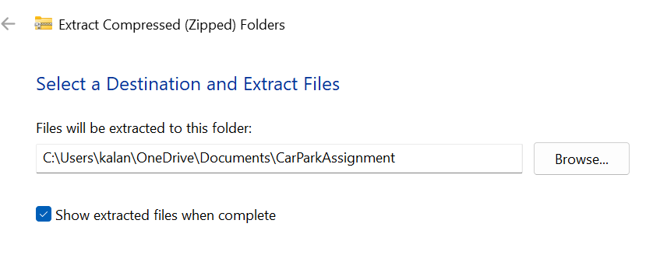

Once the folder has been extracted, open the CarParkAssignment.sln file.
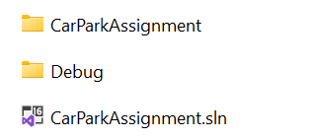

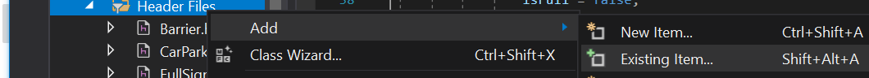
Once the solution file has opened, you must add all the header files. You do this by right-clicking on ‘Header Files’ and clicking on ‘Add’ and then ‘Existing Item’.

Add all 7 header files by holding ‘ctrl’ and left-clicking on all the header files. Once they have all been selected, click the ‘Add’ button. All of the header files will then be added to the ‘Header Files’ section.
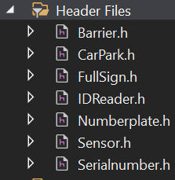
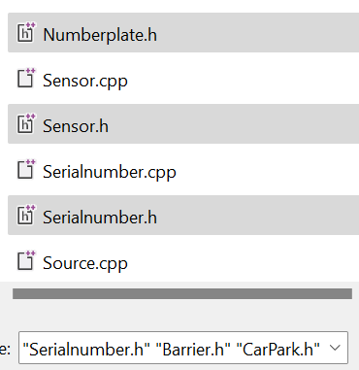

Repeat this process in the ‘Source Files’ section to add all of the .cpp files.
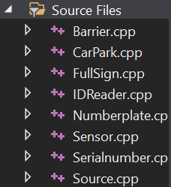
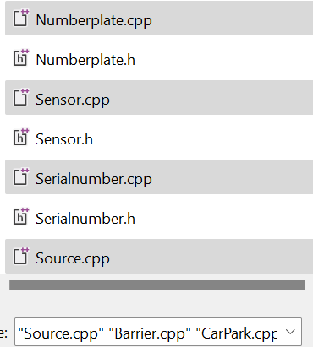

Once all header and .cpp files have been added, you are ready to run the code. To do this, click the ‘Local Windows Debugger’ button at the top of the navigation menu.
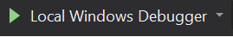

Once the button has been clicked, the code will run. This concludes the user guide that explains how to run the code.
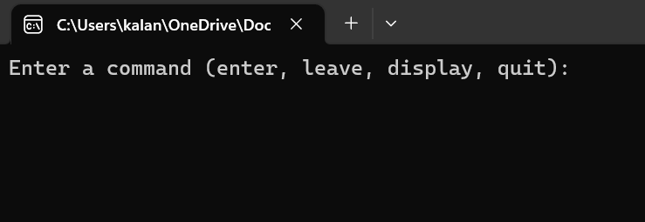

Video Demonstration

Below is the link to the YouTube video of the car park program demonstration.
https://youtu.be/FetbLPvVpEw

References

[1] | “C++ Core Guidelines: Class Rules,” 21 August 2017. [Online]. Available: https://www.modernescpp.com/index.php/c-core-guidelines-class-rules. [Accessed 14 April 2023].
[2] | “const (C++),” [Online]. Available: https://learn.microsoft.com/en-us/cpp/cpp/const-cpp?view=msvc-170. [Accessed 14 April 2023].
[3] | “Abstract class,” 23 February 2023. [Online]. Available: https://en.cppreference.com/w/cpp/language/abstract_class. [Accessed 14 April 2023].
[4] | “Object Composition-Delegation in C++ with Examples,” 21 January 2022. [Online]. Available: https://www.geeksforgeeks.org/object-composition-delegation-in-c-with-examples/. [Accessed 14 April 2023].
[5] | “C++ Inheritance,” [Online]. Available: https://www.tutorialspoint.com/cplusplus/cpp_inheritance.htm. [Accessed 14 April 2023].
[6] | “C++ Polymorphism,” [Online]. Available: https://www.w3schools.com/cpp/cpp_polymorphism.asp. [Accessed 14 April 2023].
[7] | “Virtual Destructor,” 20 February 2023. [Online]. Available: https://www.geeksforgeeks.org/virtual-destructor/. [Accessed 14 April 2023].
[8] | Y. Goyal, “C++ vector vs C++ array,” [Online]. Available: https://www.educba.com/c-plus-plus-vector-vs-c-plus-plus-array/. [Accessed 14 April 2023].
[9] | “Difference between Static and Dynamic Memory Allocation in C,” 12 August 2021. [Online]. Available: https://www.geeksforgeeks.org/difference-between-static-and-dynamic-memory-allocation-in-c/. [Accessed 15 April 2023].
[10] | A. Rawat, “Arrays vs Vectors in C++,” [Online]. Available: https://iq.opengenus.org/array-vs-vector-cpp/#:~:text=The%20differences%20between%20array%20and,or%20dynamic%3B%20Vector%20is%20dynamic. [Accessed 15 April 2023].
[11] | “Vector in C++ STL,” 20 March 2023. [Online]. Available: https://www.geeksforgeeks.org/vector-in-cpp-stl/. [Accessed 15 April 2023].

Appendix

Header Files

Barrier.h
#pragma once

//This section creates a Barrier class
class Barrier {
public:
void raise();

void lower();
};

FullSign.h
#pragma once

//This section creates a FullSign class
class FullSign {
public:
void SwitchOn();

void SwitchOff();
};

Sensor.h
#pragma once

//This section creates a Sensor class
class Sensor {
public:
void carPresent();
};

IDReader.h
#pragma once

//This section creates an IDReader class that is the parent class
class IDReader {
public:
virtual ~IDReader();
};

Numberplate.h
#pragma once

#include "IDReader.h"
#include <string>
//This section creates a Numberplate class that inherits from the IDReader class
class Numberplate : public IDReader {
public:
Numberplate(std::string plate);

//This function gets the numberplate from the car
std::string getPlate() const;

//This member variable stores the numberplate
private:
std::string plate_;
};

Serialnumber.h
#pragma once

#include "IDReader.h"
//This section creates a Serialnumber class that inherits from the IDReader class
class Serialnumber : public IDReader {
public:
int ReadNumber() const;

};

CarPark.h
#pragma once
#include "Numberplate.h"
#include "Barrier.h"
#include <vector>

//This section creates a CarPark class
class CarPark {
public:
CarPark(int capacity);

//This function allows a car to enter the car park
void enterCarPark(Numberplate car);

//This function allows a car to leave the car park
void leaveCarPark(Numberplate car);

//This function displays all of the cars that are parked in the car park
void displayCars();

//This function gets the number of spaces that are left in the car park
int freeSpaces();

//This function checks if the car park is full
bool isFull();

private:
std::vector<Numberplate> cars_; //This vector stores all of the cars that are parked in the car park
int capacity; //Maximum number of spaces in the car park
Barrier barrier_; //Barrier object that allows the barrier to be raised or lowered
bool isFull_; //This bool shows if the car park is full or not
};

Source Files

Barrier.cpp
#include "Barrier.h"
#include <iostream>

using namespace std;

void Barrier::raise() {
cout << "Barrier has raised." << endl;
}

void Barrier::lower() {
cout << "Barrier has lowered." << endl;
}

FullSign.cpp
#include "FullSign.h"
#include <iostream>

using namespace std;

void FullSign::SwitchOn() {
cout << "Full sign at entrance is ON." << endl;
}

void FullSign::SwitchOff() {
cout << "Full sign at entrance is OFF." << endl;
}

Sensor.cpp
#include "Sensor.h"
#include <iostream>

using namespace std;

void Sensor::carPresent() {
cout << "A car has been detected at the sensor." << endl;
}

IDReader.cpp
#include "IDReader.h"

IDReader::~IDReader() {
}

Numberplate.cpp
#include "Numberplate.h"

Numberplate::Numberplate(std::string plate) : plate_(plate) {}

std::string Numberplate::getPlate() const {
return plate_;
}

Serialnumber.cpp
#include "Serialnumber.h"
#include <iostream>
#include <string>
#include <limits>
#include "IDReader.h"

using namespace std;

int Serialnumber::ReadNumber() const {
int number;
cout << "Please insert your card into the card reader (6 digit number): ";
while (!(cin >> number) || to_string(number).length() != 6) {
cout << "Invalid card. Please insert a valid card: ";
cin.clear();
cin.ignore(numeric_limits<streamsize>::max(), '\n');
}
return number;
}

CarPark.cpp
#include "CarPark.h"
#include <iostream>

CarPark::CarPark(int capacity) : capacity(capacity), isFull_(false), barrier_() {}

void CarPark::enterCarPark(Numberplate car) {
if (cars_.size() < capacity) {
cars_.push_back(car);
barrier_.raise();
std::cout << "The car with the numberplate " << car.getPlate() << " has entered the car park." << std::endl;
barrier_.lower();
if (isFull_) {
isFull_ = false;
}
}
else {
isFull_ = true;
std::cout << "There are no spaces available. The car with the numberplate " << car.getPlate() << " cannot enter the car park." << std::endl;
}
}

void CarPark::leaveCarPark(Numberplate car) {
for (int i = 0; i < cars_.size(); i++) {
if (cars_[i].getPlate() == car.getPlate()) {
cars_.erase(cars_.begin() + i);
barrier_.raise();
std::cout << "The car with the numberplate " << car.getPlate() << " has left the car park." << std::endl;
barrier_.lower();
if (isFull_) {
isFull_ = false;
std::cout << "There are now spaces available in the car park." << std::endl;
}
return;
}
}
std::cout << "There is no car in the car park with the numberplate " << car.getPlate() << std::endl;
}

void CarPark::displayCars() {
std::cout << "Cars currently parked:" << std::endl;
for (int i = 0; i < cars_.size(); i++) {
std::cout << cars_[i].getPlate() << std::endl;
}
}

int CarPark::freeSpaces() {
return capacity - cars_.size();
}

bool CarPark::isFull() {
return isFull_;
}

Source.cpp
#include <iostream>
#include <string>
#include <vector>
#include "Barrier.h"
#include "CarPark.h"
#include "FullSign.h"
#include "IDReader.h"
#include "Numberplate.h"
#include "Sensor.h"
#include "Serialnumber.h"

using namespace std;

//This is the main function
int main() {
CarPark carPark(10); //This creates a car park object that contains 10 spaces
string command;
string plate;
Sensor carPresent;
FullSign SwitchOn;
FullSign SwitchOff;
bool isFull = false;

//This main loop receive commands from the user
while (true) {

cout << "Enter a command (enter, leave, display, quit): ";
cin >> command;

if (command == "enter") {

if (carPark.freeSpaces() == 0) {
isFull = true;
}
else {
isFull = false;
}

if (isFull) {
SwitchOn.SwitchOn();
}
else {
SwitchOff.SwitchOff();
}

carPresent.carPresent();

//This displays the number of car spaces that are left after each command
cout << "Number of car spaces left: " << carPark.freeSpaces() << endl << endl;

Serialnumber scanner;
int scannedID = scanner.ReadNumber();

if (carPark.freeSpaces() == 0) {
isFull = true;
}
else {
isFull = false;
}

cout << "Enter the cars numberplate: ";
cin >> plate;
Numberplate newCar(plate); //This creates a new Car object with the entered numberplate
carPark.enterCarPark(newCar); //This calls the enterCarPark function to add the car to the car park
}

else if (command == "leave") {
carPresent.carPresent();
cout << "Enter the numberplate of the car that is leaving the car park: ";
cin >> plate;
Numberplate leaveCar(plate); //This creates a new Car object with the entered numberplate
carPark.leaveCarPark(leaveCar); //This calls the leaveCarPark function to remove the car from the car park
}

else if (command == "display") {
carPark.displayCars(); //This calls the displayCars function to display all of the cars in the car park
}

else if (command == "quit") {
break; //This breaks out of the while loop and exits the program
}

else {
cout << "Invalid command. Please enter a valid command (enter, leave, display, quit)" << endl;
}

if (carPark.freeSpaces() == 0) {
isFull = true;
}
else {
isFull = false;
}

if (isFull) {
SwitchOn.SwitchOn();
}
else {
SwitchOff.SwitchOff();
}

//This displays the number of car spaces left after each command
cout << "Number of car spaces left: " << carPark.freeSpaces() << endl << endl;
}

return 0;
}

