

LCMB7026
International Marketing Principles and Practices

Assessment Component 1

Report Title: A Comparative Analysis of IKEA's International Marketing Strategies in India and the United Kingdom

Submitted by:
Name- Nishat Hossain
ID- 2437429

Submission deadline: 24th April 2026 by 2PM

Abstract
This report focuses on an international marketing analysis of IKEA business in India and the United Kingdom comparing the balance between global and the local adaptation of the international brand. The product adaptation, pricing, distribution, and ethical issues examined in the study as far as the differences between the two markets are established using PESTEL, the cultural dimensions of Hofstede, STP, and the 7Ps framework. Results indicate that although IKEA continues to uphold its initial philosophy of democratic design and affordability, a lot of localisation is necessary in India owing to sensitivity to price, family involvement in decision making, and regulatory challenges. On the contrary, UK markets require digital innovation and sustainability leadership. Among the recommendations, it is advised to speed up the integration of the omni-channel in India and improve the programs of the circular economy in the UK.

Table of Contents
Abstract 2
Introduction 4
Objectives of the report 4
Background of chosen organisation 4
Section 1: IKEA's Marketing Strategy 6
A. Comparative Study of the Market in the two countries 6
PESTEL Analysis 6
Hofstede Cultural Model Comparative Analysis 8
B. Comparative Analysis of STP and International Marketing Mix (7Ps) 13
Segmentation, Targeting and Positioning (STP) 13
International marketing mix (7Ps) 16
C. Directional Development Strategy - IKEA in India 22
D. IKEA Marketing Mix Ethical Problems 23
E. Recommendations 25
Section 2: Reflective Account 26
Reflective Account through Gibbs Reflective Cycle 26
Conclusion 29
References 30

Introduction

Objectives of the report
This report involves an analytical compared study of the international marketing of IKEA in India and the United Kingdom. It analyses based on the PESTEL to analyse macro-environmental factors, cultural dimensions as developed by Hofstede to determine deep rooted cultural differences to consumer behaviour, and STP to analyse segmentation, targeting and positioning strategies. A step-by-step analysis of international marketing mix (7Ps) proves the point how IKEA is developing the product, price, place, promotion, people, process and physical evidence to adapt to the specifics of the market. A reflective account of the research using Gibbs Reflective Cycle of documenting how the research has been carried out and what has been learnt as a result of this comparative study.

Background of chosen organisation
About IKEA- The Swedish multinational furniture and home furnishing retailer IKEA is one of the most prevalent and successful global brands in the world, which started in 1943 when Ingvar Kamprad began it (Hollensen, 2022).
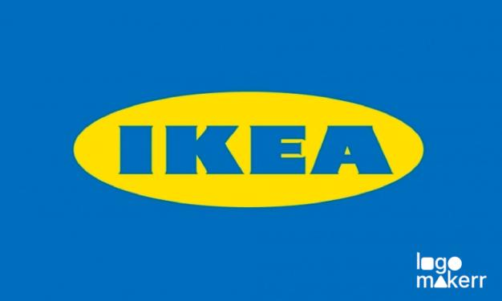
Figure: IKEA logo (Batra & Keller, 2020).

Mission Statement: The mission of IKEA is to provide a better everyday life of the many people. This mission statement is a summary of the most essential declaration by the company to provide well-designed and functional home furnishing goods at prices that as many people as possible can afford (Kotler and Keller, 2021).
Key Vision Statement: The key vision statement of IKEA is to provide better everyday life to the multitude of the people though the provision of a full assortment of well-designed and functional home furnishing products at prices so small that the majority of the population is capable of affording them (IKEA, 2023).
Future Vision: In the future, IKEA has a clear vision of the future focused on sustainability and circularity. As of 2030, the company has made an effort to achieve a fully circular business with the aspiration of designing all products to be reused, repaired, to be repurposed and to be recycled (IKEA, 2023).

Section 1: IKEA's Marketing Strategy

A. Comparative Study of the Market in the two countries

PESTEL Analysis

PESTEL Analysis is a strategic framework used to evaluate external macro-environmental factors Political, Economic, Social, Technological, Legal, and Environmental that affect an organization.
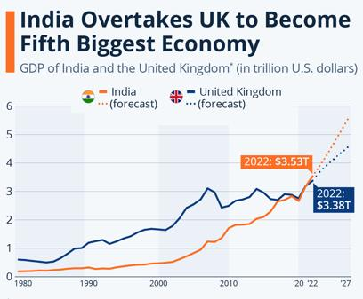
Figure: comparison (IKEA, 2023).

Political Factors
India:
Favourable: Such government initiatives as the Make in India contribute to the FDI → to enable IKEA to expand and source in the region. This has helped IKEA increase its operations in the country and to source its products locally in line with government initiative to increase manufacturing and employment (Cavusgil, Knight and Riesenberger, 2020).
Unfavourable: Complex regulations and local sourcing of 30% rule → makes business trickier. Although local sourcing can aid in stimulating the Indian economy, it involves IKEA coming up with strong supply chains and alliances that are not necessarily consistent with its practices of sourcing globally.
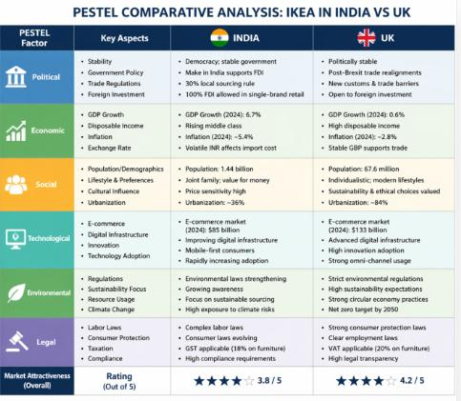
Figure: PESTEL framework (Chernev, 2020).

UK:
Favourable: Sustainable politics means stability in the political system. The UK enjoys stable and sustainable political factors which render it a predictable market in the international businesses. Having clear and consistent regulations, businesses such as IKEA have a feeling of security (Morrison, 2020).
Unfavourable: Brexit → disruption of the supply chain and barriers to trade. In the case of companies such as IKEA, it has brought about logistical challenges and made things more difficult, costly, and delayed because of the necessity to adapt to new trade barriers. This has led to a more difficult and uncertain business environment, post Brexit.
Economic Factors
India:
Favourable: Increase in GDP growth- growing demand of furniture and Rising middle class-growing purchasing power. As more people are earning higher disposable incomes, and demand more affordable furniture, the advent of IKEA into the Indian market has come in at the right time Meyer and Peng, 2023).
Unfavourable: Inflation slows down disposable income and Income inequality → restricts target market. Also, IKEA does not have an adequate access to the target market because of the overall income inequality in the country, with a considerable amount of the population having no access to mid-range furniture.
Sales Impact: Reduced pricing policy was required / affects the profitability but volume. Nevertheless, lowering prices and carrying out even higher sales volume, IKEA can continue to have a stable presence in the market, though at reduced profit margins.

UK:
Favourable: This implies that favourable GDP and GNP would lead to high consumer spending. Also, the heightened attention to sustainability in the UK creates a motivation to make responsible buying choices among consumers which is also aligned to the green activities of IKEA.
Unfavourable: The high inflation will reduce the level of discretionary spending. With the increased cost of living among the consumers, prices of non-essential commodities like home furnishings will be reduced. This inflationary force may influence the overall demand of IKEA goods, in the mid-range price bracket (Hollensen, 2022).
Sales Impact: Sales are affected by cost of living crisis that make it unstable, and brand loyalty makes it stable. The brand loyalty of IKEA has served to buffer the impact, since people will be willing to patronise a brand that they have faith in even at such tricky moments.

Social Factors
India- The social environment of India is highly affected by various cultural practises, family model, and regional differences in consumer behaviour (De Mooij, 2019). Home and furnishing in India are traditionally associated with family reunions, celebration events and livestock coexistence.
UK: British consumerism is highly penetrating into home decor and personalisation, with a high culture of DIY home upgrading (Solomon, 2020). UK market is typified by varied consumer groups, including low-end students and high-end homeowners who are after high-end designs (De Mooij, 2019).

Hofstede Cultural Model Comparative Analysis:
Power Distance
India: India ranks higher (77) on the power distance scale, which means that it is characterised by a society that tolerates hierarchical relations and unequal distribution of power (Hofstede, Hofstede and Minkov, 2020).
UK: The UK is moderately rated on the pressure of power (35), and it is a reflection of a society in which equality and a needless hierarchy are not tolerated (De Mooij, 2019). British are often accustomed to self-service selling and flat organisations and this naturally coincides with the IKEA store format whereby patrons go about selecting their own products and possibly even assemble furniture on their own.
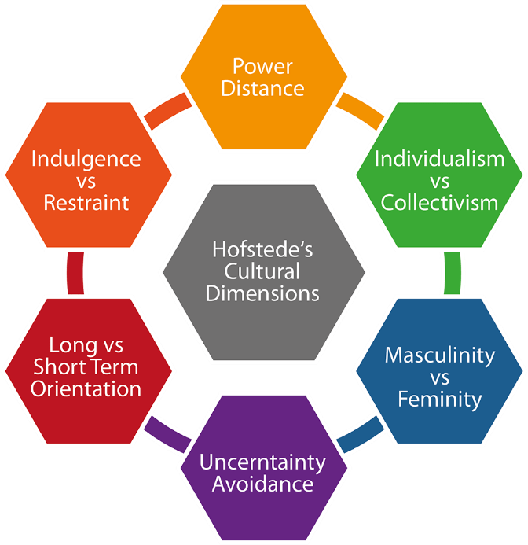
Figure: Hofstede’s dimensions (Doole & Lowe, 2021).
Advantages of Hofstede Model
Hofstede model assists companies such as IKEA to understand the cultural differences by identifying important cultural dimensions in the countries such as power distance, individualism, and uncertainty avoidance (Hofstede, Hofstede and Minkov, 2020).
Disadvantages of Hofstede Model
Cultural differences can be reduced to the generalities that Hofstede model tries to put national cultures in categories that are pre-defined. In certain instances, the data can be old or does not reflect the fineness of personal likes.
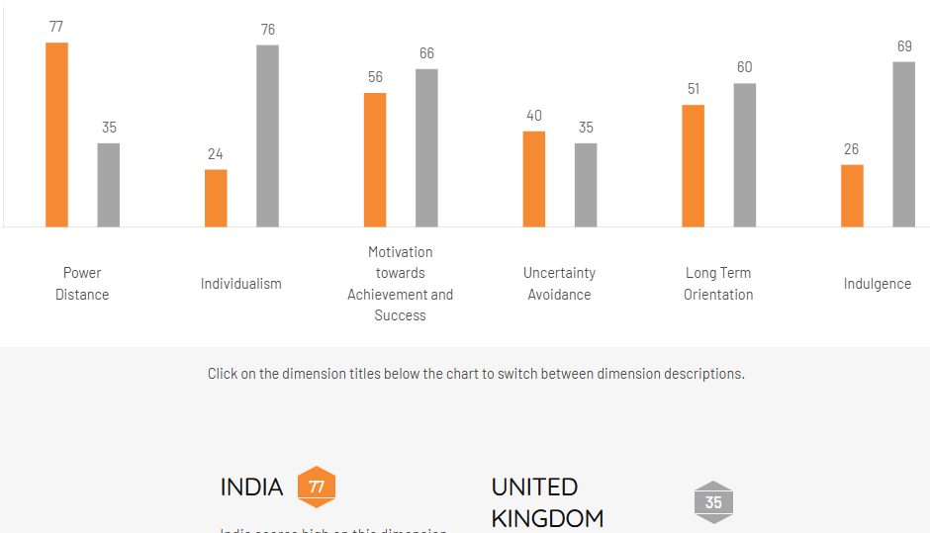
Figure: Comparison (Baines, Fill and Rosengren, 2021).
Individualism vs. Collectivism
India: India is rated 48 on individualism, which means that its values are collectivist and individualist (Hofstede, Hofstede and Minkov, 2020). Purchasing households often involve making decisions based on the family, and with home furnishing, it is more likely to be a family decision and not necessarily about the individual.
UK: With a score of very high (89) on individualism, the UK has one of the highest levels in the world, which at the same time serves as an indicator of the culture that prizes personal choice, individual expression and self-reliance (Solomon, 2020).
Masculinity vs. Femininity
India: India has a masculinity score of 56, which means the society is moderately masculine; where success, achievement and material possessions are prioritised (Cavusgil, Knight and Riesenberger, 2020).
UK: UK has a score of 66 on masculinity, approximately higher than in India, and its consumer culture prioritises performance, quality and functional excellence (Keegan and Green, 2020). The British consumer value products that integrate style and functionality and IKEA fits well in this category with its Scandinavian philosophy of design based on clean lines and functionality and longevity.
Uncertainty Avoidance
India: India is not very high in uncertainty avoidance (40), meaning it does not mind ambiguity or likes experimenting with various products and brands (Hofstede, Hofstede and Minkov, 2020). This is beneficial to IKEA because the Indian consumers might be willing to experience the novel flat-pack, self-assembly idea. Nevertheless.
UK: The UK is also low on uncertainty avoidance (35), a sign that this country is pragmatic and open-minded as well as comfortable with innovation and new retail ideas (Doole and Lowe, 2021). The concept of IKEA is not new to British consumers and the low uncertainty avoidance has enabled the brand to penetrate massively.
Long/Short-term Orientation
India: India scores 51 on long-term orientation, which indicates a state of equilibrium between the traditional values and a pragmatic approach to adaptation (De Mooij, 2019). Indian customers consider long-term functionality and durability in the furnishings they buy, considering it investments

UK: The UK also scores 51 being similarly balanced, although British consumers are also inclined towards trends in home decor more often changing the interior depending on the current fashion (Baines, Fill and Rosengren, 2021). IKEA exploits this by updating product ranges regularly, seasonal collections and low prices that motivate people to constantly re-decorate their homes Dunning & Lundan, 2019).
Indulgence vs. Restraint
India: India has a score of 26 on indulgence, which shows a reserved society where the indulgence is controlled according to social norms (Hofstede, Hofstede and Minkov, 2020). Impulse buying is less frequent, and customers are more likely to be conscious and price-aware in their consumption.
UK: The UK has a score of 69 on indulgence; this measure shows that it has a culture with a tendency to leisure, spending, and personal enjoyment (Solomon, 2020). The British people tend to use discretionary spending on home improvement as a way of exploring their identity and pleasure.
Technological Factors
India: Retail and e-commerce have changed radically in India due to its on-the-fly digital transformation, shaped by low-cost smartphones and ubiquitous internet (Kotler and Keller, 2021). To tap into the Indian market, which has many consumers other than physical stores, IKEA has utilised digital platforms such as a strong e-commerce platform and an app in an Indian language. Virtual room planning using augmented reality tools has been especially applicable in India.
UK: UK has been among the most developed digital retail markets in Europe, where e-commerce penetration and product sophistication among consumers in terms of online shopping experiences are high (Baines, Fill and Rosengren, 2021). IKEA has also made large investments in digital infrastructure in the UK with click-and-collect, home delivery and planning solutions.

Environmental Factors
India: In India, environmentalism is on the rise due to the high rate of pollution, government policy, and activism among young people (IKEA, 2023). IKEA has also undertaken sustainability projects in India such as renewable energy investments, sustainable sourcing and lowering its carbon footprint. The company has also launched products that are designed using sustainable resources like bamboo, jute, and recycled fabrics.
UK: One of the most environmentally-conscious consumer groups in the universe, the UK boasts well-established regulatory frameworks in the key areas of carbon emissions, waste management, and sustainable business practises (Doole and Lowe, 2021). IKEA UK has also reacted by making a promise that by 2030 it will have achieved climate-positive provide furniture take-back and recycling initiatives, and increasingly use renewable and recycled materials. In the UK market.
Legal Factors
India: The Indian legal framework regarding foreign retailers involves the regulations on FDI in single-brand retail, the compulsory local sourcing policy, labour laws that differ after each state, and the complicated taxation framework with GST (Rugman and Collinson, 2021).
UK: The legal system is quite robust, and consumer protection laws, employment policies and intellectual property rights are well-developed in the UK (Gillespie and Hennessey, 2020). New trade rules and customs demands have created legal headaches to any company with a European supply chain post-Brexit. The UK GDPR in data protection also includes strict guidelines of data protection.

Similarities & Differences of PESTLE
Similarities
Inflation is a problem that affects both India and the UK, and is a factor that affects the consumer buying behaviour in these markets. Moreover, both nations are experiencing a growing environmental awareness and consumers are increasingly considering sustainability in their buying choices.
Differences
Whereas India is a developing market that has a high growth potential, UK is a mature market that has already developed consumer habits. The regulatory environment in India could be rather complex due to bureaucracy and non-constant policies, and it is one of the reasons why the UK has a more predictable and stable regulatory environment (IKEA, 2023).

B. Comparative Analysis of STP and International Marketing Mix (7Ps)

Segmentation, Targeting and Positioning (STP)
STP is an abbreviated term that refers to Segmentation, Targeting, and Positioning - a model that can be applied to define which groups of customers to target, which groups are the most profitable, and then how to position the brand within a positioning framework.
Segmentation
India: IKEA targets the Indian market based on the demographic and geographic variables (Kotler, Armstrong and Opresnik, 2021). Demographic targets are young city dwelling professionals, newly-wed households, and those with bigger families in Tier-1 and Tier-2 cities. Psychographic segmentation determines the aspirational consumers who desire modern, practical living space but cannot afford it due to their budget constraints.
UK: IKEA uses demographic, psychographic and behavioural segmentation (Chernev, 2020) in the UK. These are the first-time homeowners, students renting living space, young families, and environment-sensitive consumers. The core customer groups defined by behavioural segmentation include frequent redecorators and DIY enthusiasts.
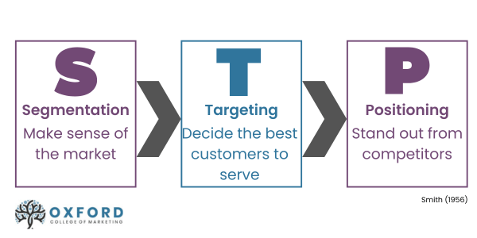
Figure: STP marketing (Gillespie & Hennessey, 2020).

VALS (India vs UK)
India
In India, consumers are categorized into various groups, depending on their lifestyle and aspirations. Aspirational buyers in general, referred to as Achievers are budget conscious consumers ready to buy affordable, but fancy products. The first type of consumer is known as strives, and the latter is known as Experiencers; they are younger age and city residents, who are ready to embrace modern design and new products.
UK
In the UK, segmentation consists of closely related, yet different classes. The thinkers pay attention to quality, sustainability and functionality, whereas the Experiencers are concerned with design and self-expression. The DIY customers are known as the makers: they like to assemble their furniture and personalize it, which can be attributed to the UK culture of individualization and home décor (IKEA, 2023).
Targeting
India: IKEA will focus on the growing Indian middle-income consumer base (especially families with an annual income of INR 5-20 lakhs) who yearn to own inexpensive yet fashionable home products (Gillespie and Hennessey, 2020).
UK: In the UK, IKEA targets a broader audience, which includes a large demographic segment of students and established families (Hollensen, 2022). The main segment is still the value-conscious customers who want quality design at reasonable prices. Moreover, IKEA is also targeting environmentally conscious shoppers with its sustainability programmes and eco-friendly products.

Positioning
India: In India, IKEA will become a more affordable, stylish, and accessible brand of home furnishing that enables good design to be available to the many (Keller, 2019). The positioning focuses on value of money, contemporary Scandinavian design that fits Indian lifestyle, and the desire to have a better way of life.
UK: In the UK, IKEA has established itself as the place where people can find affordable and well-designed and sustainable home furnishings (Vrontis and Thrassou, 2020). The positioning of the brand utilises its long-standing reputation of democratic design, functionality and environmental responsibility.
Perceptual Map
IKEA is positioned in one of the exclusive quadrants as low-price and medium-high perceived quality. Such competitors in price/quality segments include West Elm or Crate and Barrel in the high-price/high-quality category, and discount furniture in the low-price/low-quality category. The customers tolerate self-assembling in favour of low cost and trendy design. Conversely, Wayfair has more pre-made products at a higher price and the local carpenters have the individualized fully customized products but at a high cost. The strategic positioning of IKEA presents a good enough sweet spot, which is fashionable, practical, and affordable and does not seem to be meant for disposal (Hollensen, 2022).
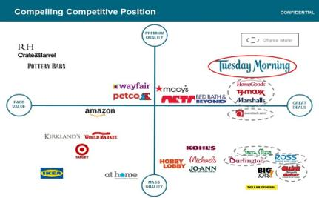
Figure: IKEA (Hollensen, 2022).
Similarities & Differences (Positioning)
Similarities
The fundamental approach of IKEA in both locales is to provide cheap yet high-quality designs that focuses on functionality. This positioning enables IKEA to serve a diverse consumer market whereby it offers cheap but fashionable furniture to both price and quality-conscious consumers.
Differences
In India, the IKEA positioning will be more about affordability and accessibility whereby stylish furniture is accessible to the broader population, on the side of the expanding middle classes. In the UK, the brand focuses on sustainability and lifestyle, as a responsible option to those with environmental concerns, who appreciate both utility and responsible production methods (Hollensen, 2022).

International marketing mix (7Ps)
Making deliveries to customers through Product, Price, Place, Promotion, People, Process and Physical Evidence is a marketing mix (7Ps).

Figure: Marketing mix (Kotler and Keller, 2021).
Product
India: IKEA has tailored its products to the Indian market by adding smaller pieces of furniture that fit perfectly in small urban apartments, Indian kitchen offerings, and items in colours and materials favoured locally (Keegan and Green, 2020). The company has selectively offered a variety of about 7,000 products out of the total global variety together with selective additions like masala boxes, pressure cookers, and tawa pans.
UK: IKEA sells its entire product line of more than 9,500 products in the UK, which is indicative of the market being mature and well-established (Kotler and Keller, 2021). The global range is highly standardised with products, but there are a few small adaptations to the British tastes such as a specific version of beds being made to UK standards and a UK-style kitchen being designed.
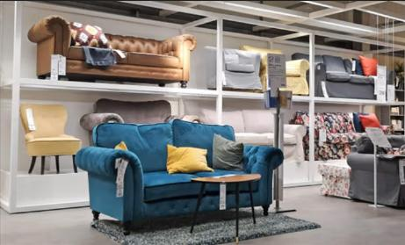
Figure: Product management (IKEA, 2023)
Price
India: Pricing in India is a vital strategic tool, and IKEA has applied price cuts in India to make sure that it is affordable in a highly rate-sensitive market (Hollensen, 2022). The company launched products at a price of INR 69 (approximately PS0.65) which is very low when compared to other comparable markets. Reduction of cost is made possible by local sourcing of more than 50 percent of the products. IKEA employs penetration pricing in India and low-cost approach.
UK: In the UK, IKEA continues to position itself as value-for-money with appropriate pricing in comparison with other furniture stores (Baines, Fill and Rosengren, 2021). The prices are typically higher than those in India but placed under the premium competitors like John Lewis or Habitat. The company has the continuous low-price policy, accompanied by the sales periodically, IKEA Family member supplies, and the advantages of the loyalty programme. Pricing based on value in UK and pricing in competition.
Place (Distribution)
India: The distribution approach at IKEA in India is based on large format stores in major cities and intensive e-commerce alongside smaller stores with a city-centre format (Dunning and Lundan, 2019). The company started e-commerce in India and then started setting up physical stores in some cities appreciating the role of digital in reaching the geographically distributed consumer base in India.
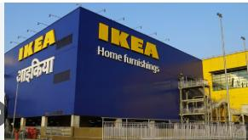
Figure: IKEA India (Baines, Fill and Rosengren, 2021).

UK: IKEA has more than 22 large-format outlets properly distributed around major metropolitan areas in the UK, with city-centre planning studios and comprehensive online shopping platform (Doole and Lowe, 2021). The highly established UK logistical system facilitates effective distribution throughout the country, and IKEA has also invested in eco-friendly delivery services such as electric vehicle fleets. Direct Channels are IKEA stores and Website & app and Indirect Channels are Logistics providers and Delivery partners.
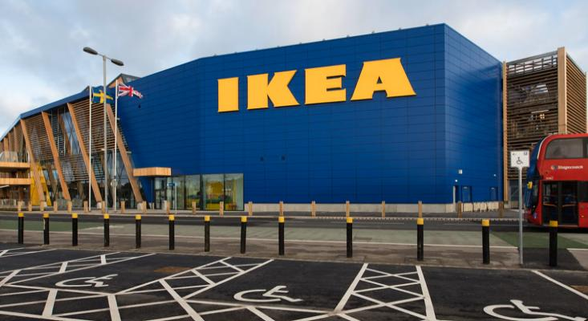
Figure: IKEA UK (Hollensen, 2022).
Promotion
India: IKEA has made its promotional campaign in India very local by employing Bollywood celebrities, supporting with regional language advertising, social media advertising in websites utilised in India: Instagram and YouTube, and experiential branding through in-store events (Batra and Keller, 2020).
UK: IKEA uses integrated marketing communications in the UK, and these tasks include television advertising, digital marketing, social media, catalogues (which are now largely digital) and in-store experience marketing (Kotler, Armstrong and Opresnik, 2021). The campaign Wonderful Every day is the perfect representation of the promotional philosophy of IKEA in the UK.

People
India: The company pays great attention to employee training in India that enables them to lead consumers through the novel store structure and self-assembly idea (Kumar and Pansari, 2022). The company recruited locally and made investments in cultural training to make staff relate to various Indian consumer segments in an authentic manner. As of early 2025, IKEA India employs nearly 3,000 staff members across its operations. In India- Expansion has resulted in a huge number of employees. Also, concentrate on new retail concept training.
UK: Co-workers IKEA, in the UK, are trained to facilitate an independent shopping experience, providing support when asked without interfering with the culture of self-service (Wilson and Gilligan, 2021). IKEA UK employs nearly 12,000 co-workers (staff) across its retail operations. Diversity and inclusion programmes are part of the employee engagement programmes that promote a positive in-store environment. In the UK- Established workforce and pay attention to the efficiency in customer service.
Process
India: India has modified the purchasing process to encompass new services to home deliver all products and provide professional assembly services at minimal costs and custom planning consultation (Yip and Hult, 2020). Checkout procedure supports the use of various payment methods such as UPI, mobile wallets and cash on delivery, which reflects the preference of Indian payments.
UK: IKEA has a well-established process in the UK, where self-service warehouse pickups apply, self-scan and other efficient checkout systems are in place, and w properly arranged click-and-collect services (Johnson et al., 2020). Plans on online purchases are highly advanced with virtual planning tools, real availability and rescheduling of delivery.
Customer Complaint Process
Once a customer has a problem with IKEA product or service, they may be able to get the process of complaint started online or in the store. The process usually starts with the customer leaving his/her complaint on the site which may be via different means e.g. IKEA site, mobile application, or in-store (Baines, Fill and Rosengren, 2021).

Physical Evidence
India: IKEA India store is modelled after the global room-set experience but adds Indian living situations, such as the compact apartment designs, Indian kitchen designs, and areas that mirror a local lifestyle trend (Malhotra, 2020). The on-store restaurant serves a threat of Swedish and Indian food with biryani and samosas as well as traditional Swedish meatballs.
UK: The UK in the UK, IKEA outlets adopt the standard international style with inspirational room scenes based on the British style and size of homes (Solomon, 2020). Swedish food market and restaurant form the iconic components of the IKEA UK experience, making the restaurant a major driver of footfalls.
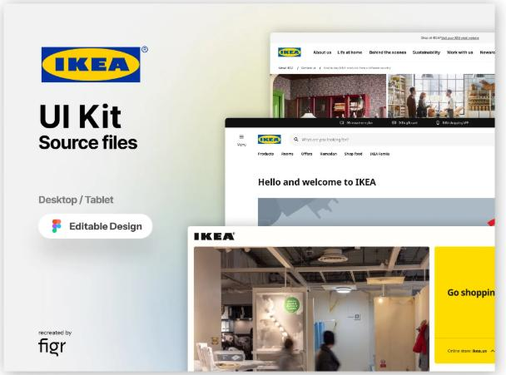
Figure: UK website (Vrontis and Thrassou, 2020).

7Ps Similarities & Differences
Similarities:
In both markets, IKEA has a good brand name and a single product design, which embodies the global brand image of low prices and quality. An omni-channel distribution strategy, a combination of physical stores and e-commerce, is also a common advantage of both markets to reach a large customer base.
Differences:
Pricing in India is on the lower side as it is aimed at the price sensitive market and on the other hand in the UK pricing is rather higher but still not as high as premium competitors. In India, the preference of product adaptation is higher because there is customization of furniture to local lifestyle, including smaller living space designs and designs that can be related to the culture. The UK conversely is more of a digital orientated with a greater emphasis on online shopping experiences.

C. Directional Development Strategy - IKEA in India
Market Development
The penetration of IKEA in India is a typical market development approach, when considering existing product perception to a whole new geographical market (Hollensen, 2022). Its first store was launched in Hyderabad in 2018, with strategic plans of growth into Mumbai, Bangalore and Delhi-NCR.
Product Development
In addition to market development, IKEA has also been working on product development by designing India-based products and tailoring the available products to the local demand (Vrontis and Thrassou, 2020). Products that are specifically Indian-cooking, storing smaller apartments and textiles in patterns that the Indians particularly like are a real product innovation in Indian terms.
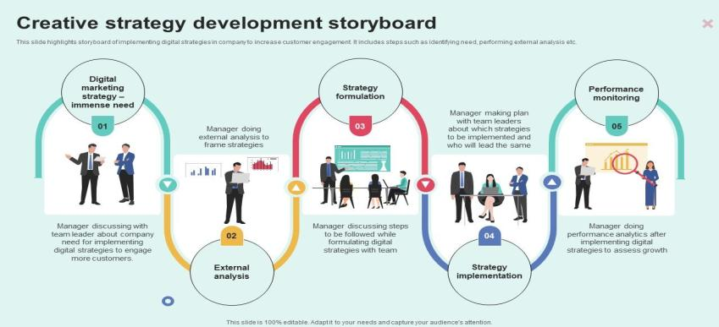
Figure: development strategy (Johnson et al., 2020).
Diversification Elements
The related diversification components have also been established in India by IKEA in services like interior design advice, services of home furnishing planning and the integrated online-offline retail model that transcend their traditional form (Porter, 2018). Although investments in renewable energy projects in India are mainly made in the context of increased sustainability, this trend is also a kind of diversification.

D. IKEA Marketing Mix Ethical Problems
Ethical Issues in India
Labour and Sourcing Ethics: The initiative by IKEA to source more than 50 percent of its Indian goods domestically brings a significant ethical question of sourcing in its supply chains (Rugman and Collinson, 2021). IKEA has rolled its IWAY code of conduct through the Indian suppliers where labour standards must be met, though monitoring.
Pricing Ethics: IKEA has been aggressively pricing its furniture as a strategy to enable commercial operations in India, but this approach casts doubt on the potential effects to the small-scale furniture manufacturers and traditional craftspeople in India (Morrison, 2020).
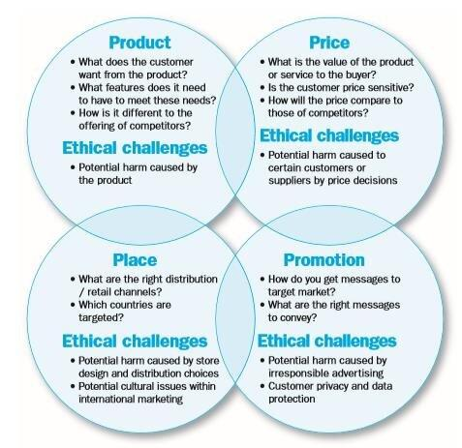
Figure: Ethical challenges in marketing mix (Keegan & Green, 2020).

Ethical Issues in the UK
Environmental Claims: In the UK, the chain of sustainability marketing employed by IKEA has been questioned in regards to the veracity of its environmental claims (IKEA, 2023). The conflict between increasing a disposable, fast-furniture consumption model and assuming a sustainable brand pose ethical contradictions in their nature.
Data Privacy: IKEA has been developing a wide range of digital activities in the UK, such as its app, e-commerce platform, and the IKEA Family programme are used to gather a great deal of consumer data (Grunig, 2018). The ethical aspect of using this information within the UK GDPR and using it to market one to one remains a current ethical issue. Openness in the data collection and usage practises is necessary.
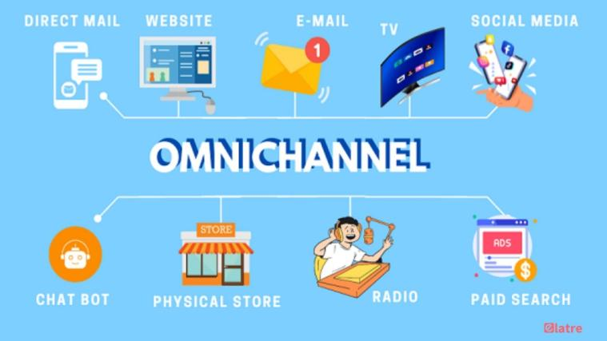
Figure: Omnichannel retail (Keller, 2019).

E. Recommendations
Recommendation 1: Hasten Omnichannel Integration in India
IKEA needs to be more active in unifying its physical and online stores in India and utilise fast rates of digital penetration in the country as an opportunity to facilitate smooth shopping experiences (Yip and Hult, 2020).
Recommendation 2: Enrich Sustainability Credentials in UK
IKEA needs to increase the degree to which it implements a circular economy in the UK market by increasing furniture rental and subscriptions, expanding the buy-back programme, and investing in the full recyclability of the design of products (IKEA, 2023).
Recommendation 3: Localise More in India with Strategic Partnerships
IKEA ought to strengthen collaboration with Indian artisans, designers and social enterprises to design India-only collections that have the power to celebrate local craftsmanship without compromising on the company design philosophy (Cavusgil, Knight and Riesenberger, 2020).
Recommendation 4: Have Dimensional Store Formats
In both markets, IKEA must keep building smaller, centrally located store formats to serve to supplement large suburban warehouses (Kotler and Keller, 2021). In India, such formats are able to reach high-saturated urban centres where big box stores are not feasible.

Section 2: Reflective Account

Reflective Account through Gibbs Reflective Cycle
Description
This section presents a reflective report on the research, analysis and preparation process that I adopted to undertake the comparative international marketing analysis of IKEA in India and in the United Kingdom. The assignment has made me analyse macro-environmental forces, cultural dimensions, segmentation and targeting, overall marketing mix, directional development strategy and ethical aspects of IKEA in two very different markets. I carried out broad secondary research, utilised various theoretical models, and unified the findings into a comparative piece of analysis. I had started out by defining the extent of the task, where I was dividing it into smaller parts, and then methodically researching every aspect before I wrote the final report over a composite of multiple weeks.
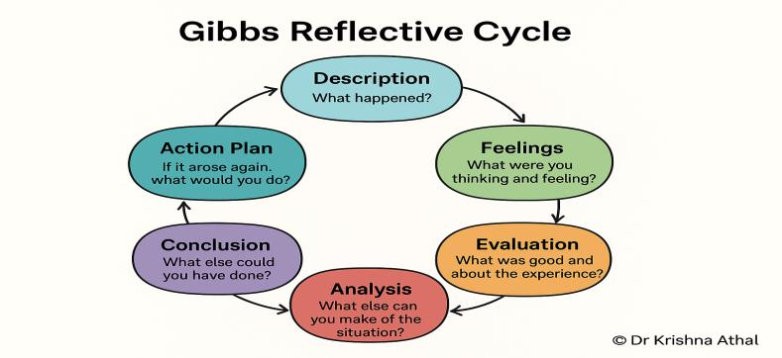
Figure: Gibbs reflective cycle (Kotler & Keller, 2021).
Feelings
I was quite excited and slightly overwhelmed at the beginning of the assignment because it was so broad. It was mentally stimulating to contemplate the prospect of comparing two such different markets, India, with its complexity and dynamism, and the UK, with its maturity and sophistication. But the first thing I was not so sure of was finding the balance of depth and breadth within the word limit. This confidence grew as time progressed during the research phase as I found patterns and insights emerging out of the data.
The Hofstede-based cultural analysis was both interesting, because I learned not only why IKEA performs differently in this or that market, but also why it does. Moreover, I was also pleased by the fact that I was able to find significant connexions between theoretical frameworks and the actual marketing practises of IKEA.
Evaluation
Considering the entire process, I think that a few things worked out. My choice of structuring the research based on themes instead of countries worked out, and it was able to compare the results in a genuine way instead of merely providing two separate analyses. Applying various frameworks (PESTEL, Hofstede, STP, 7Ps, and Ansoff) presented an integrated multi-lens approach to IKEA international marketing strategy. Specifically, my attention was inclined to the cultural analysis section because I could go beyond merely describing the dimensions proposed by Hofstede to outlining their specific implications in marketing strategy.
The ethical analysis was also one of the stronger parts of the assignment, as it enabled me to critically judge the IKEA practises and not merely describe them. Conversely, I also realise that there are areas that can be further developed. The digital marketing strategies could have been discussed in a more detailed manner, especially considering the swift development of e-commerce in both markets. Another issue that I encountered was the inability to find recent academic works specifically on the IKEA operations in India, since the subject of entering the Indian market is very recent, and the academic analysis remains at its early stages.
Analysis
There were a few critical lessons learned about international marketing analysis during the research process. To begin with, I learned the essential role of cultural context in marketing strategy evaluation. Though the Hofstede paradigm has been at times criticised due to its oversimplification, it actually helped me better understand the difference in approaches of IKEA in India and the UK. IKEA has been widely discussed as a case of standardisation, although my examination of it found that there were lots and lots of adaptation of products, prices, distribution and promotions in relation to the Indian market, which argues that the reality is a bit more complex than contained in the textbooks.
Third, the ethical analysis illuminated the multifaceted Ness of being responsible in various contexts of institution and culture. Ethical behaviour in the UK, with its more developed regulatory framework.
Conclusion
This reflective practise has led me to the conclusion that international marketing analysis needs not only theoretical understanding but contextual sensitivity and critical thinking. I was taught that there is no single framework that gives the full picture; instead, it is now the combination and integration of the several different analytical tools that will produce the most insightful analysis. It also occurred to me that I could have been more disciplined in my time management, especially at the initial stages of the project, during which I was spending too much time on general reading and not enough attention on the particulars of the assignment. Next time, I would start with a more detailed research plan and schedule, devoting definite time frames to each part of the analysis.
Action Plan
In the future, I will specialize in secondary research skills to improve the quality of academic work. First, I will formulate a research plan at the outset of each project, identifying the relevant research questions and choosing academic sources like journals, books, and credible online databases. This will ensure a solid foundation for my analysis.
Second, I will improve my skills of literature review where I have to evaluate different pieces of literature critically rather than describing them. I will compare different authors and find gaps in literature to make my work more analytical than descriptive.
Third, a wider range of theoretical frameworks (Hofstede, Trompenaars, and GLOBE) will be used to offer a broader understanding of the context- cultural and business. This will allow me to corroborate my arguments with established theories.
Finally, I will devote more time to organising and synthesising information from various sources and ensuring proper referencing using academic standards. I will also conduct continuous reflection throughout the research process so as to enhance the overall quality of my work.

Conclusion
As far as this comparative analysis shows, the international marketing strategies used by IKEA in India and the UK are a complex continuum between global standardisation and local adaptation. Although the fundamental brand philosophy of democratic design and low-cost home furnishing remain the same, the actual application in the marketing mix varies significantly depending on cultural, economic and competitive forces that dominate each market. India is a high growth potential with great need of localisation and consumer education, and the UK needs consistent innovation, sustainability leadership and digital excellence in an already competitive market.

References
Baines, P., Fill, C. and Rosengren, S. (2021) Marketing. 5th edn. Oxford: Oxford University Press.
Batra, R. and Keller, K.L. (2020) 'Integrating marketing communications: new findings, new lessons, and new ideas', Journal of Marketing, 84(6), pp. 24–44.
Cateora, P., Gilly, M. and Graham, J. (2020) International Marketing. 18th edn. New York: McGraw-Hill.
Cavusgil, S.T., Knight, G. and Riesenberger, J. (2020) International Business: The New Realities. 5th edn. London: Pearson.
Chernev, A. (2020) The Marketing Plan Handbook. 6th edn. Chicago: Cerebellum Press.
De Mooij, M. (2019) Consumer Behavior and Culture: Consequences for Global Marketing and Advertising. 3rd edn. London: SAGE.
Doole, I. and Lowe, R. (2021) International Marketing Strategy. 8th edn. London: Cengage Learning.
Dunning, J.H. and Lundan, S.M. (2019) Multinational Enterprises and the Global Economy. 3rd edn. Cheltenham: Edward Elgar.
Gillespie, K. and Hennessey, H.D. (2020) Global Marketing. 5th edn. London: Routledge.
Grunig, J.E. (2018) 'Strategic behavioral paradigm of public relations', Journal of Communication Management, 22(4), pp. 387–404.
Hofstede, G., Hofstede, G.J. and Minkov, M. (2020) Cultures and Organizations: Software of the Mind. 4th edn. New York: McGraw-Hill.
Hollensen, S. (2022) Global Marketing. 8th edn. Harlow: Pearson.
IKEA (2023) IKEA Sustainability Report FY23. Available at: https://www.ikea.com (Accessed: 10 March 2026).
Johnson, G., Whittington, R., Regner, P., Angwin, D. and Scholes, K. (2020) Exploring Strategy. 12th edn. Harlow: Pearson.
Keegan, W.J. and Green, M.C. (2020) Global Marketing. 10th edn. Harlow: Pearson.
Keller, K.L. (2019) Strategic Brand Management. 5th edn. Harlow: Pearson.
Kotler, P. and Keller, K.L. (2021) Marketing Management. 16th edn. Harlow: Pearson.
Kotler, P., Armstrong, G. and Opresnik, M.O. (2021) Principles of Marketing. 18th edn. Harlow: Pearson.
Kumar, V. and Pansari, A. (2022) 'Competitive advantage through engagement', Journal of Marketing Research, 53(4), pp. 497–514.
Malhotra, N.K. (2020) Marketing Research: An Applied Orientation. 7th edn. Harlow: Pearson.
Meyer, K.E. and Peng, M.W. (2023) International Business. 4th edn. London: Cengage.
Mintzberg, H. (2019) The Rise and Fall of Strategic Planning. New York: Free Press.
Morrison, J. (2020) International Business: Challenges in a Changing World. 2nd edn. London: Macmillan.
Porter, M.E. (2018) Competitive Strategy: Techniques for Analyzing Industries and Competitors. Rev. edn. New York: Free Press.
Rugman, A.M. and Collinson, S. (2021) International Business. 8th edn. Harlow: Pearson.
Saunders, M., Lewis, P. and Thornhill, A. (2019) Research Methods for Business Students. 8th edn. Harlow: Pearson.
Solomon, M.R. (2020) Consumer Behavior: Buying, Having, and Being. 13th edn. Harlow: Pearson.
Vrontis, D. and Thrassou, A. (2020) 'Adaptation vs. standardisation in international marketing', International Marketing Review, 24(6), pp. 601–630.
Wilson, R.M.S. and Gilligan, C. (2021) Strategic Marketing Management. 4th edn. Oxford: Routledge.
Yip, G.S. and Hult, G.T.M. (2020) Total Global Strategy. 4th edn. Harlow: Pearson.

