
personal reflection on team work
Lecturer: Melanie Squirels


University of Wales TSD

Effective Teamworking and Communication Module

BMSW4009

March 2025
ALEXANDRA ZARA
Student ID: 2329733

Contents
Introduction 2
Main Findings 3
Tuckman's teamwork theory 3
Main Learnings About Myself Within Teams 4
Conclusions 4
References: 5

Introduction

This report is a reflection of my personal experiences working within a team during a group assignment at university, where I considered myself the leader. My leadership style was to encourage team members to share their ideas and flourish in their fields. In addition to individuals' willingness to work as a team, excellent leadership and management can encourage effective teamwork. (8 Ways You Can Improve Your Communication Skills - Professional & Executive Development Harvard DCE 2024). I believe the strength of the team is each member, also, you can succeed best and quickest by helping others to succeed.
According to (Peter Hawkins, Leadership Team coaching [2021]) the team leader is sometimes seen as an essential team member, sometimes as an external influencer. The lector assigned us to groups of five and gave us the responsibility to identify the reason for a construction company's delay in the estimated completion of the contract, and to implement Edward De Bono's six-hat theory. That was the moment when I was certain that I would be the leader, as I was the only one socialising with everyone and was aware of their personalities and the challenges we would face during this task.
I will use SWOT analysis and Bruce Tuckman's phases of group growth to reflect on my leadership position, the team's obstacles, and my leadership and teamwork lessons in my report.
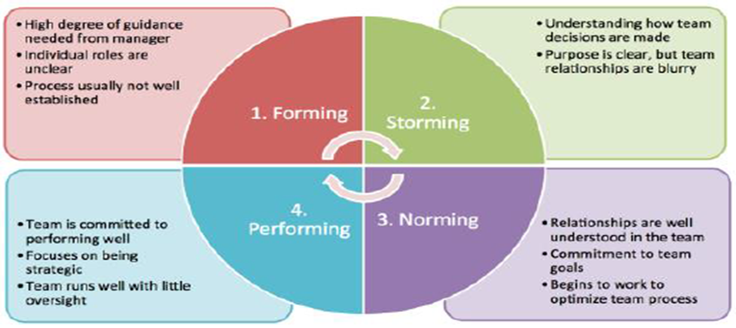

Main Findings

My primary leadership objectives were to ensure the project proceeded as planned and to assist the team in achieving its objectives. I wanted each member of the team to feel valued and engaged in my leadership style. Alone we can do so little; together we can do so much Keller (2025). The team was better able to accept responsibility and cooperate as a result. I emphasised that every individual had a unique set of abilities that would enable them to excel in their own fields of expertise, whether it strategy planning, creative design, or study.
In addition, I felt like I had to help settle disagreements during the job. When people on my team couldn't agree on where the project should go, I had to step in and help them find a solution that worked for everyone.
The Tuckman and Belbin theories of team building may be used to address the problems of formality and team building. According to the case study, all colleague must work together to accomplish the task success. Implementing teamwork ideas may help the teams become more formal and operate better together. Tuckman theory of teamwork and Belbin theory may be used to address the problems of formality and team building.

Tuckman's teamwork theory
According to Tuckman, Bruce W., and Mary Ann C. Jensen (1977), five steps should be taken to improve and make it official the team. It consists of the following stages: forming, storming, norming, performing, and adjourning.

Bruce Tuckman’s model
Several models and ideas have helped me shape how I think about team relationships and how they work together. People have used Bruce Tuckman's model of team growth (Forming, Storming, Norming, Performing, and Adjourning) to help them understand the different steps a team goes through. Because I knew about these stages, I was better prepared for the problems that were bound to come up during group work and could help my team through each one. For instance, we argued about who should do what during the "Storming" part of our group projects. I knew this was a normal part of the process, so I tried to calm things down and help the team agree. This helped us move on to the "Norming" and "Performing" stages.

Belbin's Team roles idea has also helped me find out the different parts that people usually play in groups and what my partners were good and bad at, which let me give them work that fit their natural traits. One partner easily became a "Plant" and came up with creative ideas, while another was a natural "Completer-Finisher" and ensured our work was done correctly. By recognising these roles, made the team work better together and more quickly.
Using models like Tuckman's stages of group growth and Belbin's Team Roles has helped me deal with problems in teams and make my contributions to group projects better. As time goes on, I will keep building on these lessons to make sure that every team I work with has a setting that encourages trust, teamwork, and success.

Main Learnings About Myself Within Teams
- I learnt a lot about my talents, development areas, and collaborative attitude via team-based tasks in this session:
- I prioritise communication and inclusivity as a team leader, fostering respect and admiration.
- I am empathic and focused on team dynamics, maintaining an inviting atmosphere, resolving conflicts, and supporting team members. I sometimes prefer avoiding confrontation to solving problems directly
- I tend to over-analyse choices and seek advice from team members, which might delay decision-making, particularly when there are different perspectives.
- I am a supportive leader who needs to trust my team more. I like offering counsel but struggle to distribute duties. I need to trust the staff more and encourage them to take charge of tasks.

Conclusions

In conclusion, this report highlights my experiences as a team leader, where I focused on inclusivity, communication, and supporting my team members' strengths. With Tuckman's steps of group growth and Belbin's team roles, I was able to help the team work together better and get through tough situations. This method taught me how to trust my team, resolve conflicts, and make better judgements. I'll keep improving these talents to improve collaboration and leadership.

References:

- Peter Hawkins Leadership Team coaching. [2021]. Available at: https://books.google.co.uk/books?hl=en&lr=&id=1xgwEAAAQBAJ&oi=fnd&pg=PP1&dq=What+are+the+key+components+to+make+effective+and+successful+teamwork&ots=r4xam9tlO9&sig=3_Th7kl_RT87z42zxkKBjMVM-gM&redir_esc=y#v=onepage&q&f=false. (Accessed on 12/03/25)
- 8 Ways You Can Improve Your Communication Skills - Professional & Executive Development | Harvard DCE. 2024. Available at: https://professional.dc.harvard.edu/blog/8-ways-you-can-improve-your-communication-skills/. (Accessed on 12/03/25)
- Keller, H. (2025) 'Alone we can do so little; together we can do so much.' Available at: https://www.azquotes.com/quotes/topics/team-leader.html (Accessed: 4 March 2025).
- Dyson, B., Howley, D. and Shen, Y. 2020. ‘Being a team, working together, and being kind’: Primary students’ perspectives of cooperative learning’s contribution to their social and emotional learning. Physical Education and Sport Pedagogy 26(2), pp. 137–154. Available at: https://doi.org/10.1080/17408989.2020.1779683. (Accessed on 12/03/25)
- Patterson, D. 2022. 4.5. In-depth look: Tuckman’s Model – Five stages of team development. Available at: https://ecampusontario.pressbooks.pub/hrstrategicprojectmanagementtheory/chapter/4-5-in-depth-look-tuckmans-model-five-stages-of-team-development. (Accessed on 12/03/25)
- Tuckman, Bruce W., and Mary Ann C. Jensen. "Stages of small-group development revisited." Group & organization studies 2.4 (1977): 419-427.

