Sharette Antoinette Lawrence (2017889)

Module Title: Psychology in Health and Social Care Module Number: BMHP4019_BIRM
Annotated Bibliography
Lecturer: Rebecca Kavanagh

Annotated Bibliography

Reference 1
Babakr, Z., Mohamedamin, P., and Kakamad, K. (2019). Piaget's Cognitive Developmental Theory: Journal of Critical Reviews. Research Gate: Internet. DOI:10.31014/aior.

Slide 6 “Piaget’s proposed four cognitive developmental stages for children”

This journal developed my understanding around the way in which knowledge is constructed. The journal also explored how intellectual development in children progresses - systematically - throughout a series of identifiable stages from basic knowledge or as Piaget terms ‘schemas’. Schemas are created by a child’s:
ability to interact
accept the status
recognise future changes
accept additions to status.

However, I am wondering, though, why the author fails to recognise the importance of emotional relationships with others’ on cognitive development within Piaget's research: for example the final stage is devoid of the emotional and spiritual content found in people's thinking. Arguably, then, this gap would, for me, alludes to an incomplete account of human cognitive development. In addition the language used has not been defined well: for example what does Piaget mean by ‘accommodation' and 'assimilation’? This lack of clear definitions means that it is hard to determine cause-and-effect relationships.

Reference 2
British Psychological Society (2021). What Is Psychology. [Internet]. Available at: https://www.bps.org.uk/public/what-is-psychology. (Accessed:19th October 2021)

Slide 10 “Psychology is the scientific study of the mind and how it dictates and influences our behaviour, from communication and memory to thought and emotion.”

This source of information was useful in that it allowed me to simplify and, thus, explain the complexities of Psychology. The information in this article advanced my understanding as to the way in which many professions use psychology as a way to understand people and, consequently, their behaviours. As The British Psychological Society is the legal governing body of Psychology in the United Kingdom, I would, therefore, argue that this information is trustworthy and reliable.

Reference 3
Eysenck, M. (2017). Simply Psychology. Fourth Edition. London: Routledge

No direct quotes were used, booked used as general basis for further research and reading

Although I did not cite this reference in my presentation, I did read several chapters of this book. As a consequence, I learnt lots about Erikson and how he identified adolescence aged 14 to 20 years old as being in the crisis stage called ‘identity versus role confusion’. In this stage, according to Erikson, the adolescent would search for community and sameness within the questioning, and redeveloping, of a (hetero)sexuality.
However, I questioned why this stage does not recognise those who do not fit within this heterosexual format.
I wonder, then, how can these LGBT+ individuals negotiate this stage of identity versus role confusion when conflict and trauma are presenting through a manifestations of additional LGBT-specific adolescence related transitions?
According to psychosocial theory, intimacy vs. isolation is a stage of psychosocial development in which individuals face the crisis of being alone versus being involved in meaningful relationships. However, I am wondering - what was Erikson’s definition of a ‘meaningful relationship’?
The author also states limitations of Erikson’s research: for example the research primarily describes the development of European American males which suggests this work is only relevant to a specific culture and gender.

Reference 4
Eysenck, M. (2002). Simply Psychology. Second Edition. East Sussex: Taylor & Francis
Slide 5 “Psychology has a role to play in most everyday situations. It is relevant to almost everything in our everyday lives as Sigmund Freud was first to recognise”.

The author recognised how Freud studied the importance of early years development of the mind and, thus, the impact this has in adulthood. Therefore, I found it very interesting to read around how his theory on child sexuality is seen as one of the most significant theoretical models of the 20th century.
However, the author notes how Freud’s research is heavily reliant on the subjective process of his own interpretations and, thus, he potential for his own bias needs to be acknowledged. I wonder, then, can these assumptions be scientifically measured.
The author also argued how Freuds sample was bias due to it consisting of - mostly - white middleclass Vietnamese children and women who were all presenting with distress in some form or another. This suggests a lack of generalised ability beyond this specific culture and population.

Reference 5
McLeod, S., A. (2020). The 4 Stages of Cognitive Development’, Background and Key Concepts of Piaget's Theory. Available at: https://www.simplypsychology.org/piaget.html (Accessed: 10th October 2021)

Slide 7
“Sensorimotor stage: birth to 18-24 months
Preoperational stage: 2 to 7 years
Concrete operational stage: 7 to 11 years
Formal operational stage: ages 12 and up”

I found the McLeod (2020) article useful in that it provided me with the blueprint of all the cognitive stages by name and age group. The simplicity of the way in which this article was presented by McLeod was also very useful for my target audience group.
I did, however, wonder why there was no mention of mentally restrictive children and, consequently how they fit into his stages or what happens if a child is unable to complete the stage. The way in which the emphasises linear developmental stages is restrictive: I wonder, then, if creating a model which emphasises the importance of fluidity within the stages of development could help to decrease the restriction in which linear stage-by-stage modals put on individualised development? This would, for example allow more perspective on the way in which neurodiverse children develop schemes.

Reference 6
Orenstein, G., A., and Lewis., L. (2020) ‘Erikson's Stages of Psychosocial Development’. [Internet]. Florida: Stat Pearls Publishing; Available at: https://www.ncbi.nlm.nih.gov/books/NBK556096/. (Accessed: 15th October 2021)

Slide 9
“Stage 1 - Infancy period - Birth – One year old:
Trust vs. Mistrust
Stage 2 - Toddler – One year old – Three years:
Autonomy vs. Shame, doubt
Stage 3 - Preschool – Three years – Five years:
Initiative vs. Guilt”

Orenstein, G., A., and Lewis., L. (2020: 18) article explores how Erikson’s eight stage psychosocial developmental theory was broadly based on Freud’s psychosexual theory. I found it very interesting reading around how during each of the eight developmental stages the two conflicting areas must be fully resolved to ensure the individual develop into “a confident, contributing member of society”.
However, if these tasks are not mastered, Erikson argues that feelings of inadequacy will materialise. This article, then, helped me to include information on the 3 primary stages in the presentation but looking into these stages further, I would argue that Erikson’s limited variation of subjects do not represent a true snapshot of society in 21st century.
In addition, the lack of recognition of individual differences in development such as how race/gender/ethnicity/disability and/or sexuality could help, or hinder development is confirmed by the author as to have not been part of the theory basis.
The latter 4 stages do seem to be in slight repetition of the primary 4 stages which supports the phrase “twice a child once a man”.

Reference 7
Osmosis Organization. (2021). Developmental Milestones: Clinical Practice. [Image] Available at: https://www.osmosis.org/learn/Developmental_milestones:_Clinical_practice. (Accessed: 7th October 2021).
Slide 3
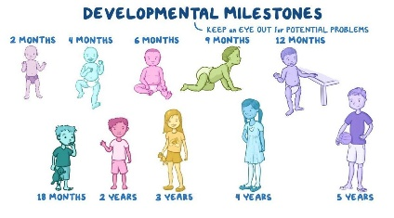
The simplistic layout and colourful images helped to set the tone for the intended audience by simplifying how combining age and development helps to explain psychological theories and, thus, the stages of development - be it cognitive or lifespan stage.

Reference 8
Soung, J. (2020). The 4 Stages of Cognitive Development, Background and Key Concepts of Piaget's Theory. [Image]. Available at: https://www.verywellmind.com/piagets-stages-of-cognitive-development-2795457. (Accessed: 17th October 2021).

Slide 7

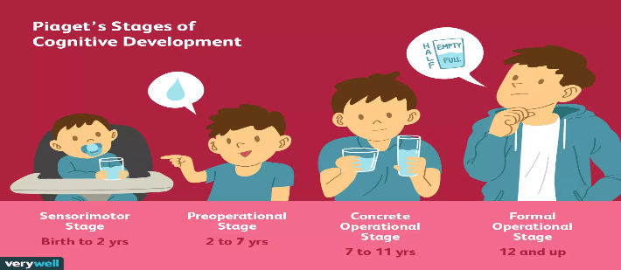
This picture was beneficial in that it depicts the stages in a single vision and has the name and age group of each stage clearly stated. In addition it shows the physical appearance of the age group and referral of the thinking stage to help the intended audience relate to stages.

Reference 9
Vygotsky, L. S. (1978). Mind in society: The development of higher psychological processes. Cambridge, MA: Harvard University Press.
No direct quotes in PPT but used as basic research
This book helped me to compare the difference of Piaget and Vygotsky theories.
Vygotsky’s used a number of tools to stimulate development. This includes:
• cultural and psychological tools
• symbols (number and language systems)
• diagrams.
This research pushed me to critically assess the quantity of Vygotsky views of each theory discussed. For example I was interested to find out through reading this book that, similar to that of Piaget, Vygotsky portrayed a direct ignorance towards the importance of social and cultural input on child development. It could, therefore, be argued that Vygotsky neglects the role of the individual by concentrating on the collective: that the mind is not separate from the group. This means that his theory does not recognise how individuals can rise above social norms based on their ability to bring about personal understanding.

