DATA HANDLING AND BUSINESS MODELLING
DATA ANALYSIS AND VISUALISATION
Assignment 2
STUDENT NAME: GABRIEL MEZO
STUDENT ID: 2030169

Table of Contents
Part 1: Superstore sales and profitability trend 3
Sales trend 3
Profitability trend 4
Use of excel for pre-processing data 5
Using Excel for data pre-processing 5
Challenges faced in analysing Superstore data 8
Part 2: Data analysis and interpretation 9
2.1 Students favorite ice-cream flavor 9
2.2 Student Male and Female 11
2.3 Measures of central tendency 11
2.4 11
2.5 Data mining and text mining methods 11
Data mining methods 11
Text mining methods 12
2.6 Advantage and disadvantages – Excel and SSPS 13
Advantages and disadvantages of Excel 13
Advantages and disadvantages of SPSS 14
References 14

Part 1: Superstore sales and profitability trend

Sales trend
It can be seen from the trend in figure 1 there was a relatively steeper decline in Superstore sales from approximately $4,209,896.85 in 2009 to $3,560,087.04 in 2010. It can be seen in figure 2 that this is the largest decrease in sales experienced by Superstores representing a 15.44%. The sales continued to drop to $3,439,944.98 in 2011 which shows a slightly less decrease at 3.66%. This reduction in sales is an increase of approximately 12%. From 2011 onwards Superstore sales increased to $3,715,761.95 to 2012. From figure 1 this shows an increase of 8.33%.
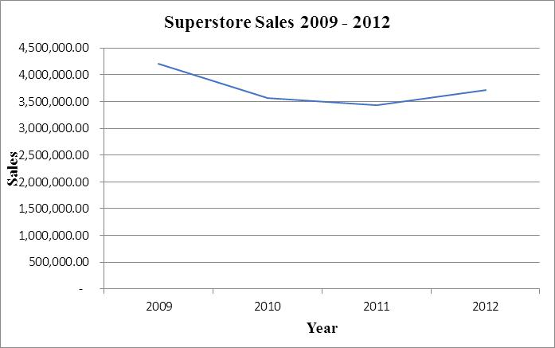
Figure 1 - Superstore sales trend from 2009-2012
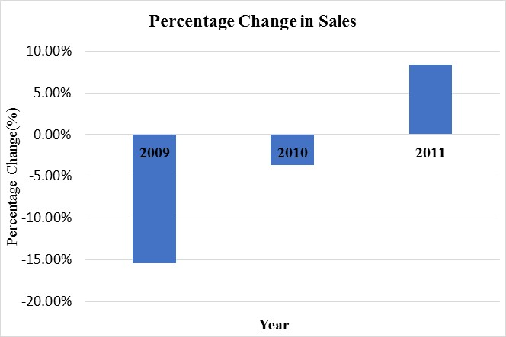
Figure 2 - Superstore sales percentage change from 2009-2011

Profitability trend
From figure 3 below it can be seen that Superstore profitability has decreased from $434,096.02 in 2009 to $364,917.33 in 2010. In correlation to figure 4 this shows a 15.94% decrease in profitability. Figure 3 further shows that from 2010 profitability picked up for Superstore to $380,310.50 which is a slight increase of 4.22%. Despite this increase, Superstore experienced a decrease in profitability to $342,444.13 which represent a 9.96% decrease. It can be observed from figure 3 below that there is an overall downward trend in Superstore profitability in comparison to the Superstore sales trend. Despite Superstore sales increasing from 2011 to 2012, their profitability has decreased from the same time period.
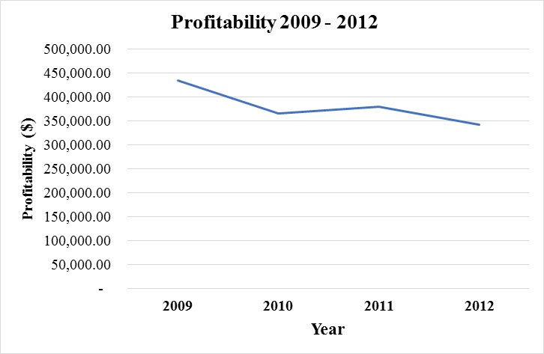
Figure 3 - Superstore profitability trend from 2009 - 2012
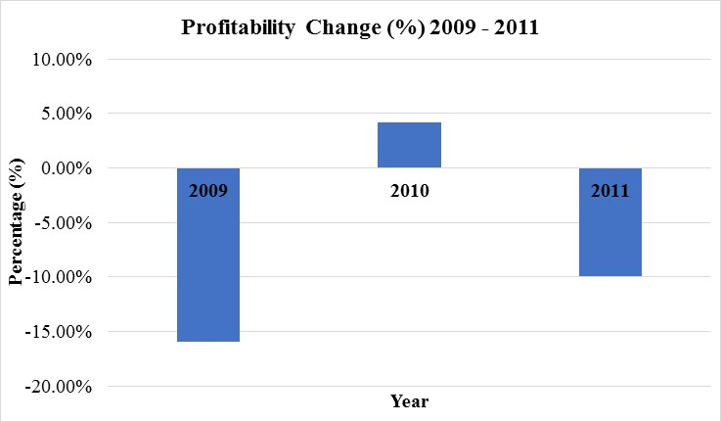
Figure 4 - Superstore profitability change (%) from 2009 - 2011

Use of excel for pre-processing data

Using Excel for data pre-processing
Data pre-processing consists of a step wise process that is used to prepare raw data that is collected, gathered, or derived from another source by making it usable to apply the desired statistical, numerical, and non-numerical functions (Yang, 2018). It consists of a sequential steps that smooth out the irregularities in the raw and unstructured data set to prepare it for the user to perform statistical analysis and transform it into relevant and useful information (Mailey et al., 2016). In the modern era where there is variety and volume of data available along with technology such as machine learning and artificial intelligence, the need for data pre-processing is greater as it is now being employed by everyone in decision making. The need for data pre-processing arises because of data collection the data being unorganized, meaningless, and messy making it challenging to use data analysis tools, methods and techniques (Hameed and Nauman, 2020).
Often times the data in this form cannot be used to derive useful information that can be used in decision making because logical sense cannot be made out of it. Therefore data pre-processing is important as it brings the complied data during the initial stages of data collection into a form that can be used to perform statistical methods and techniques to make useful, relevant, logical and structured. The data points in data sets need to be visualized by the user to understand the type of data and statistical analysis needs to be performed to be able to extract the required information. As mentioned earlier that during the early stages of data collection, raw and unstructured data will often have irregularities such as error rate, missing values there is possibility that information that will be derived from this inconsistent data will lead to poor decision making (Patil et al., n.d.) Even with technological advancements such as big data analysis, business intelligence, and machine learning these challenges cannot be overcome thus making data pre-processing extremely important (Patil et al. n.d.) Through the spreadsheet format and view of MS excel and tabulation of data into rows and columns it allows the user to visualize the available data. It makes it possible for the user to gain a rough understanding of the data available and figure out mentally the nature and type of data in hand. With this information the user is able to make links and connections with the objective at hand to make a mental mapping of the functions that will need to be used to arrive at the post processed data.
MS excel is a software used as a tool that used to analyse large sets of data and use in date pre-processing given the in-built functions and features. There are a wide array features and functions available in MS excel such as IF, VLOOKUP, and PIVOT tables. There are other functions and features in excel that can be used such as moving average tool, Lowess Smoothing tool, trendline analysis, and exponential data smoothing (Murtala, 2019). The moving average tool is used to understand the underlying pattern of the data at hand. It selects a few data points and averages them out and forms a trend line that shows the pattern of the data. As mentioned in the previous section that it is important for the user to visualize data sets, the trend lines created by the moving average function throughout the data set enables user to do so. Another data smoothing technique offered by excel is the Lowess smoothing line. This is a data smoothing technique that provides smoothed out data points from the available data set using a complex in built function by removing extreme numbers relative to the data set known as outliers (Schaich, 2022). The removal of these data points from the data set provides a visualization to the user to understand the impact of extreme values/outliers on the data set and develop an understanding of the underlying pattern of the data set. In data processing the purpose that the LOWESS smoothing line function fulfils is data cleaning by removing outliers in the data thereby removing any undue influence and bias from the data set and skewing data analysis results (Shan and Gubin, 2019).
This step also enables the concept of data reduction through removing the outliers and transforming the data into a data set that is representative of the actually underlying pattern. In addition to these techniques that provide a visual representation and enables the user to developing an understanding and identifying the underlying pattern of the data there are trend lines that are also used. The above mentioned are slightly complex data smoothing techniques. Some basic level functions that excel provides in data processing are the IF, LOOKUP, and Pivot table functions. The IF function is a conditional statement that allows the user to compare the actual data in hand with an expectation and pre-conceived notion they have (Microsoft, n.d.). The IF statement provides users with two results and that is the expectation or the pre-conceived notion of the user will either be true or not (Microsoft, n.d.). This allows the user to analyse the data by developing an understanding and identifying the underlying trend of the dataset. Similarly, the LOOKUP function consists of horizontal and vertical lookup which depending on the dataset can be used at the discretion of the user for data analysis. For example the VLOOKUP function is used extract data from the raw and unstructured data set into a new excel sheet where the user is compiling the data driven by their objective and purpose they are willing to serve (Mahnken and Moehrle, 2018). In cases where there are large sets of data that is unstructured and raw without much meaning the user can derive the use of the pivot table function is valuable. Through the pivot table by having a basic level understanding of the data, users are able to compile the raw and unstructured data sets into modified reports as per requirement (Dahr et al., 2022). The pivot table function is a dynamic tool that enables the users to organize large amounts of data into their desired format conveniently (Dahr et al., 2022).
Through the above mentioned explanation and information pre-processing data follows the steps of data reduction, data cleaning, data integration, and data transformation Several distinct steps are involved in pre-processing data (Mailey et al., 2016). Data in spreadsheets are sources they have been collected from may be compiled in different places and with the use of LOOKUP function as explained above can enable users to integrate data (Obaid et al., 2019). As mentioned above the removal of outliers in the data set reduces any influence present in the data set and reduces the dataset to underlying pattern that is truly representative by reducing the data (Obaid et al., 2019). This entire process of data smoothing and cleaning ultimately leads to data transformation from raw, illogical, and unstructured data into logical, useful, and structure data (Guari at al., 2017). MS excel provides spreadsheets consisting of numerous amounts of rows and data that can tabulate various types of information (Rahman et al., 2021). This allows the user of the data set to visualize the data in tabular format. In addition to this and the above mentioned features and functions users are able to pre-process data, clean data, and smooth the data to being applying statistical and numerical functions and analysis to organize data into a structured format for decision making.

Challenges faced in analysing Superstore data
In pre-processing the available data set for Superstore the primary challenge was the Order Data column. This was because there were some cells that were formatted in the date formula. Some cells in this column were formatted as text and the primary challenge was due to this. This is because, converting these cells to the date did not convert. This posed challenges. To overcome this challenge, those dates that were readily in the date format, the Right function of excel was used to extract the year from the order date into column D. Once the year was extracted from the order date column the year information that was extracted into column D was used to sort sales and profitability associated as per the roes. This made it possible to use the subtotal function to calculate the annual sales and profitability for 2009, 2010, and 2018. To fulfil the other requirement of using a second function the pivot table was also used to determine yearly profit and sales.
In the 21st century there are many data analysis tools that can be used to analyse large data sets such as the Superstore data set provided. MS Excel was used to analyse the data set which was more than sufficient as the required information was extracted as shown above. The functions used to derive this information was the subtotal function and the use of the pivot table. There are other functions that can be used to derive the same information as the above such as the IF and VLOOKUP functions to name a few. To show a graphical representation of the annual sales and profitability of the data the line graph was used. There are other graphical options that can be used to illustrate the annual profitability and sales. Many of these functions are useful in data smoothing and pre-processing and in some they are not. It entirely depends on the expertise level of the user. For instance, university students will not be able to smooth and clean out a data set with the same quality an experienced professional with 10 years of experience in the financial industry will. The choices of the functions mentioned above depends on the ability of the user to visualize the data which is dependent on the knowledge and experience level.

Part 2: Data analysis and interpretation

2.1 Students favorite ice-cream flavor
From figure 5 and 6 below it can be seen that the most favorite ice-cream flavor for students is vanilla, followed by strawberry and the chocolate.
Figure 5 - Pivot table showing students favorite ice-cream flavors

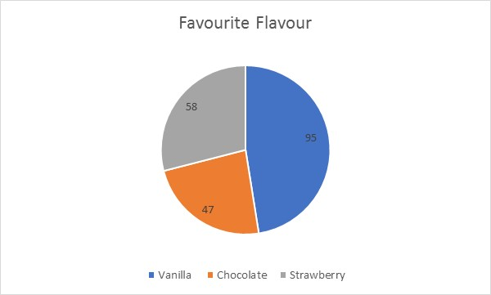
Figure 6 - Pie chart for favorite ice-cream flavors
From figure 7 and 8 below it can be seen from the 200 students surveyed there are 91 students that are male and 109 students that are female.
Figure 7- Number of male and female students

2.2 Student Male and Female
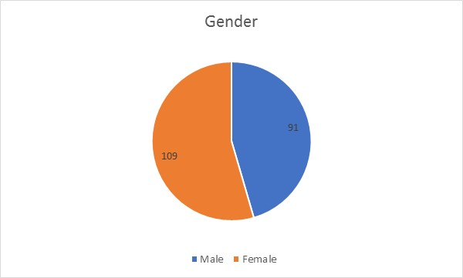
Figure 8 - Number of male and female students

2.3 Measures of central tendency
To determine a relationship between students favorite flavor of ice-cream and video game scores, puzzle scores, and gender there is a limitation that prevents determining this. To determine a relationship with variables, the ideal tool is to use the correlation coefficient and this calculation can be performed for continuous variables. Continuous variables are most often found to be numerical data (Kaliyadan and Kulkarni, 2019). Since these variables are numbers, coefficient correlation can be used to determine relationships (Schober et al., 2018). Categorical data does not take numerical values and can be classified into categories (Agresti, 2018). In this case the data is categorical as the students responses are recorded and categorized into ice-cream flavor categories and gender. Therefore a relationship cannot be defined.
For the reasons stated above, due to the same limitations measure of central tendency cannot be calculated as there are no continuous variables provided.

2.4 K-means clustering example

Workings
In this section, we used SPSS to perform K-means clustering analysis with Gender as label by cases and video and puzzle as variables. The number of clusters was set at 4 with method as iterate and classify (see figure below)
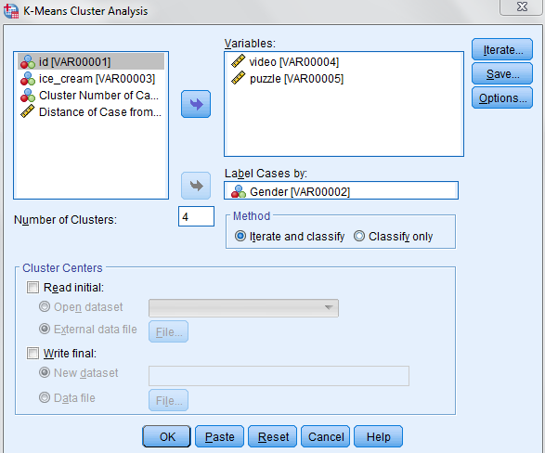
The iterations were set as default see figure below
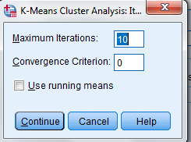
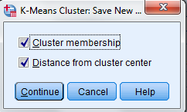
And options selected as followed
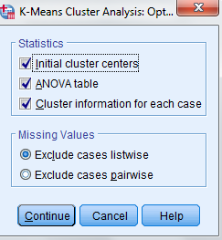

Clustering Output
The final output is presented and discussed below:
The initial cluster centres are show in following table
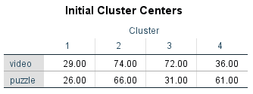
The iteration history is as followed:
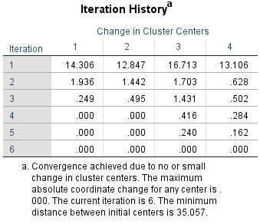
The iteration history shows that in first iteration all cluster joins next cluster and cluster cente is updated. Same trend is observed in second and third iterations. However, there is no change in first and second clusters in 4th and 5th iterations and finally the redistribution of units stops in sixth iteration.
The final cluster centre is as followed:
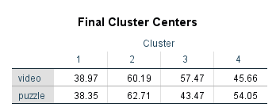
Furthermore, the ANOVA table shows puzzles has greater impact on clustering (f=202.525) as compared to video (f=163.228)
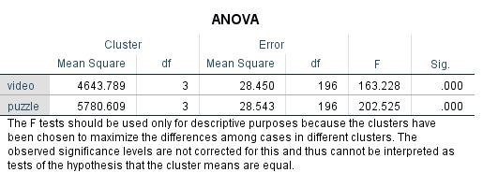
Finally, following table shows number of cases in each cluster and that there is no missing values:
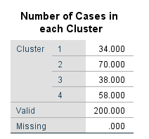

2.5 Data mining and text mining methods

Data mining methods
Data mining is a tool used in business decision making that involves the process of compiling data for a defined objective and performing data analysis techniques to derive useful, relevant, reliable, and meaningful information (Sugiyarti et al., 2018). In the 21st century there is a wide and diverse availability of data that is stored in databases, cloud servers, and the internet that is transformed into relevant and meaningful information to enable organisations from small to large multinational corporations in making business decisions (Osman, 2019). Through major technological advancements in the past 30 years data analysis tools, methods, and techniques such as data mining is being used across carious industries. These industries are retail, health-care, financial services, manufacturing, education, and government to name a few (Gupta and Chandra, 2020). Data mining in particular and specific industries is not much different than the basic definition explained earlier. In the healthcare industry for disease prediction research and studies, data mining is a tool used to analyze large amounts of data to extract relevant relationships (Mudaliar et al., 2019). Organisations such as Walmart in the U.S. use methods and techniques provided by data mining software to analyse large data sets to for inventory control, inventory management, and understanding customer purchasing patterns and trends to maximize profitability (Gopal, 2019). The retail industry uses regression analysis in data mining to understand factors that affect their business performance such as understanding market conditions, customer behavior, assess competitor performance (Teng and Gong, 2018). In the banking industry banks use data mining technology to analyse customer behavior and trends to reduce the number of customers lost in using banking services (Khalid et al., 2021). The banking industry uses a machine learning technology known as Support Vector Machine (SVM) to achieve this technology that uses techniques like regression analysis (Karvana et al., 2019).

Text mining methods
Text mining is the process of transforming unstructured data into structured data using data extraction and analysis tools to create useful and relevant information (Kumar et al., 2020). This is also the primary different between data mining and text mining. Data mining is used to develop structured data into meaningful, useful, and relevant information whereas text mining organizes data in raw, highly-detailed and illogical form that is unstructured (Tandel et al., 2019). Technological advancements have made it possible for industries such as financial services, medical, and government to name a few (Usai et al., 2018). Banks in the financial sector use data collected through the following methods data include transactional data, logged data, and application data. External data sources for banks consist of information available on the social media platforms and websites that is representative of relevant customer information used to understand customer needs and enhance financial services provided by banks. There are various methods and techniques used through text mining in the financial sector such as: keyword extraction, named entity recognition, gender prediction, sentiment analysis, topic extraction, and social network analysis (Westermeier, 2020). In the financial sector, banks collect data from internal and external sources on which text mining methods and techniques are applied to create useful information for business decision making (Pejic et al., 2019). Financial sectors take advantage and leverage data analysis techniques available to transform a variety of semi-structured and unstructured data collected through the above text mining techniques (Pejic et al., 2019). In the medical field text mining technology is used since there are instances where traditional data processing methods and techniques used cannot be used to fulfill data extraction objectives (Sun et al., 2018). Similar to the financial sector the medical field is another example where unstructured and semi- structured data needs to be developed and transformed into structured data. The main strategy is to convert semi structured and unstructured texts into computer-readable-structured data by means of information extraction and natural language processing (NLP) technologies (Sun et al., 2018)

2.6 Advantage and disadvantages – Excel and SSPS

Advantages and disadvantages of Excel
Microsoft (MS) Excel is a software program developed by Microsoft that allows users to perform numerical calculations through its built-in functions and features as well as non-numerical functions such as data organisation (Constantinescu et al., n.d.). The various functions and feature allows Excel users analyse large data sets, perform data modelling, record and maintain data (Anderson et al., 2020). These are the primary reasons for the use of excel by everyone across the world ranging from the average person to large corporations. Some advantages of Microsoft excel is that the user friendliness, simplicity due to basic level functions, minimal expertise level required, and cost-effectiveness (Rahman and Muktadir, 2018). Even though there are advanced functions and features excel provides there is also relative ease in using it and minimizing the requirement within organisations to hire employees with special Excel knowledge (Perkhofer et al., 2019). The simplicity of its nature to a certain extent saves time as well and enables effective decision making due to its uncomplicated functionality. In contrast, in the era of big data there are some disadvantages of excel such as inability to analyse, complete data modelling, and performing numerical calculations on relatively large data sets (Perkhofer et al., 2019). In the organisation’s Excel is seen as an effective project management tool as it allows managers to maintain project completion status and maintain progress data (Glegg et al., 2019). Excel is also applicable to other industries such as in fisheries where a variety of data related to biological, physiochemical and geomorphological information to be processed and analysed (Das et al, 2022). In addition to this MS excel is used as a tool in the financial services industry to perform financial modelling, ratio analysis, and regression analysis to understand profitability of potential investment prospects (Paradi and Sherman, 2018).

Advantages and disadvantages of SPSS
Statistical Package for the Social Sciences is shortly known as SPSS developed my IBM (Ho, 2017). SPSS is more inclined towards specialized statistical computations in comparison to excel (George and Mallery, 2019). As mentioned above with Excel’s inability to analyse large data sets and perform complication calculations, SPSS does not have this limitation (Pallant, 2020). Therefore some advantages of using SPSS is that large data set can be analysed, more variables can be analysed, and complicated calculations cane be done (Erfanian et al., 2020). Some disadvantages of using SPSS is due to the scientific and statistical functionality of the software there may be need for special expertise in data analysis (Geroge and Malley, 2019). In comparison to the above with excel users being the average person not requiring much training. Those that do use SPSS may need to have experience, specific knowledge, and training that may reduce the utility of the software in decision making (Pallant, 2022). Some real-life examples of SPSS being used can be in an education setting for students is that it can be used with MS excel to complete their academic assignments (Mustika et al., 2022). This is because SPSS provides the advantage for them to download an import data available in excel and complete the required statistical analysis. There are also examples of SPSS being used in the financial services sector as exemplified by Islamic banks in Zanzibar, Tanzania (Khamis and AbRashid, 2018). This example shows that the regression analysis and correlation analysis are performed in these banks using SPSS.

References
Agresti, A., 2018. An introduction to categorical data analysis. John Wiley & Sons.
Akoglu, H., 2018. User's guide to correlation coefficients. Turkish journal of emergency medicine, 18(3), pp.91-93.
Anderson, D.R., Sweeney, D.J., Williams, T.A., Camm, J.D. and Cochran, J.J., 2020. Modern business statistics with Microsoft Excel. Cengage Learning.
CONSTANTINESCU, Ș. and ANGHELESCU, A., USING EXCEL IN PROJECT MANAGEMENT. LIMBI STRĂINE ȘI COMUNICARE, p.38.
DAHR, J.M., HAMOUD, A.K., NAJM, I.A. and AHMED, M.I., 2022. IMPLEMENTING SALES DECISION SUPPORT SYSTEM USING DATA MART BASED ON OLAP, KPI, AND DATA MINING APPROACHES. Journal of Engineering Science and Technology, 17(1), pp.0275-0293.
Das, B.K., Jha, D.N., Sahu, S.K., Yadav, A.K., Raman, R.K. and Kartikeyan, M., 2023. Introduction to Electronic Spreadsheet and Microsoft Excel. In Concept Building in Fisheries Data Analysis (pp. 195-208). Springer, Singapore.
Erfanian, F., Latifnejad Roudsari, R., Heydari, A. and Noghani Dokht Bahmani, M., 2020. A narrative on the use of vignette: its advantages and drawbacks. J. Midwifery Reprod. Health, 8, pp.2134-2145.
George, D. and Mallery, P., 2019. IBM SPSS statistics 26 step by step: A simple guide and reference. Routledge.
Glegg, S.M., Ryce, A. and Brownlee, K., 2019. A visual management tool for program planning, project management and evaluation in paediatric health care. Evaluation and program planning, 72, pp.16-23.
Gopal, M., 2019. Applied machine learning. McGraw-Hill Education.
Guan, Z., Ji, T., Qian, X., Ma, Y. and Hong, X., 2017, July. A survey on big data pre-processing. In 2017 5th Intl Conf on Applied Computing and Information Technology/4th Intl Conf on Computational Science/Intelligence and Applied Informatics/2nd Intl Conf on Big Data, Cloud Computing, Data Science (ACIT-CSII-BCD) (pp. 241-247). IEEE.
Gupta, M.K. and Chandra, P., 2020. A comprehensive survey of data mining. International Journal of Information Technology, 12(4), pp.1243-1257.
Hameed, M. and Naumann, F., 2020. Data preparation: A survey of commercial tools. ACM SIGMOD Record, 49(3), pp.18-29.
Kaliyadan, F. and Kulkarni, V., 2019. Types of variables, descriptive statistics, and sample size. Indian dermatology online journal, 10(1), p.82.
Karvana, K.G.M., Yazid, S., Syalim, A. and Mursanto, P., 2019, October. Customer churn analysis and prediction using data mining models in banking industry. In 2019 International Workshop on Big Data and Information Security (IWBIS) (pp. 33-38). IEEE.
Khalid, L.F., Abdulazeez, A.M., Zeebaree, D.Q., Ahmed, F.Y. and Zebari, D.A., 2021, July. Customer churn prediction in telecommunications industry based on data mining. In 2021 IEEE Symposium on Industrial Electronics & Applications (ISIEA) (pp. 1-6). IEEE.
Kumar, A., Dabas, V. and Hooda, P., 2020. Text classification algorithms for mining unstructured data: a SWOT analysis. International Journal of Information Technology, 12(4), pp.1159-1169.
Mahnken, T.A. and Moehrle, M.G., 2018. Multi-cross-industry innovation patents in the USA-A combination of PATSTAT and Orbis search. World Patent Information, 55, pp.52-60.
Malley, B., Ramazzotti, D. and Wu, J.T.Y., 2016. Data pre-processing. Secondary analysis of electronic health records, pp.115-141.
Microsoft. N.D. Excel functions. Accessed at November 20th at https://support.microsoft.com/en-us/office/excel-functions-alphabetical-b3944572-255d-4efb-bb96-c6d90033e188
Mudaliar, V., Savaridaasan, P. and Garg, S., 2019. Disease prediction and drug recommendation android application using data mining (virtual doctor). International Journal of Recent Technology and Engineering, 8.
Murtala, M.A., 2019. SPATIO-TEMPORAL ANALYSIS OF RAINFALL TRENDS AND IN NORTHWESTERN NIGERIA.
Mustika, I., Nabella, S.D. and Mulyadi, M., 2022. DATA-PROCESSING TRAINING USES A SPSS APPLICATION FOR IBNU SINA UNIVERSITY MANAGEMENT STUDENTS. International Journal of Engagement and Empowerment, 2(2), pp.179-183.
Obaid, H.S., Dheyab, S.A. and Sabry, S.S., 2019, March. The impact of data pre-processing techniques and dimensionality reduction on the accuracy of machine learning. In 2019 9th Annual Information Technology, Electromechanical Engineering and Microelectronics Conference (IEMECON) (pp. 279-283). IEEE.
Osman, A.S., 2019. Data mining techniques.
Pallant, J., 2020. SPSS survival manual: A step by step guide to data analysis using IBM SPSS. Routledge.
Paradi, J.C., Sherman, H.D. and Tam, F.K., 2018. Data envelopment analysis in the financial services industry. Springer.
Patil, A., Shinde, S., Surwase, S., Patil, T. and Chaskar, A., COVID-19 FUTURE FORECASTING USING MACHINE LEARNING. Journal homepage: www. ijrpr. com ISSN, 2582, p.7421.
Perkhofer, L.M., Hofer, P., Walchshofer, C., Plank, T. and Jetter, H.C., 2019. Interactive visualization of big data in the field of accounting: A survey of current practice and potential barriers for adoption. Journal of Applied Accounting Research.
Rahman, A. and Muktadir, M.G., SPSS: An Imperative Quantitative Data Analysis Tool for Social Science Research.
Rahman, S., Bendre, M., Liu, Y., Zhu, S., Su, Z., Karahalios, K. and Parameswaran, A.G., 2021. NOAH: interactive spreadsheet exploration with dynamic hierarchical overviews. Proceedings of the VLDB Endowment, 14(6), pp.970-983.
Sarker, I.H., 2021. Data science and analytics: an overview from data-driven smart computing, decision-making and applications perspective. SN Computer Science, 2(5), pp.1-22.
Schaich, L., 2022, May. Monte Carlo Modeling Approach for Anaerobic Digestion and Biogas Utilization. In Residuals and Biosolids 2022. Water Environment Federation.
Sugiyarti, E., Jasmi, K.A., Basiron, B., Huda, M., Shankar, K. and Maseleno, A., 2018. Decision support system of scholarship grantee selection using data mining. International Journal of Pure and Applied Mathematics, 119(15), pp.2239-2249.
Tandel, S.S., Jamadar, A. and Dudugu, S., 2019, March. A survey on text mining techniques. In 2019 5th International Conference on Advanced Computing & Communication Systems (ICACCS) (pp. 1022-1026). IEEE.
Teng, X. and Gong, Y., 2018, July. Research on application of machine learning in data mining. In IOP conference series: materials science and engineering (Vol. 392, No. 6, p. 062202). IOP Publishing.
Usai, A., Pironti, M., Mital, M. and Mejri, C.A., 2018. Knowledge discovery out of text data: a systematic review via text mining. Journal of Knowledge Management.
Westermeier, C., 2020. Money is data–the platformization of financial transactions. Information, Communication & Society, 23(14), pp.2047-2063.
Yang, H., 2018. Data preprocessing. Pennsylvania State University: Citeseer.

