
Merita Karanxha
Student ID: 2544824

Assessment 1 – Reading Task Template
Upload your photo of your A3 in-class notes here:
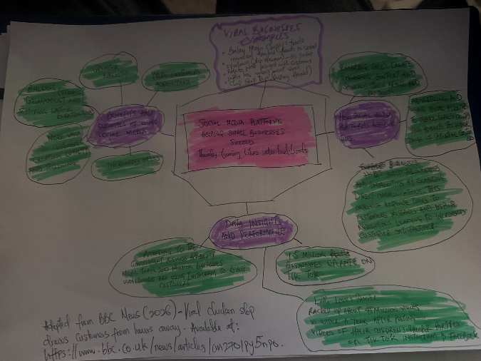

1. Answer these questions using the sentence starters below
a. What is the main idea of the text?
The main idea is that social media helps small businesses grow by attracting more customers, increasing sales, and making businesses well known.
b. What are two key points?
One key point is that businesses can become popular very quickly when their videos go viral on social media.
Another key point is that customers are willing to travel long distances or buy online after seeing businesses advertise on TikTok, Instagram, or Facebook.
c. What part of the text did you find most important? Why?
The most important part is the examples of real businesses, such as Honeywood Sandwich Shop, because they show how social media can help a small business become successful.
d. Was anything unclear or difficult to understand?
I don’t know how social media videos go viral, but the business examples helped me understand the results that it is good for business.
e. How did creating a mind map help you understand the text better?
Creating the mind map was very difficult for me so I asked for help and looked online for tips. I have attached a picture above for reference.
2. One sentence reflection
Question: What did you find challenging about this task?
The hardest part was choosing the most important information because the article included many different examples of successful businesses

