
Skills for the Workplace
Module Assignment Submission
Student Name: | Konstantinos Tsene
Student Number: | 2125449
Module No: | BMSK4004
Module Title: | Problem Solving and Decision Making

Statement of Confirmation of Authenticity
By the act of making this submission, the student declares that this is the work of the student named above. The work has not, in whole or in part, been knowingly presented elsewhere for assessment, or where assessment has been built on a previous assessment, this has been identified. Where materials have been used from other sources it has been properly acknowledged. If this statement is untrue, the student acknowledges that an assessment offence has been committed.
Attention is drawn to the plagiarism and unfair practice policies of both the University and of ILM.

Table of Contents
Bullying- Major Problem in an Organization 2
Identifying the Problem and helping in Decision Making Process 3
Alternative Solution to the Problem 6
Office Debates: 6
Team Lunch: 7
Visiting Amusement Parks: 7
Field Games 7
Counselling Sessions: 7
Feedbacks and Suggestions: 8
Identifying the most Appropriate Option 8
Problem and its Impact on the employees 10
Detailed Plan for Implementing the Solution 11
Communicating the Plan with the Relevant Stakeholders 12
Monitoring the Successful Implementation of Solution 14
References 17
Appendix 20

Bullying- Major Problem in an Organization
Workplace bullying is a verbal, physical, social or psychological abuse by the manager, employers or employees to another person or group of people. The issue of bullying at a workplace is very complex (Plimmer et al., 2021). Bullying can mentally effect a person and it can make them isolate in the workplace. Work place bullying can happen to anyone and at any work environment. Workplace bullying can happen to anyone who is doing internship, a student at work place, volunteer, beginner at work, casual or permanent employees. Places where bullying can take place could be an office, shop, restaurant, government organization and community groups.
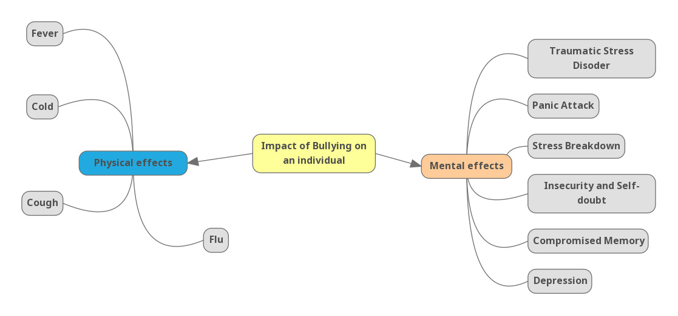

Source- By Author
The above diagram is a mind map which is showing the impact of bullying on an individual or an employee. There are two types of impact of bullying. These two types are mental and physical. Bullying can make a person weak mentally and physically. Mental illness can cause depression, compromised memory, insecurity and self-doubt, panic attack, stress breakdown and traumatic stress disorder (Kemp, 2014). On the other hand, physical impacts could be fever, cough, cold and flu. Beyond physical and mental impacts, bullying can also affect the company financially. Loss of productivity, healthcare cost, absenteeism, and work place turnover and reputation damage can take place in an organization that can affect the company beyond financial cost (Feijó et al., 2019).
Loss of production takes place when people avoid doing work or it becomes very difficult for people to work in high-anxiety situations (McTernan et al., 2013). Employers face a loss of productivity due to workplace bullying and employees also feel a loss of motivation and it causes them in not giving extra effort or working extra hour at workplace.
High-stress level can have an impact on the health of employees and this can cost an employer in the form of sick leave or health insurance costs. In case the employee does not leave the company, the employer may be forced to pay the cost of rehabilitation as well as counselling fees. Big loss of time will occur at the workplace when high-stress situations will lead to absenteeism in employees. Employees may call it sick leaves when they are not sick or maybe they will go on extended stress leaves (Olsen et al., 2017). Bullying can make the employees leave the place of work and this will increase the cost of company as replacement cost. According to the study, employees targeted by bullies have a 67% chances to lose their jobs. Company’s when considering the cost of rehiring and training, it can cost the employers billions of dollars as well as reputation, sales, morale and productivity. Also, when an employee is unhappy with the company, he\she will tell about it to someone and this can cause reputational damage to the company. It also becomes very difficult for the company to find another employee for hiring (Salin, 2018).

Identifying the Problem and helping in Decision Making Process
For decisions making process, first the organization needs to spot the signs of bullying. As discussed above, bullying can be verbal, physical or online. Many bullies feels a lot braver when they can target people or bully people with the help of internet. It is not that online bullying is not visible but proper observation is needed for spotting the bullying (Parker, 2014). Organization should observe the bullies and on the other hand people should identify that when they are being bullied or not. There is a thin line between bullying and non-bullying behaviour and it is important for the organization and the employees to understand it (Baillien, 2017).
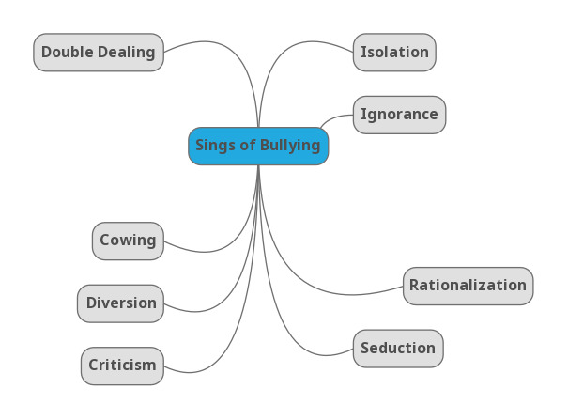
Source: By Author
In the above mind map, sign of bullying is mentioned. These terms are used by bullies to establish control and fear over the victims. When the person who bullies justify his\her behaviour even when it is wrong or unjustified. It is known as rationalization. The bullies give a logical reason behind his\her wrong behaviour. When someone constantly criticizes someone’s work or behaviour, usually without any particular reason, it is known as criticism. Cowing is manifesting someone with physical contacts, verbal abuse, making someone feel lower than others, and embarrassing someone purposely (Dzurec, 2017). Diversion is playing dumb in front of anyone and then making fun of them, cancelling important meeting without any reason, avoiding people and changing the subject to distract the issues or to change the issue. Double dealing on the other hand means lying or not telling the truth. Creating false hopes with no plans in fulfilling them. Some other kind of bullying could be blaming other for mistakes done by someone else, purposefully blocking someone’s work of making threat about job security, designing a target or task which is unachievable to see the person fail, spreading fake rumours about other employees and their work and making fun of someone’s opinion and decisions. An organization should identify all these bullying behaviour and should work on improving it (Rayner, 2020).
The size of the organization does not matters. As, every organization should form strict policies for dealing with bullying. A healthy and positive environment is needed in every organization for people to work (Di Fabio, 2017). For stopping the problem like bullying in an organization, the very first thing an organization can do is to accept that bullying is a major problem in an organization. After this only, organization can form rules and regulation related to bullying. The first step an organization can take in the prevention of workplace bullying is drawing a written anti-bullying policy (Spruce, 2019). It should be drawn up keeping in mind the Health and Safety Authority’s Code of Practice on the Prevention and Resolution of Bullying at Work (refer to appendix 4,5, and 6). Three steps that an organization can take against bullying is:
Source- By Author
Employers should have Occupational Health and Safety act to make the workplace a safe and risk-free environment. Workplace should be psychologically, physically and mentally healthy. The manager or the employer should set values and standards of behaviours that provide a safe workplace for all the working employees. Culture of respectful behaviour and communication at workplace also helps in the growth of the organization (DA, 2017). By showing effective leadership, senior management committee can work on identifying, prevent and respond to workplace bullying. This process will help in preventing unreasonable behaviour at workplace by the bullies. By setting the workplace culture, the employer and manager can make the employees aware of the workplace’s standards of training and role modelling. On the other hand, employers and managers should also keep an eye on what they are doing or saying by themselves. As the behaviour of managers and employers also impacts the culture of the workplace (Redmond, 2015).

Alternative Solution to the Problem
Some alternative solutions to the problem of bullying can be team building exercises (refer to appendix 2). Team building exercises helps in enhancing the bonds of the employees. These types of exercises helps in the smooth running of management. Employers and team leaders can learn about their teammates and teammates will come to know more about the organization and the employers (Kurtulmuş, 2020).
Gantt Chart of Alternative Solution
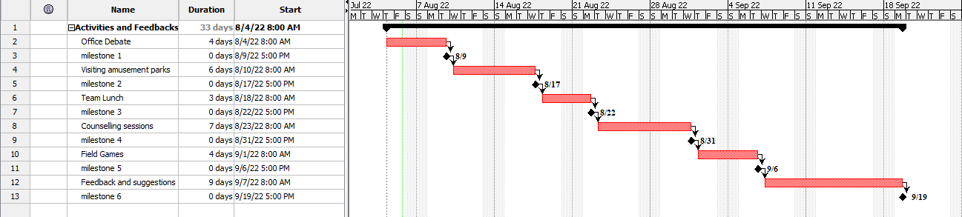
Source: By Author
Team building exercises helps in better interaction of the employees and the employer and it will help different groups understanding each-other. This will give chances to the employees to have open conversations. Team members will develop relationship with other employees inside and outside the organization (Zhang, 2018). This can help in improving the environment of the organization in a positive way and it will naturally eliminate the chances of bullying in an organization. Office debates, going on office lunch, having counselling sessions, field games and a feedback session will clear the mind of the employees and the organization (Riener & Wiederhold, 2016).
Office Debates: There will be two teams during the time of debates. Debates will be in informal way. The team which will be in the ‘for’ side will speak in ‘for the topic’. The other team will play the game ‘against the topic’. Interesting debate topics will be presented by the HR or manager. In addition, as discussed the topics will be informal, so the topic of the debate will be disclosed at the time of game itself. It will give an equal opportunity for each employee as no one will come prepared. For making this game fairer, chits will be kept in a box and each employee will pick up one chit (Brinkley, 2017). Employee with the chit of ‘against the topic’ will go in the opposite team and employees with ‘for the topic’ chit will join the other team. The organization can plan to have office debate activity 4 days a month.
Team Lunch: Team lunch is another alternative to boost up employees and to eliminate bully. The organization will organize a team lunch where all the employees will have lunch together. It will increase the interaction between employees and the manager. Positive interaction between employees will increase good feeling, morale and it will also improve work satisfaction. The organization can organize team lunch 3 times a month.
Visiting Amusement Parks: Amusement park is a different world from the office environment. Employees need breaks like these from their work to eliminate load of work and it is also important for a change. This will increase the work satisfaction between the employees and will also boost relationship with other employees and managers. It will also be beneficial for the physical health of employees. An organization can plan 6 days of amusement park visit in a month.
Field Games: Here, just like debates, teams will be distributed. Chits will be given to each employee and according to the chits, the employees will be distributed. In this, the organization can conduct many games like cricket, football, hide and seek and basketball. This team building activity will help the employees in creating strong teams and it will also teach management process to the employees. By playing these games, the co-workers will get to know each-other in more personal ways, apart from knowing someone only in the work area. By playing together, bonds will become strong between employees and they will build a sense of trust on each-other. The organization can plan to have field games 4 times in a month.
Counselling Sessions: If an employee is not well mentally, it will interrupt the success of the company. For eliminating the mental pressure from the employees, employees counselling is needed. A place where an employee can speak his\her heart out and can come up with anything will give them a sense of safety. It will reduce turnovers. Keeping a counselling session will also help the organization in knowing the negative activities in the organization. It will reduce unnecessary arguments at workplace and it will create a positive environment at workplace. This will build a transparent wall between the employees and the organization. The organization can plan to have counselling sessions 7 times a month.
Feedbacks and Suggestions: A successful organization is built with the help of its employees and their feedbacks. Employees are the people who spend eight to nine hours in an organization. How they feel in an organization, what their requirements are and what are the negative things in an organization that should be eliminated. Only an employee can give answers to these questions. Feedback and suggestion sessions will open up employees and their ideas. Feedback will be from both the sides i.e. both employees and managers will give their feedbacks to each-other. The organization can plan to have feedback and suggestions session nine days a month.

Identifying the most Appropriate Option
There are three main category in decision making technique, random, intuition based and analytical. When it comes to an organization or business, analytical approach can lead informed decision making. Analytical decision making is a time taking process (Okoli, 2018). It compiles data and evidence before giving any specific conclusion. While decision making, all the details need to be looked after.
When it comes to decision making, there are many techniques but the best decision making techniques in this scenario will be the cost analysis technique and affinity diagram techniques can be taken in use (refer to appendix 1). As the organization is ready to form a legal policy, the organization should represent a budget (Meidell, 2017). The total budget of the company is 200,000. The organization will form an external committee, there cost will also be calculated. The company will hire advocates and psychiatrists to form the rules legally. Psychiatrist will observe the mind-set of the employees and will coordinate with the advocate for making the policy in more effective way. All this will cost the organization.
Committee hired by the Organization | Cost of Organization
Advocate | 60,000
Psychiatrist | 70,000
External Committee | 35,000
Templates | 4,000
Total Cost | 169,000

As the total cost that the organization will bear is 169,000 and budget of the organization is 200,000.
Affinity diagram is the best decision making technique as it uses visual tools to help the organization (Widjaja, 2014). Affinity diagram also helps the in breaking down a complex information easily. Here, as the complex problem is bully. Managers can talk to each employee and can ask them about the issue of bully. After collecting all the information, with the help of brain-storming session, manager can communicate to its employees (Widjaja, 2014).

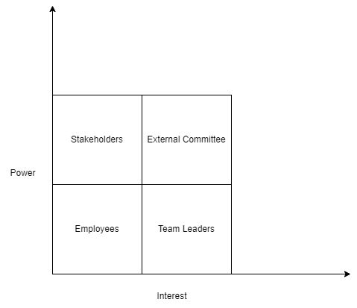
Source- By Author
In the above grid analysis, it is being shown the interest and power of management. As the problem here is bullying, the most interested committee with power will be the external committee (Park, 2018). Followed by stakeholders who will have power and whose interest in the policy will be very important. Employees will have least power and interest because this policy is for them and they will be the main part of the management for whom the rules and regulations will be formed. Team leaders on the other hand will have interest in this policy but no power will be given. This will happen to keep this policy on an unbiased platform.

Problem and its Impact on the employees

Detailed Plan for Implementing the Solution
As bullying is a serious issue in an organization. Solution for bullying is important. There should be a proper detailed plan to stop the bully. For stopping the bully in an organization, the organization should form an external committee (refer to appendix 3). The main thing to keep in mind here is that the all the members of the committee will be from outside. Only one member from the organization can be the part of this external committee (Towbin, 2018). This committee should be unbiased for the employees and superiors of the organization. This external committee will be responsible for ensuring that each case of bullying will be brought in logical conclusion. The committee will insure that there will be a respectful relation between the employees and managers (Beirne, 2013). The organization will be asked to circulate the message that ‘bullying is strictly prohibited and if found guilty, no such act will go unpunished or unnoticed’. The external committee will receive the complaints related to bully. They will also be responsible for providing regular and periodic report and work with the existing legal institutes. This committee will have the power to assist the responsible authorities to take action.
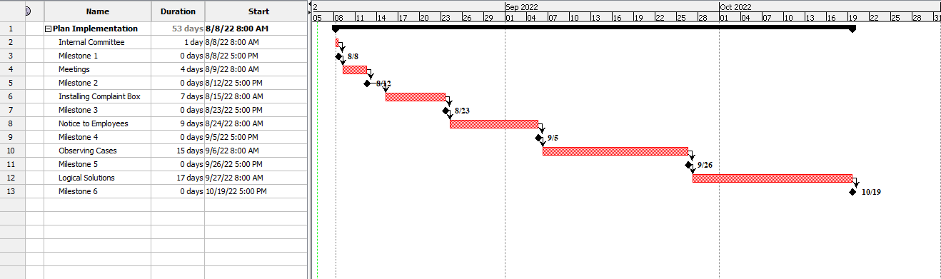
Source- By Author
The committee can ask the organization to install a complaint box which should be monitored regularly. And according to the issue or complaint, the committee will take necessary and appropriate action. All the employees will be taught about human rights, democratic values, equality and respect for others. The committee will also educate the employees with anti-bullying policies to help prevent bully.

Communicating the Plan with the Relevant Stakeholders
Stakeholders can be known as the real asset of the company as they provide the required financial support to the company when needed. Ultimately it becomes important for the company to provide equal support to the stakeholders as well and one of the major supports includes allowing the stakeholders to equally participate in the company’s new policies (Butt, 2016). Once this step is achieved, it becomes important for the company to communicate and inform the stakeholders about the new policies that are coming into effect. Initially, before communicating the new plans and policies to the stakeholders, it is important to identify the actual stakeholder of the company. Following is the list of the stakeholders and the appropriate ways to communicate the new plan to these stakeholders of the company.

Communication Plan
Stakeholders | Objective | Message | Channel | When to inform
Employees | The change that will take place will directly affect the employees. | Strict policies for bullying at workplace | Meeting and Emails | Before and after implementing the policy
Clients | To ensure client’s satisfaction and increase in sales | Introduction of anti-bullying policies | Zoom, mails or advertisement | After implementing the policy
Investors | For maintaining a strong and transparent relationship | Anti-bullying policy | Meetings or formal emails | After implementing the policy
Suppliers | Reducing the risk of strikes. | Anti-bullying organization | Meeting or mails | After implementing the policy

- Employees- The backbone of a company can be considered as the employees, who are responsible for all the necessary actions and work that are accomplished in the company which ultimately increases the value of the company. To communicate the new plans to the employees, initially, it is important to gather all the employees in one place, be it a training room, conference room, or any other space in the organization which can hold all the employees at once. Once, all the employees are gathered, it will become easy to communicate the new plan to all the employees of the company. But there will be a scenario in which a few employees will be on leave and keeping that in mind after the meeting is held and the plans are communicated, a dedicated mail explaining the plan to all the employees will be sent to them. This process will ensure that every employee is given the information irrespective of their presence on a particular day in the organization. Apart from this, if any employee wants to give his or her opinion on the new policies, the company will welcome them.
- Clients- Clients are the external stakeholders of the company and it will be equally important for the plan to be conveyed to them as well. The reason for communicating the plan to clients will lead to many positive outcomes, one of them being the increase in the goodwill of the company. A company that is willing to promote the idea of the anti-bullying environment in an organization will no doubt find itself in the good eyes of its clients, customers, and all the other related people. In addition to this, the company will also get a bonus benefit of indirect promotion in the market when the clients will communicate this to other people. It is also known as mouth publicity. Also, to communicate the plan to the clients, one of the alternatives a company can opt for is sending the mail to them, and in that mail, all the necessary plans will be mentioned in brief. The organization can also play ads, informing about their new policy to the clients.
- Investors- The financial backbone of the company are always the investors and it is very important for the company to communicate the plan with them. Investors play a major role in the success of the company. This is the reason why the organization should maintain a strong and transparent relationship with the investors (Hoffman, 2016). For communicating the plan with the investors, the organization either can have a face-to-face meeting for better understanding or the organization can send an official email to the investors, informing them about the new policies and rules of the company.
- Suppliers: Effective communication between the suppliers and the organization cannot be reinforced enough. Communicating with the suppliers can reduce the risk of strikes. Communicating the policies to the suppliers will make the relationship between the organization and the suppliers. The organization can communicate the plan to the suppliers by either having a meeting or by sending them a formal mail.

Monitoring the Successful Implementation of Solution
Monitoring policies is process by which stakeholders follow and assess policies to ensure that the policies are developed, inscribe, ratified and implemented as calculated. It also calculates and understands various mode of decision making and how technical, financial, social, environmental and political factors can affect the decision-making (Janssen, 2017). It also helps in identifying the gaps in the development and implementation of the policy. It also outlines the important areas of improvement and also helps in providing valuable information to advocates and policymakers
Action Plan
GOAL
The main goal of monitoring the policy is to identify whether the policy is rightly implemented correctly or not and for collecting important data related to the policy.
Steps | Responsibility | Resources Required | Hazard Forecast | Outcome
Aspiring the policy environment | Policy is appraised in a systematic way | Employees | Alternative policy option | Identifies risks and uncertainty
Stakeholder’s involvements | Effect on stakeholders | Internal and external stakeholders | Another alternative | Support or oppose of the policy
Progress documentation | Proper Execution | Employee and manager | Lack of organizational resources | Saves money, time and eliminate flaws
Evaluation findings | Tick-box exercise | Stakeholders | Problems created by the policy | Positive and negative impact of the policy

Collecting important data becomes easy and it never being compromised or even missed. Monitoring a policy in an organization requires some steps and these steps are:
- Appraising the policy environment: This step ensures that the policy is appraised in a systematic way. It also brings evidence to bear on alternative policy options. It also judges the sum up of the policy environment, profits, and its distribution. This step also monitors the uncertainties and risks.
- Stakeholder’s involvement: As every new policy of an organization affect the stakeholders. It is very important to ensure that all the stakeholders are supporting the new anti-bully policy. Support or oppose by the side of the stakeholder can affect the policy of the organization (Soltani, 2015). As stakeholders are the backbones of the company, there reaction and involvement in the implementation of the plan is very important.
- Documentation of the progress: This process internally captures all the information important to properly execute an organizational policy. By documenting the progress of the policy step by step, the organization can bring the areas of improvement in light. Making proper progress report will save money, save time, eliminate the flaws and will ensure compliance.
- Evaluation Findings: Evaluation finding is a tick-box exercise. It involves final steps that helps in evaluating the findings. These are share the learning with others, celebrate the positives, make improvement in those fields which need improvement, use the finding in the planning process and establishing an impact culture as a learning organization.

References
Baillien, E..E.J..G.C.a.Z.D., 2017. Towards a conceptual and empirical differentiation between workplace bullying and interpersonal conflict. European Journal of Work and Organizational Psychology, 26(6), pp.870-81.
Beirne, M..&.H.P., 2013. Workplace bullying and the challenge of pre‐emptive management. Personnel Review, 42(5), pp.595-612.
Brinkley, A..M.H..&.M.F., 2017. What benefits does team sport hold for the workplace? A systematic review. Journal of Sports Sciences, 35(2), pp.136-48.
Butt, A..N.M..&.S.J., 2016. Project change stakeholder communication. International Journal of Project Management, 34(8), pp.1579-95.
DA, L.H., 2017. Ten Ways to Reduce Workplace Drama. The Journal of Medical Practice Management : MPM, 33(1), pp.19-23.
Di Fabio, A., 2017. Positive Healthy Organizations: Promoting well-being, meaningfulness, and sustainability in organizations. Frontiers in psychology, 8, p.1938.
Dzurec, L.C..K.M..&.G., 2017. The incongruity of workplace bullying victimization and inclusive excellence. Nursing Outlook, 65(5), pp.588-96.
Feijó, F.R., Gräf, D.D., Pearce, N. & Fassa, A.G., 2019. Risk Factors for Workplace Bullying: A Systematic Review. International journal of environmental research and public health, 16(11).
Hoffman, A.J., 2016. Communicating About Climate Change with Corporate Leaders and Stakeholders. Oxford Encyclopedia of Climate Change Communication, Oxford, UK: Oxford University Press, DOI, p.39.
Janssen, M..v.d.V.H..&.W.A., 2017. Factors influencing big data decision-making quality. Journal of Business Research, 70, pp.338-45.
Kemp, V., 2014. Antecedents, consequences and interventions for workplace bullying. Current opinion in psychiatry, 27(5), pp.364-68.
Kurtulmuş, B.E., 2020. Toxic Leadership and Workplace Bullying: The Role of Followers and Possible Coping Strategies. The Palgrave Handbook of Workplace Well-Being, pp.1-20.
McTernan, W.P., Dollard, M.F. & LaMontagne, A.D., 2013. Depression in the workplace: An economic cost analysis of depression-related productivity loss attributable to job strain and bullying. An International Journal of Work, Health & Organisations, (4), pp.321-38.
Meidell, A..&.K.K., 2017. How the enterprise risk management function influences decision-making in the organization – A field study of a large, global oil and gas company. The British Accounting Review, 49(1), pp.39-55.
Okoli, J.a.W.J., 2018. Crisis decision-making: the overlap between intuitive and analytical strategies. Management Decision, 56(5), pp.1122-34.
Olsen, E., Bjaalid, G. & Mikkelsen, A., 2017. Work climate and the mediating role of workplace bullying related to job performance, job satisfaction, and work ability: A study among hospital nurses. Journal of Advanced Nursing, 73(11), pp.2709-19.
Park, H..B.B.a.B.J., 2018. External Whistleblowers’ Experiences of Workplace Bullying by Superiors and Colleagues. Journal of Business Ethics, 161(3), pp.591-601.
Parker, K.A., 2014. THE WORKPLACE BULLY: THE ULTIMATE SILENCER. Journal of Organizational Culture, Communications and Conflict, 18(1), pp.169-185.
Plimmer, G., Nguyen, D., Teo, S. & Tuckey, M.R., 2021. Workplace bullying as an organisational issue: Aligning climate and leadership. An International Journal of Work, Health & Organisations, 36(2), pp.202-27.
Rayner, C..&.L.D., 2020. Managing Workplace Bullying: The Role of Policies. In Bullying and harassment in the workplace, pp.497-519.
Redmond, S.A..W.S.L..C.S..K.A..F.K..B.K.a.H.A.M., 2015. A brief introduction to the military workplace culture. Work, 50(1), pp.9-20.
Riener, G. & Wiederhold, S., 2016. Team building and hidden costs of control. Journal of Economic Behavior & Organization, 123, pp.1-18.
Salin, D..C.R..A.O..A.E..B.J..D.P..Z.E., 2018. Workplace bullying across the globe: a cross-cultural comparison. Personnel Review, 48(1).
Soltani, A..H.K..R.B..&.S.R., 2015. Multiple stakeholders in multi-criteria decision-making in the context of Municipal Solid Waste Management: A review. Waste Management, 35, pp.318-28.
Spruce, L., 2019. Back to Basics: Preventing Workplace Bullying. AORN Journal, 110(3), pp.288-97.
Towbin, A.J..P.L.A..M.J.A..&.O.T.J., 2018. Building and Implementing an Operational Plan. Operations Management, 38(6), pp.1694-704.
Wang, H..X.Z..&.Z.X.J., 2018. Modeling complex linguistic expressions in qualitative decision making: An overview. Knowledge-Based Systems, 144, pp.174-87.
Widjaja, W..&.S.M., 2014. Bring your own device: ubiquitous approach to digital affinity diagram collaboration. In Proceedings of the 2014 ACM International Joint Conference on Pervasive and Ubiquitous Computing: Adjunct Publication, pp.287-90.
Widjaja, W..Y.K.a.T.M., 2014. Efficient Group Discussion with Digital Affinity Diagram System (DADS). In International Conference on Cooperative Design, Visualization and Engineering, 50(1), pp.203-13.
Zhang, X.C..L.H..R.C..R.J..C.T.M..&.P.D., 2018. Trapped as a Group, Escape as a Team: Applying Gamification to Incorporate Team-building Skills Through an ‘Escape Room’ Experience. Cureus, 10(3).

Appendix
- There are 16 different types of decision making techniques. These are affinity diagram, analytic hierarchy process, conjoint analysis, cost analysis, decision making trees, game theory, heuristic methods, influence diagrams approach, linear programming, multiple criteria decision analysis, multi-voting, net present value and present value, paired comparison analysis, pro and con technique, scientific method, and trial and error (Wang, 2018).
- Alternative solutions are important to generate verity of options for managing a problem.
- Solution implementation is important as it plays a significant role in bringing outcomes. Without implementing the correct solution, there will be no outcome.
- Setting values and standards in an organization means valuing the guiding principles of the organization that provides an organization with purpose and direction.
- Effective leadership is important in an organization for its success. An effective leader executes the company’s vision. It set the tone and the culture of the organization. An effective leader creates, plan, secure resources and look out and improve errors.
- Modelling behaviour is a way in which behaviour is learned. Professional behaviour is important to follow in an organization and this includes respecting the bosses, managers, colleagues and other staff members of the organization.

