To share your video recording from teams

To record your video:

- Go to calendar on teams and click ‘meet now’
- Make sure your camera and mic is on and click ‘join now’
- Click on the share content button and share your presentation (arrow pointing up on image below
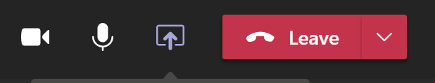
- Start your recording (see image below)
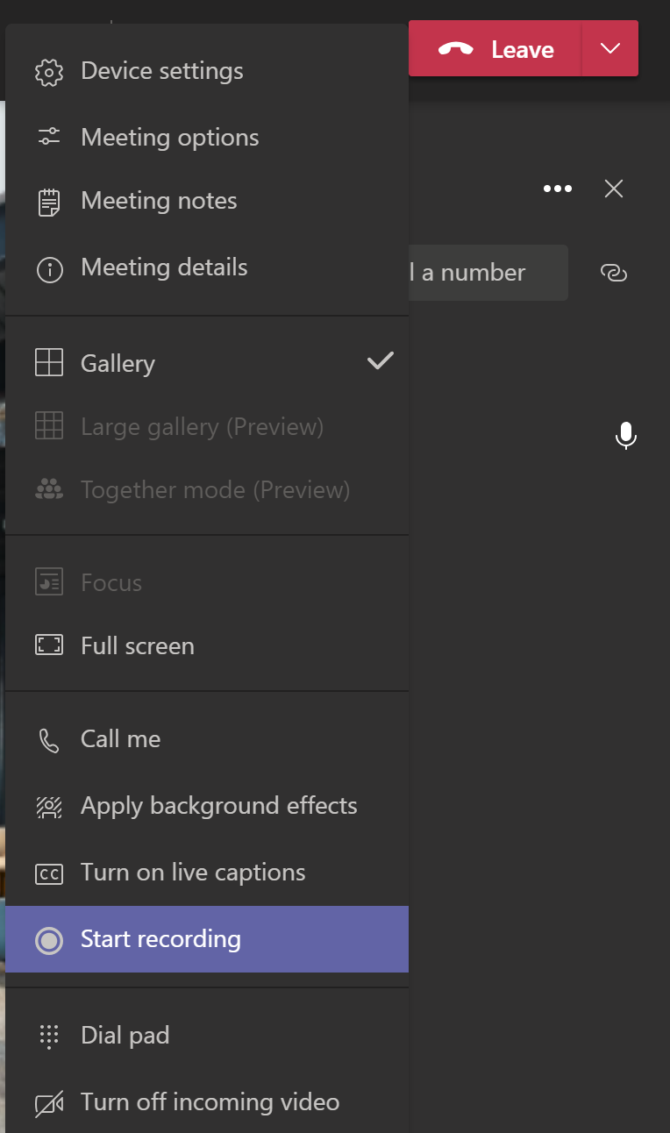

- Once you have recorded your meeting click on the stop recording button
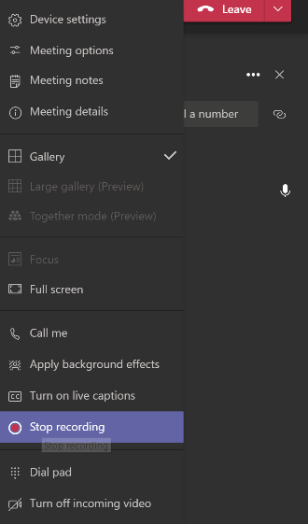

- You will find your recorded presentation in the chat section of your meeting, do not exit your meeting until you have completed the steps below.
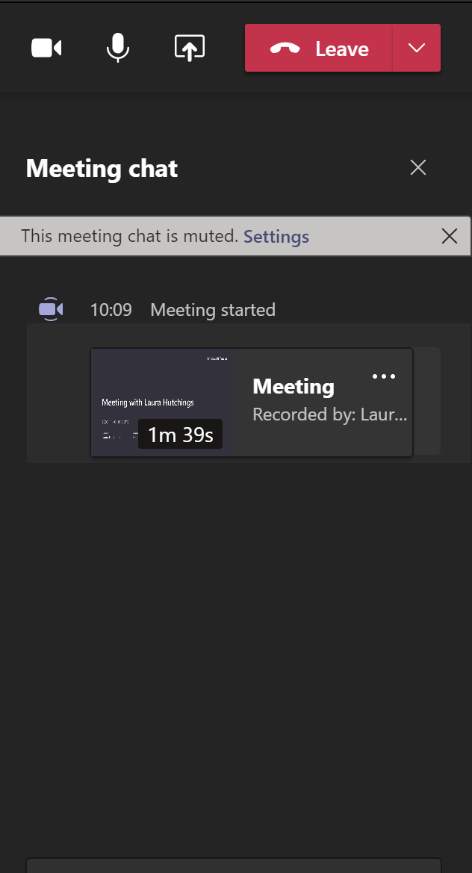

- Option A: Click on the three dots next to where it says ‘meeting and click on ‘get link’

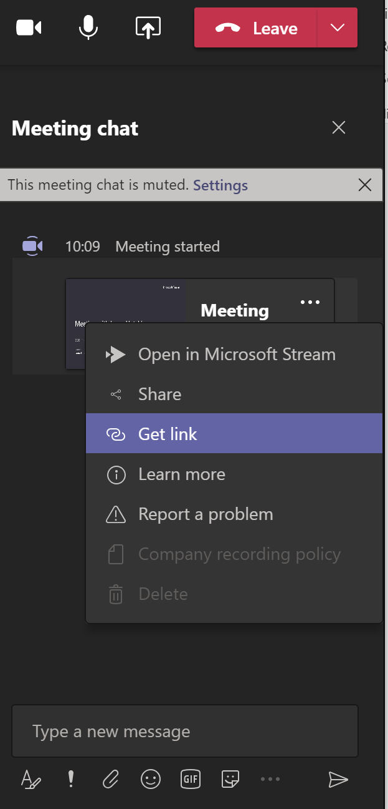

- Copy link and then upload this link on a word document and submit via Turn it in

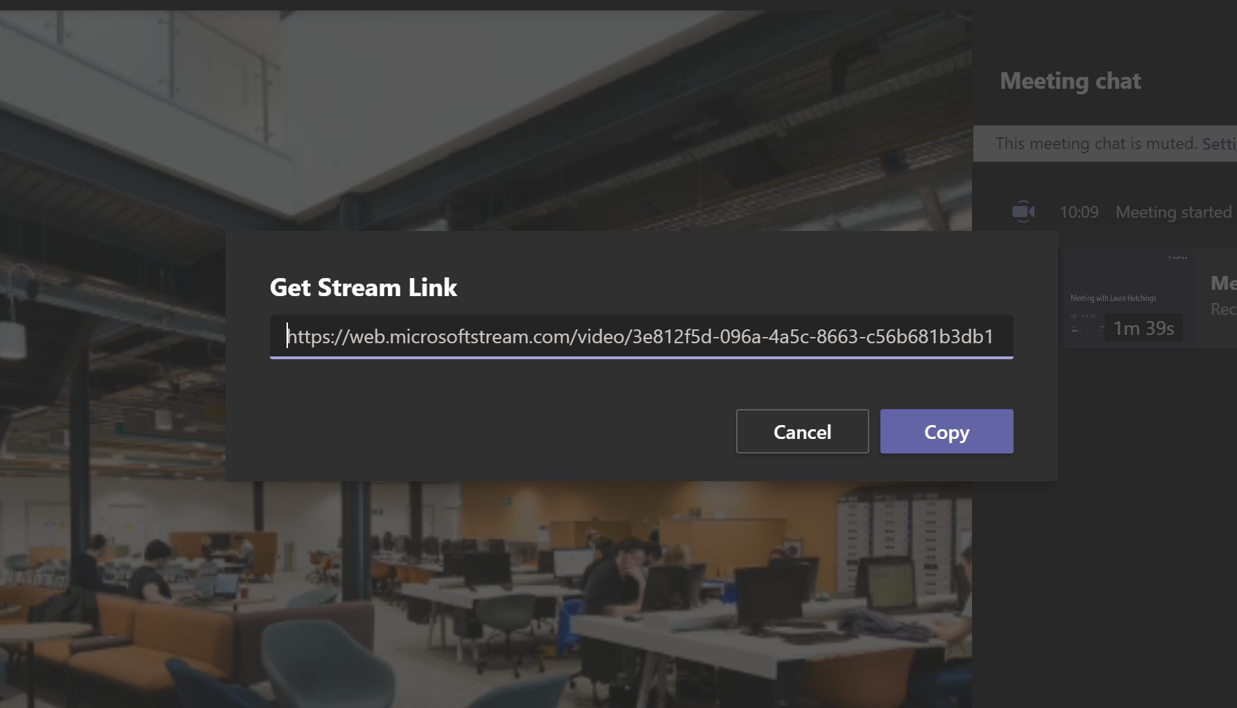

- Option B: Click on the three dots next to where is says ‘meeting’ and then click ‘open in Microsoft Stream’

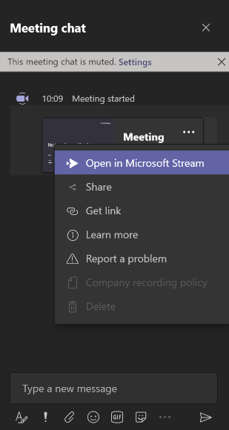

- In MS Stream click on ‘my content’ and then ‘videos’

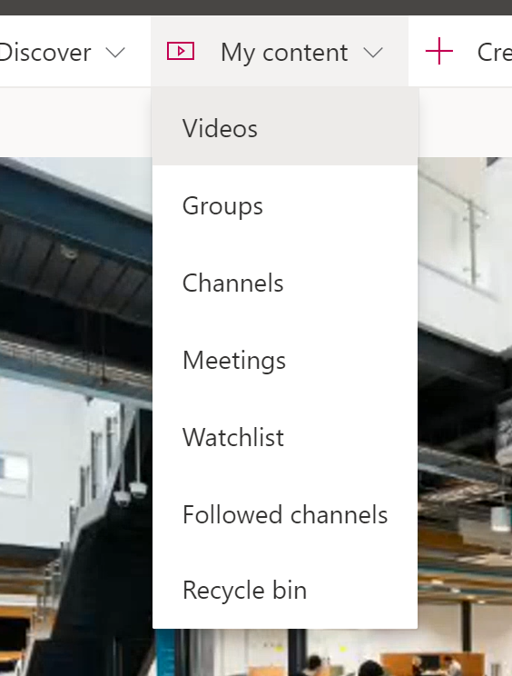

- Your most recent video recorded will be displayed at the top of the page. Click on the three dots and then on the share button.

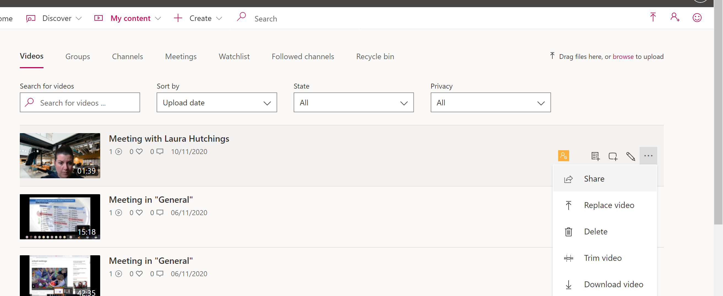
10. You will need to copy the link and then upload this link on a word document and submit via Turn it in

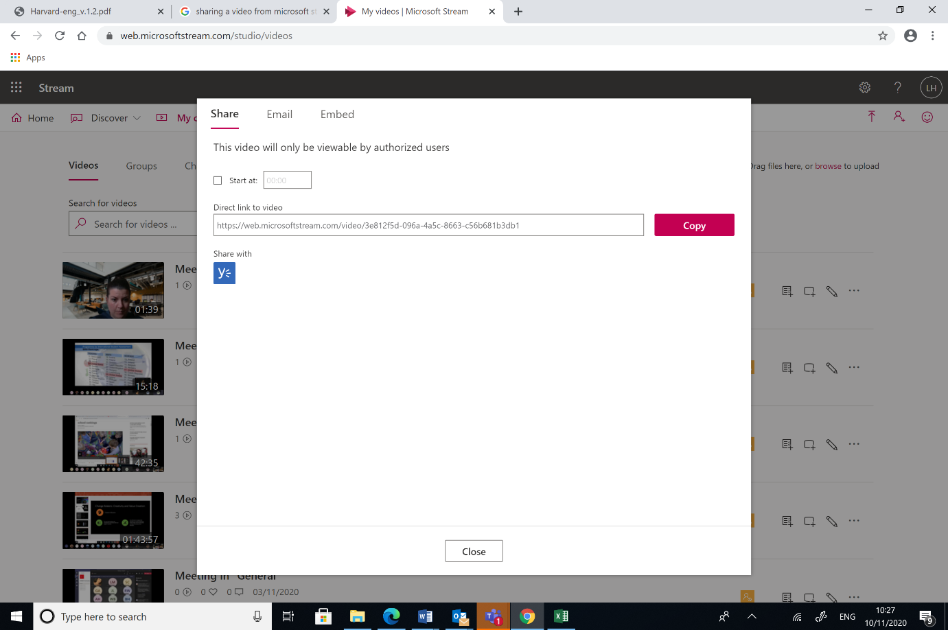
Important:

Ensure that I have access to your presentation! Go to ‘update video details’

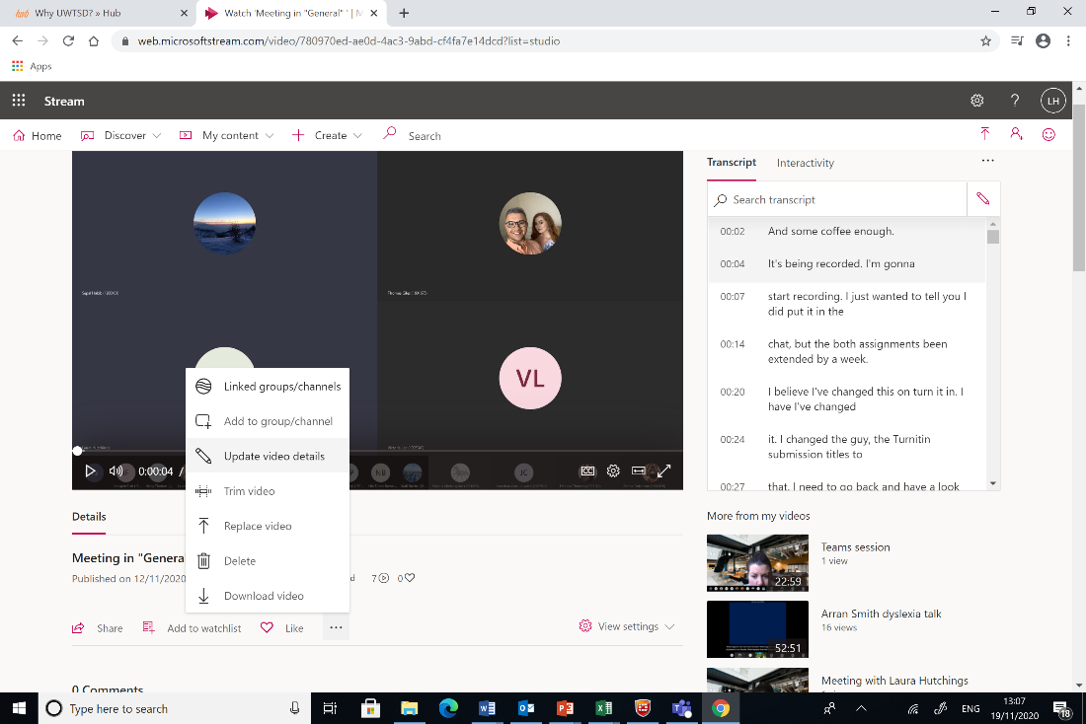

Type in my name and click apply



