

The Design and Development of a Database Model for Electronic Informed Consent

by
Brandon Philip Gorman MBCS

Supervisor: Dr Nik Whitehead

Project submitted as part of the requirements for the award of
BSc (Hons) Computing (Data and Information Systems)

July 2023

DECLARATION

I, Brandon Philip Gorman MBCS declare that I am the sole author of this Project; that all references cited have been consulted; that I have conducted all work of which this is a record, and that the finished work lies within the prescribed word limits.

This work has not previously been accepted as part of any other degree submission.

Date : 23/07/2023

FORM OF CONSENT

I Brandon Philip Gorman MBCS hereby consent that my Project, submitted in candidature for the B.Sc.(Hons) Computing (Data and Information Systems) degree, if successful, may be made available for inter-library loan or photocopying (subject to the law of copyright), and that the title and abstract may be made available to outside organisations.

Date : 23/07/2023

Acknowledgements

I would like to express my gratitude to the several people over the past four years, who have supported my personal and professional growth. Without your help and support I wouldn’t have matured and grown in the way I have, and for that, I thank you.

Firstly, I would love to thank my family for their love and support and pushing me on, even when times were tough. My family’s constant encouragement has been a core foundation of my success.

Secondly, I would like to express my appreciation to my work colleagues/university colleagues Emily, Sharla, Bryoni, Katie and Ethan. Without their presence the degree programme wouldn’t have been the same. From our late-night study sessions to our early morning meet ups, their friendship and encouragement has been a vital lifeline throughout this degree, I am truly grateful for sharing this experience with them.

Next, I would like to thank Dr Nik Whithead for their experience and knowledge. I am deeply grateful for their mentorship and guidance throughout this project. Without Dr Nik I wouldn’t have had the confidence or ability to complete this project.

When technology moves on so do, we. For that, I would like to thank ChatGPT for assisting me in developing a key structure for my literature review and providing me with key information on highly complex topics.

Finally, I would like to thank the Starbucks, Coryton staff for their friendly service and providing us with a social environment with great coffee. Starbucks, Coryton provided a hub for so many social events for the study group and I, but also gave us an environment that ensured we got so much of this very report completed. – Thank you to you all.

Abstract

Health and social care services provide several vital procedures and examinations to the citizens of Wales. As part of any procedure or examination the requirement to obtain consent is both an ethical and legal requirement.

Currently in Wales, consent forms for examinations and treatments are paper-based, and such paper-based forms have limitations such as accessibility, negative environmental impacts as well as an impact of service production and productivity.
The report provides an overview of the current consent process employed within Wales and the current successes NHS Wales have had in digitising paper-based processes such as discharge advice letters and nursing care records.
The author researched the current workflows, processes and forms used within Wales, and translated the outcomes into digital deliverables. The report depicts a standardised schema following nationally agreed standards mandated by HM Welsh Government.
The author concluded that the project was successful in proving a solution can be designed and can be employed by the specialist health authority: Digital health and Care Wales. The primary research referenced throughout the evaluation stage also shows a key interest by health and informatics professionals for an integrated solution.

Table of Contents
Acknowledgements 3
Abstract 4
Table of Figures 6
Chapter One: Introduction 7
Chapter Two: Literature Review 11
Informed Consent 11
Informed Consent in Practice 11
The Legal Context 12
How is Informed Consent Approved 13
Reasons for Forms: A Health Care Context 13
Record Keeping and the Patient Pathway 13
Use of Standardisation 14
Quality Improvement and Research 15
Paper-Based Forms and Limitations 15
Service Inefficiency 15
Accessibility 16
Environmental Impact 17
Benefits of Electronic Forms 17
Accessibility 17
Regulatory Compliance 18
E-Form Integration 19
Development and Implementation and Challenges of eForms 20
Conclusion 22
Chapter Three: Research and Development Methodology 23
Research Methodology 23
Development Methodology 25
Chapter Four: Design and Implementation 27
Database Deign 27
NHS Wales Data Standards 28
Change Control Notification 29
Implementation Outcome 29
Chapter Five: Evaluation 30
Chapter Six: Conclusions and Recommendations 32
Chapter Seven: Reflection 34
Chapter Eight: Appendices 36
Appendix Once: Database Design – Normalisation 36
Appendix Two: Database Design – DDL Examples 38
Appendix Three: Data Standards 40
Appendix Four: Change Control Notification 42
Appendix Five: XML Transfer 43
Appendix Six: Initial findings 44
Chapter Nine: Acronyms 45
Chapter Ten: References 46

Table of Figures

Figure 1 NHS Wales Informed Consent Form: 1. Taken from NHS Wales Shared Services Partnership 8
Figure 2 NHS Wales Discharge Advice Letter. Taken from WCP: UAT 10
Figure 3Entity Relationship Diagram. Produced by Brandon Gorman 28
Figure 4 E-consent data sharing. Produced by Brandon Gorman 29
Figure 5 Bar graph showing expected vs actual preference to e-Consent. Produced by Brandon Gorman 31
Figure 6 NHS Wales APC Data Set. Taken from the NHS Wales Data Dictionary 38
Figure 7 NHS Wales EDDS Data Set. Taken from the NHS Wales Data Dictionary 39
Figure 8 XML Transfer. Designed by Brandon Gorman 41

Chapter One: Introduction
Healthcare is a vital building block to a modern society. In Wales the NHS provides medical services to “some 3 million people who live in the country” [1]. With this is mind, several of the services provided include medical procedures. “Between April 1st 2009 – March 31st 2014 there were over 39 million individual patient episodes recorded that related to surgical procedures in the UK” [2] , in Wales this translated to 2.8 million. Medical procedures play a significant role in the diagnosis and treatment of patients as well as providing the most effective outcomes possible. Medical procedures incorporate several activities (excluding the procedure itself) including initial patient assessments, the review of patient pathology reports, medical imaging as well as therapies-based care. The collection and storage of the noted details above is critical in ensuring a transparent medical record that can provide medical professionals with the details they require to perform their duties, maximise effective communication as well as ensure the hospital and its associated health board complies with the NHS Act 2006 as well as the additional health-based legislation in Wales.

Still to this day many consent forms for medical procedures are paper based. Medical professionals across Wales will manually input the details of the procedure as well as the additional detail required for the examination or treatment required. The three forms in use within Wales are Consent Form 1, Consent Form 2 and Consent Form 4.

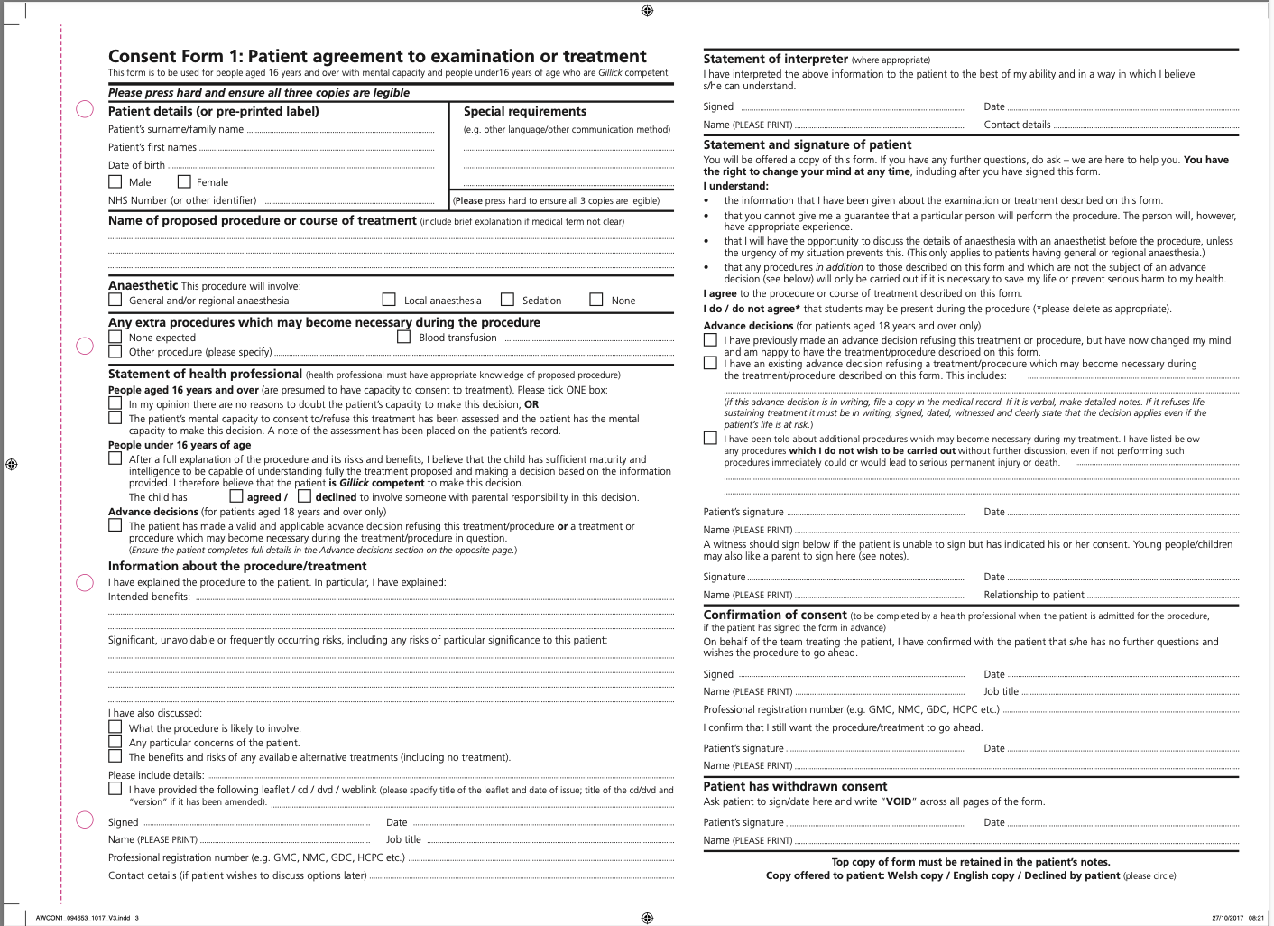
Figure 1 NHS Wales Informed Consent Form: 1. Taken from NHS Wales Shared Services Partnership

- Consent Form 1 is for those patients aged 16 years and over with mental capacity and people under 16 years of age who are Gillick competent [3].
- Consent Form 2 is for those patients Agreement of person with parental responsibility to examination or treatment for a child under 16 years of age who is not Gillick competent [3].
- Consent Form 4 is for those patients Treatment in Best Interests is for patients aged 16 years and over who lack capacity to consent to examination or treatment [3].

Despite the progress made in the All-Wales Approach to digitise services and improve NHS processes, consent forms for examinations and procedures have lagged. Due to the continued use of paper-based forms there are significant challenges that NHS staff, both clinical and clerical encounter; misplaced forms, handwriting and increased time in filling in details already on file. Such challenges can result in higher levels of error and delays in providing care which all compromise patient safety.

The All-Wales Approach that was commissioned in 2015 has an aim in “Improving access to information and introducing new ways of delivering care with digital technologies must be at the heart of our service plans and our vision for prudent healthcare.” [4]. The report outlines the main objectives providing information to the patient, supporting professionals, improvement and innovation and joint planning. Several of the tasks within these objectives over the years have indeed been met, including the procurement of the Welsh Community Care Information System, the development of the Welsh Results and Reports Service and the development of community pharmacy services.

In 1999 the people of Wales voted in favour of devolution and the establishment of the National Assembly for Wales. This was later enacted under the National Assembly for Wales (Transfer of Functions) Order 1999. This landmark constitutional change meant for the first time since 1969 the responsibility of health was moved away from the sectary of State for Wales to the health minister elected by the Welsh Assembly.

The NHS in Wales is a publicly funded institution under the purview of HM Welsh Government. The Welsh government operates under the principals set out in the National Health Service Act 1946 [5]. Although the core principals of the health service remain (free at the point of delivery), there has been significant reform to heath and care services to meet the needs of 21st century Wales.

With the establishment of a new legislative body the structure of the NHS in Wales has changed to meet the needs of a changing demographic in Wales. The structure in its current state is made up of eight key components. HM Welsh Government, The Health Minister, Chief Executive of NHS Wales, University and Teaching Health Boards, University and NHS Trusts, Primary Care General Practitioners, Third Sector Treatments and Specialist Health Authorities. The newly developed structure was later placed into law under The National Health Service Reform and Health Care Professions Act 2002.

Since the National Health Service Reform and Health Care Professions Act 2002, there have been subsequent acts passed changing the way the NHS in Wales operates. As of 2023 the NHS’ operational functions are as follows:
- Health Boards. - A health board is responsible for providing NHS services to citizens within its boundaries, this includes secondary and certain tertiary care services.
  - Betsi Cadwaladr University Health Board
  - Hywel Dda University Health Board
  - Swansea Bay University Health Board
  - Cardiff and Vale University Health Board
  - Cwm Taf Morgannwg University Health Board
  - Aneurin Bevan University Health Board
  - Powys Teaching Health Board
- NHS Trusts. Provide specialised health and care services, that support health boards.
  - Welsh Ambulance Services NHS Trust
  - Velindre University NHS trust
  - Public Health Wales NHS Trust
- Specialist Health Authorities. Provide support services to the whole health and care system with certain mandatory powers over the health boards and NHS trusts.
  - Digital Health and Care Wales
  - Health Education Improvement Wales
- Primary Care Services. Primary Care Services are the responsibility of both the Welsh Government and Health boards. The way GP services are funded however, isn’t straight forward. GP practices are funded under the General Medical Services (GMS) Contract. When a citizen state they have visited an NHS GP, the truth is, they are visiting a private GP practice who happens to hold an GMS contract funded by Welsh government and sponsored by a health board.

The development of electronic forms for treatments and examinations aims to improve service efficiency and improve overall patient care. NHS Wales and its partner organisations have acknowledged the success of the digitisation process by digitising discharge advice letters as well as nursing forms across Wales [6]. Electronic Forms (e-forms) capitalise on digital technology and its architecture for the capture and maintenance of clinical based data. The use of e-forms allows for patient details to be accessible via computers, tablets and mobile, eliminating the requirement for paper forms and minimising duplication of patient details.

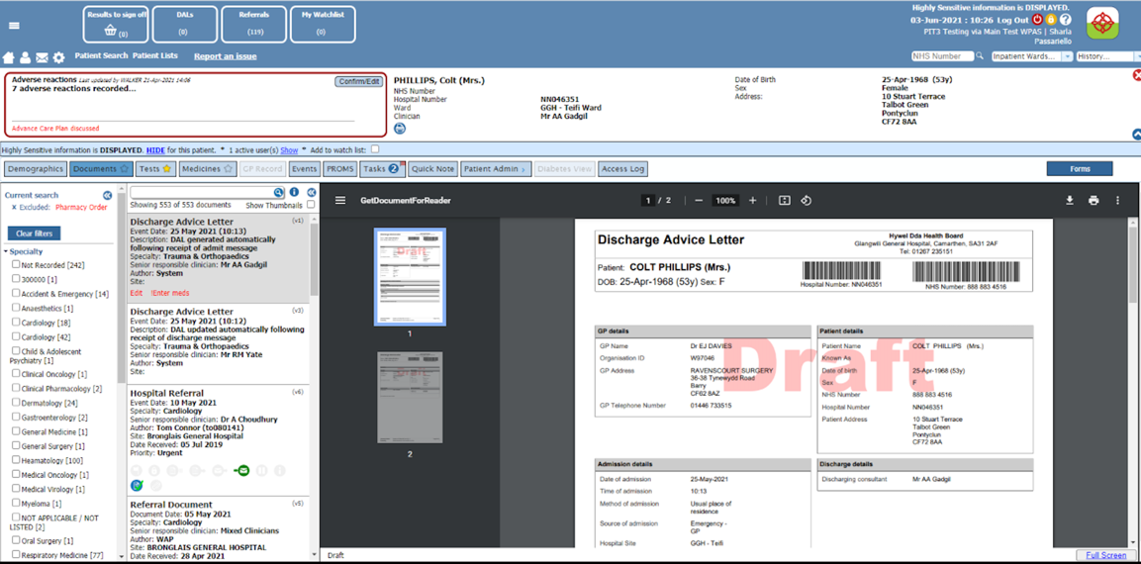

Figure 2 NHS Wales Discharge Advice Letter. Taken from WCP: UAT

The use of e-forms within NHS Wales has a potential to improve patient care, enhance staff and technology efficiency. But the use of e-forms can also counter many problems encountered by NHS staff by improving transparency, enhanced data collection and increased patient engagement. An opinion piece on a British Medical Journal [7] article focusing on digital consent also highlights the very points previously made; “Our initial studies have started to demonstrate that patients feel more involved in their treatment decisions when using the Concentric digital consent system - enhanced with lay-facing information and multimedia explanations.”

The following report will investigate the design and development of e-forms in a medical context focusing on the database structure on examination and treatment. The report will investigate the key elements involved and will debate the challenges involved with such a development and implementation. The report will also review case studies across the UK and beyond of successful applications of e-forms in this medical context and analyse the impact they had on patent care and the overall outcomes of the organisations. The report will then propose a solution as well as a peer reviewed recommendation by both clinical informaticians and operational teams.

Chapter Two: Literature Review

Informed Consent

Informed Consent in Practice
Informed consent is a fundamental principle in both medical and research ethics. The university of Oxford Ethics Resource Centre [8] surmises this by stating “Informed consent is one of the founding principles of research ethics. Its intent is that human participants can enter research freely (voluntarily) with full information about what it means for them to take part, and that they give consent before they enter the research.” As the university of Oxford suggests informed consent can only be provided where the patient has been made fully aware of the risk, benefit and alternative available to them.

Informed Consent comes under the Autonomy pillar of medical ethics. The Four Pillars of Medical Ethics are beneficence, non-maleficence, autonomy and justice [9].

Firstly, Beneficence. The Oxford Concise Medical Dictionary (8 ed.) [10] defines beneficence as “doing good: one of the four principles of medical ethics. The obligation to act in patients’ best interests”. In an informed consent context, the obligation to provide key details regarding a potential examination or procedure, and if applicable the alternative of a procedure if one exists.

Secondly, Non-maleficence. Non-maleficence in its most simplistic form is a statement of no harm to a patient. Varkey [11] defines non-maleficence as “Nonmaleficence is the obligation of a physician not to harm the patient. This simply stated principle supports several moral rules − do not kill, do not cause pain … deprive others of the goods of life.”. As suggested by Varkey from a clinical perspective, it would be the responsibility of the clinician to assess to benefits and drawbacks and chose the best medical decision based on the medical details and evidence they have.

Next, Autonomy. In a medical and clinical environment, the term autonomy means that the patient has the decision-making power for their own treatment. In an informed consent context this is the core of its development. The British Medical Association [12] states “In medical practice, autonomy is usually expressed as the right of competent adults to make informed decisions about their own medical care.”. Naturally there are exceptions to this under the Mental Capacity Act and the Medical Doctrine that suggests consent from a guardian or partner may not always be required [13].

Finally, justice. In a health and social care setting is the ideation of the ethical weighting of a particular issue and if its compatible with the law and the patient’s rights. The Medic Portal [14] highlights “is the principle that when weighing up if something is ethical or not, we have to think about whether it’s compatible with the law, the patient’s rights, and if it’s fair and balanced.”.

The Legal Context
Unlike many counties who have codified legalisation defining the boundaries of informed consent, the United Kingdom doesn’t follow suite. The United Kingdom follows English Common law that is made up of legislation, codes of practice as well as convention. Professor Suzanne Rab [15] provides a clear historical context to the UK legal system by stating “The constitution is unitary in that the Parliament in Westminster is the supreme law-making authority. Since 1999, devolution has provided for the transfer of powers from the Westminster Parliament to assemblies … authority from powers that they have been granted by the Parliament in Westminster.”

There are four significant cases that have defined informed consent. Border v Lewisham and Greenwich NHS Trust, Montgomery v Lanaekshire Health Board, SXX v Liverpool Women’s NHS Foundation Trust and Tasmin v Barts Health NHS Trust [16].

Firstly, Border v Lewisham and Greenwich NHS Trust. The case was handed down by the court of appeal on 21st January 2015, and involved a patient who was admitted to A&E. The admission was based in the suspicion of fracture of the right humerus [17]. The patient highlighted during the initial admission that they had recently underwent a “left mastectomy and axillary-node clearance, which increased the risk of oedema if a cannula were inserted into her arm.” [17]. The key facts of the case in addition to the medical admission highlights the medical practitioner, despite a warning from the patient inserted a cannula where an infection ultimately turned in to oedema. The judge in this case had found the patient didn’t consent to the cannula but dismissed her claim as they found that “the insertion of the cannula was carried out in accordance with standard practice, and it would have been bold to have delayed the insertion – and therefore dismissed the claim.” [17]. What the case highlights that consent must in fact be verbal and communicated to ensure the treatment provided is supported by the patient.

Secondly, Montgomery v Lanaekshire Health Board. In March 2015 the UK Supreme Court handed down a judgement relating to the titled case. The patient in this case was a diabetic and heavily pregnant. The patient in this case was under the supervision of an obstetrician due to the prediction that the patient’s baby would be larger [17]. The medical professional “was aware of a 9-10% risk of shoulder dystocia” [17], that relates to their inability of the shoulder to pass through the pelvis. The medical professional made and informed decision not to inform the patient of the potential risk of shoulder dystocia due to the risk of this occurring was low. The Supreme Court heard that shoulder dystocia did in fact occur and the child was born with several disabilities.

The court concluded that the medical professional wasn’t at fault based on the evidence that was provided at the time. The Supreme Count however did highlight that an adult who holds the capacity to consent should be informed of the status and options available to them.

Finally, SXX v Liverpool Women’s NHS Foundation Trust. The case was brought by two twins who were born in 2015. One of the twins lives with a neurological disability. The mother highlighted concern of a vaginal birth during the case due to a singular incident with a family member seven year prior. Although, the concerns were acknowledged by the medical staff the medical staff persuaded the patient to have a vaginal birth. The case also emphasised that the clinical choice wasn’t referred to the consultant. Experts agreed that the mother should have been referred for a caesarean. The court also found a breach of duty and not respecting the mother wishes [18].
The legal cases highlighted shows the importance of consent. The cases also have shown that without establishing any form of consent, verbal or written health and social care providers are at risk of becoming liable for damages. The cases also promote the importance of communication as well as providing a method of auditing such details.

How is Informed Consent Approved
Informed consent can be broken down into three core areas. Legal, ethical and administrative. All three areas ensure “the legal rights of patients and guiding the ethical practice of medicine” [19].

Firstly, legal. Informed consent provides clarity to all parties involved in the examination or procedure that is scheduled to take place. In addition to this the consent provided also ensures the patients views are heard and ensures the prevention of any unwanted procedures.

Next, ethical. The use of consent forms also sets an ethical precedent, allowing the patient to be fully engaged within the process of their treatment. In addition to the protections for personal choice the use of informed consent can provide re-assurances that no automated decision-making is being made.

Finally, administrative compliance. The administrative arm of informed consent provides a way of documenting the ethical and legal requirements as well as providing reassurances to all those involved.

Reasons for Forms: A Health Care Context

Record Keeping and the Patient Pathway
During the patient pathway a patient will go through several processes before undergoing an examination or treatment. This stage of the pathway is also referred to as the “Pre-operative Assessment” phase. This phase of the patient pathway is where a medical professional will assess and ask questions about a patient’s health and home circumstances. The NHS pre-operative assessment page [20] also states, “This is to check if you have any medical problems that might need to be treated before your operation, or if you'll need special care during or after the surgery.”. As the quote from the NHS suggests the patient will be asked several questions about their health as well as have any addition pre-operation tests performed. Such details will need to be documented and the way this is collected is via a form. The article medical record keeping clarity, accuracy, and timeliness are essential by Dr Abdelmageed [21], emphasises that “The maintenance of good medical records ensures that a patient’s assessed needs are met comprehensively.”. As Dr Abdelmageed suggests all medical interactions should be recorded at the earliest opportunity to ensure a clear timeline of a patient journey though the health service.

Use of Standardisation
Although the patient pathway has become a lot clearer over the decades, across the globe rules and processes health care provides must follow to ensure the details collected on a patient are valid and prove effective and efficient care have increased.

In 2004 the Health Records and Communications Practice Standards Group [22] developed the “Health Record and Communication Practice Standards for Team Based Care”. This documents aim was to provide guidance for a “single model for documenting and communicating that information which forms the patient health record does not currently exist” This changed the way form application was applied with the standard applying six core principles:
- All encounters shall be recorded.
- All entries shall be clear accurate and titled with the clinician’s name and title.
- No use of abbreviations.
- All documents, arguments, and evidence for care shall be enclosed.
- All missing details should be escalated.

With the introduction of this standard many service improvements have been made form clinical research work processes. Richesson et al [23] states “Data-capture standards can facilitate efficacious development and implementation of new studies, element reuse, data quality and consistent data collection, and interoperability.”

With the prevision of more standards organisations have been able to integrate and share data across boundaries that were once thought as time wasting. With the use of data standards such as messaging formats the transfer of vital information has become easier. The book Patient Safety: Achieving a New Standard for Care [24] highlights this milestone “Message format standards facilitate interoperability … structuring data as they are exchanged.”. As the author highlights as data standards have improved along with technology message transfer has become more accessible with less limitation of boundaries.

Quality Improvement and Research
With data capture being the norm in a healthcare context, the way organisations use this data has changed over the years. The use of forms has had a significant impact on several areas such as quality improvement, clinical research, and population health management.

Firstly, quality improvement. The use of forms across the health service has enabled health and care organisations the ability to perform significant analysis on services. This is done through several different avenues such as performance monitoring, clinical decision making and patient experience and engagement. Bircher et al [25] highlights that “The quality of the care we provide is measured, benchmarked by… the National GP Patient Survey.”. Birchers comments suggest that quality management is measured by the patient experience and the understanding of the process they have been through.

Next, clinical research. With information being collected on various procedures and conditions, the ability to use the collected data for clinical research has become increasingly attractive to both public and private organisations. With the use of data collected by forms, standards such as Systematised Nomenclature of Clinical Terms (SNOMED CT) [26] can provide researchers with quantifiable information to analyse and test for new and upcoming research. Ruch et al [27] have also suggested the use of SNOMED CT within a clinical research environment can also assist with medical and clinical strategy highlighting that the standard can directly record clinical details of patients and minimising the use of broad terms aiding research to focus on a study or experiment at hand.

Finally, population health management. The use of forms provides an opportunity for public health organisations to target interventions as well as early detection certain illnesses and conditions. Tulane University [28] highlights that contextualised data becomes information as a set of rules or processes have been applied organisations and their professionals can then provide valuable insights to officials that define public health policy going forward.

Paper-Based Forms and Limitations
NHS stakeholders along with other health and social care providers have a significant reliance on paper-based consent for examinations and treatment. This reliance can result in several limitations and well as widening the digital maturity gap within an organisation.

Service Inefficiency
The use of paper-based forms requires both clinical and clerical staff to manually fill in information that may already be on file, this causes a significant diversion to patient care. Additionally, the use of paper forms can lead to inconsistencies between files and miscommunications that can lead to incorrect diagnosis and treatment. Stausberg et al [29] also suggests this “Inconsistencies between a patient’s electronic and paper-based medical record and leads to significant problems for health care staff in daily practice” As suggested by Stausberg as paper forms aren’t always up to date the care provision intended may no longer be appropriate this can cause significant delays in the patient pathway.

Pamela from caseCTRL [30] also highlights several points that also emphasise the service inefficiencies relating from manual form inputs. Members of staff becoming single points of failure. Many organisations who use paper-based forms have a dedicated team who provide the service in partnership with medical professionals. Medical professionals rely on their staff and support teams to provide real times answers regarding patient details whilst also having conflicting information with additional notes attached to the informed consent forms. “The scheduler is the one source for almost every stakeholder in the OR to know what happens … blocks to prevent overtime, for example.” [31] As suggested by the previous citation the use of physical forms provides the inability to provide real time information as and when required.

Accessibility
Health organisations are significant in size and depending on the treatment prescribed a patient may be transferred several times a day. Due to these physical forms being stored locations there are times where accessing the forms become problematic due to only a single copy being available. Ali [32] states in a white paper “Physicians find it challenging to share information accurately and quickly with each other when using paper charts, particularly in busy practices.”. As initially highlighted the location also plays a factor and can cause a significant delay Ali’s [32] white paper also suggest this “if you need a record from the previous year and cannot find it, you will have to spend a considerable amount of time searching through the entire stack again”.

Due to the physical forms being filled in as and when available to do so, many professionals experience problems when working in partnership or remotely with other medical professionals. Mutshatshi et al [33] highlights a report that found “769 nurses were found guilty of professional misconduct, with 587 professional nurses being charged amongst others with failure to record their nursing actions in the patient record”. This suggests that due to pressures and the accessibility issues of paper-based record provide a fragmented service that compromises health, but more concerningly highlights gaps in care that that could have otherwise been avoided. Studies performed have also shown a significant level of frustration with medical staff with the physical form filling. Mazmanian [34] detailed that medical professionals were detailing medical events after the fact, and although the details provided were indeed perfect, they appeared to be inaccurate or didn’t accurately describe the medical diagnosis or examination that had taken place. Mazmanian goes further suggesting these perfect, yet inaccurate form filling is due to the requirement for an up-to-date record.

Physical forms in addition to geographical location and time-based issues also lack the ability to integrate to perform in time analysis. Paper forms are unique to the medical professional and/or staff who create them, because of this, different medical professionals will interpret and record things differently. This is referred to as “data silos”. In a medical context Asiimew et al [35] highlights that “vast amounts of research and clinical data remain in silos, held and managed by individual researchers, operating under different standards and governance structures; a framework that impedes sharing and effective use of data”. As Asiimew et al highlights due to the data being siloed it is difficult to produce insights as well as measure conditions and evaluations the same way.

Environmental Impact
As physical forms suggest, it the use of a paper-based document that provides details for a patient or professional. The environmental impact of physical forms has contributed to deforestation, intensive energy consumption as increased waste.

The US Environmental Agency who manages and promotes the environment highlighted that discarded paper made up approximately 36% of municipal wated generated in 2014. In context this adds up to 67 million tons [36]. Although developments in recycling techniques have been made the manufacturing and transportation processes involved still pose a negative impact overall.

The use of energy to produce paper is extremely high. Peng et al suggest that the paper making industry is the fourth largest consumer of energy [37]. Due to a high energy consumption, paper costs can rise significantly. A UK based paper distribution company highlights that the rise in energy has a direct impact on paper costs. Actionpoint.co.uk [38] states “The main reason is the spiralling cost of natural gas, which is having a catastrophic impact on paper mills in Europe. In some instances, paper mills’ gas bills are 15 times higher than they were in January 2021”. These effects are felt not just by the environment but by the NHS also. NHS England [39] predicts that each NHS Trust (215) could save “between £500,00 and £1 million”.

Benefits of Electronic Forms
Electronic forms benefit patients, professionals, and the overall organisation in several ways. These benefits range from improved accessibility, standardisation and integration.

Accessibility
Consent forms in an electronic format provides patients and medical professionals the ability to provide details as and when required but also allow patients to provide details away form a clinical setting. In a workflow context this has the potential to minimise additional appointments regarding the patient side of consent, however, areas of consent regarding a clinician must be done in person [40] . Bastek [41] highlights the importance of removing consent during the COVID-19 pandemic stating “eConsent became vital during COVID, when family members couldn’t come to the hospital and research staff were often working off-site. But…increase recruitment long after the pandemic is over.”.

Additionally, with an electronic form the requirement to locate a physical set of notes will no longer be required with access to a tablet device or computer. Bastek [41] makes the same statement in a report into benefitting E-Forms. “With eConsent, you’ll no longer need to pull participant binders or spend a long time finding signed consent forms, making sure all of the latest versions have been used, and checking the completion and accuracy of signatures, initials, and dates.”.

The national census recorded 215,000 people in Wales were born outside the UK or 6.9% of the Welsh population [42]. Amongst this number, Polish and Romanian people had the highest share of those foreign born. With e-consent forms, health and social care organisations can breakdown speech barriers that would otherwise require translation services that cost over £1 million to the Welsh taxpayer [43]. By employing the services of translators, organisations can develop official written and audio translations which can in the long term cut costs. Brelsford et al [44] also suggests the use of native speakers to develop such content buy stating “Step 1—Initial forward translation to Spanish. Two native Spanish speakers (Argentine and Ecuadorian) who routinely consent Spanish speakers to participate in biobank research provided the initial forward translations…These two individuals then discussed each issue to reach a resolution.”. As highlighted Brelsford et al the use of native speaker provides a clear translation but can also have issues, due to local dialects. Such issues as Brelsford et al notes will be discussed until a resolution. This will minimise any potential discrepancies between the medical professional and patient involved.

In addition to language barriers, many individuals in Wales suffer from disabilities that can deny patients the inability to physically consent despite their ability to confirm consent to a medical professional. HM Welsh Government reports that there are 45083 people who are registered disabled (physical or sensory) [45]. E-Forms can provide flexibility as well as adaptations to meeting the needs of those with specific needs. This adaptation is devised during the software development lifecycle phase. Nganji et al [46] also suggest this “A user sensitive inclusive design (USID) is a software design method that takes into account the various characteristics of its targeted user group. This is normally a usability issue and therefore a concern in usability engineering”.

The use of e-forms can provide health and social care organisations the ability to expand their user base by providing greater access to patients with physical and sensory needs as well as promoting better and freer choice in operative and examination-based care.

Regulatory Compliance
For any form to be made usable by a health and care organisation it must follow several regulations to ensure patient safety. One such regulation is the Health and Social Care Act 2008, Regulations 2014: Regulation 11. The care quality commission [47] states “The intention of this regulation is to make sure that all people using the service, and those lawfully acting on their behalf, have given consent before any care or treatment is provided.” As suggested by the care quality commission the requirement to consent is required before any treatment or examination. The regulation also highlights those individuals who can consent on the behalf of those who aren’t able to consent themselves.

The NHS itself also provides a list of definitions defining the type of consent used for treatment and examination. The NHS states there are three types. Voluntary, informed and capacity [48]. Unlike the care quality commission, the NHS [48] also highlights that all consent “must be voluntary and informed, and the person consenting must have the capacity to make the decision.”. This also ensures that service provider is in line with the Mental Capacity Act 2005. E-Forms can be designed to endure this is recorded by an authentication method or by secondary medical sign off.

E-Form Integration
The use of e-forms provides health and social care organisations the ability to integrate with other services within an organisation’s architecture.

The integration with other services enables for automatic transfer of data from one application to another ensuring patients details are available to other services as and when needed. InterSystems [49], a medical provider in data technologies also highlight the importance of health-based integration saying, “Digital health depends on the free flow of data within organisations, across communities, between information systems, from devices to apps, and from healthcare providers to innovators.”.

If correctly applied the use of integration can provide vital updates to clinicians in real-time, as notifications. The case for automated messaging can also be reversed and sent to patients where a consent form is awaiting a specific action. Although not highlighting patient consent the Iranian Journal of Public Health [50] highlights “Information systems provide assembly, analysis, and dissemination of data necessary to guide, promote and evaluate the disease prevention and health promotion programs.” Digital Health folio3 also suggests that health information system integrations also have a positive impact on health and social care services. The article in essence hights four main benefits improve heath capabilities, reduction in health and care costs, increased accuracy and a patient centred approach. [51].

The use of integrations doesn’t just benefit end users and patients, but also provides a level of stability to the organisation’s informatics teams. Two standards that provide integration services is Health Level 7 (HL7) [52] and Fast Healthcare Interoperability Resources (FHIR) [52].

The use of FHIR provides application teams the ability to translate data items from other services and use them in a different system. This functionality comes via FHIRs Application Programmable Interface. (API). Mandel et al says [53] “The FHIR API is a contemporary, resource-oriented HTTP interface to search for, create, read, update, and delete FHIR resources representing clinical, administrative, and infrastructure data”. With the use of an API patient consent and other details can be shared and used across several platforms without the needs of the details being duplicated. The use of integration services such as FHIR provides organisations the ability to adapt current workflow processes and reduce costs providing a more streamlined service.

The use of HL7 on the other hand provides a national integration standard that can be deployed across a health and social care organisation [54]. HL7 has several benefits that can provide organisations reduced reliance on manual conversion or translation tasks.

Firstly, data transfer across different specialist information systems. Health and social are organisations daily need to have the ability to communicate with each other. These includes a patient’s medical record, laboratory and radiology systems as well as medical imaging. The use of HL7 allows the transfer to details across the information architecture minimising duplication and thew repeating of specific events.

Next, improved decision-making abilities. With the use of a nationally agreed standard such as HL7, the speed in receiving information improves. This allows for medical staff to make highly pressing decisions faster [52].

Finally, data compliance. With the use of a standard like HL7 organisations can ensure their data is in compliance with UK and Welsh government legislation and regulation providing confidence to service users and the wider public [52].

Development and Implementation and Challenges of eForms
The development and implementation of eForms in a health and social care environment can provide patients and practitioners thew ability to review and maintain patient detail. However, the development and implementation of the solutions can pose several challenges. The challenges encountered range from technical to legal.

Firstly, user experience with an interface. Depending on the user and their requirements, at times can be difficult to create an informed consent form that meets the needs of all. In other industries companies and organisations have been able to successfully design and develop information solutions to meet their customer needs. Once such industry is the tourism industry. Yang et al says “Electronic tourism is one of the leading industries of E-business. In the travel and tourism domain many systems have been implemented to support personalized services.” [55]. As Yang suggests the use of business information (collected) to better promote continual service improvement is vital for a strong user interface and user experience.

Secondly, mobile compatibility. With businesses adapting to a mobile world where details are available as and when needed. Informed consent must follow suit. An opinion piece by MDC [56] emphasises the importance of e-form accessibility “The benefit of our electronic informed consent platform is that forms can be accessed on a range of smart devices including smartphones, computers and tablets.”. As the opinion piece advocates patient accessibility to documents regarding their care should be available to them as and when required.

Thirdly, digital literacy. The use of digital applications provide ease to several services within the health and social care sector. Despite this, a report highlighted by Sunderland University [57] sighted that “23% of organisations report a significant skills gap”. This poses a significant problem for organisations as health practitioners “rely on pre-existing technology which is already unfit-for-purpose – causing issues for even those tasks which should be relatively straightforward” [57]. Additionally, the use of digital technology up until recently has been absent from many medical professions training. The Royal College of Nursing [58] has also acknowledged this by highlighting that “The effective use of information and digital technologies is a key enabler in delivering health and social care … on care delivery, practice, education and research.”. The success in the development and implementation of new digital solutions will rely on education reform and organisation promoting internal training processes.

To continue, digital poverty. Digital poverty poses a significant challenge for universal implementation of e-consent. Access to stable infrastructure in particular areas of United Kingdom is a core issue for digitisation. The Digital Poverty Alliance [59] states that “6% of the UK population have no access to the internet – with 20% of young people aged 8-24 lacking the ability to get online.”. Due to this there are several impacts that affect e-consent from being applied from digital literacy to digital exclusion. Digital exclusion can have several factors however, socio-economic issues such as low incomes, vulnerable groups and lack of public transport are particular causations [60].

Finally, audit. The use of audit functionality is of upmost importance to ensure the safety of the organisation, the patient and the medical professionals involved. Version control is one such was of auditing. Version control allows an organisation to track the differences on the form over time and what a patient at different point consented to. Winthereik et al [61] also highlights this point by saying “One way is to generate audit reports on the basis of the information that has been entered into the record.”. As highlighted by Winthereik auditing the flow of information ensures a clear understanding of the details and actions of a specific patient.

Auditing, however, isn’t just based on the version control but can also refer to the retention period of medical records. The British Medical Association has highlighted that records must be retained “10 years after death” [62] and with the use of digital solutions record must follow the same processes as if the records were paper.

Conclusion
To conclude, electronic informed consent is an ambitious programme of work wanted by health and social care organisations and their patients. The literature explored highlights the positive impact the proposed implementation of a digitised solution would have on Wales highlighting developments in efficiency, patient engagement and workflow improvements.

The literature review however, stressed several challenges that will need to be addressed to meet the complex needs of the health and social care sector in Wales. Areas of consideration include technical obstacles such as user interfaces and user experience to developing services suitable to a mobile era. The review also highlighted the level of legal and regulatory processes that will need to be applied to ensure compliance of services, as well as the digital maturity across an organisation and its userbase to successfully implement and champion the technologies used.

The use of electronic informed consent has the overall potential to align with the “Once for Wales” agenda linking another set of paper-based processes with national digital services such as the Welsh clinical Portal, Welsh Nursing Care Record and the Welsh Care Records Service. By producing a solution to facilitate e-consent will also provide organisations the opportunity to provide better and alternative ways of communicating vital information regarding the examination and treatment services health and social care providers provide.

Chapter Three: Research and Development Methodology

Research Methodology
To develop a robust backend database for informed consent forms for examinations and treatment the author will need to specify the core objectives and key requirements. As well as produce a through database design that subscribes to the NHS Wales data standards with scope of implementing the IT Infrastructure (ITIL) Library principals of continual service improvement.

Philosophy
To fulfil the above the author will conduct phenomenological based research. As described by Neubauer et al [63] “As a research methodology, phenomenology is uniquely positioned to help health professions education (HPE) scholars learn from the experiences of others.”. As highlighted by Neubauer et al by conducting phenomenological based research the author can take perspectives from medical professionals and patients to better develop the database structures required to build the e-forms for treatment and examinations.

Although phenomenological based research will provide an active stream of examples and scenarios, phenomenological based research isn’t always repeatable in the context of heath care, the health service isn’t guaranteed a particular number of cases. To work around this, the author can take historical (anonymised) consent forms and test their use within the database. The use of an additional methodology in the current stage isn’t appropriate but will become appropriate in the integration and User Interface development phase.

Approach
The author will take an inductive approach to the research and development methodology. By applying the following methodology, the author will be able to apply real time data collection form medical practitioners providing the author scope to identify patterns or additional points of discussion throughout the project. Thomas et al [64] describes the inductive approach as “to (a) condense raw textual data into a brief, summary format; (b) establish clear links between the evaluation … are evident in the raw data.”. With the core objectives pre-defined and nationally agreed data standards provided the author at the database development stage shouldn’t encounter any problems with the approach employed, however, if clinical requirements continually changing a deductive ‘light’ approach may be utilised for new or upcoming areas of treatment or examination.

Strategies

Scope, Audit, Patient Pathway and Testing
The once for Wales project that aims to digitise the paper passed processes and to streamline overall workflows, encompasses several different disciplines. Due to the conflicting demands on the service, the prioritisation of different elements trumped informed consent. To promote the value to of informed consent the author converted the consent for used across Wales into a digital model. The digital model was well received [65] and provided the precedence required to move to the database design and development phase.

Firstly, scope. To start the design and development phase of the project the scope of the project was needed to be defined. To do this to author determined that the data requirements and the functionality requirements will have been nationally defined by the Welsh Information Standards Board (WISB). WISB is a Welsh Government service that provides the assurance required for all national systems adopted and used throughout NHS Wales (Please refer to the NHS Wales Data Standards sub chapter for further details). With the nationally agreed standards in place the author has an agreed set of data item required.

Details that were missing included consent statuses. The nationally agreed consent form used in Wales already holds the agreed questions and answers and the translation of such items are manageable.

Secondly, entity relationships. During the patient pathway and patient can, in theory, have 12 procedures recoded again one episode at a time. With this process in mind the author needed to ensure the key functionality allowed for multiple consent forms to be applied to a single episode, with several different procedures applied.

Next, Data audit. To ensure service compliance with information governance as well as legislation mandated by government the author took the standardised system requirements framework to ensure all changes to a record are audited to ensure organisations and system administrators can view what modifications have been made and by whom.

Finally, testing and validation. The author developed a testing plan based off the testing scripts used by DHCW. The testing performed was both functional as well as performance testing to ensure the database meet the requirements set out in the scope. This also provided the author with the feedback required to make any additional changes that were appropriate.

Conducted Action Research
The author conducted an analysis on the current informed consent form process and found the following within it:
- Consent can only be achieved by the explanation from then clinician.
- Consent is request for any procedure or examination, no exceptions.
- Consent must be voluntary.
With the following obtained the use of a digitised form must also contain constraints ensuring the form can hold the clinicians’ details as well as well a document all examinations or procedures conducted by a health and social care organisation. Depending on the organisation/ health board the procedures or examination offerings may differ.

Agile Working
To ensure the service is developed in a way that provides value and constant improvement, the use of the agile methodology provides the reassurance and structure needed. As suggested by the Agile Alliance [66] “Agile is the ability to create and respond to change. It is a way of dealing with, and ultimately succeeding in, an uncertain and turbulent environment.”. The author applies the agile framework to ensure the customer alongside additional clinical services have their requirements met whilst in a live environment. Set changes are requested and approved by a statutory body (Change Advisory Board), and then applied into a scheduled change window based off the agreed sprint process.

Once a change has been approved and properly scrutinised, the same testing phase within the research methodology will be applied to ensure the functionality is fit for purpose and meets the desired criteria set out in the initial scope.

Development Methodology
To ensure a smooth development process the author will apply an Agile approach to their work. The agile methodology allows for requirements gathering and as well as solutions improvements all while supporting a live service [67]. Using this methodology will also allow the author to focus on their database solution.

As part of the solution the author intended was to apply three core principals to the solution:
- Database Version Control [68]
- Automated Testing [68]
- Database Automation [68]

Firstly, database versioning. The use of database versioning can be applied in different areas from the schema to the data itself. Following core software development methodologies and best practice guidance, the database solution will have a data versioning functionality that will store changes made throughout it time stored.

Secondly, automated testing. Automated testing can encompass several different styles such as regression testing as well as data integrity [69]. In the case of database testing the use of a stored procedure triggering an insert query to ensure data travels into the correct tables/views etc.

Finally, database automation. Closely related to automated testing, the use of scheduled tasks can provide database the ability to accurately process data as well and provide reporting functions as well as provide regulatory compliance standards to unstandardised data [70].

To implement this the author is required to design a database schema that follows the principals of third normal form. Once designed the author will then apply Data Definition Language to Microsoft SQL Server to translate the design into a prototype.

Chapter Four: Design and Implementation

Database Deign

Data Normalisation
To ensure the data provided is of an industry standard. The author applied the use of data normalisation to ensure the data is as intact as possible and removes the potential of duplication. More importantly the author implemented 3rd normal form. Microsoft [71] also states “Normalization is the process of organizing data in a database. It includes creating tables and establishing relationships…more flexible by eliminating redundancy and inconsistent dependency.”. The author also applied the relevant data standards that minimise the amount of normalisation required (Please refer to Appendix One & Five).

Data Definition Language
To ensure the proposed solution is aligned with DHCWs development standards the author used Data Definition Language (DDL) with the use of MS SQL Server to host the solution.
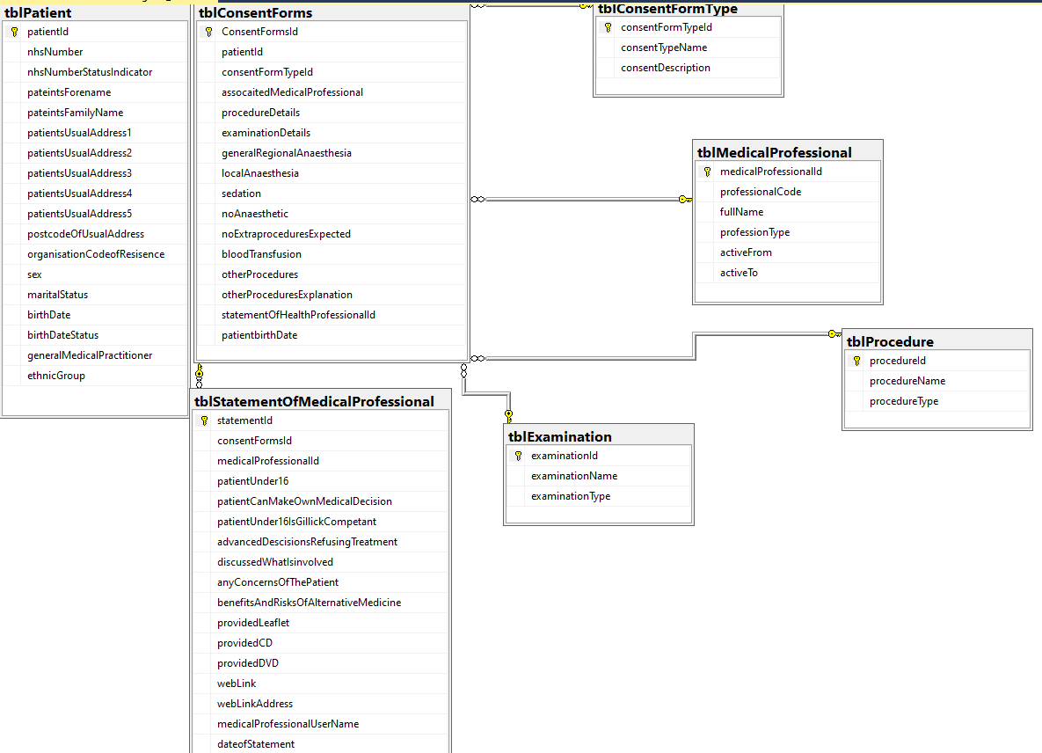
Figure 3Entity Relationship Diagram. Produced by Brandon Gorman
Figure Three shows the initial Entity Relationship Diagram for storing informed consent data. Although each table appears simplistic, there are several different procedures and triggers that support the system, additionally, with the service supporting the “Once for Wales” agenda, most dataset with will view via an Application Programmable Interface or have a direct feed into another system, reducing the duplications of data.

Firstly, the patient pathway. The patient pathway dictates the system a patient or a medical professional would use. In the case of informed consent, the systems used will be the Welsh Patient Administration Service and Welsh Clinical Portal. What this means, is that several vital pieces of data will be taken for other systems, reducing duplications, and ensuring information quality measures are met.

Secondly, the use of the Classifications of Interventions and Procedures v4 (OPCS) [72]. The use of OPCS will be required to record the examination or procedure that would be undertaken. To store this data the author created two entities, ‘tblExamnination’ and ‘tblProcedures’, each data store would collect data from the national reference data repository and distribute it across the service when required (Please refer to Figure 4).

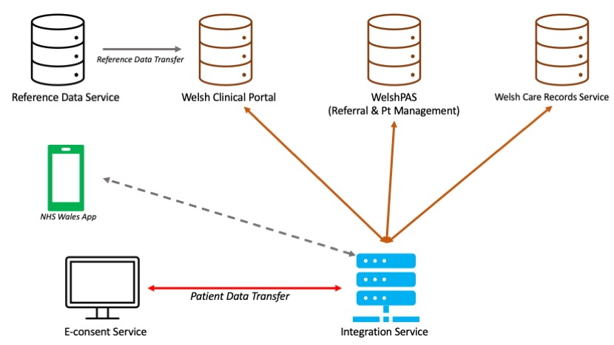
Figure 4 E-consent data sharing. Produced by Brandon Gorman
Finally, XML procedure. To ensure a smooth transition in message translation, and the vital patient data can be read and received by several different services, the author employed the use of XML for its data transfer. As described by Amazon [73] “Extensible Markup Language (XML) lets you define and store data in a shareable manner”, this provides a neutral format where the data can then be translated and transmitted via an integration service to read by different services (Refer to Appendix Five for XML Transfer and example).

NHS Wales Data Standards

The NHS in Wales adopts nationally agreed data standards to ensure services across Wales report key pieces of information in the same way. By apply such standards the understanding of information becomes more transparent. The application of data standards in the context of electronic informed consent is no different. Due to the success of data standard implementations across Wales the application will adopt agreed standards into the design of database application (Refer to Appendix Three for data set examples).

Firstly, Admitted Patient Care dataset (APC). The APC dataset “is to provide activity figures for admitted care” [72]. In addition to this the APC dataset provides several vital data items that will be required for patient management in a consent form context. The APC dataset can be broken into four key areas, patient demographics, referral details, provider spell details and diagnostic information. With the use of electronic forms much of the information can come from other sources minimising duplication and reducing any potential data quality issues.

Secondly, The Critical Care Dataset (CCD). The CCD dataset provides key data items that are required to be collected if any treatment is required as an emergency. The difference between the CCD and APC in this regard is the aftercare details which in a consent context isn’t relevant. However, key data items that can be considered but not compulsory includes Respiratory Support Days and organ support.

Finally, Emergency Department Data Set (EDDS). The EDDS data set provides both national and local services with the relevant information required on a patient in an emergency context. Three data items will be used form the dataset, Triage category, Triage start, Triage End.

Change Control Notification
To ensure services are audited and managed in accordance with ISO 20000 [73] any changes or proposed changes must be formally requested as a change record or Change Control Notification (CCN).

The purpose of the CCN is to ensure the organisation has adequately measured the value and risk involved. Once a change has been approved by the statutory authority it speaks to the author can then action to change developing the DDL and SQL as outlined in the CCN (Please refer to Appendix Four for full CCN).

Implementation Outcome
The use of E-Consent has been a highlighted area, however, due to other milestones set out by the Welsh government there hasn’t yet been any official traction on adopting an electronic approach. Despite this, e-consent is very much on the agenda and the outcome has shown that adopting a digital solution from a data perspective is in fact possible.
Interoperability between existing services and the E-consent database has been proven to work with the conversion of key data items into XML ready for data transfer.

Although the code was applied correctly, there was no way of viewing the transfer of data via a scheduled task via a server hosting the SQL instance. Despite this the code develop clearly generated the message structure required.

Chapter Five: Evaluation
The author has explored the use of e-consent forms in the context of examinations and procedures, critically assessing the legal contexts and foundations as well as the social and political reasoning behind its potential development and use in Wales.

The author conducted primary research into e-consent by asking NHS colleagues to assess the current use of consent forms and how nationally agreed standards as well as systems and services already employed by the NHS can improved by the ‘All Wales Agenda’.

Although the research conducted provided a significant amount of insights to stakeholder requirements, the author failed to contacted an investigation and ask questions regarding technical requirements, infrastructure requirements and potential digital maturity challenges.

Due to the inability to connect the solution to a development environment the ability to actively view the transfer of messages between the solution and other active services across the national information architecture wasn’t possible. If the author were to have the resources, they would have worked with the relevant application teams to develop a more details solution that also integrates pathology related details as well as the ethical and legal questions the form currently holds.

A presentation by the author [76] who reviewed informed consent in an earlier stage had found that a high proportion of the medical community had a clear understanding electronic informed consent and that despite the concept being clearly understood it application was unheard of (Please refer to Appendix Six).

Despite the medical community not having signed consent forms remotely, the author had found that there was in fact an interest in having an integrated electronic solution:

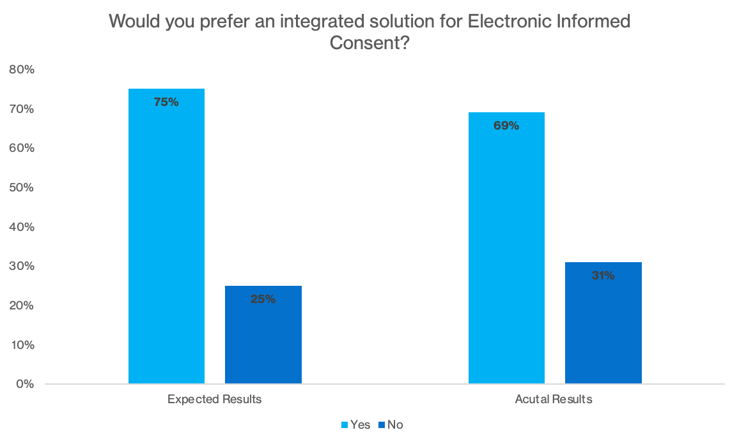
Figure 5 Bar graph showing expected vs actual preference to e-Consent. Produced by Brandon Gorman

The above results show a common trend, where medical professionals are “satisfied with the EHR system” [77], suggesting a more positive reaction to its development and use.

Chapter Six: Conclusions and Recommendations
The author has conducted significant research into the use, development, positives and challenges encountered with paper and digital consent forms. The author explored the reason why modern democracies as well as developing nations employ such ethics and how these ethics have affected legal proceedings throughout the years.

The author conducted research into the current forms used within NHS Wales and the different forms of consent Wales acknowledges. Despite the difference is consent the types of the author emphasised the core foundations of consent, and despite a patient’s condition the three core principles of voluntary, capacity and informed.

The author also found the challenges with e-consent forms derived from socio-economic issues such as poverty, but other factors such as age and digital maturity are root causes.

To remedy the use of paper forms and transition to a digital solution, the author took the nationally agreed standards that are agreed national by medical professionals. These data standards were then translated into an entity relationship diagram where interoperability as well as the national agenda were taken into consideration.

The author, based off the nationally agreed standards and “Once for Wales” agenda designed a database solution collecting the relevant data items (as mandated by HM Welsh Government), they also employed procedures to translate the SQL data into XML format in preparedness for service integration.

The author also based several aspects of the database solution from primary research, by asking professionals question relating to their knowledge of consent and preferences for an integrated solution. The results confirmed the longing for a solution within the purview of national information architecture currently employed.

The project also highlights several new topics to be investigated by the NHS in Wales.

Firstly, a national data standard for e-consent. The author employed three core standards throughout their project, however, a new nationally agreed standard would have reduced the time the author needed in locating the relevant data items.

Secondly, standardising the messaging format. The messaging formats used across NHS vary, from FHIR to HL7. Standardising the messaging format across the national architecture could reduce integration time and resources on the local systems.

Finally, the project scope and initial solution can be adopted by DHCW. The research within this report has provided the foundation research and a standardised dataset to start further discussions and scoping for the design and developed on e-consent forms within WCP or another centralised application with NHS Wales.

To conclude, the above has highlighted the significant work required not just to develop an e-consent solution within the regulation set out by both Welsh and UK governments, but also the wider social and economic impact that the solution will have. Although the initial requirements set out in the introduction have been met, to design and develop a database solution that reflects the current consent form. New requirements have now materialised because of the report:
- To design an application that supports those with disabilities, following the UK Health Regulatory Authority guidance.
- To outline a policy in partnership with Public Health Wales to tackle digital poverty and access to digital consent.
- To employ the “low code” approach and apply common code standards to the solution.
These new requirements will need to be included as a Critical Success Factor if any solution were to be devised going forward.

Chapter Seven: Reflection
The project detailed in this report had a key focus on medical ethics and regulatory compliance and required the author to convert the regulatory and ethical details into a data model. The following reflection with focus on the personal development and experiences encountered throughout the project.

The role of digital health has increased over the past decade and has improved processes as well as overall patient care. The project’s main objective was to design and develop a database solution that can be integrated with a pre-existing service used within NHS Wales. The author played a key role in the discovery, design and develop phases, some of which were areas they had no prior experience in.

The author developed new and worked upon existing skills that have not just supported the rollout of the project, but also within a commercial environment.

Firstly, subject matter knowledge. Informed consent is a complex area of study. The additional element of computing adds an additional level of complexity. The author, in addition to their requirements of understanding what was needed, had to understand the legality and ethics behind it. Due to the research in several supreme court cases the author has an increased understanding in the subject and can provide significant points to consent in a commercial environment.

Next, business analytics. The author adopted a new skill, in business analysis with designing requirements and translating mandated data standards. This has also been beneficial in a commercial environment where requirements gathering has become a much simpler process.

Finally, technical understanding. Throughout the project the author adopted XML functionality. To successfully apply this functionality the author asked for real examples of how the transaction and translation process worked and why XML translation was required. The author now fully appreciates the use of XML and its association with technologies such as FHIR and HL7.

Although the project taught the author several lessons, the author experienced a significant challenge in the categorisation of medical procedures. Although the author understands the anatomical positions of certain procedures translating these into a data solution wasn’t simplistic and required the support of the Terminology Team, who were able to confirm and generate a schema for future development. The lesson learnt in this regard to this was to understand clinical specialties will require additional refinement and dsata items as certain procedures can be done in various places on the body. Without this information the incorrect procedure could in fact be done, which could lead to lawsuits and damages.

To conclude, the overall project has promoted a significant level of personal progression as well as ensuring the author has the tools needed to adapt and adopt to changing situations. The project has proven the importance of the “Once for Wales” agenda and the importance on e-consent moving forward. The author has developed to skills necessary to promote the project to a wider audience and to a more refined and specialist team of support staff.

Chapter Eight: Appendices

Appendix Once: Database Design – Normalisation
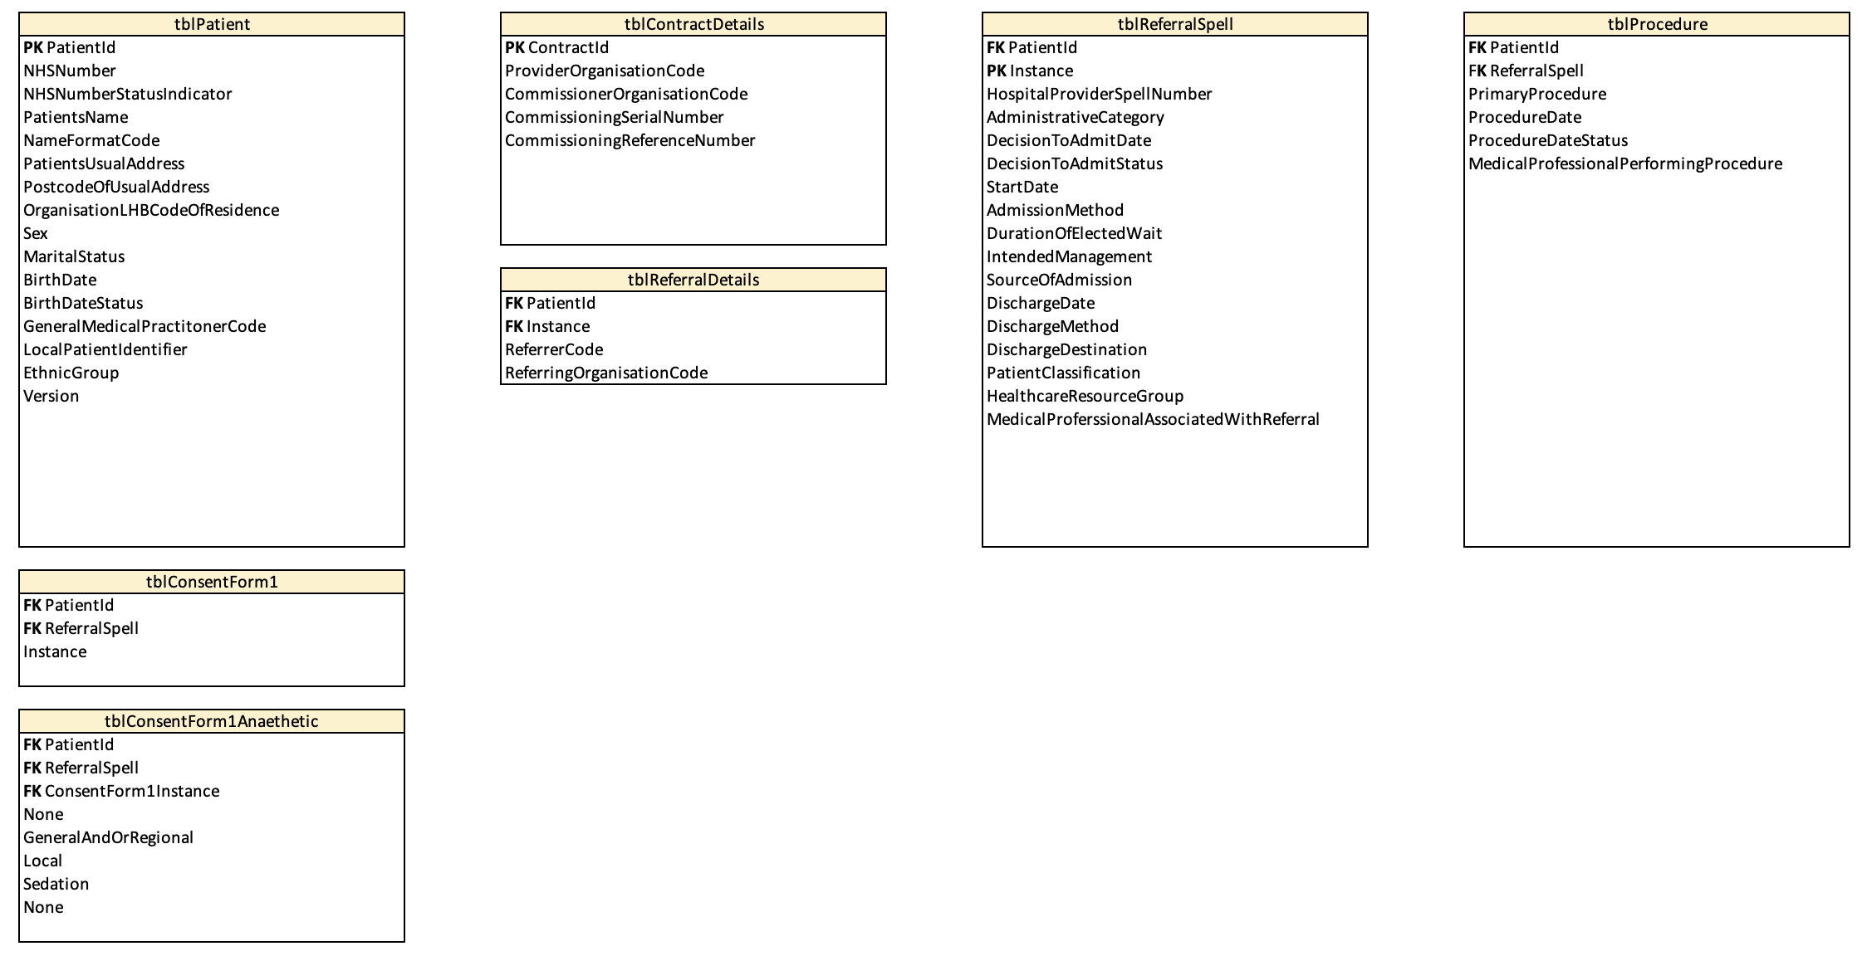

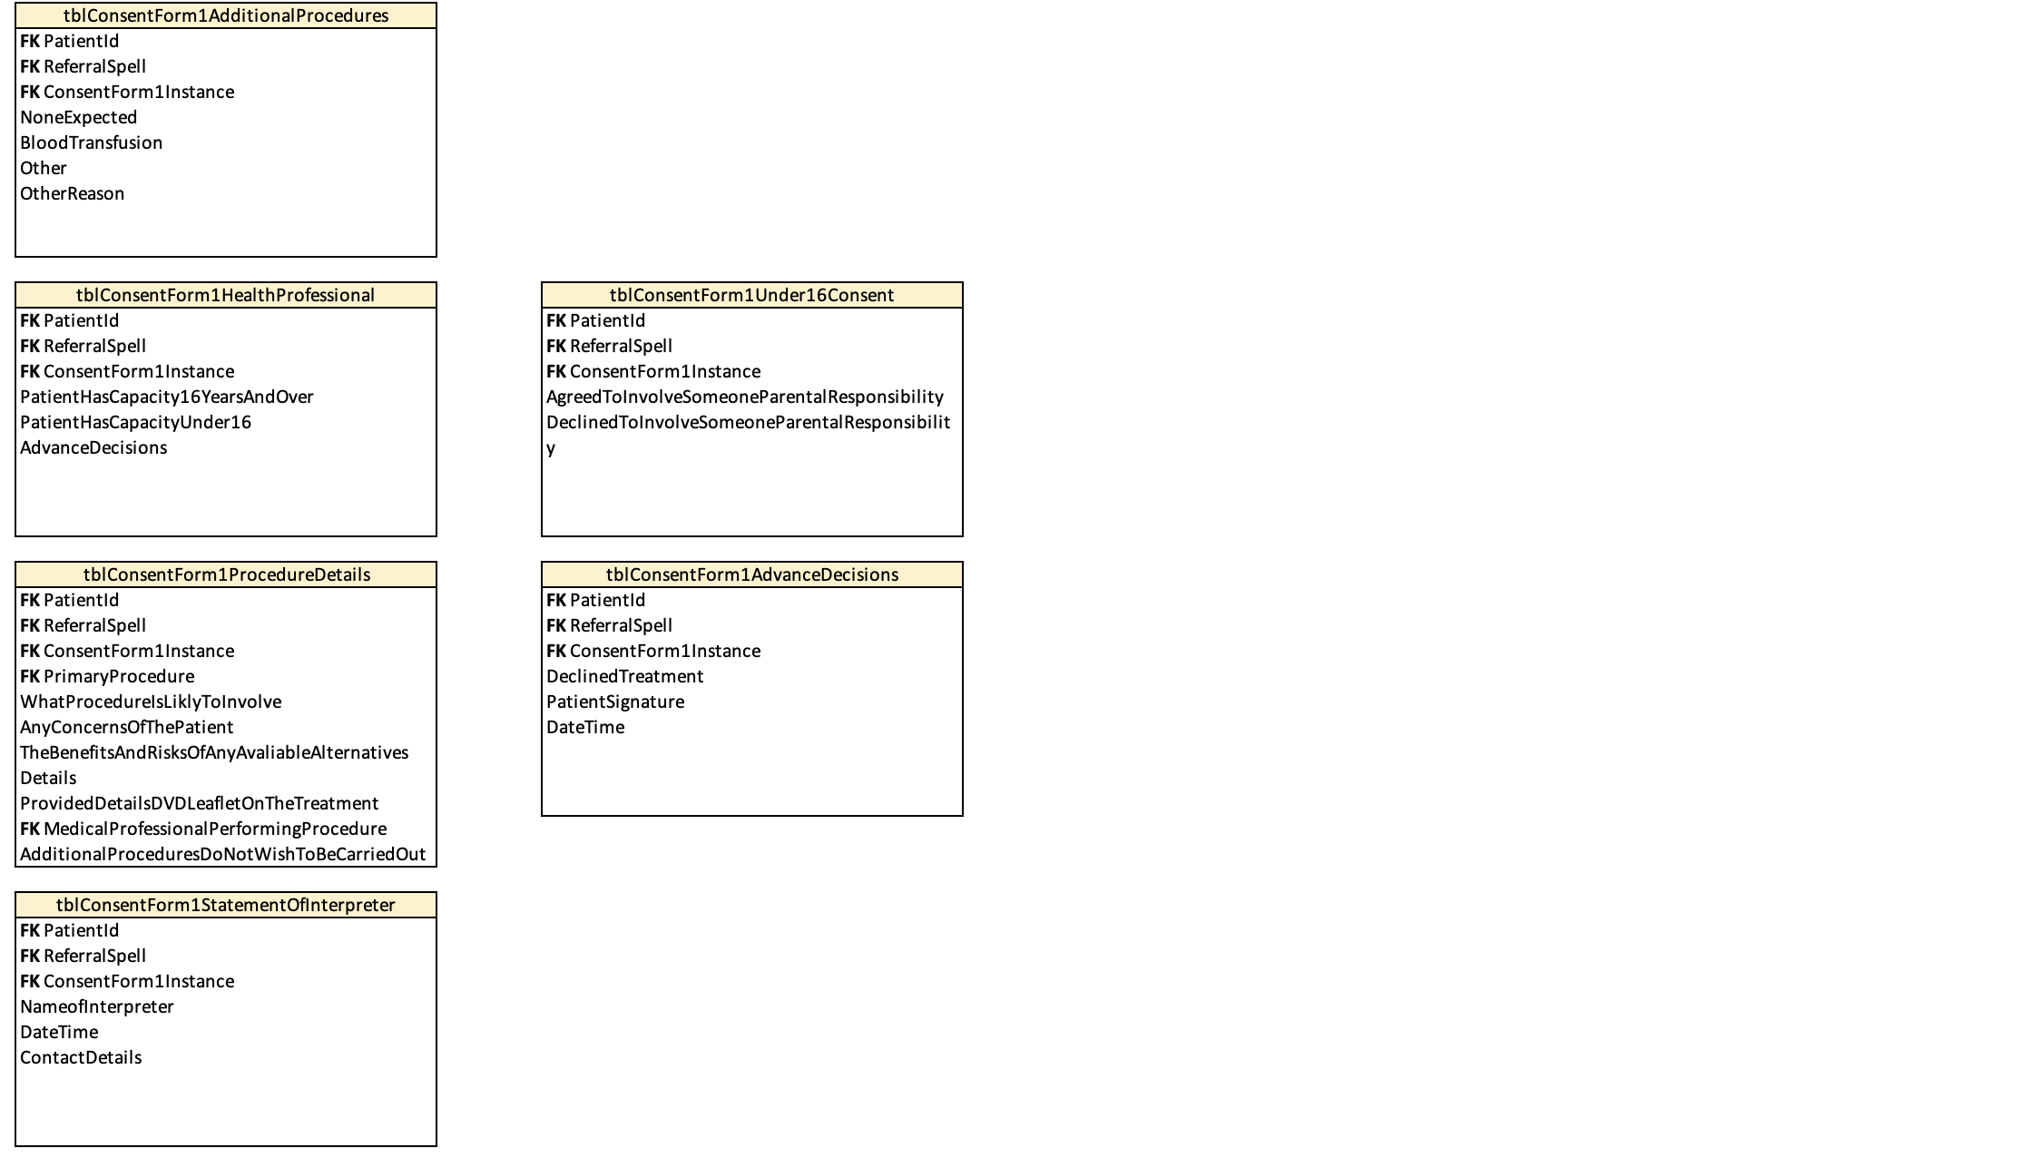
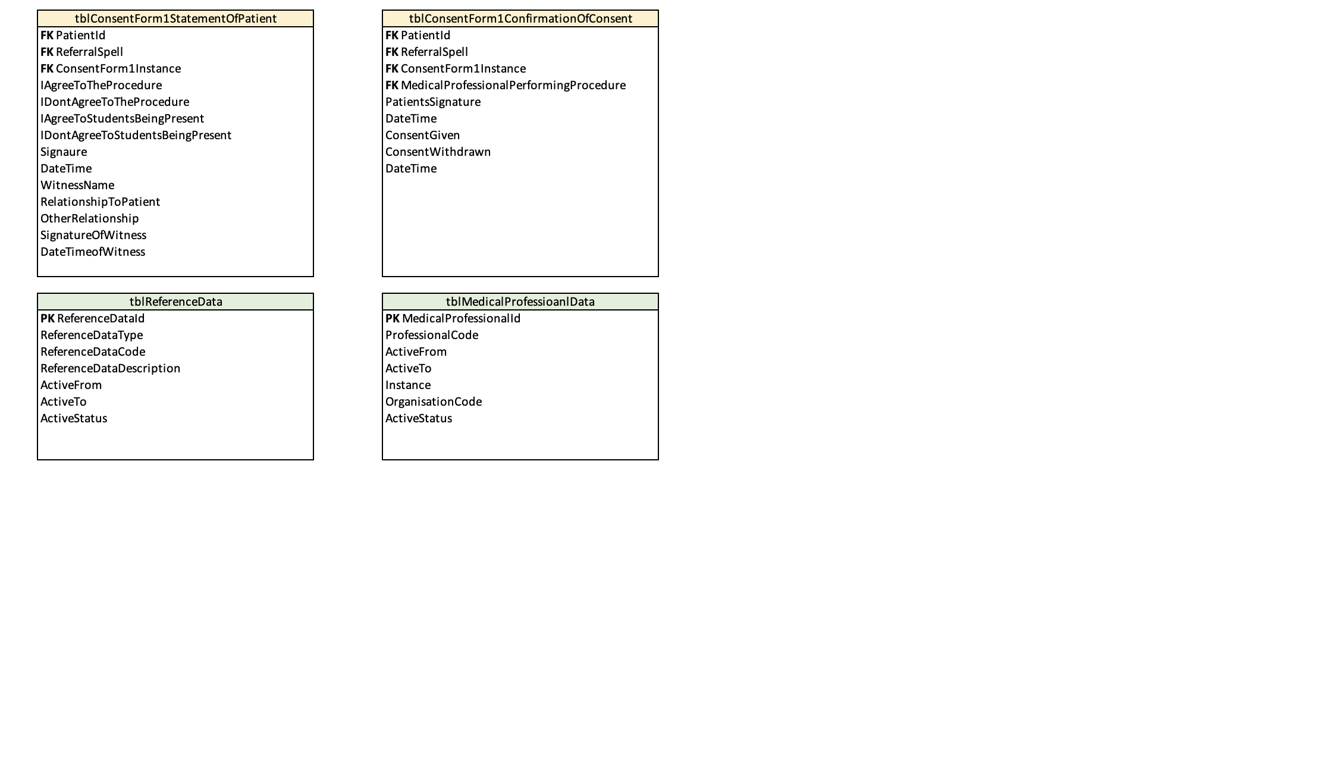

Appendix Two: Database Design – DDL Examples
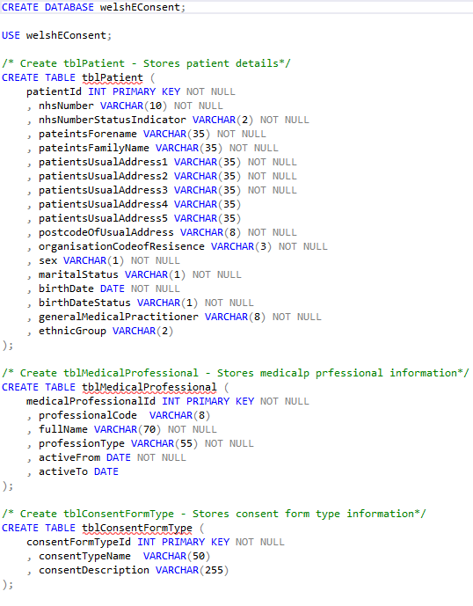

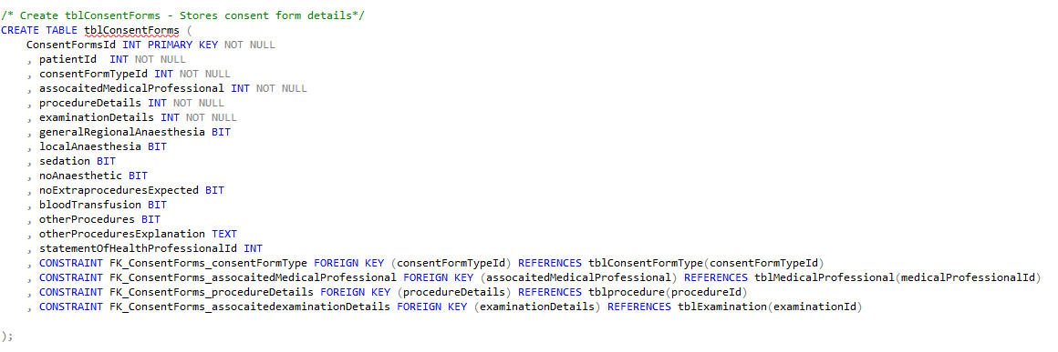

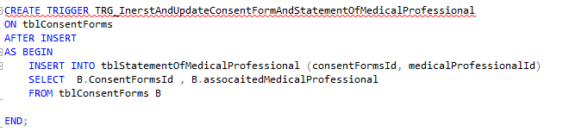



Appendix Three: Data Standards

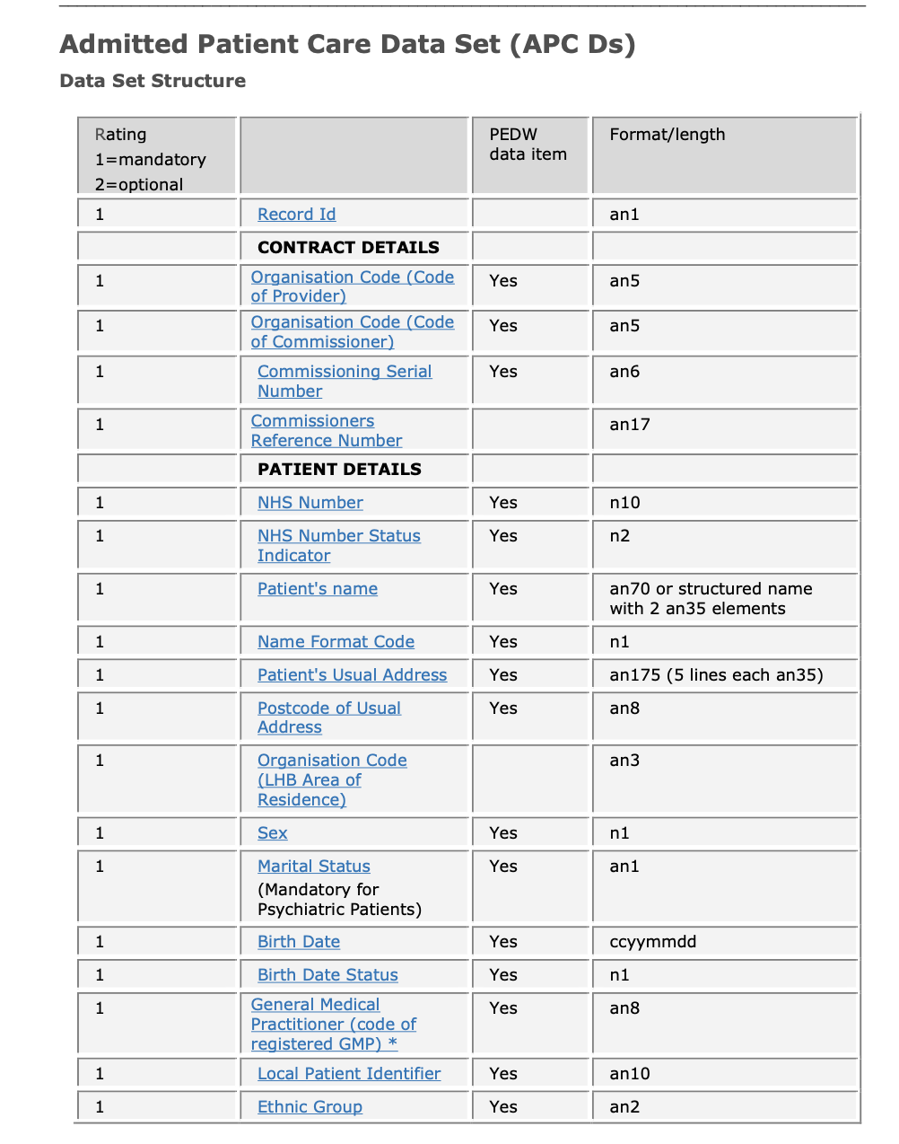
Figure 6 NHS Wales APC Data Set. Taken from the NHS Wales Data Dictionary

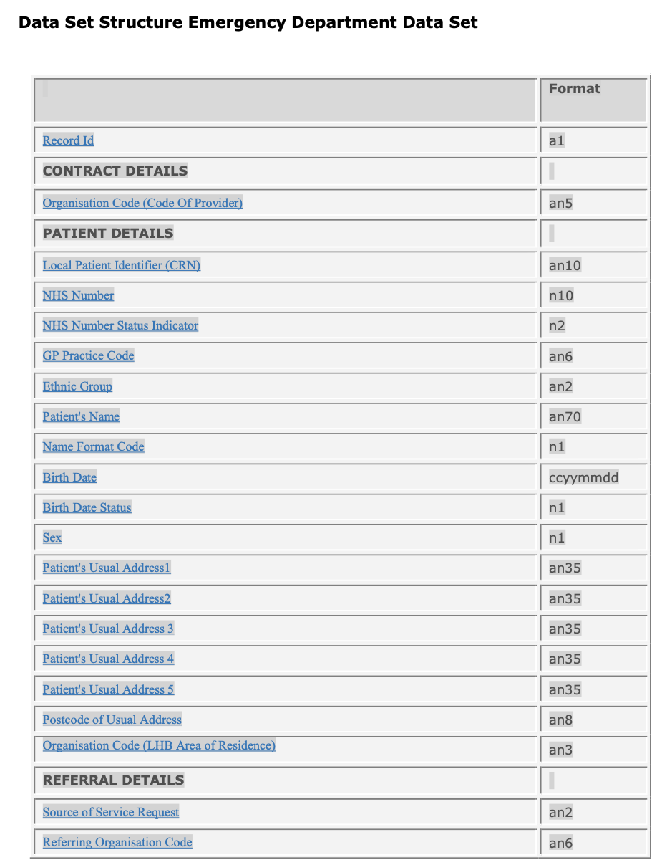
Figure 7 NHS Wales EDDS Data Set. Taken from the NHS Wales Data Dictionary

Appendix Four: Change Control Notification

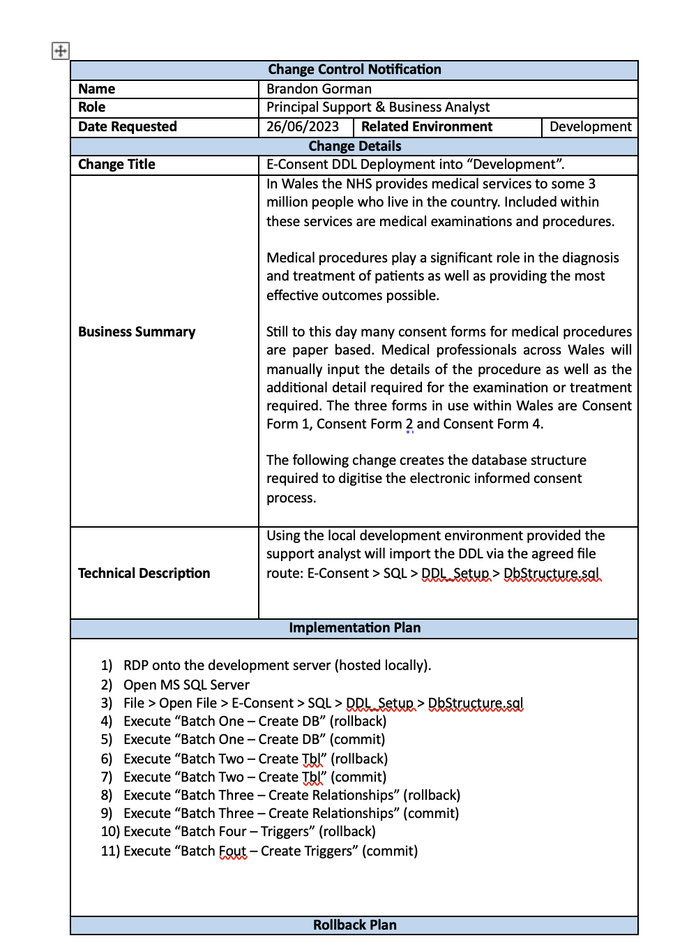
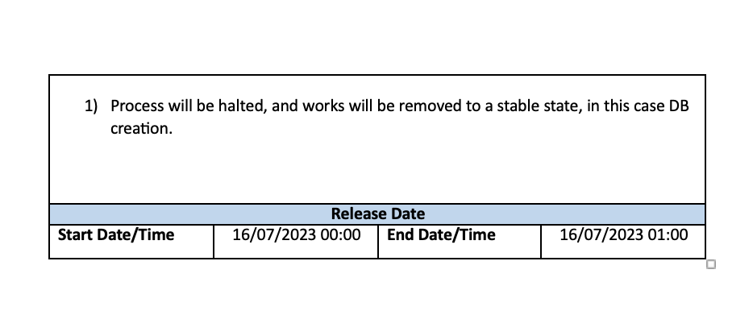

Appendix Five: XML Transfer

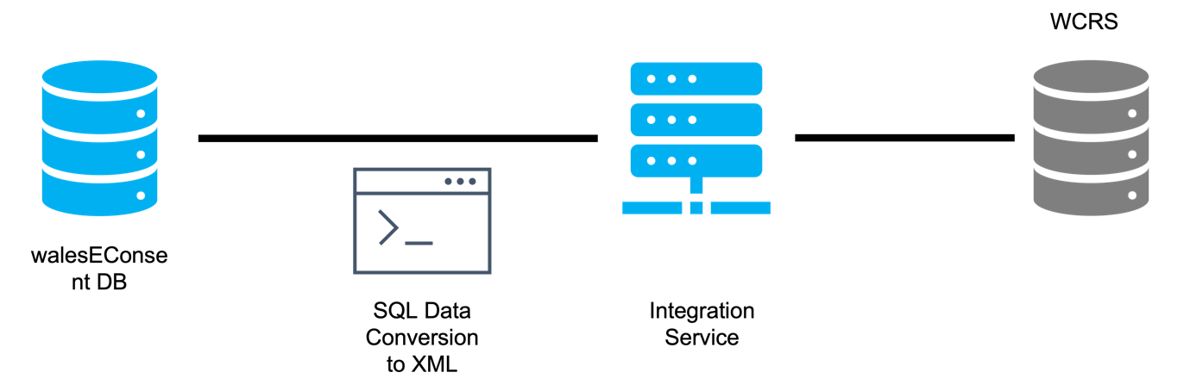
Figure 8 XML Transfer. Designed by Brandon Gorman

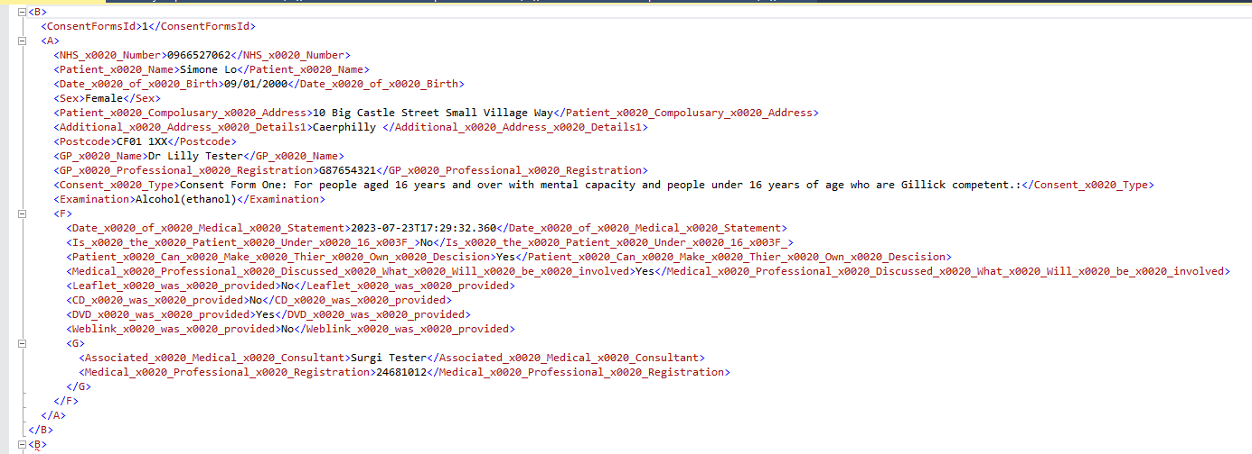

Appendix Six: Initial findings

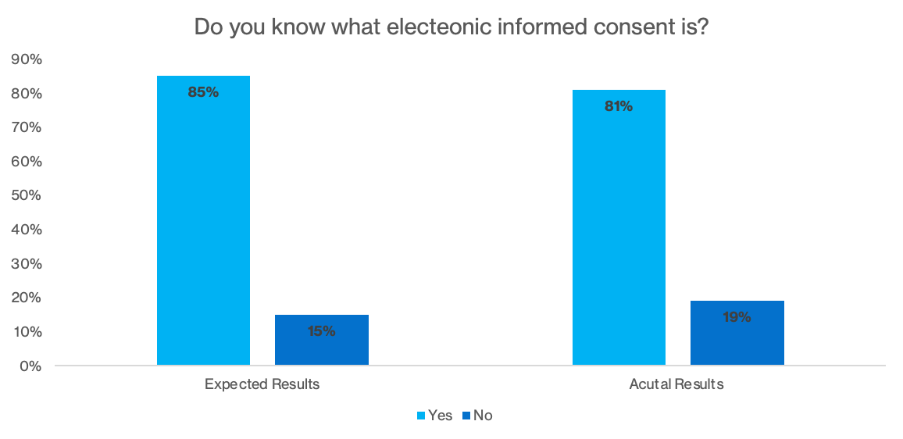

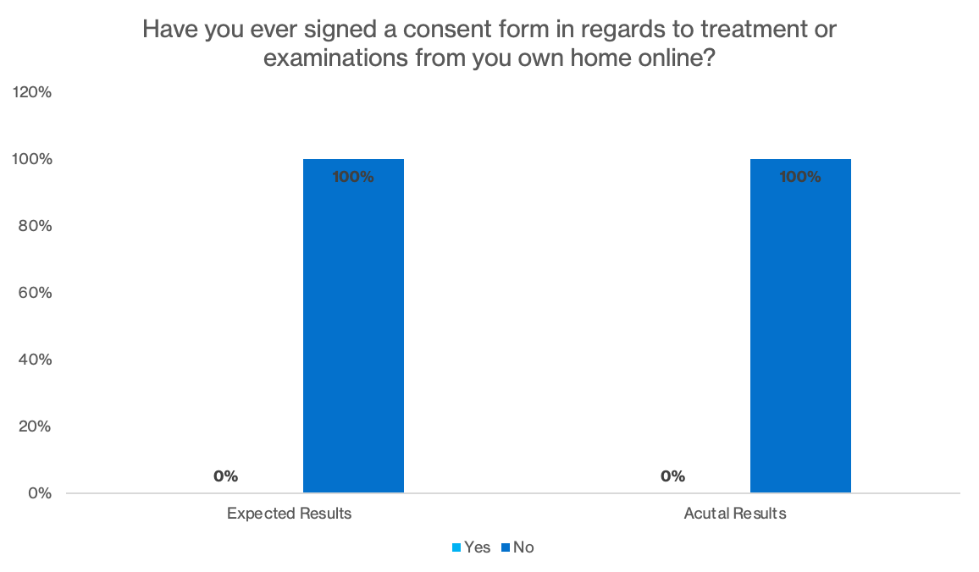

Chapter Nine: Acronyms

Acronym | Meaning
DHCW | Digital Health and Care Wales
NHS Wales | National Health Service Wales
PHW | Public Health Wales
HM | His Majesties
WISB | Welsh Information Standards Board
WCP | Welsh Clinical Portal
WelshPAS | Welsh Patient Administration System
WCRS | Welsh Care Records Service
HL7 | Health Level 7
FHIR | Fast Healthcare Interoperability Resources
DDL | Data Definition Language
SQL | Structured Query Language
CCN | Change Control Notification
APC | Admitted Patient Care
EDDS | Emergency Department Dataset
MHRA | Medicines and Healthcare Products Regulatory Agency

Chapter Ten: References

[1] | NHS Wales, “About Us,” NHS Wales, [Online]. Available: https://www.nhs.wales/about-us/#:~:text=NHS%20Wales%20is%20the%20public,who%20live%20in%20the%20country.. [Accessed 20 June 2023].
[2] | T. Abbott, A. Fowler, T. Dobbs, E. Harrison, G. A and R. Pearse, “Frequency of surgical treatment and related hospital procedures in the UK: a national ecological study using hospital episode statistics,” British Journal of Anaesthesia, vol. 119, no. 2, pp. 249 - 257, 2017.
[3] | NHS Wales Shared Services Partnership, “All Wales Consent Forms: Patient Consent to Examination or Treatment,” [Online]. Available: https://nwssp.nhs.wales/ourservices/welsh-risk-pool/welsh-risk-pool-programmes/all-wales-consent-to-examination-and-treatment-improvement-programme/all-wales-consent-forms-patient-consent-to-examination-or-treatment/. [Accessed 20 June 2023].
[4] | His Majesty's Welsh Government, “Informed Health and Care: A Digital Health and Social Care Strategy for Wales.,” His Majesty's Welsh Government, Cardiff, 2015.
[5] | His Majesty's UK Government, “National Health Service Act 1946,” legislation.co.uk, 5 July 1948. [Online]. Available: https://www.legislation.gov.uk/ukpga/Geo6/9-10/81/contents/enacted. [Accessed 8 July 2023].
[6] | His Majesty's Welsh Government, “Nursing records go digital – a case study,” 25 October 2021. [Online]. Available: https://digitalpublicservices.gov.wales/nursing-records-go-digital-a-case-study/. [Accessed 20 June 2023].
[7] | T. Richards, “Will obtaining digital consent from patients in advance of undergoing procedures improve the quality of the consent process?,” The British Medical Journal, 2022.
[8] | University of Oxford, “Informed Consent: Information and guidance for researchers,” University of Oxford, [Online]. Available: https://researchsupport.admin.ox.ac.uk/governance/ethics/resources/consent. [Accessed 3 July 2023].
[9] | the Medic Portal, “Medical Ethics,” [Online]. Available: https://www.themedicportal.com/application-guide/medical-school-interview/medical-ethics/?v=79cba1185463. [Accessed 3 July 2023].
[10] | Oxford University Press, Concise Medical Dictionary (8 ed.), Oxford: Oxford University Press, 2010.
[11] | B. Varkey, “Principles of Clinical Ethics and Their Application to Practice,” Medical Principles and Practice, vol. 30, no. 1, pp. 17-28, 2021.
[12] | The British Medical Association, “Autonomy or self-determination as a medical student,” The British Medical Association, 1 May 2020. [Online]. Available: https://www.bma.org.uk/advice-and-support/ethics/medical-students/ethics-toolkit-for-medical-students/autonomy-or-self-determination. [Accessed 8 July 2023].
[13] | W.-C. Leung, Response to: Consent may be hard to obtain for incompetent patients when relatives object, Sunderland: The British Medical Journal, 1998.
[14] | The Medic Portal, “Medical Ethics: Justice,” The Medic Portal, [Online]. Available: https://www.themedicportal.com/application-guide/medical-school-interview/medical-ethics/justice/?v=79cba1185463#:~:text=Justice%20–%20in%20the%20context%20of,if%20it%27s%20fair%20and%20balanced.. [Accessed 8 July 2023].
[15] | S. Rab, “Legal Systems in the UK (England and Wales): Overview,” [Online]. Available: https://uk.practicallaw.thomsonreuters.com/5-636-2498?transitionType=Default&contextData=(sc.Default)&firstPage=true. [Accessed 3 July 2023].
[16] | Enable Law, “CONSENT FOR MEDICAL TREATMENT: RECENT CASE LAW,” Enable Law, 14 February 2017. [Online]. Available: https://www.enablelaw.com/news/latest-news/consent-medical-treatment-recent-case-law/. [Accessed 3 July 2023].
[17] | R. M. Paige, “Clinical negligence: patients’ wishes are paramount,” Park Square Barristers, 14 March 2015. [Online]. Available: https://www.parksquarebarristers.co.uk/news/clinical-negligence-update-border-montgomery/. [Accessed 14 July 2023].
[18] | P. Sankey, “Montgomery fallout,” Concentric Health, 1 Febuary 2017. [Online]. Available: https://concentric.health/news/montgomery-fallout/. [Accessed 14 July 2023].
[19] | D. E. Hall, A. V. Prochazka and A. S. Fink, “Informed consent for clinical treatment,” Canadian Medical Association Journal, vol. 185, no. 5, pp. 533-540, 2012.
[20] | NHS, “Before surgery,” NHS, London.
[21] | W. Abdelrahman, “Careers Medical record keeping: clarity, accuracy, and timeliness are essential,” The British Medical Journal, 2014.
[22] | Health Records & Communication Practice Standards Group, Health Record and Communication Practice Standards for Team Based Care, London: NHS England, 2004.
[23] | R. Richesson and P. Nadkarni, “Data standards for clinical research data collection forms: current status and challenges,” National Library of Medicine, vol. 18, no. 3, pp. 341-246, 2011.
[24] | Institute of Medicine (US) Committee on Data Standards for Patient Safety, Patient Safety: Achieving a New standard for Care, Washington DC: National Academies Press (US), 2004.
[25] | J. Bircher, “Prioritising quality improvement,” The British Medical Journal, 2019.
[26] | NHS Digital, “SNOMED CT,” [Online]. Available: https://digital.nhs.uk/services/terminology-and-classifications/snomed-ct. [Accessed 23 July 2023].
[27] | P. Ruch, J. Gobeill, C. Lovis and A. Geissbühler, “Automatic medical encoding with SNOMED categories,” MC Medical Informatics and Decision Making, 2008.
[28] | tulane University: School of Public Health and Tropical Medicine, “Discovering Public Health Issues With Data,” 24 June 2022. [Online]. Available: https://publichealth.tulane.edu/blog/public-health-issues/. [Accessed 20 June 2023].
[29] | J. Stausberg, “Comparing paper-based with electronic patient record: Lessions Learned during a Study on Diagnosis and Procedure Codes,” Journal of the American Medical Informatics Association, vol. 10, no. 5, pp. 470-477, 2003.
[30] | CaseCTRL, [Online]. Available: https://blog.casectrl.com/author/admin. [Accessed 23 July 2023].
[31] | PAMELA, “Surgery Scheduling: 5 Reasons Why Paper-Based Forms Do Not Work,” caseCTRL, 29 June 2021. [Online]. Available: https://blog.casectrl.com/surgery-scheduling-5-reasons-why-paper-based-forms-do-not-work. [Accessed 21 June 2023].
[32] | D. N. Ali, “The problem with paper charting - and how EHR can help,” 15 November 2022. [Online]. Available: https://www.ehrinpractice.com/problem-with-paper-charting.html. [Accessed 25 June 2023].
[33] | T. Mutshatshi, T. Mothiba, P. Mamogobo and M. Mbombi, “Record-keeping: Challenges experienced by nurses in selected public hospitals,” Curationis, vol. 41, no. 1, 2018.
[34] | K. Pine and M. Mazmanian, “Institutional logics of the EMR and the problem of “Perfect” but inaccurate accounts.,” in 17th ACM Conference on Computer Supported Cooperative Work & Social Computing, Baltimore, 2014.
[35] | R. Asiimwe, S. Lam, S. Leung, S. Wang and R. Wan, “From biobank and data silos into a data commons: convergence to support translational medicine,” Journal of Translational Medicine, vol. 19, pp. 1-13, 2021.
[36] | Environmental Protection Agency, “Advancing Sustainable Materials Management: 2014 Fact Sheet,” Environmental Protection Agency, Washington DC, 2014.
[37] | L. Peng, X. Zeng, Y. Wang and G.-B. Hong, “Analysis of energy efficiency and carbon dioxide reduction in the Chinese pulp and paper industry,” Energy Policy, vol. 80, pp. 65-75, 2015.
[38] | actionpoint.co.uk, “Rising paper prices in 2022 FAQs,” actionpoint.co.uk, 6 April 2022. [Online]. Available: https://actionpoint.co.uk/rising-paper-prices-in-2022-faqs/. [Accessed 25 June 2023].
[39] | NHS England, “Cutting reliance on paper will make patients safer, says NHS England,” NHS England, 1 Spetember 2015. [Online]. Available: https://www.england.nhs.uk/2015/09/cutting-reliance-on-paper/#:~:text=The%20estimated%20annual%20cost%20of,make%20them%20available%20to%20patients.. [Accessed 25 June 2023].
[40] | World Medical Association, “World Medical Association Declaration of Helsinki: ethical principles for medical research involving human subjects,” JAMA, vol. 210, no. 20, pp. 2191-2194, 2013.
[41] | A. Bastek, “The Benefits of eConsent Forms for Clinical Trials,” [Online]. Available: https://florencehc.com/blog-post/the-benefits-of-econsent-forms-for-clinical-trials/#:~:text=With%20eConsent%2C%20you%27ll%20no,signatures%2C%20initials%2C%20and%20dates.. [Accessed 27 June 2023].
[42] | His Majesty's Welsh Government, “Demography and migration in Wales (Census 2021),” 2 November 2022. [Online]. Available: https://www.gov.wales/demography-and-migration-wales-census-2021-html#:~:text=Out%20of%20the%20estimated%203.1,were%20born%20outside%20the%20UK.. [Accessed 27 June 2023].
[43] | B. Hughes, “Wales' NHS spends £1m-plus on translating for pateints,” 1 April 2013. [Online]. Available: https://www.walesonline.co.uk/news/wales-news/wales-nhs-spends-1m-plus-translating-2495275. [Accessed 27 June 2023].
[44] | K. M. Brelsford, E. Ruiz and L. Beskow, “Developing informed consent materials for non-English-speaking participants: An analysis of four professional firm translations from English to Spanish,” Clinical Trials (London, England), vol. 15, no. 6, pp. 557-566, 2018.
[45] | His Majesty's Welsh Government, “Local authority registers of disabled people: as at 31 March 2022,” 21 February 2022. [Online]. Available: https://www.gov.wales/local-authority-registers-disabled-people-31-march-2022. [Accessed 27 June 2023].
[46] | J. Nganji and S. H. Nggada, “Disability-Aware Software Engineering for Improved System Accessibility and Usability,” International Journal of Software Engineering and its Applications , vol. 5, no. 3, pp. 47-62, 2011.
[47] | Care Quality Commission, “Regulation 11: Need for Consent,” Care Quality Commission, London, 2022.
[48] | NHS England, “Overview: Consent to treatment,” [Online]. Available: https://www.nhs.uk/conditions/consent-to-treatment/#:~:text=Defining%20consent&text=informed%20–%20the%20person%20must%20be,treatment%20does%20not%20go%20ahead. [Accessed 27 June 2023].
[49] | InterSystems, “Healthcare Interoperability,” [Online]. Available: https://www.intersystems.com/uk/use-cases/healthcare-interoperability/. [Accessed 27 June 2023].
[50] | M. Habibi-Koolaee and L. Shahmoradi, “Integration of Health Information Systems to Promote Health,” Iriainian Journal of Public Health, vol. 45, no. 8, pp. 1096 - 1097, 2016.
[51] | Folio3, “Benefits Of Integrated Healthcare Systems | Complete Guide for 2023,” [Online]. Available: https://digitalhealth.folio3.com/blog/benefits-of-integrated-healthcare-systems/. [Accessed 2 July 2023].
[52] | HL7 UK, “Home,” HL7 UK, [Online]. Available: https://www.hl7.org.uk. [Accessed 14 July 2023].
[53] | J. C. Mandel, D. A. Kreda, K. D. Mandl, I. S. Kohane and R. B. Ramoni, “SMART on FHIR: a standards-based, interoperable apps platform for electronic health records,” Journal of the American Medical Informatics Association, vol. 23, no. 5, pp. 899-908, 2016.
[54] | Kodjin Interoperability Suite, “HL7 INTEGRATION: STANDARDS AND BENEFITS,” Kodjin Interoperability Suite, 14 February 2023. [Online]. Available: https://kodjin.com/blog/hl7-integration-standards-and-benefits/. [Accessed 14 July 2023].
[55] | Y. Yang, “Semantic User Model Inferences for Travel Recommender Systems,” Tourism Informatics: Visual Travel Recommender Systems, Social Communities, and User Interface Design, p. 15, 2010.
[56] | MD Consents, “Accessibility and its role in informed consent,” MD Consents, 12 March 2021. [Online]. Available: https://mdconsents.com/accessibility-and-its-role-in-informed-consent/. [Accessed 4 July 2023].
[57] | University of Sunderland, “DIGITAL LITERACY IN HEALTHCARE,” 1 November 2021. [Online]. Available: https://online.sunderland.ac.uk/digital-literacy-in-healthcare/. [Accessed 4 July 2023].
[58] | Royal College of Nursing, “Improving Digital Literacy,” Royal College of Nursing, 18 July 2017. [Online]. Available: https://www.rcn.org.uk/Professional-Development/publications/pub-006129. [Accessed 4 July 2023].
[59] | Digital Poverty Alliance, “Digital poverty: The Facts,” Digital Poverty Alliance, [Online]. Available: https://digitalpovertyalliance.org. [Accessed 14 July 2023].
[60] | E. J. Helsper and B. C. Reisdorf, “The emergence of a “digital underclass” in Great Britain and Sweden: Changing reasons for digital exclusion,” New Media & Society, vol. 19, no. 8, p. 1253–1270, 2017.
[61] | B. R. Winthereik, I. van der Pkoeg and M. Berg, “The Electronic Patient Record as a Meaningful Audit Tool:Accountability and Autonomy in General Practitioner Work,” Work. Science, Technology, & Human Values,, vol. 32, no. 1, pp. 6-25, 2007.
[62] | British Medical Association, “Minimum length of retention of GP records,” British Medical Association, [Online]. Available: https://www.bma.org.uk/advice-and-support/ethics/confidentiality-and-health-records/retention-of-health-records. [Accessed 2023 July 2023].
[63] | B. E. Neubauer, C. T. Witkop and L. Varpio, “How phenomenology can help us learn from the experiences of others,” Perspectives on Medical Education, vol. 8, no. 2, pp. 90-97, 2019.
[64] | D. R. Thomas, “A General Inductive Approach for Analyzing Qualitative Evaluation Data,” American Journal of Evaluation, vol. 27, no. 2, pp. 231 - 246, 2006.
[65] | B. P. Gorman, “Industrial Based Reseach: Electronic Informed Consent,” Cardiff, 2022.
[66] | Agile Alliance, “Agile 101,” Agile Alliance, [Online]. Available: https://www.agilealliance.org/agile101/. [Accessed 5 July 2023].
[67] | wrike.com, “What Is Agile Methodology in Project Management?,” wrike.com, [Online]. Available: https://www.wrike.com/project-management-guide/faq/what-is-agile-methodology-in-project-management/. [Accessed 4 July 2023].
[68] | DBMaestro, “5 Keys For Implementing Agile Database Methodologies,” 2 March 2017. [Online]. Available: https://www.dbmaestro.com/blog/database-devops/implementing-agile-database-methodologies. [Accessed 15 July 2023].
[69] | N. Vaidya, “Database Testing using Selenium and TestNG,” 7 March 2023. [Online]. Available: https://www.browserstack.com/guide/database-testing-using-selenium#:~:text=Automated%20database%20testing%20can%20cover,incorrect%20data%2C%20and%20duplicate%20data.. [Accessed 15 July 2023].
[70] | M. Raza, “Database Automation Explained: Concepts & Best Practices,” 26 August 2021. [Online]. Available: https://www.bmc.com/blogs/database-automation/. [Accessed 14 July 2023].
[71] | Microsoft Inc., “Description of the database normalization basics,” 14 July 2023. [Online]. Available: https://learn.microsoft.com/en-us/office/troubleshoot/access/database-normalization-description. [Accessed 15 July 2023].
[72] | Digital Health and Care Wales, “NHS Wales Data Dictionary,” 22 December 2022. [Online]. Available: https://dhcw.nhs.wales/information-services/information-standards/data-standards/data-standards-files/data-standard-change-notices-docs/dscns-2022/20221124-dscn-2022-57-apc-legal-status-retirement-v0-1pdf/. [Accessed 6 July 2023].
[73] | International Standards Organisation, “ISO/IEC 20000-1:2018 Information technology — Service management — Part 1: Service management system requirements,” [Online]. Available: https://www.iso.org/standard/70636.html. [Accessed 14 July 2023].
[74] | Business Research Methodology, “Phenomenology,” [Online]. Available: https://research-methodology.net/research-philosophy/phenomenology/. [Accessed 15 July 2023].
[75] | IBM, “Generating DDL scripts,” 16 March 2021. [Online]. Available: https://www.ibm.com/docs/en/radfws/9.6.1?topic=scripts-generating-ddl. [Accessed 16 July 2023].

