ADRIAN PATRASC 2024889
Academic and Employability Skills - BMSW4001
Module Leader: Sylvia Hoffmann
February - weekend

Introduction

This assignment is aiming to reflect on my online learning experience as a student at University of Wales Trinity Saint David.
I will be using the Kolb reflective model which will help me analyse a few skills that I am planning on gaining from this course, hopefully transforming them from weaknesses into strengths.

Summary

In the next lines I will be analysing a few of the skills I will need in order to succeed in my professional career. These skills are my weaknesses as well.
According to Forsyth (2007) time management is about organising your time in a effective manner with the outcome of being successful and efficient.
As per my experience as a student at the University of Wales Trinity Saint David, I can affirm that managing my time is not one of my strengths. As soon as the course started, I was feeling overwhelmed, and I wanted to quit after the first week of study.
I had to remind myself several times that because of my age and the fact that a have a family and a full-time job, I will need to pay more attention and to organise my time to be able to gain experience and skills from this course.
Going forward I started planning my week in order to be able to have some study time for my modules and to start writing my assignments. I can surely say that it was not an easy thing to plan and organise, most of the time not being able to stick to my plans.
As Ingram (2020) stated in his book, the key to manage your time effectively is to be motivated and to prioritise tasks by importance, this way we have a to-do list in place with the priorities at the top of the list. Therefore, I started this way to plan my week and I can say that by the end of the semester I managed to improve my time management.
In conclusion I am aware now that I need to set goals and tasks to be able to concentrate myself and plan them accordingly, prioritising the important ones. I am not able to affirm that I transformed this skill in one of my strengths, but I am working on it.
Academic writing is, according to Bailey (2011) the formal way of writing, with a clear structure and reliable information supported by research.
As soon as the course started, I knew that academic writing won’t be one of my strengths. As English is not my main language, I was aware that I will be struggling at the writing part, even more due to the fact of using formal and academic words.
After a few weeks into the course, I started writing my assignment and I planned to do at least one paragraph every couple of days, this way I will be able to write reliable and appropriate information for the main subject of the assignment. The research part took me a while and I found this quite stressful because I was not able to find information related to my subject.
The plan I made to be able to deal with this new task in my student life was working and my assignment was going well. I got stuck a few times, but I had to motivate myself in order to get the work done on time.
For the future I will make sure I will improve my academic writing by reading more books and articles, so my English will improve as well.

Online Learning Experience can be defined as the distance learning by using the technology and innovative devices to be able to acquire new skills and access knowledge (Khan and Ally, 2017).
Even if I have access to internet and I own innovative devices, I can affirm that I do not know how to use them at their full capacity. I never had to use my mobile device or laptop for meetings or to create documents, hence I knew when I started my course that I will need to improve my technological skills.
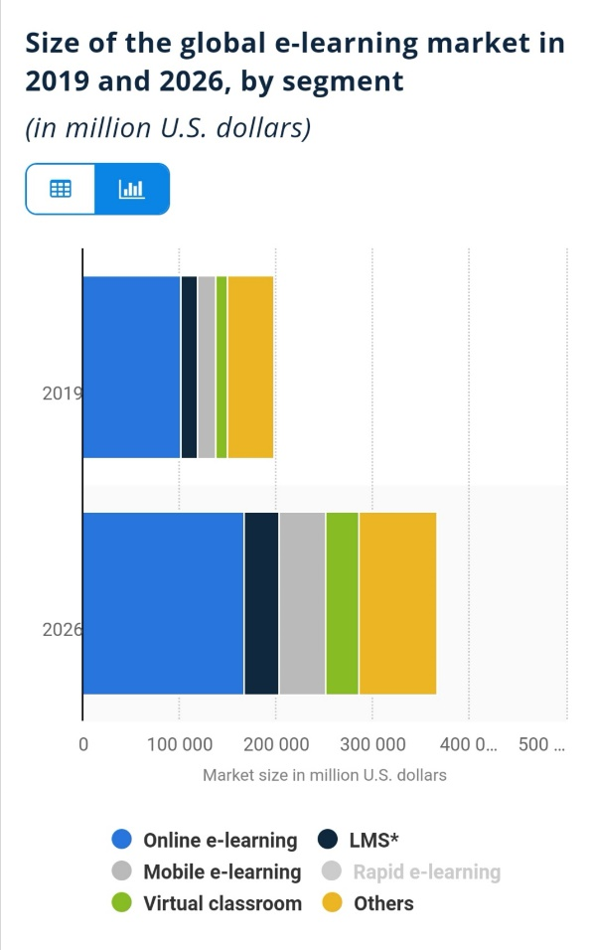
From the beginning of the course, I experienced issues with the technology as I was not prepared with enough information to deal with this. My plan for this issue was to do more research and to use the learning by doing method. The learning by doing method can be defined as the method which applies the theoretical knowledge into practical situations (The Learning Agency Lab, 2020).
As we can see from the graph below, belonging to Statista (2021), the E-learning market size is predicted to double in size by 2026. The digital e-learning market is anticipated to grow drastically due to the flexibility and accessibility this type of learning can offer.
As per my experience with digital learning I can say it was quite difficult at the beginning, but slowly I started to learn and adapt to the new situation.
Hopefully by the end of the course I will be able to gain more knowledge and develop skills related with technology which will hep me in my future career.

Conclusion
The conclusion that can be drawn from this assignment is that I need to practice more in order to be able to gain skills, train efficiently and perform effectively. By using the Kolb reflective model, I managed to analyse and reflect upon my experiences at the university. It was not an easy reflection and more than anything, I will find it difficult to work on my weaknesses in order to transform them in strengths and skills.

Reference List

Bailey, S., (2011) Academic Writing. A Handbook for International Students. Taylor & Francis Publisher.
Forsyth, P., (2007) Successful Time Management (Creating Success). Kogan Page Publisher.
Ingram, G., (2020) Time Management: A Step by Step Guide to Planning Your Day for Extreme Productivity (How to Plan Your Week, Stay Productive and Motivated the Entire Time). Gerald Ingram Publisher.
Khan, B. H. and Ally, M., (2017) International Handbook of E-Learning Volume 1. Routledge Publisher
Osland, J., Kolb, D. A., Rubin, I. M., Turner, M. (2007) Organizational Behavior. An Experiential Approach. Prentice Hall Publisher.
Statista (2021) Size of the global e-learning market in 2019 and 2026, by segment. Available at: https://www.statista.com/statistics/1130331/e-learning-market-size-segment-worldwide/ (Accessed on the 18th of April).
The Learning Agency Lab (2020) Learning by Doing: What You Need To Know. Available at: https://www.the-learning-agency-lab.com/the-learning-curve/learning-by-doing (Accessed on the 14th of April).

