Exploring how Emotion and Hidden Meaning are Portrayed in Different Styles of Animation: A Comparison of Three Animated Films.
Emily Olivia May Marsh P149134
BA (Hons) Graphic Design
Submitted in partial fulfilment of the requirements for the degree of BA (Hons) University of Wales Trinity Saint David, Swansea
12th December 2018
5731 Words
Donna Williams

Contents

Visual Material 3
Introduction 4
Chapter 1: Colour 5
Chapter 2: Corpse Bride 7
2.1: Film Description 7
2.2: Character Designs 7
2.3 Emotion and Hidden Meaning in a Scene 12
Chapter 3: Inside Out 15
3.1: Film Description 15
3.2: Character Designs 15
3.3 Emotion and Hidden Meaning in a Scene 21
Chapter 4: Spirited Away 24
4.1: Film Description 24
4.2: Character Designs 24
4.3 Emotion and Hidden Meaning in a Scene 28
Chapter 5: Comparison of Three Films 32
Conclusion 34
Bibliography 35

Visual Material
Figure 1: Warner Bros. Pictures (2005) Maudeline and Finis Everglot [Screenshot] Corpse Bride.
Figure 2: Warner Bros. Pictures (2005) Victor Van Dort and Victoria Everglot [Screenshot] Corpse Bride.
Figure 3: Warner Bros. Pictures (2005) Victor Van Dort [Screenshot] Corpse Bride.
Figure 4: Warner Bros. Pictures (2005) Emily, the Corpse Bride [screenshot] Corpse Bride.
Figure 5: Warner Bros. Pictures (2005) Emily Playing Piano [Screenshot] Corpse Bride.
Figure 6: Warner Bros. Pictures (2005) Victor Van Dort and The Corpse Bride [Screenshot] Corpse Bride.
Figure 7: Pixar Animation Studios (2015) Riley’s Emotions [Screenshot] Inside Out.
Figure 8: Pixar Animation Studios (2014) Anger Concept Art [Art] Available at: https://www.iamag.co/the-art-of-inside-out/ (Accessed: 9th December 2018).
Figure 9: Pixar Animation Studios (2015) Disgust [Screenshot] Inside Out.
Figure 10: Pixar Animation Studio (2014) Joy Concept Art [Art] Available at: https://www.iamag.co/the-art-of-inside-out/ (Accessed: 9th December 2018).
Figure 11: Pixar Animation Studios (2014) Fear Concept Art [Art] Available at: https://www.iamag.co/the-art-of-inside-out/ (Accessed 9th December 2018).
Figure 12: Pixar Animation Studios (2014) Sadness Concept Art [Art] Available at: https://www.iamag.co/the-art-of-inside-out/ (Accessed 9th December 2018).
Figure 13: Pixar Animation Studios (2015) Sadness at the Control Panel [Screenshot] Inside Out.
Figure 14: Pixar Animation Studios (2015) Core Emotions [Screenshot] Inside Out.
Figure 15: Pixar Animation Studios (2015) Riley’s Parents [Screenshot] Inside Out.
Figure 16: Studio Ghibli (2001) Chihiro Work Outfit [Screenshot] Spirited Away.
Figure 17: Studio Ghibli (2001) Chihiro Normal Outfit [Screenshot] Spirited Away.
Figure 18: Studio Ghibli (2001) Chihiro and Haku [Screenshot] Spirited Away.
Figure 19: Studio Ghibli (2001) Haku [Screenshot] Spirited Away.
Figure 20: Studio Ghibli (2001) Red Bridge [Screenshot] Spirited Away.
Figure 21: Studio Ghibli (2001) No Face [Screenshot] Spirited Away.
Figure 22 and 23: Studio Ghibli (2001) Flowers [Screenshot] Spirited Away.
Figure 24: Studio Ghibli (2001) Pigs [Screenshot] Spirited Away.

Introduction
In this dissertation, I will be discussing how animation shows emotion and hidden meaning through visual representation. Animation has always interested me and I like to look at the hidden meaning behind them. I will be looking at three different films and analysing several characters to conclude how these characters express emotion through their designs. I will also be looking at a scene from each film which demonstrates strong emotions. I have picked the scenes that have had an emotional impact on me when watching them for the first time. To do this, I will need to look at colour theory and psychology, as these are important to know when analysing animation, and will apply this to my three chosen animation pieces. According to Kendra Cherry (2018), studies have shown that colour is one of the best ways to visually show emotion in everyday life. It can be used to influence actions, mood and reactions. Certain colours have been shown to affect the body, such as increased blood pressure, increased metabolism and eyestrain. A lot of colours have a universal meaning; however, some colour meanings are subjective.

Chapter 1: Colour
Black is usually considered as a symbol of menace or evil, but can be used to symbolise power (Cao, 2018). Black is often used at funerals as it can symbolise death and mourning, but in some cultures, such as ancient Egypt, it can be used to represent life and rebirth (Cherry, 2018).
White is used to represent purity and innocence and it’s used to add space or highlights to a piece. It shows cleanliness, freshness and simplicity because of it being blank, although it can be cold and isolated if used in a different situation (Cherry,2018).
Red is a strong colour that takes on several meanings. It can mean love and war, but it always shows off importance. It can be used as a warning and attracting attention (Sao, 2018).
Blue is usually preferred by men; therefore, it’s considered a masculine colour. It is a favourite colour for many people, which is why it can make people feel calm and peaceful, and can also be reliable. The most common feeling people get from blue is sadness and loneliness (Cherry, 2018).
Green is linked to nature and healthiness and because of its neutral tones, it also links with stability (Cao, 2018). However, a common emotion that is associated with green is jealousy. This could be because of the phrase “green with envy” (Cherry, 2018).
Yellow is commonly known for being a happy colour as it’s bright and cheerful, and can seem energetic because of this. However, because it’s so bright it can be a warning as it’s eye-catching. This means that it can be an aggressive colour as well as cheerful (Cherry, 2018).
Purple can be associated with royalty and wealth, as in ancient times it cost a lot to dye things purple because how uncommon purple is in nature (Cherry, 2018). Because of the mystery relating to purple, this can also be linked with fear. This is because of the fear and phobias are associated with the unknown of what’s going to happen (Cao, 2018).
A lot of people think of pink as a feminine colour, but it’s also linked to sugar and sweets. This gives pink an innocent feeling to it. Also, as pink is a lighter red, it’s used along with red to express love and romance (Cao, 2018).

Chapter 2: Corpse Bride
2.1 Film Description
This film is a stop motion animation set in late 1800’s in Victorian times. The story revolves around Victor Van Dort, who is in an arranged marriage with Victoria Everglot. The marriage is set to solve the problems of the Everglots who need the money to keep them off the streets and the problems of the Van Dorts who want to climb higher in society. However, everything goes wrong when Victor can’t learn his vows properly. He runs away into the woods to learn them. He finally learns his vows correctly; however, he then finds himself married to Emily, the corpse bride. Emily then takes Victor to the underworld while Victoria waits for him to return (IMDb, 2018).

2.2 Character Designs
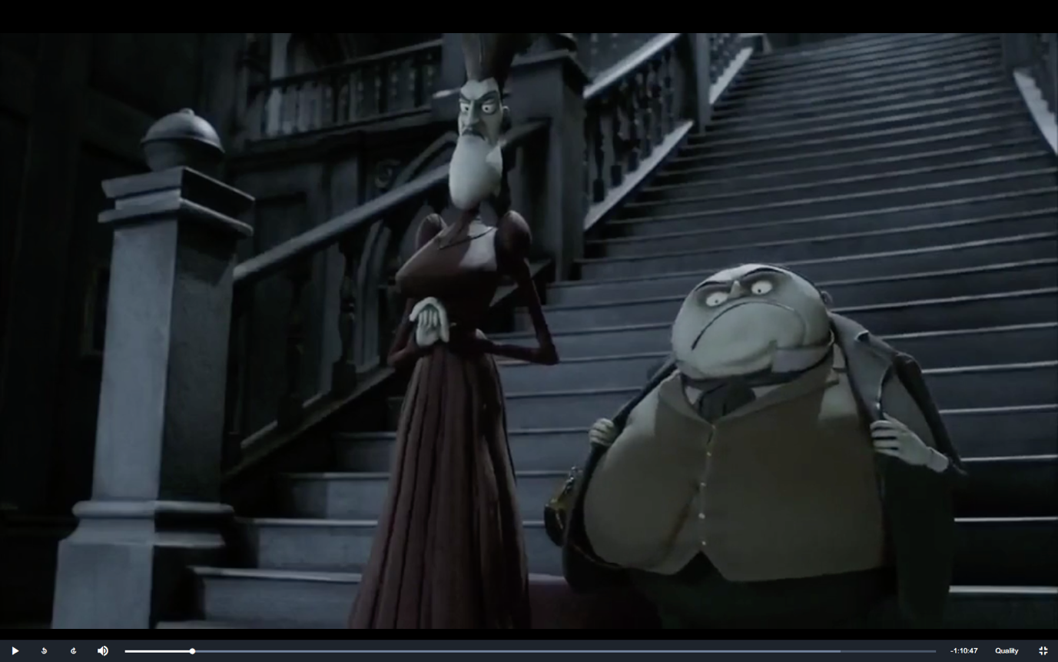
Figure 1: (Corpse Bride, 2005)
Maudeline and Finis Everglot are examples of using body shape to give off personality. Maudeline’s angular body indicates that she has a sharp and cold-hearted personality, and her long face shows she sees herself as elegant and high in society. Her height is also an indication of this; she towers over Finis, implying that she has more power than him in their relationship and she thinks she deserves to keep her status.
The height of her hair makes her seem taller than she is, giving the illusion that she’s not as high in society as the audience is led to believe. She also looks after her hair, showing off her pride.
Finis, on the other hand, looks very different from Maudeline as he’s short and round. The drastic difference between their appearances represents the conflicts in their relationship, as they have admitted to not liking each other at all. His shortness is also an indication of his short temper, which is shown in the film when Victor runs away and Finis threatens to kill him.
Maudeline and Finis never smile throughout the film. This is to show that they don’t like to show emotion often. This is because the audience is meant to think that the Everglots are the main antagonists of the film right from the start. Ed Hooks defines a villain as a normal person who has a massive flaw (Hooks, 2011). The Everglot’s massive flaw is that they are run by money, therefore misleading the audience into thinking they are the main antagonists.
However, their frowns could be that they find emotion a sign of weakness and lower class and therefore don’t show it. The only times they show emotion throughout the film are when they are vulnerable. They also try to show emotion when meeting the Van Dort’s. This could be because they are looking down on them and trying to lower themselves to their level to seem more appealing to the Van Dort’s.
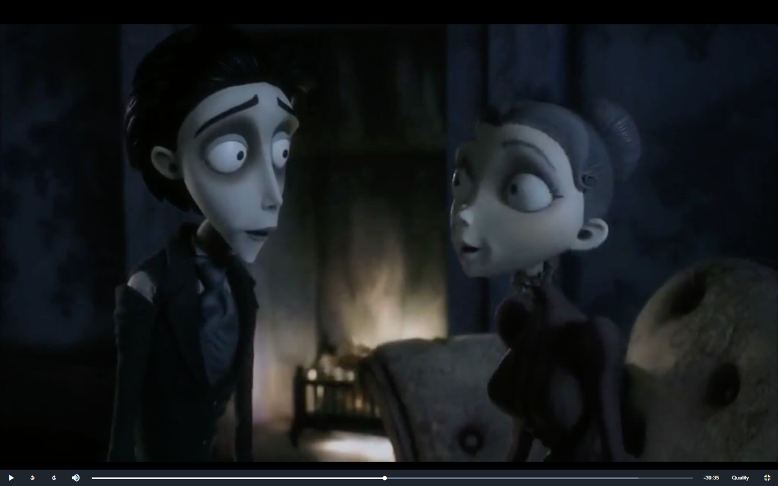
Figure 2: (Corpse Bride, 2005)
Victor and Victoria are two of the main characters in the film. They are meant to be the gender counterparts of each other as they look and act similar. Hayo Miyazaki, the creator of Spirited Away, once said:
“if you’ve got a girl, you’ve got a boy; if there’s a boy, there’s a girl. That’s what makes the world.” Hayo Miyazaki (2008, p. 223).
This means that in a film, having a boy and a girl similar to each other creates balance in the film, therefore it’s needed to make the film decent. It is also to appeal to both boys and girls, creating a bigger audience.
During the film, their appearance becomes more rugged. This is to show that they stop caring about how society views them and therefore don’t need to look presentable. It also represents that they both become stressed easily as they both start to look this way when they encounter Emily, the Corpse Bride. This could also mean that they are starting to become associated with the Land of the Dead as the dead characters’ outfits are also ripped and rotted.
According to Ed Hooks, a hero is defined as a normal person who has to overcome a big obstacle in order to get what they want (Hooks, 2001). Victor’s goal is to marry Victoria, but he has to get out of the Land of the Dead to do this. This is to show Victor is the hero of the film.
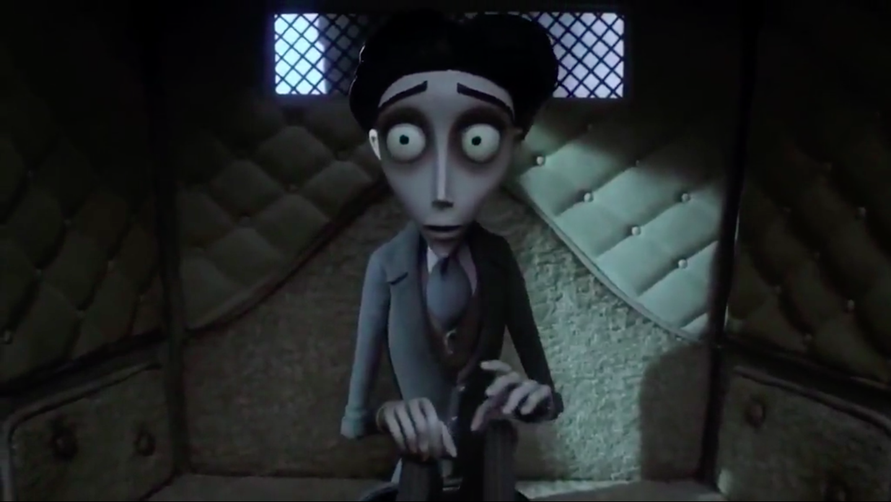
Figure 3: (Corpse Bride, 2005)
Victor’s face always looks worried and confused. This indicates that he is an anxious person and he’s not sure how to solve situations a lot of the time. The dark circles around his eyes are also a good indication of this as they are linked to anxiety, depression and tiredness. This is proven when he keeps getting the wedding vows wrong.
The characters from the Land of the Living have a grey hue to them, like the environment. This is to show that they all blend in together, so they’re all the same. Grey is also linked to boredom, decay and age, to show that being alive isn’t as thrilling as humans are lead to believe. Greys and blacks also symbolise death and mourning (Cherry, 2018), which shows they are mourning the people in the Land of the Dead.
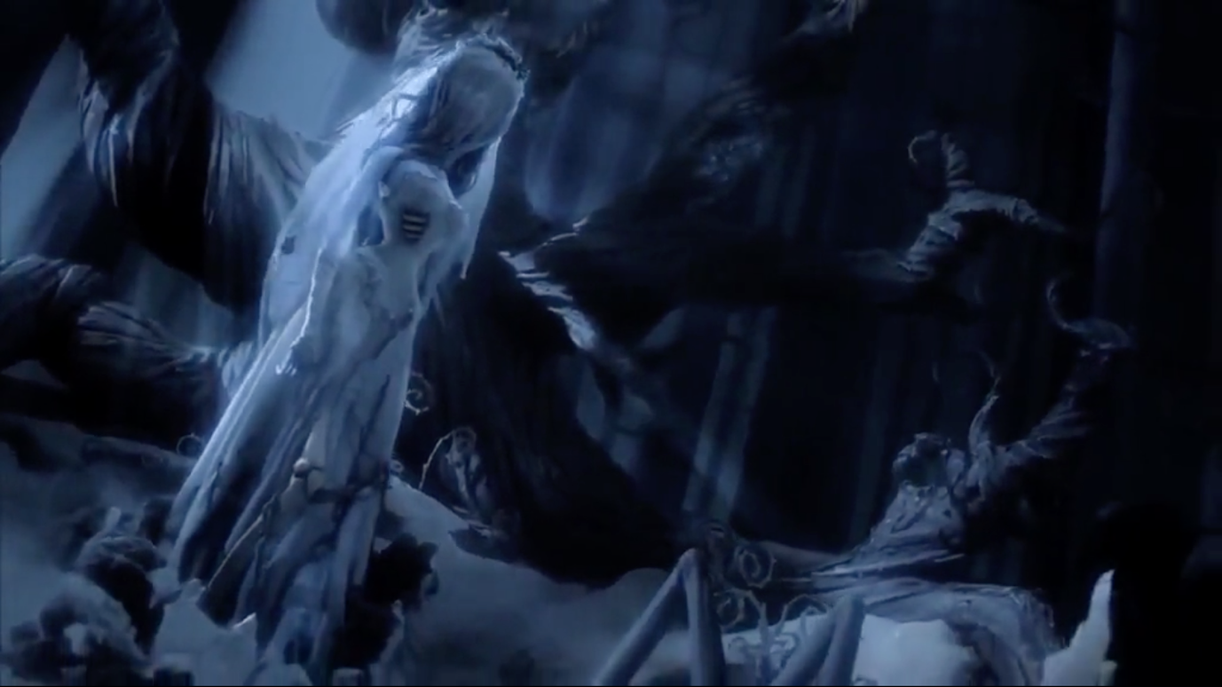
Figure 4: (Corpse Bride, 2005)
Emily is also a main character in the film. She is a good example of how colour is used to portray emotion and hidden meaning, as she has strong colours in her design. According to Kendra Cherry (2018), blue is a favourite colour for many people. This makes people like the look of Emily and they’re more likely to empathise with her. Blue also symbolises sadness, which is associated with Emily because of her past.
Her wedding dress is white, which is linked to innocence, showing that Emily’s innocence is what causes her death in the first place. The fact that her dress is ripped and rotted shows that she is hung up on the past and her innocence being destroyed.
Emily is designed to stand out from the Land of the Dead characters as she has aspects of corpses and skeletons from the Land of the Dead. This is to show that she is lonely, which is why she’s desperate to stay with Victor as she doesn’t want to be lonely anymore. Her loneliness is shown further through her white dress, as white also symbolises isolation (Cherry, 2018).

2.3 Emotion and Hidden Meaning in a Scene
A good scene to look at in Corpse Bride for emotion would be the piano duet scene. The scene starts with Emily playing the piano by herself in the bar, then Victor comes in to try and apologise to Emily for tricking her and trying to leave her for Victoria.
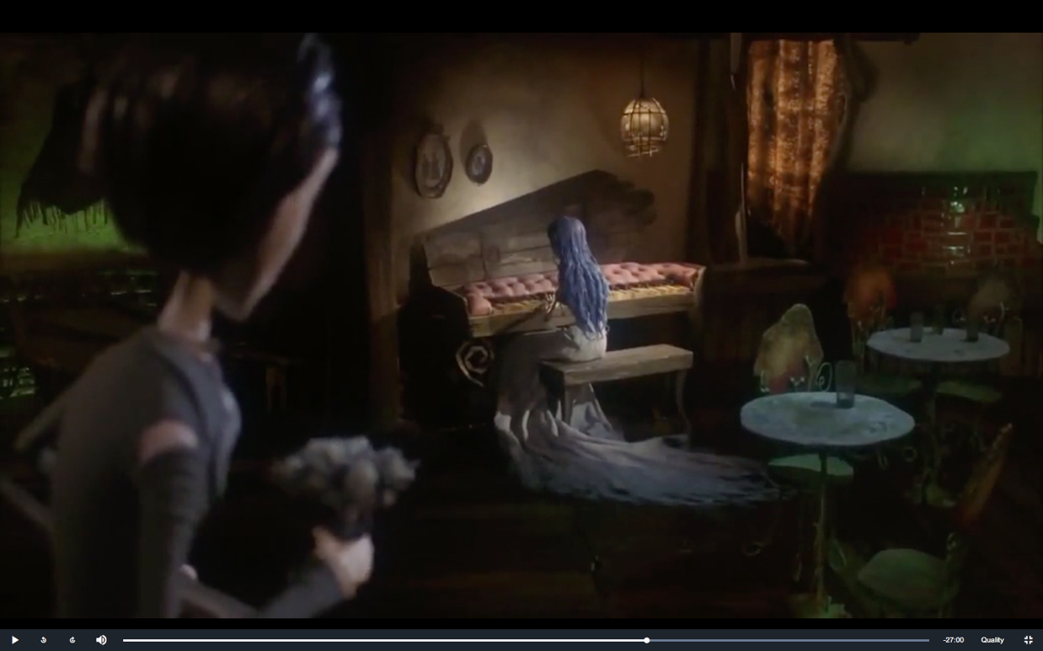
Figure 5: (Corpse Bride, 2005)
Emily being by herself shows that what happened to her makes her feel lonely. Before she died, she was happy because she thought she was going to spend the rest of her life with the man she loved, however when she died she realised that she was all by herself forever.
This scene is good for looking at emotion because of the piano duet that Victor and Emily play together. Barely any words are spoken throughout the entire scene, however the audience knows exactly what’s happening between the two characters by the pace and tune of the music. The music starts with Emily playing a sad tune without Victor there. This is to show that she’s sad about the fact that she is no longer alive and that’s what’s keeping her from being with Victor. When Victor appears, and starts talking to her, she switches to lower pitches. This is to show that she is still angry at Victor for tricking her, and that just talking to her without any meaning in his voice isn’t going to solve the issue. When Victor realises this, he starts playing the piano too. However, he starts playing similar tunes to Emily. This is Victor’s way to try and cheer her up and that he is truly sorry for what he did. However, Emily sees that as Victor mocking her, therefore she gets even more angry at him. This back and forth exchange sounds like an actual argument, ending with Emily having the last say as she finishes her part of the song and doesn’t want to play anymore.
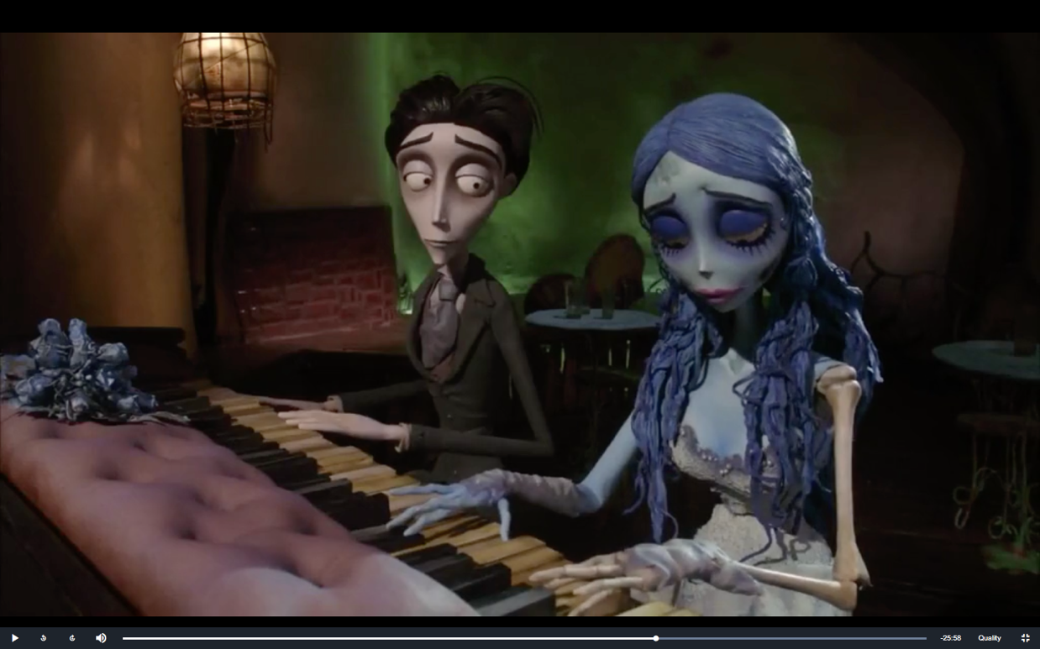
Figure 6: (Corpse Bride, 2005)
Victor changes his tune once he realises that his original plan wasn’t working and to show that Emily is right about it being wrong to leave her. He plays a version of the tune he plays near the start of the film when he is still in the Land of the Living. However, this version has a different feel to the original. The original is much slower and doesn’t have much emotion in it, however this version is faster and up-beat and has a lot more emotion put into it. This is to show that he does care about Emily and it’s to show that he feels more alive than he did before. This is a form of dramatic irony because he’s technically considered dead at this point in the film.
Victor tones it down to invite Emily to join in with him, which she does. This shows that she has forgiven him, which the audience knows even though Emily has not spoken a word to Victor.

Chapter 3-Inside Out
3.1 Film Description
This film is a CGI film based around a girl called Riley who must move away with her parents to San Francisco. With the help of her emotions, Joy, Fear, Anger, Disgust and Sadness, she must learn to live with this new life in a different place, however it is not an easy task. They try to work together to help Riley navigate a new city, however her emotions can’t decide on what to do, therefore causing conflict in Riley’s head (IMDb, 2018).

3.2 Character Designs
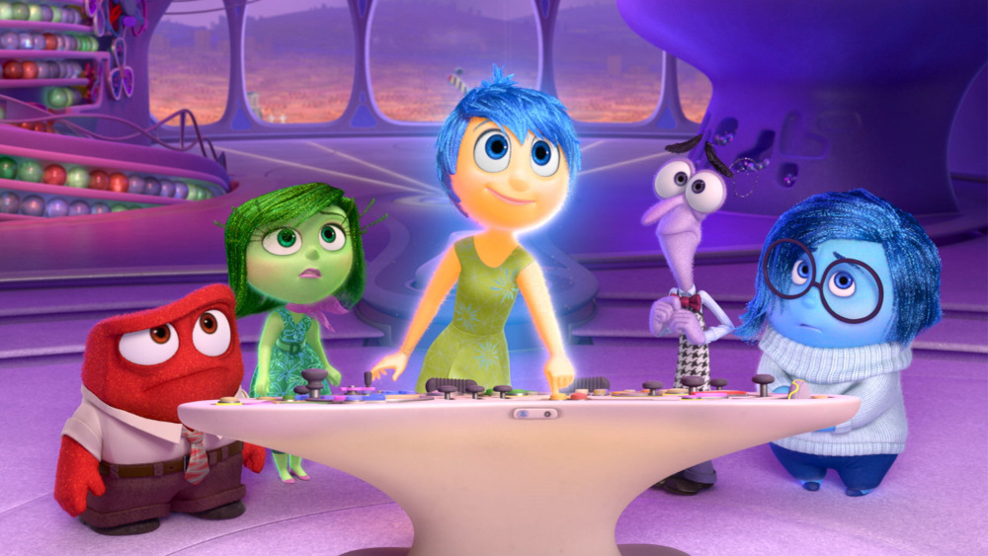
Figure 7: (Inside Out, 2015)
Inside Out is a good example of using colours to express the emotion that is being shown in films. According to Judith H. Langlois (2004, p. 315), understanding emotion is very important to a child’s development, which Inside Out had been praised for. Each character has a dominant colour that gives off the emotion that they are meant to be, so children who are watching the film can easily associate the colour with the emotion. However, it’s not just their colours that give off their personalities; it’s also their body shape and facial expressions.
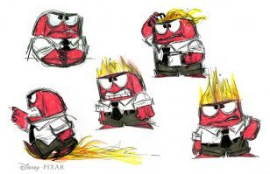
Figure 8: (Pixar, 2014)
Anger’s colour is red, which is associated with strong emotions, as stated by Kendra Cherry (2018). His appearance is a good indication of anger. Like Finis from Corpse Bride, his height shows off his short temper, and his attire shows his need to take control, which is a common way to process anger. His height is also an indication of his authority in Riley’s head, as he isn’t the dominant emotion. Another way to represent Anger’s temper is his flames which appear when he gets very angry. This is a visual representation of how anger can be dangerous. His body and face is quite boxy, which makes him seem like a brick. It could show that he’s quite stubborn, like the phrase commonly used, “talking to a brick wall”.
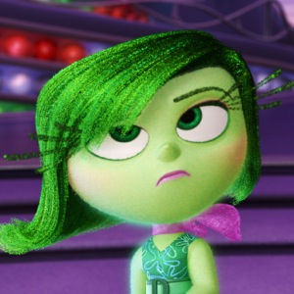
Figure 9: (Inside Out, 2015)
Disgust’s main colour is green. Although Kendra Cherry (2018) stated that green is a mostly positive colour, John Hutchings claims that green can also be negative, giving the example of green mould as to why it could link with disgust (Hutchings, 1997).
She also has a bit of pink in her character design, which could enhance the femininity of Disgust. Studies have shown that women have a bigger response to disgust than men (Sonja Rohrmann, 2008), therefore Disgust being female would give an accurate representation of Riley’s emotion.
She likes to look fashionable, which is similar to the popular girl stereotype. Her eyelashes make the audience think of long spider legs and her dress patterns look like weeds, which may be seen as disgusting or untidy, however, she makes it seem fashionable and stylish. The point of her character is to make disgusting things look pleasant and stylish.
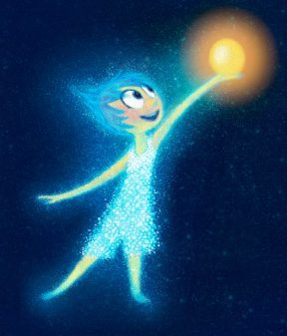
Figure 10: (Pixar, 2014)
Joy is the only emotion to have three main colours which all link to her personality. Her three colours are green, blue and yellow. Her main colour, yellow, is mainly used for happiness and it is used to get children to trust her. Blue is a peaceful and calming colour, which works well in combination with Joy’s other colours. Green, her final colour, is to give balance between the contrasting colours of blue and yellow. It’s also used to show positivity (Cherry, 2018). All these colours show she has a strong personality, which can sometimes conflict with others.
Joy’s fairy-like design and round features can make children instantly trust her. She is Riley’s dominant emotion and is meant to solve Riley’s issues. Being the tallest emotion further projects her dominance over the others. Her obsession over control shows children a simplified outlook on mental health problems, and shows how Joy is Riley copes with these issues.
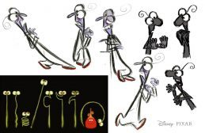
Figure 11: (Pixar, 2014)
Fear’s dominant colour is purple, which is linked to mystery and the unknown (Cherry, 2018). Both his personality and his physical appearance show uncertainty as a main characteristic for fear.
With his body looking like a bug, this may reference Entomophobia, also known as insectophobia. The fear of insects is one of the most common child phobias (University of Rochester Medical Center, 2018), making his bug-like appearance an effective representation of fear. His thin body and mannerisms, such as trembling and shaking, show fragility and weakness, with trembling and shaking being common symptoms for anxiety.
He has typical caricature-like features such as big eyes and dark circles. Both are exaggerated characteristics of being afraid and the way he dresses and acts hints to social anxiety.
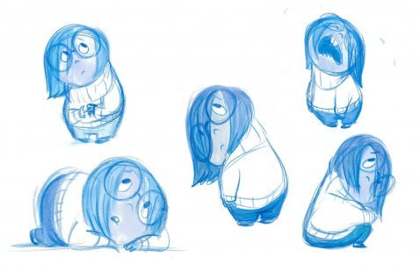
Figure 12: (Pixar, 2014)
Sadness is the last main emotion for Riley. Even though blue can be positive, like in Joy’s case, it is also used for sadness. This can be because of the phrase “feeling blue”, and because it’s associated with water and tears. Referring back to Kendra Cherry (2018), she claims blue relates to loneliness. With Sadness also wearing white, this highlights the loneliness and isolation that sadness can bring.
Her body shape is round and fluid, resembling a teardrop, which makes the audience think of sadness and feel sorry for her. She also wears comforting clothing such as a thick jumper. She wishes to feel comfortable and safe, so she dresses this way. This is a common way people use their clothes to feel better about themselves (Anderson, 2018). She wears big round glasses, which is a way of covering up securities and hiding herself. Her eyes are a lot smaller than her glasses, therefore making it more obvious that she’s hiding behind them.

3.3 Emotion and Hidden Meaning in a Scene
A good example of an emotional scene is one of the last scenes. In this scene, Riley is trying to run away from home to try and get back to Minnesota, however Sadness stops her and makes her realise that it’s a mistake and heads home. When she gets back home, she’s explaining to her Mom and Dad how she feels about living in a new city.
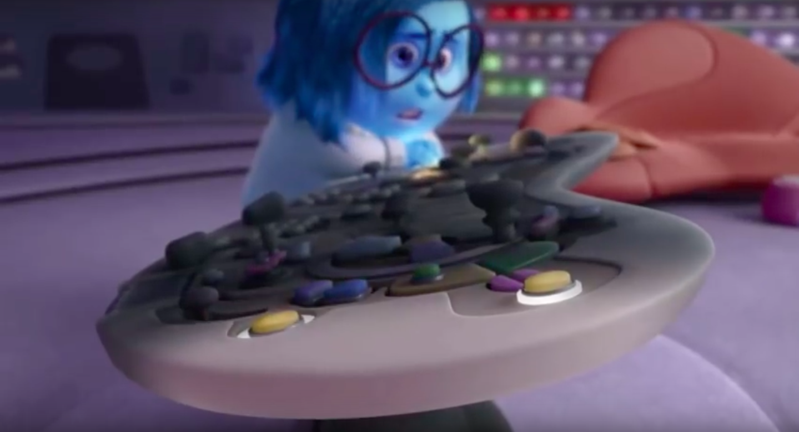
Figure 13: (Inside Out, 2015)
As Sadness is trying to cancel the idea of running away, the control panel is changing to black. This shows that Riley is slowly starting to ignore her emotions. Sadness is the only emotion that can stop Riley because she’s the strongest. This implies that Riley has fallen into Depression.
“Depression causes feelings of sadness and/or a loss of interest in activities once enjoyed.” (American Psychiatric Association, 2018)
This is why Sadness manages to stop Riley from running away, as she is the only emotion that Riley can experience.
When Riley realises that running away isn’t a good idea, her face lights up red from streetlights. Red is a sign of warning and danger. This shows that Riley realises that what she’s doing is dangerous and decides to get off the bus. The audience also sees that her bag is mostly purple with a bit of blue. This hints towards her current emotional state.
Once Riley returns home, she isn’t reacting to her parents and she’s wearing all black. This shows that Riley is led by her emotions and when they aren’t responding or don’t know what to do, neither does Riley. This also links to Riley being depressed, as stated above.
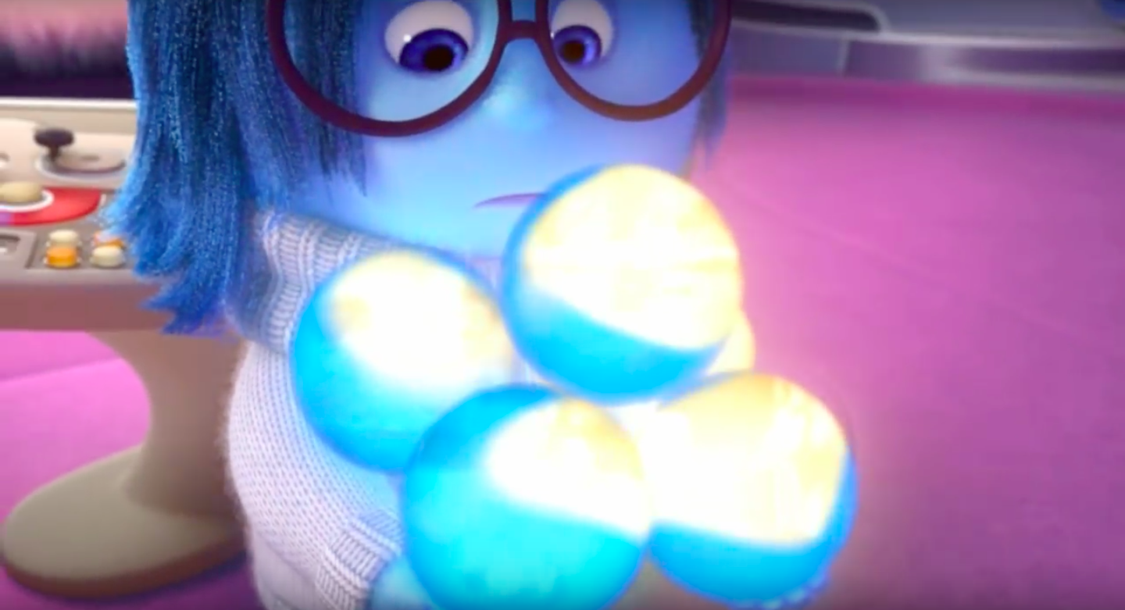
Figure 14: (Inside Out, 2015)
When Joy gives Sadness the core emotions, they all turn blue. Core emotions define Riley’s personality, so having her memories change from joy to sadness temporarily make her personality different. However, despite the memory having a different emotion now, the memory stays the same. This shows that even though she was happy at the time the memory was created, she now looks back on them and feels sad, which means Riley is starting to feel nostalgic about her memories of living in Minnesota.
Riley is starting to get confused about how she’s feeling. She knows that her memories of home are happy but she’s feeling sad when she thinks of them. This is because at this point, she thinks she can only have one emotion at a time.
For example, Riley’s Mom is wearing both red and purple, which shows how she’s both angry and afraid. However, the first colour Riley sees is red, so she assumes that her Mom is only angry.
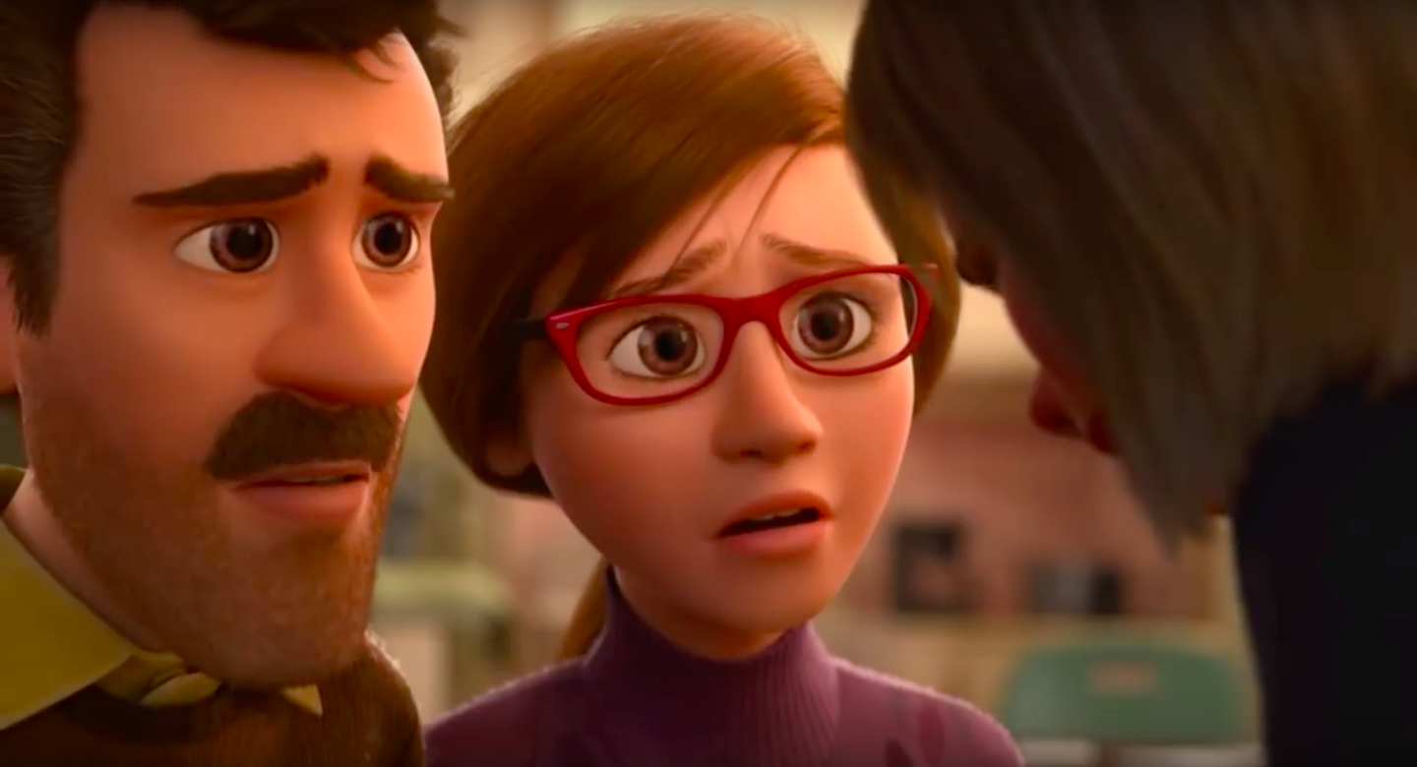
Figure 15: (Inside Out, 2015)
This scene becomes one of Riley’s core memories, however it’s both a happy and sad core memory. This shows that Riley now understands that emotions are more complex and that she can feel several emotions at a time and create a new emotion altogether. For example, experiencing anger and disgust at the same time can become hatred.

Chapter 4: Spirited Away
4.1 Film Description
This traditional style Japanese animation is based around a girl called Chihiro; a ten year old girl who had just moved away from her home with her parents to a small Japanese village in the countryside. However, they take a wrong turn towards the house and Chihiro finds herself in a world ruled by Gods, witches and spirits. She had until the morning to save her parents from being turned into pigs permanently or her and her family are stuck in this world forever (IMDb, 2018).

4.2 Character Designs
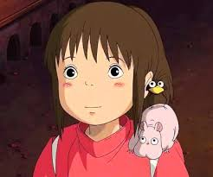
Figure 16: (Spirited Away, 2001)
Chihiro is the main character of Spirited Away. One of the main things about her that the audience notices is that she looks generic compared to a lot of the other characters. This was intentional, as the director of Spirited Away, Hayo Miyazaki, has stated that:
"[He] created a heroine who is an ordinary girl, someone with whom the audience can sympathise. It's not a story in which the characters grow up, but a story in which they draw on something already inside them, brought out by the particular circumstances. [He] wants [his] young friends to live like that, and [he] thinks they, too, have such a wish." (Hayo Miyazaki, 2001).
According to George Pitcher (1965, p.326) emotions are usually directed towards something or someone, therefore this makes children direct their emotions onto Chihiro, who is purposefully generic looking. This makes children support her throughout the film which therefore makes children like her as a character.
It is common in Anime that the character’s name can reveal something about the character. With Chihiro, this is no different. The name Chihiro in Japanese means “a thousand fathoms”. The Cambridge Dictionary states that fathom means:
“A unit for measuring the depth of water, equal to 1.8 metres or 6 feet” (Cambridge Dictionary, 2018).
This could be a subtle reference to Chihiro’s backstory. Later in the film, the audience realises that she fell in a river when she was younger and nearly drowned. This could be foreshadowing, which is defined as a warning to the characters or hint at future events (Cambridge Dictionary, 2018). This is a key point to her character as she meets the boy who saved her, Haku, which helps her get back to her parents in the end of the film.
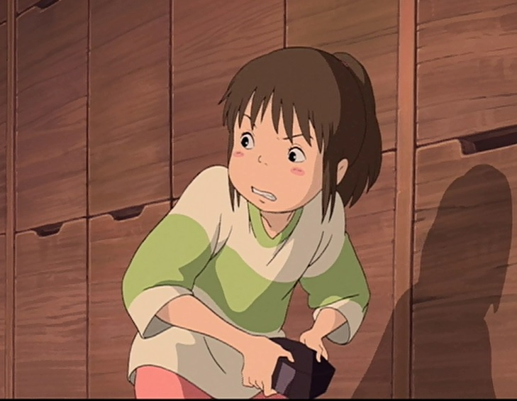
Figure 17: (Spirited Away, 2001)
Chihiro’s original outfit had more white. However, when she starts working at the bath house run by Yubaba, her outfit was more red and the white was taken away. As stated in the introduction, white can represent innocence and purity (Cherry, 2018). This shows that when she was forced to work, her innocence from being a child is taken away from her and she is forced to grow up. However, in her bath house work uniform, she still has a bit of white behind her back. This shows that she is trying to make herself seem grown up and that she’s hiding the little bit of childhood innocence she has left. When asked about showing Chihiro working in the film, Miyazaki has stated that:
“I got the idea from a documentary I saw on the NHK TV channel, about child labour in Peru. I thought that, if I were to make a film for the sake of all children on Earth, it would have to be something that any child could understand, no matter what sort of life they were living.” Hayo Miyazaki (2008, p.221).
This shows that he was trying to get as many children as possible to understand and sympathise with Chihiro, which also links to how children being forced to work can be seen has having their childhood taken away from them.
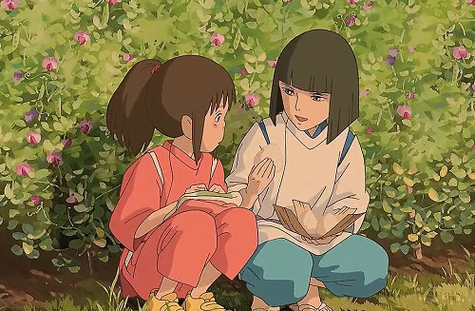
Figure 18: (Spirited Away, 2001)
Chihiro wears yellow shoes throughout the entire film, even when she is forced to work at the bath house. This is to show that she’s clinging onto the last bit of humanity she has left. The fact that they are yellow also shows happiness, as stated earlier when discussing Joy from Inside Out (Cherry, 2018). This is another way of showing that she still has the innocence of a child. All of this further shows that the message behind this film is that a lot of children are forced to grow up quickly depending on the situation and it shows how difficult it is for children to do this.
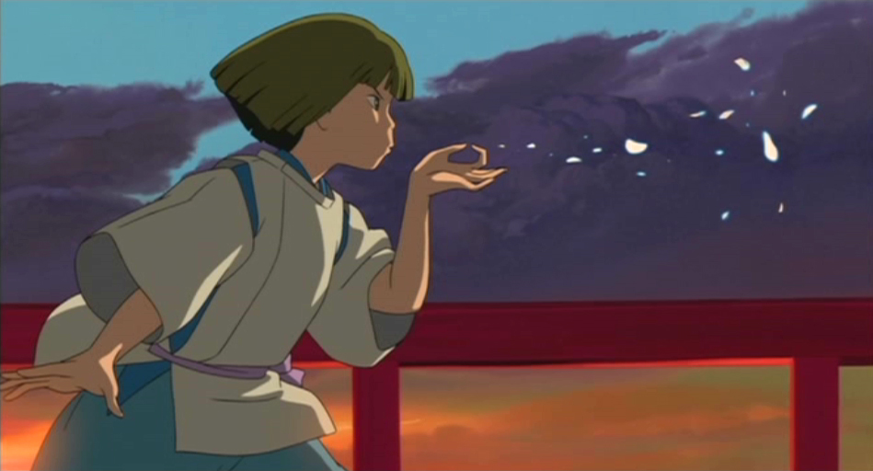
Figure 19: (Spirited Away, 2001)
Haku is the deuteragonist of the film. This means that he is the second main character after Chihiro, and it also means the audience doesn’t know what side he is on: the protagonist’s or the antagonist’s side. This is important to his character as this causes conflicts for Chihiro later on in the film when she doesn’t know who to turn to for help. Haku’s name also has hidden meaning, like Chihiro. His full name is Nigihayami Kohaku Nushi, which means ‘God of the swift amber river’. The audience doesn’t know this is his full name at the start of the film, but this name is to represent that he is not human, but the water spirit of the river that Chihiro fell into when she was younger.
His nickname throughout the film is Haku, which means white. This links back to innocence, and this helps Chihiro trust him at the start of the film as he claims to have the innocence of a child, like Chihiro. Also, he is the only other normal looking person in this spirit world, which makes Chihiro trust him more because he looks human.
His main colours are white and blue. The blue could be a representation of how he’s a water spirit. However, this could also to be linked back to what Hayo Miyazaki said about creating balance in the film, implying that Haku was made just as the opposite of Chihiro, so they added pinkish-red tones to Chihiro for femininity and blue tones to Haku for masculinity.

4.3 Emotion and Hidden Meaning in a Scene
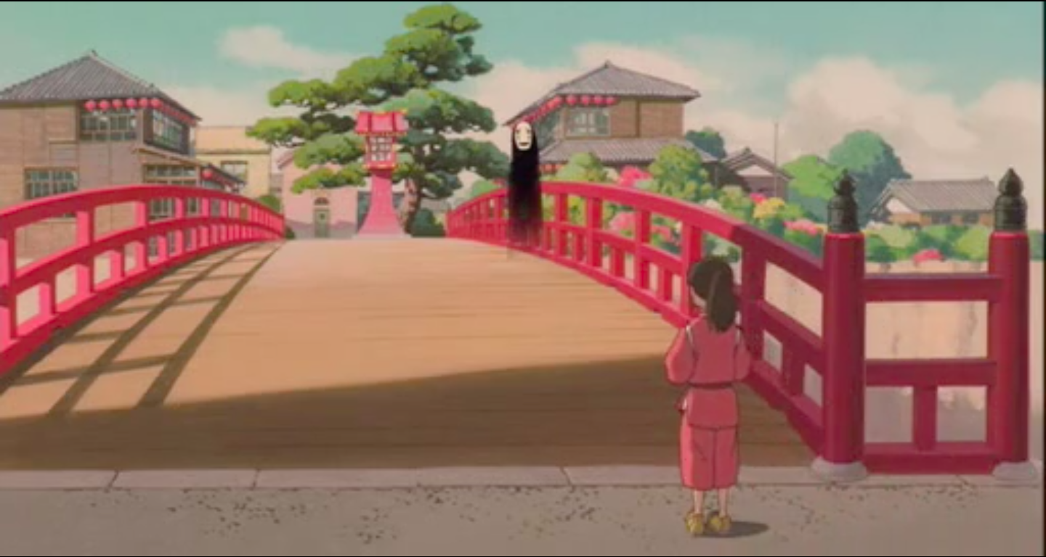
Figure 20: (Spirited Away, 2001)
In this scene, Haku takes Chihiro to her parents and helps her remember her name and human life. Before she meets up with Haku, she comes across No Face; a mysterious spirit standing on a red bridge. As stated in chapter three part three, the colour red can be used to give a warning to the character, and No Face standing on that red bridge is to warn Chihiro that she shouldn’t go and meet Haku as it could be dangerous. This is further shown when Chihiro gets to the slaughter house and the roof is red as well. However, Chihiro ignores No Face because she’s uncomfortable to be near him.
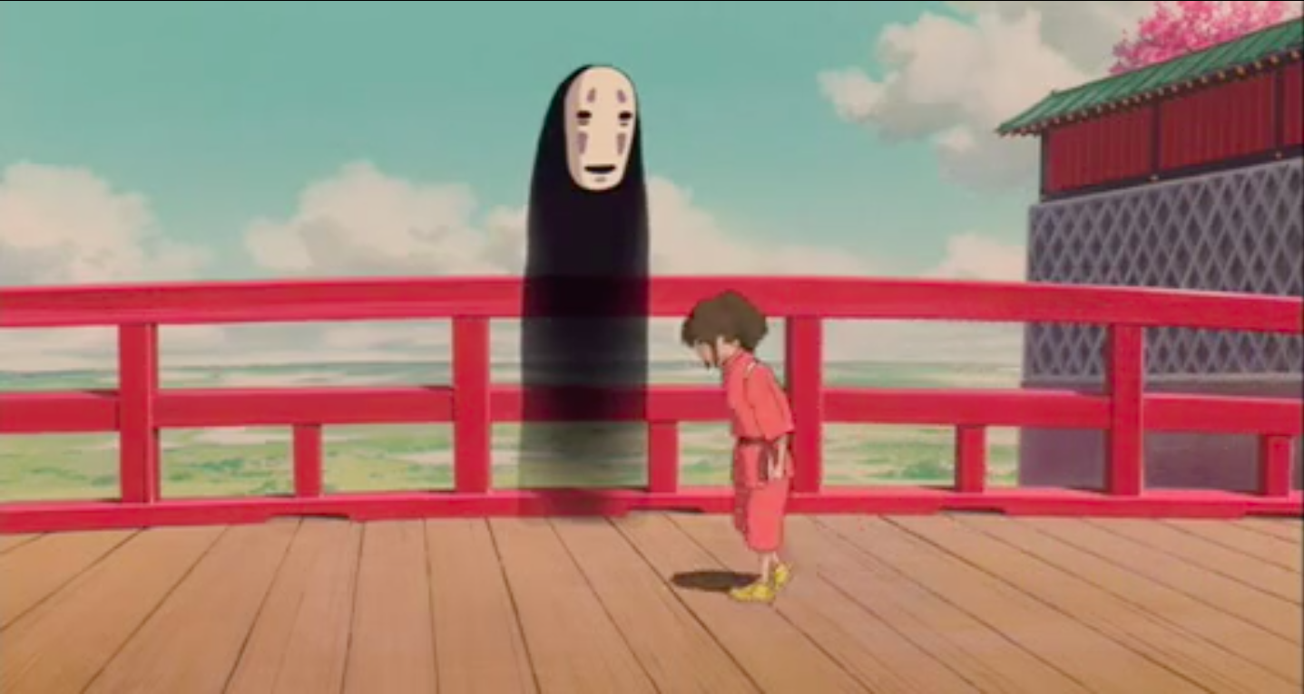
Figure 21: (Spirited Away, 2001)
However, this could also be viewed as Chihiro ignoring his warning. This is a common theme in Studio Ghibli films as the child is usually the main protagonist of the film as children are more likely to face danger because they don’t know how to recognise a threat (Blanc, 2015, p. 26).
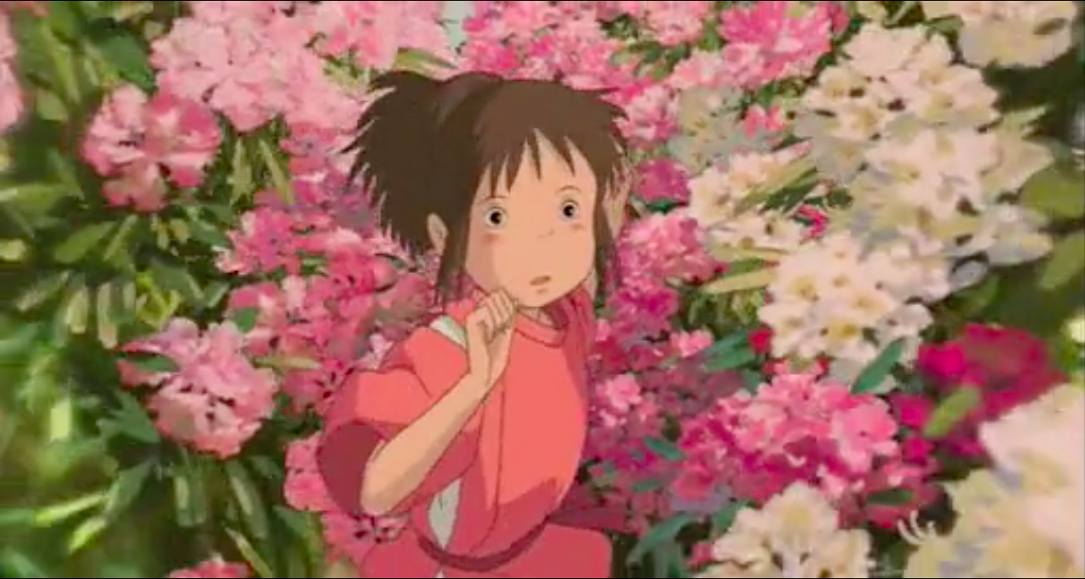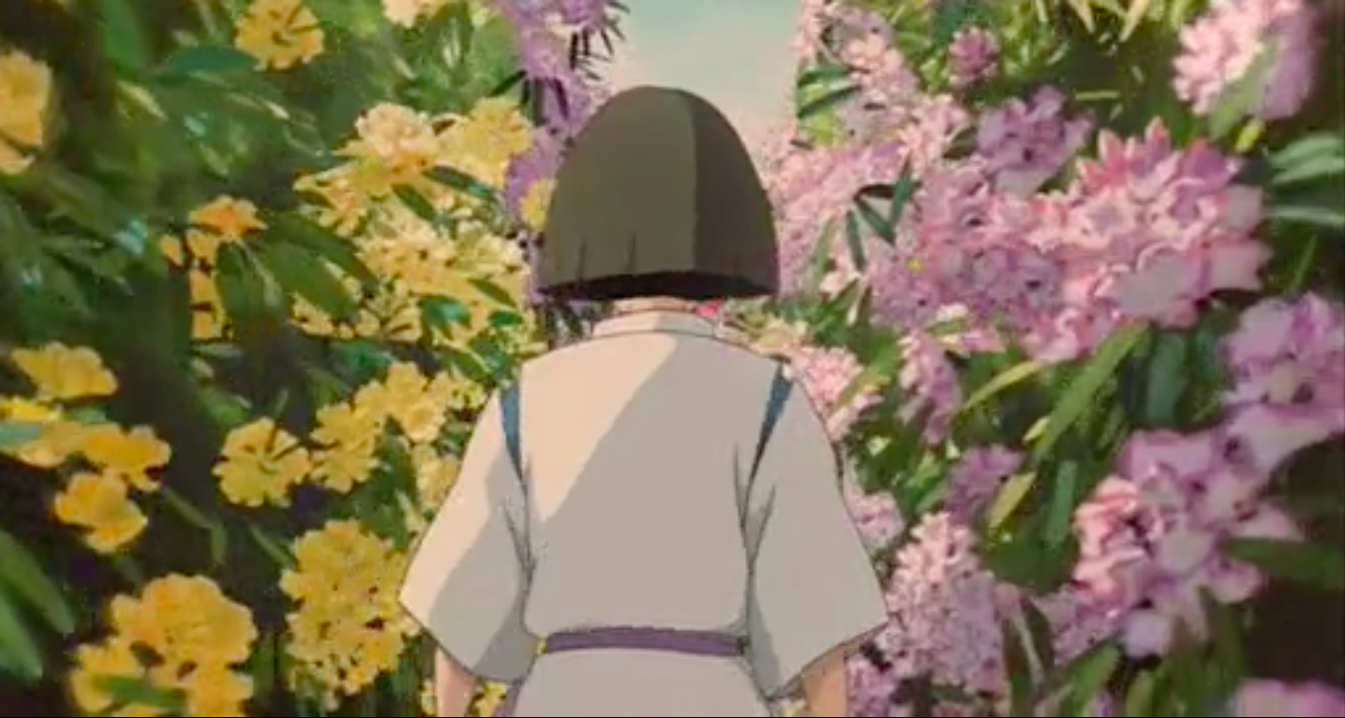
Figure 22 and 23: (Spirited Away, 2001)
The colour of the flowers shown in these shots indicate the emotions Chihiro is feeling. Because she isn’t sure what’s going on or what she’s going to find, her emotions are mixed and confused.
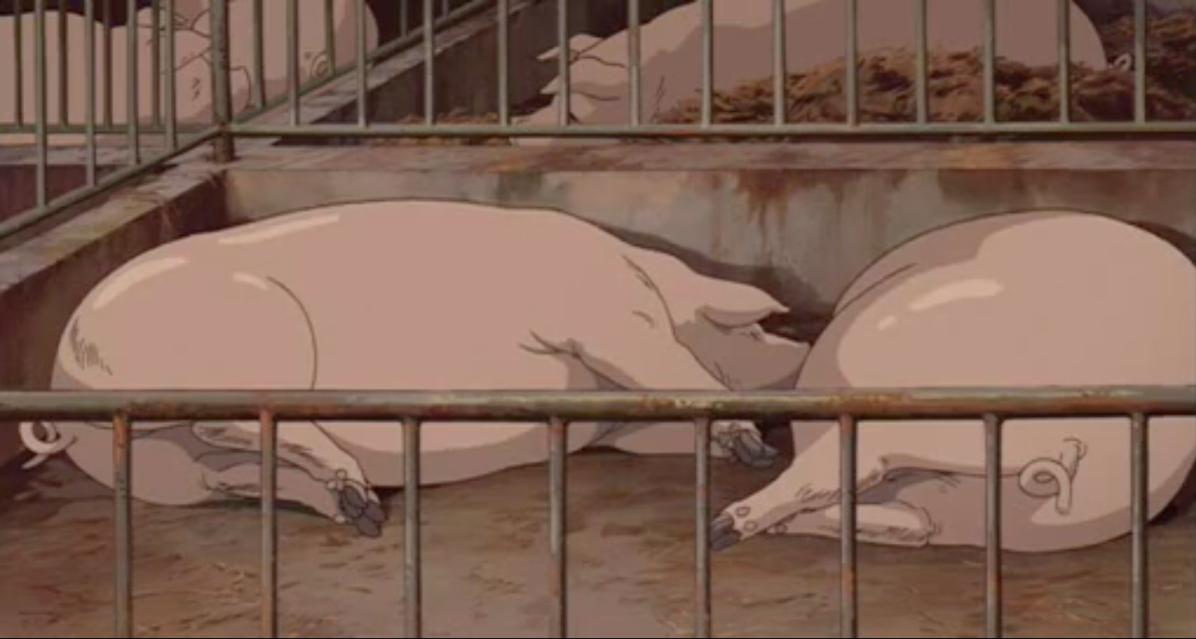
Figure 24: (Spirited Away, 2001)
Her parents being turned into pigs represents how they were when they were human.
“Chihiro’s greedy parents virtually ignore their daughter; they are self-centred and individualistic,” Blanc (2015, p. 114).
They ended up in this position because they didn’t listen to Chihiro when she said to go back to the car, and they ended up eating so much they turned into pigs. Even when they are pigs, they don’t listen to Chihiro screaming for their attention, which further shows that they ignore her.
Haku gives Chihiro back her clothes, which has a notecard with her name on it. At this point, Chihiro’s name has been taken and she’s now called Sen, and she couldn’t remember her name. Haku giving her clothes back represents that he’s giving back her humanity and her memories. This gives her the strength to help her escape with her parents.
Up until this point, the audience don’t know why Haku is helping Chihiro. However, the audience discover that Haku thinks it’s important that he remembers Chihiro’s name, even mentioning that he can’t remember his own name but he can remember hers. This is obviously important to him, and this could be because he’s gone through the same thing when he first arrived in this world, but he didn’t have the help to escape. He doesn’t want Chihiro to go through the same thing he did. However, this is speculation as it’s never confirmed throughout the film, so it’s up to the audience’s interpretation.
Haku gives Chihiro a rice ball to give her back her strength. The more she eats the rice ball, the more she cries. This is to represent that Chihiro is starting to realise that she’s going to have to grow up and face her fears, as she’s in this situation alone. As stated by Colin Odell and Nichelle Le Blanc (2015, p. 26), children are used to see an adult’s problem or issue through younger eyes.

Chapter 5: Comparison of Three Films
All three pieces use a different animation style to tell their story. Inside Out uses CGI, which is why the colours throughout the film are so vibrant. However, Corpse Bride uses stop motion, using puppets made out of clay for the characters. This is why it can be difficult to have vivid colours in the film without editing, however they use this to their advantage as they make some scenes purposefully dull and flat to give off the feeling of boredom and mourning. Spirited Away uses traditional techniques, drawing each frame out by hand. Bright and vivid colours are difficult to achieve when drawing by hand, but the softer colours used are easier on the eyes, and therefore the audience can focus on the storyline, making children focus on Chihiro and empathising with her.
Each film is a different genre; Corpse Bride is Thriller, Inside Out is Comedy-Drama, and Spirited Away is Fantasy and Adventure. Due to the different genres, the films must approach the visuals in a way that matches the style of that genre. For example, because Corpse Bride is a Thriller, all the characters and settings have an unsettling feeling to them. Also, the script includes dark humour to balance the darkness and comedy in the film. The other two films must take a more light-hearted approach, with Inside Out having the most positive visuals of the three.
They are all made by separate companies. Corpse Bride is Warner Brothers, however it is directed by Tim Burton, who arguably has one of the most established styles in animation. Inside Out is done by Pixar, and Spirited Away is by Studio Ghibli. These two companies have had a distinguished style since each company was founded. This means that each company had to develop the way they portray emotion to fit their animation style, making each method different from one another.
The protagonist of Spirited Away and Inside Out are children. This makes them view the events of the film from a childish perspective and they deal with these events in a childish way. However, Corpse Bride has an adult as the protagonist. Corpse Bride deals with mature issues, such as marriage, and Victor tries to solve these issues in a mature manner. This means the message of the film wouldn’t be carried across to the audience if the protagonist was a child. The opposite would also be true for the other films, as Inside Out deals with emotions changing as you grow up, and Spirited Away deals with children being forced to grow up too quickly. The messages would be lost if adults were the protagonist.

Conclusion
Although these films have several differences, they also have similarities. They use colour differently to fit their unique animation style and to give off contrasting atmospheres, however they all use basic colour theory to give off certain emotions. For example, in both Corpse Bride and Inside Out, they use the colours black and grey to symbolise depression and mourning. Each film has also shown foreshadowing at some point in the film. For example, in the opening scene in Corpse Bride, Victor releases a blue butterfly into the world. This represents Emily and how she will be set free by Victor at the end of the film. These similarities mean that there are several universal methods and ideas on how to portray emotion and hidden meaning. I find films more enjoyable the second time I watch them, as I usually notice hidden meanings that I didn’t notice the first time. This makes these films more enjoyable to me now because the characters and scenes I analysed give a whole new meaning to them.

Bibliography

Books
Hooks, E. (2011) Acting for Animators 3rd Ed. New York: Routledge.
Miyazaki, H. (2004) Turning Point 1997-2008. 1st Ed. San Francisco: Iwanami Shoten, Producers.
Odell, C. and Le Blanc, M. (2015) Studio Ghibli: The Films of Hayo Miyazaki and Isao Takahata 2nd Ed. Croydon: Kamera Books.

Journal
Hutchings, J. (1997) ‘Folklore’ Folklore and Symbolism of Green, 108, pp. 55-63. https://www-jstor-org.ezproxy.uwtsd.ac.uk/stable/1260708 [Accessed 30th November 2018].
Langlois, J. H. (2004) ‘Child Development’ Emotion and Emotion Regulation: From Another Perspective 75(2), pp. 315-346..
Pitcher, G. (1965) ‘Mind” Emotion 74(295), pp. 326-346.
Rohrmann, S., Hopp, H., Quirin, M. (2008) ‘Journal of Psychophysiology’ Gender Differences in Physiological Responses to Disgust, 22, pp. 65-75.

Internet
American Psychiatric Association, (2018) What Is Depression? [online] Available at: https://www.psychiatry.org/patients-families/depression/what-is-depression (Accessed: 2nd December 2018).
Anderson, C. H., (2018) 10 Unexpected Ways Your Clothes Can Change Your Mind [online] Available at: https://www.rd.com/advice/work-career/clothes-affect-mood/ (Accessed 2nd December 2018).
Cambridge Dictionary (2018) Definition of Fathom [online] Available at: https://dictionary.cambridge.org/dictionary/english/fathom#dataset-cald4 (Accessed 27th November 2018).
Cambridge Dictionary (2018) Definition of Foreshadow [online] Available at: https://dictionary.cambridge.org/dictionary/english/foreshadow (Accessed 6th December 2018).
Cao, J., 2018. 12 Colours and the Emotions They Envoke. [Online]
Available at: https://www.creativebloq.com/web-design/12-colours-and-emotions-they-evoke-61515112/2
[Accessed 7th December 2018].
Cherry, K. (2018) Colour Psychology of Pink [online] Available at: https://www.verywellmind.com/the-color-psychology-of-pink-2795819 (Accessed 30th November 2018).
Cherry, K. (2018) Colour Psychology of Purple [online] Available at: https://www.verywellmind.com/the-color-psychology-of-purple-2795820 (Accessed 30th November 2018).
Cherry, K. (2018) Colour Psychology of Yellow [online] Available at: https://www.verywellmind.com/the-color-psychology-of-yellow-2795823 (Accessed 30th November 2018).
Cherry, K. (2018) Colour Psychology: Does It Affect How You Feel? [online] Available at: https://www.verywellmind.com/color-psychology-2795824 (Accessed 30th November 2018).
Cherry, K. (2018) The Colour Psychology of Black [online] Available at: https://www.verywellmind.com/the-color-psychology-of-black-2795814 (Accessed 30th November 2018).
Cherry, K. (2018) The Colour Psychology of Blue [online] Available at: https://www.verywellmind.com/the-color-psychology-of-blue-2795815 (Accessed 30th November 2018).
Cherry, K. (2018) The Colour Psychology of Green [online] Available at: https://www.verywellmind.com/color-psychology-green-2795817 (Accessed 30th November 2018).
Cherry, K. (2018) The Colour Psychology of Red [online] Available at: https://www.verywellmind.com/the-color-psychology-of-red-2795821 (Accessed 30th November 2018).
Cherry, K. (2018) The Colour Psychology of White [online] Available at: https://www.verywellmind.com/color-psychology-white-2795822 (Accessed 30th November 2018).
IMDb (2018) Corpse Bride (2005) [online] Available at: https://www.imdb.com/title/tt0121164/ (Accessed 17th October 2018).
IMDb (2018) Inside Out (2015) [online] Available at: https://www.imdb.com/title/tt2096673/ (Accessed 9th November 2018).
IMDb, (2018) Spirited Away (2001) [online] Available at: https://www.imdb.com/title/tt0245429/ (Accessed 27th November 2018).
University of Rochester Medical Center, (2018) Phobias in Children [online] Available at: https://www.urmc.rochester.edu/encyclopedia/content.aspx?contenttypeid=90&contentid=P01639 (Accessed 2nd December 2018).

Films
Corpse Bride (2005) Directed by Mike Johnson and Tim Burton [DVD]. United Kingdom and United States: Warner Bros. Pictures.
Inside Out (2015) Directed by Pete Docter [DVD]. United States: Walt Disney Pictures and Pixar Animation Studios.
Spirited Away (2001) Directed by Hayo Miyazaki [DVD]. Japan: Studio Ghibli.

