L5 - APPLICATION dEVELOPMENT (acca5012)
Assignment 2
Austin Hooper (1700481)

BSc Software Engineering

18-05-2019
Table of Contents

1. Introduction 1
2. Application Development Concepts 2
2.1. SQL Injection 2
2.2. Cross Site Scripting 3
2.3. Cross Site Request Forgery 4
2.4. Software Design Patterns 5
3. Requirements 6
3.1. Site Introduction 6
3.2. Software Requirements Specification 6
4. Design 7
5. Implementation 8
5.1. Model View Controller Implementation 8
5.2. Page Screenshots 9
6. Evaluation, Testing and Conclusion 11
6.1. Testing 11
6.1.1. Product List Displaying and Sorting 11
6.1.2. Login and Register 15
6.1.3. Administrator Restrictions 17
6.1.4. Adding, Editing and Deleting Products 18
6.2. Evaluation 20
6.3. Conclusion 20
References 21

Table of Figures

Figure 1 - Software requirements 7
Figure 2 - Database design 8
Figure 3 - Products page 10
Figure 4 - Home page 10
Figure 5 - Product details page 11
Figure 6 - Filter by product category 12
Figure 7 - Filter by product name 13
Figure 8 - Filter by description content 13
Figure 9 - Ordering alphabetically 14
Figure 10 - Ordering by price 14
Figure 11 - Filter and order example 1 15
Figure 12 - Filter and order example 2 15
Figure 13 - Register validation messages 16
Figure 14 - Register validation 16
Figure 15 - Log in form 17
Figure 16 - User logged in 17
Figure 17 - External login 17
Figure 18 - No permissions 18
Figure 19 - Admin permissions 18
Figure 20 - Creating a product 19
Figure 21 - New product 19
Figure 22 - Editing a product 20
Figure 23 - Edited product in parts list 20
Figure 24 - Delete product dialog 20

Introduction

This report documents research into application development concepts and the development of an ASP.NET web application.
Section 2 discusses web application security and design patterns. Section 3 and 4 discuss application requirements and design respectively. Section 5 details the implementation of the application software and section 6 evaluates the software.
Finally, a references list concludes the document.

Application Development Concepts

With the ease of access and use that web applications bring, they also bring security vulnerabilities. Three primary web security vulnerabilities, as noted by security company Imperva [1], are:
- SQL Injection – An attacker passes malicious SQL code into user input which then manipulates a database
- Cross-site Scripting (XSS) – An attack where scripts are included in a webpage from malicious user input which then access user details, log keystrokes and may even access location data.
- Cross-site Request Forgery (CSRF) – An attack where a malicious web application performs actions on another web application in which the end user is authenticated

2.1. SQL Injection

SQL injection is a form of attack where malicious query code is inserted into a string which is then executed against a database [2]. It is one of the most common forms of web hacking methods [3]. The most common form of SQL injection consists of code being inserted into user input elements such as a username or password text box.
The injection of malicious code works by terminating a string and adding an SQL command afterwards. An SQL comment (“--") can then be used to stop the remainder of the query from running. See an example of this process below, where the user has input: “' or ''='” into login fields;

SELECT * FROM users
WHERE username = '' or ''=''
AND password = '' or ''=';

This instance works using the concept that “=” evaluates to true. A similar example is “' OR 1=1 -- ”, as 1 = 1 is always equal to 1 (true). This then selects all user details (where 1 = 1), even if the login details are incorrect, because of the OR operator.
This method can then be used to delete tables or even the database itself, as well as accessing confidential information.
The two most common countermeasures for SQL injection are use of prepared statements and validating user input, which can filter out potentially malicious input [4].
Prepared statements, or parameterised statements, are used to execute database statements repeatedly and efficiently [5]. They protect against SQL injection as the query and the data are sent to the database separately.

2.2. Cross Site Scripting

Cross site scripting (XSS) is a well-established form of attack where a web server is tricked into presenting malicious JavaScript to the user [6].
Malicious JavaScript code is “injected” when server-side code directly outputs data which was input by users. For example, if some code prints out the most recent user comment as follows:

Print “<p>Most recent comment:</p>”;
Print “<p>” + mostRecentComment + “</p>”;

This would function properly if the expected input was given. However, a user could make a comment of “<script>DoSomethingDodgy();</script>” which would then be executed as the “comment” is printed to the page.
Cross site scripting may not seem significant in comparison to other attacks such as the previously discussed SQL injection, however, it still has serious implications. As discussed by leading web security firm Acunetix [7], JavaScript is able to access a user’s geolocation, webcam and microphone. It is also able to access site cookies, increasing the impact of cross site scripting. Another example of the severity of cross site scripting comes from basic JavaScript functionality. JavaScript’s KeyboardEvent key property can be used to get the currently pressed key as demonstrated by W3Schools [8], which could be used in cross site scripting to create a keylogger.
The primary method to protect against cross site scripting is to sanitise user input and never directly display unchecked user input to a page. User input can be filtered and specific keywords such as “<script>” can be removed or replaced with blank strings.
Another method is to escape dynamic content [9]. This tells the browser to treat the user input as contents of HTML tags, as opposed to raw HTML.

2.3. Cross Site Request Forgery

Cross site request forgery (CSRF) is a form of attack where a malicious application uses the current user’s authentication to perform actions and requests on another web application, effectively bypassing the authentication mechanism [10].
CSRF is often conducted using social engineering, using links which trick the victim user to sending a malicious and forged HTTP request to the web server. It is impossible to distinguish an individual request as being legitimate or forged, as the user is authenticated and the requests were made in their name.
This form of attack can perform any number of actions on the target web application, depending on the current user’s authentication. Some possible actions that this form of attack could perform include changing the user’s login details, posting information in their name, or perform any administrative actions which they are granted access to. As a result, a successful CSRF attack can be extremely damaging to both end users and site hosts / businesses.
The primary methods for mitigating CSRF are performed on the user’s end:
- Signing out of pages when not using them
- Not allowing any browser to remember login credentials
- Avoiding browsing other content while logged into a web application in the background
There are methods which the web developers can use, however. One such method is to use anti-CSRF tokens. When the user submits a form, the anti-CSRF token is included. The application verifies the token to ensure that the request is valid, to then deny suspected CSRF attack tokens.

Software Design Patterns

In software engineering, a design pattern is a repeatable solution which can be used on commonly occurring problems. A design pattern is a template for a solution which can be used many times to solve similar problems. Design patterns are used to speed up the development process as they can be created once and used over and over again.
Software design patterns are often separated into three categories [11]:
- Creational patterns – focus on the automatic creation of objects
- Structural patterns – concern the composition of objects and classes, using inheritance and interfaces
- Behavioural patterns – focus on the communication between objects

This section will discuss the factory method pattern, a creational design pattern.
The factory method pattern defines an interface for instantiating an object, but allows a subclass to decide which class to initiate depending on the type of object [12]. This pattern is useful when the application has many classes of similar types, such as different vehicle types – a boat and a car share some properties, but are vastly different. The most common implementation of the factory method is where the creator class is an abstract class, with no implementation for the factory method which it declares.
This pattern allows for the decision making of which class to instantiate to be handled in one place. It is useful because it achieves independence from classes specific to the current application [13]. The factory method is useful as it allows for objects to be instantiated in many places without repeating code. It also makes it easier to extend or modify the application as the new class is created and the factory method is extended, as opposed to creating the new instantiation code. This is especially true for a group of related classes. For example, adding another vehicle type would be far simpler if using the factory method.
Because of these advantages, the factory method is mostly only useful in complex code with many classes.
This pattern also has downsides along with its benefits. It can make application code far more difficult to read and understand, as much of the code is hidden behind abstraction. As well as being more difficult to read, the code itself can become far more complicated, especially in larger scale applications. As with many design patterns, implementing the factory method incorrectly or in scenarios where it is not needed can be detremental to the application structure and its performance.

Requirements

Site Introduction
The implemented web application is a computer hardware store. The site has been loaded with 21 computer products for display purposes.

Software Requirements Specification

See in the below table the web application’s software requirements specification:
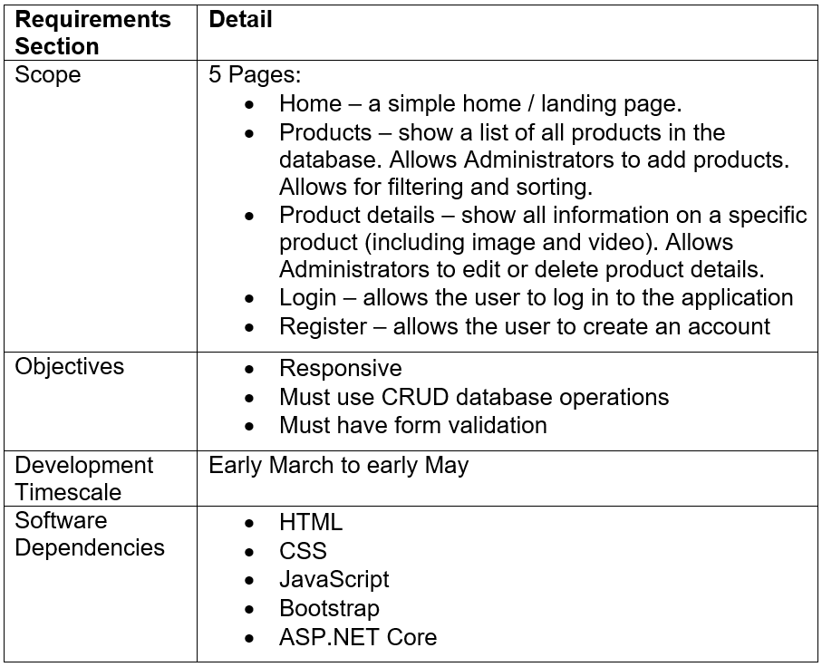
Figure 1 - Software requirements

Design

The application database was created with four tables: Customer, ShoppingBasket, Product and Order. Currently the Customer table is not linked with the application.
The database design rationale is as follows:
- Each customer has one and only one shopping basket, which holds all the items they have ordered.
- Each shopping basket has zero or more orders, each order being for a specific product
- Each order is for one product
The order table has a composite primary key made up of the Basket ID and Product ID. This table is in place to resolve a many-to-many relationship between the shopping basket and product.

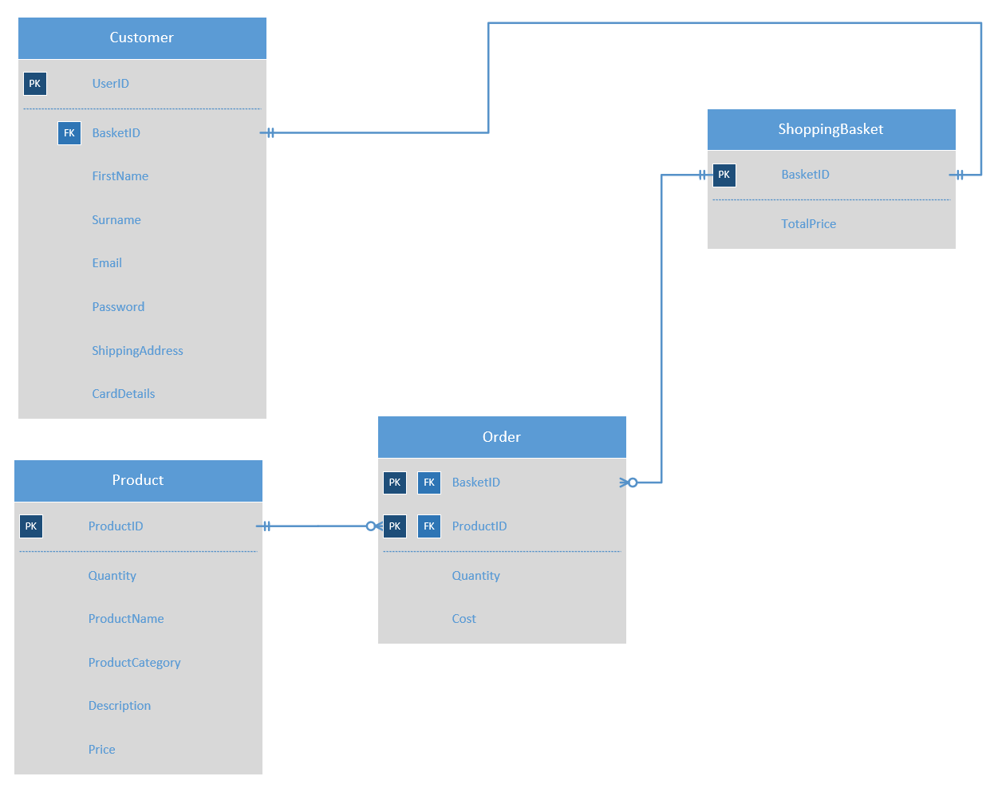
Figure 2 - Database design

Implementation

Model View Controller Implementation

A product list view was implemented to display all products from the database. The view uses Bootstrap cards for a responsive layout. Each product card contains the product name, its image and price. Clicking its image or name links to the details page for that specific product.

A product details view was implemented to display all information for one given product. This view displays the product name, price, number in stock, product category, its image and a promotional video.
A product controller was implemented to interact with HTTP requests from the rest of the application.

Page Screenshots

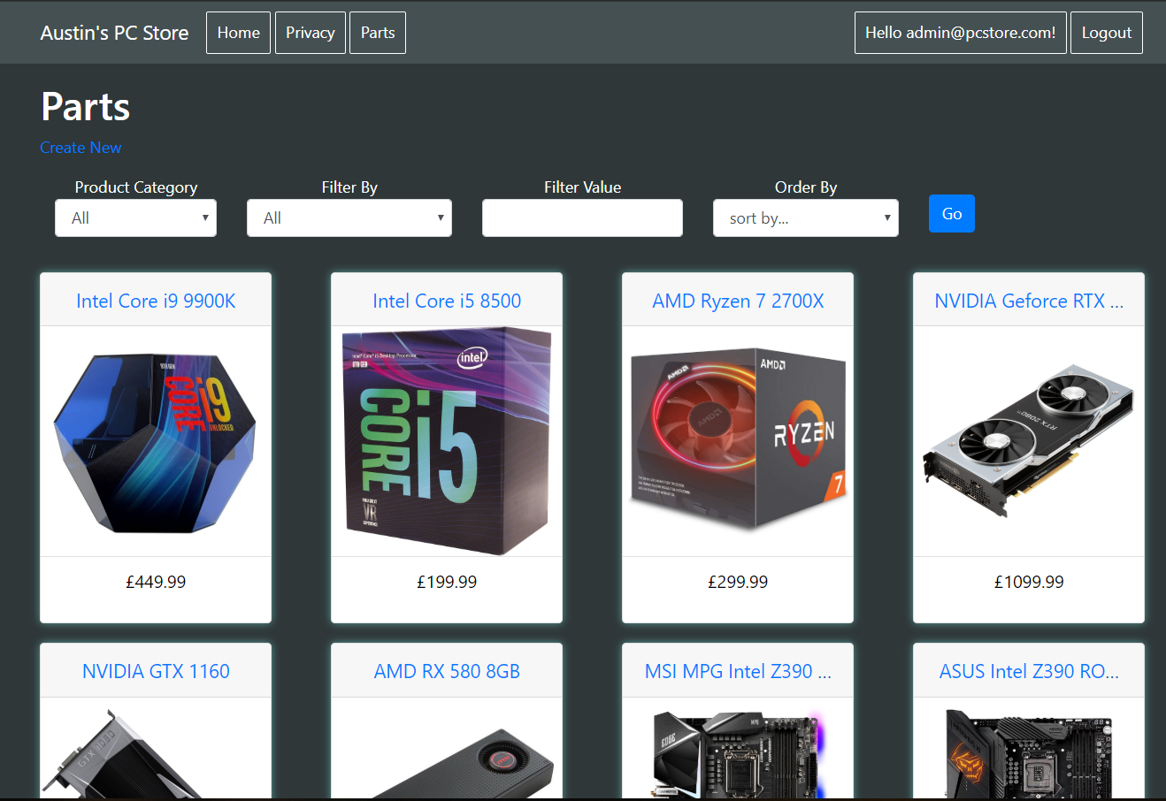

See below screenshots of the implemented web application. Some content has been omitted from this section as it is showed later on in the testing section.
Figure 3 - Products page
Figure 4 - Home page

Figure 5 - Product details page

Evaluation, Testing and Conclusion

Testing

Product List Displaying and Sorting

Sorting by category functions as expected. See below an image showing two different sorts by category – only the selected category is displayed to the user.
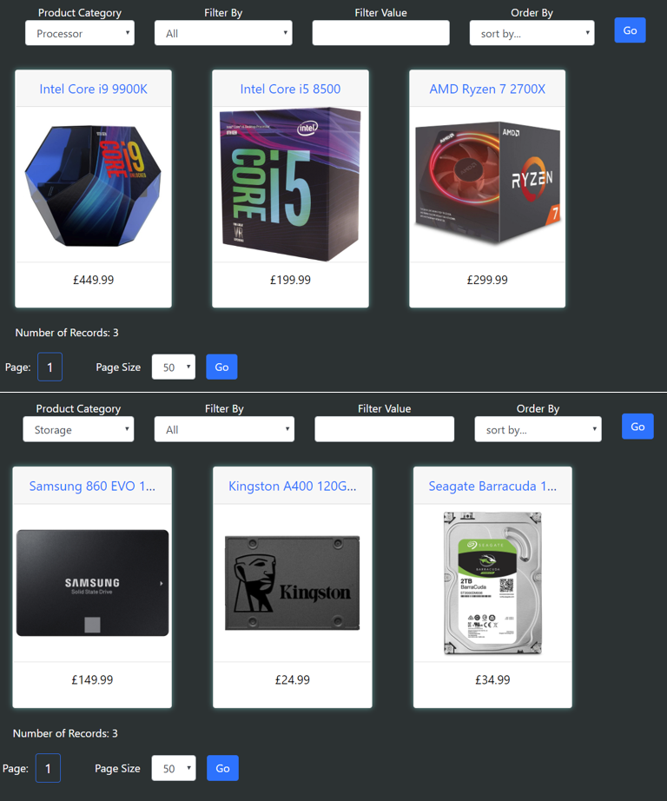
Figure 6 - Filter by product category

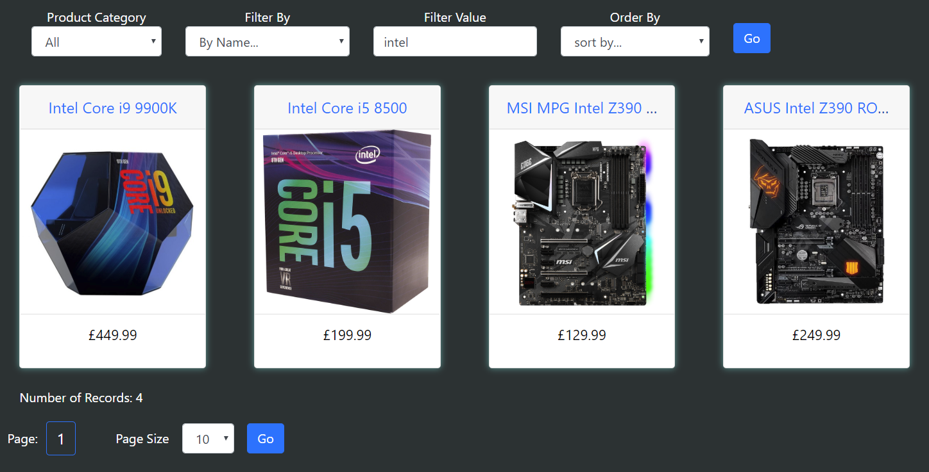
Filtering by product name functions as expected. Any products with the specified keywords in their name are displayed to the user. See below an example, filtering for only products with “intel” in the name.
Figure 7 - Filter by product name

Filtering by description contents also functions as expected. See below filtering by description containing the keyword “rgb,” showing all products which mention multicolour lighting in their descriptions:
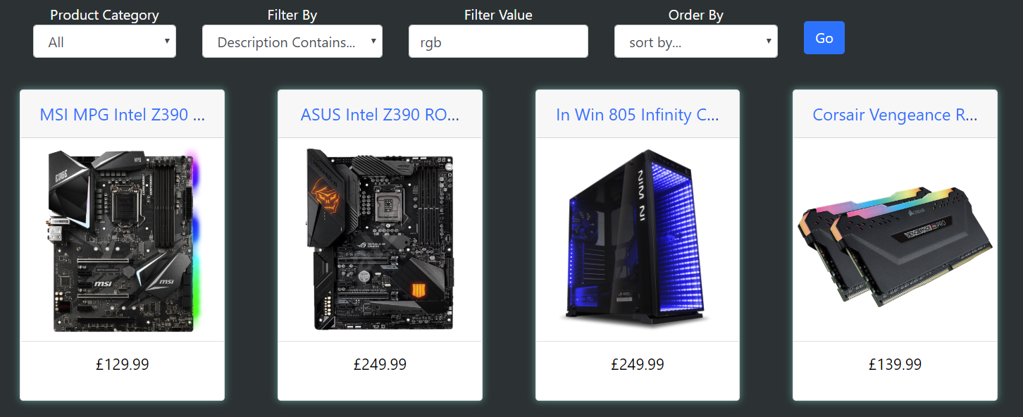
Figure 8 - Filter by description content
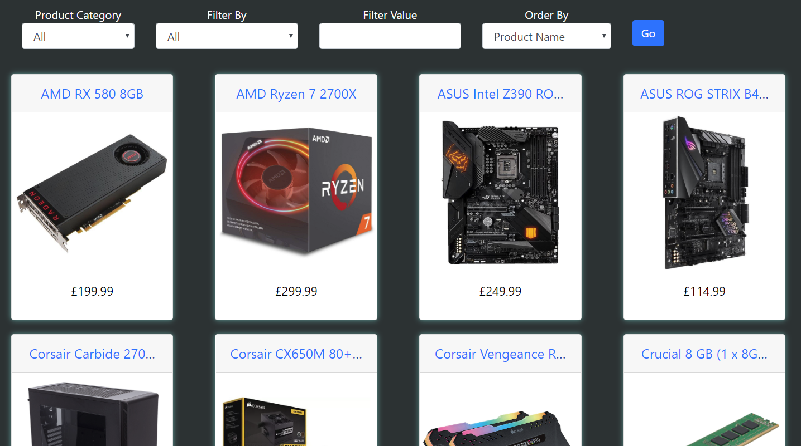
Ordering by name alphabetically works, as displayed below:
Figure 9 - Ordering alphabetically

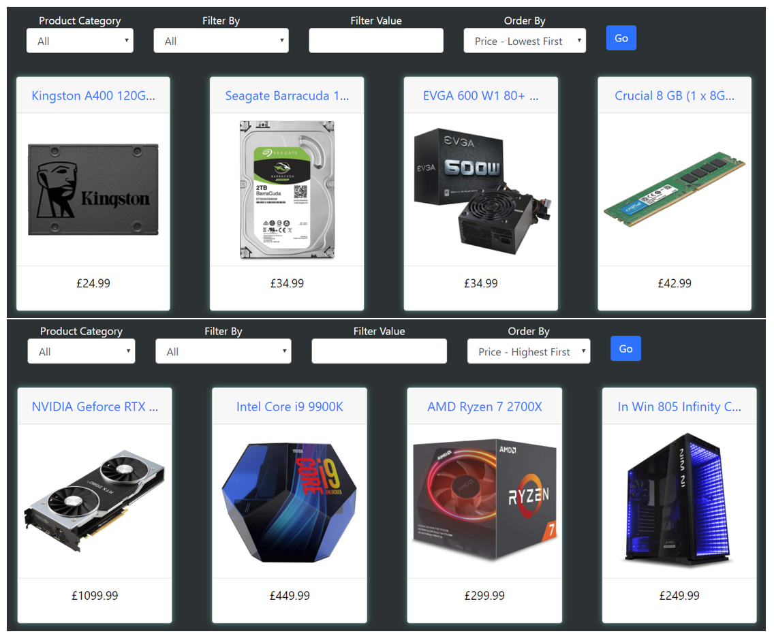
Ordering by price, both ascending and descending, also both function. See below examples:
Figure 10 - Ordering by price
Finally, any combination of the above work together. Below are two examples.
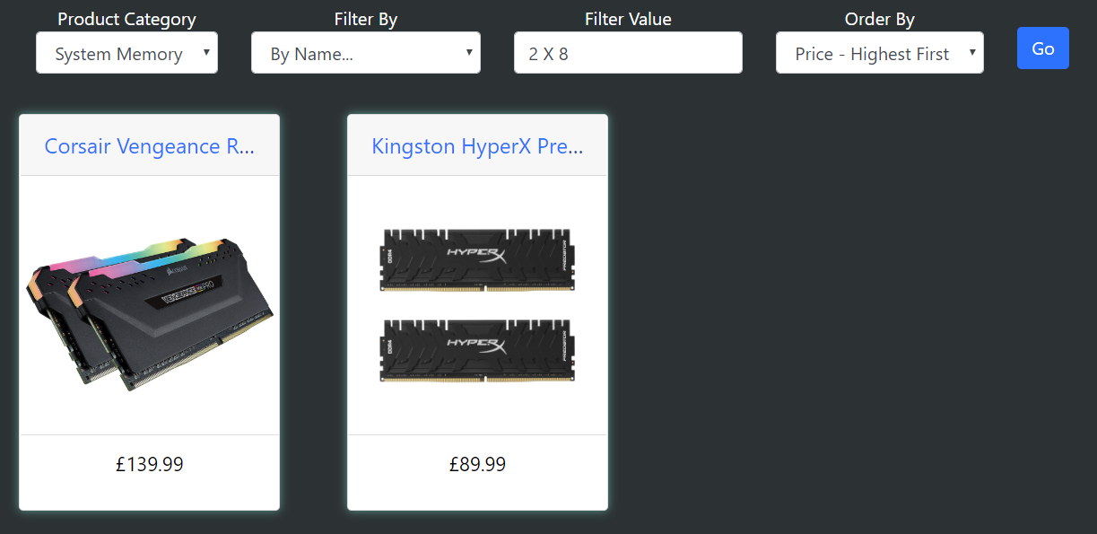
Figure 11 - Filter and order example 1
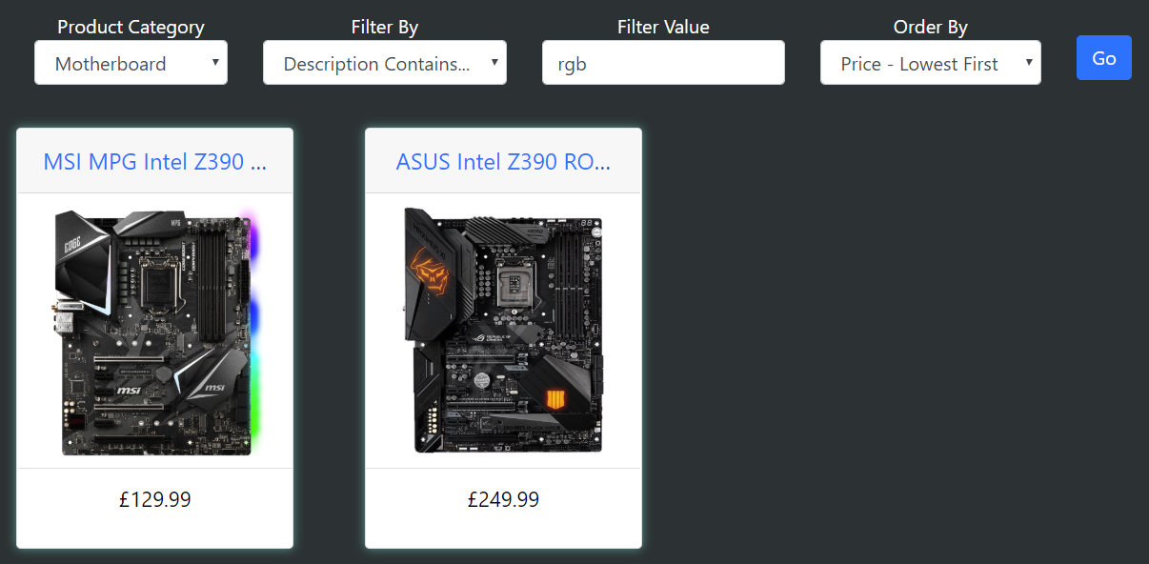
Figure 12 - Filter and order example 2

Login and Register

Registering a new user functions properly, with appropriate form validation as displayed below:

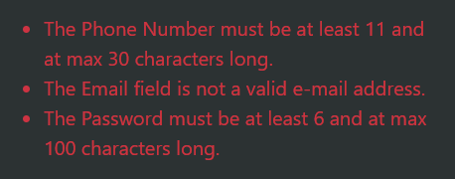
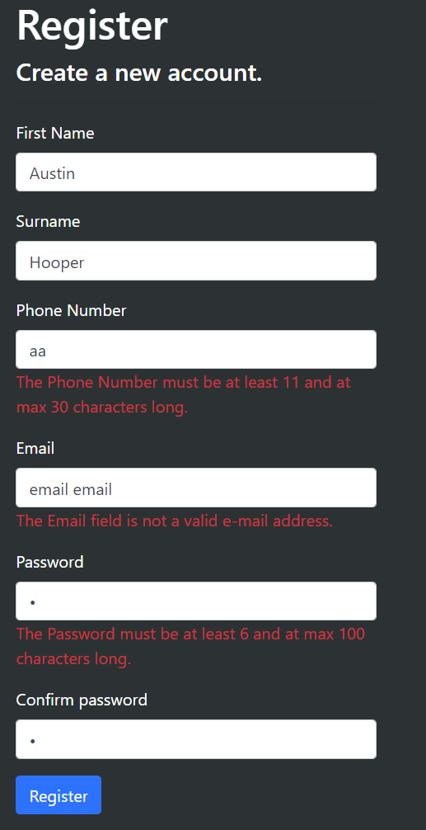
Figure 13 - Register validation messages
Figure 14 - Register validation
Upon registering, the user can then log in:
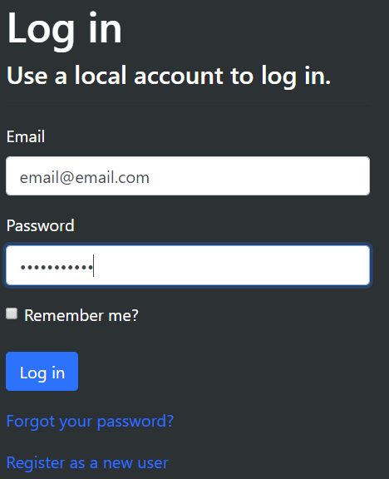
Figure 15 - Log in form


Figure 16 - User logged in

External Microsoft login functionality was also added and functions correctly in testing.
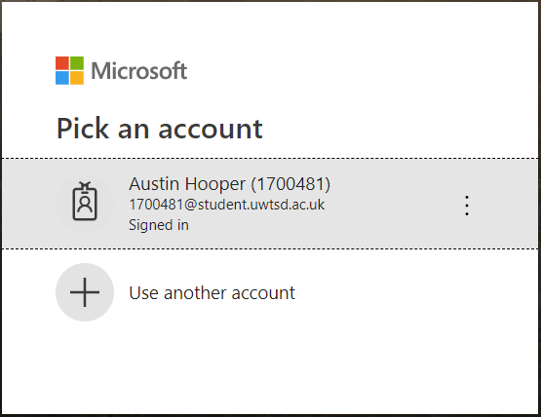
Figure 17 - External login

Administrator Restrictions

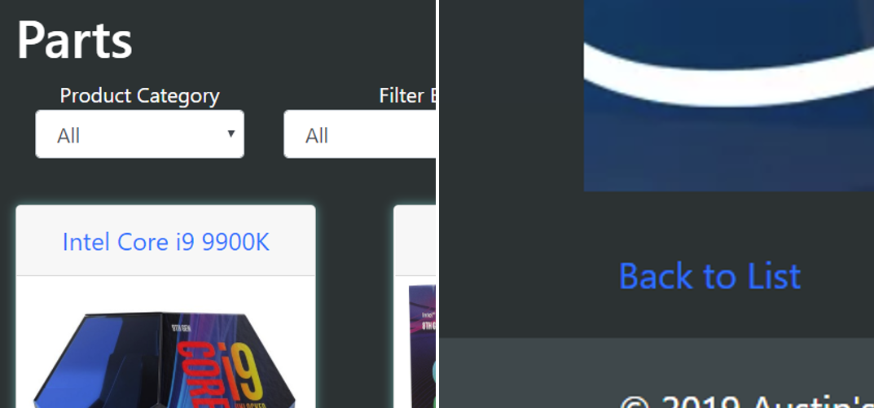
When the user is not currently logged in, or is logged in to a non-administrator account, options for creating new product instances, editing and deleting them are not displayed as shown below:
Figure 18 - No permissions

However, these options are made available once an admin account is logged in:
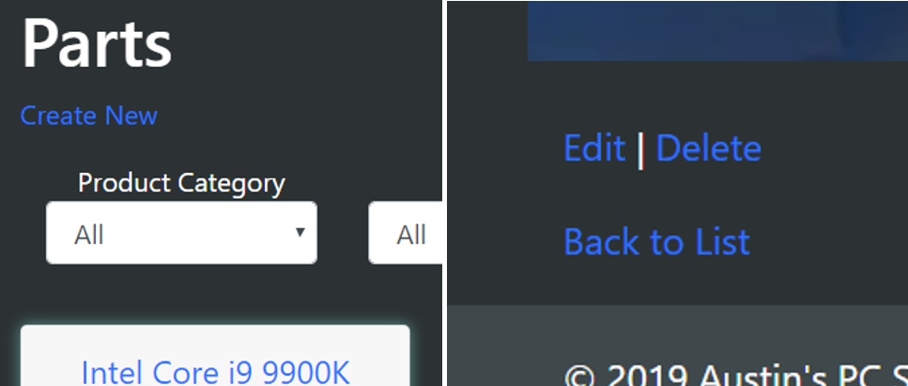
Figure 19 - Admin permissions

Adding, Editing and Deleting Products

Administrator users may add, edit or delete products from the products list page or product details page. Product values can be manually typed in, with a product category being chosen from a HTML select element.
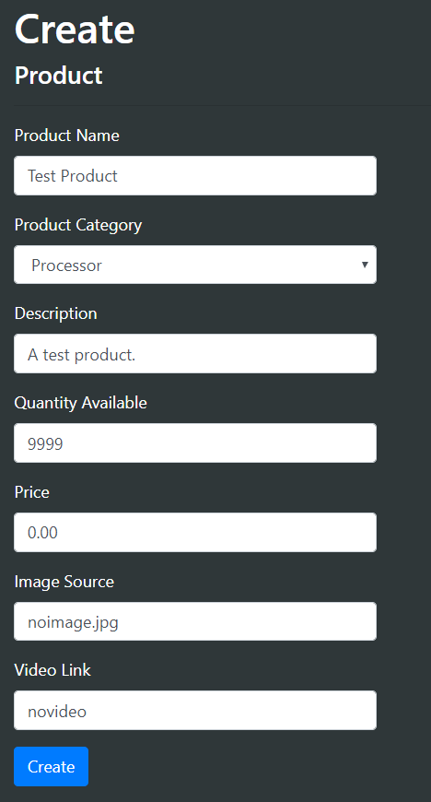
Figure 20 - Creating a product

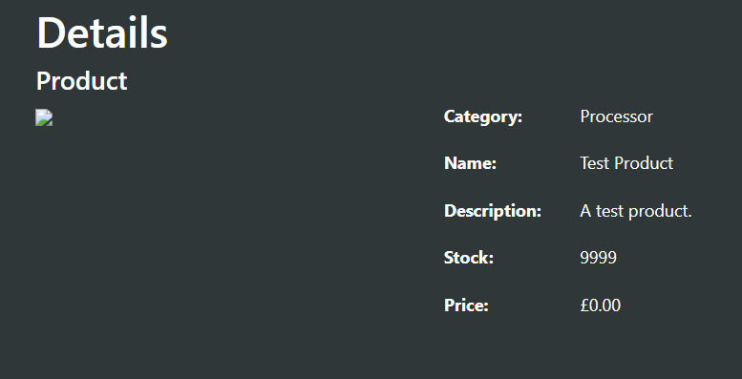
Figure 21 - New product

Once a product has been added, it displays in the product list and its details can be viewed as with any other product.
Editing a product has a similar interface to adding a product, as seen below. Once the product edits are saved, they are reflected on its product page.
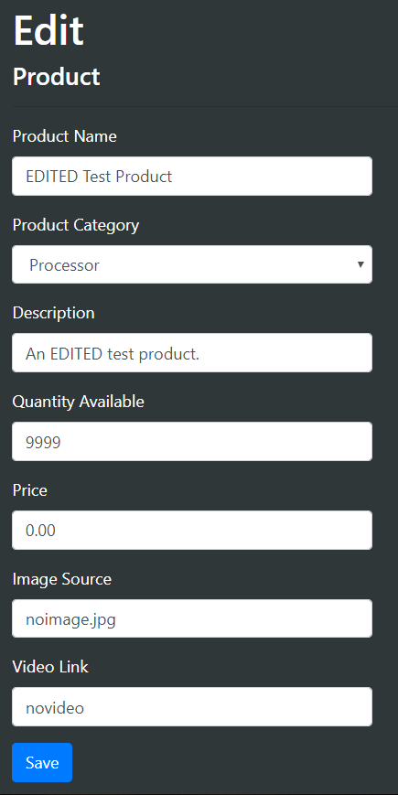
Figure 22 - Editing a product

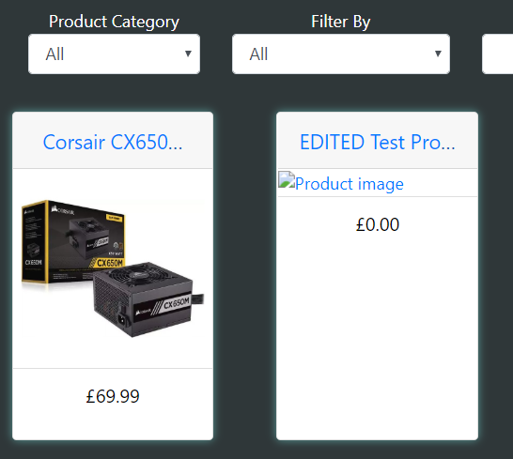
Figure 23 - Edited product in parts list

Deleting a product removes it from the database and these changes are reflected immediately.

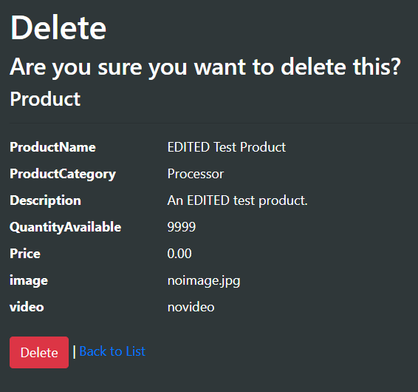
Figure 24 - Delete product dialog

Evaluation

The implemented web application is reasonably responsive, using the Bootstrap framework, with good visual design and usability. The majority of the initial functions have been implemented, though currently there is no way for a customer to order an item or input more of their details.

Some future recommendations for improvements are:
- Allowing the user to input more information on sign up, such as an address
- Implement a ‘My Account’ page, allowing the user to view and edit their registered details
- Include more products and categories. Currently there are only seven product categories with three products in each, for demonstration purposes.
- Provide more filtering fields. This could include filtering by brand, release date or price bracket.
- Allow for multiple filter fields at the same time. Currently only one product category can be filtered at a time. It would be ideal to replace the select element with check boxes to allow the user to choose a list of categories to filter
- Allow for product ordering

Conclusion

Overall, given the lack of experience with C#, the implemented web application is reasonably functional. The application meets the majority of the assessment criteria.

References

[1] Imperva, “Web Application Security | Application Security Checklist | Imperva,” 2019. [Online]. Available: https://www.imperva.com/learn/application-security/application-security/. [Accessed: 13-May-2019].
[2] Microsoft, “SQL Injection | Microsoft Docs,” 2012. [Online]. Available: https://docs.microsoft.com/en-us/previous-versions/sql/sql-server-2008-r2/ms161953(v=sql.105). [Accessed: 28-Apr-2019].
[3] W3Schools, “SQL Injection.” [Online]. Available: https://www.w3schools.com/sql/sql_injection.asp. [Accessed: 31-Mar-2019].
[4] R. Bisson, “SQL injection,” ITNOW, vol. 47, no. 2, pp. 25–25, Mar. 2005.
[5] The PHP Group, “PHP: Prepared Statements - Manual.” [Online]. Available: https://www.php.net/manual/en/mysqli.quickstart.prepared-statements.php. [Accessed: 28-Apr-2019].
[6] S. H. Huseby, Innocent code : a security wake-up call for Web programmers. Chichester: John Wiley & Sons, 2004.
[7] Acunetix, “What is Cross-site Scripting and How Can You Fix it?,” 2019. [Online]. Available: https://www.acunetix.com/websitesecurity/cross-site-scripting/. [Accessed: 30-Apr-2019].
[8] W3Schools, “KeyboardEvent key Property,” 2018. [Online]. Available: https://www.w3schools.com/jsref/event_key_key.asp. [Accessed: 30-Apr-2019].
[9] W3C, “Using character escapes in markup and CSS,” 2010. [Online]. Available: https://www.w3.org/International/questions/qa-escapes. [Accessed: 30-Apr-2019].
[10] B. Nagpal, N. Chauhan, and N. Singh, “CROSS-SITE REQUEST FORGERY: VULNERABILITIES AND DEFENSES,” i-Manager’s J. Inf. Technol., vol. 3, no. 2, 2014.
[11] Airbrake, “Software Design Patterns: A Guide,” 2019. [Online]. Available: https://airbrake.io/blog/design-patterns/software-design-patterns-guide. [Accessed: 18-May-2019].
[12] E. Gamma, Design patterns : elements of reusable object-oriented software. Addison-Wesley, 1995.
[13] J. M. Bishop, C# 3.0 design patterns. Sebastopol, CA: O’Reilly, 2008.

marking criteria and Student FEEDBACK

This section details the extent to which the assessment criteria are demonstrated by you, which in turn determines your mark. The marks available for each category of skill are shown. Lecturers will use the space provided to comment on the achievement of the task(s), including those areas in which you have performed well and areas that would benefit from development/improvement.

Common Assessment Criteria Applied (Assignment 2) | Marks available | Marks  awarded
1. Engagement with Literature Skills

Very good evidence of engagement with literature skills. (Grade mark: 80.00%) | 5 | 4
2. Knowledge and Understanding Skills

A very good discussion of some common examples of web security issues and their countermeasures. Good overview of software design patterns and a good introduction to your chosen design pattern but requires a clearer explanation of how it works and its relevance to web applications. (Grade mark: 76.00%) | 25 | 19
3. Cognitive and Intellectual Skills

A fair evaluation of the application has been provided identifying its limitations. Your testing approach is generally good, but needs to be improved to further demonstrate different test cases of the application's functionality. Some of your test cases are for default functionality provided with the VS application template which works straight out of the box. I am more interested in functionality that you have created. (Grade mark: 60.00%) | 20 | 12
4. Practical Application Skills

A very good attempt featuring a simple application based on the class tutorial but there is room for improvement. Requirements have been well thought out. Some CRUD functionality has been implemented and restricted using authorisation and you have also managed to get the default forms added by VS for editing and creating new records working. Filtering and paging is also working well. Generally, the application requires more functionality. Also change the content of the default home page added by VS. (Grade mark: 68.89%) | 45 | 31
5. Transferable Skills for Life and Professional Practice

The report is well-written and presented. (Grade mark: 80.00%) | 5 | 4

Assignment Mark (Assessment marks are subject to ratification at the Exam Board. These comments and marks are to give feedback on module work and are for guidance only until they are confirmed. ) | Late Submission Penalties (tick if appropriate) |  | 70%
 | Up to 1 week late (40% Max) |  | 70%
 | Over 1 week late (0%) |  | 70%

